Tide potential Calculation PhL 1.18.17

Start with

Ftid = mM1G ( 0/d02 – /d2)

= mM1G ( d0/d03 – d/d3)

and here is our picture

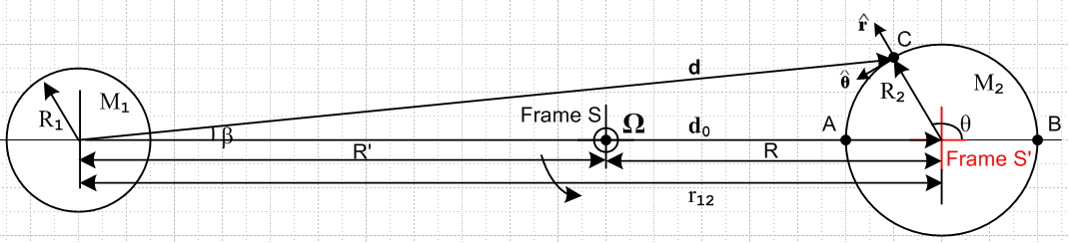

In Cartesian coordinates we can write

dx = d0 + R2 cosθ dy = R2sinθ

d = (d0 + R2 cosθ) + R2sinθ

d0 = d0

Then,

Ftid = mM1G ( d0/d03 – [ (d0 + R2 cosθ) + R2sinθ ]/d3)

now use

d2 = R22 + d02 - 2d0R0cos(π-θ) = R22 + d02 +2d0R0coθ = d02[ 1 + (R2/d0)2 + 2 (R2/d0)cosθ ]

≈ d02[ 1 + 2 (R2/d0)cosθ ]

to get

d-3 ≈ d0-3 [ 1 + 2(R2/d0)cosθ]-3/2 ≈ d0-3 [ 1 - 3(R2/d0)cosθ ] .

Then,

Ftid = mM1G ( d0/d03 – d/d3)

≈ mM1G ( d0/d03 – [ (d0 + R2 cosθ) + R2sinθ ] ) d0-3 [ 1 - 3(R2/d0)cosθ ] )

= (mM1G/d02) ( – [ (1 + (R2/d0) cosθ) + (R2/d0)sinθ ] [ 1 - 3(R2/d0)cosθ ] )

= (mM1G/d02) ( – - (R2/d0) cosθ) - (R2/d0)sinθ + 3(R2/d0)cosθ ) + O((R2/d0)2)

≈ (mM1G/d02) ( - (R2/d0) cosθ) - (R2/d0)sinθ + 3(R2/d0)cosθ )

= (mM1G/d02)(R2/d0) ( - cosθ - sinθ + 3cosθ )

= (mM1G/d02)(R2/d0) ( 2cosθ - sinθ )

Here I have again derived the hybrid Cartesian/polar coordinates version of Fttid

Now check this at the compass points

Ftid(0) = (mM1G/d02)(R2/d0) 2 point B to the right

Ftid(π) = - (mM1G/d02)(R2/d0) 2 point A to the left

Ftid(π/2) = - (mM1G/d02)(R2/d0) down at top

Ftid(-π/2) = +(mM1G/d02)(R2/d0) up at bottom

Compass agrees. I like the general formula:

Ftid(θ) ≈ (mM1G/d02)(R2/d0) ( 2cosθ - sinθ )

How might I plot this?

x = rcosθ
y = rsinθ

Ftid(r,θ) ≈ (mM1G/d02)(1/d0) ( 2rcosθ - rsinθ )

= (mM1G/d03) ( 2x- y ) // and now Cartesian!

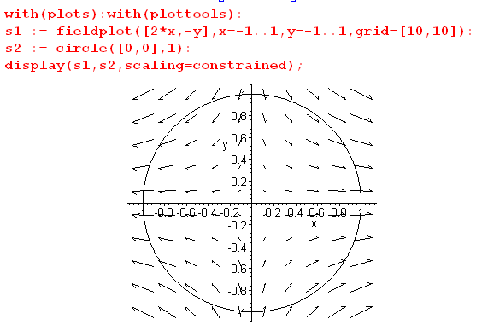

Very good. You want to think of R2 = r as a variable.

What is it in polar coordinates? ( r = R2)

Ftid(θ) ≈ (mM1G/d02)(r/d0) ( 2cosθ - sinθ )

= (mM1G/d02)(r/d0)( 2cosθ [cosθ – sinθ ] - sinθ [sinθ + cosθ ])

= (mM1G/d02)(r/d0)[ (2cos2θ-sin2θ) + (-2sinθcosθ - sinθcosθ)]

= (mM1G/d02)(r/d0)[ (3cos2θ-1) + (-3sinθcosθ) ]

= (mM1G/d02)(r/d0)[ (3{1/2)(1+cos2θ)}-1) + (-(3/2)sin2θ) ]

= (1/2)(mM1G/d02)(r/d0)[ (3{(1+cos2θ)}-2) + (-3sin2θ) ]

= (1/2)(mM1G/d02)(r/d0)[ (1 + 3cos2θ) - 3sin2θ ]
= (3/2)(mM1G/d02)(r/d0)[ ([1/3] + cos2θ) - sin2θ ]

This says

piece = - (3/2)(mM1G/d02)(r/d0) sin2θ horizontal (5) Butikov

piece = (3/2)(mM1G/d02)(r/d0) ( cos2θ +1/3) vertical (6) Butikov

So far so good! (8.8.31)

Can this force be represented by a potential? In electrostatics we have

E = -∇φ ⇒ div E = -∇2φ = 0 region of no charge

curlE = -∇ x (∇φ) = 0

So E must have zero divergence and zero curl in order to be rep by a potential. So consider

div Ftid = div( 2x- y ) = ∂2x(2x) +∂2y(-y) = 0 + 0 = 0

curl Ftid = [∂xFy- ∂yFx] + cyclic

[ 0 - 0] + 0 + 0 = 0

Therefore you NOT represent Ftid by a potential.

WRONG!!! First of all, div E = -∇2φ = "ρ" and ≠ 0.
Second of all, conservativity only involves the curl!

So the tidal force is a conservative force. yes

Here then is the force for which we seek a potential

Fg2 = -[(GM2m)/r3] r Earth gravity ok

Ftid = (mM1G/d03) ( 2x - y ) dim(F) = M L/T2 ok

dim(GMm/r2) = M L/T2 dim(GMm) = M L3/T2

Now consider dim(V) = M L2/T2

∇V(x,y) = -[(GM2m)/r3] r + (mM1G/d03) ( 2x - y ) ok

= -[(GM2m)/r3]( x + y ) + (mM1G/d03) ( 2x - y )

= [ -(GM2m)/r3) + (mM1G/d03)2 ] x + [ -(GM2m)/r3) - (mM1G/d03) ] y

= Gm { [ -M2/r3 + 2(M1/d03) ] x + [ -M2/r3 - (M1/d03) ] y } ok

Now suppose you try as ansatz,

V(x,y) = k[A2/x2 + B2/y2 - 1] ok // an arbitrary ellipse centered at Earth center
∇V(x,y) = -2kA2/x3 -2kB2/y3 ok // dim(k) = M L2/T2

Comment: Here I am assuming that V(x,y) is a multiple of the desired ellipse equation so I guess the surface V(x,y) = 0 would be an ellipse. Should have said V(x,y) = k[A2/x2 + B2/y2] and then any surface V(x,y) = constant would be an ellipse. What I did not know is that the actual surface is a quartic and not an ellipse, so this was all hopeless. (Hence Paradox below)

This does not seem to work, why is that? You would need now to have

-2kA2/x3 = Gm [ -M2/r3 + 2(M1/d03) ] x
-2kB2/y3 = Gm [ -M2/r3 - (M1/d03) ] y
or
-2kA2 = Gm [ -M2/r3 + 2 (M1/d03) ] x4
-2kB2 = Gm [ -M2/r3 - (M1/d03) ] y4 r2 = x2+y2

Just check dimensions please.

dim(kA2) = M L4/T2 dim(GmMx4/r3) = M L3/T2 * L = M L4/T2

so dimensions are OK. I do know that

r << d0 x << d0 y << d0

but this does not seem to help at all. I am stumped, this will take another day or two of burned time to figure out. It is so simple, what am I doing wrong here?

Paradox #1. Suppose I let M1→ 0 so the moon goes away slowly. The last two equations then become

-2kA2 = Gm [ -M2/r3 ] x4
-2kB2 = Gm [ -M2/r3 ] y4 r2 = x2+y2

I expect the potential surface to be a circle rather than an ellipse since there are now no tidal forces, and that means I expect to have A = B. But instead I have A ≠B. This should give A = B = R2 somehow.

Maybe I have to do this in 3D space and not fake 2D space?

Start Over! Use spherical coordinates r,θ,φ centered on the Earth with z to the right.

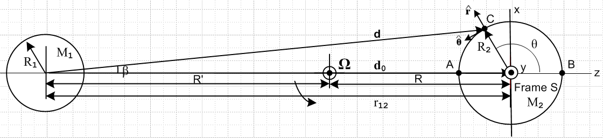

Ftid = mM1G { d0/d03 – d/d3 }

d0 = d0
C = r = rsinθcosφ + rsinθsinφ + rcosθ = x

Moon center = cm = -d0

d = C - cm = rsinθcosφ + rsinθsinφ + rcosθ + d0

= rsinθcosφ + rsinθsinφ + (rcosθ+d0)

d2 = ( rsinθcosφ)2 + ( rsinθsinφ)2 + (rcosθ+d0)2

= r2sin2θ + (d0 + rcosθ)2

= r2sin2θ + d02(1 + [r/d0]cosθ)2

≈ r2sin2θ + d02(1 + 2 [r/d0]cosθ)

= d02 [ [r/d0]2sin2θ + d02(1 + 2 [r/d0]cosθ)

≈ d02(1 + 2 [r/d0]cosθ) // ignore quadratic term

This is same as in Section 8.8, no surprise. So still get

d-3 ≈ d0-3 [ 1 + 2(R2/d0)cosθ]-3/2 ≈ d0-3 [ 1 - 3(R2/d0)cosθ ] . (8.8.22)

Now:

Ftid = mM1G { d0/d03 – d/d3 }

= mM1G { [d0]/d03 – [ rsinθcosφ + rsinθsinφ + (rcosθ+d0)]/d3 }

= mM1G { d02 – [ rsinθcosφ d-3 + rsinθsinφd-3 + (rcosθ+d0)d-3]}

= mM1G { – [ rsinθcosφ d-3 + rsinθsinφd-3 + {d02+(rcosθ+d0)d-3} ]}

STOP. Why not do this all in Cartesians.

Start over

Ftid = mM1G { d0/d03 – d/d3 }

d0 = d0
C = r = x + y + z

Moon center = cm = -d0

d = C - cm = x + y + z + d0

= x + y + (d0+z)

d2 = x2 + y2 + (d0+z)2

= d02{ [ 1 + (z/d0) ]2 + (x/d0)2 + (y/d0)2 }

≈ d02{ [ 1 +2 (z/d0) + (z/d0) 2 ] + (x/d0)2 + (y/d0)2 }

≈ d02[ 1 +2 (z/d0)] dropping all quadratic terms

d-3 ≈ d0 -3[ 1 +2 (z/d0)] -3/2 ≈ d0 -3( 1- 3(z/d0) )

Now have

Ftid = mM1G { d0/d03 – d/d3 }

= mM1G { d0/d03 – [ x + y + (d0+z) ]/d3 }

= mM1G { /d02 – [ (x/d3) + (y/d3) + ((d0+z)/d3) ] }

= mM1G {– (x/d3) – (y/d3) – ((d0+z)/d3 - 1/d02) ] }

= – mM1G { (x/d3) + (y/d3) + ((d0+z)/d3 - 1/d02) ] }

Now look at each component separately

(x/d3) ≈ d0 -3( 1- 3(z/d0) ) x ≈ x/d03

(y/d3) ≈ d0 -3( 1- 3(z/d0) ) y ≈ y/d03

(d0+z)/d3 - 1/d02 = [(d0+z)/d03] ( 1- 3(z/d0) ) - 1/d02

= [(1+(z/d0))/d02] ( 1- 3(z/d0) ) - 1/d02

= { [(1+(z/d0))] ( 1- 3(z/d0) ) - 1 } /d02

= { 1 + (z/d0) - 3(z/d0) - 3(z/d0)2 - 1} /d02

≈ { - 2(z/d0) } /d02 = -2z/d03

We then end up with

Ftid = – mM1G{ (x/d03) + (y/d03) + ( -2z/d03) }

= – (mM1G/d03){ x + y - 2z }

and this then is my 3D generalization of previous result where I had y = 0. Could make 3D field plot.

I also have

Fg2 = -[(GM2m)/r3] r

The total force acting on a particle m of water is then

F = Ftid + Fg2 = – (mM1G/d03){ x + y - 2z }-[(GM2m)/r3] r

= mG { (M1/d03 - M2/r3)x + (M1/d03 - M2/r3)y + (-2M1/d03 - M2/r3)z }

Now suppose I drop the 1/d03 terms since d0 >> r and this is OK for M1→ 0 as well. then

F = Ftid + Fg2 = – (mM1G/d03){ x + y - 2z }-[(GM2m)/r3] r

= mG { - M2/r3)x + (- M2/r3)y + ( - M2/r3)z }

and only gravity is left.

NOW: Here is an ansatz ellipsoid for the potential surface :

V(x,y,z) = k[A2/x2 + A2/y2 + C2/z2 ] // repeating the above hoping for ellipsoid

∇V = -2k[ (A2/x3) + (A2/y3) + (C2/z3) ]

Now I have the same problem as before I think. I have to identify: ∇V = Ftid and then the following must be true:

2k[ (A2/x3) + (A2/y3) + (C2/z3) ] = (mM1G/d03){ x + y - 2z } - [(GM2m)/r3] r

= (mM1G/d03){ x + y - 2z } - [(GM2m)/r3] {x + y + z }

= mG { (M1/d03 - M2/r3)x + (M1/d03 - M2/r3)y + (-2M1/d03 - M2/r3) }

which then requires that

2k(A2/x3) = mG (M1/d03 - M2/r3)x

2k(A2/y3) = mG (M1/d03 - M2/r3)y

2k(C2/z3) = mG (-2M1/d03 - M2/r3)

So converting to 3D coordinates has done NOTHING to explain my problem.

Paradox 1 Reappears: Suppose I turn off the moon. Then I get

2k(A2/x3) = mG (- M2/r3)x

2k(A2/y3) = mG (- M2/r3)y

2k(C2/z3) = mG (- M2/r3)

and this is supposed to give a sphere!!!

So I just wasted 2 hours maybe seeing if going from 2D to 3D would fix this paradox. A bad hunch.

Comment: Sometimes to fix a problem you take a wrong tack in hopes of a solution. Going from 2D to 3D was such a wrong tack and it did not resolve the paradox!

Let's try a simpler problem! There is no moon, only earth gravity so

F = mG { - M2/r3)x + (- M2/r3)y + ( - M2/r3)z }

This is supposed to be related to a sphere.

x2+ y2+z2 = A2

How is this sphere connected? It is not hard to see in sphericals

F = -(mG/r2)

V(r) = (mG/r2)

So V is constant on a sphere of radius r. But how does that work in Cartesians?

V = (mG) $\frac{1}{x2+y2+z2}$

The sphere is "on the bottom". So you don't say

V(r) = k (x2+y2+z2)

But still V = constant would give a sphere either way.

