Tide potential Calculation PhL 1.18.17

We seek a potential V(x,y) which solves this equation (no minus sign)

∇V(x,y) = Ftid = - [(GM2m)/r2] + (mM1G/d03) ( 2x - y ) // r = $\sqrt{x2+y2}$ (8.8.63)

The solution is the following (by inspection)

V(x,y) = (GM2m/r) + (GM1m/d03)( x2 - y2/2) . // ∇(1/r) = -(1/r2), r > 0 (8.8.64)

Of interest are surfaces on which V is a constant, so

(M2/r) + (M1/d03)( x2 - y2/2) = k (8.8.65)

M22 = r2[ k -(M1/d03)( x2 - y2/2) ]2 = k2r2 [1 - (M1/kd03)( x2 - y2/2)]2

≈ k2r2 [1 - (M1/kd03)( 2x2 - y2)] ⇒

(M2/k)2 = r2 [1 -ε(2x2 - y2)] ε ≡ (M1/kd03)

= (x2+y2) (1 - 2εx2 + εy2) dim(M1/k) = L

= r2 (1 - 2εr2cos2θ + εr2sin2θ) dim(ε) = L-2 (8.8.66)

Maple file "tides by potential method" has code and graphic: (8.8.67)

This is a quadratic equation in r2 which has this solution (after some work), to lowest order in ε

r(θ) ≈ (M2/k)[ 1 - (1/8)ε(sin2θ - 2cos2θ)(M2/k)2] // see v3 of current doc (8.8.68)

As was done in **, we require that the average value of r(θ) over θ be R2 . We find

<r(θ)> = c[ 1 -(1/8)ε{(1/2)- 2(1/2)}c2 ]

= c[ 1 - (1/16)c2 ε {1-2} ]

= (M2/k)[ 1+ (1/16)(M2/k)2ε ] = R2 (8.8.69)

Solving for (M2/k) gives

(M2/k) = R2(1-αεR22) (M2/k) ≈ R2 (8.8.70)

so the locus of the cubic is this

R22(1-αεR22)2 = (x2+y2) [1 -ε(2x2 - y2)] (8.8.71)

ε = (M1/kd03) ≈ (M1/[M2/R2]d03) = (M1/M2)R2/d03 (8.8.71)

At the right edge of the quartic we set y = 0 and find that

x ≈ R2 [ 1 + (15/16)(M1/M2)(R2/d0)3] (8.8.72)

which says that the high tide is

|Δ|high = (15/16)(M1/M2)R24/d03

At the top edge of the quartic we set x = 0 and find that

|Δ|low = (9/16)(M1/M2)R24/d03 (8.8.72)

The height difference is then

H = |Δ|high + |Δ|high = (M1/M2)R24/d03 { (15/16)+ (9/16) }

= (3/2)(M1/M2)R24/d03 (8.8.72)

In (8.8.33) we have H = 2a so the result is then

a = (3/4)(M1/M2)R24/d03 (8.8.73)

in agreement with (8.8.41) .

What happens now at the right edge of the quadric where y = 0:

R22(1-αεR22)2 = (x2) [1 -ε(2x2)] = x2(1 - 2εx2) ≈ x2(1 - 2εR22)

Then it seems that

x = R2(1-αεR22) * (1 - 2εR22)-1/2

≈ R2(1-αεR22) * (1+ εR22)

≈ R2 [ 1 + εR22(1-α)]

≈ R2 [ 1 + (M1/M2)R2/d03R22(15/16)]

≈ R2 [ 1 + (M1/M2)(R2/d0)3(15/16)] (8.8.72)

So the high tide is then

hhigh = (M1/M2)(R2/d0)3R2(15/16)

Now what happens at the top edge of the quadric where x = 0

R22(1-αεR22)2 = (x2) [1 -ε(2x2)] = y2(1+εy2) ≈ y2(1 + εR22)

It seems then that

y = R2(1-αεR22) * (1 + εR22)-1/2

≈ R2(1-αεR22) * (1-[1/2]εR22)

≈ R2(1 -αεR22 -[1/2]εR22)

≈ R2(1 -εR22(1/16 + 8/16))

≈ R2(1 -εR22(9/16))

≈ R2(1 -(M1/M2)R2/d03R22(9/16))

≈ R2(1 -(M1/M2)(R2/d0)3(9/16)) (8.8.72)

So the low tide is then (abs val)

hlow = (M1/M2)(R2/d0)3R2(9/16)

We then add these to get

"2a" = (M1/M2)(R2/d0)3R2 [ (15/16)+ (9/16) ]

= (M1/M2)(R2/d0)3R2 [ (24/16) ]

= (M1/M2)(R2/d0)3R2 [ (3/2) ] (8.8.72)

Then

"a" = (3/4) (M1/M2)(R2/d0)3R2 // it works!!!! (8.8.73)

This locus is close to the locus of a circle of some radius R

R2 = (x2+y2)

or

R2 = (x2+y2) (1 - 2εx2+εy2) ε ≡ (M1/kd03) R = M2/k = constant

Since d0 is large, ε is small, and R2 ≈ (x2+y2) so 1/k ≈ R/M2. Then

(M2/k)2 ≈ (x2+y2) (1 - 2εx2+εy2) ε = (M1/M2)/d03

This is a quartic curve which resembles an ellipse. For example, for ε = .05 and M2/k = 1:

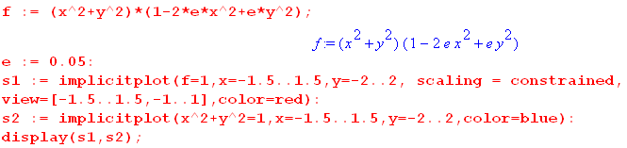

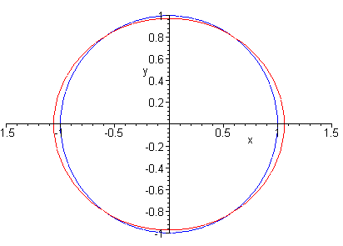
where the blue curve is a circle of radius 1.

Gm(M1/d03) (x2/2) - Gm (M1/d03) (y2/2) }

Start with

Ftid = mM1G ( 0/d02 – /d2)

= mM1G ( d0/d03 – d/d3)

and here is our picture

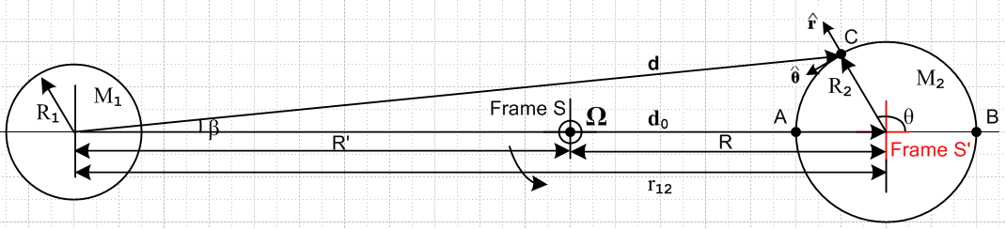

In Cartesian coordinates we can write

dx = d0 + R2 cosθ dy = R2sinθ

d = (d0 + R2 cosθ) + R2sinθ

d0 = d0

Then,

Ftid = mM1G ( d0/d03 – [ (d0 + R2 cosθ) + R2sinθ ]/d3)

now use

d2 = R22 + d02 - 2d0R0cos(π-θ) = R22 + d02 +2d0R0coθ = d02[ 1 + (R2/d0)2 + 2 (R2/d0)cosθ ]

≈ d02[ 1 + 2 (R2/d0)cosθ ]

to get

d-3 ≈ d0-3 [ 1 + 2(R2/d0)cosθ]-3/2 ≈ d0-3 [ 1 - 3(R2/d0)cosθ ] .

Then,

Ftid = mM1G ( d0/d03 – d/d3)

≈ mM1G ( d0/d03 – [ (d0 + R2 cosθ) + R2sinθ ] ) d0-3 [ 1 - 3(R2/d0)cosθ ] )

= (mM1G/d02) ( – [ (1 + (R2/d0) cosθ) + (R2/d0)sinθ ] [ 1 - 3(R2/d0)cosθ ] )

= (mM1G/d02) ( – - (R2/d0) cosθ) - (R2/d0)sinθ + 3(R2/d0)cosθ ) + O((R2/d0)2)

≈ (mM1G/d02) ( - (R2/d0) cosθ) - (R2/d0)sinθ + 3(R2/d0)cosθ )

= (mM1G/d02)(R2/d0) ( - cosθ - sinθ + 3cosθ )

= (mM1G/d02)(R2/d0) ( 2cosθ - sinθ )

Now check this at the compass points

Ftid(0) = (mM1G/d02)(R2/d0) 2 point B to the right

Ftid(π) = - (mM1G/d02)(R2/d0) 2 point A to the left

Ftid(π/2) = - (mM1G/d02)(R2/d0) down at top

Ftid(-π/2) = +(mM1G/d02)(R2/d0) up at bottom

Compass agrees. I like the general formula:

Ftid(θ) ≈ (mM1G/d02)(R2/d0) ( 2cosθ - sinθ )

How might I plot this?

x = rcosθ
y = rsinθ

Ftid(r,θ) ≈ (mM1G/d02)(1/d0) ( 2rcosθ - rsinθ )

= (mM1G/d03) ( 2x- y )

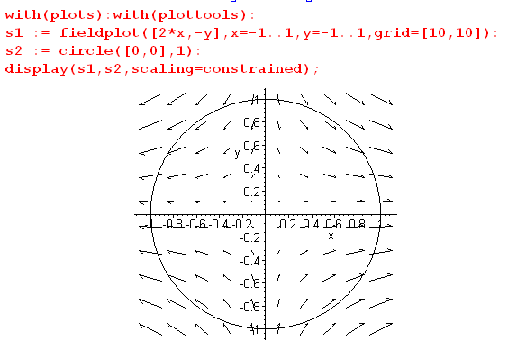

Very good. You want to think of R2 = r as a variable.

What is it in polar coordinates? ( r = R2)

Ftid(θ) ≈ (mM1G/d02)(r/d0) ( 2cosθ - sinθ )

= (mM1G/d02)(r/d0)( 2cosθ [cosθ – sinθ ] - sinθ [sinθ + cosθ ])

= (mM1G/d02)(r/d0)[ (2cos2θ-sin2θ) + (-2sinθcosθ - sinθcosθ)]

= (mM1G/d02)(r/d0)[ (3cos2θ-1) + (-3sinθcosθ) ]

= (mM1G/d02)(r/d0)[ (3{1/2)(1+cos2θ)}-1) + (-(3/2)sin2θ) ]

= (1/2)(mM1G/d02)(r/d0)[ (3{(1+cos2θ)}-2) + (-3sin2θ) ]

= (1/2)(mM1G/d02)(r/d0)[ (1 + 3cos2θ) - 3sin2θ ]
= (3/2)(mM1G/d02)(r/d0)[ ([1/3] + cos2θ) - sin2θ ]

This says

piece = - (3/2)(mM1G/d02)(r/d0) sin2θ horizontal (5) Butikov

piece = (3/2)(mM1G/d02)(r/d0) ( cos2θ +1/3) vertical (6) Butikov

So far so good!

Can this force be represented by a potential? In electrostatics we have

E = -∇φ ⇒ div E = -∇2φ = 0 region of no charge

curlE = -∇ x (∇φ) = 0

So E must have zero divergence and zero curl in order to be rep by a potential. So consider

div Ftid = div( 2x- y ) = ∂2x(2x) +∂2y(-y) = 0 + 0 = 0

curl Ftid = [∂xFy- ∂yFx] + cyclic

[ 0 - 0] + 0 + 0 = 0

Therefore you NOT represent Ftid by a potential.

WRONG!!! First of all, div E = -∇2φ = "ρ" and ≠ 0.
Second of all, conservativity only involves the curl!

So the tidal force is a conservative force.

Here then is the force for which we seek a potential

Fg2 = -[(GM2m)/r3] r Earth gravity ok

Ftid = (mM1G/d03) ( 2x - y ) dim(F) = M L/T2 ok

dim(GMm/r2) = M L/T2 dim(GMm) = M L3/T2

Now consider dim(V) = M L2/T2

∇V(x,y) = -[(GM2m)/r3] r + (mM1G/d03) ( 2x - y ) ok

= -[(GM2m)/r3]( x + y ) + (mM1G/d03) ( 2x - y )

= [ -(GM2m)/r3) + (mM1G/d03)2 ] x + [ -(GM2m)/r3) - (mM1G/d03) ] y

= Gm { [ -M2/r3 + 2(M1/d03) ] x + [ -M2/r3 - (M1/d03) ] y } ok

Now suppose you try as ansatz, WRONG!!!!

V(x,y) = k[A2/x2 + B2/y2 - 1] ok // an arbitrary ellipse centered at Earth center
∇V(x,y) = -2kA2/x3 -2kB2/y3 ok // dim(k) = M L2/T2

This does not seem to work, why is that? You would need now to have

-2kA2/x3 = Gm [ -M2/r3 + 2(M1/d03) ] x
-2kB2/y3 = Gm [ -M2/r3 - (M1/d03) ] y
or
-2kA2 = Gm [ -M2/r3 + 2 (M1/d03) ] x4
-2kB2 = Gm [ -M2/r3 - (M1/d03) ] y4 r2 = x2+y2

Just check dimensions please.

dim(kA2) = M L4/T2 dim(GmMx4/r3) = M L3/T2 * L = M L4/T2

so dimensions are OK. I do know that

r << d0 x << d0 y << d0

but this does not seem to help at all. I am stumped, this will take another day or two of burned time to figure out. It is so simple, what am I doing wrong here?

Paradox #1. Suppose I let M1→ 0 so the moon goes away slowly. The last two equations then become

-2kA2 = Gm [ -M2/r3 ] x4
-2kB2 = Gm [ -M2/r3 ] y4 r2 = x2+y2

I expect the potential surface to be a circle rather than an ellipse since there are now no tidal forces, and that means I expect to have A = B. But instead I have A ≠B. This should give A = B = R2 somehow.

Maybe I have to do this in 3D space and not fake 2D space?

Start Over! Use spherical coordinates r,θ,φ centered on the Earth with z to the right.

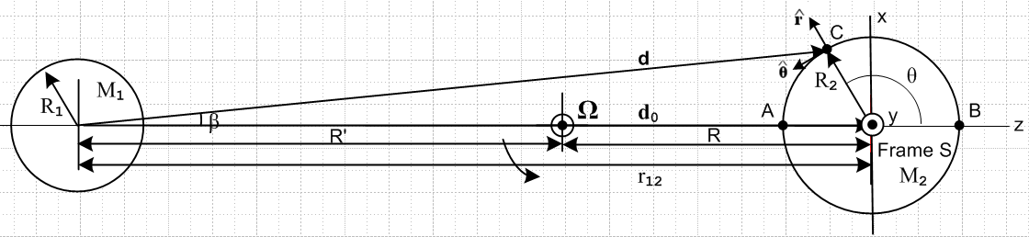

Ftid = mM1G { d0/d03 – d/d3 }

d0 = d0
C = r = rsinθcosφ + rsinθsinφ + rcosθ = x

Moon center = cm = -d0

d = C - cm = rsinθcosφ + rsinθsinφ + rcosθ + d0

= rsinθcosφ + rsinθsinφ + (rcosθ+d0)

d2 = ( rsinθcosφ)2 + ( rsinθsinφ)2 + (rcosθ+d0)2

= r2sin2θ + (d0 + rcosθ)2

= r2sin2θ + d02(1 + [r/d0]cosθ)2

≈ r2sin2θ + d02(1 + 2 [r/d0]cosθ)

= d02 [ [r/d0]2sin2θ + d02(1 + 2 [r/d0]cosθ)

≈ d02(1 + 2 [r/d0]cosθ) // ignore quadratic term

This is same as in Section 8.8, no surprise. So still get

d-3 ≈ d0-3 [ 1 + 2(R2/d0)cosθ]-3/2 ≈ d0-3 [ 1 - 3(R2/d0)cosθ ] . (8.8.22)

Now:

Ftid = mM1G { d0/d03 – d/d3 }

= mM1G { [d0]/d03 – [ rsinθcosφ + rsinθsinφ + (rcosθ+d0)]/d3 }

= mM1G { d02 – [ rsinθcosφ d-3 + rsinθsinφd-3 + (rcosθ+d0)d-3]}

= mM1G { – [ rsinθcosφ d-3 + rsinθsinφd-3 + {d02+(rcosθ+d0)d-3} ]}

STOP. Why not do this all in Cartesians.

Start over

Ftid = mM1G { d0/d03 – d/d3 }

d0 = d0
C = r = x + y + z

Moon center = cm = -d0

d = C - cm = x + y + z + d0

= x + y + (d0+z)

d2 = x2 + y2 + (d0+z)2

= d02{ [ 1 + (z/d0) ]2 + (x/d0)2 + (y/d0)2 }

≈ d02{ [ 1 +2 (z/d0) + (z/d0) 2 ] + (x/d0)2 + (y/d0)2 }

≈ d02[ 1 +2 (z/d0)] dropping all quadratic terms

d-3 ≈ d0 -3[ 1 +2 (z/d0)] -3/2 ≈ d0 -3( 1- 3(z/d0) )

Now have

Ftid = mM1G { d0/d03 – d/d3 }

= mM1G { d0/d03 – [ x + y + (d0+z) ]/d3 }

= mM1G { /d02 – [ (x/d3) + (y/d3) + ((d0+z)/d3) ] }

= mM1G {– (x/d3) – (y/d3) – ((d0+z)/d3 - 1/d02) ] }

= – mM1G { (x/d3) + (y/d3) + ((d0+z)/d3 - 1/d02) ] }

Now look at each component separately

(x/d3) ≈ d0 -3( 1- 3(z/d0) ) x ≈ x/d03

(y/d3) ≈ d0 -3( 1- 3(z/d0) ) y ≈ y/d03

(d0+z)/d3 - 1/d02 = [(d0+z)/d03] ( 1- 3(z/d0) ) - 1/d02

= [(1+(z/d0))/d02] ( 1- 3(z/d0) ) - 1/d02

= { [(1+(z/d0))] ( 1- 3(z/d0) ) - 1 } /d02

= { 1 + (z/d0) - 3(z/d0) - 3(z/d0)2 - 1} /d02

≈ { - 2(z/d0) } /d02 = -2z/d03

We then end up with

Ftid = – mM1G{ (x/d03) + (y/d03) + ( -2z/d03) }

= – (mM1G/d03){ x + y - 2z }

and this then is my 3D generalization of previous result where I had y = 0. Could make 3D field plot.

I also have

Fg2 = -[(GM2m)/r3] r

The total force acting on a particle m of water is then

F = Ftid + Fg2 = – (mM1G/d03){ x + y - 2z }-[(GM2m)/r3] r

= mG { (M1/d03 - M2/r3)x + (M1/d03 - M2/r3)y + (-2M1/d03 - M2/r3)z }

Now suppose I drop the 1/d03 terms since d0 >> r and this is OK for M1→ 0 as well. then

F = Ftid + Fg2 = – (mM1G/d03){ x + y - 2z }-[(GM2m)/r3] r

= mG { - M2/r3)x + (- M2/r3)y + ( - M2/r3)z }

and only gravity is left.

NOW: Here is an ansatz ellipsoid for the potential surface :

V(x,y,z) = k[A2/x2 + A2/y2 + C2/z2 ]

∇V = -2k[ (A2/x3) + (A2/y3) + (C2/z3) ]

Now I have the same problem as before I think. I have to identify: ∇V = Ftid and then the following must be true:

2k[ (A2/x3) + (A2/y3) + (C2/z3) ] = (mM1G/d03){ x + y - 2z } - [(GM2m)/r3] r

= (mM1G/d03){ x + y - 2z } - [(GM2m)/r3] {x + y + z }

= mG { (M1/d03 - M2/r3)x + (M1/d03 - M2/r3)y + (-2M1/d03 - M2/r3) }

which then requires that

2k(A2/x3) = mG (M1/d03 - M2/r3)x

2k(A2/y3) = mG (M1/d03 - M2/r3)y

2k(C2/z3) = mG (-2M1/d03 - M2/r3)

So converting to 3D coordinates has done NOTHING to explain my problem.

Paradox 1 Reappears: Suppose I turn off the moon. Then I get

2k(A2/x3) = mG (- M2/r3)x

2k(A2/y3) = mG (- M2/r3)y

2k(C2/z3) = mG (- M2/r3)

and this is supposed to give a sphere!!!

So I just wasted 2 hours maybe seeing if going from 2D to 3D would fix this paradox. A bad hunch.

Let's try a simpler problem! There is no moon, only earth gravity so

F = mG { - M2/r3)x + (- M2/r3)y + ( - M2/r3)z }

This is supposed to be related to a sphere.

x2+ y2+z2 = A2

How is this sphere connected? It is not hard to see in sphericals

F = -(mG/r2)

V(r) = (mG/r2)

So V is constant on a sphere of radius r. But how does that work in Cartesians?

V = (mG) $\frac{1}{x2+y2+z2}$

The sphere is "on the bottom". So you don't say

V(r) = k (x2+y2+z2)

You just need to have "V be constant on a sphere".
In this case I can integrate the force to get a potential:

F = -(mG/r2)

V(r) = $^{\int_{r}^{∞}{}}$F • dr = -$^{\int_{r}^{∞}{}}$(mG/r2) = mG/r

If I try to do that in Cartesians, how does it go?

F = mG { (-M2/r3)x + (- M2/r3)y + ( - M2/r3)z }

V(r) = ∫path F • dr = ∫path { { (-M2/r3)xdx + (-M2/r3)ydy + (- M2/r3)zdz }

You can pick any path you want to make the integral be simple. Suppose I try a path from the divergent origin and do it in Cartesian steps. Then

V(r) = $^{\int_{0}^{x}{}}$ (-M2/r3)xdx + $^{\int_{0}^{y}{}}$ (-M2/r3)ydy + $^{\int_{0}^{z}{}}$ (-M2/r3)zdz

I will need:

$^{\int_{∞}^{x}{}}$ $\frac{xdx}{(x2+y2+z2)3/2}$ = $\sqrt{x2+y2+z2}$ // says Maple

Somehow it integral is path independent it seems that you get

$\sqrt{x2}$ + { $\sqrt{x2+y2}$ - $\sqrt{x2}$ } + { $\sqrt{x2+y2+z2}$ - $\sqrt{x2+y2}$ } = 1/r

and there is your hard-won result.

Int (∞,0,0) to (x,0,0)] x integrand
+ Int (x,0,0) to (x,y,0)] y integrand
+ Int (x,y,0) to (x,y,z)] z integrand giving what I quote just above.

So in the sphere case, you just want to show that V = V(r) so it is constant on a sphere.

Another way:

V(r) = ∫∞00x00 (-M2/r3)xdx + ∫x00xy0 (-M2/r3)ydy + ∫xy0xyz (-M2/r3)zdz

The three indefinite integrals are all the same!! So could write

V(r) = I1(x,0,0) - I1(∞,0,0) + I1(x,y,0) - I1(x,0,0) + I1(x,y,z) - I1(x,y,0)

= I1(x,y,z) - I1(∞,0,0) = I1(x,y,z) =$\sqrt{x2+y2+z2}$

What do you do for an ellipse? What is constant on an ellipse? The string distance.

I think I have stated the problem correctly, going back to 2D, ∇V = + F

∇V(x,y) = Gm { [ -M2/r3 + 2(M1/d03) ] x + [ -M2/r3 - (M1/d03) ] y }

Compute V(x,y) and show it is constant on the desired ellipse.

How about just guessing the V(x,y) ! For the two 1/r3 terms I know that

V13(x,y) = GmM2/r r = $\sqrt{x2+y2}$

For term #2 my guess is

V2(x,y) = Gm 2(M1/d03) (x2/2)

For term #4 my guess is

V2(x,y) = - Gm (M1/d03) (y2/2)

Then my candidate potential is this

V(x,y) = GmM2/r + Gm 2(M1/d03) (x2/2) - Gm (M1/d03) (y2/2) }

= Gm { M2/r + 2(M1/d03) (x2/2) - (M1/d03) (y2/2) }

So this is constant not on a circle but on a distorted circle. We then have this equation

M2/r + 2(M1/d03) (x2/2) - (M1/d03) (y2/2) = k // some constant

M2/r = k - 2(M1/d03) (x2/2) + (M1/d03) (y2/2)

M22 = (x2+y2)[ k - 2(M1/d03) (x2/2) + (M1/d03) (y2/2)]2

= (x2+y2)k2 [1 - 2(M1/kd03) (x2/2) + (M1/kd03) (y2/2)]2

≈ k2(x2+y2) [ 1 + 2*{-2(M1/kd03) (x2/2) + (M1/kd03) (y2/2)} ]

≈ k2(x2+y2) [ 1 - 4 (M1/kd03) (x2/2) + 2(M1/kd03) (y2/2) ]

≈ k2(x2+y2) [ 1 - 2 (M1/kd03)x2 + (M1/kd03)y2 ]

M22 ≈ k2(x2+y2) [ 1 - 2εx2 + εy2 ] ε = (M1/kd03)

(M2/k)2 ≈ (x2+y2) [ 1 - 2εx2 + εy2 ]

Since ε << 1. we see that R2 ≈ M2/k = radius of the basic circle (R2 = radius of Earth). My quartic is now

R22 ≈ (x2+y2) [ 1 - 2εx2 + εy2 ] k = (M2/R2) ε = (M1/kd03) = (M1/M2) R2/d03

Imagine plotting this thing.

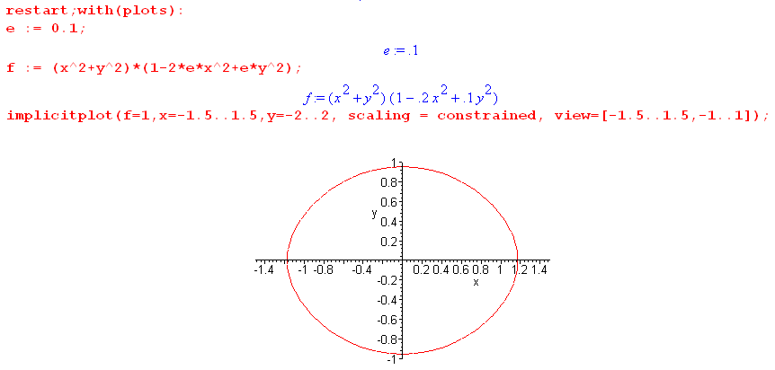

So there is your ellipse-like curve. How far to the right of 1 does it go? At that point we have

R22 ≈ x2 [ 1 - 2εx2 ]

which you have to solve for x. Write as

a ≈ z [ 1 - 2εz ]

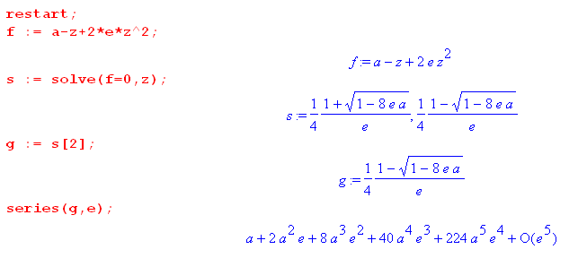

So the solution is that z = a + 2ea2 which I translate to

x2 = R22 + 2εR24 = R22(1 + 2εR22)

x = R2$\sqrt{1 + 2εR22}$ ≈ R2(1 + εR22) = R2 + εR23

Then the little tide height is

h = εR23 = (M1/M2) R2/d03 * R23 = R2 (M1/M2) (R2/d0)3

My answer to this question from Section 8,8 is this:

a = (3/4) R2 (M1/M2) (R2/d0)3

which is pretty close. So why don't I have a 3/4 sitting there?

I think I could redo this doing a better job.

You see the distortion, but this is a quartic which I have to approximate with a quadratic somehow.
General problem:

f(x,y) = x2+y2 + ε1(x2+y2)x2 + ε2(x2+y2)y2

= x2+y2 + ε1x4 + (ε1+ε2)x2y2 + ε2y4

The equation of an ellipse is this

A2y2+B2x2 = x2y2

Could do a least squares fit to estimate A and B. Go back to

M12 ≈ k2(x2+y2) [ 1 + 2εx2 - εy2 ] ` ε = 2(M1/kd03)

Accept this as a quartic, not an ellipse. Have

(x2+y2) [ 1 + 2εx2 - εy2 ] = (M1/k)2

At the left edge how far is it displaced from the circle :

xcircle = (M1/k)

xq2 [ 1 + 2εxq2 ] = (M1/k)2

2εxq4 + xq2 - (M1/k)2 = 0

xq2 = [ -1 ±$\sqrt{1+4(2ε)(M1/k)2}$]/(4ε)

≈ [ -1 ±(1 + 4ε(M1/k)2 -(1/8) 82ε2(M1/k)4 ) ] /(4ε)

≈ [ -1 +(1 + 4ε(M1/k)2 -(1/8) 82ε2(M1/k)4 ) ] /(4ε)

≈ [ 4ε(M1/k)2 -8ε2(M1/k)4 ) ] /(4ε)

= [ (M1/k)2 -2ε(M1/k)4

= (M1/k)2 -2ε(M1/k)4

= (M1/k)2 ( 1 -2ε(M1/k)2)

=xcircle2 ( 1 -2ε(M1/k)2)

xq = xcircle $\sqrt{1 -2ε(M1/k)2}$

Sign is wrong, but there is a plan here where you evaluate the thing "a".

I am not sure why this method is so horrible! It gives a quartic to which you have to fit an ellipse, and then you can get A and B for the ellipse, incredibly ugly!
Taylor never mentions "ellipse" but just does what I am doing above to get the tide height!

Go back to the surface which I think is exact

M12 ≈ k2(x2+y2) [ 1 - 2εx2 - εy2 ] ` ε = 2(M1/kd03)

