Question 2 2.15.17

This doc seems confused. I was at a confused stage on this topic. I had not yet understood that Frame S and Frame S' both exist in x-space and x'-space is superfluous.

Question: How do you apply the full machinery of tensor doc to a transformation which is a simple rotation, such as perhaps R = Rz(α) for some fixed α value. [ good question ]

Comment: I never added a section to tensor doc addressing this question (I don't think). [ correct ]

When I say "machinery", I mean x' = F(x) becomes x' = Rz(α)x which is a linear transformation.

• The R matrix is therefore R = Rz(α) according to (2.8.7).

The underpinning concept is this Picture A

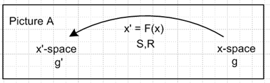

• Both metric tensors are δij which means up and down indices are the same in both "spaces".

• Contravariant and covariant vectors are the same, so we talk just about a "vector".

• A tensorial vector by definition is something that transforms according to V' = RV or V'i = RijVj

• In this case, a position vector like r' = Rr is in fact a tensorial vector.

• The basis vectors in un are Cartesian basis vectors for x-space. I think we can treat x-space as Frame S in the language of frames doc. [ correct ]

• The covariant a • b dot product is just the regular geometric dot product.

[ all the above are true, granted ]

What is the meaning of Picture A?

If you apply it to r' = Rr it seems to map a vector r in x-space into a vector r' in x'-space. For polar coordinates the x'-space has axes labeled r and θ since x' = (r,θ). You then map a point (x,y) in x-space into a point (r,θ) in x'-space. In Picture A, x-space is always the domain of a mapping or transformation, and x'-space is the range of that mapping. For our z rotation, let's try to draw a picture, showing that a point in the domain maps into a point in the range:

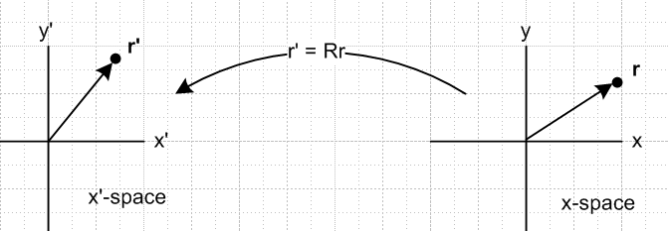

The arrow on the left is rotated by amount α relative to the one on the right. Note all axis labels. I have not discussed the word "Frame" so far.

Let us now digress to look at the infamous passive discussion pictures:

PASSIVE VIEW
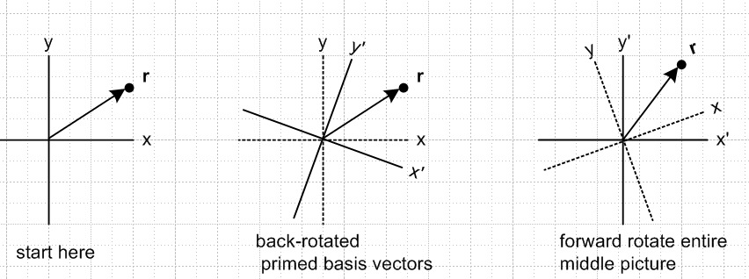
Frame S Frame S'

For the first time the word Frame appears. In Frame S, the vector r has coordinates (x,y). On the right in Frame S' it has different coordinates (x',y') that I can calculate by doing r' = Rz(α)r . Note that

r = x + y = x' ' + y' ' x = • r x' = ' • r and so on

There is only vector r, and it has different coordinates in the two coordinate systems.

Confusion: When I say "calculate r' = Rz(α)r ", I must mean (r)'i = Rij(r)j since the only vector anywhere has the name r. I cannot very well say r = Rz(α)r .

Observation: One cannot help but notice the strong similarity between the rightmost picture of the set of 3 and the x'-space picture above. The big difference is that the vector is called r' in one case, and r in the other.

Question: How do we make sense of this r and r' labeling confusion?

What would the active view pictures look like? Rotate the apparatus within Frame S:

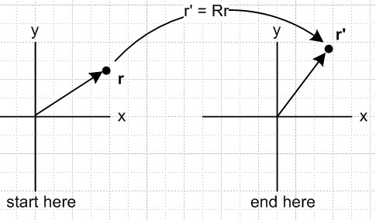 ACTIVE VIEW

Now we have a new vector r' = Rr but it is still in Frame S. So this is a mapping x-xpace → x-space.
The apparatus was rotated. Now compare this to Picture A

This is the exact same mapping, but instead of R: X→X, it is R: X→X' so the domain in Picture A has a different name X' from the domain X of the active view business.

For polar coordinates, a mapping like the active view does not make much sense. That mapping has to go from (x,y) space to (r,θ) space which must have axes of different labels.

Question: Is Picture A closer to the Passive View, or to the Active View? I think the Passive View wins here hands down. The only problem there is the r and r' discrepancy. In the Active View we have no space anywhere whose axes are labeled x' and y'.

So let's give up on Active view and do side-by-side with the passive view stuff:

PASSIVE VIEW

PICTURE A

In both these ideas, the x'-space coordinates of the destination point are exactly the same. So that is another positive feature of the comparison. The problem is the NAME of the destination point.

r = x + y = x' ' + y' ' x = • r x' = ' • r and so on

I think the only resolution is to say that in r' is a shorthand for (r)' which is a notation I was considering in frames doc, and then you have (r)' = Rr as the means to compute the x'-space coordinates of the only vector in town which is r. You then have (r)'i = Rij(r)j which is exactly what you want to say. This gives you the x'-space coordinates of the vector r. Then (r)'1 = x' and (r)'2 = y' and then everything seems to work.

You could create a new vector r' in x'-space such that (r')i = (r)'i , that would not violate any laws of the universe. Then for that new vector you would say r' = Rr so that (r')i = Rij(r)j .

I think this passive view interpretation of Picture A must be correct! If so, we then have

Implications:

• The basis vectors called e'n in frames doc are also called e'n in this tensor doc interp. (e'1 = ' )

• The basis vectors called en in frames doc are called un in this tensor doc interp. (u1 = ) .

• Frame S is associated with x-space

• Frame S' is associated with x'-space.

Error noted: Somewhere I said (it may be gone) that "both Frame S and Frame S' are in x-space, and the basis vectors in x-space are the un for Frame S and tangent base vectors en for Frame S. " This idea vaguely applies to the center picture of the triple passive set below (as is shown below in the discussion of the en), but I think I have to reject the entire idea with regard to Picture A. I much prefer the new interpretation arrived at above.

Question: In this tensor doc interp, what has become of the tangent base vectors en ???

According to tensor doc (3.2.4),

en ≡ Se'n = R-1e'n = Rz(-α)e'n (3.2.4)

What exactly does the equation en = Rz(-α)e'n mean? In the Picture A world, I have to consider this to be a mapping from x'-space to x-space which agrees with my repeated comment that the en are in x-space. Then for example

e1 = Rz(-α)'

I will add these vectors to the Picture A picture above

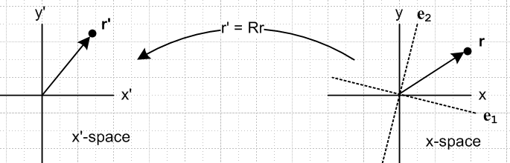

Coordinate line interpretation. If I vary y' while holding x' = K = constant, that is a vertical line in x'-space (parallel to the y' axis) . Into what does this map in x-space? Whatever it is, it is called the y' coordinate line. The tangent to this y' coordinate line will be e2 . So consider,

Rz(α) = $\left(\begin{matrix}cosα & -sinα \\ sinα & cosα\end{matrix}\right)$ r' = Rz(α)r

$\left(\begin{matrix}x' \\ y'\end{matrix}\right)$ = $\left(\begin{matrix}cosα & -sinα \\ sinα & cosα\end{matrix}\right)$$\left(\begin{matrix}x \\ y\end{matrix}\right)$ $\left(\begin{matrix}x \\ y\end{matrix}\right)$ = $\left(\begin{matrix}cosα & sinα \\ -sinα & cosα\end{matrix}\right)$$\left(\begin{matrix}x' \\ y'\end{matrix}\right)$

x' = cosα x - sinα y x = cosα x' + sinα y'
y' = sinα x + cosα y y = - sinα x' + cosα y'

If x' = K we then have

K = cosα x - sinα y

sinα y = cosα x - K

y = (cotα) x - (K/sinα) = mx + b

For small α, this indicates a large positive slope and perhaps a large negative intercept. Here I show two coordinate lines passing through the point r . The directions of the en agree with the previous picture.

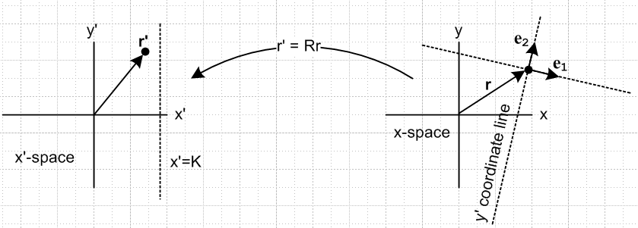

So then, I asked "what has become of the tangent base vectors en" ? They exist in x-space and I have drawn them. They of course depend on α and so are NOT axis aligned in x-space. They do line up with the directions of the primed axes in my middle picture above from the passive view procedure.

Conclusion: We do not associate the tangent base vectors en of tensor doc with either the x-space or the x'-space Cartesian axis-aligned basis vectors in Picture A. However, they are associated with the Frame S' axes in the middle picture above where we have back-rotated the Frame S basis vectors to get the Frame S' ones. But this is not a tensor doc Picture A situation .

Next step: how does this apply to vectors other than r' = Rz(α)r ? Like V' = Rz(α)V ?
Related question: this require Special Case #4 ?

