Question 2 v3 2.15.17

2.26.17. I am pretty happy with the answer given below to various questions. This is not written up in Appendix J of frames in a clearer manner than below.

Question: How do you apply the full machinery of tensor doc to a transformation which is a simple rotation, such as perhaps R = Rz(α) for some fixed α value.

Comment: I never added a section to tensor doc addressing this question (I don't think).

When I say "machinery", I mean x' = F(x) becomes x' = Rz(α)x which is a linear transformation.

• The R matrix is therefore R = Rz(α) according to (2.8.7).

The underpinning concept is this Picture A

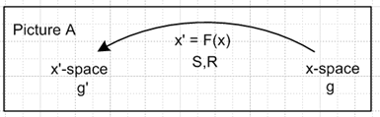

• Both metric tensors are δij which means up and down indices are the same in both "spaces".

• Contravariant and covariant vectors are the same, so we talk just about a "vector".

• A tensorial vector by definition is something that transforms according to V' = RV or V'i = RijVj

• In this case, a position vector like r' = Rr is in fact a tensorial vector.

• The basis vectors in un are Cartesian basis vectors for x-space. I think we can treat x-space as Frame S in the language of frames doc. [ correct, but in addition x'-space = x-space ]

• The covariant a • b dot product is just the regular geometric dot product.

What is the meaning of Picture A?

If you apply it to r' = Rr it maps a vector r in x-space into a vector r' in x'-space. For polar coordinates the x'-space has axes labeled r and θ since x' = (r,θ). You then map a point (x,y) in x-space into a point (r,θ) in x'-space. In Picture A, x-space is always the domain of a mapping or transformation, and x'-space is the range of that mapping. We can write R: X → X' .

Application of Picture A to a simple rotation: Active View

For our z rotation Rz(α), let's try to draw a picture, showing that a point in the domain maps into a point in the range:

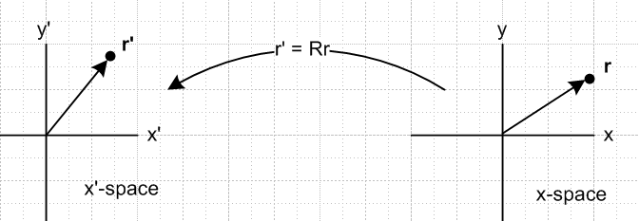

The arrow on the left is rotated by amount α relative to the one on the right. Note all axis labels. I have not discussed the word "Frame" so far.

Recall now the Active View rotation picture, where sides are reversed from above,

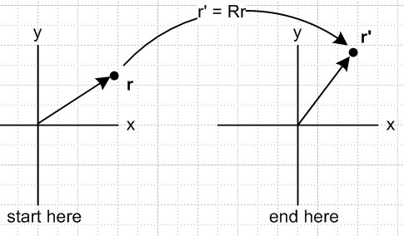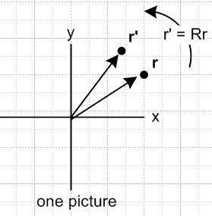

For general curvilinear coordinates mappings, the x'-space is always different from x-space and that is how things were done in tensor doc. The mapping was R: X → X' (x-space into x'-space). In going from (x,y) to (r,θ) you need the two spaces! They have different metric tensors g and g' . [ correct ]
However, in the "application of Picture A" to the "rotate the apparatus and keep the basis vectors fixed" Active View, we know that the mapping is in fact R: X → X. The apparatus does not go into a new space, it stays in the old space but is rotated within it. So this is the first Big Fact to get straight. To make Picture A compatible with the notion of rotating the apparatus, you just set X' = X, so there is then only one space which we might as well take to be X-space. [ correct ]
In the active view, you can combine the start and end picture into the same space, as I usually do. This is shown on the right above. Remember that in the Active View, there is only one set of basis vectors and there are two vectors r and r' and they are related by r' = Rr. [ correct ]
Saying that x'-space is the same as x-space implies that the basis vectors are the same, so you would then have to say in tensor doc that e'n = un in this application. These are axis-aligned unit vectors in x-space. [ strangely, I think this is correct. If X' = X, then their basis vectors are the same. ]
I think this is the most straightforward application of tensor doc to frames doc. It would also apply to special relativity Lorentz transformations, where again the two spaces have the same metric tensor. When you write x'μ = Rμνxν you are rotating the 4-vector xμ into a new 4-vector x'μ in the same Minkowski space.
Note that in the Active View there is only one Frame which is Frame S. The Frame of x'-space is exactly the same, it is also Frame S. There is no Frame S' anywhere!!!

Application of Picture A to a simple rotation: Passive View

Recall the general idea of the passive view: Vector r stays put, and the axes are back-rotated.

PASSIVE VIEW
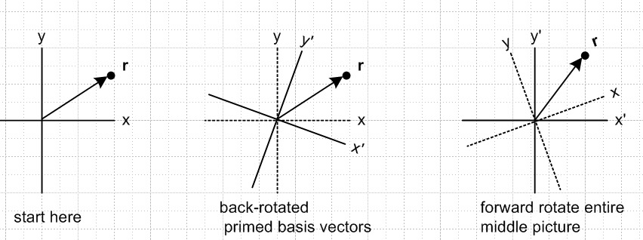

(a) Frame S seen (b) Frame S and Frame S' (c) Frame S and Frame S'
from Frame S both seen from Frame S both seen from Frame S'

Now for the first time we have two distinct Frames called Frame S (as earlier) and Frame S' (new).

There is no vector r'. I would describe the passive transformation as (r)' = Rz(α)r in vector notation, and this is nothing more than a shorthand for (r)'i = Rij(r)j . There is no vector called r'. The prime in this last equation indicates that the component of r is taken in Frame S', a notation used in frames doc.

Now since we have two frames, we should have two sets of basis vectors! The basis vectors for Frame S we know, from the Active View analysis, can be taken to be un = e'n. (both tensor doc notation). These are axis-aligned Cartesian unit vectors like . Note that in tensor doc these two vector types are not related to each other in any way. The connections we DO have in tensor doc are these

en ≡ Se'n = (R-1)e'n (3.2.4)
un = S u'n = (R-1)u'n (3.5.3)

In light of our frames doc application fact that un = e'n, we can write the first equation as

en ≡ (R-1)un ( tensor doc notation) [ correct ]

So unlike in general tensor doc, these two bases are related as shown!

Recall from frames doc that we have e'n= R-1en (frames doc notation) where the e'n are back-rotated versions of the en. How shall we connect this into tensor doc?? We shall make this connection:

en = (R-1)un ( tensor doc notation)
e'n = (R-1)en ( frames doc notation) [ both correct ]

Both tensor doc basis vectors un and en exist in Frame S in x-space.
It should then turn out that the tangent base vectors en are the axes of Frame S'.[ yes! ] The en we then expect to line up with the x' and y' axes in picture (b) above! .[ yes! ]

Digression on tangent base vectors en and coordinate lines to which they are tangent.

Here I show x'-space in the full separate-space Picture A sense so we can address this subject.

If I vary y' while holding x' = K = constant, that is a vertical line in x'-space (parallel to the y' axis) . Into what does this map in x-space? Whatever it is, it is called the y' coordinate line. The tangent to this y' coordinate should be e2 . So consider,

Rz(α) = $\left(\begin{matrix}cosα & -sinα \\ sinα & cosα\end{matrix}\right)$ r' = Rz(α)r // Picture A mapping Active View

$\left(\begin{matrix}x' \\ y'\end{matrix}\right)$ = $\left(\begin{matrix}cosα & -sinα \\ sinα & cosα\end{matrix}\right)$$\left(\begin{matrix}x \\ y\end{matrix}\right)$ $\left(\begin{matrix}x \\ y\end{matrix}\right)$ = $\left(\begin{matrix}cosα & sinα \\ -sinα & cosα\end{matrix}\right)$$\left(\begin{matrix}x' \\ y'\end{matrix}\right)$

x' = cosα x - sinα y x = cosα x' + sinα y'
y' = sinα x + cosα y y = - sinα x' + cosα y'

If x' = K we then have

K = cosα x - sinα y

sinα y = cosα x - K

y = (cotα) x - (K/sinα) = mx + b

For small α, this indicates a large positive slope and perhaps a large negative intercept. Here I show two coordinate lines passing through the point r . The directions of the en agree with the previous picture.

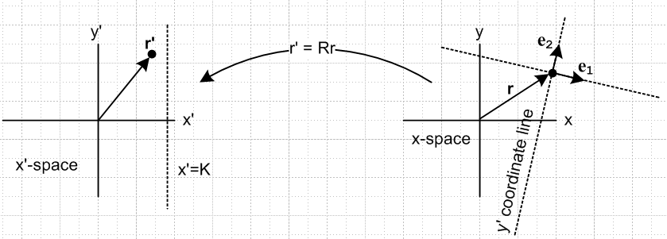
only y' is allowed to vary vertical dotted line on left maps into
other variables are held fixed the y' coordinate line

The directions of the ei are what we expect from the simple fact that en = (R-1)un above: They are back=rotated versions of the Cartesian un in x-space.

[ I guess this picture above is OK, but it does require both spaces to draw. It seems not helpful if you are trying to emphasize F: X → X and X' space is not needed. ]

So we are just trying to get happy with the connection proposed above

en = (R-1)un ( tensor doc notation)
e'n = (R-1)en ( frames doc notation) [ correct ]

It is unfortunate that the name en is used in both docs for different things. [ correct ]

Resume Passive View discussion

Recall the Passive View pictures from above,

(a) Frame S seen (b) Frame S and Frame S' (c) Frame S and Frame S'
from Frame S both seen from Frame S both seen from Frame S'

The basis vectors of Frame S are the un (tensor doc).
The basis vectors of Frame S' are the en (tensor doc).

Both are unit vectors, unlike in polar coordinates where the en are only axis-aligned.

Summary of the Connection between Frames Doc and Tensor Doc

• Tensor doc Picture A has R:X→X', whereas frames doc has R:X→X. [ correct ]

• In the frames-doc use of tensor-doc Picture A, X = X' and thus e'n = un = Cartesian basis vectors of Frame S. [ correct ] In this use, x'-space is exactly the same as x-space [ correct ] , and there is really only one "space" [ correct ] . In the Passive view below, we shall find that this one x-space has two Frames called Frame S and Frame S'. [ correct ]

• In the Active View where the apparatus is rotated within Frame S, we have r' = Rr where r' is a new vector, and the equation components of r' = Rr are are (r')i = Rij(r)i. There is no Frame S' in the Active View, and there are no back-rotated basis vectors for Frame S' because there is no Frame S'. [ correct ]

• In the Passive View where the apparatus stays put and new basis vectors are defined as back-rotated versions of the Frame S basis vectors un, we find that the Frame S' basis vectors are the tangent base vectors en of tensor doc [ correct ] , and in fact en = (R-1)un. Now there is no vector r', only r exists and is viewed in two different Frames and has different components in those two frames. We write (r)' = Rr as a shorthand for the transformation rule (r)'i = Rij(r)j and no vector r' appears anywhere.

• In the Passive View we could create a new vector r' according to r' ≡ Rr and then with respect to this new vector one could write r' = Rr meaning (r')i = Rij(r)j . Thus (r')i =(r)'i . [ correct ]

• The connection between the basis vectors of tensor doc and those of frames doc is this: [ correct ]

frames doc tensor doc
en ↔ un (axis-aligned in x-space) basis vectors of Frame S
e'n ↔ en ( tangent base vectors in x-space) basis vectors of Frame S'

Question: How does this all apply to vectors other than r and r' ??

In tensor doc, a tensorial vector is something that transforms as V' = RV which is an Active View statement like r' = Rr above. We get a new "velocity" in Frame S by rotating the old one. In the Passive View, we interpret this to say (V)' = RV to get the coordinates of V in either Frame S or Frame S'
The basis vectors are exactly the same as shown above. We can write

V = Viui = (V)'ie i tensor doc notation for basis vectors

V = Viei = (V)'ie' i frames doc notation for basis vectors

In order to even talk about the second sums, you have to have a Frame S', and that means you have to be thinking of the Passive View. The above expansions agree with those shown in tensor doc

V = V1 u1 + V2 u2 +... = ΣnVn un where un • V = Vn un = gni ui
V = V1 u1 + V2 u2 +... = ΣnVn un where un • V = Vn
V = V'1e1 + V'2e2 +... = Σn V'n en where en • V = V'n en = g'ni ei
V = V'1e1 + V'2 e2 +... = Σn V'n en where en • V = V'n (7.13.10)

Once again, we can define a vector V' ≡ RV in order to get components (V')i .

Question: Does this require that Frame S and Frame S' have the same origin? (Special Case #4)

Look back at our Passive View

(a) Frame S seen (b) Frame S and Frame S' (c) Frame S and Frame S'
from Frame S both seen from Frame S both seen from Frame S'

We do show the two origins as being the same in these pictures. Then

r = riui = (r)'ie i tensor doc notation for basis vectors

r = riei = (r)'ie' i frames doc notation for basis vectors

Suppose we had different origins, as shown in frames doc Fig 1,,

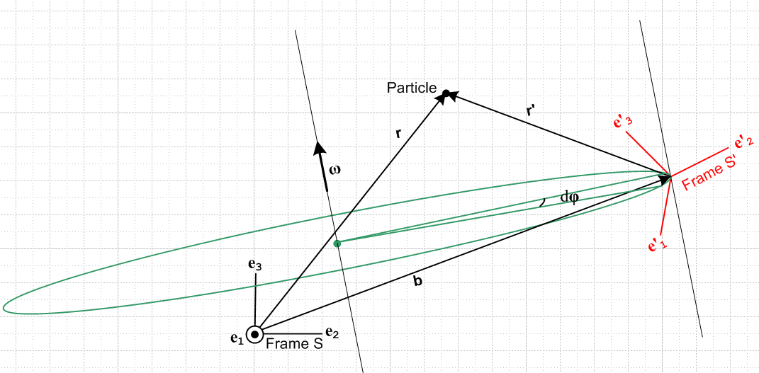

Here we have defined two vectors called r and r' as shown where

r = b + r'

Now we cannot simply define r' ≡ Rr because we already have a vector named r' which is clearly not the same as Rr. So we have to be very careful in using both Active and Passive views. The "prime" operator is now overloaded!!! It is not overloaded IF we use the Passive View and IF we do not define the vector r' ≡ Rr. Recall that the rule then is that (r)' = Rr . In the above Fig 1, the vector r can be written either way

r = (r)iei = (r)'ie' i frames doc notation for basis vectors

and the rule (r)' = Rr tells us that (r)'i = Rij(r)j and we thus relate the components of vector r in the two systems. We can do the same for vector r'. Thus, all in frames doc notation,

r = (r)iei = (r)'ie' i
(r)'i = Rij(r)j or (r)' = Rr

r' = (r')iei = (r')'ie' i
(r')'i = Rij(r')j or (r')' = Rr'

So when the two origins are not aligned, the above equations apply.
When the origins do align, we have r = r' and there is only one vector really.

What about other vectors?

We know for example that

v = v' + ω x r' + S

Here the prime has a special meaning! It indicates a time-derivative vector that is "natural". Analogous to the above, we can write

v = (v)iei = (v)'ie' i
(v)'i = Rij(v)j or (v)' = Rv

v' = (v')iei = (v')'ie' i
(v')'i = Rij(v')j or (v')' = Rv'

We treat the two vectors v and v' completely separately ! We do not create v' ≡ Rv.

Fact: We retain the idea that (v)' = Rv and (v')' = Rv' even if the origins do not coincide.

Fact: My description above depends heavily on the notation (a)' if I want to use vector notation!!!

Question: What do the above equations look like in Dirac notation?

v' = (v')iei = (v')'ie' i
is
|v'> = (v')i|ei> = (v')'i|e' i>

(v')'i = Rij(v')j or (v')' = Rv'
is
<e'i|v'> = Rij<ei|v'> = <e'i | ej> <ei|v'>
(v')'i Rij (v')j

Compare to frames doc (1.1.14)

Rmn = (e'm)n = en • e'm = enTe'm = <en|e'm> = <e'm|en> . (1.1.14)

The first index does indeed have the prime, hurray that this worked!

Question: What about the basic tensor doc equation V'a = RabVb

For rotations you would write this as V'a = RabVb. In this notation it makes sense in the Active View, just the way v' = Rv makes sense in the Active View (if we did not already have another meaning for v' ). In the Passive View, this "famous" tensor doc equation really means (V)'a = RabVb so it is giving you the components of vector V in Frame S' in the sense described above. And I write it as (V)' = RV .

