Archive of old Section 8 (b) just before it was replaced on 11.29.16

(b) Interpretation of the Centrifugal and Euler Fictitious Forces

Comment: Most books properly focus on the Coriolis term and neglect the other two terms with a casual comment that the centrifugal term is the usual term one expects for a problem involving an object on the rotating Earth. Since these books have r ↔ r' , one sees the term ω x (ω x r) and vaguely associates this with the obvious rotation of a Particle on the Earth's surface about the central axis of the Earth. This is of course a wrong association, since r' in (8.6) is a local vector in Frame S' having nothing to do with the long vector r to the center of the Earth (see Fig 4.9). So here we seek an interpretation of ω x (ω x r') where r' is the short vector to the Frame S' origin.

Consider our general Fig 4.2 picture from above, where ω points directly at the viewer,

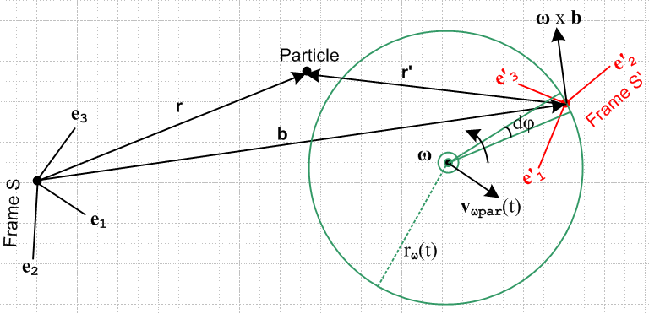 Fig 8.1

Suppose in the above picture v' = 0. Then (8.6) becomes

F'fict = – mS – mω x (ω x r') – m x r' .
frame centrifugal Euler

The – mS fictitious force arises from the acceleration of the origin of Frame S' relative to the origin of Frame S and needs no further comment. This term is non-vanishing in the discussion below.
We now consider the centrifugal and Euler forces at the same time. As usual, all rotations are "instantaneous" since the rotation axis and vector ω may be changing.
Since v' = 0, as seen from Frame S' the vector r' shown above is fixed and so is our Particle. Vector r' is "soldered" to the e'n basis vectors. In Frame S, both ends of the vector r' are moving so it is not quite obvious what the vector is doing. To clarify the situation, consider this simplified view extracted from the above drawing (below right). Each end of the vector r' is rotating about the ω rotation axis. The two ends of r' rotate on different circles in different planes, but at the same angular frequency ω.

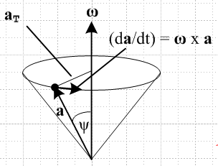 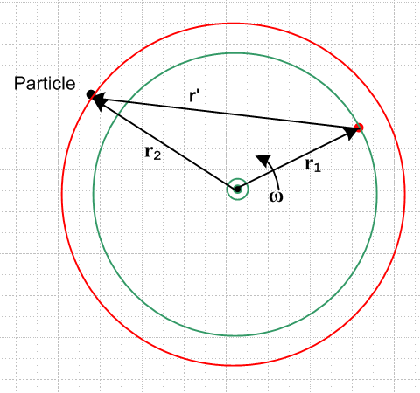 Fig 8.2

Here the red circle perhaps lies above the plane of paper while the green one lies in the plane of paper, so that r1 lies in the plane of paper but r2 does not. Regardless, we know that the following conical motion equations apply (as in (1.23) which says (da/dt)S = ω x a for rotation in Frame S, left image above) ,

(dr1/dt)S = ω x r1 // r1 + r' = r2 => r' = r2 – r1
(dr2/dt)S = ω x r2 . (8.7)

These equations are just the G rule (2.1) applied to vectors r1 and r2, since r1 and r2 are fixed in Frame S'

∂S'r1 = ∂S'r2 = 0 .

Subtracting the second equation from the first and using r' = r2 – r1 tells us that (dr'/dt)S = ω x r' so we can then apply our generic cone picture on the left side of Fig 8.2 to r' as well :

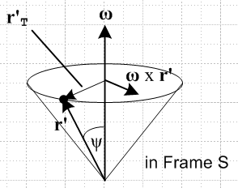 Fig 8.3

(dr'/dt)S = ω x r' = v'S . (8.8)

Since ∂S'r' = 0, (8.8) is just the G Rule for vector r', so that would be a more direct way to obtain this result, but hopefully the previous picture of rotating r' is useful. This cone picture is what we get if we maintain the Frame S motion of vector r' in Fig 8.1 or 8.2, but we translate r' so its tail lies fixed on the ω rotation axis.
Now apply ∂S to (8.8) to get the first line, and then use (8.8) again to get the last expression,

(d2r'/dt2)S = ∂S(ω x r') = ω x (dr'/dt)S + x r'
or
a'S = ω x v'S + x r' = ω x (ω x r') + x r' . (8.9)
Suppose in the disk at the top of the cone we define temporary polar coordinates r,θ in the obvious manner. Then we have

ω x r' = ω r' sinψ = ω r'T
so
ω x (ω x r') = ω r'T ω x = - ω2r'T . // centripetal acceleration (8.10)

This is then recognized as the usual - ω2R centripetal (center seeking) acceleration for motion around a circle of radius R = r'T.
Meanwhile, for the special case that and ω point in the same direction we have

x r' = r' sinψ = r'T // Euler acceleration (8.11)

which is the expected result, say, for a static ant at R = r'T on an accelerating turntable.
Thus we have "interpreted" the centripetal and Euler acceleration contributions as promised. Since r' and therefore our Particle are fixed in Frame S', and since the Particle nevertheless feels both these accelerations, it ascribes to these forces a fictitious nature.
If one stands on a carpet that is being accelerated ac to the right, one feels there is a force -mac shoving him or her to the left, an example of a fictitious force. Thus, given our two fictitious accelerations above, we multiply by mass m and add a minus sign to get the fictitious forces,

F'fict = – mω x (ω x r') – m x r' + frame + Coriolis .
centrifugal Euler

To summarize again, we have intepreted the centrifugal and Euler terms in the full F'fict shown in (8.6) where r' is the "short vector" local to frame S'.
When is not in the same direction as ω, we still have equation (8.8) and its (d/dt)S derivative (8.9) so the Euler acceleration is x r'. In this case, we can draw a version of the cone picture above with ω replaced by and some different cone angle φ, as shown on the right below. The Euler acceleration is thus tangential to the circle (red arrow) which forms the top of the cone in this picture.

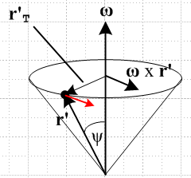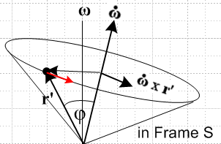
Fig 8.4

Notice that the vector r' is in exactly the same location in both these pictures. In terms of the cone picture on the left, the red Euler acceleration arrow is at some inscrutable angle relative to the cone.

