First rewrite Text after (1.34)

This doc has been installed and further edited inside frames doc, do not view again! Archive only.

Angular momentum. We set mass m = 1, so momentum p = mv = v. One can then think of all L objects below as really being L/m and use that fact to reinsert m's at the end.
The drawing of interest is a reoriented Fig 1, to which we have added arbitrary points c and c',

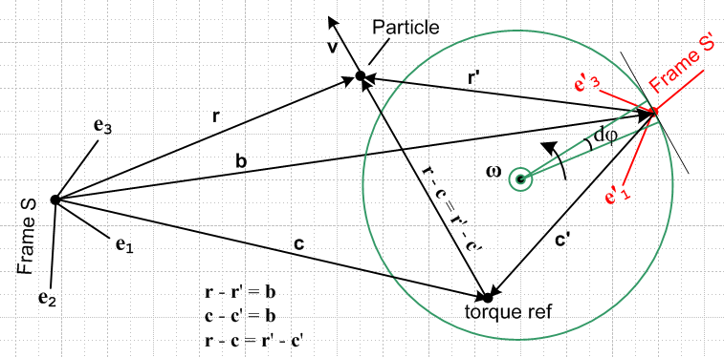 Fig 1.4

Whereas the linear momentum p of a particle does not require a reference point, angular momentum L does require such a reference point. For example, the Particle in the above figure has many different values of L in Frame S, some of which we might denote as follows,

L(0) = r x v // L in Frame S with respect to Frame S origin
L(c) = (r-c) x v // L in Frame S with respect to Frame S point c
L(b) = (r-b) x v // L in Frame S with respect to Frame S point b
L(b) = r' x v . // L in Frame S with respect to Frame S' origin

The last two lines are exactly the same since b is a vector between the two origins.
Using the general form L(c), we may identify the following two "natural" angular momenta in Frames S and S',

L(c)S ≡ (r-c) x vS = (r-c) x v ≡ L(c)
L'(c')S' ≡ (r'-c') x v'S' = (r'-c') x v' ≡ L'(c') . (1.35)

The time derivative of the first of these objects is given by

(c) = (c)S = ∂S L(c)S = ∂S [(r-c) x vS] = (vS - S) x vS + (r-c) x ∂S vS = – S x vS + (r-c) x aS
= – x v + (r-c) x a .

A similar result is obtained by priming everything on the above line, so we end up with these four equations:

L(c) = (r-c) x v
(c) = (r-c) x a – x v

L'(c') = (r'-c') x v'
'(c') = (r'-c') x a' – ' x v' . (1.36)

The discussion of angular momentum continues in Section 11.

***********************************

11.2 Expression of L(c) and (c) in terms of Frame S' objects // was (b)

We replicate Fig 1.4 which now includes a single torque reference point which is c is Frame S and c' in Frame S'.

(11.2.1)

where the three equations shown are obvious from the drawing,

r - r' = b (11.2.2)
c - c' = b (11.2.3)
r - c = r '- c' (11.2.4)
Again mass m = 1 so momentum p = mv = v. For arbitrary reference point c one has from (1.36),

L(c) = (r-c) x v (11.2.5)
(c) = (r-c) x a – x v (11.2.6)
L'(c') = (r'-c') x v' (11.2.7)
'(c') = (r'-c') x a' – ' x v' . (1.36) (11.2.8)

The reference point c might be moving. We know from Sections 6 and 7 how r,v,a and r',v',a' are related,

r = r' + b (6.1) (11.2.9)
v = v' + ω x r' + S (6.6a) (11.2.10)
a = a' + x r' + 2 ω x v' + ω x (ω x r') + S . (7.6a) (11.2.11)

The middle equation above can be written,

= ' + ω x r' + S (11.2.12)

The torque reference point c in Fig 11.3 is just like the particle point r, so the above for c becomes

= ' + ω x c' + S (11.2.13)
Part of the goal of Section 5 is to express L(c) and (c) in terms of Frame S' quantities. In the following all algebra is shown to provide an easily traceable path since there won't be any result verifications:

L(c) = (r-c) x v = (r'-c') x v = (r'-c') x [ v' + ω x r' + S ] // (11.2.4), (11.2.10)
= (r'-c') x v' + (r'-c') x [ (ω x r') + S]
= L'(c') + (r'-c') x [ (ω x r') + S] . // (11.2.7)

(c) = (r-c) x a – x v // (11.2.6)

= (r'-c') x [ a' + x r' + 2 ω x v' + ω x (ω x r') + S] – x v // (11.2.4), (11.2.11)

= (r'-c') x a' – ' x v' + (r'-c') x [ x r' + 2 ω x v' + ω x (ω x r') + S]– x v + ' x v'

= '(c') + (r'-c') x [ x r' + 2 ω x v' + ω x (ω x r') + S] // (11.2.8)
– x v + ' x v'

= '(c') + (r'-c') x [ x r' + 2 ω x v' + ω x (ω x r') + S]
– (' + ω x c' + S) x ( v' + ω x r' + S) + ' x v' // (11.2.13), (11.2.10)

= '(c') – (r'-c') x Ffict – (' + ω x c' + S) x ( v' + ω x r' + S) + ' x v' // (8.6)

These results may now be summarized:

L(c) = L'(c') + (r'-c') x [ (ω x r') + S] (11.2.14)

(c) = '(c') – (r'-c') x Ffict – (' + ω x c' + S) x ( v' + ω x r' + S) + ' x v' . (11.2.15)

These equations express L(c) and (c) entirely in terms of Frame S' objects, for the general case where the angular momentum reference point c is arbitrarily selected. The second equation can be written

'(c') – (c) = (r'-c') x Ffict + (' + ω x c' + S) x ( v' + ω x r' + S) – ' x v' (11.2.16)

This section is fully updated, do not edit here

11.3 Fictitious Torques and Newton's Rotational Law in a non-inertial frame // was (c)

We now compare Newton's (2nd) Law for linear motion with that for circular motion, both in Frame S,

F = = ma = m // and "natural" in Frame S (11.3.1)

N(c) = (c) = I(c) α = I(c) = (mr2) // (c) and "natural" in Frame S (11.3.2)

Here is a drawing showing the various parameters :

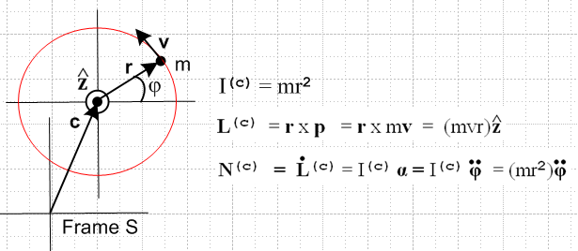 (11.3.3)

Here L(c) is the angular momentum of our Particle in Frame S relative to reference point c, N(c) is some externally applied torque about that same reference point acting on the Particle. Quantity α = is the angular acceleration about the point c and I(c) is the moment of inertia about point c.

In Frame S' we want to find some effective Newton's Rotational Law,

N'(c')eff = '(c') // eff. Newton's Rot Law in Frame S' (11.3.4)

N'(c')eff = N(c) + N(c)fict // defines N(c)fict (11.3.5)

where N(c)fict is the fictitious torque that mysteriously appears in non-inertial Frame S', so then

N(c) + N(c)fict = '(c') . (11.3.6)

We can then apply this bogus Newton's Rotational Law in non-inertial Frame S' as long as we include the fictitious torques N'(c')fict along with the real torques N(c) which are just those present in inertial Frame S. This is in complete analogy with the use of fictitious forces as reviewed in Section 8.

Solve (11.3.6) for N(c)fict and then replace N(c)by (c) in (11.3.2) to get

N(c)fict = '(c') - (c) , (11.3.5)
Replacing the right side of the above using (11.2.16) gives

N(c)fict = (r'-c') x Ffict + (' + ω x c' + S) x ( v' + ω x r' + S) – ' x v' (11.3.6)

where

Ffict = – mS – mω x (ω x r') – 2m ω x v' – m x r' . (8.6)
frame centrifugal Coriolis Euler

_____________________________________________________________________

