This has been installed, do not edit here.

8.2 Interpretation of the Centrifugal and Euler Fictitious Forces

To emphasize the long and short vector idea in our interpretation of the centrifugal and Euler fictitious forces, we take the Earth scenario of Fig (4.7.1) rather than a more general situation like Fig (4.2.1) :

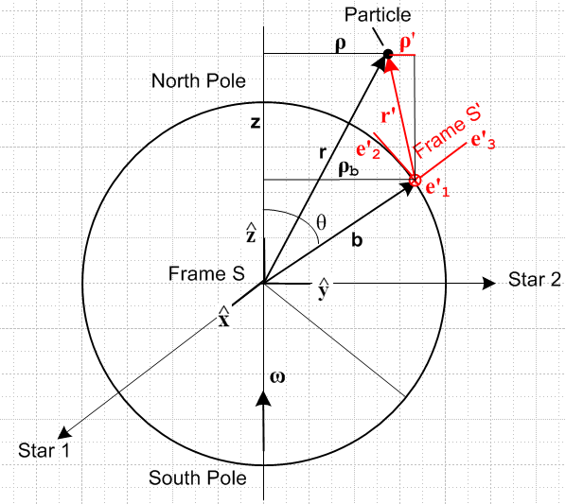 (8.2.1)

Suppose in the above picture v' = 0 so r' is static in Frame S'. Then (8.1.8) becomes

F'fict = – mS – mω x (ω x r') – m x r' . (8.1.8) with v' = 0 (8.2.2)
frame centrifugal Euler

In this expression it is the short vector r' which appears in both the centrifugal and Euler terms.
Since Fig (8.2.1) is a Special Case #1 situation, we know from (7.13) that,

S = x b + ω x (ω x b) . // Special Case #1 (7.13) (8.2.3)

Inserting this into (8.2.2) gives,

F'fict = – m [ ω x (ω x b) + x b] – mω x (ω x r') – m x r'

= – mω x (ω x [b+ r']) – m x [b+ r']

= – mω x (ω x r) – m x r .
centrifugal Euler (8.2.4)

Now the frame term – mS is gone and it is the long vector r which appears in the two fictitious force terms. Equation (8.2.4) is the conventional form for F'fict. The centrifugal term may be written

Ax(AxC)=(A•C)A - A2C
– mω x (ω x r) = – mω2[ x ( x r)] = – mω2 [ (• r) - r ] = – mω2 [ z - r ]

= + mω2ρ (8.2.5)

which is the usual way one states this centrifugal force. The vector r in Fig (8.2.1) is doing conical motion about the ω vector, and the tip of r executes circular motion with radius vector ρ.

If the Earth rotation were varying only in magnitude, one would have for the Euler force in (8.2.4),

– m x r = – mr x = – mr sinθ // (E.2.15)

= – mρ = – maφ // (E.3.6) (8.2.6)

and this is the expected fictitious linear force directed in the - direction. Accelerate your Persian Rug to the right, you feel a fictitious force to the left. We end up then with

F'fict = + mω2ρ – maφ . (8.2.7)
centrifugal Euler

Looking at the expression (8.2.3) for the frame acceleration component S, we can break it down in similar fashion to get (see Fig (8.2.1),

– mS = – m ω x (ω x b) – m x b
= mω2ρb – mρb . (8.2.8)
centrifugal Euler

where these terms are for the origin of Frame S' located at b in Frame S. The vector b in Fig (8.2.1) is doing conical motion about the ω vector, and the tip of b executes circular motion with radius vector ρb.

Finally, we return to the two short-vector terms in (8.2.2),

ΔF'fict = – mω x (ω x r') – m x r'
= – mω2ρ' – mρ' . (8.2.9)
centrifugal Euler

These terms describe the two fictitious forces relative to the Frame S' origin. The vector r' in Fig (8.2.1) is doing conical motion "about the ω vector", and the tip of r' executes "circular motion" with radius vector ρ'. To see this conical motion more clearly, we show on the left below how the static (in Frame S') vector r' moves on the blue lampshade surface as the Earth rotates. When the tails of the r' vectors on this lampshade are translated to a common point, one obtains the conical motion shown on the right. The angle ψ is determined by r' • = r'cosψ.
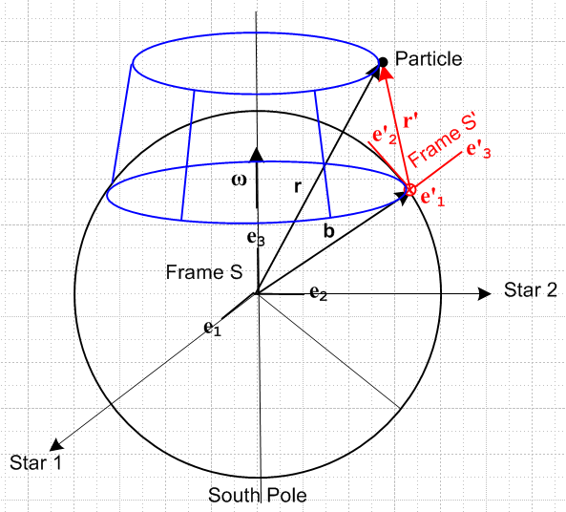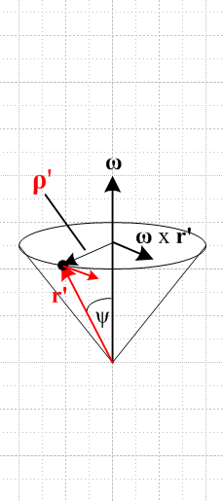
(8.2.10)

The point of this interpretative section is that, since b + r' = r, the centrifugal and Euler forces are additive: those of the Frame S' origin (b) plus those relative to the Frame S' origin (short r') add up those relative to the center of the Earth (long r).

