Section 8.7 rewrite PhL 1.11.15

These sections were installed on 1.20.17 so do not edit here!!

8.7 Special Case #3

Consider the following situation which we shall call Special Case #3 where we have replaced the rotation vector ω by Ω where now Ω = dφ/dt :

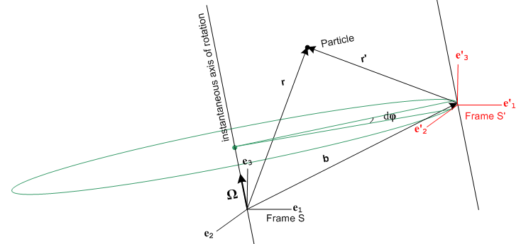 (8.7.1)

This resembles Special Case #1 because the rotation axis passes through the origin of Frame S. However, in this figure we intend that the axis of Frame S' always line up with those of Frame S, so the only thing that varies is the vector b(t). The axes e'i are no longer "soldered" to the b vector, and e'i = ei at all times. Although the axes of Frame S' do not rotate relative to those of Frame S, we still put this case into our "rotating frames" basket because the origin of Frame S' is instantaneously rotating about the Ω axis.
In Special Case #3 there is no distinction between ∂Sa and ∂S'a for any vector a :

∂Sa = ∂S[aiei] = (∂Sai) ei = (∂tai) ei

∂S'a = ∂S'[aiei] = (∂S'ai) ei = (∂tai) ei . (8.7.2)

One can interpret ∂Sa = ∂S'a as being the G Rule ∂Sa = ∂S'a + ω x a with ω= 0.

Thus we can just write = ∂Sa = ∂S'a . The complicated analysis of Sections 6,7 and 8 is now much simpler:

r = r' + b

= ' + ⇒ v = v' +

= ' + ⇒ a = a' + . (8.7.3)

Newton's Law in Frame S' now has only one fictitious force,

ma' = ma - m

F'eff = F - m

F'fict = – m . // Special Case #3 (8.7.4)

Recall that our general case fictional force expression was

F'fict = – mS – mω x (ω x r') – 2m ω x v' – m x r' . (8.1.8)
frame centrifugal Coriolis Euler

In Special Case #3 only the "frame" portion of the fictitious force exists and we can interpret this as being the full fictional force in which we set ω = 0 and = 0.
Regardless of how the Frame S' origin moves through space, we can always interpret its motion as an instantaneous rotation, as suggested by this drawing,

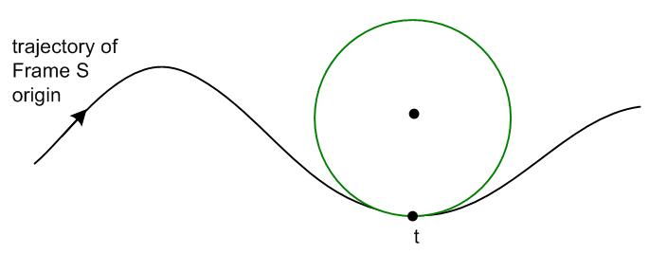 (8.7.5)

At time t the Frame S' origin is rotating along the green circle shown.

8.8 Tides on the Earth

The basic picture

In general, the orbital pattern of a binary system has this planar appearance, where each object traverses its own ellipse
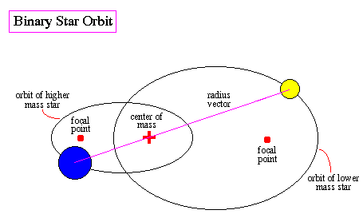 (8.8.1)
http://abyss.uoregon.edu/~js/ast122/lectures/lec10.html

In this section, however, we restrict our interest to a special case where each mass traces out a circular path, not an elliptical one. The picture is this, where we define R1,R2, M1,M2, r12,R,R' as shown:

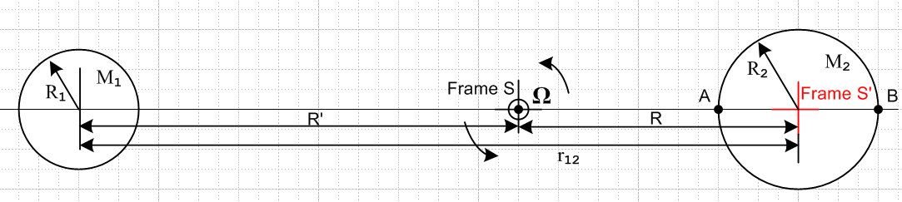
(8.8.2)

Each object is assumed to be a spherically symmetric mass distribution and can thus be treated as a point mass at its center for gravitational purposes (see Section D.5). An inertial Frame S has its origin at the center-of-mass point, and the binary system rotates in the plane of paper at angular frequency Ω about this Frame S origin. Frame S' is attached to sphere 2 and we assume that sphere 2 maintains its orientation "relative to the stars" so that at some later time we have this picture

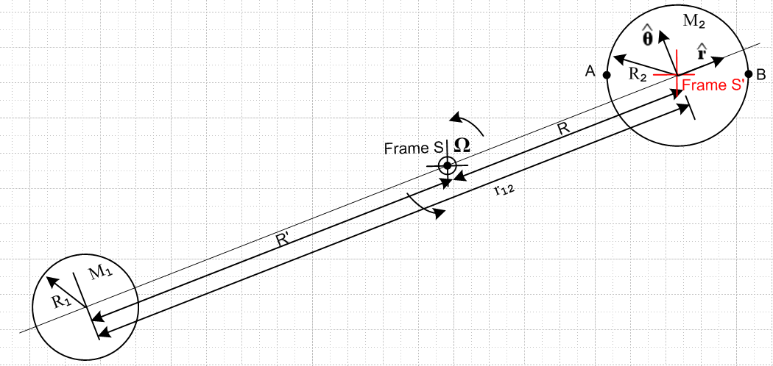
(8.8.3)

The situation with Frame S and Frame S' is then exactly that of Special Case #3 described in the previous section, where b = R and the only fictitious force in Frame S' is F'fict = – m . Points A and B are two fixed points on the surface of sphere 2. To apply Fig (8.8.3) to the Moon-Earth system, we temporarily turn off the rotation of the Earth (M2) about its axis, so the this new Earth has a fixed orientation relative to the stars.

Distance R can be found from the usual center-of-mass equation (viewed from Frame S),

0 = [M2R - M1R' ]/(M1+M2) R+R' = r12 (8.8.4)

which reports out the obvious fact that

R = r12 [M1/(M1+ M2)]
R' = r12 [M2/(M1+ M2)] . (8.8.5)

We collect here some data on the Sun, Earth and Moon :

MS = 1.989 x 1030 kg RS = 695,700 km G = 6.674 x 10-11 m3/(kg-sec2)
ME = 5.972 x 1024 kg RE = 6371 km (8.8.6)
MM = 7.342 x 1022kg RM = 1737 km TM = 27.32 days (sidereal)

rES = 1.496 x 108 km // average e = .0167
rME = 384,400 km // average e = .0549

We then compute,

1 ------- 2
Earth-Sun R/R2 = r12 [M1/(M1+ M2)] /R2 = rES [ME/(ME+ MS)] /RS = .000646
Moon-Earth R/R2 = r12 [M1/(M1+ M2)] /R2 = rME [MM/(MM+ ME)] /RE = 0.737

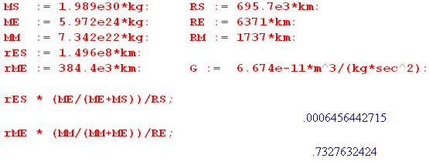 (8.8.7)

So for the Earth-Sun system, the center of mass is basically at the center of the Sun, while for the Moon-Earth system, the center of mass lies at a point 3/4 the radius of the Earth from the center. We could redraw our figure for these two cases, but the kinematics does not change, so we won't bother.

Force Equations

Newton's Law for a mass m in non-inertial Frame S' is, according to (8.7.4),

F'eff = ma' where F'eff = F – m (8.8.8)

and F is the sum of all Frame S forces acting on mass m.

It is clear from Fig (8.8.3) that (since R is a constant)

b = R d/dt = Ω d/dt = - Ω // see (E.5.6)
= R d/dt = RΩ
= RΩ d/dt = - RΩ2 . (8.8.9)

Therefore (8.8.8) becomes

ma' = F'eff = F + m RΩ2 . (8.8.10)

For a Particle in or on the Earth, the real forces are

F = Fg1 + Fg2 + Fng where

Fg1 = the gravitational force due to sphere 1 (the Moon)
Fg2 = the gravitational force due to sphere 2 (the Earth)
Fng = any non-gravitational forces (8.8.11)

and then (8.8.10) may be written

ma' = Fg1 + Fg2 + Fng + m RΩ2 . (8.8.12)

This is the effective Newton's Law for a mass m in Frame S'. If a mass m is at rest on the surface of the Earth (in Frame S') , then a' = 0 and we find

Fng = - Fg1 - Fg2 - m RΩ2 . (8.8.13)

If there are no other non-gravitational forces affecting mass m, then Fng is just the force of the Earth's surface pushing up on mass m to hold it in place so it has a' = 0.

The relation between r12 and Ω

If we were to replace sphere 2 (the Earth) with a point mass M2 at its center, nothing would change in our orbiting picture. This point mass does a circular orbit around the binary center of mass with radius R and angular frequency Ω. The usual rule for circular motion of a point particle says that the gravitational force balances the centrifugal force, so

M1M2G/r122 = M2Ω2R
or
M1G/r122 = Ω2R . (8.8.14)

Now we do a thought experiment. We imagine the Earth's core to be solid and we grind out a small spherical cavity around the Earth's center point. We take the ground-out material and compress it into a point mass m and we place that mass m at the center of the cavity. The orbit of the Earth-Moon system is unaffected by this alteration. In effect we now have two point masses in identical orbits with the moon: the Earth of mass M2-m and the central particle of mass m. For each we have M1G/r122 = Ω2R. The claim then is that the point mass m simply floats in the center of the cavity. In Frame S' there is no total force acting on this mass m to cause it to move from its position. This total force of 0 is the sum of the gravitational force pulling it to the Moon, and the centrifugal force pushing it away from the Moon,

0 = - (Fg1 + m RΩ2)
or
mM1G/r122 = m RΩ2
or
M1G/r122 = Ω2R

which is the same as (8.8.14) above. We can replace the R in (8.8.14) with the R of (8.8.5) to get

M1G/r122 = Ω2 r12 [M1/(M1+ M2)]
or
(M1+ M2)G/r123 = Ω2 (8.8.15)

and this is the relationship between r12 and Ω for given masses M1 and M2.
Using (8.8.14) in (8.8.12) one finds,

ma' = Fg1 + Fg2 + Fng + (mM1G/r122) . (8.8.16)

Tidal Force at an arbitrary point on the Earth

Now consider a particle of mass m at some arbitrary location C on the surface of the Earth. We define angles θ and β as shown, where β is very small,

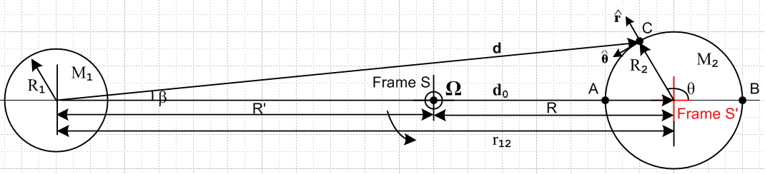
(8.8.17)

Here we show a brand new and which have nothing to do with those used in Fig (8.8.3). The old in (8.8.16) is now 0, a unit vector to the right in (8.8.17). Vector d points to point C from the center of sphere 1 while vector d0 links the two object centers, so d0 = r12. We can then write

Fg1 = - (M1mG/d2) (8.8.18)

and so (8.8.16) is recast once again as

ma' = Fg1 + Fg2 + Fng +( mM1G/r122) 0

= - (M1mG/d2) + Fg2 + Fng + (mM1G/d02) 0

= Fg2 + Fng + mM1G ( 0/d02 – /d2)

Fg2 + Fng + Ftid, (8.8.19)
where
Ftid ≡ mM1G ( 0/d02 – /d2) . // tidal force (8.8.20)

For a mass m at the center of the Earth, d = d0 so Ftid = 0 in agreement with our thought experiment above.
It is the fact that sphere 1's gravitational field varies slightly (in direction and magnitude) at different points on sphere 2 (as shown in (8.8.18)) which results in the tidal force. Equation (8.8.20) appears in Taylor[1] p 332 as equation (9.12) and in Butikov[13] as equation (2). We have tried to match Taylor's notation.

Comment: If the rotating Moon-Earth system in Fig (8.8.17) were replaced by a static non-rotating system in which the Earth and Moon were held apart by a very long, stiff (1020 N) rod, would the tidal force be the same as shown in (8.8.20)? Or would the water bulge only on the side of the Earth facing the Moon? In this case we have in inertial Frame S' the following force on a mass m on the surface of the Earth

F' = ma' = Fg1 + Fg2 + Fng // Earth, Moon and Stick

Since the gravitational force Fg1 of M1 on a mass m at point A is larger than at point B, it seems likely that water would only bulge on the A side of the Earth. So it is not just the non-uniformity of the gravitational field that causes the double-bulge tide on the real Earth, it is this non-uniformity in combination with the balance provided by the rotation which causes there to be zero force on a particle at the center of the Earth.

Tidal force in Cartesian coordinates

It is useful to express Ftid in both Cartesian and polar coordinates with the approximation that
R2/d0 << 1. In that case, from the law of cosines and Fig (8.8.17),

d2 = R22 + d02 - 2d0R0cos(π-θ) = R22 + d02 +2d0R0coθ = d02[ 1 + (R2/d0)2 + 2 (R2/d0)cosθ ]

≈ d02[ 1 + 2 (R2/d0)cosθ ] (8.8.21)

so that

d-3 ≈ d0-3 [ 1 + 2(R2/d0)cosθ]-3/2 ≈ d0-3 [ 1 - 3(R2/d0)cosθ ] . (8.8.22)

Armed with this fact, we next write, again looking at Fig (8.8.17),

d0 = d0
d = (d0 + R2 cosθ) + R2sinθ . (8.8.23)

We assume for now the usual x axis to the right and y axis up, though this will be changed below. Then,

Ftid = mM1G { d0/d03 – d/d3 }

= mM1G { d0/d03 – [(d0 + R2 cosθ) + R2sinθ ] d0-3 [ 1 - 3(R2/d0)cosθ ]}

= (mM1G/d03) { d0 – [(d0 + R2 cosθ) + R2sinθ ] [ 1 - 3(R2/d0)cosθ ]}

= (mM1G/d03) { d0 – d0 - R2 cosθ - R2 sinθ + 3R2cosθ} + order[(R2/d0)2]

≈ (mM1G/d03) {2R2cosθ - R2 sinθ }

= (mM1G/d03) { 2x - y } . (8.8.24)

Using this simple form, it is easy to plot the tidal force field Ftid(x,y) in the region of the Earth,

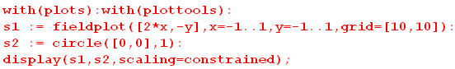

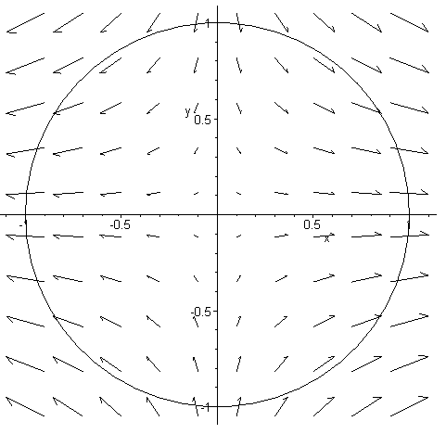 (8.8.25)

We can evaluate Ftid at the left, right, top and bottom of the Earth:

left: A (x,y) = (-R2,0) Ftid = -2R2(mM1G/d03) points left
right: B (x,y) = (R2,0) Ftid = 2R2(mM1G/d03) points right
top: (x,y) = (0,R2) Ftid = -R2(mM1G/d03) points down
bottom: (x,y) = (0,-R2) Ftid = R2(mM1G/d03) points up (8.8.26)

and these results seem in agreement with the above field plot.

One gets the general impression that the water surface might have the following shape, where the black arrows show the magnitude of the tidal force at various locations, in agreement with (8.8.25) and (8.8.26),

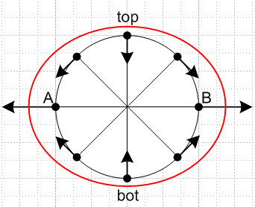 (8.8.27)

The tidal acceleration is very weak compared to the local gravitational force on the Earth. For the lunar tidal case, continuing the Maple code above we find for the tidal acceleration at point B,

aB = 2R2(M1G/d03) = 2(M1G/d02)(R2/d0) = 2(MMG/rM-E2)(RE/rM-E)

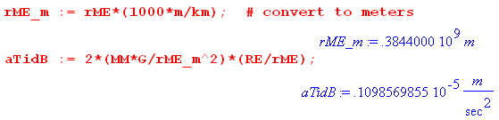 (8.7.28)

so basically the tidal acceleration is 10-7 the size of g = 9.8. It is rather amazing what such a small force can do when it is differentially applied to a lot of water.

Tidal force in polar coordinates

To express the tidal force in polar coordinates, we use (E.5.4) with ρ→ r = R2 and φ→θ to get

= cosθ – sinθ r = R2
= sinθ + cosθ . (8.8.29)

Then,

Ftid = (mM1G/d03) { 2x - y }

= (mM1G/d03) { 2rcosθ [cosθ – sinθ ] - rsinθ [sinθ + cosθ ]

= (mM1G/d03) { (2cos2θ - sin2θ) + ( -3cosθsinθ) } . (8.8.30)

The coefficients of the unit vectors can be simplified,

2cos2θ - sin2θ = 2(1/2)*(1+cos2θ) - (1/2)(1-cos2θ) = (1/2) [ 2 + 2cos2θ - 1 + cos2θ ]

= (1/2) [ 1 + 3cos2θ] = (3/2) [ cos2θ +1/3 ]

-3cosθsinθ = (-3/2) 2sinθcosθ = -(3/2)sin2θ . (8.8.31)

Therefore the tidal force in the polar coordinates appearing in Fig (8.8.17) is,

Ftid = (3/2) (mM1G R2/d03) [ (cos2θ +1/3) - sin2θ ] . (8.8.32)

Since the term with the 1/3 is radially symmetric around the Earth, it really has no effect on tides and is usually just dropped. This last result appears in Butikov as (5), (6) and (7).

Equation of the water surface

Here we follow the development of Butikov[13]. We first make an ansatz that the water surface on an idealized non-rotating water-covered Earth is described by the following simple ellipse,

r(θ) = R2 + a cos2θ . a > 0 (8.8.33)

The constant term is R2 so that <r(θ)> = R2. One chooses the angle 2θ to get the shape suggested in Fig (8.8.27). The problem then is to determine the constant a which will be << R2.
Consider the following picture of the water on the Earth,

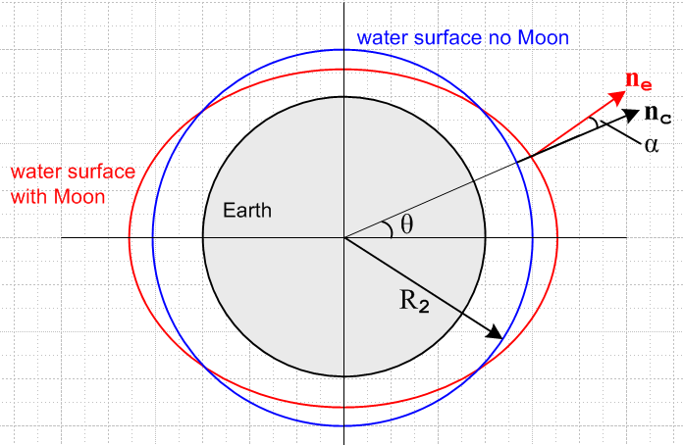 (8.8.34)

Here nc is normal to the black circle at angle θ, while ne is normal to the red ellipse. In polar coordinates, we know that c = , and we wish to compute e. Our motivation is to compute angle α which will then lead us to an expression for a. So far we know that cosα = c• e = • e .
Define

f(r,θ) = r - R2 - acos2θ

and the ellipse (8.8.33) is then given by f(r,θ) = 0. We know that the normal to a 2D surface is given by its gradient, so in polar coordinates we have

ne = ∇f(r,θ) = (∂rf) + (1/r)(∂θf) = + 2(a/r)sin2θ

|ne| = (1 + [2(a/r)sin2θ]2 )1/2

1/|ne| = (1 + [2(a/r)sin2θ]2 )-1/2 ≈ 1 - (1/2) [2(a/r)sin2θ]2 (8.8.35)

cosα = c• e = • e = • ne / |ne| = • [ + 2(a/r)sin2θ ] / |ne| = 1/|ne|

≈ 1 - (1/2) [2(a/r)sin2θ]2

≈ 1 - α2/2 . (8.8.36)

Therefore using r = R2,

α = 2(a/R2)sin2θ . (8.8.37)

Having found a geometric value for α, we now seek another expression for α based on physics. Consider,

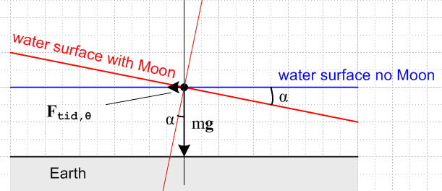 (8.8.38)

Since the affected water surface is assumed stable, the total force on the particle of water at the dot must be normal to the red surface. Therefore

|Ftid,θ| / mg = tanα ≈ α where g = GM2/R22 (8.8.39)

From (8.8.32) we then write

α ≈ |Ftid,θ| / mg = (3/2) (mM1G R2/d03) sin2θ / (mGM2/R22)

= (3/2) (M1/M2) (R2/d0)3 sin2θ . (8.8.40)

Comparing this α to that of (8.8.37) one finds,

2(a/R2)sin2θ = (3/2) (M1/M2) (R2/d0)3 sin2θ
so
a = (3/4) R2 (M1/M2) (R2/d0)3 . (8.8.41)

Thus the shape "ansatz" (8.8.33) was a good one. The result for a appears in Butikov as (9) and (11). Taylor obtains the same result in his (9.18) (h=2a) by treating the water surface as an equipotential surface.

The variation between low and high tides is H = 2a and we may compute this from (8.8.41) for both the Moon-Earth and Sun-Earth systems (in km),

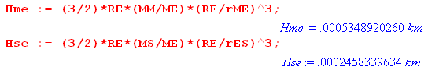
Therefore,

Hlunar_tide = 53.49 cm ~ 1.8 feet .
Hsolar_tide = 24.58 cm ~ 0.8 feet . (8.8.42)

A non-inlander will recognize these as reasonable ballpark values for ocean tides, lending much credence to the model at hand.

Comment: The red ellipse shown in (8.8.34) is the cross section in the plane of paper of a red ellipsoid formed by rotating the ellipse about the z axis. This ellipsoid the specifies the water level at all places on the Earth.

Tidal patterns for an arbitrary rotation axis of the Earth

We now turn the rotation of the Earth back on (we turned if off earlier). For the real Earth, there are many complications that arise. There are land masses. Lake water has nowhere to go. There is friction between the water and the land which slows down the Earth's rotation slightly over time. There is weather and there are ocean tidal currents which do not flow infinitely fast. We shall not attempt to analyze this general situation.
Instead, we imagine an idealized Earth covered with water and the Earth turns under the water with no "friction", and an Observer just stands in the water and measures the tide height as a function of time.
What does that Observer see? It of course depends on where the Earth's axis of rotation is located relative to our picture

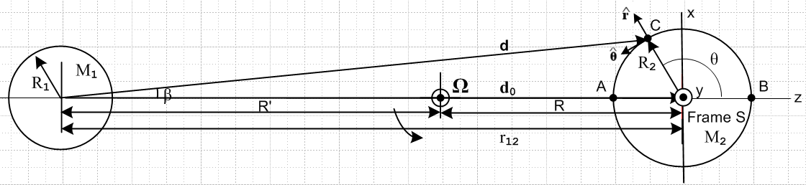
(8.8.43)

We have now redefined the Earth frame on the right to be Frame S (formerly it was Frame S') and we have drawn new x,y,z axes for this new Frame S so the z axis points away from mass M1. In Frame S then the angle θ is the usual spherical-coordinates polar angle.
We now assume that the Earth rotates about some axis ' (new Frame S') which is obtained by rotating the axis by angles θ1 and φ1 as follows (see (E.2.2) for the matrix),

' = Rz(φ1) Ry(θ1) ≡ R1 = $\left(\begin{matrix}cosθ1cosφ1 & -sinθ1 & sinθ1cosφ1 \\ cosθ1sinφ1 & cosφ1 & sinθ1sinφ1 \\ -sinθ1 & 0 & cosθ1\end{matrix}\right)$

= $\left(\begin{matrix}cosθ1cosφ1 & -sinθ1 & sinθ1cosφ1 \\ cosθ1sinφ1 & cosφ1 & sinθ1sinφ1 \\ -sinθ1 & 0 & cosθ1\end{matrix}\right)$ $\left(\begin{matrix}0 \\ 0 \\ 1\end{matrix}\right)$ = $\left(\begin{matrix}sinθ1cosφ1 \\ sinθ1sinφ1 \\ cosθ1\end{matrix}\right)$ . (8.8.44)

This rotation is sufficient to put the ' in any desired direction (θ1.φ1). The rotation R1 moves all vectors r to new vectors r' = R1r. Thus we may write

r' = $\left(\begin{matrix}x' \\ y' \\ z'\end{matrix}\right)$ = $\left(\begin{matrix}cosθ1cosφ1 & -sinθ1 & sinθ1cosφ1 \\ cosθ1sinφ1 & cosφ1 & sinθ1sinφ1 \\ -sinθ1 & 0 & cosθ1\end{matrix}\right)$$\left(\begin{matrix}x \\ y \\ z\end{matrix}\right)$ = R1 r
and
r = $\left(\begin{matrix}x \\ y \\ z\end{matrix}\right)$ = $\left(\begin{matrix}cosθcosφ & cosθsinφ & -sinφ \\ -sinφ & cosφ & 0 \\ sinθcosφ & sinθsinφ & cosθ\end{matrix}\right)$$\left(\begin{matrix}x' \\ y' \\ z'\end{matrix}\right)$ = R1-1 r' = R1T r' (8.8.45)

where the second matrix is the transpose of the first since rotations are real orthogonal R-1 = RT. If we define spherical coordinates (r,θ,φ) for (x,y,z) and (r'.θ',φ') for (x',y',z') (of course r' = r) then the above may be written, cancelling the r factors,

$\left(\begin{matrix}sinθcosφ \\ sinθsinφ \\ cosθ\end{matrix}\right)$ = $\left(\begin{matrix}cosθ1cosφ1 & cosθ1sinφ1 & -sinθ1 \\ -sinφ1 & cosφ1 & 0 \\ sinθ1cosφ1 & sinθ1sinφ1 & cosθ1\end{matrix}\right)$$\left(\begin{matrix}sinθ'cosφ' \\ sinθ'sinφ' \\ cosθ'\end{matrix}\right)$ (8.8.46)

which is three scalar equations. The third equation is this

cosθ = sinθ1cosφ1sinθ'cosφ' + sinθ1sinφ1sinθ'sinφ' + cosθ1cosθ' . (8.8.47)

If the Earth turns at rate ω so φ' = ωt, we then have

cosθ = sinθ1cosφ1sinθ'cosωt + sinθ1sinφ1sinθ'sinωt + cosθ1cosθ'
(8.8.48)
cos2θ = 2cos2θ - 1 .

Recall the equation of the water surface from (8.8.31),

r(θ) = R2 + a cos2θ . a > 0 (8.8.33)

This implies a tide height of

h(θ) = a cos2θ . (8.8.49)

Therefore on our idealized Earth which rotates about an axis (θ1,φ1) relative to Fig (8.8.43) we obtain the following tide height during the day

h(t) = a cos2θ(t) = a [ 2cos2θ(t) - 1 ]

= a [ 2 (sinθ1cosφ1sinθ'cosωt + sinθ1sinφ1sinθ'sinωt + cosθ1cosθ')2 - 1 ] . (8.8.50)

Here θ' indicates the line of latitude at which our Observer is positioned.

Example 1: (' = )

Suppose the Earth's rotation axis were in the direction in Fig (8.8.43) (pointing out of the plane of paper). In that case one has θ1= π/2 and φ1= π/2, since

' = Rz(π/2) Ry(π/2) = $\left(\begin{matrix}sinθ1cosφ1 \\ sinθ1sinφ1 \\ cosθ1\end{matrix}\right)$ = $\left(\begin{matrix}0 \\ 1 \\ 0\end{matrix}\right)$ = . (8.8.51)

Then from (8.8.50),

h(t) = a [ 2(sinθ1cosφ1sinθ'cosωt + sinθ1sinφ1sinθ'sinωt + cosθ1cosθ')2 - 1 ]

= a [ 2(sinθ'sinωt)2 - 1 ]

= a [ 2sin2θ'sin2ωt - 1 ] . (8.8.52)

If the Observer were at the Earth's equator θ' = π/2 (which is in the plane of paper of Fig (8.8.43)), one would have

h(t) = a [ 2sin2ωt - 1 ] = a sin(2ωt) = a cos(2ωt - π/2) . (8.8.53)

Comparison with (8.8.49) shows that 2θ = 2ωt - π/2 so θ = ωt - π/4. The Observer sees a full amplitude swing of ±a in the tide. As this Observer moves toward the pole so θ' decrease, the amplitude of the tide decreases as (8.8.52) shows. At the pole, where θ' = 0, one finds h(t) = -a all the time, which seems reasonable since θ = π/2 all the time and so h(θ) = a cos2θ = a cosπ = -a.
Here is a Maple rendition of this Example where we set a = 1 and ω = 1 so one day lasts T = 2π. In this code we refer to θ' as θ2:

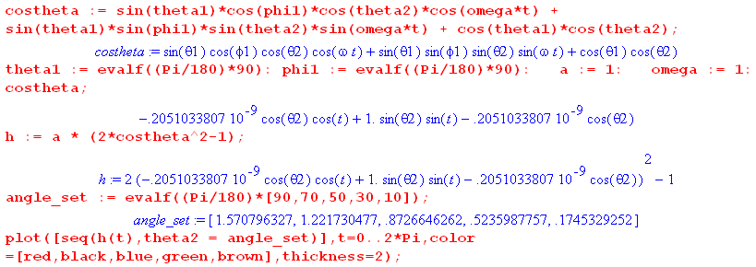

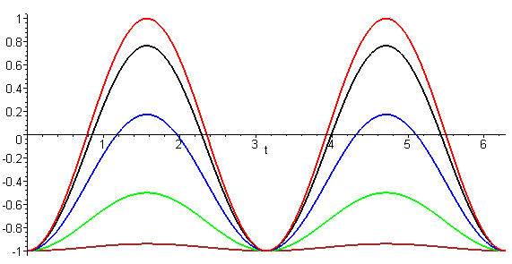 (8.8.54)

The top trace is for θ' = 90o (equator) which has the full tide amplitude, and then as one approaches the pole in steps of 20o this amplitude decreases ending up with h(t) ≈ -a for θ' = 10o. On this Earth there are always two equal high tides per day.

Example 2: (tipping ' toward the direction)

Suppose however that the Earth's rotation axis points in the direction so θ1= 0 and φ1= 0. In this case we expect to have no tides at all since for any θ' latitude line θ = θ' is constant. This is borne out in the above Maple code Maple,

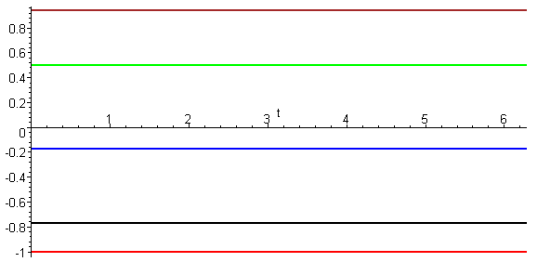 (8.8.55)

At the equator the Observer is stuck low tide all the time (bottom trace). Conversely, an Observer at the pole is stuck at high tide all the time (top trace is θ' = 10o).

As we start increasing θ1 away from 0, the nature of the tidal traces changes. Here is a set of trace sets for various θ1 always with φ1= 0:

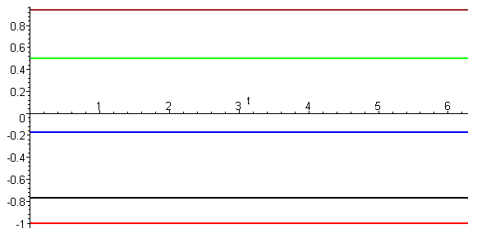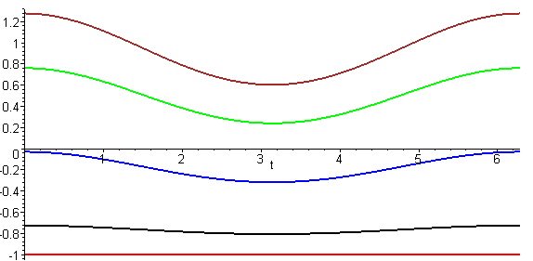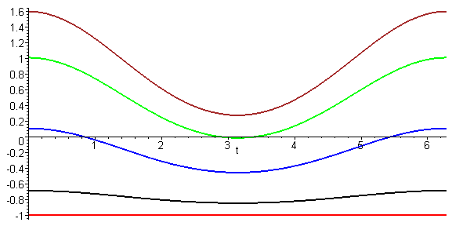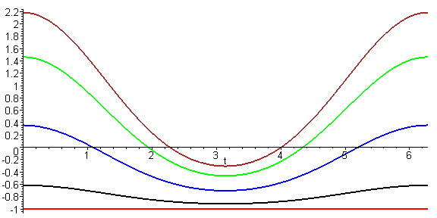
θ1 = 0 θ1 = 5o θ1 = 10o θ1 = 20o
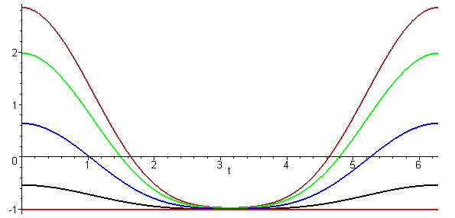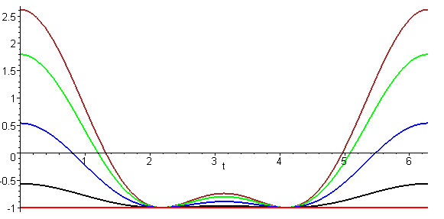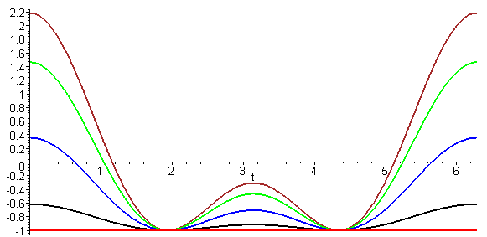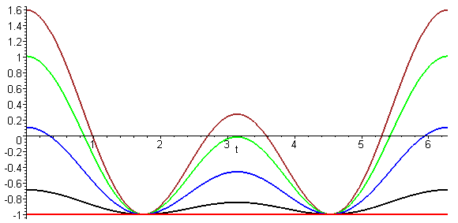
θ1 = 40o θ1 = 60o θ1 = 70o θ1 = 80o

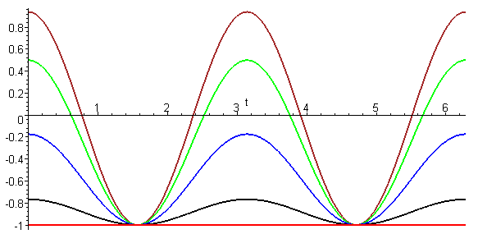 (8.8.56)
θ1 = 90o

When θ1= 0o there are no tides at all since the rotation is in the direction in Fig (8.8.43). As we gradually tip the Earth's rotation axis toward the direction, things change. Up to about θ1 = 40o there is one tide per day, but beyond this point there are two unequal tides per day and they become equal when θ1 reaches 90o. The point here is that many tidal patterns are possible depending on the Earth's direction of rotation.

Tidal patterns for the rotating Earth (but still a water world in which water flows instantly)

Relative to Fig (8.8.43) the actual axis ' of the Earth's rotation varies over time, as suggested by this picture from wiki,

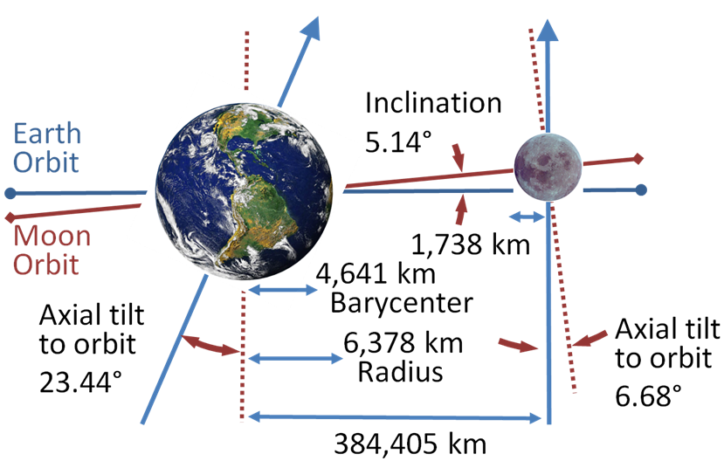 (8.8.57)

https://upload.wikimedia.org/wikipedia/commons/4/43/Earth-Moon.PNG

We transcribe the situation depicted above into a drawing more compatible with Fig (8.8.43),

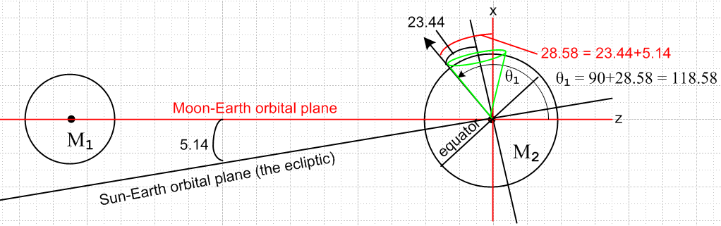 (8.8.58)

Here the black arrow is ' (Earth's rotation axis) and it is located at θ1= 118.6o and is in the plane of paper so φ1 = 0. The intersection of the two orbital planes is called the line of nodes and for the time indicated in the picture, that line is perpendicular to the plane of paper. This situation of maximum tilt 28.58o occurs once every 18.6 years, a time called the "major lunar standstill". At a time 9.3 years later than the above drawing, the Earth's rotation axis in effect moves to the right edge of the green cone and then the 28.58o = 23.44+5.14 gets replaced by 18.30o = 23.44-5.14 which is the "minor lunar standstill". The half-angle of the green cone is 23.44o.
Near the time depicted in the picture, the Earth's rotation axis in effect moves around a different cone once per month as indicated in blue in this picture (blue cone half-angle = 28.58o)

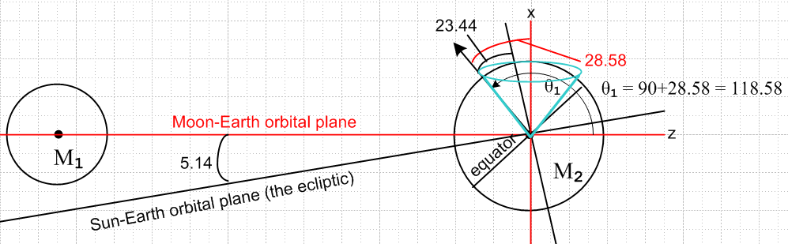 (8.8.59)

Thus, a half month later than the configuration shown, one will have θ1 = 90 - 28.58 = 61.42o. At times in between, θ1 lies in the range ( 61.4o, 118.6o) and φ1 takes small values with |φ1| ≤ 28.58o .
Here we repeat our plot set above for θ1 = 100o and φ1 = 20o just as an example:

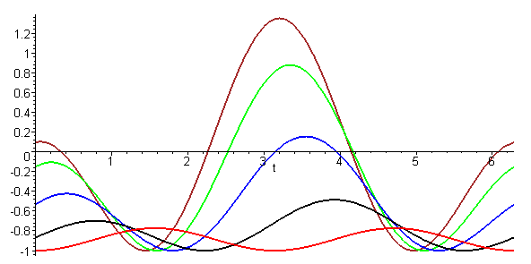 (8.8.60)

At the equator (red) there are two small equal tides per day. At other latitudes there are still two tides per day, but they are unequal.

As the Earth rotates, it is true that at any latitude θ' there is an outward-pointing centrifugal force of equal magnitude all around the Earth, but we expect this not to affect the tides.

The high tides are nominally 12 hours apart. In fact the Moon moves with a 27.3 day period in the same direction the Earth rotates, so when 12 hours has passed, the Moon has moved ahead 12/27.3 = 0.44 hours = 26.4 minutes, so one has to wait another 26 minutes for the next lunar high tide, so the time between high tides is about 12 hours 26 minutes. This causes the time of high tide to move relative to a wall clock in any location, which is why we have tide tables and tide clocks.

Roughly the solar tides have half the influence of the lunar ones as indicated in (8.8.42). They add and cancel depending on the position of the Sun and Moon. This nice picture of D.J. Jeffery shows the extremal situations (the word spring does not mean the season Spring)

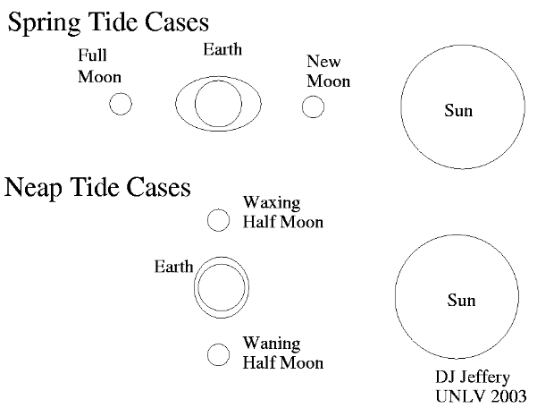 (8.8.61)

So the maximal spring tides are about 2 weeks apart and the same is true for the intervening minimal neap tides.
A good discussion of the above tidal model is given in Taylor's textbook[1] p 330-336. A more detailed discussion is presented in the excellent (and downloadable) paper by Butikov[13]. Both sources are very readable.

Tides on the real Earth

We leave the reader with this perhaps disappointing picture of actual tides on the Earth.
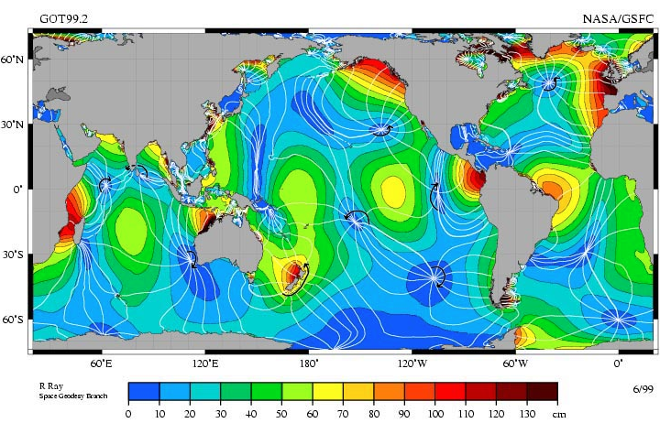
http://www.nauticed.org/sailing-blog/how-the-tides-work/ (8.8.62)

(We are unable to locate the original source of this graphic.) Presumably these are measured long-term averages of tidal high-low differences and one sees how they generally range from 0 cm to 140 cm. A wave resonance at the Bay of Fundy can cause a 1700 cm (50 foot) high/low tide difference there.
Recall our toy model calculation that

Hlunar_tide = 53.49 cm ~ 1.8 feet .
Hsolar_tide = 24.58 cm ~ 0.8 feet . (8.8.42)

At least the values in the map are in the same ballpark as the toy model! The sailing author at the above link notes that tides are almost non-existent in the Caribbean and Mediterranean seas, which are dark blue in the figure.
As Butikov points out, the simple model in which the Earth rotates under a static ellipsoid of water in a frictionless manner is very far from reality. One must consider the dynamical aspects of the problem which involve the massive water currents which attempt to maintain the tidal ellipsoid and the interaction of such currents with land and the ocean bottom and with themselves (water has some viscosity). Water does not flow at an infinite velocity, so there are inertial effects. One result is that tides are often delayed up to 12 hours and some tidal events can be delayed on the order of days relative to the toy model prediction! The problem is one of wave dynamics and forced oscillation on a rotating object and is well beyond the scope of our document (but is treated by Butikov and in his references).

