archive old Section 8.2 PhL 2.2.17

8.2 Interpretation of the Centrifugal and Euler Fictitious Forces

Comment: Most books properly focus on the Coriolis term and neglect the other two terms with a casual remark that the centrifugal term is the usual term one expects for a problem involving an object on the rotating Earth. Since these books normally have r ↔ r', one sees the term ω x (ω x r) and vaguely associates this with the obvious large-radius rotation of a Particle on the Earth's surface about the central axis of the Earth. This is of course a wrong association, since r' in (8.1.8) is a local vector in Frame S' having nothing to do with the long vector r to the center of the Earth. So here we seek an interpretation of the fictitious accelerations in (8.1.8) where r' is the short vector to the Frame S' origin.

To emphasize the long and short vector idea, we take the Earth scenario of Fig (4.7.1) rather than a more general situation like Fig (4.2.1) :

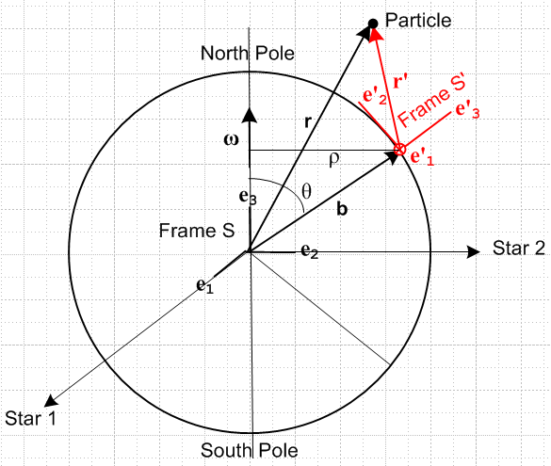 (4.7.1) (8.2.1)

Suppose in the above picture v' = 0 so r' is static in Frame S'. Then (8.1.8) becomes

F'fict = – mS – mω x (ω x r') – m x r' . (8.1.8) with v' = 0
frame centrifugal Euler

The – mS fictitious force arises from the acceleration of the origin of Frame S' relative to the origin of Frame S and generally needs no further comment. In the Earth picture, if ρ is the distance from the Frame S' origin to the ω axis, we can use spherical coordinates r,θ,φ (but ρ is cylindrical) to obtain

b = b(t) = ω = 0

S = b(t) = b [ ωsinθ ] = (bsinθ)ω = ρω // (E.2.11)

S = ρ + ρω = ρ + ρω [-ω] = ρ – (ω2ρ) // (E.5.6) (8.2.2)
Euler centripetal

We then obtain the expected Euler and centripetal accelerations associated with the long vector b. The Earth has ≈ 0 so only the centripetal term is significant.

Our goal here, however, is to interpret the centripetal and Euler terms in (8.1.8) which involve the short vector r'. We know from the G rule (2.1) applied to vector r' that

(dr'/dt)S = ω x r' = v'S (8.2.3)

because ∂S'r' = 0 when v' = 0. As was illustrated generically in (1.6.1), this means that vector r' does the following conical motion in Frame S (r'T means r' transverse),

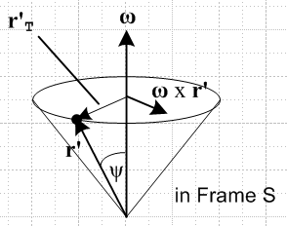 (8.2.4)

The tip of the r' arrow travels in a circle, so with b → r', ρ→ r'T and θ→ψ the above b analysis says

S = r'T – (ω2 r'T) 'T . (8.2.5)
Euler centripetal

These are exactly the Euler and centripetal accelerations appearing in (8.1.8) with v' = 0 as we now verify,

x r' = x r' = r'T (8.2.6)
vector identity
ω x (ω x r') = ω2 x ( x r') = ω2[ ( • r') - r'] = ω2 [ r'cosψ - r' ]

= - ω2 [r' - r'cosψ ] = - ω2 r'T = - (ω2 r'T) 'T . (8.2.7)

A weak link here in the visualization is how the cone Fig (8.2.4) relates to the Earth picture in Fig (8.2.1). The actual motion of r' is shown here,

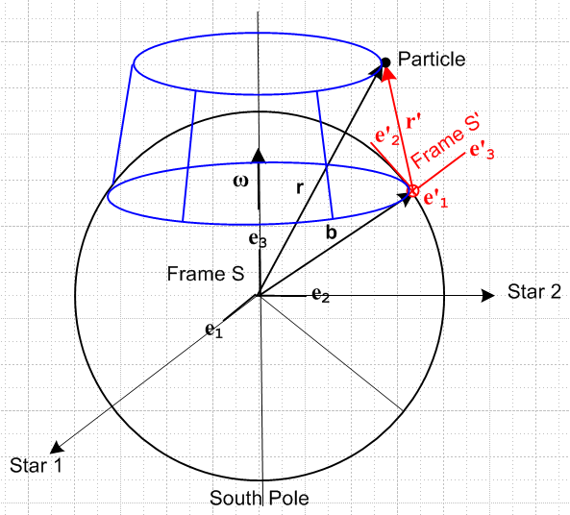 (8.2.8)

As the Earth turns, the vector r' moves on the blue lampshade surface. It is only when one moves all the vectors on this surface so their tails touch that one gets the cone picture of Fig (8.2.4). Recall our early discussion in Section 1.4 about "when are two vectors equal" and also the similar Fig (1.6.2).
If the red vector r' in Fig (8.2.8) or Fig (8.2.4) were made vertical, parallel to ω, the Euler and centripetal terms in (8.2.7) would both vanish since r'T = 0, but the corresponding terms in (8.2.2) remain the same.
The three terms shown above in (8.1.8) with v' = 0 can be combined into two terms for the Earth picture since S shown in (8.2.2) can be written S = ω x (ω x b) + x b, as in (7.13) . Then

F'fict = – mS – mω x (ω x r') – m x r' (8.1.8) with v' = 0

= -m [ ω x (ω x b) + x b] – mω x (ω x r') – m x r'

= – mω x (ω x [b+ r']) – m x [b+ r']

= – mω x (ω x r) – m x r

where now r is the "long vector" to the center of the Earth and these are then the conventional centrifugal and Euler fictitious forces which are the sums of the two groups of forces discussed above.

