New Section 13.6 PhL 12.9.16

This has been installed, do not view again.

Start with Fig ***

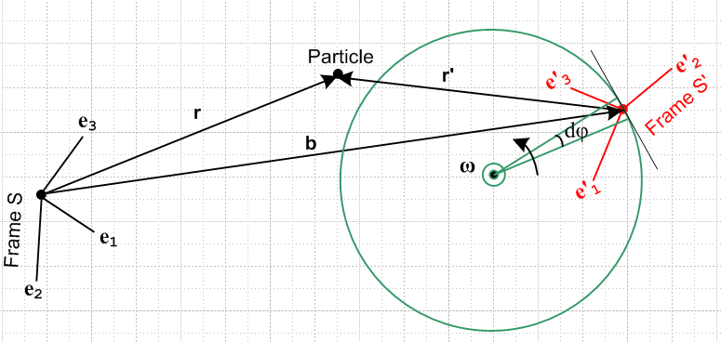

Apply the Swap Rules of *** to get

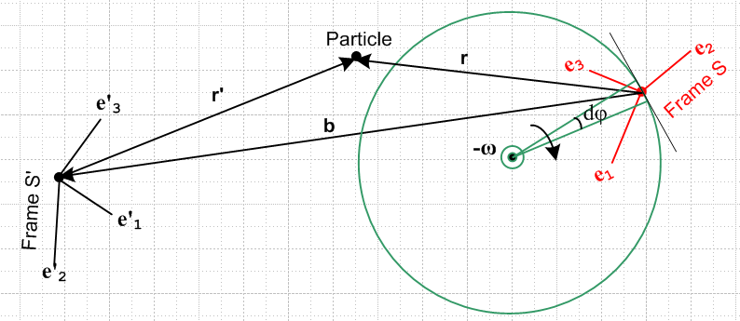

Rather than take b → -b as a label, we have flipped the arrow on the b vector to achieve the same result.

Now observe the above scenario from a camera platform which is rotating counterclockwise at rate ω with its rotation axis the same as that shown in the figure. Viewed from this camera's rotating frame, Frame S is at rest, and Frame S' is rotating counterclockwise. That viewed picture is then as follows:

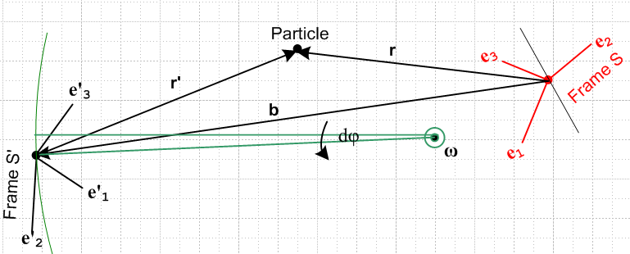

This is then the picture one sees if one observes things from Frame S. The equations relating various vector quantities are the same whether they are observed by an observer at rest in Frame S' or at rest in Frame S. Moreover, these equations are the same regardless of where one puts the ω axis, and regardless of where one places the Particle, and regardless of where and how one orients the two Reference frames. So let's move these things around a bit to get this new drawing which has the same equations,

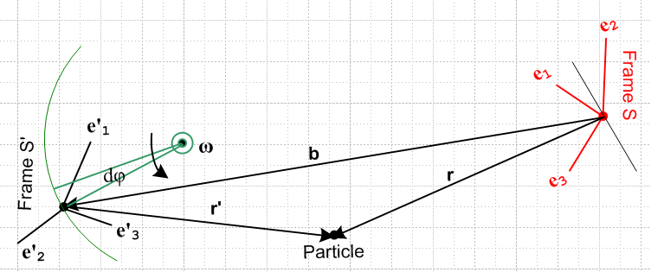

Now we rotate this picture about an axis near the center and perpendicular to the plane of paper. Such a rotation again does not change the equations associated with the picture. We then have

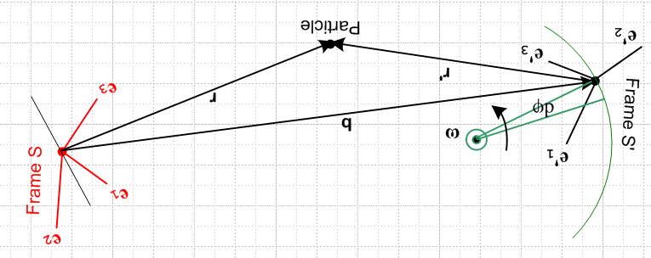

But this is the same as the picture we started with above (apart from colors and text orientation),

Since the Swap Rules, along with various equation-invariant reorientations, produce a final picture which is the same as the initial picture, when those Swap Rules are applied to a valid set of associated vector equations, the resulting equations also apply to the initial picture and are therefore valid.

