The COSY Analysis PhL 1.22.08

COSY Reviewed from Scratch

1. The COS pulse sequence.

This first pulse sequence is (π/2)x, τ , (π/2)x, t2 . In the end we will refer to τ as t1, but for notational purposes it is best to leave it as τ for now.

A. The first pulse.

Our TE ρ has the term Iz which is turned into -Iy by the first pulse being Rx(π/2). We just look this up in the sandwich page to find:

exp(- i θ I1x) I1z exp(+ i θ I1x ) = I1z Cθ - I1ySθ [θ1= Ω01τ ]

Then set θ = π/2 and we get RHS = -I1y. Do same for I2z which becomes -I2y .

ρ = − I1y − I2y

B. Free propagation after the first pulse: comparison of phasing vs matrix "views".

Work first on − I1y. We are going to apply this triple operator:

R(φ = πJτ, 2I1zI2z)R(θ1= Ω01τ, I1z) R(θ2= Ω02τ, I2z)

where we show the angle and the acting generator. The R(θ2) does nothing to 1 space, then R(θ1)gives

exp(- i θ1 I1z) I1y exp(+ i θ1 I1z ) = I1y Cθ1 − I1x Sθ1

so the action of the two rightmost operators gives

= − I1y Cθ1 + I1x Sθ1

Now for the last rotation we can use these rules from our sheet:

exp(- i φ 2I1zI2z) I1x exp(+ i φ 2I1zI2z ) = I1x Cφ + 2I1yI2z Sφ [ φ = πJτ ]
exp(- i φ 2I1zI2z) I1y exp(+ i φ 2I1zI2z ) = I1y Cφ − 2I1xI2z Sφ

giving a final result of

= − ( I1y Cφ − 2I1xI2z Sφ)Cθ1 + (I1x Cφ + 2I1yI2z Sφ) Sθ1

= − I1yCφCθ1 + 2I1xI2z SφCθ1 + I1x Cφ Sθ1 + 2I1yI2z Sφ Sθ1

Now if we perform the same triple rotation on the −I2y term, we get the same answer with 1 ↔ 2, so our final result after free propagation for τ is this:

ρ = − I1yCφCθ1 + 2I1xI2z SφCθ1 + I1x Cφ Sθ1 + 2I1yI2z Sφ Sθ1 + (1↔2)

= − I1yCφCθ1 + 2I1xI2z SφCθ1 + I1x Cφ Sθ1 + 2I1yI2z Sφ Sθ1
− I2yCφCθ2 + 2I2xI1z SφCθ2 + I2x Cφ Sθ2 + 2I2yI1z Sφ Sθ2

From the raise/lower argument, each of these 8 terms involves only single-quantum coherences. But we know this already because that's what we had after the first pulse, and we know the each coherence merely "phases" during free run, though the matrix view somewhat obscures this fact.
We could at this point make the various replacements such as I1y = (1/2i)(I1+ − I1-)(I2α + I2β) and read off the exact value of each coherence, such as ρ-α = ρ-β = +(1/2i)CφCθ1 = +(1/2i)cos(πJτ)cos(Ω01τ). But : there are other terms that contribute to these same coherences, so you have to do everything. For example, you might write I1yI2z = (1/2i)(I1+ − I1-)I2z(I2α + I2β) =
(1/2i)(I1+ − I1-)(I2α − I2β)/2 which also contributes to ρ-α and ρ-b. We know by a different argument that in fact ρ-α = +(1/2i) exp[-i (Ω01 + πJ)τ ] when we add up all the terms, so probably this second method is the right way to compute a specific coherence. [ Assumed λ=0 for the moment. ] However, if you are going to apply more pulses, you need to have the "matrix representation" of ρ. How would you know, for example, what a (π/2)x does to ρ-α ? You need to "rotate" the entire matrix ρ and this is going to mix its elements in some way, so you cannot just track ρ-α all by itself through a pulse. That is WHY we need the matrix viewpoint on ρ.

C. The second pulse. This pulse is also Rx(π/2). Our sandwich rules for the single generator terms come from these rules from our sandwich page, where on the right we set θ = π/2,

exp(- i θ Jx) Jy exp(+ i θ Jx) = Jy cosθ + Jz sinθ = + Jz => Iy→ Iz
exp(- i θ Jx) Jz exp(+ i θ Jx) = Jz cosθ − Jy sinθ = − Jy => Iz → − Iy

=> I1y → I1z
I1x → I1x
2I1xI2z → 2(I1x)(−I2y) = −2I1xI2y
2I1yI2z → 2(I1z)(−I2y) = −2I1zI2y

so our result for ρ becomes

ρ = − I1yCφCθ1 + 2I1xI2z SφCθ1 + I1x Cφ Sθ1 + 2I1yI2z Sφ Sθ1 + (1↔2)
→ − I1zCφCθ1 − 2I1xI2y SφCθ1 + I1x Cφ Sθ1 − 2I1zI2y Sφ Sθ1 + (1↔2)

D. Result of the entire sequence up to time t2=0 where the FID begins:

ρ = − I1zCφCθ1 − 2I1xI2y SφCθ1 + I1x Cφ Sθ1 − 2I1zI2y Sφ Sθ1 + (1↔2) // agree p 396 top

We can see that the first term is a 0-quantum term, while the second term is a mixture of 0-quantum and 2-quantum. The next two terms are 1-quantum and these are the ones we care about because this is what our receiver can see. We take note that our second pulse took terms that were all 1-quantum, and blasted them into a mixture of 0,1 and 2-quantum, so if we were drawing a "coherence flow picture", we would show this happening. Maybe I will do this picture later on.
So, keeping only the 1-quantum terms we have

ρ = I1x Cφ Sθ1 − 2I1zI2y Sφ Sθ1 + (1↔2) // agrees 13.2

At this point we can use these trig formulas

2Cφ Sθ1 = Sθ1-φ + Sθ1+φ // = 2Sθ1Cφ
2Sφ Sθ1 = Cθ1-φ − Cθ1+φ

giving at time t2 = 0 at the start of the FID:

ρ = I1x Cφ Sθ1 − 2I1zI2y Sφ Sθ1 + (1↔2)

= I1x(Sθ1-φ + Sθ1+φ)/2 −I1zI2y (Cθ1-φ − Cθ1+φ) + (1↔2) // agrees (13.5) + (13.4)

E. Location and Nature of the resulting 2D Fourier spectrum peaks. Let's now compute one of the coherences: I1x = (1/2)(I1+ + I1-)(I2α + I2β) so the first term gives this contribution:
ρ-α = (1/2)(Sθ1-φ + Sθ1+φ)/2. Then inside the (1↔2) we have −I2zI1y (Cθ2-φ − Cθ2+φ) so we will write I1yI2z = (1/2i)(I1+ − I1-)(I2α - I2β) and so ρ-α = +(1/2i) (Cθ2-φ − Cθ2+φ). So our total here is that

1 2 3 4
ρ-α = (1/2)(Sθ1-φ + Sθ1+φ)/2 +(1/2i) (Cθ2-φ − Cθ2+φ).

In each trig function, the θ variable has time τ which we now call t1, so in the conjugate Ω1 variable we will see four peaks! These four peaks are at frequencies Ω01 ± πJ (in-phase, peaks 1 2)and Ω02 ± πJ (antiphase, peaks 3 4) in the Ω1 variable. At this point in time, all the t1 action is completed. As we now go into the FID period t2 > 0 our ρ-α picks up exp[-i (Ω01 + πJ)t2 ] so this means a peak at Ω2 = Ω01 + πJ only.
Now look at the picture on page 397. I have shown where the four peaks 1,2,3,4 are located on the "−α vertical line". Notice that the Ω1 variable runs up the left edge of the graph, so these peaks are at four different frequencies in Ω1. These are four peaks in ρ-α in the Ω1 spectral variable. But all four of these peaks have a peak in Ω2 at Ω01 + πJ only as we have just said. This is what determines the horizontal position of the "−α vertical line". In a 2D FT, we are only interested in peaks which are simultaneous in both spectral variables, and those are the points marked 1,2,3,4 on this picture.
What about ρ-β ? It is exactly the same as ρ-α but the second term changes sign (just look at the projector expressions), so we have [ I put the sign inside the cosine factor ]

5 6 7 8
ρ-β = (1/2)(Sθ1-φ + Sθ1+φ)/2 + (1/2i) (− Cθ2-φ + Cθ2+φ).

Here we have the same four peaks in Ω1 but the two peaks at Ω1 = Ω02 ± πJ have the opposite sign to our peaks in ρ-α . The Ω2 peak will now be at the ρ-β frequency which is Ω01 − πJ. So these peaks I have numbered 5,6,7,8.. So these four peaks are on the "−β vertical line" which is located 2πJ to the left of the -α vertical line, see the picture.
So, we now see that there are four Cθ2 type peaks [ 3,4,7,8] which form the anti-phase quartet where a black dot means negative and white dot means positive. Peaks 3 and 8 are white since they are positive. These four peaks are located near (Ω1, Ω2) = (Ω02, Ω01) . We have assumed Ω01 > Ω02 so this quartet is located at large Ω1 and small Ω2 which means this quartet is OFF the diagonal of the graph, and is referred to as the "cross-peak" for this reason.
The other four peaks [ 1,2,5,6] all have positive phase (but are shown grey, not white) and they are all located near (Ω1, Ω2) = (Ω01, Ω01) which is ON the diagonal.

Now what about the other two coherences ρα- and ρβ- ? These are obtained by (1↔2) because the meaning of the box notation is ρ12 in terms of "position". So our formulas will be the same as the above but with this swap, so we will get

1' 2' 3' 4'
ρα- = (1/2)(Sθ2-φ + Sθ2+φ)/2 +(1/2i) (Cθ2-φ − Cθ2+φ).

5' 6' 7' 8'
ρβ- = (1/2)(Sθ2-φ + Sθ2+φ)/2 + (1/2i) (− Cθ2-φ + Cθ2+φ).

As before, each of these coherences has four peaks on vertical lines which are located at the energies Ω02 ± πJ, so these lines are to the left of the previous two lines. In fact, an easy way to think of the above is that we make 8 peaks which are located at Ω01 ↔Ω02 on the graph. This means the following:

(1) the anti-phase quartet will be at (Ω1, Ω2) = (Ω01, Ω02) which is the mirror location of where the other anti-phase quartet was located.

(2) the in-phase quartet will be at (Ω1, Ω2) = (Ω02, Ω02) which is still on the diagonal, but lower down toward the origin.

It is pretty clear now that the four quartets form a square with the two diagonal quartets lying on the diagonal. and the two cross-peak quartets on the other two square corners away from the diagonal.

One other detail. We know that the "nature of the peak" ( in terms of is it A or D type) is determined by the constant a = 2iρ(t2 = 0). For all the cosine terms above we get real a because they all have a (1/2i) factor so these will be nice Re = A type peaks. The sin terms all have a ~ +i = exp(+iπ/2). As shown on page 108, this means that Re = D so where we would like a nice A peak, we get that twisted D peak thing.
[ But below I show this is not quite right. In fact, after we convert to expos, all our peaks will "have real a" and for all peaks therefore we will have Re = A. ]

And again, yet one other detail. We know that we don't need to think about the + coherence peaks because the quadrature receiver tells us our final signal just in terms of the − peaks. But we can ask: "where are the + peaks? ". To find out, we need to C.C. the above expressions AND the t2 phase that follows. This second part means that the + peaks will all be at Ω2 < 0, so will in quadrant II.

F. More detail on exactly where peaks are located.

First, let's review the 1D FT situation. On page 98 we see the "expected form" of s(t). It is shown having a complex constant a and then a positive sign times Ω0 . If we do a FT in the standard way using our standard formulas, we get page 102 eq (5.10) for the FT which says there is a peak at Ω = Ω0 and we get the A and D forms shown there.
We know that during a FID, our + and - coherences run at some exp(+iΩboxt) where the sign is always positive and the Ωbox frequency is labeled to match our coherence. So let's just pick one of the coherences above and add this to it:

ρ-α = [ (1/2)(Sθ1-φ + Sθ1+φ)/2 +(1/2i) (Cθ2-φ − Cθ2+φ)] exp(+iΩ-ρt2)

where θ1= Ω01t1 θ2= Ω02t1 φ = πJt1, where I am as usual leaving off the relaxations. The form we want for our 2D analysis is shown top of page 111 and is of the form

s(t) = 2iρ(t) = a exp(+ib1t1)exp(+ib2t2)

because this under FT will put a 2D peak at the single location (Ω1,Ω2) = (b1,b2). So, to see where all the peaks really are, we can write

sinx = (eix - e-ix)/(2i) cosx = (eix + e-ix)/(2)

Doing this, we see that each of the four terms in ρ-α above is really two peaks so we have

ρ-α = (1/2)([ei(θ1-φ) - e-i(θ1-φ))/(2i) ]+ [ei(θ1+φ) - e-i(θ1+φ))/(2i)])/2 +
(1/2i) ([(ei(θ2-φ) + e-i(θ2-φ))/(2)] − [(ei(θ2+φ) + e-i(θ2+φ))/(2)] ) exp(+iΩ-αt2)

Now, the peaks we "talked about earlier" are really those of the first exponential in each [..] because these contain the frequencies we talked about leading to the various conclusions. So, this says that for every peak we have at some Ω1 = b1 value, there is a corresponding peak at Ω1 = - b1 , but the sign of the mirrored peak depends on which one you are talking about. So, looking back at page 397, our four peaks 1,2,3,4 have reflected peaks on the negative Ω1 axis. In fact, all 16 peaks are reflected below the axis.
In contrast, peaks are not reflected to the left of the vertical axis because the t2 exponential is already in exp form. So the complete picture of all quadrants would have peaks only in quadrants I and IV, assuming the Ωi > 0 which we know is only true if γ < 1 so this is not the case for protons. [ The + coherence peaks will be in quadrants II and III. ]
What about the "nature" of the various peaks? Remembering that s(t) = 2iρ, it now appears that all peaks in fact yield a = real because each of the terms above now has as 1/(2i) sitting in it. So in light of this, I wonder if Malcolm's comment on page 397 isn't wrong? (nothing in errata) On page 111, there is only one "a" factor that goes with the pair of expos, so I don't see how you can say that something is "dispersive in a particular direction". If a = real, then you get (5.23) which at least looks like a peak, and the Im is the phase twist peak. So perhaps this goes on my "error list".

G. Conditions for applying States. Page 115.

(1) The a are all real". Well, yes, in fact all 8 of our peaks have real a!

(2) Peaks are mirrored in the horizontal axis, BUT only for our cosine terms do we have "identical a" for the pair of mirrored peaks. So we know that our States will only apply to the cosine terms.

So for the moment, ignore the sine terms and work ONLY with the cosine terms. Since these meet the states requirement, we "do" the states method and we end up with Re Sstates = A1A2 for each peak. This assumes we find a matching "sine experiment" we can do (see below).
Now, since our cosine terms are those cross-peak quartets, after States we will end up with the very nice pictures shown on page 397.
I don't know what the diagonal peaks will be because I have not yet looked at the Ssin sequence. We need to do that next! (see comments at the end of the next section 2. )

−−−−−−−−−−−−−−−−−−−−−−−−−−−−−−−−−−−−−−−−−−−−−−−−−−−−−−−−−−−−−−−−−−−−−−−−

2. The SIN pulse sequence (BRUTE FORCE).

This sequence is (π/2)-y, τ , (π/2)x, t2 . In the end we will refer to τ as t1, but for notational purposes it is best to leave it as τ for now.

A. The first pulse.

The first pulse is R-y(π/2). We just look this up in the sandwich page to find:

exp(- i θ I1y) I1z exp(+ i θ I1y ) = I1z Cθ + I1xSθ [θ1= Ω01τ ]

Then set θ = −π/2 and we get RHS = − I1x. Do same for I2z which becomes -I2x .

ρ = − I1x − I2x

and this agrees with my visualized right hand rule.

B. Free propagation after the first pulse.

Work first on − I1x. We are going to apply this triple operator:

R(φ = πJτ, 2I1zI2z)R(θ1= Ω01τ, I1z) R(θ2= Ω02τ, I2z)

where we show the angle and the acting generator. The R(θ2) does nothing to 1-space, then R(θ1)gives

exp(- i θ1 I1z) I1x exp(+ i θ1 I1z ) = I1x Cθ1 + I1y Sθ1

so the action of the two rightmost operators gives

= − I1x Cθ1 − I1y Sθ1

Now for the last rotation we can use these rules from our sheet:

exp(- i φ 2I1zI2z) I1x exp(+ i φ 2I1zI2z ) = I1x Cφ + 2I1yI2z Sφ [ φ = πJτ ]
exp(- i φ 2I1zI2z) I1y exp(+ i φ 2I1zI2z ) = I1y Cφ − 2I1xI2z Sφ

giving a final result of

= − (I1x Cφ + 2I1yI2z Sφ)Cθ1 − ( I1y Cφ − 2I1xI2z Sφ) Sθ1

= − I1xCφCθ1 − 2I1yI2z SφCθ1 − I1y Cφ Sθ1 + 2I1xI2z Sφ Sθ1

Now if we perform the same triple rotation on the −I2x term, we get the same answer with 1 ↔ 2, so our final result after free propagation for τ is this:

ρ = − I1xCφCθ1 − 2I1yI2z SφCθ1 − I1y Cφ Sθ1 + 2I1xI2z Sφ Sθ1 + (1↔2) ******

From the raise/lower argument, each of these 8 terms involves only single-quantum coherences.

C. The second pulse. This pulse is also Rx(π/2). Our sandwich rules for the single generator terms come from these rules from our sandwich page, where on the right we set θ = π/2,

exp(- i θ Jx) Jy exp(+ i θ Jx) = Jy cosθ + Jz sinθ = + Jz => Iy→ Iz
exp(- i θ Jx) Jz exp(+ i θ Jx) = Jz cosθ − Jy sinθ = − Jy => Iz → − Iy copy ok

So

ρ = − I1xCφCθ1 − 2I1yI2z SφCθ1 − I1y Cφ Sθ1 + 2I1xI2z Sφ Sθ1 + (1↔2) // checked
→ − I1xCφCθ1 + 2I1zI2y SφCθ1 − I1z Cφ Sθ1 − 2I1xI2y Sφ Sθ1 + (1↔2) //checked

D. Result of the entire sequence up to time t2=0 where the FID begins:

ρCOS = − I1zCφCθ1 − 2I1xI2y SφCθ1 + I1x Cφ Sθ1 − 2I1zI2y Sφ Sθ1 + (1↔2) // copy ok

ρSIN = − I1z Cφ Sθ1 − 2I1xI2y Sφ Sθ1 − I1xCφCθ1 + 2I1zI2y SφCθ1 + (1↔2) // swap done ok

Here is a rule that would take you from the COS to the SIN formula:

Cθ1 → Sθ1
Sθ1 → - Cθ1

This seems VERY reasonable to me. Next, let's keep only the single-quantum terms. So:

ρCOS = + I1x Cφ Sθ1 − 2I1zI2y Sφ Sθ1 + (1↔2) //checked

ρSIN = − I1xCφCθ1 + 2I1zI2y SφCθ1 + (1↔2) // checked

Now let's do the trig formulas to use in the SIN version. We get

Cφ Cθ1 = (Cθ1-φ + Cθ1+φ )/2 // checked
Sφ Cθ1 = − (Sθ1-φ − Sθ1+φ )/2 // checked

Install these into the SIN formula to get

ρSIN = − I1x (Cθ1-φ + Cθ1+φ )/2 − 2I1zI2y (Sθ1-φ − Sθ1+φ )/2 + (1↔2) //checked

The above agrees with Levitt (13.4) page 397, and (13.5), but he has I2x in place of I1x which is wrong I am sure, because I traced it all the way back. Now put the results next to each other:

ρCOS = + I1x(Sθ1-φ + Sθ1+φ)/2 − 2I1zI2y (Cθ1-φ − Cθ1+φ)/2 + (1↔2) // copy ok
ρSIN = − I1x (Cθ1-φ + Cθ1+φ )/2 − 2I1zI2y (Sθ1-φ − Sθ1+φ )/2 + (1↔2)

And finally we see what we want to see: In the second terms, we have COS → SIN as the only change, and that is what you need for States to work. ( constant does not change! )
Now look at the first terms. Suppose we "tried out" the first terms in ρSIN as our "cosine terms". The thing does not work because the matching "sine terms" have an overall sign change! So it only works this one way! But probably a modified States could make this work in the reverse manner, but so what.
So, my "brute force method" got the right answer.

3. Another method for getting the SIN result.

The words are extremely delicate in this kind of discussion. See document "confusion about rotation operators.doc" for more information.
Suppose I do the (π/2)-y pulse experiment in the lab system S and this creates some density matrix ρ at a later time just before the second pulse is to be applied. I don't yet know what ρ is. The result is some <α|ρ|β>.
Now, suppose I observe this same experiment from a frame of reference S' that is rotated Rz(-90) relative to the original frame, so that the new frame S' is obtained by rotating backwards 90 degrees. In this S' frame, I think I am doing a (π/2)x pulse experiment because the x' axis is where the -y axis is. The result of the experiment done in frame S' is <α'|ρ|β'> where for example |β'> = U-1|β> where U = Rz(90). I know this result <α'|ρ|β'>, and I know that <α'|ρ|β'> = <α|ρ'|β>, so I know what ρ' is. This is what I got from my (π/2)x calculation.
Now, consider that <α|ρ'|β> = <α'|ρ|β'> = <α|UρU-1|β>, therefore we know that ρ'= UρU-1. But I know the result ρ', so ρ = U-1ρ'U = Rz(-π/2)ρ'Rz(π/2). Therefore, to find the density matrix ρ resulting from the (π/2)-y pulse, I take the result ρ of the (π/2)x pulse and apply the sandwich as shown.

So, I should be able to take my ρ at the point just before the second pulse and get the correct SIN term ρ by applying these operators. That COS ρ was this:

ρCOS = − I1yCφCθ1 + 2I1xI2z SφCθ1 + I1x Cφ Sθ1 + 2I1yI2z Sφ Sθ1 + (1↔2) checked

Here is what the Rz(-π/2) ρ Rz(-π/2)-1 operation does to our matrices: (first we quote the rule)

exp(- i θ Jz) Jx exp(+ i θ Jz) = Jx cosθ + Jy sinθ = Jy => Ix → -Iy
exp(- i θ Jz) Jy exp(+ i θ Jz ) = Jy cosθ − Jx sinθ = − Jx => Iy → + Ix chkd

and then we have set θ = -π/2.

This makes our new SIN result before the second pulse be this:

ρ = − I1yCφCθ1 + 2I1xI2z SφCθ1 + I1x Cφ Sθ1 + 2I1yI2z Sφ Sθ1 + (1↔2) copy checked

→ − I1xCφCθ1 − 2I1yI2z SφCθ1 - I1y Cφ Sθ1 + 2I1xI2z Sφ Sθ1 + (1↔2) // checked ******

This agrees with the result from our "brute force method" at this point, and the rest of the computation is done in that brute force section above, so no point on repeating it here. We have verified that our S and S' frame interpretation of things as outlined above is correct, that is the main point of this section. It was just an exercise. I don't do any "problems" in my Levitt course, and this stuff is a substitute.

4. Comments on States: (taken from spin dynamics.doc)

(A) General. Assume the conditions given on page 115. On page 116 are some pictures and both are t1 on one axis and Ω2 on the other axis. Each picture has two activities because he is assuming there are two terms in Scos which I call l = 1 and l = 2. If you were to write the cosine out as the sum of two expos, then it would be clear that the resulting spectrum (with a = real) will have four peaks, and each peak has the form shown in (5.22). When you multiply out, you get Re = AA-DD and Im = AD+DA as shown on page 113. Each such peak is illustrated p 113 and 114, so if you have four of these peaks going and each one looks the same, you end up with the pictures on page 117. This is all what results from a cosine form. The pictures are really showing Re only: the upper one from the cos term has the form AA-DD just mentioned, and the Im part for this is not plotted. For the sine term, we pick up a 1/2i when converting to expos, so this is going to reverse the Re and Im parts and we will have Re having the ugly form AD+DA (modulo overall sign I have not figured out), and this is what the lower picture p 117 shows.
Here is the States fix. Some equations are needed to see what happens.

Re Scos = Σ a cos( ) Re L2
Re Ssin = Σ a sin () Re L2 // because the a's are real

Therefore, Sstates = Re Scos + i Re Ssin = Σ a exp(...) Re L2

Then do the second Fourier transform on the Ω1 variable to get

FT(Sstates) = Σ a L1 Re L2

Then finally we get Re { FT(Sstates) } = Σ a Re L1 Re L2 = Σ a A1 A2 as shown top of page 118, very good, all understood. So in practice, imagine you do lots of "shots" varying both t1and t2 and you store this all in RAM as s(t1, t2). I guess you repeat each shot lots of times to reduce noise. These things are already digitized, you probably did that in real time as the shots ran with A/D's. You do all this first for the cos experiment, then for the sin experiment and collect all the data. Then you do the two FT2 as shown page 119 and store that back in RAM. Then you run through all this data and create the States signal shown by doing just what the arrows say. Well, you have buffers for each curved edge box, so you point things accordingly. THEN you do the second FT and the thing that comes out nice is the final Re.
So this is a very nice way to get the clean peaks. You have to "find some experiments" that make the sine and cos terms, however, with all the a being real.

B. States bad terms for COSY. Just for fun, here is what happens if we blindly process the "sin terms" in COSY through our same machinery. In this case, we have acos = + i and asin = − i and of course sin ↔ cos. Then we get, using the fact that Re(iz) = −Im(z),

Re Scos = Re{ Σ i sin( ) L2 } = − Im { Σ sin( ) L2 } = − Σ sin( ) Im L2

Re Ssin = − Re{Σ i cos () L2 } = + Σ cos( ) Im L2

Therefore, Sstates = Re Scos + i Re Ssin = − Σ sin( ) Im L2 + i Σ cos( ) Im L2

= i Σ { cos( ) + i sin ( ) } Im L2 = i Σ exp(..) Im L2

We then do the second FT on exp(..) which produces L1 so we then have

Sstates = i L1 Im L2 => Re{Sstates} = − Im{L1 Im L2 } = − Im L1 Im L2 = − D1D2

Really, each a is multiplied by 1/2 so get - (1/2) D1D2. This is what Malcolm shows on page 397 bottom for each of the four peaks of an off-diagonal quartet, but I seem to have an extra minus sign. I need the initial sign difference in order to get the proper exp(..), so I like the relative sign difference. Maybe he has the wrong sign.
In any event, the conclusion for COSY is that you improve the quality of the cross-peaks, and you worsen the quality of the diagonal peaks. Based on the above, with a + sign + D1D2 the plots shown on page 398 look exactly right to me. Wonder how I would make these in Maple! DONE, it was trivial, see mws file in this directory. I replicate his picture pretty well. Here it is:

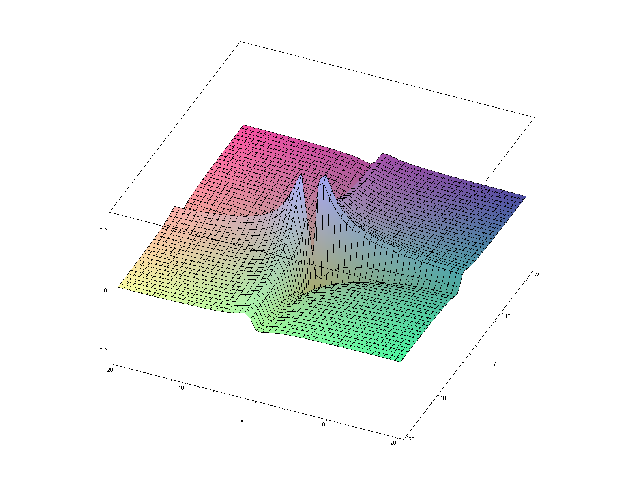

and here is the AA peak

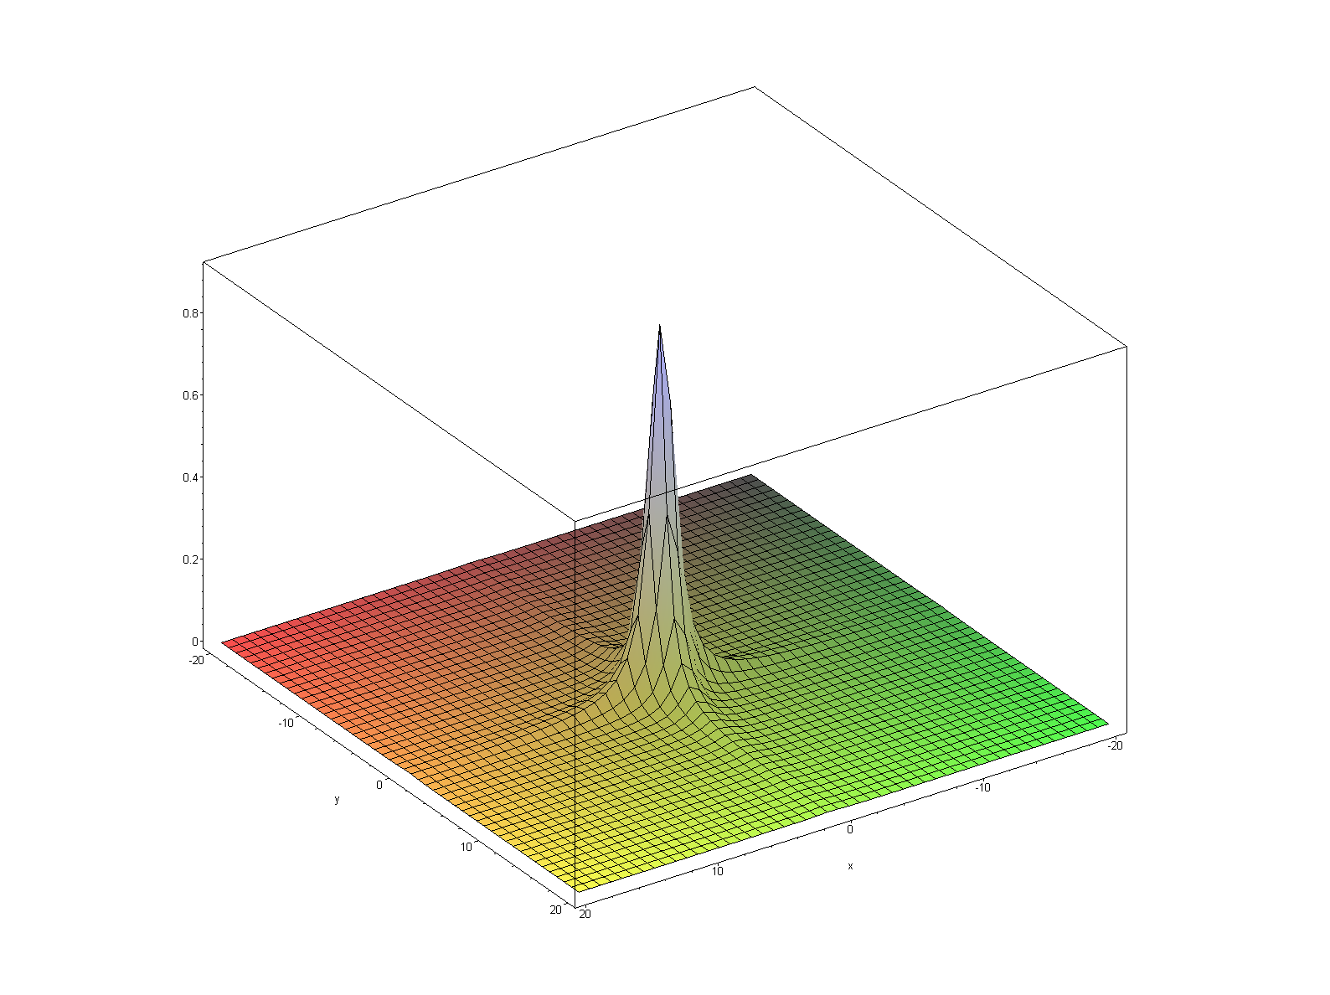

5. What would happen if you did NOT do States? Just doing the COS experiment we get this:

ρ-α = (1/2)([ei(θ1-φ) - e-i(θ1-φ))/(2i) ]+ [ei(θ1+φ) - e-i(θ1+φ))/(2i)])/2 +
(1/2i) ([(ei(θ2-φ) + e-i(θ2-φ))/(2)] − [(ei(θ2+φ) + e-i(θ2+φ))/(2)] ) exp(+i(θ1+φ) in t2)

If we directly do FT on this, we get 8 peaks, but 4 are off on the negative axes so we ignore them. So ignoring those, we get

FT(2iρ-α ) = (1/2) { L1(θ1-φ) + L1(θ1+φ) + L1(θ2-φ) - L1(θ2+φ) } L2 (θ1+φ)

But our system puts out the Re and Im of this thing, so you can look at either of these. But for each of the four peaks, we have the problem outlined on page 313. We get:

Re (L1L2) = A1A2 - D1D2 Im(L1L2) = A1D2 + D1A2

the first one has shape p 13 which is not bad, but has long tails. Here is what the Re looks like to the same scale as the above plots, and you see better here than in Levitt the ugliness. At least it is basically a peak on one side of the mesh plane:

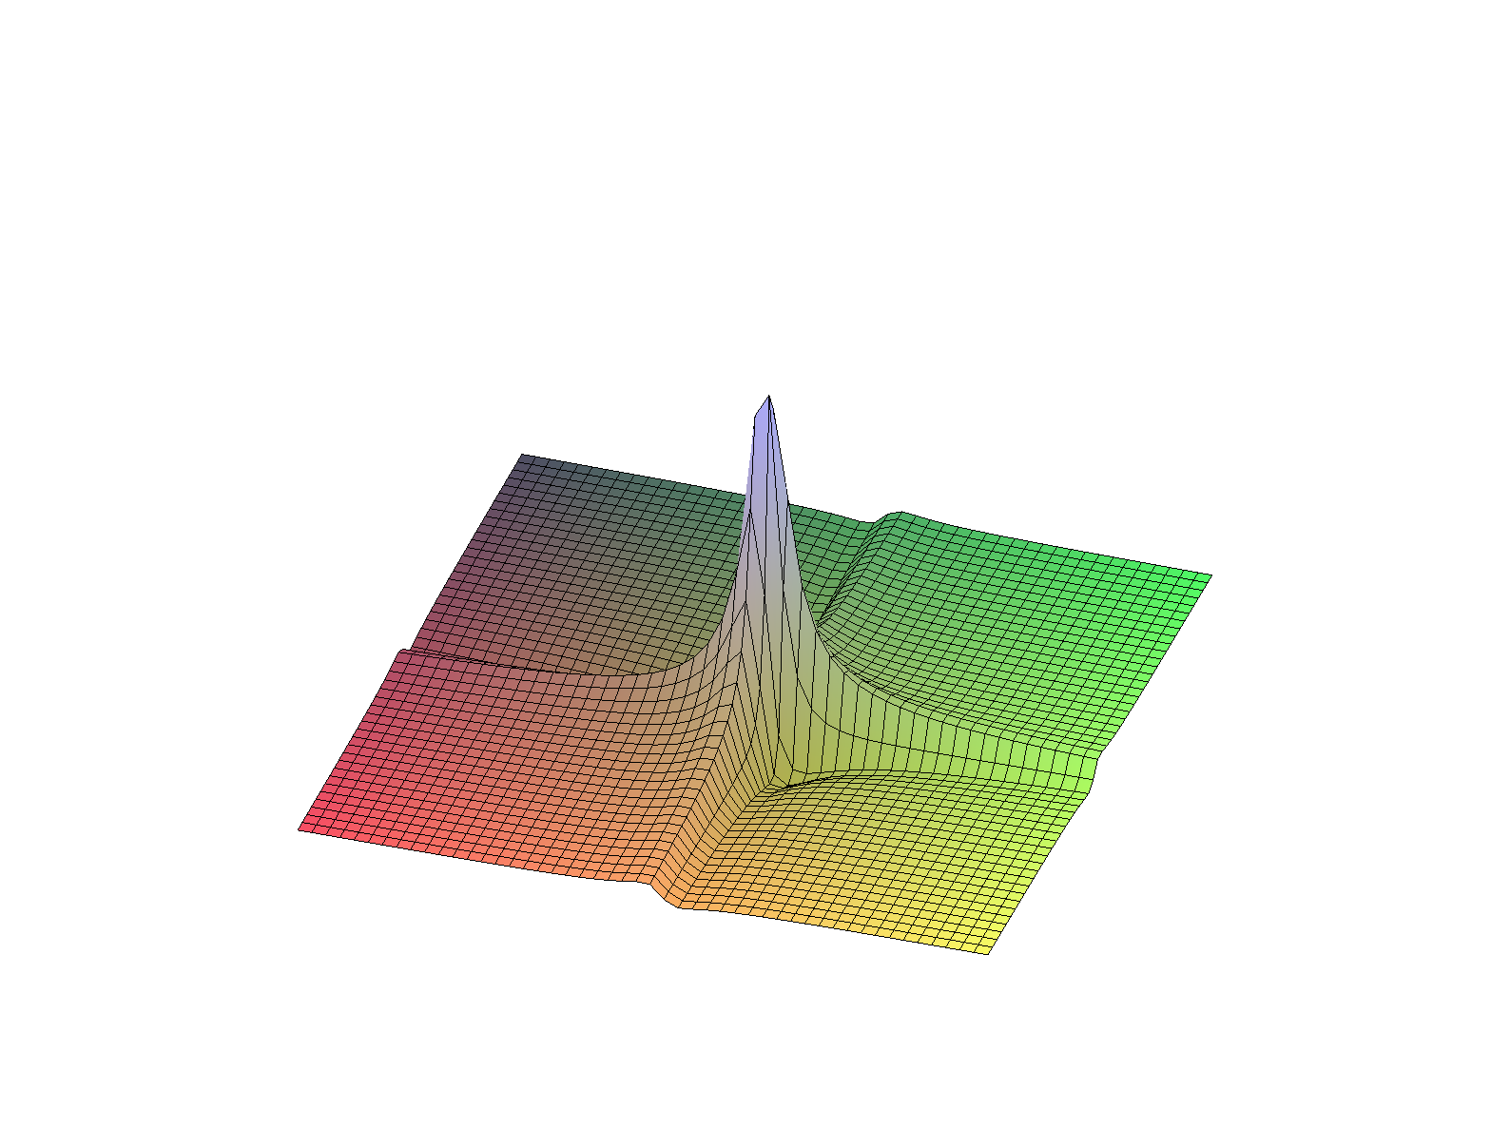

Then here is Im which sticks out equally above and below the mesh plane if you look at it in Maple.

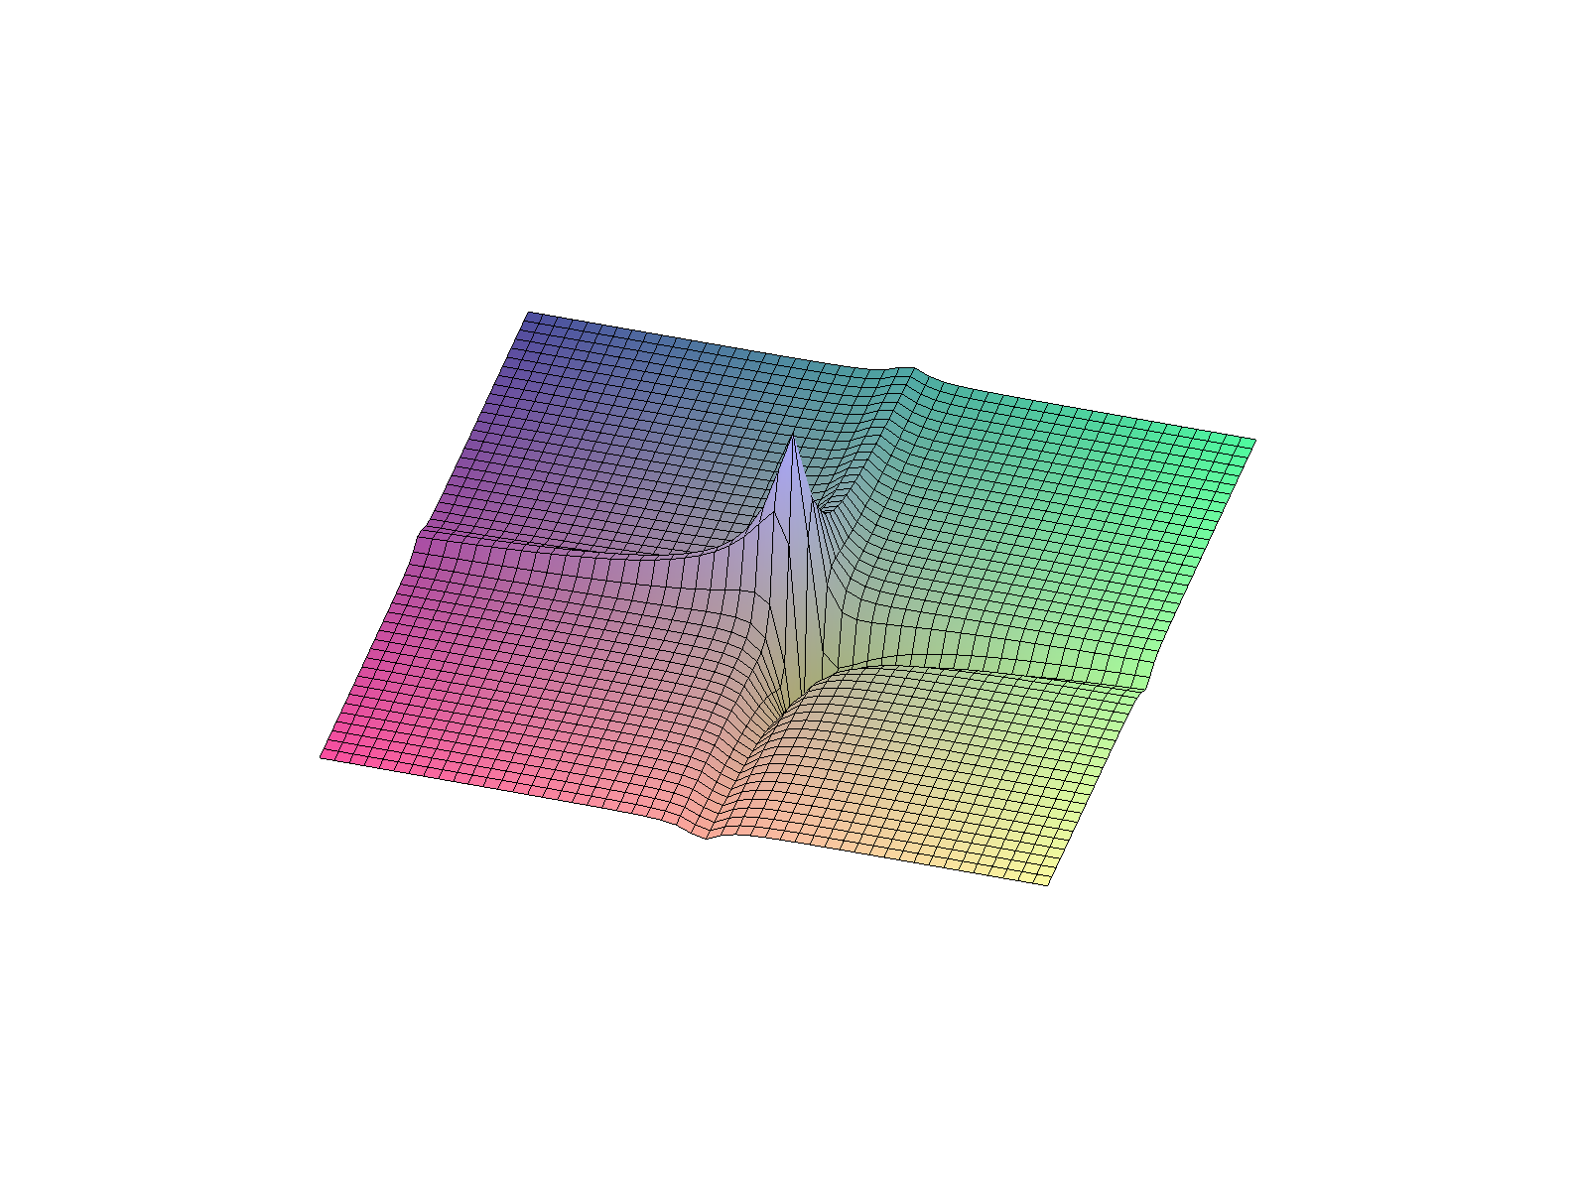
So my point is that things like States really are worth doing to get clean plots amidst the noise and other error you are going to have in your experiments.

Hardware for COSY

First, here is the "hardware" if you don't do States:

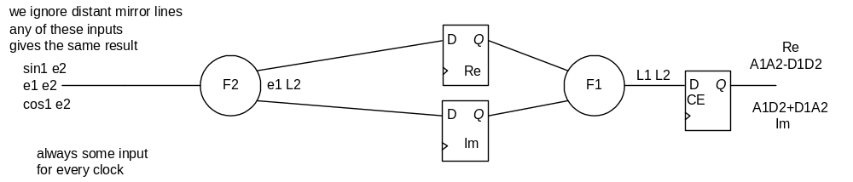

The three inputs shown have the same expo positive phase component so give the same result if we only care about one output spectral quadrant. On every clock we get a pulse shot of one of the three kinds shown, and we clock the intermediate register on every clock and the output register as well. We get one output sample for every input sample. The problem is that we don't have A1A2 appearing anywhere! The slanted lines carry real or imaginary parts, the horizontal lines carry complex numbers.

Now here is the States hardware

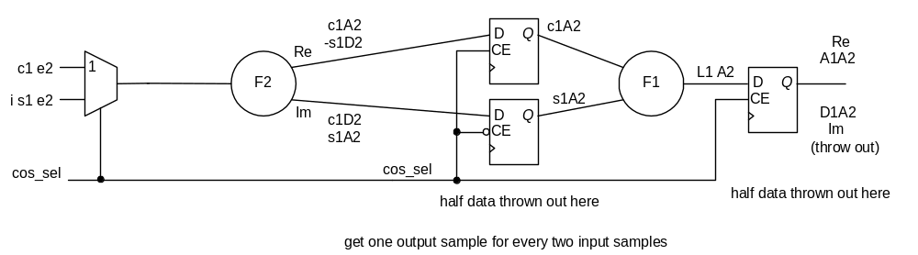

This uses a standard phase-cycle "front end" with N=2. The upper MUX input is the COS pulse sequence output with the (π/2)x pulse, where c1 means cos(Ω01t1), e2 means exp(+iΩ02t2). The lower MUX input is the SIN pulse sequence output with the (π/2)-y pulse and we have added a φdig during the SIN shot to get the factor of i shown at the input. The two inputs alternate every clock the way a normal phase cycle would work. On every clock, we drive one sample through the (here combinatoric) F2 box (Fourier Transform in t2 to Ω2). At the output of the F2 logic we show the Re and Im parts for each of the input choices. When the COS input drives, we latch the output c1A2 into the upper latch and the lower latch holds. When we drive the SIN input, we clock the lower register and hold the upper. After the second clock, we have our two desired inputs going to the F2 box, so on the third clock we clock the complex output in the output register shown, and we find that the Re part of the output is the desired A1A2 signal.
Although we have a N=2 phase cycle "front end", we don't add the outputs of the two-cycle phase at any point in the system! Thus, the front end is NOT acting as a filter in the sense of Levitt Appendix 17.10. In fact, for each complex sample that comes into F2, we keep only one of the two real outputs. The F1 box processes 1 user sample every 2nd clock. Our reward for throwing data away is that we get the A1A2 spectrum. In terms of noise, we would have to average twice as many shots to get the same S/N figure.

Here is a nice COSY picture from a PPT which shows graphically where all the sines and cosines come from: They happen to use (π/2)-x here for the two pulses.

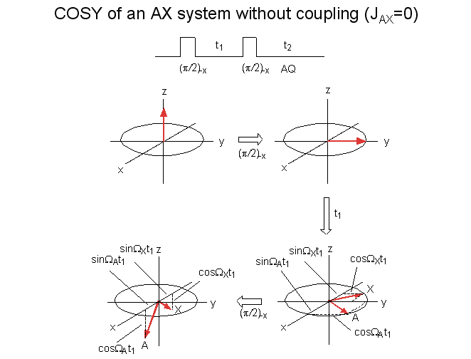

You could do FID after the first knockdown, but then you don't get 2D. The pictures are very good here. The final phase is not shown, the two final red arrows will rotate around z and pull apart for the same reason they did during t1. The two spins have different chem shifts and so different free-run frequencies. I think I like this picture! I have the PPT this came from.
from

