Jim, 1/25/08

There is some good physics going on at the 457 Club (10th Ave, that is). I am getting a lot of mileage out of Maple which is so simple to operate. For example, here are a few commands,

x0 := 1;
lambda := 1;

d := x->-(x-x0)/(lambda^2 + (x-x0)^2); // I should have used x = ω
plot3d( d(x)*d(y), x=-20..20, y=-20..20, grid=[50,50]);

a := x->lambda/(lambda^2 + (x-x0)^2);
plot3d( a(x)*a(y), x=-20..20, y=-20..20, grid=[50,50]);

and I get the nice plots below which show the ReL1 * ReL2 and ImL1* ImL2 peaks in a 2D Fourier spectrum as encountered in NMR experiments with two time variables in the pulse sequences. The more dimensions you use, the more isolated become the peaks, and in organic molecules there are lots of peaks, and even more in biological molecules. The symbol L stands for the Fourier Transform of
exp([i(ω-ω0)-λ]t) . My book refers to this thing L = 1/[λ + i(ω-ω0)] as the "Lorentzian line" and
L = A + iD for the absorption and dispersion parts. In NMR, λ = 1/T2 where T2 is the transverse spin dephasing relaxation time. The implied (ω01,ω02) is the 2D peak position which, when there are several peaks, can uniquely ID a molecule you have in solution, perhaps inside your liver or brain. We want the NMR experiment to have a pulse sequence which brings out A1A2 and not D1D2 for reasons these plots show. Although the book I am reading is about basic NMR, this subject would be called in-vivo MRI spectroscopy (MRS) in the medical application.
In my science fiction novel not yet written, amusement parks will have instantly-creatable computer generated "mountains" which allow kids to hike around on 2D functions to get a thorough appreciation of them. There would of course be some limits imposed on height and especially depth for safety reasons.

-Phil

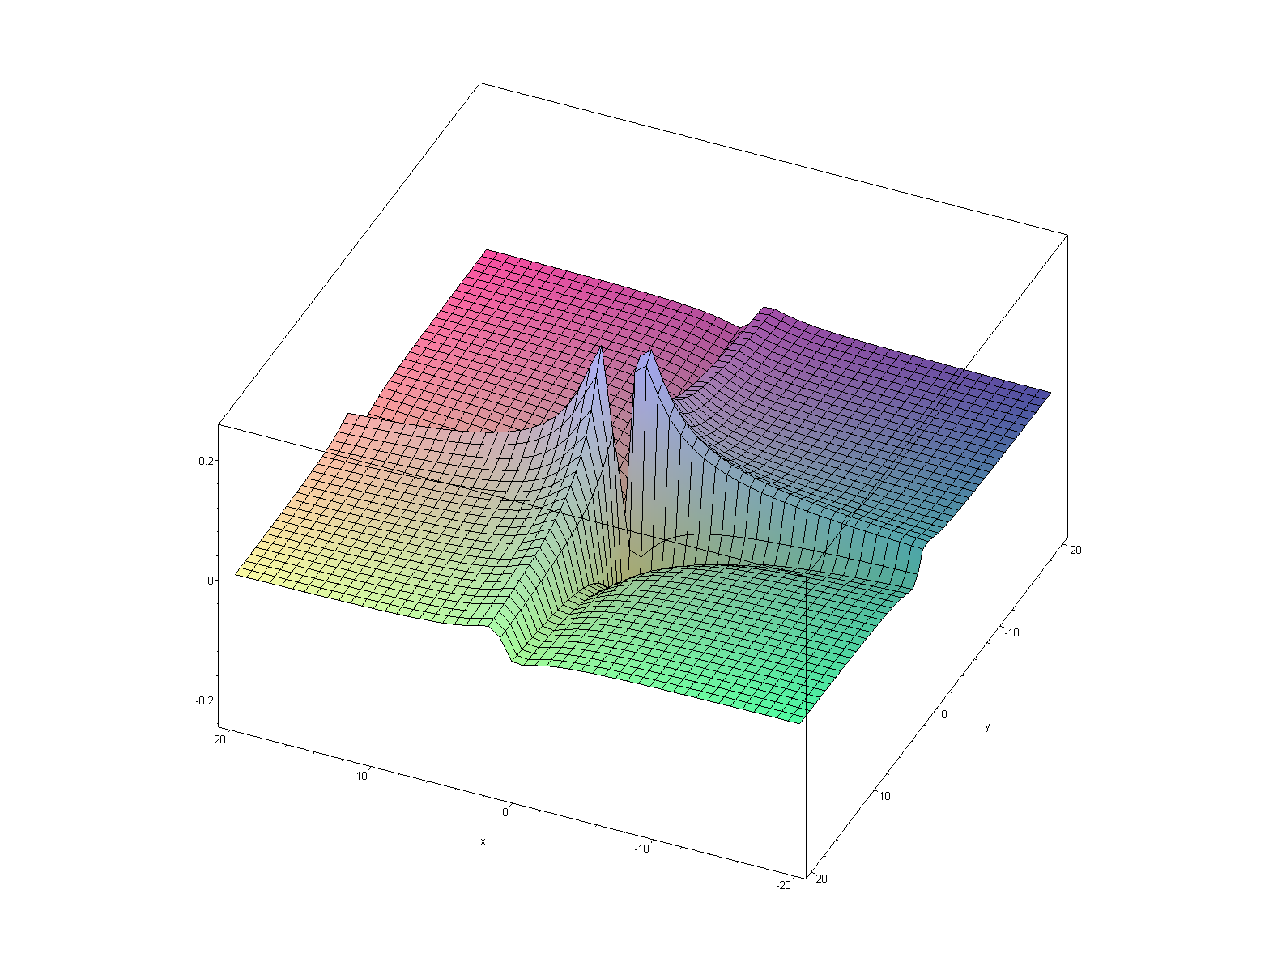

D1D2

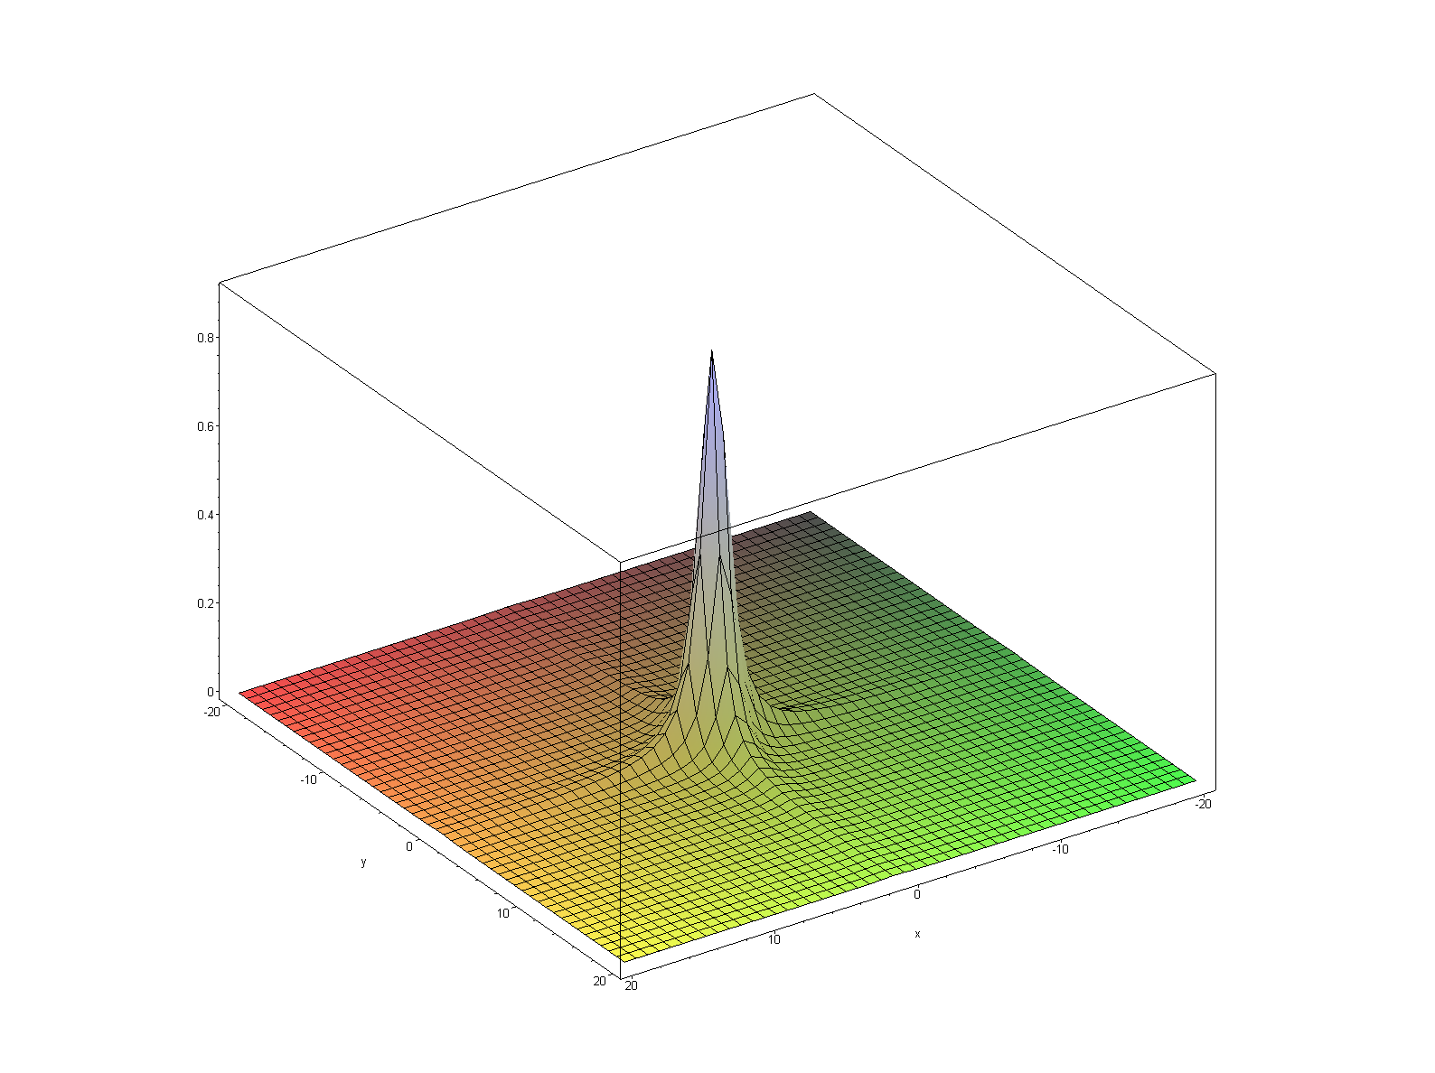

A1A2

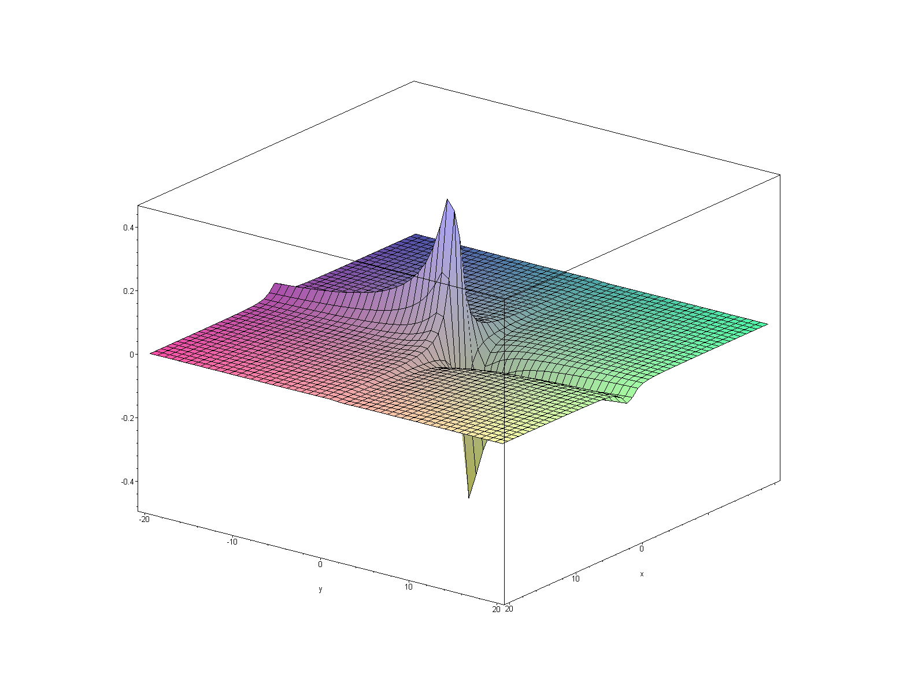
A1D2

plot3d( a(x)*d(y), x=-20..20, y=-20..20, grid=[50,50]);

In Maple I view at 400% before cutting and pasting into Word to get these nice looking pix. Of course I remind you that in Maple these plots are all "live" and can be real-time rotated in 3D. And this is only Maple V from 1997. I know it's easy to do this in MATLAB too, but that thing is so heavy duty and Maple is so simple, once you grok its GUI. ( "Grok my GUI in the Bosom of Abraham" will be a gospel hit in this same unwritten novel).

