Spin Dynamics, some errata and comments PhL 12.11.07

Hi Malcolm,

I looked at your Spin Dynamics on-line errata (having your date as 11 Nov 07) and think I have not replicated anything already there, but I could be wrong.
My paperback edition of your book shows April 2006 as the most recent printing date on the copyright page. I bought it from US Amazon for $59.86 on 27 August 2007 (no tax and "free super-saver shipping"). This probably looks like a peanuts price in terms of those giant pounds you get paid with in the UK!
Please take my comments below with a friendly grain of salt. Your book is stunningly excellent and I hope you will maintain it through more editions. Many of my comments are suggestions for "hinted exercises" that would help the reader better follow the main underlying development of those Hamiltonians in the first half of the book. My feeling is that you have put in all the detailed machinery for the reader to make the various jumps, it seems a shame to omit a few guiding cairns in certain places.
I plan to read your entire book, but so far I am at page 355. Not knowing your publishing plans, I thought I would submit "errata" that I have found so far, rather than wait till I finish the book. Also, some things I mention below might be presented by you in the rest of the book, sorry if that is the case.
Please see my other document for less technical comments.

-Phil Lucht
Salt Lake City
___________________________________________________________________________________

Page xxiv: Near your website reference, it might be nice to say something like "In the extremely unlikely event that errors are discovered in this book, they will hopefully be posted as errata on this website."
___________________________________________________________________________________

Page 9. ( large objects have no angular momentum...)Your notes point out that the claim made here is not quite right. I just want to comment that there are two other issues, lest they survive your correcting edits:

(1) There is a grammar problem here.

is: "and there are no large objects have angular momentum"
perhaps should be: "and there are no large objects having angular momentum"

(2) The reader might not know that "supplementary notes" are on your website and are not located in some obscure place in your 686 page book. [ Maybe they are and I haven't found them yet! ]
___________________________________________________________________________________

Page 23: When I read a book, I usually take lots of notes, and I like to know the page number of the page I am looking at. I might reference an equation by the page it is on. In particular, I am often interested in the first page of a chapter. I look up where a chapter starts in the index, but then I can't find that page because someone has carefully deleted the page number just on those pages where I most need to see it! As I look at other books, I see this is somewhat of a tradition, though many people put the number at the bottom of the first page of a chapter. See if you can find page 223 of your book, where both facing page numbers are deleted. Well, it sure is fun to squawk!
___________________________________________________________________________________

Page 172: In equation (7.3) you show the (r) argument of the various "electric multipoles" like C⁽¹⁾(r) . It seemed odd that you omitted these arguments in Eq (7.4) but included them in the V functions. In other words, the reader might like to see something like ∫dr C⁽¹⁾(r) V⁽¹⁾(r) just for consistency.
___________________________________________________________________________________

Page 204: Regarding the through-space dipole-dipole Hamiltonian: it seems almost inhumane to not assist the reader in knowing where the seemingly bizarre Hamiltonian form comes from, at least by giving hints in an end-of-chapter exercise. Here was my derivation which is probably not the best but it is easy to mechanically carry out. The entire first part here could be skipped by just quoting the magnetic field B₁ of a magnetic dipole m₁ with reference to some book.
We have dipoles m₁ at r₁ = 0 and m₂ at r₂ = r (and r ≠ 0 so no delta function gobbledygook). The idea is that m₁ makes a field B₁(r) which is seen at location r by dipole m₂ and the interaction is then H = -m₂•B₁.
We start with the "well known vector potential of a magnetic dipole" ( I had to go drag out my old Bleaney & Bleaney),

A₁ = (μ₀/4π) m₁ x r / r³ and B₁ = ∇ x A₁ so B₁ = (μ₀/4π) ∇ x [ m₁ x (r / r³) ] .

Use the vector identity: ∇ x ( a x b ) = a (∇•b) - b (∇•a) + (b•∇) a - (a•∇) b with a = m₁ and b = ( r/r³).
The middle two terms vanish since m₁ is a constant, leaving us with

B₁ = (μ₀/4π) [ a (∇•b) - (a•∇) b] = (μ₀/4π) [ m₁ (∇•( r/r³) - (m₁•∇) ( r/r³) ]

= (μ₀/4π ) [ m₁ ∂_{i} (r_{i}/r³) - m_{1i} ∂_{i} ( r/r³) ]

The two derivatives appearing here are given by (notice that the first one vanishes),

∂_{i} (r_{i}/r³) = [ r³ (∂_{i}r_{i}) - r_{i} ∂_{i}(r³) ]/r⁶ = [ r³ (3) - r_{i} ( 3rr_{i}) ]/r⁶ = [ r³ (3) -3r³) ]/r⁶ = 0
∂_{i} ( r/r³) = [ r³ (∂_{i}r) - r ∂_{i}(r³) ]/r⁶ = [ r³ ∧ - r 3rr_{i} ]/r⁶ = [ ∧ - 3 ∧ r_{i} /r ] / r³

giving the final result B₁(r) = - (μ₀/4π ) [ m₁ - 3 (m₁•∧) ∧ ] / r³ as the B field of magnetic dipole m₁ located at the origin. Then

H (energy) = -m₂•B₁ = - (μ₀/4πr³ ) [ 3 (m₁•∧) (m₂•∧) - (m₁•m₂) ]
= { - (μ₀/4π) γ₁γ₂ ² / r³ }[ 3 (I₁•∧) (I₂•∧) - (I₁•I₂) ] which is your Eq. (7.34)

where the I_{k} operators are dimensionless. Divide by if want H in ω-units.
I guess this would be a good exercise because it helps the reader with an important step in the main-line flow of your development.
___________________________________________________________________________________

Page 212: In that wonderful appendix chapter 17 if might be nice to throw in a paragraph somewhere to this effect, starting with equation (7.46), one can say

<H>_{iso} = < 2π I₁ • J • I₂ >_{iso} = 2π I₁ • <J>_{iso} • I₂ // since spins don't tumble much

but we must have <J>_{iso} = k 1 (k = constant) since no other isotropic 3x3 matrices exist. But

<J>_{iso} = Σ_{i} (R_{i}⁻¹JR_{i})/N

where we average over some large number N of random rotations R_{i} to get an isotropic average. Taking the trace of both sides,

tr <J>_{iso} = tr (k 1) = k tr(1) = 3k

tr [ Σ_{i} (R_{i}⁻¹JR_{i})/N ] =[ Σ_{i} tr (R_{i}⁻¹JR_{i})] /N = [ Σ_{i} tr (R_{i} R_{i}⁻¹J)] /N = [ Σ_{i} tr (J)] /N = tr(J)

where we used the cyclic property of the trace (see Section 6.12.4). Thus, 2π I₁ • <J> • I₂ = 2π k I₁• I₂ and k = tr(J)/3 = (1/3)[ J_{xx}+ J_{yy}+ J_{zz} ].

So now (7.47,8) are derived from (7.46), the reader is more empowered and confident. And the mystery of the isotropic δ tensor on page 194 is also "revealed", Eq. 7.25, ( but your donut pictures there were quite revealing). Also, the above derivation seems a lot easier than exercise 7.2 on page 220. The reader might think s/he has to actually do all that nasty work to derive the result. [ But it's still a good exercise.]
___________________________________________________________________________________

Page 213: On the top of this page, and several other places in this book, we see things like I₁• I₂ replaced by the simpler form I_{1z}I_{2z} and the secular approximation is invoked. Appendix 17.5 explains that the secular approximation involves throwing out matrix elements of H going to states far distant in energy. But I don't think the reader is told what this has to do with I₁• I₂→ I_{1z} I_{2z}. You could provide some kind of motivational explanation like this (provided of course it is correct, I am not sure): the terms thrown out like I_{1x}I_{2x} involve the raising and lowering operators, for example, I_{1x} = ( I_{1x}⁺ + I_{1x}⁻)/2. These operators when sandwiched between spin angular momentum states only contribute to off-diagonal elements, of the type the secular approximation throws out (in appropriate situations). For example,
< I₁, m₁ | I_{1x}⁺ | I₁, m₁> ~ < I₁, m₁ | I₁, m₁+1> = 0. In contrast, the z operators do contribute to diagonal elements, < I₁, m₁ | I_{1z}⁺ | I₁, m₁> = m₁ .
___________________________________________________________________________________

Page 261: I want the Levitt Award for the most insignificant typo found in the book. The 2x2 matrix
$\left(\begin{matrix}1 & i \\ -i & 1\end{matrix}\right)$ should be $\left(\begin{matrix}1 & - i \\ -i & 1\end{matrix}\right)$, which conveniently does not affect the following calculations.
___________________________________________________________________________________

Page 264: Several times in the book we run into situations like the picture on page 264 and the three part rotation shown in Eq 9.32. It seems odd that you omit the comment you would undoubtedly make if you were teaching a live class on this subject, something to this effect: "the rotation shown in the picture and which we are calling R_{φp}(β) can be carried out by z-rotating the white arrow backwards by amount φ_{p} to the x axis, rotating amount β about the x axis, and then rotating the white arrow back to its original location, and this is why R_{φp}(β) = R_{z}(φ)R_{x}(β)R_{z}(-φ). "
By the way, your 1995 Euler Angle supplementary notes link seems to have pooped out.
___________________________________________________________________________________

Page 268: Comments on the graphs. I may be off in space, but I think I calculated that

| <β| H | α> |² = | <β| R_{y} (θ) R_{z}(ω_{eff}τ_{p})R_{y} (-θ) | α> |² = S_{θ}²S_{β/2}² where β = ω_{eff}τ_{p} and tanθ = ω/Ω .

= sin² ( ωΩτ_{p}/2 ) / [ 1 + (Ω/ω)² ]

If correct, this would be the equation describing both graphs on this page. Perhaps this would be a satisfying end of chapter exercise for the reader with some hints given.
___________________________________________________________________________________

Page 281: You say that the ρ₋ coherence rotates and has a phase the same as that of the transverse magnetization, but when I read this it was not clear to me why this was true. I found it helpful at this point to note that M ~ <I> and to compute that

<I_{x}> = tr [ ρ I_{x} ] = Re(ρ-)
<I_{y}> = tr [ ρ I_{y} ] = Im(ρ-)

and then the pair of pictures and equations below them suddenly made sense.
___________________________________________________________________________________

Page 294: The equations in (10.31) involve general M, but the picture shows M being in the x-y plane as it would be after a (π/2)_{x} pulse. I think there may be several situations like this in the book. I have a secret suspicion that this is because the book's author is a coniphobe and does not like to draw an M vector precessing on its cone. Probably free precession works just fine if M is riding its cone. Well, yes, I do remember some anti-cone invective earlier in the book. Some day when you have absolutely nothing to do, maybe you can explain to me why cones are bad. I am dead sure you have some very excellent reasons. I have seen some pretty horrible cone pictures in my previous life. Maybe the caption of the figure could say "Precession of the transverse part of the magnetization vector".
___________________________________________________________________________________

Page 302: The box (10.43) says T₂≤ 2T₁ is a "theoretical limit" and you have a long footnote on this subject involving transition probabilities and adiabatic contributions etc. May I offer the following geometric proof of this theoretical limit for people who don't understand all that fancy stuff. The claim is that if we violate T₂≤ 2T₁, then the magnetization unit vector's spiral track (shown for example at the limit in the top figure on page 305) will move outside the unit sphere, which cannot happen regardless of details of relaxation processes.
As magnetization decays, we know that M_{z} = 1 - exp(-t/T₁) and M_{ρ} = exp(-t/T₂) and we require that M_{z}² + M_{ρ}² ≤ 1 during the decay, which says the M vector cannot go outside the unit sphere. So define f(t):

f(t) ≡ M_{z}² + M_{ρ}² - 1 = [ 1 - exp(-t/T₁)] ² + [exp(-t/T₂)]² - 1

= exp(-2t/T₁) + exp(-2t/T₂) - 2 exp(-t/T₁).

We know that f(0) = f(∞) = 0 and we are wondering if f(t) ever goes positive in between, meaning M goes outside the unit sphere (puncturing the surface). Change to a different variable x:

x = exp(-t/T₁) ⇒ f(t) = (x² -2x) + x^{2a} ≡ F(x) where a = T₁/T₂

This is the sum of a negative parabola and a positive power curve in the range [0,1]. This curve goes positive near the x=0 end if the slope is positive there:

F'(x) = 2x - 2 + 2ax^{2a-1} ⇒ F'(0) ≈ -2 + 2ax^{2a-1}

If a ≥ 1/2, lim_{x→0} x^{2a-1} = 0 so slope is -2. If a < 1/2, lim_{x→0} x^{2a-1} = +∞. so slope is positive. The conclusion is that we must have a ≥ 1/2, otherwise F(x) = f(t) goes positive and our magnetization vector punctures the unit sphere. But a ≥ 1/2 means (T₁/T₂) ≥ 1/2 or T₂≤ 2T₁ which is the "theoretical limit". This of course is within the context of our simple model of exponential relaxation decays.
Here are some plots from Excel where the negative parabola is blue, the positive power curve purple, and the sum curve F(x) is yellow. The a=.3 case shows the unit sphere being punctured at the left end of the interval, which is x near 0 or t = large, meaning the end of the relaxation period. The unit sphere is closing down as the spiral moves up, and the magnetization vector pushes through it near the end of its run.

a = .3 a = .5 a = .7
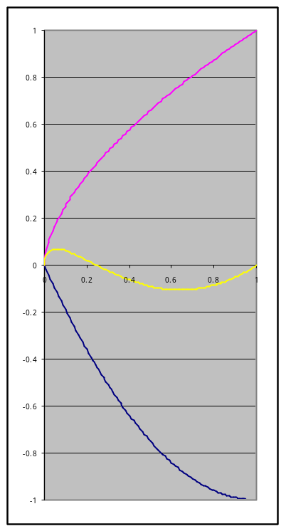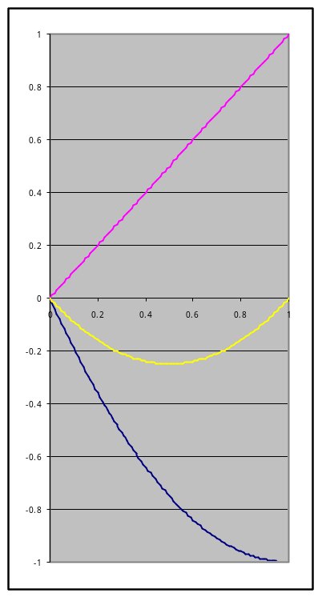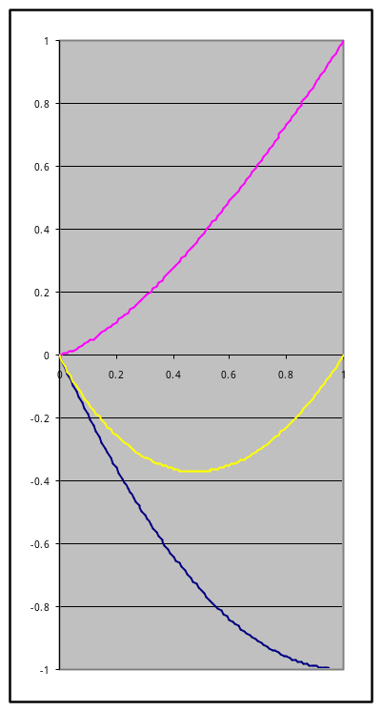
___________________________________________________________________________________

Page 324-5: Your graphical explanation of the spin echo effect is simply superb. One small detail: I think maybe the arrows shaded more darkly than others in Fig 11.16 represent sample regions with weaker B fields, not stronger B fields. Wouldn't a weaker B field cause less precession in a given amount of time? Maybe this is a problem in the printing of my book which seems to show the arrows closest to the starting point as being darker.
My friend Jim Ball (emeritus physics U. of Utah) says Hahn once gave a talk here and brought some kind of clear plastic cylinder with a clear liquid in it, with some red stuff along the central axis. He turned some kind of stir crank on the cylinder, and the red stuff was dispersed into the clear liquid, surprising no one. People were surprised however when he later turned the crank the other way and the red stuff reconverged on the central axis. This was his spin echo demonstration.
___________________________________________________________________________________

Page 343. I think the problem here begins on page 341 where you say you will be working with γ >0 and δ₁ < δ₂ . This of course means both ω's are negative and yes, ω₁⁰ > ω₂⁰ . Then from Eq (12.4) we know that the ββ state has the highest (positive) energy and goes at the top of the energy level drawing in Fig 12.4 page 343 (and indeed, that is where it is). The problem is that the two close states in the middle are shown incorrectly. I think the |αβ> state should appear above the |βα> state:

energy |αβ> - energy |βα> = ω_{αβ} - ω_{βα} = ω₁⁰ - ω₂⁰ > 0 // recall ω₁⁰ > ω₂⁰ above

This sort of graphical problem then persists in every single "energy level drawing" such as page 345, 346, 347, 348, 351, 354 and I am not sure about page 355. Your errata correction fixes this problem in the two figures 12.13 and 12.14 on page 354. Notice that on page 346 you reveal the state labels on the two middle energy levels, and their level positions are wrong there as in the other pictures. I don't think any equations are incorrect, however.
___________________________________________________________________________________

Page 353: There is some comment the would be useful here regarding the spectral lines, but I can't quite put my finger on it. The energy levels in your pictures really are like the electronic levels of atomic physics, and the coherence arrows with a single + or - signs I think are indicating the locations of possible single-photon transitions and these are allowed by their selection rules (spin-1 photons) and that is why we get the four spectral lines. The upward transitions can occur of course only when the B^{RF} field is applied, supplying photons in the right energy range. You do discuss this earlier on page 292. Perhaps the ++and -- coherence arrows are double-photon transitions? The coherence sum shown in eq 12.13 must be the sum of that four downward single-photon emission amplitudes and these make the NMR signal. I guess I am griping that the significance of a "coherence" is not explained to the reader in an entirely satisfying fashion in this book.
In a more general vein, your whole book uses quantized spins but classical electromagnetic fields. If these fields were also quantized (and they really are), then the photon interpretation of the pictures would be appropriate and a double-photon emission just the creation of two field quanta at once. But you would say that (probably all) NMR experiments are carried out with very large numbers of photons, and the details of the spectral peaks are most easily described using classical fields. I wonder if the spontaneous emission present only in the quantized field theory affects any NMR experiments.
___________________________________________________________________________________

Page 355: I know you have an errata fix for these two pictures, but something still looks fishy to me. It would sure be helpful to have the four levels labeled so we know what is going on. Since γ < 0 for these pictures, we know that |αα> now has the highest (positive) energy, so that must be the top state. Then ββ is the bottom state. I suspect that αβ is the left state and βα the right state. Basically, this levels picture is the same as that in Fig 12.13, but flipped up-side-down (since γ changed sign and both ω's changed sign). I think this would mean that the αβ level which, after you corrected it, is the upper middle level in Fig 12.13, should be the lower middle level in Fig 355, so this is then wrong (if I have the levels identified correctly). More serious is that the coherence arrows are labeled in what seems to be an impossible way. If the upper level is for state |αα>, if cannot have a departing coherence arrow with a β in it. I suspect the upper right coherence should be -α and the lower left one should be -β. Then of course the little arrows pointing to the two corresponding spectral peaks have to be adjusted.
I have forgotten what the convention is for which direction the coherence arrows go, but that would be another thing to make sure is right in corrected versions of these pictures. Putting state labels on the four levels in all pictures would probably be healthy.
The lower picture 12.15b has similar problems to 12.15a.
You know, these figures and many others are ambitious pictures and I appreciate the author's efforts to show lots of detail with lots of labeling. A lazier author would not have even attempted the kinds of exceptional drawings you have scattered throughout your book.

The bottom of page 355 is "how far I am" in reading your book, so I have nothing to say about the rest (yet). However, I did read some of the Appendix Chapter 17, so there are few more things maybe to say here.
___________________________________________________________________________________

Page 577: After much pain (and with the usual accompanying enlightenment) I was able to derive the electric quadrupole Hamiltonian shown in (17.11), including your errata corrections. My answer was this

H_{quadrupole} = eQ/[4I(2I-1)] * { (3I_{z}² - I²) V_{zz} 2,0 // H = energy
// I = dimensionless
+ (I_{z}I₊ + I₊I_{z}) (V_{xz} - i V_{yz} ) 2,1

+ (I_{z}I₋ + I₋I_{z}) (V_{xz} + i V_{yz} ) 2,-1

+ I₊² ( V_{xx} - V_{yy} - 2iV_{xy})/2 2,2

+ I₋² ( V_{xx} - V_{yy} + 2iV_{xy})/2 } 2,2

where eQ is given by:

eQ = <I,I | Σ_{i} e_{i} ( 3 z_{i}² - r_{i}²) | I,I> = <I,I | ∫d³r ρ(r)( 3z² - r²) | I,I> .

where the integral is over the weighted charge density of the nucleus when it is in the | I,M=I> spin state, which integral is (twice) the 2,0 component of the electric quadrupole moment tensor.
What are the dimensions of things here? We seem to have dim(H) = charge X² potential/X² which is then charge * potential which is correct, energy. The operators I in the result are meant to be dimensionless. If H needs to be in ω-units, then divide RHS by , and this agrees with your errata.
Then if we throw out all terms involving raising or lowering operators which don't have diagonal matrix elements (~ secular), we get

H_{quadrupole} (ω units) = ω^{Q} (3I_{z}² - I²) V_{zz} where ω^{Q} = eQ/[4I(2I-1)]

which agrees with (7.30) page 201, and errata-corrected p 578, and we know now what "Q" is.

I don't have Slichter's book, so the derivation I looked at was given in this nice paper

www.nyu.edu/projects/jerschow/PAPERS/qeq.pdf

and begins with the energy stored in two overlapping charge distributions ( A = nuclear, B = electronic). [ This in itself is interesting to derive, requiring various JD-Jacksonian gymnastics ]

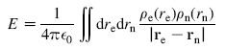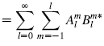

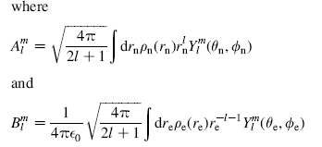

and then eQ = 2 < I,M=I | A₂⁰ | I, M=I >. The fascinating step, as you I think comment on somewhere, is that you can simply "replace" the true tensor operator A₂₀ with a T₂₀ tensor combination of spin operators k * (3I_{z}² - I²), which looks a lot like (3z² - r²). You can make this replacement because Wigner-Eckart says you will get all the right matrix elements as long as you normalize the replacement correctly. The poor reader wonders how on earth the electric charge situation of the nucleus can be related to the nuclear spin operators. He associates the spin maybe with a magnetic moment and magnetic field, not any kind of electric field. I suppose the answer is that the nuclear charge distribution has an angular momentum ( and in our case = 2) which really does interact with the nuclear spin, just as people keep claiming in those angular momentum sections of their books.
___________________________________________________________________________________

Page 578: Regarding "the secular approximation", here are some comments from my notes on your book which made the term a little less mysterious to me.

L. sæculaŽris, f. sæcul-um generation, age, in Christian Latin ‘the world’, esp. as opposed to the church

Related to French derivative siecle which means a century. Not clear to me how this word got to mean worldly in Christian usage. Perhaps worldly means subject to the generations, whereas other-worldly means eternal. In the physics literature, you see the phrase "secular motion" used in reference to long-term motions, with fast motions filtered out. Perhaps the idea was first used in astronomical calculations. So that is the general idea of any "secular approximation".

Of course in quantum mechanical perturbation theory the "secular approximation" I suppose throws out the effect of far away states because they cause large energy difference denominators in correction terms which are thus small -- again the idea of throwing out high frequency information. Anyway, I just thought is was useful to realize that the secular approximation is not specific to Hamiltonians or even to quantum mechanics.
I think on page 179 you use another secular approximation (perhaps RWA, rotating wave approx) when you throw out the anti-precession circular half of the B^{RF} plane wave.
___________________________________________________________________________________

