Solid Mechanics Lecture Notes PhL 10.15.12

I found some very good notes at this location, something like my notes I would say.

http://homepages.engineering.auckland.ac.nz/~pkel015/SolidMechanicsBooks/index.html

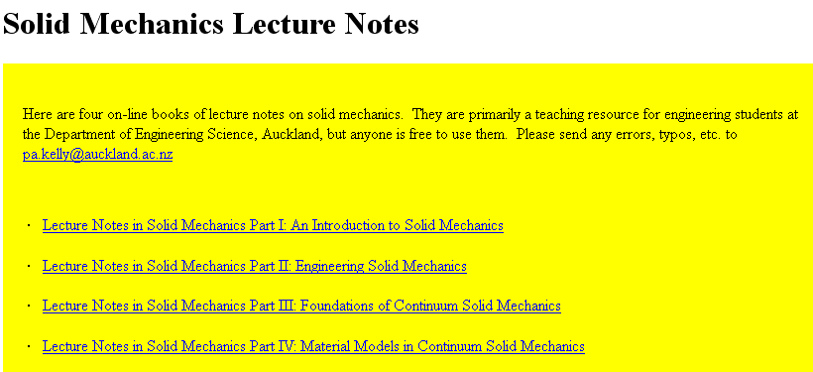

The author is up one page here

http://homepages.engineering.auckland.ac.nz/~pkel015/

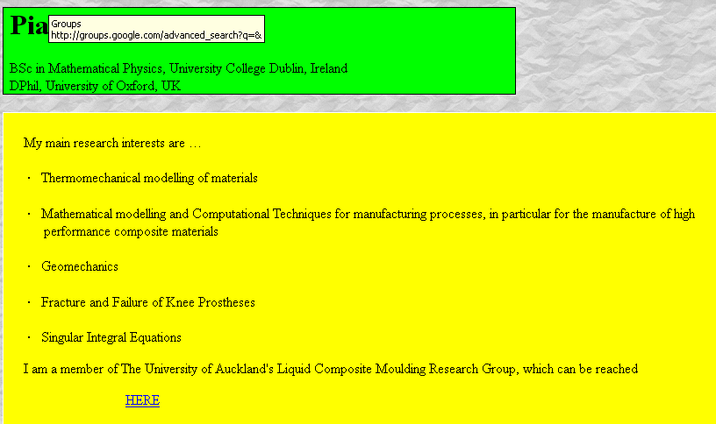

and here is he is at http://www.des.auckland.ac.nz/uoa/piaras-kelly



His four volumes are not downloadable as a PDF. They are all in tiny sections. But I found "downloadthemall" and reassumbled them into four books. Obviously he is working toward a book here, maybe I will find some stuff to help him.

