Comments on the Pozar book PhL 2.26.14

I discovered this book and some notes on it while web searching for "surface currents", meaning Debye surface currents. The book only deals with the usual δ-thick surface currents, but it was very interesting and has much useful stuff. The title is Microwave Engineering in the 3-300 GHz range and things are always in the skin effect limit. See comments at the end. I should add this as a reference somehow! Done!

Chapter 1: Electromagnetic Theory

This has a large overlap with my chapter 1, but I do potentials and gauges instead of plane waves and reflections and such things. Yes, I am very "potential oriented" in line with King!

Maxwell's equation (1.1a) looks wrong, why is "M" sitting in there? He calls M a "fictitious magnetic current", unrelated I think to my magnetization M. Well, they are just putting it in case someone finds magnetic monopoles! Very strange, and of course the Miss teacher goes with this idea. I will ignore all his M's, but it has the potential to cause trouble later I think!
Here is an interesting table

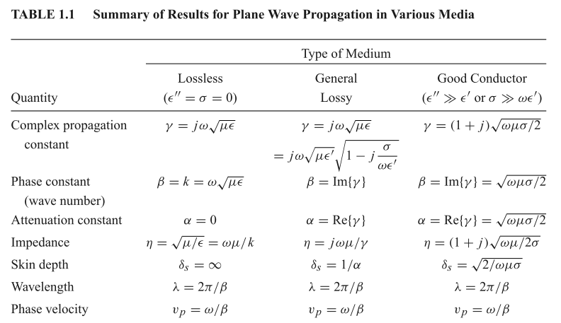

He uses
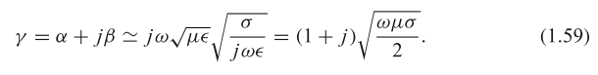
From me,

β = (j - 1) $\sqrt{ωμσ/2}$ = complex (2.1.6a)

So the connection seems to be

γPozar = β*me

I think all this stuff is OK.

Chapter 2: Transmission Line Theory

This is something I should definitely be looking at! I have long looked for a solid section, not just a tiny piece, and this seems a major part of this book.
He refers to what I call "total inductance" by the phrase "self-inductance". His nice thing is to relate C to this external E field storage, something I did not do (though I did relate L to H storage!)
Page 53 example 2.1 the E and H fields are pulled out of a hat! And where does his R integral come from?

OK, I have browsed through this entire chapter. It's main concern is with reflections, Smith Charts, SWR, discontinuities, exactly the stuff I say I have omitted. I should give Pozar as a reference for this stuff. Nowhere did he compute any parameters even for a simple coax line, but that is probably coming. He does talk about loss and he has γ = jk where k is my Chapter 4 wavenumber. The chapter is certainly not heavy duty on the E&M stuff. Here were the topics:

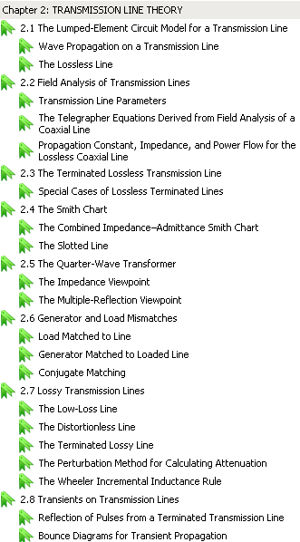

He never talks about fields inside wires, but that may be coming. It really is an "engineering approach". Matching loads, return loss, a way to compute the loss parameter α. I like it, and my document is not much threatened by what I have seen so far. No Bessel functions, no Kelvin functions, just all very different from me. I will continue my review tomorrow of his nice book.
There was nothing really about surface currents in this chapter [ this is how I came across this book, searching on surface currents] . The Rs skin effect surface resistance was defined and used in some examples. Again, this entire book lives in the skin effect regime by which I think I mean δ << a where a is conductor size. I might want to declare a few "regimes". I have been very mushy on that subject.

Chapter 3: Transmission Lines

He assumes my usual z dependence, then jams that form into the two curl equations to get lots of equations (3.5). He really says for TEM that Ez and Hz = 0 exactly, so maybe my new surface currents will fix that problem.

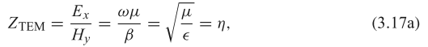
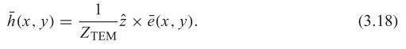

He gives a procedure for analyzing any line: solve the capacitor problem, get the E field, use the above to find the H field, line integrate that to get total current I, very simple! You then have Z0 = V/I. Nothing about inside conductors, no details about surface charges. So this is a procedure for finding Z0. Notion of wave impedance like ZTEM shown above versus Z0, unrelated.
He then looks at losses due to dielectric and due to α of the wavenumber. A simple result I did not state in lines doc!

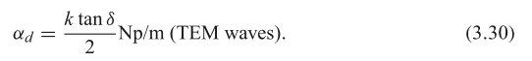

He then does the parallel plate geometry for all modes TEM, TE and TM.

He then treats the rectangular waveguide in details, and the sine stuff finally appears. He gives a lot of attention to attenuation in all modes, something I glossed over. He is very good with this stuff, and has some nice 2D field pattern pictures. [ He motivated me to add more loss stuff in lines doc! ]
He next does the circular waveguide and finally Bessel functions appear. He repeats all the stuff done for the square line, including attenuation details.
Then he gets to the coax cable and finally derives the φ result just quoted earlier.
His next geometry is a thin dielectric slab on a ground plane, and get gets fields in and above the slab. There are TM and TE modes.
Next comes the stripline which is this:

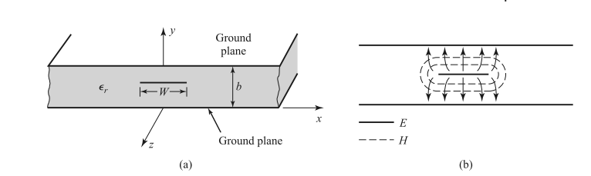
He refers to dielectric areas as "substrate" for some reason.
He then does a little numerical Laplace solution for the above microstrip geometry.

Next geometry is microstrip which is sort of the lower half of a stripline above

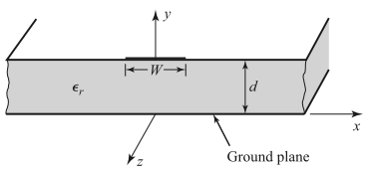

Eventually we get to group velocity.

OK, a very good and practical chapter, exactly what the engineering student wants and needs. Any microwave job such as at L3 would involve using these basic kinds of lines.

Chapter 4: Microwave network analysis

I just took a quick look here. The game is what happens in general with an n-port object. You can define both a Z and Y matrix, and an S-matrix !!! This all has to do with reflections out of each port. The signal flow graph is another similar tool.

Big section then on "discontinuities", both natural and intentional for some design purpose.

Then coupling into waveguides. Recall the Torrey beer can thing with the coax stuck in the side with a little top sticking into the can. If we were driving, that would activate modes of the can, and reciprocity
goes the other way. So Pozar shows how you compute all this stuff, I like it. Just browsing I get the main points of how this all works. Aperture driving has equivalent dipoles to simulate what is happening and so on.

General discussion of various applications, good reading!

I have finished browsing this book. I skipped all the meaty sections, mainly interested right now in the transmission line stuff and the general comments stuff. I should give this book a reference for sure.

General Comments about Pozar's book.

1. It has lots of nuts and bolts about designing microwave circuits. General "component" methods with matrices, for example. The book is 756 pages long! Theory of n-ports and scattering matrix.

2. It has two long chapters on "transmission lines" where TEM is included with TE and TM in a unified presentation. He later does lots of geometries. He is always interested in attenuation! My paper is very weak on that topic. [ But I improved it. ]

3. He never mentions the vector potential, and is distant therefore from the King approach. He always used the fields directly. He does not do my two-cylinders problem, it happens. But he does lots of stuff with fields and is not shy about doing so.

4. He says basically nothing about what happens inside a conductor or at the surface of a conductor. I was expecting to see something there. No surface currents (except with respect to skin depth), no Kelvin functions.

5. In his microwave world, 3 to 300 GHz it is always assumed that skin depth is small compared to transverse dimensions. There are places where he talks about the DC limit and quasi-static.

6. He clarified the meaning of stripline and microstrip, which are not the same and which also are not just parallel plate lines.

7. He introduces many words and phrases of the practice, current as of 2012. Here are the microwave frequency bands of interest

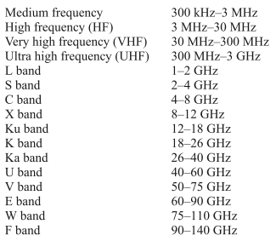

I think the L3 stuff was in K band.

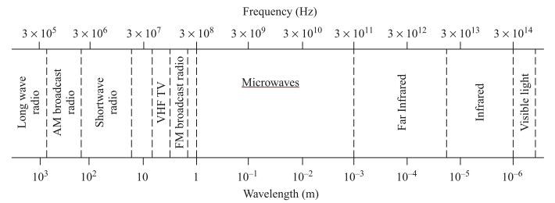

He talks about "millimeter wave" which puts you at the high end. For example, 1 mm means 300 GHz.

