Preface PhL 1.13.12

Morse and Feshbach were MIT Physics professors. Feshbach is the younger.

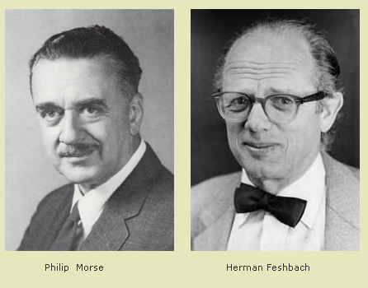

Philip Morse (1903-1985) died in Concord, MA. He invented "operations research" which means data-driven analytic decision making, important in WW II. Princeton PhD 1929. Worked with Sommerfeld. Started MIT in 1931. A definite Mucky-Muck Jason and manager type. His OR work was against the German U-boats, how do you stop them! In addition to M&F, he wrote a QM book with Condon. a thermal physics book, and some acoustics books. Maybe his job was detecting submarines!

Herman Feshbach (1917-2000) was about 14 years younger than Morse. PhD MIT in 1942. He founded Union of Concerned Scientists and dealt with nuclear cold war issues. In addition to M&F, he wrote a book on nuclear physics. It is the Feshbach family that has a website to sell the reprinted books for $250.

http://www.feshbachpublishing.com/

I had an email com and learned there is no errata.

So Morse was 50 in 1953, and Feshbach was maybe 36.

Preface says they "taught the course for 16 years", on or the other. I think they invented the "math methods" title for courses. Field theory is their focus. Book is about math tools. They call it a "treatise". Only some underlying physics is even mentioned. This is not a math book on theorems, so no real rigor. Mention of "it can be shown". Examples will not be trivial, they will be complicated. Comments on choice of references. Comment on their selection of symbols and mention of the symbol glossary. Mention of the stereo pictures. Thanks to grad students who took their courses since 1935. They ask for reports of errors (so where is the errata??)

No comments about how someone might use this book in a course! First year grad student they say might use the book. But this would be a 4 year course, 2000 pages jammed with equations and problems etc. They claim it is complete and self-contained.

Here is a review written 1956 by Mark Kac, and it has some negative comments with which I agree somewhat. I might also add that many of their symbols seem overly elaborate, fancy German script letters no one can write on a blackboard, and the dyad stuff is just not for me. Perhaps simple matrix/linear algebra was just not well known at this time, I am confused by that.

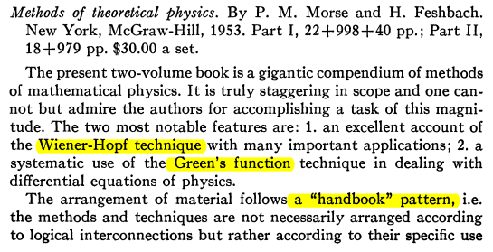
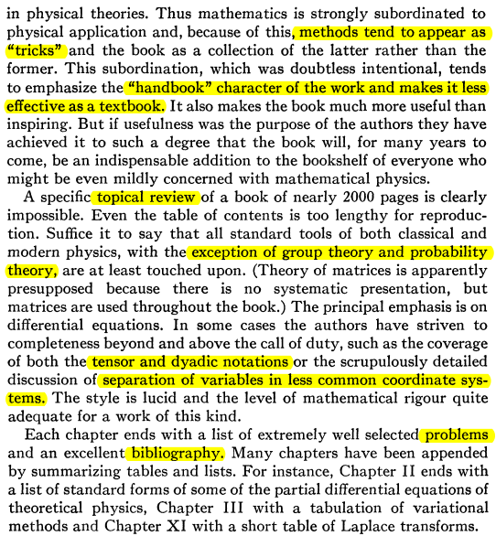
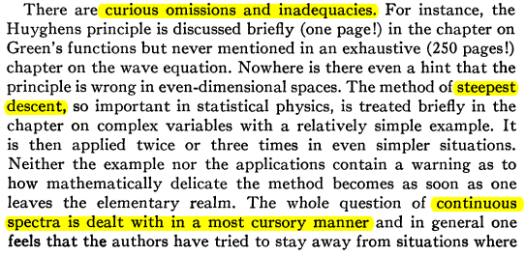
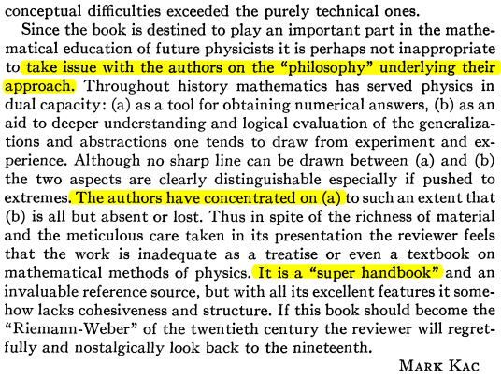

Now that I am done reviewing the thing, I do think it has value for me in this sense: when I want to learn details of some particular "math method" because I am studying some area of physics that uses that method (eg, stellar structure) I might come back to M&F and look at some of their examples which use that same method. I think I know where to find things now in M&F.

So as a handbook, this M&F is a little bit like the Lebedev book of 500 problems some of what are solved by Lebedev (and friends). But M&F has very many more words! It is the theory plus problems, not just the problems.

