Morse & Feshbach Chapter 1 notes PhL 1.5.12

Purpose here is just to take a very high-altitude survey of this two-volume book set. I want to make sure I could teach a course from it if I had to. I have never just browsed through before. I want to know what is and what is not contained herein.
The set contains 12 chapters. Each chapter has sections such as 1.1, 1.2 below. Within these sections are some subsections with bolded names. The general TOC shows all the sections and subsection titles.

Methods of Theoretical Physics (1953)

Chapter 1: Types of Fields (1-117)

The opening paragraphs discuss PDE's and their solution fields as perhaps Procrustean in approach, but I think they mean to say nevertheless there is a good payoff. They will not do "rigor" ahead of "physics" in this book. They note that a PDE model can at the same time be "too smooth" out in the open compared to real physics, and "too sharp" at discontinuities and singularities. Out in the open, things are not as smooth as the model says, and the real world does not have those singularities either. We are warned to think about those "ratios" like mass per volume as V→0 as being not too large and not too small, the notion of the PDE physics of air being an example. So this seems a good introduction to a 2000 page book largely on PDE's of physics!

1.1 Scalar fields (4). They refer to surfaces of constant ψ value as "isotimic surfaces", a word not in the ODE. I would call these contours of the function, and for temperature "isotherms". The "normal lines" are perp to the isotimic surfaces, fine. Then a discussion of the Laplacian and 2D rubber sheet as example. The stretch is minimized, center is average of boundary value, etc. Interesting comments about "bulginess" in 2D and "lumpiness" in 3D, and how ∇2ψ=0 means cannot have either. Have to think -∇2ψ = ρ to see that large ρ means large ψ at that point, a "lump".

1.2 Vector fields (8). Boldfaced Latin. Dot and Cross product. Axial (pseudo)vectors (presented strangely), a•bxc object. Write unit vector as i the way I do (but no hat for them). Flow lines as lines which follow the field arrows. Their first stereo pictures, they do nothing for me, I think this was a bad idea. If course flow lines have perp surfaces which get no name here other than "potential surfaces". F•ds = 0. Then comes the notion of a flux surface integral of F•dA. They write this for closed surface using F•dA which is not a notation I would have used. A bit on Gauss's integral law for a source point. Then they use the same notation for a line integral F•ds , a "circulation integral". Comments about region of a vortex, a place where the field direction lines go around in circles, the opposite of irrotational. Sources and vortex lines are both singularities (point and line, in 3D ie).

1.3 Curvilinear coordinates (21).

–––––––––––––––––––––––––––––––––––––––––––––––––––––––––––––––––––––––––––––––––
Comparison of notations:

M&F PL
a1 1 // unit vector along coordinate line, tangent base vector
ai• i = αi = γi1 i • // a particular "direction cosine"
ai• j = βi = γi2 i • // a particular "direction cosine"
ai• k = γi = γi3 i • // a particular "direction cosine"
m p 30 em // non-unit vectors along coordinate lines
am p 22 m // unit vectors along coordinate lines
fm p 30 F' m // contravariant components
fm p 30 F' m // covariant components
Fm p 29 F' m // components onto unit vectors
hm = |m| h'm = |em| // scale factors
∂ξm/∂ξ'n ∂xm/∂x'n = Smn = Smn
∂ξ'm/∂ξn ∂x'm/∂xn = Rmn = Rmn
F = Σm fmm F = Σm F' mem
F = Σm Fmam F = Σm F' m m
F = Σm fmm F = Σm F'm em
Fm = fm hm F' m = F' m h'm

f'n = Σm Rnmfm 1.3.12 F'n = ΣmRnmFm // going Cartesian to curvilinear, contravariant
(F'n/hn) = Σm Rnm (Fm/hm) (F'n/h'n) = Σm Rnm (Fm/hm)

f'n = Σm Rnmfm 1.3.13 F'n = RnmFm // going Cartesian to curvilinear, covariant

F' m = Σn (h'm/hm) Rnm Fm // now the unit scaled vector transforms

Fn' = Σm γnm Fm Fn' = Σm γnm Fm // transforms using direction cosines

On page 22, M&F say that ai are unit vectors, and on page 30 then define their m as my em which is very confusing since "today" people think of the hat as indicating a unit vector, whereas they use it for just the opposite sense!

Consider now 1.3.12

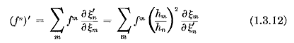
Translating this to my notation gives

F' n = Σm Rnm Fm = Σm Fm (hm/h'n)2 Smn

I feel M&F have an "error" in 1.3.12 because hn should be hn' and refers to their ξ' space. I will assume that in the following. Then the equation above seems to require that

Rnm = (hm/h'n)2 Smn = (hm/h'n)2 Rnm = (gmm / g'nn )Rnm

=> Rnm = g'nn Rnm / gmm

Now in M&F world, coordinate systems are orthogonal, which means g'nn = 1/g'nn since the metric tensor is diagonal. Then the above becomes

Rnm = g'nn Rnm gmm

For an orthogonal system, this then agrees with my section 7 (n) result

Rab = g'aa'Ra'b' gb'b

So finally I see why they are showing those scale factor ratios as above in 1.3.12.
I think M&F have a general problem in that they try to refer to general x and x' spaces using ξ and ξ', but then should also then have hn and hn' corresponding scale factors, but I never see hn' anywhere.

My main point here is that the M&F unit-scaled vector components Fn are my Fn and transform this way, where I correct for their prime-on-h problem,

(F'n/h'n) = Σm Rnm (Fm/hm)

F'n = Σm (h'n/hm) Rnm Fm

and you see this strange extra factor (h'n/hm) . Now when they finally on page 54 get around to talking about dyads, the write this as the transformation rule for their matrix

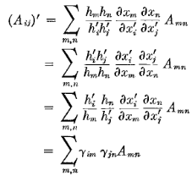

I can translate the second line this way

A'ij = Σm,n (h'ih'j/hmhn) Rim Rjn Amn

This Amn object has the same scaling idea as their Fm but on both indices. This is a type of object I never would use. It is not really a rank-2 tensor, for example. It is the thing that transforms with the direction cosines directly, just as they show above.
Then on page 55 they do relate this to the corresponding true tensor aij

where there should be a full slash before the last hm on the right.

___________________________________________________________________________________

A direction cosine γij is like • in sphericals, n2 of them. Orthogonal systems. Curvilinear unit vectors called ai . Notion of scale factor hi and obvious formula for same (orthogonals only). I just added this to my tensor doc in a good place. MF relate the direction cosine to my R and S elements, but then go on to argue that direction cosines never appear anywhere, only the scale factors do (hurray! I never mention direction cosines in my tensor doc). They discuss curvature of coordinate lines and even have a mention of "torsion" and "total curvature". Simple derivation of the dV rule and simple J for orthogonals. Example with sphericals as ξi. Euler angles. Comments on how a vector field transforms between two curvilinear systems. A somewhat strange introduction of contravariant and covariant vectors.

1.4 The Gradient Operator ∇. (31) Expressed in curvilinears. Notion of (n•∇) ψ. Unusual placement of discussion of "infinitesimal rotations" by angle dω, using cross product notation. If ψ'(x) = eiω•L ψ(x) is a rotated field, then dψ'(x) = iω•L ψ = iω•r x p ψ = -ω • (r x ∇)ψ(x), and their point is that ∇ appears. Divergence is next, limit of flux/volume, gets result in curvilinears. Gauss's Theorem is the divergence theorem and is "derived" as superposition acting on the definition of divergence. They use this stuff to "invert" Poisson's formula in a simple way for ρ (q) in terms of ψ (ignores BC's! ). Page 39 and we are on to the curl, again in curvilinears. Back to those vortex lines. The A = curl B has lines which are the "vorticity lines" of B. Then comes Stokes Theorem. Then vector identities with ∇.

1.5 Vector and Tensor Formalism (44). The use the phrase "tensor calculus". They use upper and lower indices for the two vector types, orthogonal n=3 world only, the basic R and S transform laws appear now. The ∇ is shown to be covariant. Rank 2 tensors. Contraction. Axial vectors? Christoffel symbols introduced, not tensors. Covariant derivative written as fi,j and they show this is a mixed rank 2 tensor on page 49. Then fi.j . This discussion ends p 52 or so. By their admission, this is very minimalist discussion and I don't think they will ever use it. The unit-vector fields are called "the real fields". Noted that contra and covariant fields' components don't even have same dimensions.
Next topic is vector can be expanded as sum of a gradient and a curl of scalar and vector potentials, Helmholtz' Theorem and a proof is given by getting formulas for the potentials φ and A. I am not sure I knew this simple fact.

1.6 Dyadics and other vector operators (54).
_____________________________________________________________________________

Notes added starting page 55. What is this dyadic thing? Their presentation is very unclear. I know that aij is the true rank-2 tensor (see notes above) so they first state that

| U | = ann = trace(aij) = spur(aij) // fine

which I guess they are somehow thinking of the "norm of the dyadic U ".
Then next write ( same a notation used for base vectors and for matrix a, beware!)

<U> = ai εijk Ajk = i εijk Ajk = i εijk hjhkajk = a vector

<U>i = εijk Ajk

If Ajk is sym + antisym, this εijk Ajk picks out only the antisym part. So the vector <U> is proportional to the so-called "dual vector" Lai discusses in association with an antisymmetric matrix.

They next write

U • B = Σmn m AmnBn = Σm (AB)mm

which is a vector with coefficients (AB)m where A = matrix, B = vector. Therefore

(U • B)m = (AB)m = Σn AmnBn

So I can just associate object U with this matrix A really. If you put the vector on the left, you get

(B • U)n = Σm BmAmn

so we can compare

(U • B)m = Σn AmnBn = [ AB ]m

(B • U)m = Σn BnAnm = [ BTA]m

I am fine with this, the only confusion is that Anm is the strangely scaled tensor which transforms simply with direction cosines for orthogonal systems.
They discuss U* in a sense where I would call it UT because it is in terms of AT matrix.
Enough for now. I agree that this stuff really is "archaic" but the word dyad keeps appearing even in modern books like Lai.

Continuing a bit, M&F finally get around to juxtaposing two vectors in 1.6.6 where a term is a1A11a1 which the reader would rearrange as A11 a1a1 and then the reader wonders what on earth a1a1 means. What it really means is a1a1T = $\left(\begin{matrix}1 \\ 0 \\ 0\end{matrix}\right)$ (1 0 0) = $\left(\begin{matrix}1 & 0 & 0 \\ 0 & 0 & 0 \\ 0 & 0 & 0\end{matrix}\right)$ so in fact it is a matrix. In fact

(a1a1)ij = (a1)i(a1)j = δ1iδ1j

We see more abutting vectors in 1.6.7 where now a term is a1A1 .This is confusing because notation A1 is usually used to indicate a component of vector A, but here A1 is a vector with 1 as a label. Later on p 58 they take two vectors like this, called Am and Bm and say you can make a dyadic out of these two vectors and then sum over m to get another more general dyadic

U = Σm AmBm

What they never seem to say is this simple fact that Lai says

U = ab => Uij = aibj

Now to confuse things even more, on p 58 we see this statement:

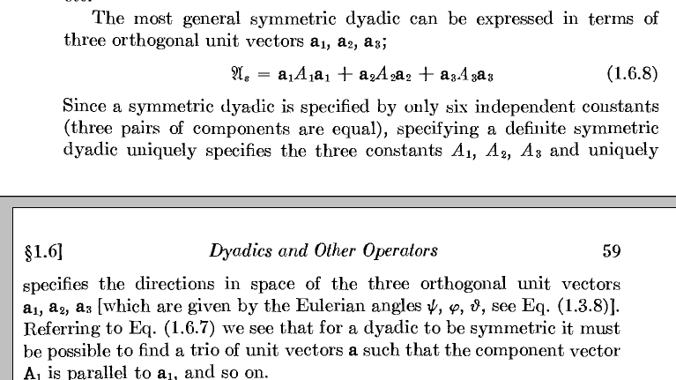

NOW A1 is a scalar, not a vector, I guess in fairness then have italicized it. Equation 1.6.8 means that if you diagonalize this symmetric matrix, you get Λ = diag(A1, A2, A3). Now suppose we solved this EV equation

U φ = λ φ

and suppose the three eigenvalues are λ = A1, A2, A3 and suppose the three EV's are a1, a2, a3. As I show in matrix binder theorem 15D, if R is a matrix whose columns are the ai , then UR = RΛ which is then the same as U = RΛR-1. We can then write this as ( R orthogonal)

U = (a1 a2 a3 ) $\left(\begin{matrix}A1 & 0 & 0 \\ 0 & A2 & 0 \\ 0 & 0 & A3\end{matrix}\right)$ $\left(\begin{matrix}a1T \\ a2T \\ a3T\end{matrix}\right)$ = (a1 a2 a3 ) $\left(\begin{matrix}A1a1T \\ A2a2T \\ A3a3T\end{matrix}\right)$

= a1 A1 a1T + a2 A2 a2T + a3 A3 a3T

and then this is the meaning of M&F's claim above

When we say that the vectors ai are the rows of matrix R-1 = RT, if notation v means a column vector, as it normally does, we need to add a T symbol to make a row vector!

Now this is consistent with the basic dyadic idea

U = (ab) means U = abT = $\left(\begin{matrix}a1 \\ a2 \\ a3\end{matrix}\right)$ (b1b2b3) = etc (ab)ij = aibj

So you need to think of the "right side" vector as a transposed vector. You do NOT want to think of the left vector as transposed because then the result is a scalar!
Now here is how M&F want to write my EV equation

U a1 = A1 a1 me
Us • a1 = A1 a1 M&F

So everything is just fine. More translation

U v me, matrix U acting on a column vector to its right to create a column vector
U • v M&F same thing

vTU me, matrix acting on a row vector to its left to create a row vector
v • U M&F same thing

wT U v a scalar
w • U • v M&F same thing

So when U acts on vectors, you put a T symbol on the left vector when there is one.
But when U is written as (ab), you put a T on the right vector.

I don't think the fact that their Aij matrix has strange scaling has much to do with dyadics at all! It just happens that Aij in their example is this way. It could be any matrix Aij.

Now look at M&F p 60 :

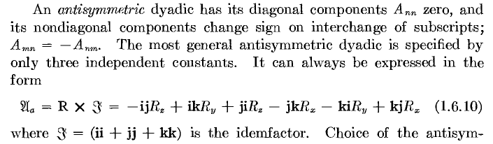

and compare this to Lai who says

What happens if we apply the M&F matrix to a vector a ?

Ua• a = Uaa = Ta = (R x I) • a = R x (I • a) = R x ( Ia) = R x a = tA x a

This sill "idemfactor" is just the identity matrix.

I = ii + jj + kk → i iT + j jT + k kT = etc = 3x3 identity matrix

Thus, the M&F R vector is the "dual vector" of Lai.

It is all archaic malarky! I keep coming back to that conclusion. It is just matrix stuff reformulated in archaic notation. We now from Lai that

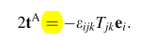

so tA is "half the vector" shown on the RHS. Now M&F say

so M&F regard the RHS of the above as "the rotation vector of Ua". They do not R the dual vector.

_________________________________________________________________________________

It seems that a dyadic is a rank 2 tensor scaled by pairs of scale factors and they want to use German cap letters for such a thing. Trace is called spur. As you read this, it seems that a dyadic is just a linear matrix operator. They want to write A:B as matrix product. The rule for A-1 is stated. I think the real idea is simply that M = ABT which let's you make a matrix by combining two vectors in the reverse order of a dot product. Then 1 1 is really the matrix $\left(\begin{matrix}1 & 0 & 0 \\ 0 & 0 & 0 \\ 0 & 0 & 0\end{matrix}\right)$. Seems quite dated and useless to me. They wander off in this dyadic context to talk about eigenvectors and the secular determinant. They go on and on, doing a lot of usual linear algebra stuff but using their dyadic notation. For example, notion of diagonalizing a matrix. p 64. Then "dyadic fields" and they call this all "dyadic algebra". Stress and strain given as example. Shear. Elastic medium. Bulk and Young modulus. So they are doing a quick run-through of continuum mechanics in dyad formalism. Then suddenly on p 73 we do "complex numbers" out of the blue and then "quaternions". Tensor and versor. And then suddenly we are on to "abstract vector spaces" on p 76, coupled harmonic oscillators as an example and I guess the normal mode coordinates as abstract vectors. This section is on "operators" so I guess this fits in. More on the EV problem in terms of E3. Then on to "quantum operators" and how non commuting means you can measure both. We are STILL using the German dyadic notation! A little view of quantum's vector space with complex aspect. The SI appears. Matrices extended to complex elements, and notion of the Hermitian adjoint of a dyadic (ie, of a matrix). Hermitian and unitary matrices. More on QM operators like momentum, uncertainty principle in terms of Δx and Δp. Spin operators. More on quaternions, then on to rotation operators p 91. D = ei(M/)θ is their notation, but they seem to avoid the word "generator" and no mention of groups.

1.7 Lorentz transformations, 4-vectors, spinors (93). A little review of special relativity, p = mdx/dτ with proper time. The ∂μ gradient is called (grad) and then ∂μ∂μ = 2 d'Alembertian (same symbol in BD). The 4D version of the stress tensor. Then on to 2D spinors and Dirac 4-spinors (I think). STILL in the horrible dyadic notation. So doing 2D representation rotation group stuff without mentioning same. Horrible! Note: M&F avoid talking about a metric tensor, they just say that invariants are like p2- E2 . I think they might use the imaginary time trick in a few places.

Problems (107) 1.1 through 1.33.

Table of vector identities and of horrible dyadic identities (114).

Table of curvilinear coordinate properties (115) Here the general forms are given, then cylindricals and sphericals only.

Bibliography (117). M&M and Goldstein and Dirac get mention.

Comments: Well, based on this chapter alone, I would never want to use this 1953 book for a course! The dyadic version of linear algebra is just a disaster IMHO. This chapter is a grab bag trying to do quantum mechanics, relativity, vector algebra and linear algebra. I am reminded of the M&F version of the Legendre functions, a similar disaster. So I guess we relegate these books to "reference" works. I am a little surprised at this opening chapter, though some of the general ideas are well stated. This chapter is about 1/8th of the first volume! I am glad I surveyed this chapter today, now I have a brief record of what is in there. There is no large chunk of knowledge here that I know nothing about, for example.

