Morse & Feshbach Chapter 10 notes PhL 1.14.12

Chapter 10: Solution of Laplace and Poisson (1173-1330) 157 pages
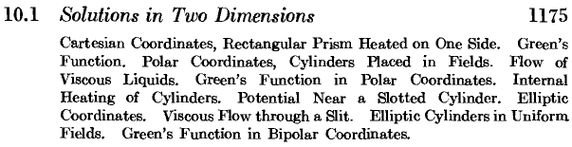

So this is the subject of Potential Theory without and with sources: electrostatics, static heat flow, special fluid flow, etc. Chapter 6 of Stakgold, but in this section all 2D stuff. The idea as usual is to do 3D problems with extrusion symmetry, so "cylinders" really means circles and disks and such things. The slotted cylinder is the 2D wedge problem. After doing problems with circles, M&F ponder how things are different if you have ellipses in 2D (and thus "elliptical cylinders"). Notice that approximation theory of Ch 9 is gone now, we are back to ideal world problems.
Something is wrong with the list shown above! It is not complete, it does not match the actual chapter. Oy. It goes awry after "viscous flow through a slit", so I add here the missing sections

Viscous Flow through a slit (1197)
Green's Function for Elliptic Coordinates (1202)
Potential Inside a Cylinder with a narrow slot (1206)
Parabolic Coordinates (1207)
Bipolar Coordinates (1210)
Two cylinders in a uniform field (1211)
Green's Function for Bipolar Coordinates (1213)

Whereas Stak generally did n dimensions, M&F only do n=2 and n=3. That kept them plenty busy!

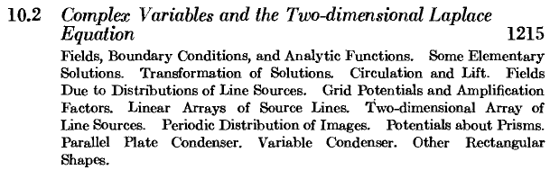

We know that analytic functions have real and imaginary parts that solve Laplace, they are "harmonic functions". It is not surprising that potential theory can be formulated and studied in terms of analytic functions. I am most familiar with this subject in terms of "conformal mapping" between two spaces, one of which is usually Cartesian 2D. This plays a major role in the M&S book for cylindrical coordinate systems based on 2D conformal systems. But I think this section takes a more general view of the subject formulated in terms of a complex variable. Again, this is all just 2D. Example of a grid in a triode tube!

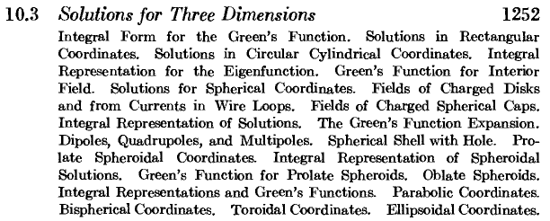

This is the 3D meat and potatoes chapter. The "charged spherical cap" item means a sticky dipole layer on same. And the later spherical hole section means a small hole and approximation, perhaps this was reviewed in MacDonald's writeup. M&F are not doing any kind of complete solution to this problem, no inversion method etc. Green's function expansion means my 1/R formulas in various systems. And "integral form for Green's Function" just means a continuous spectrum expansion of 1/R, for example

This is a famous section of this book because it deals with Potential Theory in a variety of curvilinear coordinate systems. Stak only did Cartesian, cylindricals and sphericals. For example. Smythe (1950) also has some prolate and oblate stuff, but toroidal only in his problems. Smythe's static book design section is similar to M&F in that there is a 2D chapter followed by a 3D chapter. Smythe's TOC detail lists are even more massive that the M&F ones! Good old Smythe!

Problems (1309) 10.1 to 10.38

A. Trig and hyperbolic function formulas (1320)
B. Bessel Functions (1321) -- I and K are called "hyperbolic Bessel functions" , integrals, etc
C. Legendre functions (1325) -- integer order, then imaginary argument as in spheroidals, and special :
Toroidal harmonics (1329) -- what I think I call cylinder functions with order n-1/2

or from the TOC:

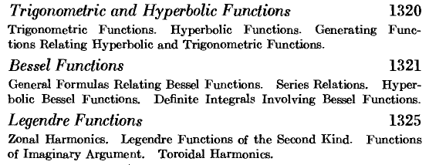

Bibliography (1330)

Bateman PDE book, Jeans, Jeffreys Math methods book, Lamb hydrodynamics, MacMillan potential theory, Smythe 1950. It is a fairly short list.

