Morse & Feshbach Chapter 11 notes PhL 1.14.12

This is the big WAVES section of M&F, first 2D then 3D. Waves were mentioned in volume 1, and here we have elaboration and applications. I like the constant acoustic emphasis, more down to earth it seems than E&M waves. As usual, lots of obscure curvilinear coordinate systems appear, some approximations appear, lots of weird new atomic functions.
Stakgold's waves Chapter 7 part is more "theoretical", n dimensions at times, propagators. Stak does not use oddball coordinate systems, and does not in general have oddball problems (read "real world" type problems). There is a spectrum from pure math theory with theorems and proofs and toy situations only, and pure handbook application with no theory. Stak is 1/3 from the left end, M&F is 1/3 from the right end. I am sure I could find an acoustic calculations handbook somewhere that might be at the right end.
Nothing on computer work of course in this 1953 book which still has "math tables" in the back. This is an analytic book, not a digital book.

Chapter 11: The Wave Equation (1173-1330) 157 pages
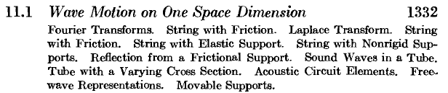

So the two examples here are the string in various forms, and sound compression waves in a tube. Friction means force proportional to velocity. Note various kinds of supports for the string including elastic. As for the tube, ends can be open or closed or something else, same idea of playing with the boundary conditions. The "circuit elements" is a way to model acoustic situations with R,L,C-like circuit elements, I have never played with such a thing, maybe Jeff Davis has.

The next title really should say in Two Space Dimensions to be consistent with the adjacent titles!

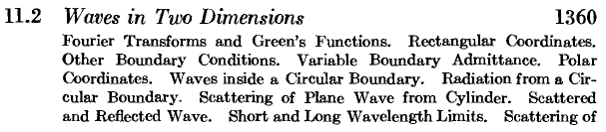
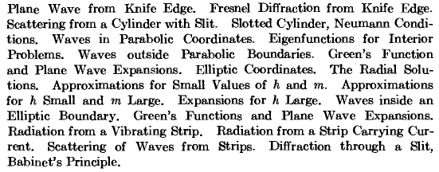

As expected, they get right into issues of impedance and admittance at the boundaries. This just means the wall is not "perfect" in some sense, perhaps not perfectly Dirichlet or Neumann. I see the drumhead situation early on in the list. With the circle we can do waves inside (EF's), or we can scatter from the outside. The famous "knife edge" appears here as in Stak. Wow, a parabolic boundary problem. Then we get into "periodic Mathieu functions" like Sem(h,z) which appear in the atoms of elliptical cylinder coordinates (p 1407). Notice the parameters h and m. M&F seem to do approximations in various ranges for these parameters in the TOC list above. So there is a stress on elliptical stuff here, because circular stuff is the simple case covered in the first part of this section. Babinet gets mention.

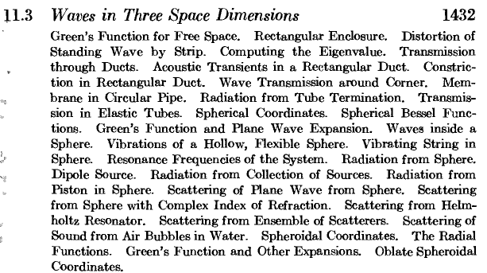

Waveguides, perhaps sound ducts (speaker cabinets!) Corners! Elastic tubes! Scattering from air bubbles in water. Chock full of good 3D wave examples. Flexible sphere radiator. All good stuff.

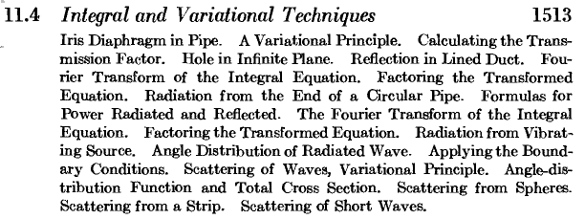

Scattering from spheres noted (blood cells in eyes). It might be that this entire section is approximation theory or is not, I am not sure.

It would be fun to learn how to do these unusual problems.

Problems (1555) 11.1 to 11.32

Addition theorems are given in each of these sections along with the usual special function data:

A. Cylindrical Bessel functions (meaning J, N, H)

B. Weber functions (as for parabolic coordinates)

C. Mathieu functions (elliptical coordinates) -- various kinds, lots of detail here

D. Spherical Bessel Functions -- lower case j and so on

E. Table of Laplace Transforms

Bibliography

C&H, Morse on acoustics, Rayleigh on sound,

