Morse & Feshbach Chapter 12 notes PhL 1.14.12

They don't mention the "imaginary time" connection between SE and heat equation, seems odd. The web mentions it. So just as Chapter 11 was "the wave chapter" we might call this "the diffusion/heat/SE" chapter.

Chapter 12: Diffusion and Wave Mechanics.

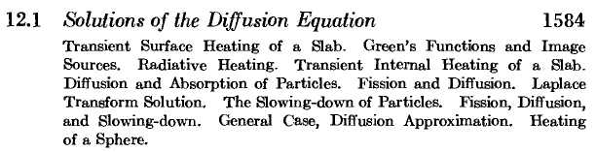

Radiative heading refers to the Stak radiative boundary condition, I know about this at least. So we open here with heat problems, then switch to solutes and their diffusion. Then the fission section is an application to the diffusion of neutrons in a nuclear reactor ( they are created too fast to sustain fusion and have to be slowed down). The last section concerns sunlight hitting a rotating earth! There is a heat source on one side (sun) and radiative heat loss on the other side. Right up my alley.

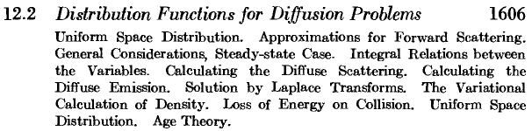

This seems to open with some "gas physics" where particles have a "distribution" of velocities. Maybe you want to scatter something off such a gas. Diffuse reflection from a statistical surface. This is an area of the canyon I have never visited. Stak did the simple heat equation. I think here you are doing approximations again and statistical averaging probably.

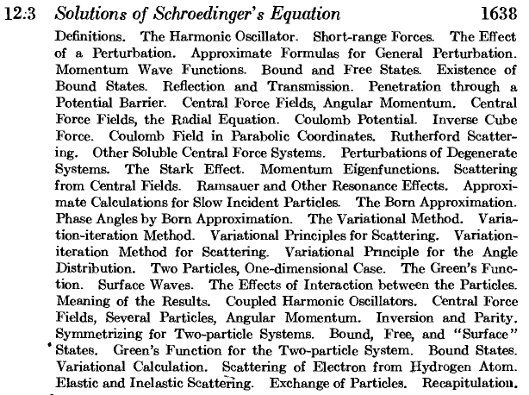

So this is the M&F "Quantum Mechanics" section. Recall that Morse wrote his own QM book at one time. I presume they are doing fairly advanced QM topics here. It seems non-relativistic.

Problems (1745) 12.1 to 12.32

A. Jacobi Polynomials (but they don't use the standard notation)

B. Semicylindrical Functions -- never even heard of these babies! Like Jm(4)(z). This is so obscure that basically M&F is the only hit on the web. Some book suggests Sonin used these. Here is the definition

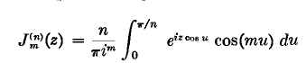

Note that

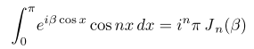

So I guess n = 2 would be "semi-cylindrical".

Bibliography (1758)

Bateman PDE book 1932, Bethe on neutron diffusion, Chand on stellar distribution stuff, Hopf has a whole book on radiative equilibrium stuff (the H of WH), a Blatt and Jackson paper 1949, hear of JDJ PhD at MIT.

