Morse & Feshbach Chapter 13 notes PhL 1.14.12

Chapter 13: Vector Fields

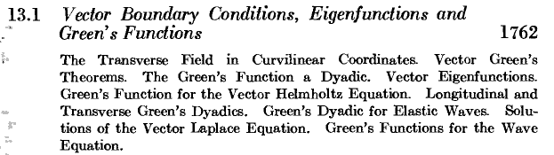

This section opens with the "vector Helmholtz equation:

and I immediately wonder about the definition of ∇2F . He wants to do this:

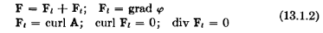

Pretty soon we get to this:

so I guess they "really are" talking about the vector Laplacian. They get off into their dyadic notation and try to get the Green's Function for vector Helmholtz. M&S have a whole chapter on Vector Helmholtz by the way. I think you need this for E&M working with the fields directly, and also in continuum mechanics, and also in viscous flow problems (where you cannot get velocity from a potential).

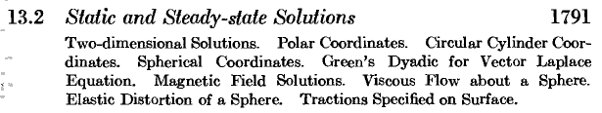

Sometimes you cannot "get away with" just finding a potential and deriving vector fields from it, and then you are stuck with this heavy duty formalism which I have encountered before. My own notes are on spherical coordinates only, suitable for radiation I think. I think M&F restrict to that system as well.

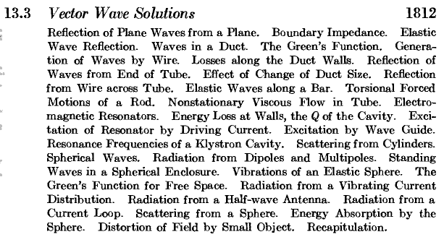

This looks like standard E&M fare. I guess since E and B separately do satisfy Helmholtz in the wave scenario (see green Jackson Multipole fields chapter eg), every E&M wave type problem is fair game for this chapter, so we have the "half wave antenna" and "radiating current loop". They do state that the radiation back-effect on the proposed antenna current is ignored, things are bad enough without that. Think King's book. The last item is wave scattering of a sphere, something I have messed with at one time somewhere. Mie scattering.

Problems 13.1 to 13.30

A. Table of Spherical Vector Harmonics (1898) .

I have pretty good PL notes on this subject in a vector harmonics folder in the EM area. You end up with three bolded vector function objects floating around, perhaps X,Y,Z and maybe this is the P,B and C of M&F.

Bibliography (1901)

An early Born optics book of 1933, Jeans, Riemann-Weber (see below), Slater, Frank, Sommerfeld, Stratton, Love, Milne-Thomson on hydrodynamics.

About Riemann-Weber. [ see next paragraph! ] This was the M&F of an earlier era! Two volumes. "Partial Differential Equations of Mathematical Physics". One edition was 1925. Weber did not join the consortium until the 4th edition, say some notes "the new Riemann-Weber". The 5th edition as 1910, and 6th just a reprint. It is of course in German, and you can buy a reproduction for $30 or so, but I don't see the contents on the web. My blurb seems to talk about making a 7th edition. Riemann died in 1866, hmm. Weber died in 1913. Another source says the first Riemann-Weber was 1900 and was "the book" for all the QM pioneers. It was really Weber's book but was based on 40 year old Riemann lecture notes that had been collected in 1869.

Aha! I see that the torch was carried on by Frank and Mises :

"The theoretical physicist Philipp Frank (1884–1966) and the applied mathematician Richard von Mises (1883–1953) both received their university education in Vienna shortly after 1900 and became friends at the latest during the Great War. They were attached to the Vienna Circle of Logical Positivists and wrote an influential two-part work on the differential and integral equations of mechanics and physics, the Frank-Mises, of 1925 and 1927, with its second edition following in 1930 and 1935.This work originated in the lectures that the mathematician Bernhard Riemann (1826–1866) delivered on partial differential equations and their applications to physical questions at the University of Göttingen between 1854 and 1862, which were edited and published posthumously in1869 by the physicist Karl Hattendorff (1834–1882).The immediate precursor of the Frank-Mises, however, was the extensive revision of Hattendorff’s edition of Riemann’s lectures that the mathematician Heinrich Weber (1842–1913) published in two volumes, the Riemann-Weber, of 1900 and 1901, with its second edition following in 1910 and 1912. I trace this historical lineage, explore the nature and contents of the Frank-Mises, and discuss its complementary relationship to the first volume of the text that the mathematicians Richard Courant (1888–1972) and David Hilbert (1862–1943) published on the methods of mathematical physics in 1924, the Courant-Hilbert, which, when it and its second volume of 1937 were translated into English and extensively revised in 1953 and 1961, eclipsed the classic Frank-Mises."

Frank-Mises also in German, can get this 2-volume set for $18 on the web. There is a 1943 reprint.

The rest of this book an Appendix with several parts.

Glossary of Symbols

It includes this strange entry

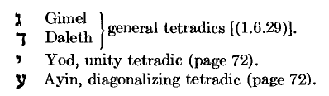

And then lots of numerical tables since this is the pre-computer era.

Bibliography on special functions.

Finally the index. Both volumes have the same 2-volume TOC and the same 40-page 2-volume index.

So indeed, I think one might say that this 1953 M&F really did become the new Riemann-Weber after all. Recall Koch's comments from his 1956 review in the Preface section of these notes.

