Morse & Feshbach Chapter 9 notes PhL 1.14.12

This is the first chapter of volume II. I will review the detailed M&F TOC contents only and will not skim all 1000 pages as I did for the first volume, mainly because I know this stuff pretty well.

Before delving into a chapter like this, I would have to have some particular problem in mind, some motivating goal. Otherwise yes, it is just a cookbook of approximation techniques, pretty dry reading.

Chapter 9: Approximate Methods (999-1172) 173 pages

In the first volume we treated toy idealized problems. In the real world, serious problems can never be solved exactly in this manner, so approximation methods are always needed. One class of methods is to do perturbation around a problem which is solvable (separable, say), and of course the perturbation has to be relatively small in some sense. You might perturb the boundary conditions ("surface perturbation") or the ODE itself ("volume perturbation"). Example of two electron SE for atom is given with the e2/r12 term as the perturbation. Acoustic examples (Morse area) might have columns in a room to worry about.
This chapter shall treat three approximation methods, perturbation being just the first:

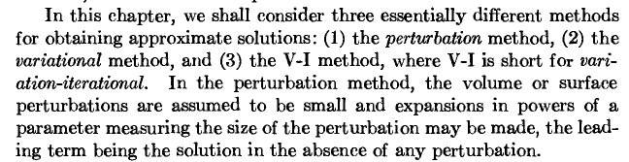

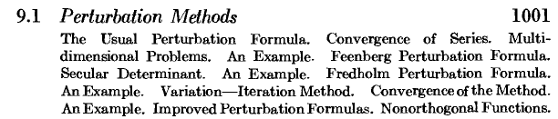

The Usual Formula is what we always do in QM to get a perturbation series with first order, second order, and so on. M&F treat this in a very general manner which looks good and you see the usual "energy difference denominators". M&F write lots of the lower levels of this series. Feenberg came up with some improvement in the series regarding denominators and this involves use of a certain secular determinant. M&F then get into the "Fredholm" formulas which I think are those involving the trace approximation and which I have written up somewhere. As usual, M&F provide real world solid examples. So yes. this would be a good place to study "perturbation theory" in a systematic way, not just for quantum mechanics. You might have trouble finding a big general section on perturbation theory in other books. You want the general method to apply to any PDE ODE or IE not just say the SE.

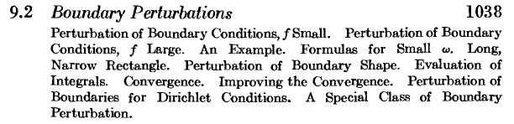

Again Morse did acoustics research where all this stuff comes in. You might do volume and surface perturbation theory at the same time! Here is what "f" means:
So perhaps you have a Neumann exact solution and you need to add in a little Dirichlet on your boundary with small coefficient f. Large f of course means you are perturbing around the Dirichlet solution. This general form is like Stak's "radiative" BC. Note that f is not a constant, it is a function of location on the surface S. As usual, examples are given.

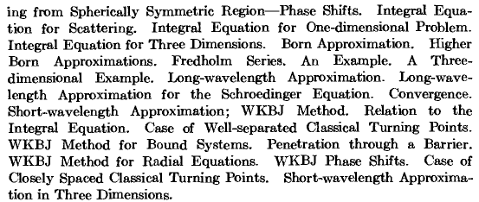

This is a very famous subject and relevant for the particle folks. It is one thing to do approximations to find EF's for the "bound states" of a problem. But here we have continuous spectrum "scattering" type approximation. The phase shifts of the partial wave expansion are here. Higher Born terms. Fredholm scattering series. The famous WKB method to which they add the letter J for some reason. This subject appears in great detail in Schiff for example where you see Schiff Chapter 9 "Approximation methods in collision theory", and of course the whole Goldberger Watson Collision Theory book I have. This is a monstrous subject, but one can at least hope to get down the basic ideas.

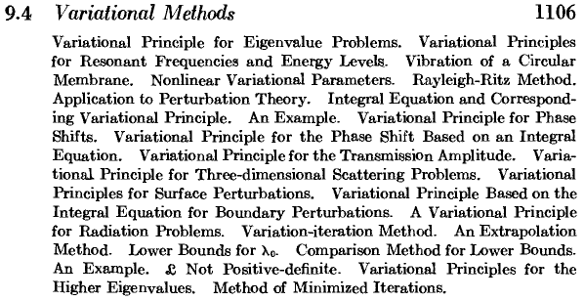

Stak did some of this for finding eigenvalues, iterative methods, fit things with parameters, find bounds. I am pretty sure I could read and understand this section if I wanted to. Notice that the "variation iteration" method appears in the TOC block above.

Problems (1158) 9.1 to 9.11

A. Appendix Reviews ALL the methods in a lot of detail.

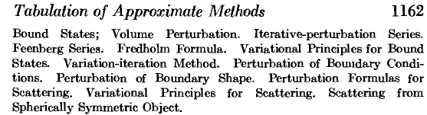

Bibliography (1170)

Condon and Morse's QM book. Feenberg's note in 1948. Schiff is here. Pauling and Wilson QM.

