Stationary State Perturbation Theory Meta Notes

Here I provide meta overview notes for several different documents of raw notes that I took at various times while reading various books. ( Examples are annotated in a separate document).

1. Messiah SSPT R1 Chap 16.doc (but not the Resolvent section or Application sections) 1
non-degenerate case 1
degenerate case 2
2. Messiah SSPT R2 Chap 16.doc (Round Two notes) 4
PART 1. Generalities, Setup, and Algorithm for the non-degenerate solution to all orders. 5
PART 2. The eigenvalue problems at various levels 6
PART 3. Computing various state corrections 8
Result for | 1; n, ε₁>: 8
Result for | 2; n, ε₁>: 9
Result for |1; m,ε₂>. 10
2. Messiah Round Two notes "bad": Q_{0a}⁽¹⁾(E_{a}⁰ - H₀) ≠ Q₀⁽¹⁾ 11
4. Degenerate Perturbation Theory (doc) 13
PART 1. Notation, normalization, finding the B' coefficients (non-degenerate) to first order 13
PART 2: Systematic all-orders attack; handling of the case W_{ms,1} = W_{mi,1} 15

History: This SSPT subject is clear from any author for the non-degenerate situation. It is the situation with one or more nested degeneracies that is the problem. I first read about this stuff in Schiff and he made a mess of the degenerate case IMHO. (I have not included meta notes here on his Chapter 8 SSPT presentation, by the way.) After this, I went off and tried to "roll my own" degenerate case development, document 4 above. I was stymied by the situation where Wmi,1 = Wmj,1 and did not know what to do next. But I had the right plan, and later came back and updated these notes. After that I read Saxon whose approach is just "different", and then finally I read Messiah who was much more sophisticated than any one else using his Q0 and Q0a operators to compact things down to chewable form. I did read his final Kato section, but will write that up in separate notes because it is plenty complicated and we have enough to do here without Kato. At this point I have not read Messiah's SSPT application sections (but I did in fact read these finishing 2.14.09, see separate document on these great examples. )

____________________________________________________________________________________

1. Messiah SSPT R1 Chap 16.doc (but not the Resolvent section or Application sections)

This is 24 pages of notes.

non-degenerate case

The first 6 pages of raw notes has this contents list

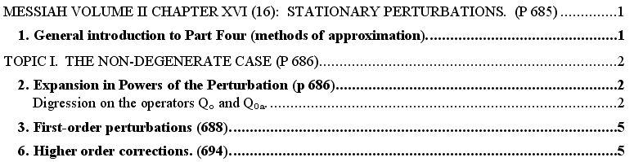

When I first got into this, I had to make a translation chart so I could compare Messiah to Schiff which I had just finished reading. Their approaches are quite similar in that they both do full expansions in λ for both states and energies, which is not how Saxon did things. Next, I had to deal with Messiah's use of what seemed at first to be very fancy (and new to me) operators called P0 and Q0 and Q0a.

P0 = |0><0| Q0 ≡ 1 - |0><0| = Σk≠a |k><k| Q0a = Q0 (Ea0 - H0)-1 Qo

These same operators later reappear in the degenerate theory, but here we are non-degenerate so Q0 is just the perp space projector for a single state "a". Here is the basic idea: (1) the perturbation equations have the typical form (this one gathers all the terms of order λ3)

(H0 - Ea0) |3> = (ε1 - V) |2> + ε2 |1> + ε3 |0>

(2) If we apply Q0a to both sides and use the "mini theorem" Q0a(H0 - Ea0) = Q0 , we get the above with Q0 on the left, and Q0a applied to all terms on the right. (3) But Q0|n> = ( 1 - |0><0|)|n> = |n> – <0|n> = |n> due to the special <0|n>=0 normalization condition that both Schiff and Messiah use. Thus, the above becomes (here I show the two lower state corrections as well)

|1> = Q0aV |0>
|2> = Q0a (V-ε1)|1>
|3> = Q0a (ε1 - V) |2> + ε2 Q0a |1> + ε3 Q0a |0>

which gives an explicit formula for the correction state |3>. One can then insert this correction state into the energy formula to get ε4 = <0|V|3>, for example. Thus, one has in essence the energies and states for all orders of perturbation theory, just doing the above. So this is why Messiah introduces these "fancy operators". When you do the details, you get the normal perturbation theory results. So the non-degenerate problem is fully solved.

degenerate case

This is the much more difficult problem and I have 16 pages of Messiah raw notes on this topic, again excluding the resolvent method idea of Kato.

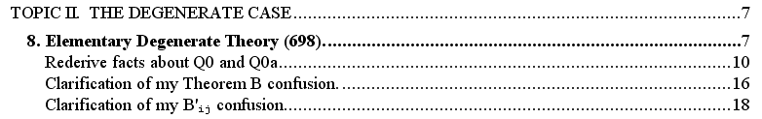

This picture shows the nature of the problem, just a typical complex situation:
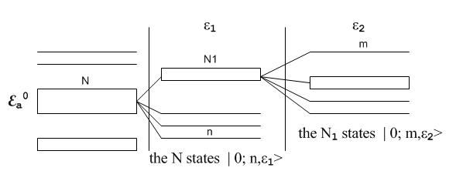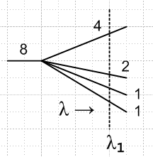

Here on the left we have a degenerate group of N states which in first order split into a still-degenerate group of N1 states and some other non-degenerate states like "n". Then in second order the group of N1 states splits more and some states might still be degenerate in the third column, whereas others like "m" may be non-degenerate at that point. The "problem" is how to handle all this "degeneracy stuff". The non-degenerate methods don't work. In my Round 2 notes, I compute some of the energy and state corrections for states "n" and "m" shown in this picture as a sort of exercise. On the right I show a more primitive picture of the same idea, where here splitting increases with increased λ in some vague manner, and this picture is showing only the level ε1 splitting.
The crucial fact to understand is this: states like |0; m, ε2> shown above are projections into the λ=0 world (limλ→0) of certain specific states which solve the full SE to all orders. So this state |0; m, ε2> is some very delicate linear combination of the bases states |r> which might span the space Ea0 on the left. When we started the problem, we start with some generic states |r> and |k> which span Ea0 + (Ea0) ⊥ = H.
We always assume this set of states is orthonormal to make calculations easy. The problem of finding the delicate linear combinations of states like |0; m, ε2> requires solving a finite eigenvalue problem at each level of perturbation until the state in question becomes a singlet. It is very messy. At the ε1 level, the EV equation is relatively simple, being basically V|0; n,ε1> = ε1,n|0; n,ε1> with the space Ea0. So the first EV equation results in the N states |0; n,ε1> which diagonalize V, the perturbing Hamiltonian. At the next level, the EV equation is more obtuse and has the form (VQ0aV) |0; m,ε2> = ε2,m, |0; m,ε2> and this is within the subspace called Ea(1) that is represented by the N1 group of states in the above figure. This subspace has projectors P(1) and Q(1) in Messiah notation, for example, Q(1) = Σk∈E(1)⊥ |k><k| . This second order EV equation was not easy to find theoretically (we had to carefully thread a path to it), and secondly, it is not very simple since (VQ0aV) involves an infinite k sum. I don't even know what the third order EV equation looks like, and I doubt it has just (VQ0aVQ0aV) as the operator. Maybe 10 of my 16 pages of raw notes concerns finding the lowest two EV problems, and stating them in operator form as well as matrix form. Of course in the dense Messiah text, all this is done in about 3 pages.
All states beginning with "0" are in the N-dimensional space Ea0 and are certain "correct" linear combinations of the starting N base states |r> which span Ea0 . Of course correction states like |1; n,ε1> will have components of all basis functions in both Ea0 and (Ea0) ⊥, and similarly for all higher state corrections. So we might say that there is some full state to all orders called | n,ε1> and our main perturbation theory concern is finding its projection | 0; n,ε1> which lies in Ea0.
Another topic I discuss is the resolution of my "Theorem B" mystery, as first presented in a different doc. The mystery was that I kept finding that I could not have base states in Ea0 which did not diagonalize V. I later realized that the perturbation equations are only valid for states which have certain properties, and one of these is that the states like |0; n,ε1> must be certain linear combinations of the base states |r> which diagonalize V. So if you start with the perturbation equations, you are going to have states which diagonalize V! Said another way, if you start with some random um basis functions which span Ea0, these are likely not going to be the correct states |0> that appear in the perturbation equations.
In the second last notes section here, I was pondering my pert doc expansion

ψmi,n = { Σj≠iB'ij,n umj } ⊕ Σk≠m B'ik,n uk n > 0

and I remembered having trouble finding the B'ij,n coefficients which show how states move within Ea0. I realized that this problem is a reflection of the degenerate theory operator equations like

Q0|3> = Q0a (ε1 - V) |2> + ε2 Q0a |1> + ε3 Q0a |0>

In the degenerate theory, you cannot remove the Q0 on the LHS since Q0|3; n> = 1 - Σr|0;r><0;r| and you cannot claim that <0;r |3; n> = 0 since there are various states "r". In the degenerate case, we had <0|3> = 0 from the normalization condition, because these were two levels of the same state in that case (which in addition was a "correct" state). Thus, the perturbation equations when acted upon by Q0a give you equations like the above which only give you information about the portion of |3> that is in the perp space of Ea0, so you only get the B'ik,n coefficients. You have to work harder to obtain the B'ij,n coefficients by rising up another level in the theory and using the "full" perturbation equations, not the "Q0a-projected" ones. I do some of this in my Round Two notes.
The last section of my notes here I now entitle "flailing around with no real success". Here, I was able to obtain a result for the recalcitrant coefficients B'ij,1 but only provided that initial state i and the perturbation direction of change state j were not degenerate at the ε1 level:

B'is,1 = (ε1i – ε1s )-1 * <s | VQ0aV|i> = (ε1i – ε1s )-1 [Σk≠mVsk Vki (Em - Ek)-1 ]

where the states i and s are legal ones which diagonalize V. This effort was really just a repeat of what I had already done in my degen doc notes, and I ended up stuck at this same location. Suppose these two states i and j were still degenerate in the N1 bundle as shown in my picture above? I then gave a small effort at using states which diagonalized VQ0aV but did not succeed in getting all the B'ij,1 coefficients.

____________________________________________________________________________________

2. Messiah SSPT R2 Chap 16.doc (Round Two notes)

The notes in this Round Two doc have three distinct parts.

PART 1. Generalities, Setup, and Algorithm for the non-degenerate solution to all orders.

The first part attempts to present the Messiah approach in a more systematic manner, talking first about general projection operators R and F = Rf(Ω)R and getting the basic math separated off. Even though the "topic I" title says non-degenerate, I try to keep things fully general except in the last subsections h-l as is clear from this TOC:

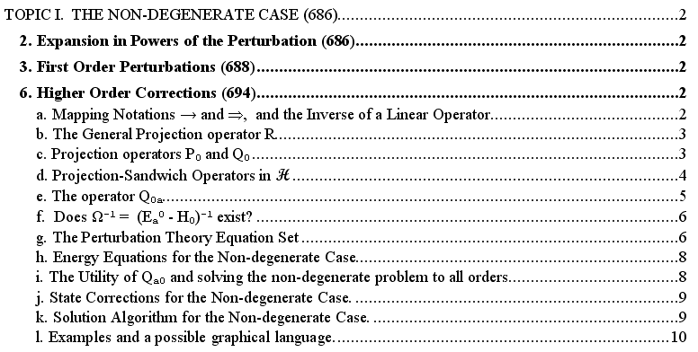

I learned here that you really need the projection operator R on both sides to avoid singularities. The references in this TOC to Messiah sections 2,3,6 are just a token umbrella for my presentation here and should really be ignored. The lettered line items in the TOC above really provide a "meta review" of what I did in this section. Here is a short list of results that are valid in both the degenerate and non-degenerate cases:

The perturbation equations which basically say Hψ = Eψ (and an example)

(H0 - Ea0) |s> = ( ε1 - V ) |s-1> + Σj=2,3..s εj |s-j> s = 1,2,3...
(H0 - Ea0) |4> = (ε1 - V) |3> + ε2 |2> + ε3 |1> + ε4 |0> s = 4

Closure of the above equations with an arbitrary <r| in Ea0 (and an example)

0 = <r| ( ε1 - V ) |s-1;n> + Σj=2,3..s-1 εj <r| s-j;n> + εs<0;r| 0;n> s = 1,2,3...
0 = <r| (ε1 - V) |3;n > + ε2<r|2;n > + ε3 <r |1;n > + ε4<r| 0;n> s = 4

The energy correction equations:

εs = <0;n| V |s-1;n> s = 1,2,3...
ε3 = <0;n| V |2;n>

The Qo equations which result from application of Qa0 to the above perturbation equations (+ example)

Q0 |s> = Q0a V |s-1> – Σj=1,3..s εj Q0a |s-j> s = 1,2,3...
Q0 |4> = Q0aV |3> – ε1 Q0a |3> – ε2 Q0a |2> – ε3 Q0a |1> s = 4

Notice that we have no equations which tell us the portion of state |s> inside Ea0 . The last equations tell us only the portion of |s> that lies inside (Ea0) ⊥. This is "the big problem" in the degenerate case.

PART 2. The eigenvalue problems at various levels

This brings us to the second part of the Round Two notes which has this TOC section

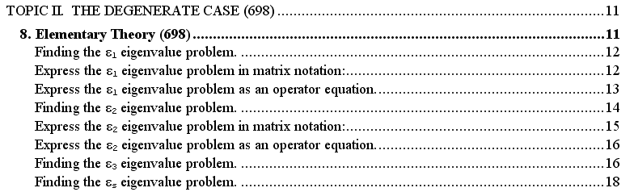

Here I am reviewing the methods used by Messiah to "find" the eigenvalue (EV) problem at each level.

The ε1 level EV problem is simply this, in ket format:

P0V |0; n, ε1> = ε1,n |0; n,ε1> or V |0; n, ε1> = ε1,n |0; n,ε1>

where on the right I remove the P0 because I implicitly agree to stay inside the space Ea0. I imagined there were N degenerate states, so this was an NxN diagonalization problem. You can see that P0 has to be there if you do something like apply a bra from the perp space <k| so that both sides then give 0. Otherwise you get a false claim that <k| V |0; n, ε1> = Vkn = 0, which is not true. This ε1 level problem is the "famous" problem in SSPT and we know that we need to find states that diagonalize V if our initial states did not do that already. Not much difficulty here.
I continued on then to reframe the problem as a matrix problem,

Σr' Vrr' ψ(n)r' = ε1,n ψ(n)r ψ(n)r = <r | 0; n,ε1>

where the <r| are some arbitrary "initial" base states that span Ea0, and in which basis V is likely not diagonal yet. This then yields the eigenvalues of the N states ε1,n and the "correct" states | 0; n,ε1> which are the limits of true SE solutions (unless of course there is still degeneracy, in which case we still don't know the correct states). I went on to define U(1)r,n = <r | 0; n,ε1> so one can think of the basis change from |r> to | 0; n,ε1> as a unitary transformation and the columns of the matrix are the eigenvectors "and all that stuff".
Finally, I wrote down the level ε1 eigenvalue problem as an operator equation P0V P0 = ε1 P0. Due to the projectors, this operator equation contains I think the same information as the ket formulation above. It just seems that the operator equation is more general, and when you apply it to a ket |0; n, ε1> you obtain the EV equation shown above. This operator equation is entirely restricted (both sides) to the space Ea0 and the restriction is explicit due to the P0. The equation is used in the search for the ε2 EV equation below.

The ε2 level problem is messier. In my notes I give a concise derivation of the EV ket form which is

P(1)(V Q0aV) |0; m,ε2> = ε2 |0; m,ε2> (V Q0aV) |0; m,ε2> = ε2 |0; m,ε2>

where in my state notation, the initial 0 means it is the λ→0 limit (the λ0 expansion term of a state), the m is state label so we can distinguish the states, and ε2 means this is an eigenstate of the level 2 EV problem. As before, we can restrict to the N1 dimensional subspace Ea0(1) and remove the projector P(1). The following picture shows both the ε2 and the ε1 problems:

So in this example, the level 1 diagonalization was an NxN problem, while the level 2 diagonalization is an N1x N1 problem.
When this level 2 EV problem is written in matrix notation, we have to be a little careful. We get

Σm"=1,N1 <0; m',ε1| (V Q0aV) | 0;m",ε1><0;m",ε1 |0; m,ε2> = ε2,m <0; m',ε1|0; m,ε2>

Σm"=1,N1 (V Q0aV)m'm" ψ(m,ε2)m" = ε2,m ψ(m,ε2)m'

where the trick is that the subscripts on the matrices refer not to the old |r> states ( as they did in the level 1 problem), but to the new states | 0;m",ε1> that were found as solutions of the level 1 EV problem. So you are supposed to start here having already computed the | 0;m",ε1> (which merely diagonalize V).
Finally, I write this level 2 EV problem as an operator equation

P(1)(V Q0aV) P(1) = ε1 P(1)

but such an equation does not really seem to buy much except in this sense. When I went from level 1 to level 2, the level 1 operator equation P0V P0 = ε1 P0 was used in order to find the above level 2 operator equation, and then when this was applied to |0> we got the level 2 EV problem.

The ε3 and εs level problems were too hard for me. I was unable to thread a path to find the ε3 operator equation, nor did Messiah or anyone else tell me what it was (maybe the resolvent thing does, see later). I gave the ε3 a quick shot, but could not find the way to grandmother's house.

PART 3. Computing various state corrections

And so now we come to the third part of the Round Two notes which has this TOC section

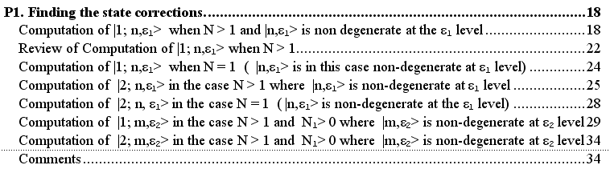

I spent so much time here because of my history of inability to find those B'ij coefficients (those inside a subspace) in my older notes. Messiah's book completely ignores this question, but it is something we need to know if we think we have a "theory".

Here then is a summary of the results I obtained in reference to our same picture showing two non-degenerate "final states of interest" called "n" and m":

Result for | 1; n, ε1>:

First, the method used here was this:

(1) Use the s=1 perturbation equation to get the perp space coefficients called ck below
Q0 |1> = Q0aV |0> and close with <k| s = 1
(2) Use the s=2 perturbation equation to get the Ea0 space coefficients Cn'
(H0 - Ea0) |2> = (ε1 - V ) |1> + ε2 |0> and close with < 0; n', ε1| s = 2

The results are then these:

| 1; n, ε1> = Σn'=1,N Cn' |0; n',ε1> + Σk∈Eoa⊥ ck |k>
ck = (Ea0 - Ek)-1 Vkn
Cn' = (Vnn – Vn'n')-1 Σk∈Eoa⊥ Vn'k (Ea0 - Ek)-1 Vkn Cn = 0
Vn'n' ≡ < 0; n', ε1| V |0; n',ε1> = ε1,n'
Vn'k ≡ < 0; n', ε1| V |k>
ε1 = Vnn
ε2 = < 0; n, ε1| V |1; n, ε1> = Σk∈Eoa⊥ ck Vnk = Σk∈Eoa⊥(Ea0 - Ek)-1 |Vkn|2

Notice that the matrix elements of V use the orthonormal |0; n,ε1> states which result from "the first diagonalization" which diagonalizes V within Ea0. Of course V is not diagonal when one index is in the perp space, such as Vkn. The above result is the same as that which I got in my older Schiff perturbation notes, and I quote

ψ'mi,1 = { Σj≠iB'ij,1 umj } ⊕ Σk≠m B'ik,1 uk
B'ij,1 = [Σk≠m B'ik,1<umj| H' |uk>] /(Wmi,1 – Wmj,1 ) B'ii,1 = 0

The denominator is non-zero because we assume that our state of interest (i = n) is a singlet as in the picture. If this is not the case, see results below for state "m".
In the special case N=1, we cannot easily take a limit of the above result, so I quote here the result directly from the non-degenerate theory (second subsection in above Part 3 TOC): (the limit in retrospect seems to be that Cn' = Cn= 0 )

| 1; n, ε1> = Σ k∈Eoa⊥ (Ea0 - Ek)-1Vkn |k>
ε1,n = Vnn
ε2,n = < 0; n, ε1| V |1; n, ε1> = Σ k∈Eoa⊥ (Ea0 - Ek)-1 |Vkn|2

Notice that the level 1 and 2 energy corrections are formally the same whether N=1 or N>1. Of course in the N>1 case, we have to find the "correct" states "n" = |0; n, ε1> in order to compute Vnn and Vkn. In both cases, the ε2 comes only from the perp space, but the perp spaces are of different size in the two cases (in the sense that they differ by N-1 states).

Result for | 2; n, ε1>:

Before dealing with the state "m", I computed this second order state correction for "n"

The method used here was this:

(1) Use the s=2 perturbation equation to get the perp space coefficients called dk below
Q0 |2; n, ε1> = Q0aV |1; n, ε1> – ε1 Q0a |1; n, ε1> and close with <k| s = 2
(2) Use the s=3 perturbation equation to get the Ea0 space coefficients Dn'
(H0 - Ea0) |3; n, ε1> = (ε1,n - V) |2; n, ε1> + ε2,n |1; n, ε1> + ε3,n |0; n, ε1> s = 3
and close with <0; n',ε1|.

The results are then these:

| 2; n, ε1> = ( Σn'=1,N Dn' |0; n',ε1> + Σk∈Eoa⊥ dk |k>
Dn' = – ( Vnn – Vn'n')-1 Σk∈Eoa⊥ Vn'k dk + ε2,n Cn' Dn= 0
dk = <k|2; n, ε1> = (Ea0 - Ek)-1 <k| (V-ε1) |1; n, ε1>

where we have to make use of Cn' and |1; n, ε1> from the previous section above,

| 1; n, ε1> = Σn'=1,N Cn' |0; n',ε1> + Σk∈Eoa⊥ ck |k>
Cn' = (Vnn – Vn'n')-1 Σk∈Eoa⊥ Vn'k (Ea0 - Ek)-1 Vkn Cn = 0

Thus, for example, we have

Dn' = – ( Vnn – Vn'n')-1 { – Σk∈Eoa⊥ Vn'k dk + ε2,n Σk∈Eoa⊥ Vn'k (Ea0 - Ek)-1 Vkn }

with a common factor ( ε1,n – ε1,n')-1 for both terms.
I then recomputed the above results in the case N = 1 and I got

|2; n, ε1> = Σk dk |k>

with dk as shown above. So the effective limit of the N>0 case is to set Dn' = 0 .

Result for |1; m,ε2>.

I picked a particular method for dealing with this problem, see raw Round Two notes for details. I was able to obtain N-1 equations in N-1 unknowns as follows:

0 = Σn"=N1,NVm'n" Fn" + Σk∈Eoa⊥Vm'kek m' ≠ m N1-1 equations

ε1,m Fn' = Σm"=1,N1Vn'm" Em" + Σn"=N1,NVn'n" Fn" + Σk∈Eoa⊥Vn'kek n' = N1...N = N-N1 eq

where
ek ≡ <k| 1; m, ε2> = (Ea0 - Ek)-1<k|V |0; m, ε2> = (Ea0 - Ek)-1Vkm

Em" ≡ <0; m",ε2| 1; m, ε2> Em = 0 // N1 - 1 unknowns

Fn" ≡ <0; n",ε1| 1; m, ε2> // N - N1 unknowns.

Here the directly computable coefficients ek are the usual "perp space" projections of | 1; m, ε2> . The N-1 "unknowns" are the Em" and Fn" coefficients, which are the projections of | 1; m, ε2> onto the other states besides "m" in the third column of the figure, and onto the states like "n" in the second column. So the formal solution here is to solve this system of equations for the E and F coefficients and then our answer is this:

| 1; m, ε2> = Σm"=1,N1 |0; m",ε2> Em" + Σn"=N1,N |0; n",ε1> Fn" + Σk∈Eoa⊥ |k>ek

An implicit part of this solution is that we have to solve the level 1 EV problem to learn the states
|0; n",ε1>, and we also have to solve the level 2 EV problem to learn the states |0; m",ε2>. It is relative to these states that then m and n subscripts on V refer (such as in Vn'm").

I gave a half-hearted attempt at |2; m,ε2> and then called it a day.

____________________________________________________________________________________

2. Messiah Round Two notes "bad": Q0a(1)(Ea0 - H0) ≠ Q0(1)

This was an earlier version of the document reviewed just above. I call it "bad" because I got off on a wrong track trying to use buggy projection operators. Lest I stumble off in this direction again, I want to record the problem here. Here is what I tried to do. Again, I started with our usual picture,

and I defined [ sort of trying to mimic the non-degenerate theory ] [ note that these are not the same operators used by Messiah which have (1) superscripts ]

P0(1) |0; n,ε1> = |0; n,ε1> // the ONLY state passed through by P0(1)
so
P0(1) = |0; n,ε1> <0; n,ε1|
and
Q0(1) = Σn'=1,N(n'≠n) |0; n',ε1> <0; n',ε1| + Σk∈Eoa⊥ |k><k|

I then defined: Q0a(1) ≡ Q0(1)(Ea0 - H0)-1Q0(1)

I was hoping to claim my "mini theorem" so that Q0a(1) (Ea0 - H0) = Q0(1)
and then I would say

(H0 - Ea0) |1; n,ε1> = (ε1 - V ) |0; n,ε1> =>
Q0(1) |1; n,ε1> = Q0a(1) (ε1 - V ) |0; n,ε1>

Then I closed with <0; n',ε1| where n' ≠ n,

<0; n',ε1| Q0(1) |1; n,ε1> = <0; n',ε1| Q0a(1) (ε1 - V ) |0; n,ε1>

But we know that <0; n',ε1| Q0(1) = <0; n',ε1| , so write this as

<0; n',ε1|1; n,ε1> = <0; n',ε1| Q0a(1) (ε1 - V ) |0; n,ε1> n' ≠ n

and this seemed to be giving me my very desired "in space" projections I needed in order to expand
|1; n,ε1>. But then I found out that the RHS above is singular, and here is the reason. Consider this which appears above:

<0; n',ε1| Q0a(1) = <0; n',ε1| Q0(1)(Ea0 - H0)-1Q0(1)

Now consider the part to the left of the rightmost Q0(1) and insert the above expansion for the left Q0(1),

<0; n',ε1| Q0(1)(Ea0 - H0)-1 = <0; n',ε1| Σn'=1,N(n'≠n) |0; n',ε1> <0; n',ε1|(Ea0 - H0)-1 + k sum term

= Σn"=1,N(n"≠n) <0; n',ε1| 0; n",ε1> <0; n",ε1|(Ea0 - H0)-1 + k sum term

= <0; n' ,ε1|(Ea0 - H0)-1 + k sum term = <0; n' ,ε1|(Ea0 - Ea0)-1 + k sum term

= (0)-1 <0; n' ,ε1| + k sum term = ∞ + k sum term

Seeing this nonsense, I then realized that something was amiss with my modified "mini theorem". So I then tried to prove this theorem as follows:

Q0(1) = Σn'=1,N(n'≠n) |0; n',ε1> <0; n',ε1| + Σk∈Eoa⊥ |k><k|

Q0a(1) ≡ Q0(1)(Ea0 - H0)-1Q0(1)

Q0a(1) (Ea0 - H0) =?= Q0(1) // the mini theorem

Well, here is the "proof":

Q0a(1) (Ea0 - H0) = Q0(1)(Ea0 - H0)-1{ Q0(1) } (Ea0 - H0)

= Q0(1)(Ea0 - H0)-1{ Σn'=1,N(n'≠n) |0; n',ε1> <0; n',ε1|} (Ea0 - H0) } +

Q0(1)(Ea0 - H0)-1{ Σk∈Eoa⊥ |k><k| } (Ea0 - H0) }

= Σn'=1,N(n'≠n) Q0(1)(Ea0 - H0)-1|0; n',ε1> <0; n',ε1| (Ea0 - H0)

+ Σk∈Eoa⊥ Q0(1)(Ea0 - H0)-1|k><k|(Ea0 - H0)

= Σn'=1,N(n'≠n) Q0(1)(Ea0 - Ea0)-1|0; n',ε1> <0; n',ε1| (Ea0 - Ea0)

+ Σk∈Eoa⊥ Q0(1)(Ea0 - Ek)-1|k><k|(Ea0 - Ek)

= Q0(1) { Σn'=1,N(n'≠n) (0)-1|0; n',ε1> <0; n',ε1| (0) } + Q0(1) Σk∈Eoa⊥|k><k|

The first term is ill-defined and has a 0/0 situation.
The problem is that the operator Q0a(1) ≡ Q0(1)(Ea0 - H0)-1Q0(1) is ill-defined when applied to any state other than the |k> states and the one state |0; n,ε1>. So what would be the domain of such an operator? Really it can only be defined on the perp space plus the ray space of |0; n,ε1>, and that does us no good ! The problem is that if you want to have (Ea0 - H0)-1, you really need the fully armed sentries Q0 on each side as protectors!
At this point I thought I might rescue things by saying

Q0a(1) ≡ Q0(1) Q0 (Ea0 - H0)-1 Q0 Q0(1) = Q0(1) Q0a Q0(1)

where we maintain the sentries. The mini-theorem then becomes

Q0a(1) (Ea0 - H0) = Q0 Q0(1) = (1 - P0)(1 - P0(1)) = 1 - P0 - P0(1) + P0 P0(1)

= 1 - P0 - P0(1) + P0(1) = 1 - P0 = Q0

so our mini theorem just says Q0a(1) (Ea0 - H0) = Q0 and this really buys us nothing since we are still stuck with a Q0 .
I went on to do other horrible things before finding these problems (see scraps at end of bad), and now of course I have to disown all that work which took at least a day to develop.
So don't do it again!!!

____________________________________________________________________________________

4. Degenerate Perturbation Theory (doc)

I wrote these notes after reading Schiff, but before reading Messiah. Here are the contents for the first part of these notes:

PART 1. Notation, normalization, finding the B' coefficients (non-degenerate) to first order

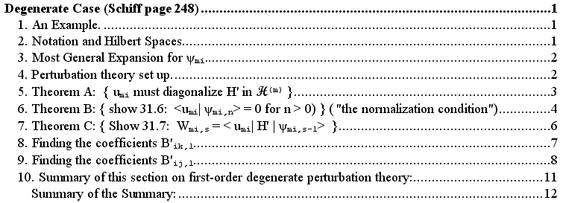

1. Example of simple spins in magnetic field situation where the B field is the perturbation. Skeletal only.

2. The idea of H = H(m)⊕ H⊥ where my H(m) is Messiah's Ea0, I use dimensionality N.

3. Most general start is ψmi = umi + Σj=1,N Bij umj + Σk≠m Bik uk
before we do the norm trick.

4. Here I look at the full SE, the expansions, and end up with the "perturbation equations" :

(H0 - Em) ψmi,0 = 0 s = 0
(H0 - Em) ψmi,1 = (Wmi,1 - H' ) ψmi,0 s = 1
(H0 - Em) ψmi,2 = (Wmi,1 - H' ) ψmi,1 + Wmi,2 ψmi,0 s = 2
(H0 - Em) ψmi,3 = (Wmi,1 - H' ) ψmi,2 + Wmi,2 ψmi,1 + Wmi,3 ψmi,0 s = 3

5. Theorem A says that states which solve the above perturbation equations must diagonalize H' within H(m). These are my Messiah states |0; n,ε1>. If you start with random basis functions for H(m), when you hit this level 1 EV problem, you have to use these new states which diagonalize H'.

6. Theorem B is the idea that we renormalize ψ and move to the B' coefficients and we then have

ψmi = { umi + Σj≠iB'ij umj } ⊕ Σk≠m B'ik uk

ψmi,0 = umi n=0
ψmi,n = { 0 + Σj≠iB'ij,n umj } ⊕ Σk≠m B'ik,n uk n = 1,2,3...

and we then find the normalization condition <0|n> = <ψmi,0 | ψmi,n> = 0 for n>0 for any state. The idea here is that now there is no perturbation change "in the direction of umi". We have normalized it out.

7. Theorem C derives the level s correction energy formula Wmi,s = < umi| H' | ψmi,s-1>

8. Here we compute the B'ik,1 coefficients within H⊥ and find: B'ik,1 = H'ki/ (Em - Ek) .

9. Here we compute the B'ij,1 coefficients within H(m) and find two interesting results:

(a) Wmi,2 = Σk≠m B'ik,1H'ik = independent of the B'ij,1 coefficients

= Σk≠m H'mk (Em - Ek)-1H'ki = (H'Q0mH')ii = Wmi,2

where Q0m = Q0(Em– H0)-1Q0 and Q0 = Σk≠m |uk><uk|, all these from Messiah.

(b) B'ij,1 = (Wmi,1 – Wmj,1 )-1 Σk≠m B'ik,1H'jk

= (Wmi,1 – Wmj,1 )-1Σk≠m H'jk (Em - Ek)-1H'ki

= (Wmi,1 – Wmj,1 )-1 (H'Q0mH')ji as long as Wmj,1 ≠ Wmi,1

and this last is the state "n" situation in my usual Messiah drawing. The states i and j are only required to diagonalize H', and the matrix H' Q0mH' is in general not diagonal. You can think of B'ij,1 as the amplitude to start in i, propagate through H' to each k and propagate back through another H' to j.

10. This is a summary section, but I think the meta notes above have gathered up everything.

Now we move on to the second part of these notes with this TOC:

PART 2: Systematic all-orders attack; handling of the case Wms,1 = Wmi,1

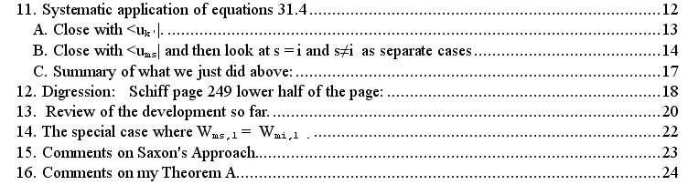

11. Here I set out to do all orders "at once". I write out the completely general equations and I come up with an iterative method to solve for corrections to all orders, provided the state of interest is not degenerate after the first diagonalization of H' (it is like Messiah notes state "n"). The gory details are done in subsections A and B, and are then summarized in C. Here is a copy of that C summary:

We took the general ladder equation and closed it first with <k| and second with <ums| and got lots of interesting results -- here they are:

ψmi,n = { Σj≠iB'ij,n umj } ⊕ Σk≠m B'ik,n uk n = 1,2,3...

Wmi,1 = H'ii (0)

Closure with <uk'|:

(Ek' - Em) B'ik',1 = - H'k'i n = 1 (1)

(Ek' - Em) B'ik',n = – Σj≠iB'ij,n-1 H'k'j n > 1

– Σk≠m B'ik,n-1H'k'k + Σt=1,n-1 Wmi,t B'ik',n-t (2)

Closure with <ums|:

(H0 - Em) ψmi,1 = - H' umi + Wmi,1 umi n = 1 (3)

B'is,n-1(1 - δs,i) [Wmi,1 – Wms,1] n>1

= + Σk≠m B'ik,n-1H'sk – Σt=2,n-1 Wmi,t B'is,n-t(1 - δs,i) – Wmi,n δs,i

The last equation (not numbered) can be further broken down as to whether s ≠ i or s = i:

B'is,n-1 [Wmi,1 – Wms,1] = Σk≠m B'ik,n-1H'sk – Σt=2,n-1 Wmi,t B'is,n-t s ≠ i (4)

Wmi,n = Σk≠m B'ik,n-1 H'ik s = i (5)

The very last equation states the famous result Wmi,n = <umi | H' | ψmi,n-1>.
Now what kind of iterative scheme do these equations allow? I am now happy to consider a state "i" which is like the state "n" in our Messiah picture, one that has become a singlet after the first level EV equation. What then can we learn about this singlet state i's coefficients?

• First, we know B'ik',1 from equation (1), and we know the Wmi,1 from (0)

• We set n = 2 in equation (4) to find B'is,1 which has only the leading term on the RHS. This equation then says B'is,1 [Wmi,1 – Wms,1] = Σk≠m B'ik,1<ums| H' |uk> = (H'Q0mH')si

• We set n = 2 in equation (5) to get Wmi,2 = Σk≠m B'ik,1 H'ik = (H'Q0mH')ii.

• We set n = 2 in equation (2) to get B'ik',2 in terms of the B'ik',1

• We set n=3 in equation (4) to get B'is,2 in terms of B'ik,2 and B'is,1 and Wmi,2

And so on. So, for a singlet state "n", this set of equations allows us to compute the corrected state ψmi,n to arbitrarily high order. The iterative process seems totally well defined. There might be some "operator method" to put things into a more compact notation, but eventually we have to do all the calculations at each stage that this iterative method implies.

12. This section really is a digression, way out of the main flow. I return to it below.

13. This "review" pretty much exactly duplicates the review at the end of section 11 above, which I quote directly above. I probably should just remove this thing and put the digression elsewhere too, but for now things stay in the original order.

14. The special case where Wms,1 = Wmi,1 . This takes us to the analysis of the "m" type states in this Messiah picture I keep pasting again and again

We assume that our states "i" and "s" are in the above bundle of N1 degenerate states. Consider the second bulleted item above,

B'is,1 [Wmi,1 – Wms,1] = Σk≠m B'ik,1<ums| H' |uk> = (H'Q0mH')si

For both states i and s in the N1 bundle, the LHS is 0 and we get

(H'Q0mH')si = 0 i,s both in the group N1

This tells us that the "legal" states in the N1 bundle must be linear combinations of the original states which have the property that they diagonalize the matrix H'Q0mH' !!! This is a new rule that has appeared out of nowhere when we just start pondering the situation where things remain degenerate after the first round. So how do we find states which diagonalize a matrix? We consider the eigenvalue problem H'Q0mH' |i> = Ki |i>. But from the third bullet above, we know that the diagonal elements of the matrix H'Q0mH are the Wmi,2 energy corrections. Thus we have

H'Q0mH' | i > = Wmi,2| i > // where 1 means first order

This EV equation is defined in our N1 dimensional degenerate space, and the eigenvectors give us the N1 proper legal linear combination of the H(m) starting states that cause diagonalized H'Q0mH'. One of these is/becomes the state "m" shown above.

Now consider that |i > = Σj≠iB'ij,1 |umj> = the portion of our first order state correction that lies in the space Ea0. Our "solution for the B'ij,1" is the same as our solution for the eigenstates to the above EV problem, so we are suddenly done! We start with some starting states and diagonalize H'Q0mH' and then we know the B'ij,1 . There is no need for more elaborate equations here! So this is how the B'ij,1 get determined in this doubly degenerate case. In the other case, we just get B'ij,1= [Wmi,1 – Wmj,1]-1 (H'Q0mH')ji.
Now, it is not clear to me what happens to our iterative program in this case! The LHS of equation (4) is zero in all orders now, so the iterative chain described above is now broken. This is where I think Kato comes to the rescue.

12. OK, here are the digressive Schiff notes deferred above. In these notes, I peruse Schiff's treatment of the degeneracy problem in the case N = 2 where there is no perp space of |k> states to worry about. I bemoan his weak notation, but I am able to derive all of his results using my clearer notation. We start with our level 1 EV equation, where he refers to the degenerate states as l and m,

$\left(\begin{matrix}H11 & H12 \\ H21 & H22\end{matrix}\right)$$\left(\begin{matrix}a \\ b\end{matrix}\right)$ = W1$\left(\begin{matrix}a \\ b\end{matrix}\right)$
=>
( H11 - W1) a + H12 b = 0 m =1 l = 2 a = am b = al // Schiff 31.15 (p249)
H21a + (H22-W1)b = 0

The secular equation gives the eigenvalues

W1 = (H11 + H22)/2 ± [ (H11 – H22)2 +4 |H12|2 )]1/2/2 // Schiff 31.16 (p249)

Then my equation (2) above becomes this

(Em - Ek)B'ik,1 = <uk| H' |umi > k in H⊥

But then I write |umi > = a |1> + b|2> in ket notation and then I get

(Em - Ek)B'ik,1 = <uk| H' |1 >a + <uk| H' |2 >b // Schiff 31.18 (p250)

He never goes on to find the eigenvectors (a,b), just the energy correction as noted above. I then attempt to relate his notation to mine,

me Schiff me
Wmi,1 W1
B'ik,1 a k(1)
B'ij,1 a l(1) , am(1) B'12,1 and B'21,1 ( I think)

ψ1 = Σn an(1)un // Schiff
ψmi,1 = { Σj≠iB'ij,1 umj } ⊕ Σk≠m B'ik,1 uk // me

I then quote someone's web comment that they too were very confused by Schiff on this subject.
When it comes time for me to do this simple example, I will do it in my own notation. This is certainly the simplest possible example of level 1 degeneracy!

15. Comments on Saxon's approach on this perturbation theory. Here is what I have to say:

• There are no explicit power series expansions, but we are given a successive approximations rule.
• He does not normalize ψ in the special way that makes <umi| ψmi- umi> = 0.
• He does not "require" that H' must start off being diagonal in the umi, though he does end up with a result that gives the required linear combinations.
• He tends to work with objects "to all orders" rather than "in particular orders"
• He uses what I call Dij coefficients in place of Schiff's B'ik coefficients.

16. Comments on my Theorem A. -- a little collection of odd questions and past confusions

(1) First, I ponder a way to think of how Saxon does things, how he handles "orders of λ " .

(2) At the time I wrote these notes, I was still puzzled by why H' was "forced to be diagonal" and this was what I called Theorem A. I now understand this as the level 1 EV equation which must be satisfied so our states satisfy the perturbation equations, so this is no longer a mystery to me. I saw the light finally.

(3) Here I wondered if there was anything we could know about <0; i | n; j> for i ≠ j. We know when i = j that <0; i | n, i> = 0 for n>0 due to the Schiff/Messiah "normalization condition". After some fiddling, I found it was not 0, and therefore the result is not interesting. It is just the projection of a state onto another state, probably just my B'ij,n coefficient !

(4) Here I proposed a certain Theorem D which seems to say that B'ij ≡ 0 to all orders, despite our calculations in sections reviewed above! But then I showed that the "proof" of this fact was completely bogus and resulted from "hazy math" that was far from true.

