Multipole expansion of electric potential PhL 11.16.07

This is a horribly complicated subject when you dredge the outer limits, but I will try to summarize things here as best I can. I will show the logic flow, but won't actually derive any of the equations. We can do that some rainy day after the flow is well understood. The expansion of vector quantities does not appear here, see a separate older doc on that subject.

Contents:
1. Spherical Multipole Expansion of the Electric Potential
2. Taylor Expansion of the Electric Potential
3. Comments on the above two sections.
4. Multipole (Taylor) expansion of the potential energy in a charge distribution.
5. Can you write a multipole expansion for the charge density itself ??
6. Multipole Expansion using the angle γ.
7. Multipole expansion of the energy of two overlapping charge densities.
8. Angular Momentum Algebra
9. Derive formula (17.11) of Levitt.
10. Raab and De Lang Cartesian multipole expansions (from Google site)
(a) electric potential through octupole (1.3)
(b) electric field to same order (1.13)
(c) magnetic potential A through quadrupole order, definition of m_{jk}
(d) magnetic field through quadrupole order
(e) force and torque between a B field and the magnetic moments (1.59), (1.64)
(f) magnetic potential energy (interaction Hamiltonian) through quadrupole (1.67)

____________________________________________________________________________

1. Spherical Multiple Expansion of the Electric Potential

credits: http://en.wikipedia.org/wiki/Spherical_multipole_moments

First of all, we can write the potential of a point charge q at location r' viewed from position r as follows:

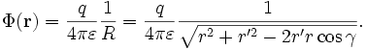

where R = | r - r'| and r' is the location of the charge in space, and we are here in SI units which have an extra 1/4πε compared to Jackson equations like (1.48) on page 20. [ I think Jackson may have changed to SI units in his later editions ]. We know that γ is the angle between the two vectors r and r'. The above expression on the right is derived from simple geometry. The above is symmetric in r and r', it happens.

Imagine the inverse square root as a function of x= (r'/r) and cosγ. Expand it in a power series in x of the form Σ x f(cosγ), then integrate to determine the f functions and you find they are P 's. Dealing with the inside and outside issues, you then end up with this single-sum expansion of the potential

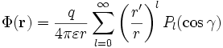

where now we have assumed that r = max(|r|, |r'|) and r' = min(|r|, |r'|). The next step is to expand the Legendre in a factorized summation form where now we have the polar angles of r and r' :

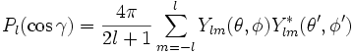 // "addition theorem"

Inserting this then gives the result:

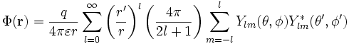

with r and r' max and min as noted earlier. This appears in Jackson on page 679 as (3.70).
Now, suppose instead of having a single point charge q, we have a charge density ρ(r') where we recall that r' is the location of the charge and r is the viewing point. We now assume that r > r' for all of ρ(r') so we are viewing from outside a sphere containing the entire charge distribution. Suppose we then integrate the above formula over the r' angles. We could then define:

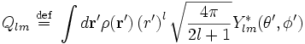

and in terms of this Q_{m} thing we could write our potential expansion as follows:

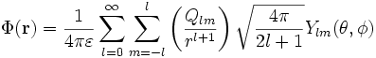

This then is the "multipole expansion of the electric potential of a charge distribution ρ as viewed from a point r which lies outside the entire charge distribution." The quantities Q_{m} care called the "electric multipole moments" of the charge distribution.
Notice that we don't see any "spatial derivatives of the potential" appearing in this formula.

2. Taylor Expansion of the Electric Potential

Imagine a unit point charge located at position r, and we view the potential from point R. We are going to do a Taylor expansion of the potential about the origin r = 0 (not about point R!). Thus, our expansion will be reasonable if the charge is somewhere "close to the origin" so r is "small". We get,
[ Greek letters represent Cartesian x,y,z components, sum on repeats ]

φ(R; r) = 1 / | r - R| = φ(r=0) + r_{α}∂_{α}φ + (1/2) r_{α}r_{β}∂_{α}∂_{β}φ + (1/3!) r_{α}r_{β}r_{γ}∂_{α}∂_{β}∂_{γ}φ + ...

where all the derivatives shown are evaluated at r = 0. Normally we would write just φ(R) for the potential at viewing point R, but the potential is a function of both variables R and r, and it happens that we are expanding in the variable r. The factors in front are just overcount correctors. We have shown the dipole, quadrupole and octupole terms here, and higher terms have the same pattern. Now we can go off and compute these derivatives. Consider: [ ∂_{α} means diff with respect to r_{α} ]

f = 1/ | r - R| ∂_{α}f = -(1/2) [ 1/ | r - R|³ ] 2 (r_{α} - R_{α}) => ∂_{α}f|^{r=0} = + R_{α}/R³

Using the ∂_{α}f shown right above here, we can apply ∂_{β} to get

∂_{β} (∂_{α}f) = -δ_{αβ} / | r - R|³ + 3 (r_{α} - R_{α}) (r_{β} - R_{β}) / | r - R|⁵

=> ∂_{β} (∂_{α}f)^{|r=0} = -δ_{αβ}/R³ + 3R_{α}R_{β}/R⁵ = (1/R⁵) [ 3R_{α}R_{β} - δ_{αβ}R²]

As a side comment, notice that trace(∂_{α}∂_{β}φ) = 0. But this says ∂_{α}∂_{α}φ = 0 which is Laplace's equation, so this serves to confirm the correctness (somewhat) of our last calculation.
Next, let's throw out the octupole term for the moment, and rewrite the quadrupole term as follows:
[ we now just show the "viewing point argument R" inside φ(R). ]

φ(R) = 1 / | r - R| = φ(0) + r_{α}∂_{α}φ + (1/6) [ 3r_{α}r_{β} - δ_{αβ}r² ] ∂_{α}∂_{β}φ + octupole and higher terms

In the [...] bracket, the first term replicates the term we had in the first place, and the second term is really zero because ∂_{α}∂_{α}φ = 0. The advantage of this last step is that the bracket is now traceless and looks very much like our second derivative. Now let's install our derivatives to get:

φ(R) = 1/ | r - R| = 1/R + (r_{α} R_{α} )/R³ + (1/6) [ 3r_{α}r_{β} - δ_{αβ}r² ] [ 3R_{α}R_{β} - δ_{αβ}R²]/R⁵ + ...

and we can marvel at the extreme symmetry of the result. Now, if R is located close to the charge, so R and r are the same order of magnitude, then all the terms are order 1/R and our expansion is not converging! That is, each term is the same general size. We want the terms to be getting smaller. That requires that R be large compared to r. Then the terms are 1/R, 1/R², 1/R³ and so on.
Now imagine a set of charges q_{i} placed at locations r_{i} . We assume each charge is close to the origin, so we are justified in doing the expansion separately for each charge! That is to say, for the charge at r_{i} , we are expanding around r_{i} = 0. We then generalize our result above as follows by adding the contribution of each term in the potential, each having its own expansion:

φ(R) = Σ_{i} q_{i} / | r_{i} - R|

= {Σ_{i} q_{i} } /R + R_{α} { Σ_{i} q_{i} r_{iα} }/R³ + (1/6) [ 3R_{α}R_{β} - δ_{αβ}R² ] { Σ_{i} q_{i} [ 3r_{iα}r_{iβ} - δ_{αβ}r_{i}²] } /R ⁵ + ...

At this point, we isolate the {} bracketed quantities as follows:

Q = Σ_{i} q_{i} = "monopole moment" = the total charge

P_{α} = {Σ_{i} q_{i} r_{iα} } = "the dipole moment"

Q_{αβ}= {Σ_{i} q_{i} [ 3r_{iα}r_{iβ} - δ_{αβ}r_{i}²] } = "the quadrupole moment"

For continuous distributions of charge, we would write these as:

Q = ∫d³r ρ(r)

P = ∫d³r ρ(r) r

Q_{αβ} = ∫d³r ρ(r) (3r_{α}r_{β} - δ_{αβ}r²)

This Q thing is the "Cartesian quadrupole moment" as opposed to the Q_{m} thing appearing above in our spherical harmonic expansion.
In terms of these moments, we can then write

φ(R) = Q/R + R•P/R³ + (1/6) [ 3R_{α}R_{β} - δ_{αβ}R² ] Q_{αβ}/R⁵ + ...

In order to get reasonable convergence of this expansion, we must have R >> a where a is the diameter of a sphere bounding all the charges.
One normally expresses this final result by rewriting in terms of a lower-case r, so now we change our viewing point from R to r and write:

φ(r) = Q/r + r•P/r³ + (1/6) [ 3r_{α}r_{β} - δ_{αβ}r² ] Q_{αβ}/r⁵ + ...

Notice the symmetry here. Both r and P are vectors. Both [ 3r_{α}r_{β} - δ_{αβ}r² ] and Q_{αβ} are traceless tensors. I wonder what the octupole term looks like.

3. Comments on the above two sections.

In Section 1, we write a formula expressing a potential φ(r) in terms of the moments of a charge distribution using the angular momentum basis functions. But we don't do any Taylor expansion in this section. In Section 2 we do the Taylor expansion in order to find the Cartesian moment expansion of the same φ(r) potential. The first expansion is easy to write to all orders, but the second we only write through quadrupole order.

4. Taylor expansion of the potential energy in a charge distribution.

Start with Jackson's formula (1.53) on page 21 which says

W = (1/2) ∫d³r ρ(r)φ(r)

Now treat the potential φ(r) as a function of r and Taylor expand it about the origin r = 0:

φ(r) = { φ(0) + r_{α}∂_{α}φ + (1/6) [ 3r_{α}r_{β} - δ_{αβ}r² ] ∂_{α}∂_{β}φ } + octupole and higher terms

where derivatives are now evaluated at r = 0. This time we don't know the potential φ, so we just leave these derivatives in place. The derivatives are just constants since evaluated at r=0, so insert to get

W = (1/2) ∫d³r ρ(r){ φ(0) + r_{α}∂_{α}φ + (1/6) [ 3r_{α}r_{β} - δ_{αβ}r² ] ∂_{α}∂_{β}φ }

= (1/2)[ φ(0) ∫d³r ρ(r) + (∂_{α}φ) ∫d³r ρ(r) r_{α} + (1/6) (∂_{α}∂_{β}φ) ∫d³r ρ(r) [ 3r_{α}r_{β} - δ_{αβ}r² ] + ...

We now of course recognize the moments defined above,

Q = ∫d³r ρ(r) P = ∫d³r ρ(r) r Q_{αβ} = ∫d³r ρ(r) (3r_{α}r_{β} - δ_{αβ}r²)

so we end up with

W = (1/2)φ(0)Q + (∂_{α}φ) P_{α} + (1/6)(∂_{α}∂_{β}φ) Q_{αβ} + octupole and higher

Comment: this is the expansion Levitt refers to on page 172.

5. Can you write a multipole expansion for the charge density itself ??

AKA : How to expand any scalar function ρ(r) using spherical harmonics.

Following the previous section, we would write:

ρ(r) = { ρ(0) + r_{α}∂_{α}ρ + (1/6) [ 3r_{α}r_{β} - δ_{αβ}r² ] ∂_{α}∂_{β}ρ } + octupole and higher terms

This is not a very useful concept I suspect. For example, if you try to integrate this term by term over all space, each term blows up.
But suppose we try to expand ρ(r) in the following manner: [ for each value of r, ρ(r,θ,φ) is some function g(θ,φ) and you can expand any reasonable g(θ,φ) on the spherical harmonics, that is my argument at least. ]

ρ(r) = Σ_{m} f_{m}(r) Y_{m}(θ,φ)

Multiply both sides by Y_{'m'}(θ,φ) and integrate over dΩ, then you get

∫dΩ ρ(r)Y_{m}(θ,φ) = f_{m}(r)

so you could compute the part of ρ(r) that belongs to each multipole. Namely:

ρ_{m}(r) = f_{m}(r) Y_{m}(θ,φ)

Then you could express your total charge density as the Levitt like sum:

ρ(r) = Σ_{m} ρ_{m}(r)

So, I guess you really can expand a charge density in this way, and this is what Levitt means by his equation (7.3). You can expand any reasonable scalar function in this way. The only problem using this with ρ is that ρ doesn't solve something simple like the Laplace equation, so we don't know what the f_{m}(r) are until someone hands you a ρ(r) and then you can compute f_{m}(r) . But these functions must exist for any ρ because we how to compute them.

6. Multipole Expansion using the angle γ.

Back in section 1 we had we took φ = (1/4πε₀) 1/ |r - r' | and expanded in this way

where γ is the angle between r and r' and r = max(|r|, |r'|) and r' = min(|r|, |r'|). The charge q is located at position r'. Let's do our same trick of having a set of charges q_{i} at positions r_{i}' and make sure that r is outside all these charges. Then we have: [ I will ignore the 4πε₀ from now on ]

φ(r) = Σ_{i} q_{i} (1/r)⁺¹ Σ (r'_{i}) P(cosγ_{i}) = Σ (1/r)⁺¹ [ Σ_{i} q_{i} (r'_{i}) P(cosγ_{i}) ]

Now you could write q_{i} = q_{i}(γ_{i}, r_{i}) meaning that the two variables γ_{i} and r_{i} determine where this charge is. And we could then write that as a continuous charge density ρ(γ,r). Then the bracketed quantity in the above becomes ∫d³r ρ(γ,r) (r ) P(cosγ). Write d₃r = 2π r² dr d(cosγ) where we pre-integrate over the azimuthal coordinate. Ie, we are using spherical coordinates where θ is γ. So we have

[ Σ_{i} q_{i} (r'_{i}) P(cosγ_{i}) ] = 2π ∫r²dr ∫d(cosγ) ρ(γ,r) (r ) P(cosγ) = ∫dV ρ(r) (r ) P(cosγ)

At this point we can replace γ with the more usual name θ and have

M = 2π ∫r²⁺ dr ∫d(cosθ) ρ(r) P(cosθ)

Since P₀ = 1 and P₁ = x and P₂ = (3x²- 1)/2 [ see MM page 98 ] we have:

M₀ = ∫dV ρ(r) = total charge

M₁ = ∫dV ρ(r) r cosθ = ∫dV ρ(r) z

M₂ = 1/2 ∫dV ρ(r) r² (3cos²(θ)- 1) = 1/2 ∫dV ρ(r) ( 3z² - r² ) = 1/2 Q₀

Convention seems to define Q₀ without the factor of 1.2, so [ this is really Q20]

Q₀ = ∫dV ρ(r) ( 3z² - r² ) M₂ = Q₀/ 2

This thing Q₀ is also called a quadrupole moment, but is different from the two things we found earlier which we also called by the same name: Q_{m} and Q_{αβ} . Notice that if ρ(r) is radially symmetric, you get the integral ∫dx (3x²-1) on [-1,1] which is exactly 3*2/3 - 2 = 0, so no quadrupole moment. A nucleus with a quad moment has a flattened charge shape of some sort.

7. Multipole expansion of the energy of two overlapping charge densities.

This is taken from a PDF I now have (and printed), written by Jerschow, chemistry NYU late 2004. The energy of interest is this: [ this appears in Jackson on page 21 as equation (1.52), but Jackson has an extra 1/2 out front to correct for overcounting. That is because he is computing the self-energy of a single charge distribution. Since we are dealing with two separate distributions, there is no factor 1/2 since there is no overcounting. ]

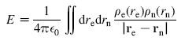

where we are thinking explicitly that e = electron charge density and n = nuclear charge density.
We expand the denominator in the usual manner,

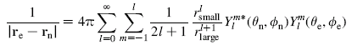

Even though it is not true inside the nucleus itself, we still just assume that r_{small} = r_{n} and r_{large} = r_{e}. That is, we assume this at all points in space, even though not true inside the tiny nucleus. If we think about the volume of the double integration in terms of the radial magnitudes we can draw this picture:

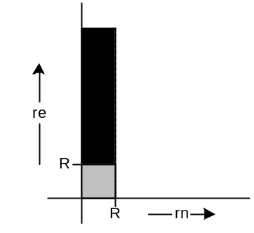

Most of the integral contribution comes from a thin vertical strip as shown, because we think the charge density of the nucleus stops abruptly at some radius R, due to the nuclear force. By making the assumption just stated, we are going to make an error in the grey square area, but this is so tiny compared to the infinitely high cross hatched region, that we think this error will be negligible.
Once we insert the 1/R expansion as shown (which really now has r_{n} / r_{e}⁺¹ inside), because each term in the sum factorizes between the two coordinate systems, we can move say the dr_{e} integral all the way to the right where only the factors 1/ r_{e}⁺¹ and Y_{m}(θ_{e},φ_{e}) lie to its right. Then the dr_{n} integral picks up the other factors. We choose where to put our overall constants and then get this result:

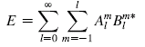

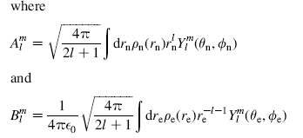

So this then is a multipole expansion of the electrostatic energy stored in two overlapping charge distributions where the n one is very small. the numbers A_{m} exactly our Q_{m} shown in Section 1 above, which we would call the spherical moments of the nuclear charge distribution. The B_{m} are something else, not clear what you would call it, some kind of moments of the electron charge distribution.
The objects Y_{m}(θ,φ) are simply functions, and the A_{m} and B_{m} are complex numbers.

8. Angular Momentum Algebra

Right now I don't have a perfect source with all this stuff, so I will piece things together from the web

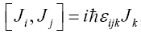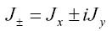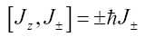
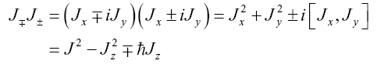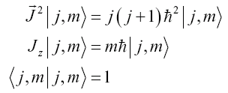

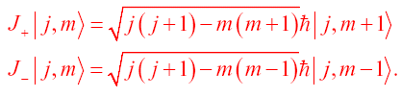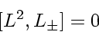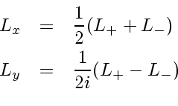
spherical harmonics

Now the |m> span a Hilbert space whose states diagonalize L² and L_{z} . When we close with <θφ| we obtain these vectors expressed in a coordinate representation, and those are the spherical harmonic functions. We can find representations of the various angular momentum operators in this space, such as

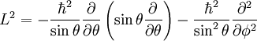

 |  |  | 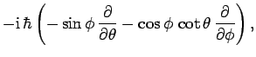 | (530)
 |  |  | 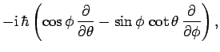 | (531)
 |  |  | 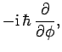 | (532)
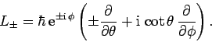

Consider these results from above:

L⁺ | m> = [ (+1) - m(m+1) ] ^{1/2} | m+1>
L⁻ | m> = [ (+1) - m(m-1) ] ^{1/2} | m-1>

If we close on the left with |θφ > we get

<θφ | L⁺ | m> = [ (+1) - m(m+1) ] ^{1/2} <θφ | m+1>
<θφ | L⁻ | m> = [ (+1) - m(m-1) ] ^{1/2} <θφ | m-1>

For the top line we can do this: note that <θφ |m> L⁺_{op} (1) = 0

<θφ | L⁺ | m> = L⁺_{op} <θφ |m> = [ L⁺_{op}, <θφ |m> ]

This equation exists in the space of complex numbers, not differential operators or abstract operators. In this space we can therefore write [ here "op" means the angle differential operators shown above ]

[ L⁺_{op}, <θφ |m> ] = [ (+1) - m(m+1) ] ^{1/2} <θφ | m+1>
[ L-⁺_{op}, <θφ |m> ] = [ (+1) - m(m-1) ] ^{1/2} <θφ | m-1>
[ L₃^{op} , <θφ |m> ] = m <θφ |m>

But this tells us that:

[ L⁺_{op} , Y_{m}(θ,φ) ] = [ (+1) - m(m+1) ] ^{1/2} Y_{m+1}(θ,φ)
[ L⁻_{op} , Y_{m}(θ,φ) ] = [ (+1) - m(m-1) ] ^{1/2} Y_{m-1}(θ,φ)
[ L³_{op} , Y_{m}(θ,φ) ] = m Y_{m}(θ,φ)

Now we make a definition: Suppose you have a set of operators A_{m} that obey the above equations written in operator space:

[ L⁺ , A_{m} ] = [ (+1) - m(m+1) ] ^{1/2} A_{m+1}
[ L⁻, A_{m} ] = [ (+1) - m(m-1) ] ^{1/2} A_{m-1}
[ L³ , A_{m} ] = m A_{m}

Any operator in the abstract Hilbert space spanned by the | m> that obeys there rules is defined to be a spherical tensor operator.
Here is a little extra I would like to add to this section. Consider two vectors a and b. We define the + and - components of these vectors as we did for L/J above

and
and you then find that

a•b= a_{z}b_{z} + (1/2) [ a₋ b₊ + a₊ b₋]

9. Derive formula (17.11) of Levitt.

We start with our result of Section 7 above,

As an aside, notice that Y_{m}(θ,φ)* = (-1)^{m} Y_{m}(θ,φ) so that: B_{m}* = (-1)^{m} B_{,-m}

where E is the electrostatic energy stored in the nuclear + electronic charge densities. The above is a classical result only, the A and B are just numbers.
Now comes the "transition from classical to quantum mechanics". We want to take the above energy formula and interpret it as a Hamiltonian operator in the Hilbert space spanned by the nuclear spin vectors we write as | I,M>. These are good quantum numbers for the nucleus, they do form a Hilbert space, and it seems a reasonable assumption that we have a correct Hamiltonian by so doing. We can interpret the charge distribution scalar function as this expectation value: <ψ | ρ(r) | ψ > = where r is now an operator in our Hilbert space and | ψ> = | ψ_{IM}> is our nuclear state (probably our ground state). The angles in the spherical harmonic functions can also be imagined as operators, and the integration is a summation of operators, and the sums A_{m} and B_{m} are themselves now operators. We replace the * with † on the B operator in our new Hamiltonian which is now this:

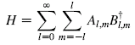

I suppose you could show that this H is in fact a Hermitian operator, but I don't want to get sidetracked on that right now. Because Y_{m}(θ,φ) satisfies the usual commutation relations which define a spherical tensor operator (see previous section), we know that the summations which form A_{m} and B_{m} are also spherical tensor operators!
Now let's look specifically at the quadrupole operator A_{2m} . First, we go look up this fact:

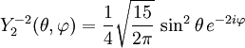
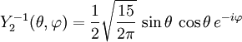
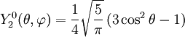
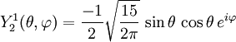
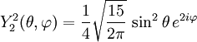

and we keep in mind these facts

x = r sinθ cosφ
y = r sinθ sinφ
z = r cosθ

We then have:
A_{m} = sqrt(4π/5) * ∫dr ρ(r ) r² Y_{2,m}(θ,φ)

Notice that we then have r² sin²θ e^{2iφ} = (r sinθ [ cosφ + isinφ])² = (x + iy)² . Putting this in, and replacing the integral (for some reason) by a discrete charge sum, we find that

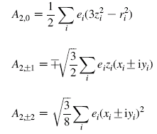

Again, the coordinates like x_{i} for the i^{th} nucleon are operators in our Hilbert space. We have just written out explicitly the 5 =2 spherical operator components.
The authors of our PDF paper now make this definition:

eQ = 2 < I,M=I | A₂₀ | I, M=I > = <II | Σ_{i} e_{i} ( 3 z_{i}² - r_{i}²) | II>

We are now thinking |,m> → | I,M> where I is the nuclear spin.
Now comes the Wigner-Eckart part of the derivation. We know from the WE theorem that ALL the matrix elements of a tensor operator can be obtained if you know ANY ONE of the matrix elements. The WE theorem says this: [ see http://electron6.phys.utk.edu/qm2/modules/m4/wigner.htm ]

where it is too bad the paste looks bad, but we can read it I think. The theorem is interested in the matrix element of a tensor operator T, <α',j',m' | T_{kq} | α,j,m>, where we previously have written T_{m} . Here, the α indicates quantum numbers other than angular momentum. The object <α',j' || T_{k} || α,j> is called the reduced matrix element, and it is just some function of α', j', k, α, j. The point is that all (2j+1)*(2k+1)*(2j'+1) matrix elements specified by <α',j',m' | T_{kq} | α,j,m> are all Clebsch-Gordon coefficients times this reduced matrix element number, whatever it is. Our author has written the RHS of the WE theorem in 4 different ways because he is writing the C-G coefficients in 4 different ways -- the reduced matrix element is the same in all cases. The second way with C^{j'}_{mq} looks wrong to me because there are not enough labels on the C symbol, but that is just the way this symbol is define. Consider:

.
The first line tells you a j-j coupling state as a sum over L-S states, so to speak. This is the details of what we mean by saying j = j₁⊗j₂ . The second line shows the reverse direction where m = m₁+ m₂. Here are some properties of the CG coefficients written as Wigner 3-j symbols:

Properties of the Wigner 3-j symbols:
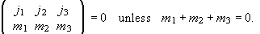
We can permute the columns of the 3-j symbol. An even permutation does not alter its value. An odd permutation multiplies the initial value by . Moreover,
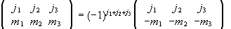.
This implies
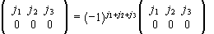
or
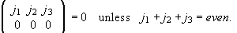

I could probably find a better website than http://electron6.phys.utk.edu/qm2/modules/m4/wigner.htm and get cleaner copies of these things, but it is at least readable.
Now we are going to apply this theorem to our situation (these pastes are stolen from

http://books.google.com/books?id=0BSOg0oHhZ0C&pg=PA78&lpg=PA78&dq=quadrupole+moment+quantum&source=web&ots=VRbCjb5ZRn&sig=oxAyXWcB_gFxc3EAbUe6IXFJNDk#PPA78,M1

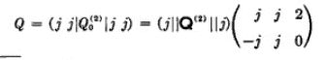

Let's see if we agree with this. The quoted theorem has k = 2 in the middle, but we want to permute the columns by one column to get the above. That picks up a phase factor (-1) ^{j + j + 2} = (-1)^{2j} and remember that j can be half-integral. The phase appearing in our theorem above is (-1)^{-j+2-j} = (-1)^{2j} and this cancels away with our permuting factor, so the above is exactly correct.
So we have embodied our reduced matrix element into the number "Q". But now, we say this:

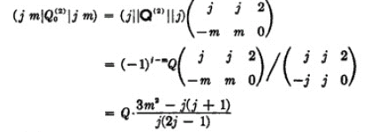

I have not verified these steps, but I know that the resulting CG coefficient is some function of m and j, so the result seems quite reasonable:
Now comes the very tricky step. Suppose we make this operator replacement:

Q⁽²⁾₀ → [Q/j(2j-1)] [ 3 J₃² - J² ]

where J₃ and J² are our usual spin operators. If we took the above matrix element of either the original operator or its replacement, we get the same expectation value!! That is,

< j m | Q⁽²⁾₀ | jm > = [Q/j(2j-1)] < j m | [ 3 J₃² - J² ] | jm >

Thus, if all we are going to do is evaluate these diagonal matrix elements, then the two operators are equally useful. We are not saying this:

Q⁽²⁾₀ = [Q/j(2j-1)] [ 3 J₃² - J² ] // not true

There is no way in the world that some coordinate-based operator Q⁽²⁾₀ which knows nothing about nuclear spins is going to be equal to the spin operator shown. It is just that we may make the replacement if all we want to do is evaluate diagonal matrix elements! That is the point to understand here. The replacement is a convenient way to track those CG coefficients, that is all it really is.
So, with this meaning in mind, we make this replacement:

< I,M | A₂₀ | I, M > = [Q/I(2I-1)] < I,M | [ 3 I₃² - I² ] | I, M >

But our PDF authors used Q_{pdf} where Q = eQ_{pdf}/2, so we make this change to get back into alignment with the notation of the PDF paper:

< I,M | A₂₀ | I, M > = [eQ/2I(2I-1)] < I,M | [ 3 I₃² - I² ] | I, M >

If we now define a new Q tensor object as follows:

Q_{2,0} = [eQ/2I(2I-1)] [ [ 3 I₃² - I ² ]

Then we have shown that

< I,M | A₂₀ | I, M > = < I,M | Q_{2,0} | I, M >

I think the PDF author has made a few errors. First, the use I(I+1) instead of I², and secondly they have a wrong factor of α two lines above their line (23).
Now, we know that Q_{2,0} is the 2,0 element of a 5-element set of tensor operators, and we should be able to compute the other elements using raising or lowering operators. So let's start with one of our results in the angular momentum section above:

[ L⁺ , A_{m} ] = [ (+1) - m(m+1) ] ^{1/2} A_{m+1}

which we now modify to our current needs,

[ I⁺ , Q_{2,0} ] = [ 2(2+1) - 0(0+1) ] ^{1/2} Q_{2,1} = [ 6 ] ^{1/2} Q_{2,1}

But we now get

[ I⁺ , Q_{2,0} ] = { eQ/2I(2I-1) } [ I⁺ , 3 I₃² - I ² ] = { eQ/4*3} [ I⁺ , 3I₃² ] = { eQ/4*3} 3 [ I⁺ , I₃² ]

We do know from our ang mom section above that [ I₃ , I⁺ ] = I₊ so [ I⁺ , I₃ ] = -I⁺ if we ignore the units, setting it to 1. We know that [a,b²] = [a,b] b + b [a,b] so we get

[ I⁺ , I₃² ] = [ I⁺ , I₃ ] I₃ + I₃ [ I⁺ , I₃ ] = -I⁺ I₃ + I₃ ( -I⁺ ) = - [ I⁺ I₃ + I₃ I⁺ ]

So we end up with:

Q_{2,1} = [ 6 ] ^{- 1/2} [ I⁺ , Q_{2,0} ] = [ 6 ] ^{- 1/2} { eQ/4*3} 3 (-1) [ I⁺ I₃ + I₃ I⁺ ]

= - [ 1/6 ] ^{1/2} (α/2) 3 [ I⁺ I₃ + I₃ I⁺ ] = - [1/6*4 ] ^{- 1/2} 3 α [ I⁺ I₃ + I₃ I⁺ ]

= - [ 9/6*4 ] ^{1/2}α [ I⁺ I₃ + I₃ I⁺ ] = - α [3/8]^{1/2} [ I⁺ I₃ + I₃ I⁺ ]

and this agrees with our PDF equation (20), exactly. If we were to repeat the calculation with the - sign, the square root 6 does not change, but we have [ I⁻ , I₃ ] = I⁻ so we get an overall sign change and this gives us the second of equation (20).
Now let's do one more:

[ L⁺ , A_{m} ] = [ (+1) - m(m+1) ] ^{1/2} A_{m+1}

[ I⁺ , Q_{2,1} ] = [ 2(2+1) - 1(1+1) ] ^{1/2} Q_{2,1} = [ 4 ] ^{1/2} Q_{2,2} = 2 Q_{2,2}

Then we have to compute // remember that

[ I⁺ , Q_{2,1} ] = - α [3/8]^{1/2} [ I⁺ , I⁺ I₃ + I₃ I⁺ ]

and we remember that

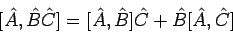

So [ I⁺ , I⁺ I₃] = I⁺ [ I⁺ , I₃] = - I⁺ ² . And also [ I⁺ , I₃ I⁺] = [ I⁺ , I₃] I⁺ = - I⁺ ² . So we get

[ I⁺ , Q_{2,1} ] = - α [3/8]^{1/2} [ I⁺ , I⁺ I₃ + I₃ I⁺ ] = - α [3/8]^{1/2} (-1) 2 I⁺ ²

and then

Q_{2,2} = 1/2 [ I⁺ , Q_{2,1} ] = α [3/8]^{1/2} I⁺ ²

which then agrees with our PDF paper equation (21).
The net result is that we know all 5 members of our tensor operator Q_{2,m} as follows:

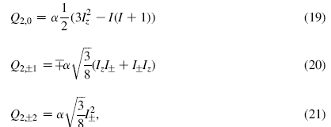

where we have to replace I(I+1) in (19) with I² (they just have an error there). So this was a good exercise of computing all members of a tensor operator if you are just given one member, using the raising and lowering operators in the commutator relations which define a spherical tensor operator in the first place.
We are pondering right now the quadrupole term of our Hamiltonian

so we are interested in:

H_{quadrupole}= Σ_{m} A_{2m} B†_{2m} ~ Σ_{m} Q_{2m} B†_{2m} = Σ_{m} Q_{2m} (-1)^{m} B_{,-m} // see note in Sec 6

where we have done the replacement of the A operator with the Q operator as outlined above. What are we going to do with our B operators?

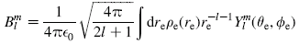

Let's look at B₂₀ which we can write out as

B₂₀ = (1/4πε₀) sqrt(4π/5) ∫d³r ρ(r)/r³ Y₂₀(θ,φ)

= (1/4πε₀) sqrt(4π/5) ∫d³r ρ(r)/r³ (1/4) sqrt(5/π)[ 3 cos²θ - 1]

= (1/4πε₀) 2/4 ∫d³r ρ(r)/r³ [ 3 cos²θ - 1]

= (1/4πε₀) (1/2) ∫d³r ρ(r)/r⁵ [ 3z²- r²] = (1/4πε₀) (1/2) Σ_{i} (-e)/r_{i}⁵ [ 3z_{i}² - r_{i}² ]

where at the end we sum over all electrons that make up the electron ρ(r), and each has the same charge of -e. Thus we have arrived at PDF equation (25).
At this point, let's go back and look at our Taylor series expansion for the energy of a charge distribution sitting in a potential, specifically [ again, no factor of 1/2 because this is not a self-energy ]

W = ∫d³r ρ_{e}(r)φ_{n}(r)

φ(r) = { φ(0) + r_{α}∂_{α}φ + (1/6) [ 3r_{α}r_{β} - δ_{αβ}r² ] ∂_{α}∂_{β}φ } + octupole and higher terms

W = [ φ(0) ∫d³r ρ(r) + (∂_{α}φ) ∫d³r ρ(r) r_{α} + (1/6) (∂_{α}∂_{β}φ) ∫d³r ρ(r) [ 3r_{α}r_{β} - δ_{αβ}r² ] + ...

And recall our PDF paper's first equation

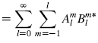

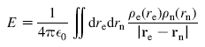

So if we ignore the (1/4πε₀), we can think of E and W as being the same thing, where the r in the first integral is r_{e} and ρ is for the electrons ρ_{e} (r_{e}) and then φ(r_{e}) = ρ_{n}(r_{n})/R = the potential that the electron sees at position r_{e} due to the nuclear charge distribution. In our Taylor expansion, we have a quadrupole term which is in Cartesian coordinates. I did not know how to do a Taylor expansion in spherical coordinates!
But let's look at just one of the terms in the "quadrupole" part of W shown above -- the term where α = β = 3. That term is

W_{quadrupole piece}= (1/6) (∂_{z}∂_{z}φ) ∫d³r ρ(r) [ 3z² - r² ] =

We are tempted to associate this one term with the following term in our Hamiltonian sum:

H_{quadrupole}= Σ_{m} A_{2m} B†_{2m} but only consider the A₂₀B†₂₀ term

Recall from the PDF paper also the fact that

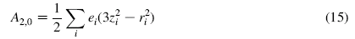

Thus we can write

W_{quadrupole piece}= (1/6) (∂_{z}∂_{z}φ) 2 * { (1/2) ∫d³r ρ(r) [ 3z² - r² ] } = (1/3) (∂_{z}∂_{z}φ) A₂₀

We would be tempted now to make this identification

B†₂₀ = (1/3) (∂_{z}∂_{z}φ) // but something is wrong here ....

and this is equation (26) except they have 1/2 and I have 1/3 ! I suspect by rotational symmetry you should triple the result since the ∂_{xx} and ∂_{yy} terms must be the same. So then I am missing 1/2.
Let's now go after this same type of result in a different way that is more direct. Recall that

B₂₀ = (1/4πε₀) (1/2) Σ_{i} (-e)/r_{i}⁵ [ 3z_{i}² - r_{i}² ]

We could write the electric potential due all these electrons (marked i) as follows:

φ(r) = (1/4πε₀)(-e) Σ_{i} (1/|r-r_{i}| ) // where r is the viewing point

As calculated in Section 2 above, we know that

∂_{β} (∂_{α}φ)^{|r=0} = (1/4πε₀)(-e) Σ_{i}(1/R⁵) [ 3R_{α}R_{β} - δ_{αβ}R²] // imagine each R as r_{i}

In particular, this says

∂_{z} (∂_{z}φ)^{|r=0} = (1/4πε₀)(-e) Σ_{i}(1/r_{i}⁵) [ 3 z_{i}² - r_{i}²] = 2 B₂₀

from which we conclude that

B₂₀ = (1/2) ∂_{zz}V(r)^{|r=0} // now this agrees with (26)

Let's now try to produce the B_{2,1} object:

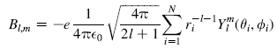

So we get

B_{2,1} = (-e) (1/4πε_{o}) sqrt(4π/5) Σ_{i} (1/r_{i})³ (-1/2) sqrt(15/2π) sinθ_{i}cosθ_{i} [ cosφ_{i} + isinφ_{i}]

Now make this replacement

(1/r_{i})³sinθ_{i}cosθ_{i} [ cosφ_{i} + isinφ_{i}] = (1/r_{i})⁵ z_{i} [ x_{i}+ i y_{i}]

So then have

B_{2,1} = (-e) (-1/2) (1/4πε_{o}) sqrt(6) Σ_{i} 1/r_{i})⁵ z_{i} [ x_{i}+ i y_{i}]

Now recall from above that

∂_{β} (∂_{α}φ)^{|r=0} = (1/4πε₀)(-e) Σ_{i}(1/R⁵) [ 3R_{α}R_{β} - δ_{αβ}R²] // imagine each R as r_{i}

In particular, consider

(∂_{x}∂_{z}φ)^{|r=0} = (1/4πε₀)(-e) Σ_{i}(1/R⁵) [ 3x_{i}z_{i} ] = ∂_{xz}φ

Then of course ∂_{yz}φ = same thing with [ 3y_{i}z_{i} ] so we can then say

B_{2,1} = (-1/2) sqrt(6) Σ_{i} (1/r_{i})⁵ z_{i} [ x_{i}+ i y_{i}] = (-1/2) sqrt(6) [ ∂_{xz}φ/3 + i ∂_{yz}φ/3 ]

= - sqrt(1/6) [ [ ∂_{xz}φ + i ∂_{yz}φ ]

and this does in fact agree with (27). I will just accept (28) as being true, I could show it without much trouble.

Now let's see if we have finally arrived at Levitt's (17.11). Here is our quadrupole Hamiltonian valid if we take an expectation value:

H_{quadrupole}= Σ_{m} (-1)^{m}Q_{2,m} B_{2,-m} = where (19) below should be I² not I(I+1)

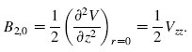
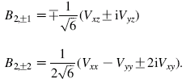

where α = eQ/I(2I-1). So I will now assemble all these terms as follows:

H_{quadrupole} = eQ/I(2I-1) * { (1/2) (3I_{z}² - I²) (1/2)V_{zz} 2,0 for Q

+ sqrt(3/8) (I_{z}I₊ + I₊I_{z}) 1/sqrt(6) (V_{xz}- i V_{yz} ) 2,1

+ sqrt(3/8) (I_{z}I₋ + I₋I_{z}) 1/sqrt(6) (V_{xz} + i V_{yz} ) 2,-1

+ sqrt(3/8) I₊² (1/2 sqrt(6)) ( V_{xx} - V_{yy} - 2iV_{xy}) 2,2

+ sqrt(3/8) I₋² (1/2 sqrt(6)) ( V_{xx} - V_{yy} + 2iV_{xy}) } 2,2

Let's now divide outside by 4, multiple inside by 4. We then get

sqrt(3/8) * 1/sqrt(6) * 4 = sqrt(16*3/8*6) = sqrt(48/48) = 1

I then get this result

H_{quadrupole} = eQ/4I(2I-1) * { (3I_{z}² - I²) V_{zz} 2,0

+ (I_{z}I₊ + I₊I_{z}) (V_{xz} - i V_{yz} ) 2,1

+ (I_{z}I₋ + I₋I_{z}) (V_{xz} + i V_{yz} ) 2,-1

+ I₊² ( V_{xx} - V_{yy} - 2iV_{xy})/2 2,2

+ I₋² ( V_{xx} - V_{yy} + 2iV_{xy})/2 } 2,2

and I also have this definition of eQ:

eQ = 2 < I,M=I | A₂₀ | I, M=I > = <II | Σ_{i} e_{i} ( 3 z_{i}² - r_{i}²) | II>

What are the dimensions of things here? We seem to have dim(H) = charge X² potential/X² which is then charge * potential V which is correct. When I think of I₊ in one of the above equations, I am thinking of having done everything with = 1. But the real operators I_{j} have dimensions, so if you mean the real operators, you should divide the overall result by ².

This agrees exactly with Levitt page 577 equation (17.11) except he has an extra overall factor of 3 which I do not have. Of course he has not said exactly how he has defined is "Q". Perhaps he defines his Q as follows:
Q_{Levitt} = 3Q = 3 <II | Σ_{i} e_{i} ( 3 z_{i}² - r_{i}²) | II>

If so, then we would be in agreement exactly. Recall our Cartesian moment definition

Q_{αβ}= {Σ_{i} q_{i} [ 3r_{iα}r_{iβ} - δ_{αβ}r_{i}²] } = "the quadrupole moment"

We can identify our Q with Q_{zz} . Wolfram page shows that Q_{xx} + Q_{yy} + Q_{zz} = 0.
To clean up this confusion, I would have to go consult the Electric Multipole chapter of this book:
Slichter, Principles of MR, 1989. Amazon shows some of this chapter, and he does get to the point of saying 1/6 V_{αβ}Q_{αβ} which agrees in scale with me (Cartesiaon). But then the excerpt stops!
I have done enough on this little problem I think. At least I now understand why the nuclear spins appear in a Hamiltonian which purports to be related to an electric field interaction, which you would think would have nothing whatsoever to do with nuclear spin state | I,M> .

AHA!!!!! I just looked at Levitt's errata and he says:

"Page 577-578. There are several errors concerning the definitions of the quadrupolar interaction. In Eq.17.11, the right-hand side should be divided by (3*hbar). In the first equation on page 578, the right-hand side should be divided by (3*hbar). See also pages 201-202."

I think he is right about dividing by 3, but I think he should divide by ² not by . I will make a note of this in case I send him some email. ******

10. Multiple Expansions of the E and B fields.

Jackson does some of this stuff, and I could do this with the tensor harmonics and all that, but here is some nice stuff from Raab and De Lang's book, a piece of which I can see on the Google book search. First, here is the expansion of an electric potential:

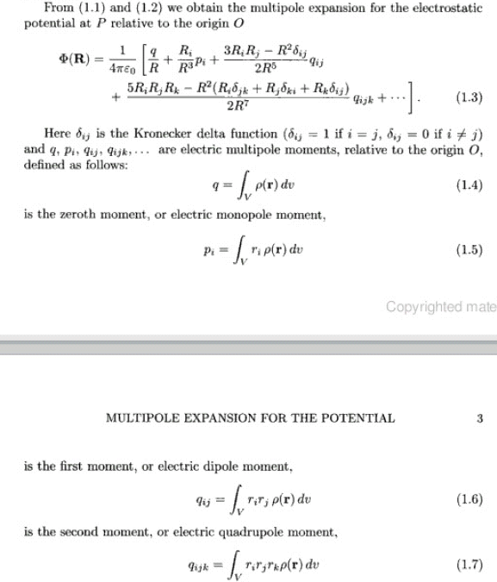

This is just straightforward Cartesian Taylor expansion and it is taken through the octupole term which is always nice. The q_{ij} are not here made traceless.
Now, if you take the gradient of the potential expansion shown above, you get an expansion for the electric field which is this:

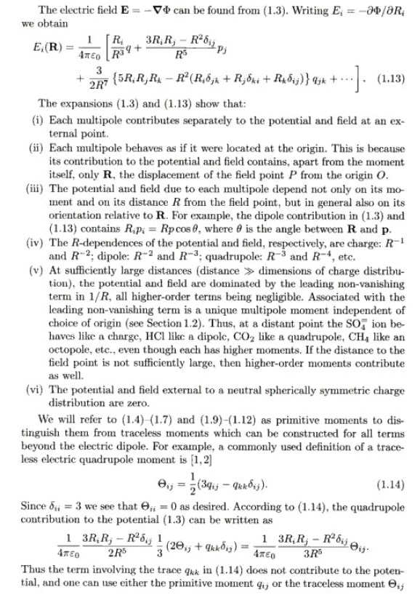

Here I have included the comments about the traceless form quadrupole moment. This is a little different from the traceless form of the factor we had in a previous section which required the Laplace equation. Here, the extra δ term contributes nothing just because that is what equation 1.3 says!
So let's look a bit at this electric field expansion:

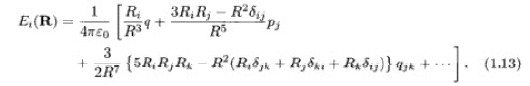

You see the first point charge term has E = qR/R³ as we expect. The quadrupole term has a complicated direction! I think it says E = [3R(R•p) - R² p]/R⁵ and the next term is there as well. [ Jackson p 101 ! ]
Now, of course we want to know next about the magnetic field situation! The Google thing skips some pages here, but we are allowed to see the results as follows:

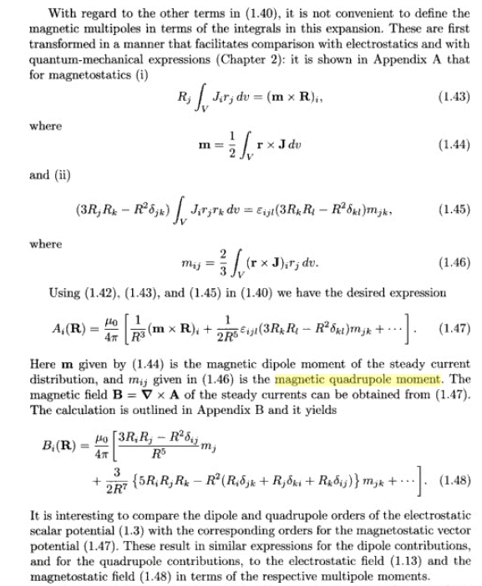

Here we first get the vector potential A expanded through the magnetic quadrupole order where you see that the Cartesian magnetic quadrupole moments m_{ij} are the integrals shown of the current density J. I don't think I have ever seen this nice result before. The dipole moment is also shown above. Then he does the messy ∇ x A calculation in an appendix and we get the B field as shown! Now let's compare:

The field expansions at least to this order are exactly the same, with the appropriate moments! And the potentials φ and A have similar expansions. This information came from:

http://books.google.com/books?id=axnYh8mx0UAC&pg=PA12&lpg=PA12&dq=%22magnetic+quadrupole+moment%22&source=web&ots=9VVsoWJGLM&sig=a2cjm_v2Z9S6-rpjABd4XbR0-pM#PPA11,M1

Multipole Theory In Electromagnetism: Classical, Quantum, And Symmetry Aspects, With Applications
(International Series of Monographs on Physics) (Hardcover)
by R. E. Raab (Author), O. L. de Lange (Author)
# Hardcover: 248 pages
# Publisher: Oxford University Press, USA (December 10, 2004) $40 used, $140 new!

I don't think this book does the m type multipole expansions, by the way, just Cartesian.

First, force and torque due to magnetic field and current density:

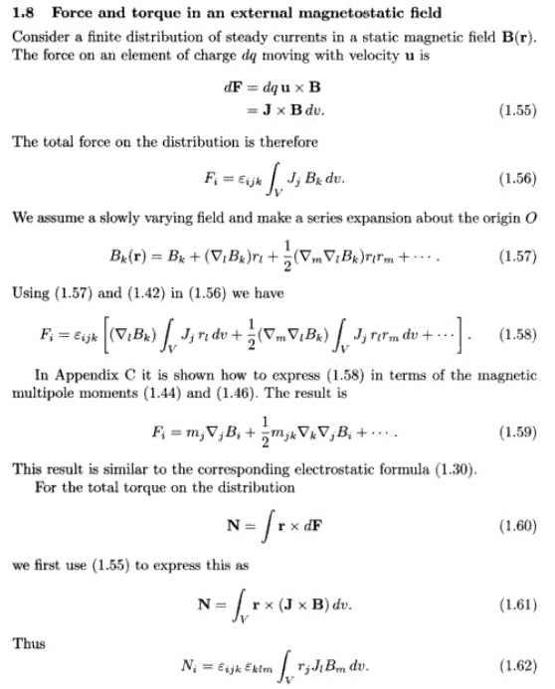
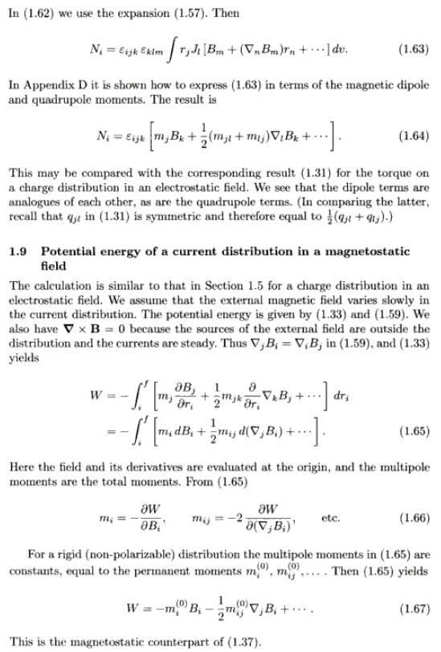

This last result is what I am really after. It tells you the Hamiltonian describing the magnetic quadrupole interaction with a magnetic field! This is something not mentioned in Levitt, but there it is, big as day. I am not surprised at the form of the result. I have done this myself above for the electric stuff which is this:

W = (1/2)φ(0)Q + (∂_{α}φ) P_{α} + (1/6)(∂_{α}∂_{β}φ) Q_{αβ} + octupole and higher

But now replace ∂_{α}φ = -E_{α} to get

W = (1/2)φ(0)Q - p_{i} E_{i} - (1/6) Q_{αβ} (∂_{α}E_{β}) + octupole and higher

where I have used Q_{αβ} = ∫d³r ρ(r) (3r_{α}r_{β} - δ_{αβ}r²). If one uses the simpler q_{αβ} = ∫d³r ρ(r)3r_{α}r_{β} , then my result becomes

W = (1/2)φ(0)Q - p_{i} E_{i} - (1/2) q_{ij}∇_{i} E_{j} + octupole and higher

and this makes the electric and magnetic dipole and quadrupole terms look exactly the same. [ We don't get to see the book's result because Google does not have equation (1.37). ]

