Spherical harmonics and Clebsch-Gordon

This is just a collection of oddball facts, will add more some day.

1. Spherical harmonic conventions. 1
2. Clebsch-Gordon Coefficients. 2
3. Derivation of Messiah Vol 1 page 495 (B.90) 3
4. The General Product of Two Spherical Harmonics 4
5. An interesting matrix element from Messiah page 697. 5

________________________________________________________________________________

1. Spherical harmonic conventions.

(1) Jackson Ylm . Let's start with green Jackson page 64. His Ylm are given in 3.53 in terms of the Plm which in turn he defines in 3.49 and 3.50. His 3.49 Plm agrees with AS p 334, I doubt there are multiple conventions for the associated Legendre functions. The scale of the Ylm is selected so this will be true:

∫dΩ Ylm(θ,φ)* Yl'm'(θ,φ) = δll'δmm'

as he shows in 3.55. So the above is a good test to make sure people have scaled their Ylm properly. This also fits with our desire to say

Ylm(θ,φ) = <θφ|lm>

1 = ∫dΩ |θφ><θφ| 1 = Σlm |lm><lm|

<θ'φ'|θφ> = δ(cosθ' - cosθ)δ(φ'-φ) <l'm'|lm> = δl'l δm'm

Jackson does not do CB since he is doing E&M, so we want to hand-off now to Messiah.

(2) Messiah Ylm .Messiah Vol 1 Appendix B page 494 B.93 gives his definition of the Ylm. We compare this to Jackson page 3.53, and sure enough we have a difference. But first, let's make sure they both agree on the Plm.

Jackson Plm : 3.49 page 64, valid for m ≥ 0 // shows (-1)m

Jackson says his form follows MO and Condon Shortley

Messiah Plm : B.72 page 493 // does not have this (-1)m factor

Thus we can say:

Plm(Jackson) = (-1)m Plm(Messiah)

Now let's look at Messiah's definition of the Ylm on page 495 B.93. His formula says

Ylm(Messiah) = [...] 1/2 (-1)m Plm(Messiah) eimφ

= [...] 1/2 Plm(Jackson) eimφ = Ylm(Jackson)

so these two authors agree on their definitions of Ylm. Normalization same B.87.

Warning: There are other normalizations in use says wiki: Some people do this,

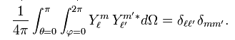

and some people do this:

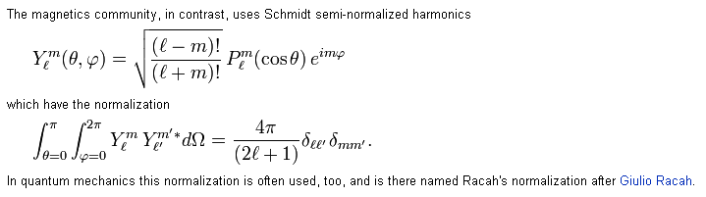

2. Clebsch-Gordon Coefficients.

(3) Messiah CG discussion. This is Vol 2 Appendix C page 1054. Right off the bat he uses this symbol

<j1 j2 m1 m2| J M>

which he refers to as C-G coefficients, and he says Condon-Shortley used exactly this symbol. He then adopts the same "phase convention" as Condon-Shortley. This amounts to saying first the implied states like |j1 m1> and |J M> have the usual behavior on application of J± , AND this coefficient is positive:

<j1 j2 j1 J-j1 | J J> > 0 (and real).

He then at once relates this thing to the Wigner 3-J symbol on page 1056 top. He then lists off the nice symmetries of the 3j symbol, which makes it a better animal that the C-S symbol.
Messiah does not then go on to state the case I am right now interested in which is l ⊗ 1, so let's continue our voyage. At least we have related our bra-ket form to the Wigner 3j symbols.

(4) Condon and Shortley. Once again I want to zero in on the Ylm . This is a 1935 early book which uses this notation:

Φ(m) = 1/$\sqrt{2π}$eimφ

Θ(lm) = (17) on page 52 = $\sqrt{2π}$ [ ...]1/2 Plm(Jackson)

Thus we find that

Θ(lm) Φ(m) = [ ...]1/2 Plm(Jackson) eimφ = Ylm of either Jackson or Messiah

but C-S don't use the notation Ylm. We then come to page 75 where we see the C-G symbol as shown above but writes it out more:

<j1 j2 m1 m2| j1 j2 J M>

CS then quote a huge closed form formula for this thing on page 75 which in includes a sum. CS go on to give their famous tables and table 23 is of interest to me right now which has j2 = 1, and this particular table they quote directly from Wigner's book Gruppentheorie p 206. [ The Wigner reference appears on page 11 after a search. This thing has be reprinted in English at least once.

E. Wigner, “Gruppentheorie und ihre Anwendungen auf die Quantentheorie der Atomspektren”, (Braunschweig: Vieweg; 1931). // recall Reimers going to Braunschweig !

Wigner, Eugene Paul. Group Theory and Its Application to the Quantum Mechanics of Atomic Spectra, Expanded and Improved ed. New York: Academic Press, 1959. A little dense

So the table is showing the <j1 j2 m1 m2| j1 j2 J M>object, not the 3-j symbol.

(5) Tinkham gives the same fancy Wigner summation formula on page 121, but the reader is not very clear what the symbols A and a are as defined by Tinkham, you have to dig around a bit. On page 124 Tinkham replicates the same table just noted above from C-S for j2 = 1.

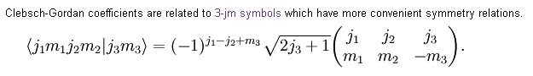
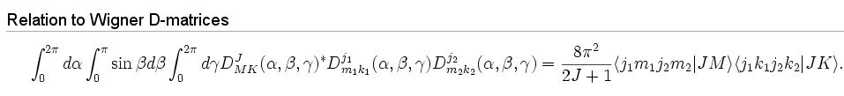

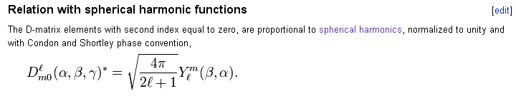

3. Derivation of Messiah Vol 1 page 495 (B.90)

I need this result for the next section.

I suppose there might be a recursion relation among the adjacent Plm . Messiah B.78 gives the result

(2l+1)z Plm(z) = (l+1-m) Pl+1m(z) + (l+m) Pl-1m(z)
or
(2l+1)z Plm(z) eimφ = (l+1-m) Pl+1m(z) eimφ + (l+m) Pl-1m(z) eimφ

which, since it has constant m, is valid in either Jackson or Messiah phase conventions. To convert this recursion thing to Ylm we have to add the ugly factors,

Ylm(θ,φ) = [ (2l+1)(l-m)!/(4π (l+m)!]1/2 Plm(z)eimφ // Jackson p 65 3.53

So do the required edits

Yl+1,m(θ,φ) = [ (2l+3)(l+1-m)!/(4π (l+1+m)!]1/2 Pl+1m(z)eimφ

Yl-1,m(θ,φ) = [ (2l-1)(l-1-m)!/(4π (l-1+m)!]1/2 Pl-1m(z)eimφ

Then we get

(2l+1)z[ (2l+1)(l-m)!/(4π (l+m)!]-1/2 Ylm(θ,φ)

= (l+1-m) [ (2l+3)(l+1-m)!/(4π (l+1+m)!]-1/2 Yl+1,m(θ,φ)

+ (l+m) [ (2l-1)(l-1-m)!/(4π (l-1+m)!]-1/2 Yl-1,m(θ,φ)

Now move the radical to the right side

(2l+1)z Ylm(θ,φ) =

(l+1-m) [ (2l+3)(l+1-m)!/(4π (l+1+m)!]-1/2 [ (2l+1)(l-m)!/(4π (l+m)!]1/2 Yl+1,m(θ,φ)

+ (l+m) [ (2l-1)(l-1-m)!/(4π (l-1+m)!]-1/2[ (2l+1)(l-m)!/(4π (l+m)!]1/2 Yl-1,m(θ,φ)

= (l+1-m) [ {(2l+1)(l-m)! 4π (l+1+m)!} / {4π (l+m)! (2l+3)(l+1-m)!} ]1/2 Yl+1,m(θ,φ)

+ (l+m) [ {(2l+1)(l-m)! 4π (l-1+m)!} / {4π (l+m)! (2l-1)(l-1-m)!} ]1/2 Yl-1,m(θ,φ)

= (l+1-m) [ {(2l+1) (l+1+m) } / { (2l+3)(l+1-m)} ]1/2 Yl+1,m(θ,φ)

+ (l+m) [ {(2l+1)(l-m) } / { (l+m) (2l-1) } ]1/2 Yl-1,m(θ,φ)

= [ {(2l+1) (l+1+m) (l+1-m) } / { (2l+3)} ]1/2 Yl+1,m(θ,φ)

+ [ {(2l+1) (l+m) (l-m) } / { (2l-1) } ]1/2 Yl-1,m(θ,φ)

Now divide both sides by (2l+1)

z Ylm(θ,φ) =

= [ { (l+1+m)(l+1-m) } / { (2l+1)(2l+3)} ]1/2 Yl+1,m(θ,φ)

+ [ { (l+m)(l-m) } / { (2l+1)(2l-1) } ]1/2 Yl-1,m(θ,φ)

and this agrees finally with Messiah B.90 page 495.

4. The General Product of Two Spherical Harmonics

Using the same CG coefficients as discussed above, write:

[|j1 m1> ⊗ |j2 m2>] = | j1m1;j2m2> = Σjm |jm><jm | j1m1;j2m2>

If we close with <θφ|, I think what happens is this (this is complete BS, but keep it as a lesson)

[<θφ| ⊗ <θφ| ] [|j1 m1> ⊗ |j2 m2>] = <θφ| [Σjm |jm><jm | j1m1;j2m2> ] // wrong

<θφ|j1 m1><θφ|j2 m2> = Σjm<θφ|jm><jm | j1m1;j2m2>

Yjm(θ,φ) Yj'm'(θ,φ) = Σj"m" Yj"m"(θ,φ)<j"m" | jm;j'm'> // wrong

So this is a sort of product of spherical harmonics rule. Tinkham has something like this on page 117 as (5-42b) but his notation is hard to follow.

Unfortunately, this formula is wrong, and my arm-waving derivation is also wrong. The correct formula from the web involves two C-G coefficients like this:

and applying it in my case (a little more general),
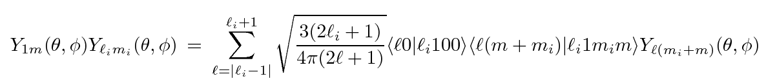

In the above, if we set m=0, we get these coefficients: <l0|li100><lmi| li1mi0> . I want to show that the term with l = li vanishes. It would have these factors: < li 0|li100>< li mi| li1mi0>. So in my normal notation I would have

Y10(θ,φ) Ylm(θ,φ), term proportional to Ylm(θ,φ) : α < l 0|l100> * < l mi| l1mi0>
<jm | j1j2m1m2>

If we look at the CG table on page 124, we are in the middle row and we have m2 = 0 so the middle column as well. But our first factor has m=0 so the first coefficient above is 0. Finally, I am getting a result that is consistent with the recursion relation B.90 derived above. I was stumped by this seeming contradiction for a while.

5. An interesting matrix element from Messiah page 697.

Consider: < l'm' | cosθ | lm>

Here we have to realize that θ a coordinate space operator, the way r would be if we had it inside some matrix element. So let's make it a cap to remind us of that fact.

< l'm' | cosΘ | lm> = < l'm' | cosΘ ∫dΩ |θφ><θφ|lm>

= ∫dΩ< l'm' | cosΘ |θφ><θφ|lm> = ∫dΩ< l'm' | cosθ |θφ><θφ|lm>

= ∫dΩ cosθ< l'm' |θφ><θφ|lm>

= ∫dΩ cosθ Yl'm'(θ,φ)* Ylm(θ,φ)

We could use the full triple-Y formula to evaluate this, but instead let's use B.90 which says

z Ylm(θ,φ) = [ { (l+1+m)(l+1-m) } / { (2l+1)(2l+3)} ]1/2 Yl+1,m(θ,φ)

+ [ { (l+m)(l-m) } / { (2l+1)(2l-1) } ]1/2 Yl-1,m(θ,φ)

Then we just have Y orthogonality integrals left and we can say

< l'm' | cosΘ | lm> = [ { (l+1+m)(l+1-m) } / { (2l+1)(2l+3)} ]1/2 δl+1, l'δm,m'

+ [ { (l+m)(l-m) } / { (2l+1)(2l-1) } ]1/2 δl-1, l'δm,m'

To pick off the second term, let's choose l' = l - 1, so then we have

< l-1 m | cosΘ | l m> = [ { (l+m)(l-m) } / { (2l+1)(2l-1) } ]1/2

= [ (l2 - m2) / (4l2-1) ]1/2 // agrees with Messiah (33) p 697

and since it is real, and position operator Θ is Hermitian (real eigenvalues), we can flip the thing around to get the form that Messiah shows.

6. Collection of formulas where we know the normalization used!

Wolfram has a lot on this subject, but you have to poke around a lot.

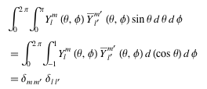

Here is a pretty good site http://quantummechanics.ucsd.edu/ph130a/130_notes/node210.html

7. These are all from http://mathworld.wolfram.com/SphericalHarmonic.html

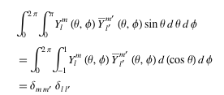

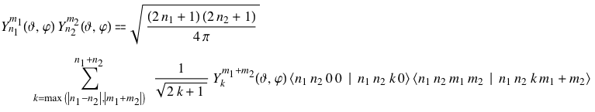

This last seems to agree with the previous version of this above.

Note: I have derived all formulas above, see "addition of angular momenta" doc. 2/17/09

