The Spherical Harmonics in Cartesian Coordinates PhL 11.4.10

This doc is filed with other angular momentum related docs, currently located here

D:\Work\My Interests\Physics\Quantum Mechanics\angmom_spin math stuff

My interest in this subject arose while I was reading Hobson's work on ellipsoidal coordinates and the Lamé functions. The first step in finding the general form of the Lamé E functions involves expressing the tesseral harmonics in Cartesian coordinates!

1. Introduction. 2
2. Maple display of P_{n}^{m} (cosθ) 4
3. Early notes: try to learn something about the nature of the tesserals, a few examples. 5
4. Angular Momentum in Cartesian coordinates. 7
5. The General Forms of the Tesseral Harmonics in Cartesian coordinates 8

___________________________________________________________________________________

Overview

In Section 1 I dismiss normalization constants, consider range of m, and set up our problem, and discuss the word "tesseral".
For Section 2 I wrote a Maple program to print out arbitrary tesseral harmonics. Maple does not know these functions a priori, since its LegenderP routine just an evaluator, so I had to do this myself. I then show all the tesseral harmonics for n = 0 through 5.
In Section 3 I convert a few specific cases of tesserals to Cartesian coordinates, and then I conjecture that all tesseral harmonics when expressed in Cartesian coordinates are homogeneous polynomials of degree n in x,y,z divided by rn. In Section 5 below I show this to be true.
In Section 4 I write down the L2 angular momentum operator in x,y,z and implement it in Maple. I then apply this L2x,y,z to two of my Section 3 sample tesseral harmonics f converted to x,y,z to verify that we really do find that L2x,y,zf = n(n+1)f. This was just confidence-building stuff.
In Section 5 I undertake the general problem of converting an arbitrary tesseral harmonic to Cartesian coordinates. This is not rocket science, because I have all the pieces as follows (last two from GR7)

∂xmPn(x) = a cosn-mθ + b cosn-m-2θ + c cosn-m-4θ + ... x = cosθ
cos(mφ) = a cosmφ + b cosm-2φ + c cosm-4φ + ....
sin(mφ) = sinφ [d cosm-1φ +e cosm-3φ + f cosm-5φ + .... ]

I am then able to show that both tesseral harmonics have the following form

Pnm(cosθ)cos(mφ) = polyn(x/r,y/r,z/r; n,m) = (1/r)n Polyn(x,y,z; n,m)
Pnm(cosθ)sin(mφ) = polyn(x/r,y/r,z/r; n,m) = (1/r)n Polyn(x,y,z; n,m)

Here, polyn(a,b,c) has terms like an and b. The notation Polyn however means that all terms in the polynomial have the same degree, so Poly means a "homogeneous" polynomial. This of course must be the case since the tesserals are dimensionless. I then combine the above lines to say

Pnm(cosθ) [cos(mφ), sin(mφ)] = (1/r)n [ Cn(x,y,z; n,m), Sn(x,y,z; n,m) ]

where in the last line I just combine the previous lines into one and give names to the homogeneous polynomials. The arguments n,m mean that the polynomial coefficients depend on both n and m. Thus, I have given a formal proof of the conjecture of Section 3 that all tesserals have this nice form (I call it a Theorem).
Next, a bit off the main flow, using Lz = (-i)(x∂y- y∂x) = (-i)∂φ I show certain relations between the S and C polynomials:

Lz[Cn(x,y,z; n,m)/rn] = i m [Sn(x,y,z; n,m)] /rn]
Lz[Sn(x,y,z; n,m)/rn] = - i m [Cn(x,y,z; n,m)] /rn]

It is pretty obvious for example that cos(mφ) is not an eigenstate of Lz, which is why we normally use the Ynm(θ,φ) functions which are eigenstates. But of course the tesserals are eigenstates of L2.
I then do some Cartesian conversion examples,

n=1:
P11(cosθ)cos(1φ) = sinθcosφ = (x/r) P11(cosθ)sin(1φ) = sinθsinφ = (x/r)
P10(cosθ)cos(0φ) = cosθ = (z/r) P10(cosθ)sin(0φ) = 0

n=2:
P22(cosθ)cos(2φ) ~ x2-y2 P22(cosθ)sin(2φ) ~ xy
P21(cosθ)cos(1φ) ~ xz P21(cosθ)sin(1φ) ~ zy
P20(cosθ)cos(0φ) ~ 2z2-x2-y2 P20(cosθ)sin(0φ) = 0

Since the last item always vanishes, we see there are (n+1)*2-1 = 2n+2-1 = (2n+1) functions for each n. In the n=2 case linear combinations give the set { xz, xy, zy, x2-y2,z2- y2 }. Each term of course should be divided by r2.
__________________________________________________________________________________

1. Introduction.

In this document, we are not concerned about the normalizing factors, but more with the general "form" that the spherical harmonics have when expressed in Cartesian Coordinates. So let's start with

Ynm(θ,φ) = cn,m Pnm (cosθ) e+imφ L2 Ynm(θ,φ) = n(n+1) Ynm(θ,φ) n = 0,1,2...

Since Lz = (-i)∂φ in our usual Lie Algebra convention, if we want LzY = mY, we must use the positive phase shown. The understanding here is that m ranges from -m to m. It is convenient to deal with the real and imaginary parts of Y separately, and I tend to refer to these real functions (without cn,m) as "the tesseral harmonics",

Re[Ynm(θ,φ)] = cn,m Pnm (cosθ) cos(mφ)
Im[Ynm(θ,φ)] = cn,m Pnm (cosθ) sin(mφ)

We know that Pn-m(cosθ) = kn.m Pnm (cosθ) for some constant kn,m. Thus,

Pn-m (cosθ) cos(-mφ) = kn.m Pnm (cosθ) cos(mφ)
Pn-m (cosθ) sin(-mφ) = - kn.m Pnm (cosθ) sin(mφ)

If we are exploring the "functional form" of our tesseral harmonics, we see that the negative m functions are just constant multiples of the positive m ones, so we might as well restrict our interest to m = 0,1...n. In doing so, we dodge the famous Condon-Shortley phase question for the negative m P functions.

So we now dispense with overall constants, and we shall study these "tesseral harmonics" :

Pnm (cosθ) [cos(mφ), sin(mφ)] n = 0,1,2... m = 0,1..n

With this limitation on m, we may use the following expression for the P functions.

Pnm (cosθ) = (sinθ)m [∂xm Pn(x)]x=cosθ

History Note. Here is a wiki quote concerning the tesserals
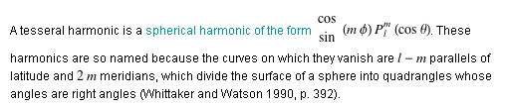

And from ODE

❑ tessella (tE"sEl@). Pl. -æ; rarely -as. Also 8 -ela.
[L., dim. of tessera.]

❑ tessera ("tEs@r@). Pl. tesseræ.
[L., f. Ionic Gr. , = Attic  four.]
1. Anc. Hist. A small quadrilateral tablet of wood, bone, ivory, or the like, used for various purposes, as a token, tally, ticket, label, etc.

The induced meaning of a tessella is pretty much a "small tile" with four sides. We speak of "tiling" a surface. More particularly, the tiles of a sphere formed by latitudes and longitudes all have right angles, though the tiles are not planar, because r,θ,φ is an orthogonal coordinate system. A tiled surface and a tessellated surface are the same thing as far as I am concerned, the phrases have loose definitions.

2. Maple display of Pnm (cosθ)

I don't know of any big tables except some data here which lists n = 0 to 8

http://ciks.cbt.nist.gov/~garbocz/paper134/node10.html

So I decided to get Maple to display Pnm (cosθ) for arbitrary n and m. I first wandered off to Maxima for a while, but then figured out how to Maple do what I wanted. The secret was using a sequence to get strings like x,x,x.. inside the diff function, and then various tricks to print out the functions using sinθ and cosθ appropriately. Here is the code, located in file "Pnm display.mws"

restart;
> with(orthopoly):
> p := (n,m,x)-> (1-x^2)^(m/2)*diff(P(n,x),seq(x,i=1..m)):
> for n from 0 to 5 do
> for m from 0 to n do
> unassign('x');
> if (m = 0) then f := P(n,x); else f := p(n,m,x); fi;
> x := cos(theta);
> g := subs(sqrt(1-cos(theta)^2)=sin(theta),f):
> printf("P(%d,%d,x)",n,m);
> print(subs(1-cos(theta)^2=sin(theta)^2,g));
> od
> od;
>

Here is some output of this little program for n = 0 to 5, presented here in two columns:

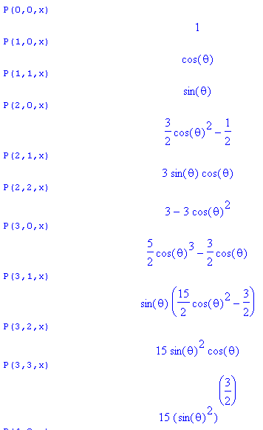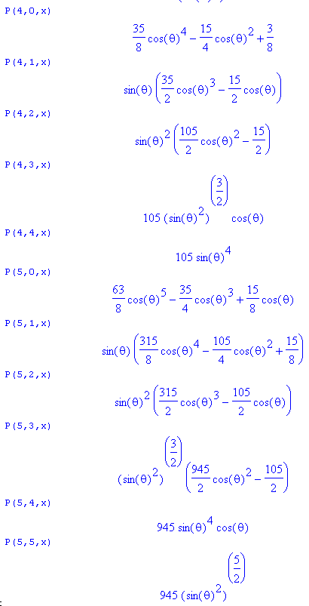

3. Early notes: try to learn something about the nature of the tesserals, a few examples.

Now let's look at a specific harmonic

P22(cosθ)cos(2φ) = 3sin2θ [ 2cos2(φ) - 1] = 6 sin2θ cos2(φ) - 3sin2θ

What patterns do we see in our expressions Maple has printed out?

• If m is even, then P is a polynomial in cos(θ) of degree n

I have not shown this here, but Maple will do expand( cos(8*φ)) stuff and you find that

• if m is even, then cos(mφ) is a polynomial of degree m in cosφ with only even powered terms

Example:

P54(cosθ) cos(4φ) = 945 sin4θ cosθ [ 8 cos4φ - 8cos2φ + 1 ]

= 945 cosθ [ 8 sin4θ cos4φ - 8 sin4θ cos2φ + sin4θ ]

= 945 z [ 8 x4 - 8 (r2-z2) x2+(r2-z2)2 ] /r5 = 945 z [ 8 x4 - 8 (x2+y2) x2+( x2+y2)2 ] /r5

= 945 z [ 8 x4 - 8 (x2+y2) x2+( x4 + 2x2y2+ y4) ] /r5

= 945 z [ - 8 (y2) x2+( x4 + 2x2y2+ y4) ] /r5

= 945 z [x4 -6x2y2+ y4 ] /r5

Let's try another one

P54(cosθ) sin(4φ) = 945 sin4θ cosθ [ 8sinφcos3φ - 4sinφcosφ ]

= 945 cosθ [ 8 sin4θ sinφcos3φ - 4 sin2θ sin2θ sinφcosφ ]

= 945 cosθ [ 8 sinθ sinφ sin3θcos3φ - 4 sin2θ sin2θ sinφcosφ ]

= 945 z [ 8 y x3 - 4 (r2-z2)xy ] /r5 = 945 z [ 8 y x3 - 4 (x2+y2)xy ] /r5

= 945 z [ 8 y x3 - 4x3y - 4xy3 ] /r5 = 4* 945 xyz [ x2-y2] = 3780 xyz [ x2-y2]

What happens when m is odd?

P53(cosθ) cos(3φ) = sin3θ (Acos2θ - B)[ 4 cosφ3-3cosφ] A = 945/2 B = 105/2

= (Acos2θ - B)[ 4 sin3θ cosφ3-3 sin3θ cosφ]

= (Az2 - Br2)[ 4x3-3 (r2-z2) x] / r5

P53(cosθ) sin(3φ) = sin3θ (Acos2θ - B) [ 4sinφ cos2φ - sinφ]

= (Acos2θ - B) [ 4 sin3θ sinφ cos2φ - sin3θ sinφ]

= (Az2- Br2) [ 4x2y - (r2-z2)y]/r5

Question: Are all tesseral harmonics equal to polynomials in x,y,z of degree n divided by rn? I think the answer is yes. This will be proven below.

4. Angular Momentum in Cartesian coordinates.

Here I write down L2 in Cartesians, and then show that some sample tesseral harmonics do in fact satisfy the expected relation L2 f = n(n+1)f. [ When I first did this, I wrongly set r = 1 everywhere and this made things not work since L2 certainly acts on powers of r. This has been quietly all repaired.]

We know how to write the angular momentum operator in Cartesian coordinates

- L2 = (y∂z- z∂y)2 + cyclic

We could consider doing the search in Cartesian space for the eigenfunctions

L2f(x,y,z) = n(n+1)f(x,y,z)

The operator L2 is dimensionless in both Cartesian and angular coordinates. Therefore, if f(x,y,z) is a polynomial of degree N, then so is L2f. Therefore, if you are looking for eigenfunctions of L2f = n(n+1)f, a polynomial in x,y,z is certainly a good candidate! However, it turns out this is not the form that the eigenfunctions have. As we shall see, the eigenfunction f(x,y,z) is a polynomial in x,y,z of degree n divided by rn. And of course there will be (2n+1) such eigenfunctions.

Let's now check a few of our test cases above using Maple to compute the Cartesian L2. Here is our testing code. We start off with this

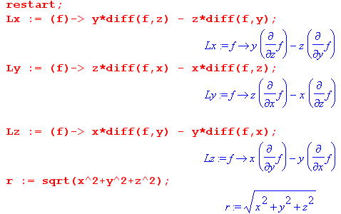
Then we can test specific functions.

First,

g = P53(cosθ) cos(3φ) = 945 z [ 8 x4 - 8 (r2-z2) x2+(r2-z2)2 ] /r5

and Maple says (we omit leading constants)

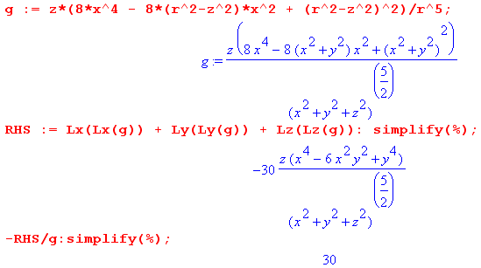

We have thus shown that L2g = 30g and this is our expected result since 5(5+1) = 30.

Second,

P54(cosθ) sin(4φ) = 945 z [ 8 y x3 - 4 (r2-z2)xy ] /r5

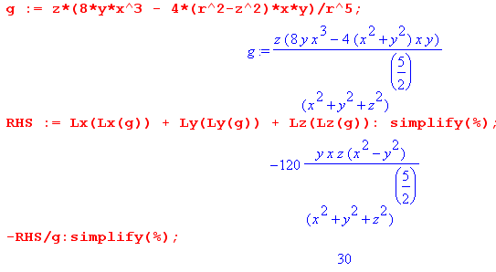

5. The General Forms of the Tesseral Harmonics in Cartesian coordinates

Here we figure out the "general forms" both in Cartesian coordinates, and also in Cartesian ratios like x/y since these are what we need when we later change to μ and ν coordinates. For the Cartesian case, we state the result in a Theorem toward the end of this section.

Question: How do we know for sure that all the tesseral harmonics Pnm(cosθ)[sin(mφ),cos(mφ)] will have the form polyn/rn ? How would we prove this? We see it is true in our test cases. Well, let's look at the structure of our expressions starting with the cos(mφ) case:

Pnm(cosθ)cos(mφ) = (sinθ)m ∂xm Pn(x) cos(mφ)

= { ∂xm Pn(x) } { (sinθ)m cos(mφ) } x = cosθ
first piece second piece

The trick is to look at the general nature of these factors. My coefficients a,b,c are generic and if the same a appears in two places, it does not mean the a's are the same. Series end when the exponent is either 1 or 0. So we have:

Pn(x) = a xn + b xn-2 + c xn-4 + .... // x means cosθ here, but not later

=> ∂xmPn(x) = a xn-m + b xn-m-2 + c xn-m-4 + ... // coefficients are functions of n and m

Meanwhile, we have some claims about multiple angle expansions. I just quote the results, you can see the detailed coefficients on page 33 of GR7:

Fact: cos(mφ) = a cosmφ + b cosm-2φ + c cosm-4φ + .... // coefficients are functions of m !

Fact: sin(mφ) = sinφ [d cosm-1φ +e cosm-3φ + f cosm-5φ + .... ] // ditto

So what happens when we glue our two pieces together? Well we then get

Pnm(cosθ)cos(mφ) = { a cosn-mθ + b cosn-m-2θ + c cosn-m-4θ + ... }
* sinmθ { a cosmφ + b cosm-2φ+ c cosm-4φ + .... }

We can write the last two factors this way:

sinmθ { a cosmφ + b cosm-2φ+ c cosm-4φ + .... }

= { a sinmθ cosmφ + b sin2θ sinm-2θ cosm-2φ+ c sin4θ sinm-4θ cosm-4φ + .... }

= { a (x/r)m + b sin2θ(x/r)m-2+ c sin4θ(x/r)m-4 .... }

= { a (x/r)m + b [1-cos2θ] (x/r)m-2+ c [1-cos2θ]2(x/r)m-4 .... }

= { a (x/r)m + b [1- (z/r)2] (x/r)m-2+ c [1-(z/r)2]2(x/r)m-4 .... }

= { a (x/r)m + b [r2- z2] (1/r)2 (x/r)m-2+ c [r2- z2]2 (1/r)4 (x/r)m-4 .... }

= (1/r)m { a xm + b [r2- z2] xm-2+ c [r2- z2]2 xm-4 .... }

= (1/r)m { a xm + b (x2+y2) xm-2+ c (x2+y2)2 xm-4 .... }

= (1/r)m [ Polym(x,y; m)] = Polym(x/r,y/r; m) // form of the "second piece"'

where the third parameter just reminds us that the coefficients depend on m. I now use Poly to indicate a homogeneous polynomial, meaning all terms have the same degree. We can move in the factors of r to get the second form shown. Every term still has the same degree: (x/r)2(y/r)3, (x/r)1(y/r)4 if m = 4.

Now the first piece was this

{ a cosn-mθ + b cosn-m-2θ + c cosn-m-4θ + ... }

= { a (z/r)n-m + b (z/r)n-m-2 + c (z/r)n-m-4 + ... }

= (1/r)n-m { a zn-m + b zn-m-2 (1/r)-2 + c zn-m-4 (1/r)-4 + ... }

= (1/r)n-m { a zn-m + b zn-m-2 r2 + c zn-m-4 r4 + ... }

= (1/r)n-m { a zn-m + b zn-m-2 r2 + c zn-m-4 r4 + ... }

= (1/r)n-m { a zn-m + b zn-m-2 (x2+y2) + c zn-m-4 (x2+y2)2 + ... }

= (1/r)n-m [ Polyn-m(x,y,z; n,m) ] // form of the "first piece"

where the n,m reminds us that the coefficients depend on both n and m.

Therefore we have shown that

Pnm(cosθ)cos(mφ) = (1/r)n-m [ Polyn-m(x,y,z; n,m) ] * (1/r)m [ Polym(x,y; m)]

= (1/r)n Polyn(x,y,z; n,m) // which was our goal!

Now let's do the sine form which starts off like this:

Pnm(cosθ)cos(mφ) = { a cosn-mθ + b cosn-m-2θ + c cosn-m-4θ + ... }
* sinmθ { sinφ [d cosm-1φ +e cosm-3φ + f cosm-5φ + .... ] }

The "first piece" is of course the same as above. The second piece can be written this way

sinmθ { sinφ [d cosm-1φ +e cosm-3φ + f cosm-5φ + .... ] }

= sinθsinφ [d sinm-1θ cosm-1φ +e sinm-1θ cosm-3φ + f sinm-1 cosm-5φ + .... ]

= sinθsinφ [d sinm-1θ cosm-1φ +e sin2θ sinm-3θ cosm-3φ + f sin4θ sinm-5 cosm-5φ + .... ]

= (y/r) [d (x/r)m-1+e sin2θ (x/r)m-3 + f sin4θ (x/r)m-5 + .... ]

= (y/r) [d (x/r)m-1+e [ 1-(z/r)]2 (x/r)m-3 + f [ 1-(z/r)]4 (x/r)m-5 + .... ]

= (y/r) [d (x/r)m-1+e [ r2-z2]2 (1/r)2(x/r)m-3 + f [ r2-z2]4 (1/r)4 (x/r)m-5 + .... ]

= (y/r)(1/r)m-1 [d xm-1+e [ r2-z2]2 xm-3 + f [ r2-z2]4 xm-5 + .... ]

= (y/r)(1/r)m-1 [d xm-1+e (x2+y2)2 xm-3 + f (x2+y2)4 xm-5 + .... ]

= (1/r)m { y [d xm-1+e (x2+y2)2 xm-3 + f (x2+y2)4 xm-5 + .... ] }

= (1/r)m Polym(x,y;m)

But this is exactly the same "form" that our previous "second piece" had, and so we end up again with the resulting form (1/r)n Polyn(x,y,z;n,m). We have just proved the following theorem:

Theorem: Pnm(cosθ)cos(mφ) and Pnm(cosθ)sin(mφ) both have the following form, when converted to Cartesian coordinates:

Pnm(cosθ) [cos(mφ), sin(mφ)] = (1/r)n [ Cn(x,y,z; n,m), Sn(x,y,z; n,m) ]

where Cn and Sn are homogeneous polynomials of degree n in x,y,z whose coefficients depend on n and m. Notice that the RHS's are therefore dimensionless, as they must be.

If we then take our Cartesian operator,

- L2 = (y∂z- z∂y)2 + cyclic

we will find that both our tesseral functions have definite angular momentum magnitude n,

L2{ Cn(x,y,z; n,m) / rn } = n(n+1) {Cn(x,y,z; n,m) / rn }
L2{ Sn(x,y,z; n,m) / rn } = n(n+1) {Sn(x,y,z; n,m) / rn }

If we take the linear combinations

Pnm(cosθ) [cos(mφ)± i sin(mφ)] = Pnm(cosθ) e±imφ = [Cn(x,y,z; n,m) ± i Sn(x,y,z; n,m)] /rn

and if we take our Cartesian operator

Lz = (-i)(x∂y- y∂x) // = (-i)∂φ

we will find that

Lz { [Cn(x,y,z; n,m) ± i Sn(x,y,z; n,m)] /rn} = ± m { [Cn(x,y,z; n,m) ± i Sn(x,y,z; n,m)] /rn}

One implication of this fact is that, equating real and imaginary parts

Lz[Cn(x,y,z; n,m)/rn] = i m [Sn(x,y,z; n,m)] /rn]
±i Lz[Sn(x,y,z; n,m)/rn] = ±m [Cn(x,y,z; n,m)] /rn]

which we can rewrite as

Lz[Cn(x,y,z; n,m)/rn] = i m [Sn(x,y,z; n,m)] /rn]
Lz[Sn(x,y,z; n,m)/rn] = - i m [Cn(x,y,z; n,m)] /rn]

Example: n=1

P11(cosθ)cos(1φ) = sinθcosφ = (x/r)
P10(cosθ)cos(0φ) = cosθ = (z/r)

P11(cosθ)sin(1φ) = sinθsinφ = (x/r)
P10(cosθ)sin(0φ) = 0

Cartesian solutions are thus: { x, y, z } / r

Example: n=2

P22(cosθ)cos(2φ) = 3sin2θ (2 cos2φ - 1) = 6 (x/r)2 - 3(1-(z/r)2) = [6x2- 3r2 + 3z2]/r2
= [6x2- 3x2-3y2-3z2 + 3z2]/r2 = [3x2 -3y2]/r2 = 3 (x2-y2)/r2
P21(cosθ)cos(1φ) = 3 sinθcosθ cosφ = 3 (z/r)(x/r) = 3 xz/r2
P20(cosθ)cos(0φ) =(1/2)[3cos2θ - 1] = (1/2) [ 3(z/r)2- 1] = (1/2) (3z2-r2)/r2
= (1/2) (3z2-x2-y2-z2)/r2 = (1/2) (2z2-x2-y2)/r2

P22(cosθ)sin(2φ) = 3sin2θ 2 sinφ cosφ = 6 (x/r)(y/r) = 6 xy/r2
P21(cosθ)sin(1φ) = 3 sinθcosθ sinφ = 3 (z/r)(y/r) = 3 zy / r2
P20(cosθ)sin(0φ) = 0

This suggests five functions, where now I ignore constants and I ignore the /r2 part

P22(cosθ)cos(2φ) ~ x2-y2 P22(cosθ)sin(2φ) ~ xy
P21(cosθ)cos(1φ) ~ xz P21(cosθ)sin(1φ) ~ zy
P20(cosθ)cos(0φ) ~ 2z2-x2-y2 P20(cosθ)sin(0φ) = 0

If we add the last two and divide by 2 we get z2- y2 so we could take these instead

xz xy zy x2-y2 z2- y2

You can see that this gets messier as n increases. For example, back in Section 3 we had

P54(cosθ) cos(4φ) = 945 z [ 8 x4 - 8 (r2-z2) x2+(r2-z2)2 ] /r5
= 945 z [ 8 x4 - 8 (x2+y2) x2+ (x2+y2)2 ] /r5
= 945 z [ 8 x4 - 8x4 - 8 x2y2+ x4 + 2x2y2 + y4 ] /r5
= 945 z [x4 + 6 x2y2 + y4 ] /r5

P54(cosθ) sin(4φ) = 945 z [ 8 y x3 - 4 (r2-z2)xy ] /r5
= 945 z [ 8 y x3 - 4 (x2+y2)xy ] /r5
= 945 z [ 8 y x3 - 4x3y - 4xy3 ] /r5
= 945*4 zxy [ 2 x2 - x2 - y2 ] /r5
= - 945*4 xyz(x-y)2 /r5

I think I could make Maple generate these functions if I really wanted (see next section).

5. Maple program to display the tesseral harmonics in Cartesian coordinates.

Maple is always a pain but I was finally able to get it to do what I wanted. There is one program and you set it either to cos(mφ) or sin(mφ) with two simple edits. The problem is getting Maple to simplify things correctly. The program is in the same file "Pnm display.mws", so I won't replicate that code here. You can see that the functions are all homogeneous polynomials of degree n.

Display of rn Pnm(cosθ) cos(mφ) for n=0 to 5 and m = 0 to n

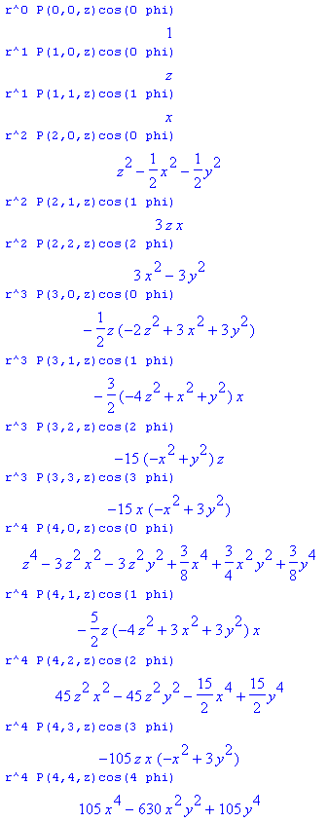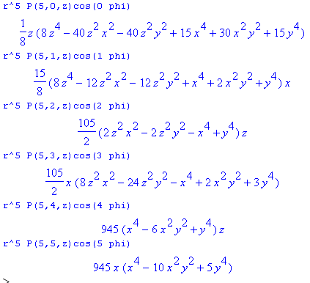

Display of rn Pnm(cosθ) sin(mφ) for n=0 to 5 and m = 0 to n

