Daddy Reif Notes PhL 4.18.07

I have found some relevant results in this book which I will do here. These notes are in no way meant as notes on the entire Daddy Reif book, just small selected topics.

1. Page 161-164 on "general relations".

In thermodynamics, you always have to worry about what variables you choose as your independent variables, and then which ones are dependent on them.

(a) Suppose you think of E = E(S,V) so entropy and volume are independent. You can then of course say:

dE = ∂∂ dS + ∂∂ dV // energy, S and V independent

This is a basic calculus result that you won't see derived in Reif or other books. Calculus of more than one variable and partial derivatives, see p3 of good old M&M.
But we also know that

dE = TdS - pdV // from first law with other work W* = 0.

So we conclude that

∂∂ = T and ∂∂ = -p

The form for dE is an "exact differential". Reif at this point gets an additional result by using the equality of second partials, this result is completely trivial and follows staring at the above:

∂∂ = - ∂∂ (5.5.5)

(b) Now, suppose instead you want to think of S and p as your independent variables. The first-law expression for dE is not the right thing now because it shows dS and dV. But suppose you define

H = E + pV // the Enthalpy S,p independent

You of course can think of H = H(S,p) and say:

dH = ∂∂ dS + ∂∂ dP

But now our first law says:

dH = (TdS - pdV) + pdV + Vdp = TdS + Vdp // which has the right form

so we conclude at once that:

∂∂ = T ∂∂ = V

and the second derivative equality then says:

∂∂ = ∂∂

(c) The next case is working with T and V independent. Here are the results:

F = E - TS // Helmholtz free energy, T,V independent

dF = -SdT - pdV

∂∂ = -S ∂∂ = -p and ∂∂ = ∂∂

(d) The next case is working with T and p independent. Here are the results:

G = E - TS + pV [ = H - TS ] // Gibbs free energy, T,p independent

dG = -SdT + VdP

∂∂ = -S ∂∂ = V and - ∂∂ = ∂∂

Now, the four "second derivative comparison" results are known as Maxwell's Relations which Reif summarizes on page 164. Then he summarizes the four exact differentials on page 166.
Since you have variables E, S, T, V, p and of course then H, F, G in addition, you can see that there are going to be a LOT of these differential forms and partial derivative relations.

2. Interpretation of Gibbs Free Energy p 295

This little section is very hard to find because it does not appear in the index under either Gibbs, free energy, or work. The section title is "reservoir with constant T and p ". We start with a statement that ΔS* ≥ 0 for "any spontaneous process". You then just write out the A and A' ΔS forms using the first law with "other work" W* included. You end up with W* ≤ -ΔG . You need the fact that both A and A' have the same T and p to make the derivation work right. If you have a quasi-static process, then W* = -ΔG and we get the result that the free energy is the maximum work that a process can do. Very simple. This is then going to be the basis of battery thermo.

3. About the chemical potential

On page 312, Reif thinks of the independent variables as being E, V and now the particle counts N_{i} . He then writes an exact differential (8.7.2) for dS with lots of partials. By comparing to a form of the first law shown in (8.7.3), he identifies the E and V partials. The partials of S wrt N_{i} are defined as the chemical potentials, to wit:

μ_{j} ≡ -T ∂∂ then dS = (8.7.6)

and we get the main result which is this:

dE = TdS - pdV + $\sum_{i=1}^{m}{}$μ_{i} dN_{i}

The idea is that μ_{i} is related to how S changes when you "add one more particle of type i" to your system. It is the marginal entropy change, and we would expect this to in fact be a function of N_{i} . The last term is the new thing, it looks a little like a "work term" and I think we will soon recast it in that manner. The dimensions of μ are energy. Reif then comes up with the alternative form which is

dG = -SdT + Vdp + $\sum_{i=1}^{m}{}$μ_{i} dN_{i} (8.7.11)

If system A is constant T and p, this a tells us that dG = $\sum_{i=1}^{m}{}$μ_{i} dN_{i} and we then know that this chemical potential sum is the amount of work we can get out of our "system" in which we are somehow adding molecules of various types N_{i} . So this is a big step forward for me!
Also, given the form above, we may arrive at this conclusion similar to the above

μ_{j} ≡ ∂∂ ≠ G/N_{j}

where Reif reminds us that this is a marginal thing, not an average thing!

Integrated forms: Reif does this on page 314 in a slightly unusual way, but the more general way is as follows. First, we assume a linear scaling rule. We write one of our energies in terms of the various variables, then we claim that if we "double everything" in the variables, then we double the energy. This means that our energy formulas all show linear scaling. Reif shows this for example in (8.7.15).
Now there is a very general and simple theorem called Euler's Homogenous Function Theorem which is derived here in just a few lines: http://mathworld.wolfram.com/EulersHomogeneousFunctionTheorem.html The result when scaling is linear (n=1) is this:

f(x_{i} ) = $\sum_{i=1}^{m}{}$x_{i} ∂∂

which says you can build the function from its derivatives wrt all independent variables. If you apply this to our four energy functions and use the derivatives appearing in the "equations of state" section of this web site: http://en.wikipedia.org/wiki/Thermodynamic_potentials, you get all these results:

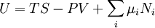
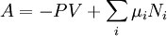
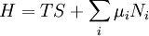
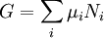
where A is the Helmholtz energy that Reif calls F, and U is E. I find these to be pretty stunningly simple results! Reif shows the 1st and the 4th on page 314 as if they were not very significant.
The last one says that the Gibbs free energy is the sum shown. Perhaps the differential forms are more practical for solving problems. The last form tells us that each molecule of type "i" contributes an amount μ_{i} to the Gibbs free energy, a pretty significant statement. So now identify μ₁ with g₁ of Baby Reif where he talks about reactions and/or dual phase system A.
Reminder: here the definitions of the 3 secondary energy functions:

H = E + pV // the Enthalpy S,p independent
F = E - TS // Helmholtz free energy, T,V independent
G = E - TS + pV [ = H - TS ] // Gibbs free energy, T,p independent

and here are the forms of the first law showing the natural independent variables.

dE = TdS - pdV
dH = TdS + Vdp
dF = -SdT - pdV
dG = -SdT + Vdp

When you add the chemical species business, you just add $\sum_{i=1}^{m}{}$μ_{i} dN_{i} to each of the four differential forms shown above, and you add $\sum_{i=1}^{m}{}$μ_{i} N_{i} to the integrated forms (as shown above_. The μ_{i} has lots of different partial derivative forms depending on which energy you use, but they are all equal I think. That is, there is only one kind of μ_{j} .
For example, suppose you are thinking in terms of F, and you have constant T and V. You then get Reif's result (8.10.1), where some of the b_{i} will be negative if you are thinking about a chemical reaction. In equilibrium, both sides are 0 for a reaction.

4. Calculating the chemical potential μ_{i} .

In the ideal gas model, which I think we could apply to a dilute solution, Reif does this starting on page 318, and the results are very useful to me. Reif expresses the total energy as the sum of all the molecule energies, each of which is in some state s_{k} . The partition function then factors and we get 8.10.6 where now have appeared the counts of each species, and a micro-partition function ζ as shown over the states of one particle of a given type. He then corrects for identical particles in the usual manner. (!)
Reif then digresses a bit, commenting on implications of the factorable partition function, then he resumes on page 322. First we write ln Z_{i} from its simple form 8.10.9. Then we insert this into the formula for F in terms of Z (see next section), uses a Stirling ln N! fix. We now have F expressed in terms of N_{j} so we now compute the derivative needed for μ_{j}, the chemical potential we are trying to compute. The final result is this:

μ_{j} = -kT ln(ζ_{j}/N_{j}) where ζ_{j} = the Boltzmann sum shown in 8.10.5.

The important fact for me is the appearance of N_{j} inside the log -- that is where my [x] type concentrations are going to come from! As shown in Baby Reif 2 notes, we have

[ j ] = (1000/N_{a}) N_{j} / V so N_{j} = V [ j] (1000/N_{a})

So we then have

μ_{j} = -kT ln(ζ_{j}) + kT ln(N_{i}) = -kT ln(ζ_{j}) + kT ln (1000V/N_{a}) + kTln [j] = μ_{j}⁰ + kT ln[j]

μ_{j} = μ_{j}⁰ + kT ln[j]

This says that the chemical potential increases as you increase the concentration.
Now, let's look at:

dG = -SdT + Vdp + $\sum_{i=1}^{m}{}$μ_{i} dN_{i}

Now assume that dT and dp are 0 as usual, and assume dN_{i} = signed b_{i} totals for reaction, then we have

dG = $\sum_{i=1}^{m}{}$μ_{i} b_{i} = $\sum_{i=1}^{m}{}$μ_{i}⁰ b_{i} + kT $\sum_{i=1}^{m}{}$b_{i} ln[i] = dG⁰ + kT ln $\prod_{i=1}^{m}{}$[i]^{bi}
= dG⁰ + kT ln Q

The b_{i} that are positive mean molecules added to the System A and will be on the top of Q and correspond to the right side of the chemical reaction where these molecules are "created". As usual, the "system A" considered above is a single chemical reaction because that is what I mean by the scaling of the b_{i} factors. If you want to scale the whole thing up to a mole of chemical reactions, multiply through by Na and you get

dG_{mole} = dG⁰_{mole} + RT ln Q // the "no name law"

This is the nameless formula that I derived by a more arm-waving method at the end of my Baby Reif 2 notes. // I just added an "alternative derivation" there which uses a lot less "arm waving" and I think has the essence of Reif's derivation, which really hinges on the big factorials.

5. Relationship between F and Z.

This is just quoted in Reif on page 321 bottom without proof, but an excellent short proof is given here:
http://theory.ph.man.ac.uk/~judith/stat_therm/node71.html#3_3helm. The upshot is this:

<S> = <E>/T + k ln Z and then F = -kT ln Z.

This proof is very clever, using an ensemble of systems to talk about <S> for the average system in an ensemble of systems. This is done, she says, because you cannot talk about the entropy of a single microstate.
Now Reif uses this result simply to show that you get a "law of partial pressure" for all quantities in the ideal gas scenario, where the rule applies not just to p, but to F, S, E and so on.

[ I later found Reif's derivation on page 216, but did not read it. ]

6. Electrochemistry:
trying to deal with a half-reaction from the start: [ I prefer Section 7 instead ]

Consider this reaction, where n is the number of electrons that moves per "a", and we don't show the fact that a or b must have charge.

a + ne⁻ → c n = number of electrons this half-reaction

as for example Parry p 333. If we treat this the same as any other chemical reaction, we can write from above that

dG_{mole} = dG⁰_{mole} + RT ln Q = G⁰_{mole} + RT ln $\frac{[c]}{[a][e-]n}$

In a quasi static half-cell, we can get all the work out of this free energy. The work we want to do is to run our n moles of electrons through our little resistive load at a very slow rate. A mole of electrons is 96,500 coulombs, call this amount of charge F because I think it is a "Faraday". The total work done can be written as VF > 0. So identify dG_{mole} = -VFn and we get

VFn = -G⁰_{mole} - RT ln $\frac{[c]}{[a][e-]n}$ => V = - G⁰_{mole}/(Fn) - RT/(Fn) ln $\frac{[c]}{[a][e-]n}$

where now each term is in volts. The constant term here is a function of the nature of this little reaction, so let's write it like this

V_{ac} = V⁰_{ac} - RT/(Fn) ln $\frac{[c]}{[a]}$ + RT/F ln [e-]

where I have now separated out the electron term.

So let's imagine another half reaction of this form

b → d + ne⁻

We will get the following equation for this reaction:

V_{bd} = V⁰_{bd} - RT/(Fn) ln $\frac{[d]}{[b]}$ - RT/F ln [e-]

Now we can add the two equations to get:

V_{ac} + V_{bd} = V⁰_{ac} + V⁰_{bd} - RT/(Fn) ln $\frac{[c]}{[a]}$ - RT/(Fn) ln $\frac{[d]}{[b]}$

And this describes a battery we can actually make and measure. First, if we set everything to 1 molar, then we get

V_{ac}(1) + V_{bd}(1) = V⁰_{ac} + V⁰_{bd}

so we then know the sum of the two V⁰ terms, but we don't know the individual terms themselves. Call this measured voltage V_{acbd}(1). Then we know

V⁰_{ac} = V_{acbd}(1) - V⁰_{bd}

Now suppose we change the reaction and install a new a'c' half reaction, keeping the other bd one. We make a new battery and make a new 1 molar measurement. We then get:

V⁰_{a'c'} = V_{a'c'bd} - V⁰_{bd}

But now we know the following:

V⁰_{a'c'} - V⁰_{ac} = V_{a'c'bd} - V_{acbd}

In this way, we can find (by direct measurement) the differences between all pairs of half-reactions of the ac type, but we cannot measure the absolute value. Therefore, we might as well set some arbitrary scale for these half reactions since we don't really care about actually working with half-reactions. We pick some standard half-reaction and declare it's potential to be 0, then we can determine all other potentials relative to it. That is what you see in Parry 333.
Now what about the [e-]^{n} concentration factor I am showing in this equation? It would really be there if you really had a cloud of electrons floating around in your solution, and if you were really doing such a "half reaction". But the half-reaction is really just a fiction, there is no intermediate reaction state that has all these electrons in solution in equilibrium. Also, a half reaction cannot really do electrical work because you cannot have a completed circuit.
In fact, this whole presentation really makes no sense. I think it is better to approach it differently as follows:

7. Electrochemistry: Half reactions as artificial things.

Start with a redox reaction of this form:

a + b → c + d with n electrons given off by b and absorbed by a.

We know that the rule for this reaction is:

dG_{mole} = dG⁰_{mole} + RT ln Q = G⁰_{mole} + RT ln ( $\frac{[c][d]}{[a][b]}$)

The total work done by this full reaction battery is going to be nFV where V is the total voltage, so we have

-nFV = G⁰_{mole} + RT ln ( $\frac{[c][d]}{[a][b]}$) => V = - G⁰_{mole}/(nF) - RT/(nF) ln ( $\frac{[c][d]}{[a][b]}$)

Let's rewrite this as

V_{acbd} = V⁰_{acbd} - RT/(nF) ln ( $\frac{[c][d]}{[a][b]}$) = V_{acbd}(all 1) - RT/(nF) ln ( $\frac{[c][d]}{[a][b]}$)

where the acbd subscript reminds us that this constant depends on all four species involved in the reaction. However, in a full cell battery, the two half-reactions occur at different physical locations and seem to be pretty independent, so maybe we can say this:

V⁰_{acbd} = V⁰_{ac} + V⁰_{bd}

Suppose such a decomposition were correct (my assumption so far), then we can write:

V_{acbd} = V⁰_{ac} + V⁰_{bd} - RT/(nF) ln ( $\frac{[c][d]}{[a][b]}$)

= { V⁰_{ac} - RT/(nF) ln ( $\frac{[c]}{[a]}$) - c } + { V⁰_{bd} - RT/(nF) ln ( $\frac{[d]}{[b]}$) + c }

= { V_{ac} } + { V_{bd} }

where we associate each {..} with a half-reaction, and c is an arbitrary constant, and we define "half reaction voltages" as shown like V_{ac}, though there is no way to measure such a thing, nor is it even meaningful in any physical sense. If we set all molarities to 1 and measure our voltage, we get:

V_{acbd}(all 1) = V⁰_{ac} + V⁰_{bd}

Now we repeat the experiment with a different a'c' to get

V_{a'c'bd}(all 1) = V⁰_{a'c'} + V⁰_{bd}

We can then determine this difference: (because the germ V⁰_{bd} cancels out)

V⁰_{a'c'} - V⁰_{ac} = V_{a'c'bd}(all 1) - V_{a'c'bd}(all 1)

In this manner, we could make a table of differences for all half reaction pairs.
Now suppose we arbitrarily set our constant c = V⁰_{xy} for some half reaction x,y. Then we write our two "half equations" as :

V_{ac} = V⁰_{ac} - V⁰_{xy} - RT/(nF) ln ( $\frac{[c]}{[a]}$)

V_{db} = V⁰_{db} - V⁰_{xy} - RT/(nF) ln ( $\frac{[d]}{[b]}$)

We then find that V_{xy}(1) = 0. So by setting c in this way, we arbitrarily set a zero value for V_{xy}(1). The tables really list things like V_{ac}(1) where the 1 indicates the "standard conditions".
We can rewrite these equations like so:

V_{ac} = V_{ac}(1) - RT/(nF) ln ( $\frac{[c]}{[a]}$) // a gets oxidized since it donates electrons
a + ne⁻ → c a has "reducing power"
V_{db}= V_{db}(1) - RT/(nF) ln ( $\frac{[d]}{[b]}$) // b gets reduced since it accepts electrons (like O)
b → d + ne⁻

The constants can be looked up in our little table [ where it will happen that some V_{xy}(1) = 0]. So these little equations are then completely explicit, all constants are known. They describe artificial half-reactions, but otherwise they are well defined as presented above, I think.
Example: Suppose we make a battery with copper and zinc electrodes, and first we pretend that the metals have molarity like anything else. Then:

a = Cu⁺⁺ c = Cu b = Zn d = Zn⁺⁺

We look up in the table to find that V_{ac}(1) = +.34 while V_{db}(1) = +.76 (the table shows the neg of this, but we want the reverse reaction). Then we have ( note that n=2)

V_{ac} = +.34 - RT/(2F) ln ( $\frac{[Cu]}{[Cu++]}$)

V_{db}= + .76 - RT/(2F) ln ( $\frac{[Zn++]}{[Zn]}$)

The only problem now is that we don't know what to do about things like [Cu] . We really have a reaction on a surface, so not really an ideal gas except perhaps in a 2D sense for ions. Nothing you do is going to change whatever [Cu] is. So the idea is to absorb whatever it is "into the constant", which is the same as just setting it equal to 1. It just changes things like V⁰_{ac}, but whatever it changes to, we still set c as shown above and the equations remain the same. So then we would say:

V_{ac} = +.34 - RT/(2F) ln ( $\frac{1}{[Cu++]}$)

V_{db}= + .76 - RT/(2F) ln ( $\frac{[Zn++]}{1}$)

If we construct a battery with 1 molar for both ions, ( maybe lots of metal and little solution) , then we will measure

V_{acbd}(all 1) = V_{ac}(1) + V_{bd}(1) = .34 + .76 = 1.1 volts

8. The Nernst Equation and Le Chatelier and Batteries (not really from Reif)

Here are clips from a web site paper CH2ch172.ppt (which I have preserved). First, consider this:

3) Le Chatelier’s Principle
a)Cu(s) + 2Ce4+(aq) Cu2+(aq) + 2Ce3+(aq) εocell = 1.36 V
b)Increase Ce4+ concentration, (ε > εo)
c)Increase Cu2+ concentration, (ε < εo)
d)Sample Exercise 17.5

Compare to Reif result above which showed that μ_{j} = μ_{j}⁰ + kT ln[j] . If you increase [j] on the left side, you increase the chemical potential μ_{j} and put the equilibrium out of balance because now sum of potentials on the left is more than the right. Reaction moves to the right, increasing final concentrations so things get back in balance. This "Le Chatelier's Principle" has been derived by Reif's chemical potential calculation.

Here is another clip: (the arrows are in the wrong place, easy to ignore)

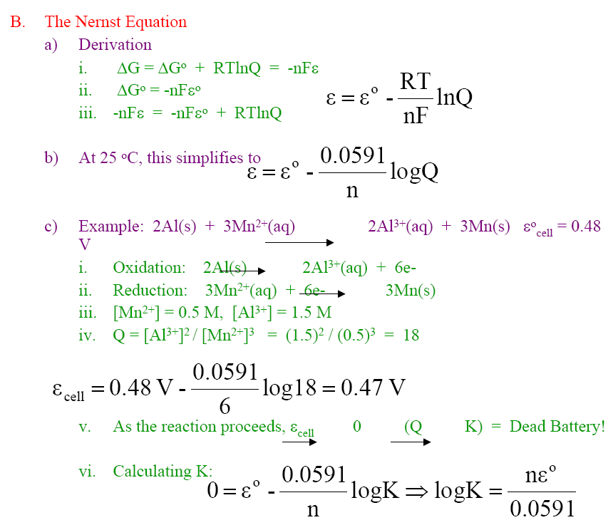

The first lines are a derivation of "The Nernst Equation", which exactly matches what we have done earlier, namely [ but some people call this the "general Nernst equation" since a full reaction.]

V_{acbd} = V⁰_{acbd} - RT/(nF) ln ( $\frac{[c][d]}{[a][b]}$)

Author has installed a certain T and also R and F. Notice that the log constant is 59 mV at 25C.

1 Faraday (F) = the charge on 1 mole of electrons = 96,485 C

In the example shown, we pick our two half-reactions as shown. Looking up in Parry page 598 I see the first reaction at +1.66 and the second is -1.18 so get Vcell = 1.66 - 1.18 =0.48 (as we see above). But then the example is done with non-1 molar solutions, so Q = (1.5)^2/(0.5)^3 = (18) and the correction term is a mere .0124 volts, call it .01 volts, so result is .47 volts. He finally shows how to find K for equilibrium where he will use ε0 = .48 volts. So this was a good exercise to work through, good notes.

Next clip is on the lead acid battery:

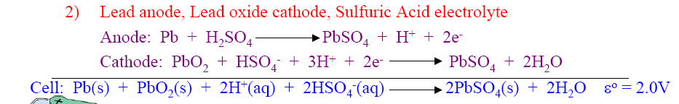

The Parry table does not show these half reactions, but here is a big table

http://www.northland.cc.mn.us/Chemistry/standard_reduction_potentials.htm

and it gives for the first above: PbSO₄ + 2e ↔ Pb_{(Hg)} + SO₄²⁻
-0.3500
and for the second PbO₂ + SO₄²⁻ + 4H⁺ + 2e ↔ PbSO₄ + 2H₂O
1.6913
So note-maker has H balance off in his first equation, but we get the point, and result 1.6913+.35 = 2.0413 volts! This is the usual 2 volt cell.
Author then shows other batteries, but in less detail.

Watson and the Nernst Equation (page 526). In the little derviation here, he starts by saying

ΔG = -RT ln (C0/C1)

where the C's are concentations of some ion on the two sides of a membrane. The reaction here has only one molecule species, you could say H+ (C0) → H+ (C1). We know that if C0 = C1 then there is certainly no ΔG difference, and that is why the usual constant is missing here. But otherwise, this is just a normal application of our general law to a very simple "reaction". He then sets ΔG = zFV in the usual way, but z = 1 in this case for H+ ions. You then solve for V = (RT/zF) ln Q in the usual manner. The constant is 59 mV at 25 C as in the notes above.
So this derivation is just fine by me now (it was not earlier! ). It is just the general Nernst equation applied to a very simple reaction. The H+ ions on the two sides have a different chemical potential μj = μj0 + kT ln[j] and the difference Δμ gives rise to the membrane potential. So now we see what bio membrane potentials are "on the order of" 60 mV, just because that is the size of the constant on front of the log.
Watson uses slightly different units than the other books used, such as for F and R.

9. Biological Cytochrome type redox reactions.

Watson page 694 shows one chart with numbers on it. Page 680 shows another one, and that is where you find a discussion. Consider this reaction:

1/2 O₂ + 2e⁻ + 2H⁺ → H₂ 0

If we try to apply our usual Nernst equation to this, we would ignore the water I think and say something like this:

V_{acbd} = V⁰_{acbd} - RT/(nF) ln ( $\frac{1}{[O2]1/2[H+]2}$)

If I look this reaction up in a table like Parry, I see that V⁰_{acbd} = 1.23 volts for "standard values". That would mean 1 molar for [H+] and I guess 1 atmosphere in some sense for the O₂. Now, the constant out front is about 59 mV if we change to log, so have

V_{acbd} = + 1.23 - (59 mV/2)log ( $\frac{1}{[O2]1/2[H+]2}$)

Now what happens if we change the [H+] to 10⁻⁷ molar from 1 molar? The new second term which was 0 is now 59.10000/2 = 29.55

- (59.1 mV/2) log (10⁻¹⁴) =(-29.55 mV) * (+14) = 29.55*14 = - 413.7 mV.

Then 1230 - 413.7 = 816.3 mV, and now I know where Watson gets his +820 mV he quotes on page 680. Also, this pH = 7 result appears in the Parry page 598 as 820 mV. But we want body temperature perhaps which is 98.6 F = 37C. At this temperature Watson says the constant is 61.5 mV, so we would be subtracting off even more. So perhaps there are other changes when you make such a huge change in a concentration as 10 orders of magnitude. So I will regard my 816 as close enough to 820 mV for gubment work.
Now that we have a point of reference we can look at page 680 again. The O₂ wants to get the electrons very much, does not want to give them up. Things at the bottom of the Parry table have negative reduction potentials which means they

A donates electrons to B, B is reduced, B is oxidizer acting on A (like oxygen)
A is a reducer acting on B, A has reducing power.

So things at the bottom of the Parry table have more reducing power. Similarly, in the bio chart on page 680, NADH has a negative reduction potential which means it does not want to be reduced, it wants to reduce something else, it has the most "reducing power" in the chart.
So we have a chain of reactions here.

NADH → NAD+ + electrons
Q + electrons → Q*

Q* → Q + electrons
c + electrons → c*

c* → c + electrons
H+ + O₂ + electrons → H₂O

In each step, the reaction proceeds with some -ΔG > 0 which gets used perhaps to generate H⁺ gradient from a protein. A negative reduction potential in the table means the object (like NADH) wants to donate electrons, which means it has a high reducing power. O₂ at the chain bottom wants to receive electrons, has strong oxidizing power. Strong reducers have negative reduction potential.
So, the potentials shown in Watson are the usual "reduction potentials" as we find in Parry.
You can think of the electrons themselves as starting in a high energy state (meaning their holder can easily get rid of them), and they end up in a low energy state (oxygen, tightly bound.). So I guess you could think of each molecule has having a Harry Gray type orbital diagram and you place them all side by side somehow and you watch the electrons go downhill. Of course this diagram is in solution, so not the same as what I am used to. I don't think I have ever seen such a diagram. But I get the idea I think.
Note that both Temperature and buffer pH probably have to be right to make these chains work.
In the photo picture on page 694, a photon is shown as jumping an electron up by about 1.2 volts, which means photon energy is 1.2 electron volts. The following picture shows that this is an infrared photon. But probably it is a visible photon and some of the jump energy goes somewhere else, perhaps into the mysterious enzyme at the bottom of the page 694 Watson figure.

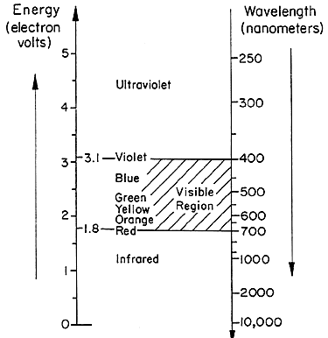

I think this concludes my long digression into the world of thermodynamics.

