About Techniscan PhL 11.26.20

The main guy there was Steve Johnson and he knew Jim Ball.
He was making a machine to do breast scans for cancer.
I was talking to him in 2007, 13 years ago.
I talked to them with the idea of getting an RDT contract going, but after several meetings it became clear that this was not going to fly. Steve had to give up control of the company to other people and those people did not want my services. I think Steve liked me but the others less so. They didn't have cash to throw around on an expensive contractor!

I recall that the scanner was connected to a massive piece of hardware not shown below

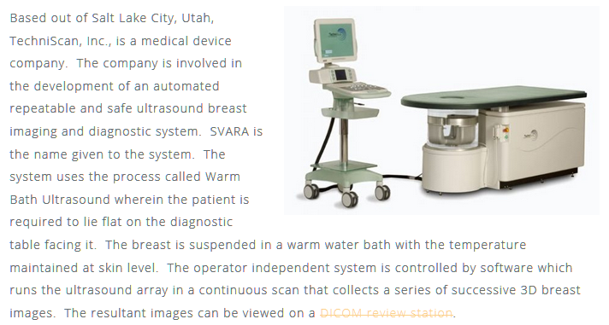

Here is what the company looked like at 1300 and 3300S on Highland. I don't remember the building.

