Transmission Lines and Maxwell's Equations
Phil Lucht
Rimrock Digital Technology, Salt Lake City, Utah 84103
last update: Feb 9, 2014

Maple code is available upon request. Comments and errata are welcome.
The material in this document is copyrighted by the author.

The graphics look ratty in Windows Adobe PDF viewers when not scaled up, but look just fine in this excellent freeware viewer: http://www.tracker-software.com/pdf-xchange-products-comparison-chart .

The table of contents has live links. Most PDF viewers provide these links as bookmarks on the left.

Overview and Summary 6
Chapter Summaries 7
Appendix Summaries 8
Chapter 1: Basic Equations 10
1.1 Maxwell's Equations in a Conducting Dielectric Medium 10
(a) Notes on Maxwell's Equations 10
(b) Integral Forms of Maxwell's Equations and Continuity 14
(c) Rules for behavior of fields and potentials at a boundary 17
1.2 The Field Wave Equations 22
1.3 The Potential Wave Equations 23
(a) The Potential Wave Equations in the Lorenz gauge 23
(b) Special Relativity Note 24
(c) The Potential Wave Equations in the King and Lorenz Gauges with Conductors 26
1.4 Retarded Solutions in the Lorenz gauge: Propagators 34
1.5 The Wave Equations in the Frequency Domain 37
(a) The Transformed Wave Equations 37
(b) The Helmholtz Integrals in the King Gauge 38
(c) King's leading factor (1/4πξ) and the final Helmholtz Integrals 40
(d) Frequency domain wave equations for fields and potentials in the Lorenz Gauge 47
(e) Self Consistency of Helmholtz Integral Solutions 49
1.6 Reinterpretation of all equations in terms of complex functions 51
(a) Complex Functions 51
(b) Monochrome time 51
(c) Why complex fields: The Fourier Transform 53
(d) Monochrome E and B fields 54
(e) A Pitfall to Avoid 55
(f) Overloaded Notation and Maxwell's Equations in ω space 55
Chapter 2: The Round Wire and the Skin Effect 56
2.1 The Implicit Wave Context and the Skin Effect 56
2.2 Derivation of E(r), B(r) and J(r) for a round wire 59
2.3 A study of the solution of a round wire 66
(a) Kelvin Functions 66
(b) Plots of |E(r)/E(a)| for various δ values 67
(c) Review of the round wire solution 71
(d) Plots of the round wire solution for Belden 8281 at 5 MHz. 73
2.4 The Surface Impedance Z_{s}(ω) of a Round Wire 75
(a) Expressions for Surface Impedance 76
(b) Low frequency limit of Z_{s}(ω) 77
(c) High frequency limit of Z_{s}(ω) 78
(d) Plots of Z_{s}(ω) versus skin depth δ 79
2.5 Surface Impedance for a Transmission Line 82
Chapter 3: Transmission Line Preliminaries 85
3.1 Why is there no free charge inside a conductor or a dielectric? 85
3.2 How thick is the surface charge layer on a conductor? 87
3.3 How does loss tangent affect dielectric conductivity? 88
3.4 Size of E fields in conductor and dielectric; conservation of total current at a boundary 90
3.5 The TEM mode fields and currents for an ideal transmission line 92
3.6 The TEM mode fields and currents for a practical transmission line 95
3.7 The general shape of fields, charges, and currents on a transmission line 97
(a) Facts about field structure 97
(b) Drawings of the fields 99
(c) More on the field and current structure 101
(d) Estimate of the ratio J_{r}/J_{z} 103
3.8 Transmission Line Preliminaries 105
Chapter 4: Transmission Line Equations 109
4.1 Computation of potential φ due to one conductor of a transmission line 109
4.2 Computation of potential φ due to both conductors of a transmission line 110
4.3 The Transmission Line Limit 111
4.4 General Calculation of V(z) 114
4.5 Example: Transmission line with widely-spaced round wires of unequal diameters 118
Power Transmission Lines 123
4.6 Example: A coaxial cable 123
4.7 Computation of A_{z} due to one conductor of a transmission line 127
Comments regarding μ 128
4.8 Computation of potential A_{z} due to both conductors of a transmission line 130
4.9 Transmission Line Limit Revisited 130
4.10 General Calculation of W(z) 131
4.11 The Classic Transmission Line Equations 134
Digression on the meaning of C' 137
An example of K = K_{L} 138
4.12 Modifications to account for μ ≠ μ₁ ≠ μ₂. 143
Chapter 5: The Transverse Problem 148
5.1 Separation of φ 148
5.2 Separation of A_{z} 150
5.3 Development of the Transverse Problem 152
(a) k_{φ} = k_{A} and the transverse equations 152
(b) The scaling boundary condition on φ_{t}(x) 154
5.4 The "low-loss" approximation 155
(a) Transverse Equations for a Low-Loss transmission line 155
(b) The scaling boundary condition (5.3.11) revisited 157
5.5 The Capacitor Problem 158
5.6 What happens if low-loss is not assumed? 164
Chapter 6: Transmission Lines with Two Circular Conductors 167
6.1 A candidate transverse potential φ_{t} 167
6.2 Ancient Greece circa 230 BC 167
6.3 Back to the Future: Calculation of K 170
6.4 Summary of Results 177
Appendix A: Gauge Invariance 178
A.0 The Poisson Equation and its Solution 178
A.1 Existence of A such that B = curl A and div A = 0 181
A.2 Existence of A' such that B = curl A' and div A' = f . 183
A.3 Existence of φ such that E = -grad φ 183
A.4 Existence of A' and φ' such that B = curl A', E = - grad φ' - ∂_{t}A', and div A' = f. 184
A.5 Gauge Invariance 185
A.6 The Lorenz Gauge and QED 186
A.7 Finding the gauge function Λ for the Lorentz Gauge: time-domain propagators 188
Appendix B: Magnetization Surface Currents on a Conductor 191
B.1 Relationship between surface current K and the field H at a conductor boundary 191
B.2 Calculation of H from the current J in a conductor 195
(a) An expression for H in terms of J 195
(b) An alternative derivation using the vector potential A_{z} 196
(c) Boundary conditions 197
(d) The Biot-Savart Law in 3D and 2D 198
B.3 General Method for computing the surface current J_{m} on a wire 199
B.4 Surface current on a round wire with uniform J 200
B.5 Computing H_{θ} for a round wire using the General Method of B.3 201
B.6 Modification of King's Helmholtz integral solution when μ₁ ≠ μ₂ 204
(a) General Discussion 204
Comments regarding μ 205
(b) Statement and Proof of the J_{m} Lemma 206
(c) Statement and Proof of the J_{m} Theorem 212
B.7 Application of the J_{m} Lemma to a round wire with uniform J_{z} 216
(a) The A_{z}^{(c)} term 217
(b) The A_{z}^{(m)} term 219
(c) Adding the two terms and checking boundary conditions 219
(d) Plots of A_{z} and B_{θ} and H_{θ} 221
Appendix C: DC Properties of a Wire 223
C.1 The DC resistance of a wire 223
C.2 The DC surface impedance of a wire 223
C.3 The DC internal and external inductance of a round wire 224
C.4 The DC internal inductance of a wire of rectangular cross section 226
C.5 The DC internal inductance of a thin flat wire 234
C.6 The DC internal inductance of a hollow round wire 239
Appendix D : The General E and B Fields Inside an Infinite Straight Round Wire 244
D.1 Partial Wave Expansion 244
(a) The General Method 245
(b) Partial Wave Expansions 246
(c) The Vector Laplacian in Cylindrical Coordinates 247
(d) The three Helmholtz equations and div E = 0 (in partial waves) 248
D.2 Solutions for E_{z,}E_{r} and E_{φ} 252
(a) The E_{z} Solution 252
(b) The E_{r} Solution 253
(c) The E_{φ} Solution 255
(d) The Charge Pumping Boundary Condition 258
(e) Application of the Boundary Conditions 259
D.3 What about the E_{φ} Helmholtz Equation ? 264
D.4 Computation of the B fields in the round wire 265
D.5 Verification that the E and B fields satisfy the Maxwell equations 269
D.6 The exact E and B fields for the m=0 partial wave 271
D.7 What about the E fields outside the round wire? 272
D.8 About the boundary condition E_{φ}(r=a,m) = 0 274
(a) The Quasi-Static Argument 276
(b) An Ansatz Argument 277
Exercise for the Reader 279
Appendix E: How Thick is Surface Charge on a Metal Conductor? 280
Appendix F: Waveguides 284
F.1 Discussion 284
F.2 The TE waveguide modes for a parallel-plate transmission line 284
Appendix G: The DC vector potential of a round wire carrying a uniform current 289
G.1 Setup and Assumptions 289
G.2 Direct solution for A_{z}(r) from the differential equation 290
G.3 Instant solution for A using Ampere's Law and computation of J_{m} 293
The Magnetization Current 293
G.4 Solution for A_{z} using the 2D Helmholtz Integral 294
G.5 Comments on the low frequency solution for A_{z} 297
Appendix H : Poisson and Helmholtz Propagators in 3D 300
Appendix I : Poisson and Helmholtz Propagators in 2D 305
Appendix J : The 3D→2D Propagator Transition 313
Appendix K : Line Parameters: Comparison of Network and Maxwell Views 319
(a) The Network Model 319
(b) Characteristic Impedance in the Network Model 319
(c) Characteristic impedance computed from Maxwell's Equations 321
(d) Low frequency case (no skin effect) 322
(e) High frequency case for round conductor (strong skin effect) 323
Appendix L: Point and Line Charges in Dielectrics 325
L.1 The potential of a point charge inside a thick dielectric spherical shell. 325
L.2 Limits of the Previous Problem 330
(a) Point charge in a cavity in a dielectric 330
(b) Point charge embedded in a dielectric sphere 331
(c) Point charge embedded in an infinite dielectric 332
L.3 The potential of a line charge inside a thick dielectric cylindrical shell 333
L.4 Limits of the Previous Problem 336
(a) Line charge in an infinite cylindrical hole in a dielectric 336
(b) Line charge embedded in an infinite dielectric cylinder 337
(c) Line charge embedded in an infinite dielectric 337
References 339

Overview and Summary

This monograph uses the Maxwell and associated potential equations to determine the behavior of infinitely-long, straight transmission lines. The presentation is loosely based on R.W.P. King's book Transmission-Line Theory. No attempt is made to address non-straight geometries, bends, stubs and many other practical applications described by King. There is no discussion of discontinuities, reflections, standing wave ratios, Smith charts, or any of the traditional topics associated with transmission lines. The emphasis is more on how one derives the transmission line parameters R,L,G,C directly from electromagnetic theory, and what approximations are made in doing so. A key requirement is that the wavelength of a transmission line wave be significantly larger than the line's transverse dimensions, something we refer to as the "transmission line limit". Although the discussion generally concerns transmission lines with two conductors, comments here and there show how the conclusions can be extended to transmission lines with more than two conductors.

Unlike waveguides, transmission lines are most easily analyzed using potentials rather than fields due to the nature of the boundary conditions. This then brings up the can of worms known as "the gauge condition". We show how a variant of the Lorenz gauge which we call "the King gauge" (since King uses it) serves to clarify the meaning of the Helmholtz integrals for the scalar and vector potentials over the surface and interior of the transmission line conductors. This subject is somewhat glossed over in King's highly compressed theoretical summary, and we could not find clarification in his many other books on the subject. By the way, most books on "transmission lines" are concerned with the practical aspects of electrical power distribution and King's book is somewhat of a rarity. It is true that a waveguide is in fact a transmission line, but we use the term "transmission line" to imply the TEM mode of transmission.

An ancillary topic receiving much attention in this document is the description of the fields, potentials and currents inside a transmission line conductor operating at angular frequency ω. Mainly the discussion concerns round wires. A uniform round wire seems a simple physical object, yet the analysis is quite complicated and involves the so-called Kelvin functions. The skin effect and surface impedance of such a wire are considered in detail.

There are very few "it can be shown" phrases in this document. Almost everything is derived in detail and the results verified against external sources. Simple examples are always presented and calculations for these examples are fully displayed, perhaps to a level of detail the reader will find annoying. Our view is that a piece of theory is useless if one cannot apply it to a simple case and get a reasonable result. This view is not shared by all practitioners in the sciences.

The reader is assumed to have some knowledge of ordinary and partial differential equations and associated calculus. Green's Functions (which we call propagators) appear frequently, since these are useful in solving differential equations, and details are provided for readers not familiar with this subject. In particular, our first major waypoint is the derivation of the transmission line potentials in the form of King's Helmholtz integrals as shown in box (1.5.23). The propagators in these integrals are the 3D Helmholtz free-space fundamental solutions e-jβR/R. This subject is fully laid out for the interested reader in Appendices H and I for the 3D and 2D Helmholtz partial differential equations which are the frequency domain Fourier transforms of the more familiar 3D and 2D wave equations.

The document consists of six Chapters which are followed at the end by Appendices A through L. These deal with issues thought too detailed or perhaps too peripheral to the main topic to appear in the main text.

Maple is used as needed to compute analytic integrals, solve equations, do unpleasant algebra, and make graphs. The reader need not be a Maple expert to read and understand the presented Maple code.

To reduce clutter, derivatives that would normally be written $\frac{∂f}{∂x}$ or ∂f/∂x are written as ∂xf. Symbols div F, curl F and grad ψ are generally used instead of ∇•F , ∇xF and ∇ψ. The scalar Laplacian is always ∇2. Symbol σ is used for conductivity, so surface charge is relegated to symbol n, which is also used to indicate a derivative normal to a surface ∂nf .

Rather than use exotic script fonts or decorations to distinguish various forms of the electric field E, we use an "overloaded" notation where the argument list determines which E function is implied.

When an equation is repeated after its first occurrence, the equation number is put in italics.

Chapter Summaries

Chapter 1 states Maxwell's Equations and associated equations which extend Maxwell's theory from the vacuum to dielectric and magnetic media. After some comments, these equations are restated in integral form using the divergence theorem and Stokes's theorem, and then the behavior of field components at boundaries is obtained. Wave equations for both the fields and potentials are described, and the subject of gauges is dealt with. Starting with Section 1.5 the wave equations are transformed to the frequency domain and Helmholtz equations with parameter β2 appear. King's Helmholtz integral solutions of these equations are then derived using what we call the King gauge. Finally, Section 1.6 clarifies the reasons for using complex fields when physical E and B fields are real.

Chapter 2 derives the E and B fields (and current J = σE) inside a round wire which is assumed to have an axially symmetric current flow. The resulting fields are rather complicated and reveal the skin effect. The surface impedance is defined and various quantities are plotted. Assumptions are made about the vector directional nature of the E and B fields in this analysis. The same problem is treated without these assumptions and for an arbitrary current distribution in Appendix D. The main results of that lengthy Appendix appear in box (D.4.9).

Chapter 3 discusses odd topics such as dielectric loss tangent, the thickness of surface charge, and why there is no free charge inside a conductor or a dielectric. The chapter concludes with a qualitative description of the E and B fields of a (TEM) transmission line, with some sketches of the fields. Various Facts about a transmission line are then stated.

Chapter 4 uses the Helmholtz integral form of the potentials to derive the well-known transmission line equations which are these,

∂zV(z) = - z i(z) ∂zi(z) = - yV(z) (4.11.11)
z = R + jωL y = G +jωC . (4.11.12)

In this process, the "transmission line limit" is assumed, which says that wavelength on the line is much longer than the transverse dimensions of the line. The analysis then yields precise meanings for the parameters R, L, G and C. L is in fact the sum of external and internal inductance contributions Le + Li and it turns out that Le, C and G are all related to each other in terms of a certain dimensionless real parameter K as shown in (4.11.30). Parameters R and Li are the real and imaginary parts of the sum of the conductor surface impedances Zs1 + Zs2. The analysis is first carried out assuming that the conductors and dielectric all have the same magnetic permeability μ, but then Section 4.12 shows how to generalize the results for arbitrary magnetic conductors and dielectric.
At this point, the transmission line parameters are clarified and are related to each other, but they are not "known" due to the fact that their solutions involve integral equations over the transmission line geometry. This is the typical chicken-and-egg problem one encounters in all real-world electromagnetic problems. Apart from trivial cases (such as very thin transmission line conductors), further approximation must be made.

Chapter 5 describes the required approximation. It is basically a continuation of the "transmission line limit" mentioned earlier, along with a notion of "low-loss", which then allows the transmission line problem to be reformulated as a 2D potential theory problem which we call "the transverse problem". It is then basically a "capacitor problem" and then any transmission line geometry can be solved at least numerically. Basically the assumption that the conductors are very good conductors transforms the transverse Helmholtz equation into the 2D Laplace equation which is the basis of 2D potential theory.

Chapter 6 then gives a complete discussion of the exact solution, within the assumptions just mentioned, for transmission lines consisting of two circular conductors of arbitrary diameter and arbitrary relative (but not intersecting) position. This includes twin-lead lines with equal and unequal conductor diameters as well as on- and off-centered coaxial lines. Since an infinite radius cylinder is a plane, this discussion also obtains the exact solution for a transmission line consisting of a round wire over a ground plane.

Appendix Summaries

Appendix A discusses gauge invariance and proves the existence of gauges in which div A can be set to any arbitrary (but reasonable) scalar function, A being the vector potential appearing in B = curl A. The notion of a Green's function or "propagator" is introduced. A few passing comments are added regarding the connection to special relativity, covariance and quantum field theory.

Appendix B analyzes the situation in which the transmission line dielectric and conductors have different magnetic permeability μ, a situation not treated in King's TLT book. This causes a bound magnetization current density Jm to appear both at boundaries (as a surface current) and in the bulk conductors (as a volume current). It is shown ("the Jm theorem") that the theory of Chapter 4 with its Helmholtz integrals for the potentials can be "rescued" by adding just the surface component of the magnetization current Jm to the true conduction current in the vector potential integrand. A simple method is given for computing this surface Jm current from the conduction current distribution J in the conductor. As usual, the round wire serves as a calculational example.

Appendix C concerns the seemingly mundane subject: "DC properties of wires". The main issue here is the DC inductance of wires which we treat from a stored energy viewpoint. Internal inductances are computed for a round wire and a hollow round pipe. It is shown that even for a simple rectangular cross section (including square), the internal inductance cannot be expressed analytically (at least using our method) and a numerical calculation is required. That calculation has been done recently (2009) by Holloway and Kuester.

Appendix D computes the E and B fields inside a round wire for an arbitrary current distribution. The wire is assumed to be one conductor of a transmission line down which a wave travels at frequency ω. The solution is obtained using azimuthal partial wave analysis. The E field Helmholtz equations are directly solved in cylindrical coordinates, and the B field is then computed from Maxwell's curl E equation. Boundary conditions at the wire surface are discussed. The results (D.4.9) are expressed in terms of the surface charge moment ηm in each partial wave. The results for the m=0 partial wave are compared with the results of Chapter 2 which assumed a symmetric current distribution. A passing glance is take of the corresponding fields outside the wire, and the issue of Eφ = 0 at a conductor surface is examined.

Appendix E ponders the thickness of the surface charge on a conductor. It is shown that the charge layer thickness is about 1/3 the radius of a copper atom for a copper conductor, and that this is 4000 times smaller than the skin depth at 100 GHz.

Appendix F is an elementary discussion of the waveguide modes of a parallel plate transmission line. It shows why there is a cutoff frequency below which no waveguide modes can operate, whereas the "transmission line (TEM) mode" on the same structure operates all the way down to DC.

Appendix G computes the DC vector potential Az inside and outside a round wire carrying uniform current. The computation is done three ways, the most difficult using the Helmholtz (Poisson) integral. When the dielectric surrounding the wire has a μ different from that of the wire, a homogeneous solution must be added to the Helmholtz particular integral solution. It is this homogeneous solution that is synthesized by adding the surface magnetization current discussed in Appendix B.

Appendices H and I derive the Poisson and Helmholtz Green's Functions for the 3D and 2D Poisson and Helmholtz differential equations. These play a major role in the entire document.

Appendix J shows how the transmission line transverse analysis replaces 3D propagators with 2D propagators of the Helmholtz and Poisson equations. Results obtained blindly in the main document are interpreted in terms of these Green's function propagators.

Appendix K presents the standard network model of a transmission line as the limit of a set of lumped circuit components. By computing the characteristic impedance Z0 both from this network model and from Maxwell's equations, it is shown that the R,L,G,C parameters of both models have the same meaning, and this makes the connection between these network-model parameters and those obtained in Chapter 4 from the Maxwell equations.

Appendix L considers a point charge located at the center of the cavity of a thick spherical dielectric shell. The problem is solved and limiting cases are obtained. The solution provides an interpretation of how bound charge is accounted for by the dielectric constant ε in Er = (1/4πε) (q/r). This 3D analysis is then repeated in 2D for a line charge in the cavity of an infinite cylindrical shell.

Chapter 1: Basic Equations

In this chapter we state the basic equations to be used later in the calculation of transmission line parameters.

1.1 Maxwell's Equations in a Conducting Dielectric Medium

Our working set of equations is the following:

curl H = ∂tD + J Maxwell curl H equation (J = Jc) (1.1.1)

curl E = - ∂tB Maxwell curl E equation (1.1.2)

div D = ρ Maxwell div D equation (ρ = ρfree) (1.1.3)

div B = 0 Maxwell div B equation (1.1.4)

B = μH magnetic permeability μ (1.1.5)

D = εE electric permeability ε (dielectric constant) (1.1.6)

J = σE Ohm's Law (σ = conductivity) (1.1.7)

div J = - ∂tρ Equation of Continuity (see item 7 below) (1.1.8)

(a) Notes on Maxwell's Equations

Although Maxwell's equations ("the Maxwell equations") provide a concise overview of classical electrodynamics, there is lot going on "under the hood" and clarification of the meaning of certain symbols seems useful, hence the following set of notes.

0. It is understood that, in a medium other than the vacuum (that is, a "ponderable" medium), all the mathematical fields shown above like E, D, B, H, J, ρ (and later A and φ) are average fields in the sense discussed in Jackson Sections 4.3 and 6.6. The partial differential equations are meaningful for differential volumes, areas and distances which are very small but still contain enough atoms or molecules (perhaps at least 1000) so that averaging makes sense. We shall refer to the various electric and magnetic fields as "fields" to distinguish them from "potentials" like A and φ, though all these quantities are mathematical fields.

1. The equations above are all expressed in SI units. The connection with cgs/Gaussian units is explained in an Appendix present in all three of the Jackson Classical Electrodynamics editions. The above equations appear in Jackson's third edition at these locations,

(1.1.1) through (1.14): p 2 (I.1a) Maxwell's Equations
(1.1.5) and (1.16): p 296 top line permeability constitutive relations
(1.1.7) p 219 (5.159) Ohm's Law constitutive relation J = σE
(1.1.8) p 3 (I.2) equation of continuity

2. All media (conductors, dielectrics between conductors) are assumed to be homogeneous and isotropic so that the quantities σ, ε and μ are constant scalars in space (not tensors) for a given medium. In the vacuum these constants take the values σ = 0, ε = ε0 and μ = μ0. An implication of σ, μ and ε being constants in space is that they pass through the div, curl, grad and ∇2 operators just as would any constant like π. One must be a little careful at a boundary between homogenous media since these constants can be different in the two media. In principle, all three quantities can vary in time, and when transformed to the frequency domain, σ(ω), ε(ω) and μ(ω) can (and do) vary with ω. However, we shall assume that for our frequencies of interest, these quantities are constant in ω and are therefore also constant in time so they pass through ∂t.

3. The difference between ε and ε0 is caused by polarization of bound charge in the medium. Equations dealing with polarization are these [ see Jackson pp 153-4 or Panofsky & Phillips pp 28-30 and p 129-130 on the polarization current ] :

PdV = electric dipole moment contained in volume dV of a dielectric (1.1.9)

Jpol ≡ ∂tP = polarization current density (1.1.10)

ρpol = - div P = polarization charge density (1.1.11)

P = ε0χeE // polarization assumed proportional to the polarizing E field (1.1.12)

D = ε0E + P = ε0(1 + χe)E = ε E = "the electric displacement " (1.1.13)

ε = ε0(1 + χe) // ε = dielectric constant, χe = electric susceptibility (1.1.14)

div E = (1/ε0)(div D - div P) = (1/ε0)(ρfree + ρol) . "E sees all charges" (1.1.15)
The E field causes polarization P either by causing existing tiny dipole objects (e.g., molecules) in the media to "line up", or by causing tiny non-dipole objects (e.g., atoms) to have dipole moments and then those get lined up. See for example Bleaney & Bleaney Chapter 10 " Dielectrics".

Comment: Since D = ε0E + P, the D and E fields are scaled differently. It might have been better had the D field been replaced by D = ε0D' in which case D' = E + P/ε0, then one can make clearer statements about D' versus E. For example, in a dielectric capacitor with fixed conductor charges (Q,-Q) there exist both D' and E fields, and D' = (ε/ε0) E > E. The D' field can be interpreted as the E field that would be present were the dielectric replaced by empty space. The dielectric in effect shields the charge, reducing E
and hence V, does not change Q, and, since Q = CV, it increases capacitance C by (ε/ε0) for fixed Q.

4. As noted in (1.1.3), the ρ in div D = ρ is the free charge density ρfree and does not include possible polarization charge density. In contrast, the E field "sees" both free charge ρfree and polarization charge ρpol , as derived above in (1.1.15) from (1.1.13),

div E = (1/ε0) ( ρfree + ρpol) = (1/ε) ρfree . (1.1.16)

In the rightmost expression, the polarization charge is incorporated into the 1/ε factor. Appendix L shows how this works physically in the case of point and line charges embedded in a dielectric.

5. The J in curl H = ∂tD + J is the conduction current Jc . If polarization current Jpol is present, it is included in the "displacement current" term ∂tD along with the Maxwell "vacuum polarization current" Jvac = ε0∂tE . That is,

Jd ≡ ∂tD = ∂t[ε0E + P] = ∂tP + ε0∂tE = Jpol + Jvac ρpol = - div P . (1.1.17)

The Jvac term ε0∂tE was "added" by Maxwell to the curl H equation (Ampere's Law) to make it self-consistent. Since div curl H = 0, and since curl H = Jd + Jc, one must have div [Jd + Jc] = 0 :

div [Jd + Jc] = div [∂tP + ε0∂tE] + div[Jc] = ∂t[div P + ε0 div E] - ∂tρfree

= ∂t(-ρpol) + ∂t(ρfree + ρpol) - ∂tρfree = 0 (1.1.18)

where we have used continuity div Jc = -∂tρfree, see item 7 below.

Comment on "Displacement": In the case of polar molecule polarization, the polarization charge and current can be viewed as being caused by a "displacement of bound charge" as suggested by this very symbolic picture of a parallel plate capacitor

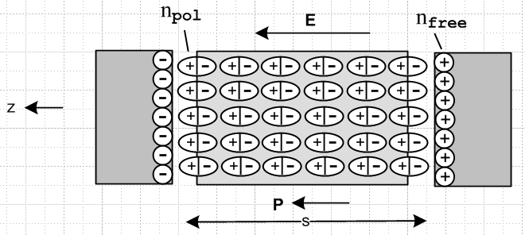 Fig 1.1

The applied E field of the plates lines up the polar molecules and thus causes a polarization charge density npol to appear on the side faces of the dielectric, as if it were an "electret" object. One can imagine that, with an AC plate voltage, as the applied E field changes to the other polarity, the polar molecules rotate in place 180 degrees putting the positive bound charge on the opposite plate, and as this happens, there is a polarization current Jpol = ∂tP inside the dielectric. In reality, the molecules are close to randomly oriented and the above effect is obtained for the "average" molecule. In any event, the E field causes surface polarization charge densities npol at the faces of the dielectric, and one then thinks of the normally neutral-everywhere bound charge distribution as being "displaced" such that one face has positive charge and the other negative. It is in this sense that Maxwell started using the word "displacement". Before the Jvac term was added, Maxwell had Jd ≡ ∂tD = Jpol and this associated ∂tD entirely with Jpol and thus with the displacement of the dielectric bound charge, and so Maxwell referred to D as the "electric displacement" and ∂tD as the "displacement current".
Fig 1.1 shows how the polarization charge acts to shield the free charge, so ntot = nfree - npol.

6. If there is any magnetization current Jm = curl M, it is absorbed into the distinction between B and H and therefore does not appear on the right side of curl H = ∂tD + Jc . The current Jm is discussed for example in Panofsky & Phillips, Sections 7-12, 7-13 and 8-1. The basic equations are as follows,

MdV = magnetic dipole moment contained in volume dV of a medium (1.1.19)

Jm = curl M = magnetization current density ( => div Jm = 0) (1.1.20)

M = χm H = magnetization // = [μ/μ0- 1] H from (1.1.23) (1.1.21)

B = μ0(H+M) = μ0(1+χm)H = μH = "magnetic induction" (informally, magnetic field) (1.1.22)

μ = μ0(1+χm) // μ = magnetic permeability, χm = magnetic susceptibility (1.1.23)

curl B = μ0(curlH + curlM) = μ0(∂tD + Jc) + μ0Jm

= μ0(∂tD + Jc + Jm) . " B sees all currents" (1.1.24)

7. The "equation of continuity" (1.1.8) expresses the fact that charge cannot be created or destroyed. Barring ionization of a dielectric, free charge and bound charge (polarization charge) cannot be converted into each other and are therefore separately conserved. Thus we have several different equations of continuity: [ see for example Haus and Melcher, Section 6.2, equations (10) and (13) ]

div Jc = -∂tρfree // conservation of free charge (aka true or unpaired charge) (1.1.25)
div Jp = -∂tρpol // conservation of polarization charge (aka bound or paired charge) (1.1.26)

div [Jc+ Jp] = -∂t[ρfree + ρpol] = -∂tρtot // sum of above two equations (1.1.27)

div [Jc+ Jd] = 0 ≠ -∂tρtot // reminder of item 5 above (1.1.12)

8. Ohm's Law J = σE is assumed to be a valid constitutive relation for our media of interest. One should keep in mind that this is an approximation, whereas the Maxwell equations and the continuity equations are not. Just under the surface charge on a conductor, Ohm's Law is violated as discussed in Appendix E due to a diffusion current generated by charges piling up at the surface.

9. As will be shown in Section 3.1, inside a medium such as a dielectric or a conductor, and at frequencies of interest to us, there can exist no net charge densities, so ρfree = 0. In a dielectric there are no available free charges, while in a conductor, any departure from neutrality would be instantly restored. All free charge densities for our application reside on the surfaces of conductors only. If we were interested in the behavior of a transmission line embedded in an electron plasma, things would be different.

10. As noted in item 1, all our equations are expressed in Système Internationale (SI) units. In this system, formerly known as "rationalized m.k.s.", the speed of light is concealed in the symbols μ0 and ε0. Here are the usual historical names given to the symbols appearing in our equations, along with one expression of the SI units for each symbol:

E = electric field (volts/m)
H = magnetic field (amp/m)
D = electric displacement (coulomb/m2)
B = magnetic field (tesla = amp-henry/m2) tesla = 10,000 gauss
J = current density (amps/m2)
ρ = charge density (coulombs/m3)
σ = conductivity of the medium (mho/m = ohm-1/m)
μ/μ0 = relative magnetic permeability of the medium (dimensionless)
ε/ε0 = relative electric permittivity = relative dielectric constant (dimensionless)
μ0 = permeability of free space = 4π x 10-7 henry/m
ε0 = permittivity of free space = 8.8541877 x 10-12 farad/m (1.1.28)

Here are some unit relations obtainable from Q = CV, V = IR, LC = 1/ω2 , τ = RC = L/R, I = dQ/dt :

coulomb = farad-volt volt = ampere-ohm henry-farad = sec2
farad = sec/ohm henry = ohm-sec henry / farad = ohm2
ampere = coulomb/sec mho = ohm-1 mho/F = sec-1

c = 1/$\sqrt{μ0 ε0}$= 2.9979246 x 108 m/sec = speed of light

Z0 = $\sqrt{μ0/ε0}$= 376.73032 ohms = "impedance of free space" (1.1.29)

Notice how the names of seven people have become forever embedded into the SI unit system.

Comment: Inevitably, any given author will at some point refer to both B and H as "the magnetic field". We shall do that throughout, using the historical symbols B or H to indicate which "kind" of magnetic field we are talking about. Some authors refer to B as the magnetic flux density or the magnetic induction to distinguish B from H.

(b) Integral Forms of Maxwell's Equations and Continuity

The equations above involving the divergence and curl operators have integral forms thanks to these two fundamental mathematical theorems which have nothing to do with electromagnetism in particular,

∫V div F dV = ∫S F • dS // "the divergence theorem" Spiegel 22.59 (1.1.30)

∫S curl F • dS = C F • ds // "Stokes's theorem" Spiegel 22.60 (1.1.31)

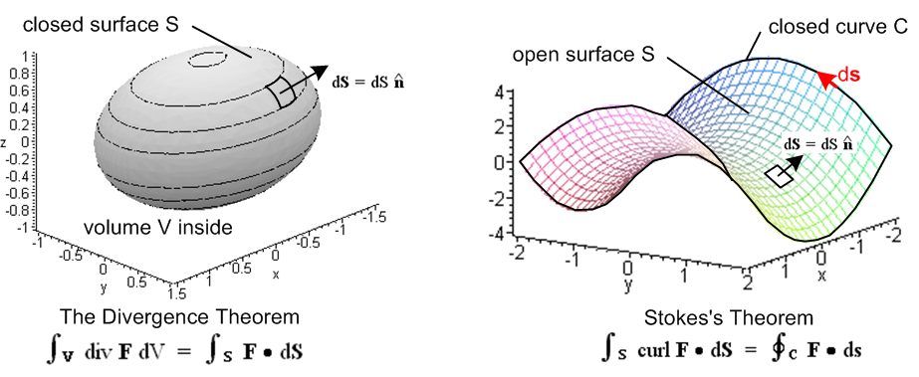
Fig 1.2

The first theorem involves a closed boundary surface S which encloses a volume V and says that the volume integral of div F over V equals the surface integral of F over S. The second involves a closed bounding curve C (possibly non-planar) which bounds an arbitrary open surface S (also possibly non-planar) and says that the line integral of F around C equals the surface integral of curl F over S. In the divergence theorem, dS points "out" from the volume, and in Stokes's Theorem, the direction of dS and ds are related by the right-hand rule where fingers fit the boundary curve and then thumb gives the direction of dS. In both theorems the differential vector area patch is dS = dS where is normal to the surface.
Both theorems have meanings in n-dimensional space, but of course our interest is for n = 3. Both theorems are not hard to derive and this is done in textbooks usually by breaking up the surface into tiny squares and the volume into tiny cubes. Once one sees these derivations, the theorems become less mysterious.
In general terms, the divergence theorem says that div F is somehow a source of the field F and the amount of F flowing out through a closed bounding surface equals the amount of F that is generated inside the volume. When F is the electric field E, the divergence theorem is called Gauss's Law and says that the total electric flux "flowing out" [ that is to say, ∫S E•dS ] equals the total of the source inside the volume [ (1/ε)∫V ρ dV ], usually called "the total charge enclosed". Thus,

div D = ρ ⇔ ∫V ρ dV = ∫S D • dS (1.1.32)
div E = ρ/ε ⇔ ∫V ρ dV = ∫S ε E • dS . (1.1.33)

Since the magnetic field has no corresponding charge, one always has ∫S B • dS = 0, a theorem which seems to have no name,

div B = 0 ⇔ ∫S B • dS = 0 S is any closed surface (1.1.34)

The surface integral of an E or B field is often referred to as the total electric or magnetic "flux" passing through the surface, even though nothing is really flowing in a mechanical sense.

The divergence operator also occurs in the equation of continuity (1.1.8) so we have

div J = - ∂tρ ⇔ -∂t[∫V ρ dV] = ∫S J • dS . (1.1.35)

This is the prototype application of the divergence theorem in that it is easily understandable: the total electric current flowing out through some closed surface S must equal the rate at which the total charge inside the surface is decreasing. One can write a similar statement for mass flowing out from a volume in which ρ would be the mass density and J = ρv the mass current, v being the velocity field.

The Stokes theorem is a bit more mysterious. Since this theorem is associated with George Stokes, it is called Stokes's theorem, but is sometimes called Stokes' theorem (one would not say Gauss' theorem). The curl of a vector field is associated with the amount of "rotation" the field has at some point in space, and in fact curl is sometimes written Rot. If one considers a tiny patch and finds that the line integral of the field around the boundary of that patch is non-zero, then the vector field has a non-zero curl at that point in the direction normal to the patch. At any point where a fluid has a vortex, the curl is non-zero, for example. When Stokes's theorem is applied to the electric field, one has

curl E = - ∂tB ⇔ C E • ds = -∂t[∫S B • dS] . (1.1.36)

This says that the voltage induced around a closed loop (the "electromotive force") is proportional to the rate of change of the magnetic flux through that loop, a principle known as Faraday's Law of Induction. If water power rotates a wire loop in the presence of some magnets, one has an electric generator.
On the other hand, when Stokes's theorem is applied to the magnetic field, one gets

curl H = ∂tD + J ⇔ C H • ds = ∫S [∂tD+J] • dS (1.1.37)

curl B = με ∂tE + μJ ⇔ C B • ds = μ ∫S [ε ∂t E + J] • dS (1.1.38)
μ constant in space, ε constant in time

When the situation is static, one has H • ds = ∫S dS • J which says the line integral of the magnetic field H around some loop equals the total current passing through any open surface whose boundary is that loop (the "current enclosed"), a principle known as Ampere's Law.
Later we shall encounter a certain "vector potential A" which is related to the B field by B = curl A. Since we are writing out "integral forms" of differential relationships, we can then add this to the list,

curl A = B ⇔ C A • ds = ∫S B • dS . (1.1.39)

If the bounding curve C were a wire carrying a current I which creates both A and B, then both sides of the above integral form will be proportional to I, and the constant of proportionality is by definition the self-inductance L of the loop,

C A • ds = ∫S B • dS = [magnetic flux through surface S] = L I . (1.1.40)

There are of course many surfaces S which span a given curve C, and (1.1.39) says that all such surfaces give exactly the same ∫S B • dS and thus the same L, so L is really a geometric property of the curve C.

We shall be using most of these integral forms in the document below.

(c) Rules for behavior of fields and potentials at a boundary

Consider the boundary between two different media called 1 and 2. Consider a tiny red "math loop" of width L and height 2s which straddles the media boundary which here is seen edge on,

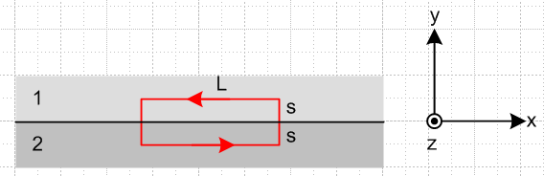 Fig 1.3

For the electric field we have from above (for our loop, dS = dS )

curl E = - ∂tB ⇔ E • ds = - [∫S (∂tB) • dS] . (1.1.36)

Since the loop is tiny and since the fields are assumed to be non-singular, we can regard E and B as a constant everywhere on the loop (for our purposes here). The line integral around the loop is then (start at lower left corner)

E • ds = LEx(2) + s Ey(2) + s Ey(1) – LEx(1) - s Ey(1) - s Ey(2)

= L [Ex(2)- Ex(1)] .

The area integral on the right side of (1.1.36) is

-∫S (∂tB) • dS = - ∂tBz(1) sL - ∂tBz(2) sL = - sL [∂tBz(1) + ∂tBz(2)]

so the integral form in (1.1.36) says

[Ex(2)- Ex(1)] L = - s L [∂t Bz(1) + ∂t Bz(2)] .

As long as ∂tBz is finite at the surface, as s→0 the right side vanishes and we conclude that

[Ex(2)- Ex(1)] = 0 .

We then summarize for both the x and z directions by saying (t means tangential to boundary)

Et1 = Et2 or (1/ε1)Dt1 = (1/ε2)Dt2 (1.1.41)

so the tangential (parallel) components of the electric field is continuous through a boundary.

A similar analysis using the curl H equation,

curl H = ∂tD + J ⇔ H • ds = ∫S [∂t D+J] • dS (1.1.37)

leads to

[Hx(2)- Hx(1)]L = s L[∂t Dz(1) + Jz(1) + ∂t Dz(2) + Jz(2)] .

As long as ∂tDx and Jx are finite (non-singular) at the surface, we conclude from s→0 that

Ht1 = Ht2 or (1/μ1)Bt1 = (1/μ2)Bt2 . (1.1.42)

However, it is possible to have J be singular at the surface in the form of a surface current K where

J = K δ(y) J = amp/m2 K = amp/m (1.1.43)

and in this case we find that

[Hx(2)- Hx(1)] L = ∫S [J] • dS = ∫S Kδ(y) • dS = ∫S Kz δ(y) dx dy = ∫S Kz dx ≈ Kz L

which we summarize as

Ht2 - Ht1 = Kzfree or (1/μ2)Bt2 - (1/μ1)Bt1 = Kzfree (1.1.44)

where we imagine = x as the meaning of the z in Kz. Notice that this Kz is a "free" surface current, and not a bound magnetization surface current since such a magnetization current is not "seen" by H.

We mention here a result similar to (1.1.44) which applies to a special situation of Fig 1.3 above where we assume a vector potential of the form A = Az(y,z) . This vector potential is constant on the boundary surface in the x direction, and has only an Az component. In this case,

B = curl A = (∂yAz - ∂zAy) + (∂zAx - ∂xAz) + (∂xAy - ∂yAx)

= (∂yAz) = Bx where Bx = ∂yAz (1.1.45)

and then (1.1.44) says

(1/μ2) (∂nAz)2 - (1/μ1) (∂nAz)1 = Kzfree (1.1.46)

where ∂n is the derivative of the vector potential Az in a direction normal to the surface (n pointing from medium 2 to medium 1). If μ1= μ2= μ0, we have (∂nAz)2 - (∂nAz)1 = μ0Kz and then Kz is proportional to the normal slope jump in Az at the boundary surface. As earlier, Kz is a "free" surface current.

Next, we put a tiny "Gaussian pillbox" straddling the two media. Area A and height 2s are both very small so the fields are approximately the same at all points in the box.

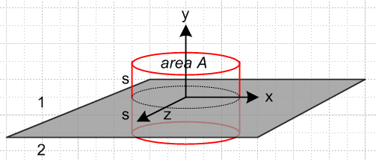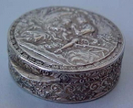
Gaussian Pillbox a pill box circa 1830
Fig 1.4
For the electric displacement D we consider

div D = ρfree ⇔ ∫V ρ dV = ∫S D • dS (1.1.13)

where volume V is of the box shown. The surface integral is

∫S D • dS = Dy(1)A - Dy(2)A + contributions from the sides of the box

The contributions from the pairs of box sides cancel since the fields are assumed constant and finite over the box on either side of the boundary. Assuming the only charge density is a surface charge density nfree on the boundary between the two media, the volume integral is nfreeA and then the conclusion, generalized to the perpendicular field component, is

Dn1 - Dn2 = nfree or [ε1E1n - ε2E2n] = nfree . (1.1.47)

If the two media are conducting dielectrics with Ohm's law Jc = σE, we can apply continuity (1.1.25) to the Gaussian box to find that

div Jc = - ∂tρfree ⇔ -∂t[∫V ρfree dV] = ∫S Jc • dS (1.1.35)

so that

-∂tnfree = [Jn1- Jn2] = σ1En1 - σ2En2

or for monochrome time dependence (coming soon, along with notation explanation),

-jω nfree = σ1En1 - σ2En2 . // frequency domain

Recall now from (1.1.47) that

nfree = ε1En1- ε2En2 . (1.1.47)

Adding the last equation to 1/jω times the previous equation gives

0 = [ε1 + σ1/jω] En1 - [ε2 + σ2/jω]En2

In terms of the complex dielectric constants ξi ≡ εi + σi/jω this says that 0 = ξ1En1 - ξ2En2 so that

ξ1En1 = ξ2En2 // frequency domain (1.1.48)

In the limit that, say, medium 2 becomes a perfect conductor, ξ2 ≈ σ2/jω → ∞ and En2 → 0, but the product is maintained equal to ξ1En1 .

Returning again to the special case in which vector potential A = Az , since E = -∇φ - ∂tA (as shown later), we have Ey = -∂yφ since Ay = 0. In terms of Fig 1.3 where y is the direction normal to the surface, we have En = -∂nφ and then (1.1.47) may be written

ε2(∂nφ)2 - ε1(∂nφ)1 = nfree (1.1.49)

which can be compared to (1.1.46). If ε1 = ε2 = ε0, we have (∂nφ)2 - (∂nφ)1 = nfree/ε0 and then nfree is proportional to the normal slope jump in φ at the boundary surface.

Finally, the other divergence equation

div B = 0 ⇔ ∫S B • dS = 0 S is any closed surface (1.1.34)

leads to the conclusion that

Bn1 = Bn2 or μ1Hn1 = μ2Hn2 . (1.1.49)

We now summarize these rules in a box, always assuming that there is no singularity in some quantity to invalidate the claims:

Rules for continuity of normal and tangential fields at a boundary: (1.1.50)

The fields here are either F(x,t) or F(x,ω) except the last rule which is only for E(x,ω) :

t = tangential = parallel = || :

Et1 = Et2 or (1/ε1)Dt1 = (1/ε2)Dt2 (1.1.41)

Ht2 - Ht1 = Kzfree or (1/μ2)Bt2 - (1/μ1)Bt1 = Kzfree (1.1.44)

Special case A = Az(y,z) : (1/μ2) (∂nAz)2 - (1/μ1) (∂nAz)1 = Kzfree (1.1.46)

n = normal = perpendicular = ⊥ : ( symbol n is also used for surface charge density)

Bn1 = Bn2 or μ1Hn1 = μ2 Hn2 (1.1.49)

Dn1 - Dn2 = nfree or [ε1En1 - ε2En2] = nfree (1.1.47)

and for monochrome time dependence: ξ1En1 = ξ2En2 where ξ = ε + σ/jω (1.1.48)

Special case A = Az : ε2(∂nφ)2 - ε1(∂nφ)1 = nfree (1.1.49)

Tangential and normal boundary conditions can always be written in the following manner,

Ft1 = Ft2 ⇔ n x F1 = n x F2
Fn1 = Fn2 ⇔ n • F1 = n • F2 (1.1.51)

as can be seen by expanding F = Fn + Ft and noting that x = 0 and • = 1. The E and B boundary conditions in the above table appear as follows in King (1945), page 204 (obtained from the University of Utah's robotic automated retrieval center ARC),

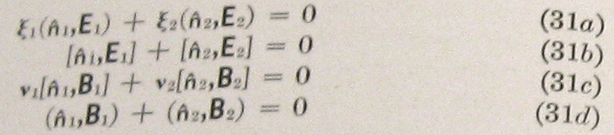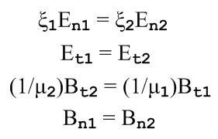

where 1 = - 2, (n,F) = n • F , [n,F] = n x F , and ν = 1/μ.

1.2 The Field Wave Equations

In the following, quanties μ and ε are treated as constants, independent of space and time.

The E wave equation may be derived using these steps :

curl E = - ∂tB // Maxwell (1.1.2)

curl curl E = -∂tcurl B = -μ∂t[curl H] = -μ∂t[ ∂tD + J ] // curl both sides and Maxwell (1.1.1)

grad divE - ∇2E = -μ∂t[ ∂t[εE] + J ] // vector identity on left and D = εE

(∇2 - με∂t2)E = μ∂tJ + (1/ε) grad ρ . // div E = ρ/ε

The B wave equation uses these steps :

curl H = ∂tD + J // Maxwell (1.1.1)

curl curl H = curl [∂tD] + curl J // curl both sides

grad div H - ∇2H = ε ∂t(curl E) + curl J // vector identity on left and D = εE

(1/μ)grad div B - ∇2H = εμ ∂t(-∂tH) + curl J // Maxwell (1.1.2) and B = μH twice

(∇2 - με ∂t2)H = - curl J // since div B = 0 (1.1.4)

The two results are then

(∇2 - με ∂t2)E = μ∂tJ + (1/ε) grad ρ (1.2.1)

(∇2 - με ∂t2)B = - μ curl J (1.2.2)

which agree with Jackson p 246 (6.49) and (6.50). Recall that με = 1/v2 where v is the speed of light in the medium of interest. These two equations are undamped driven wave equations.

1.3 The Potential Wave Equations

(a) The Potential Wave Equations in the Lorenz gauge

It is possible to work with the scalar and vector potentials φ and A instead of the fields E and B. If φ and A can be determined, then E and B are fully determined by (1.3.1) below. However, in the other direction, if E and B are known, then φ and A are determined only up to a certain "gauge transformation" degree of freedom, a subject discussed in Appendix A. The fields E and B are physically observable quantities while the potentials φ and A in general are not and should be regarded as intermediate "helper" functions. In SI units, the E and B fields are obtained from φ and A in this manner : [ Jackson p 239 (6.7) and (6.9)]

B = curl A E = - grad φ - ∂tA . (1.3.1)

A = vector potential (tesla-m = amp-henry/m = volt-sec/m) E = volt/m
φ = scalar potential (volts) B = tesla .

Appendix A (Fact 4) shows that there is a continuum of possible choices (φ,A) all of which give the same physical fields (E,B) according to (1.3.1). It turns out that, along this continuum, div A takes different functional forms. Fact 4 shows that there always exists a choice (φ,A) for which div A = any function one wants! Selecting f(x) for div A = f(x) is called "making a gauge choice". Different gauge choices just result in different (φ,A) potentials, but always the same (E,B). In the following derivations of the wave equations for A and φ, we shall be making a certain gauge choice as indicated.

The following steps are used to develop the φ wave equation. In the vacuum one has μ = μ0 and ε = ε0 and με = 1/c2 and these are the parameters one sees in the Jackson equation references below.

E = - grad φ - ∂tA // (1.3.1) [= Jackson (6.9)]

div E = - div grad φ - ∂t (div A) // take div of both sides

∇2φ + ∂t[div A] = -ρ/ε // div E = ρ/ε [= Jackson (6.10)] (1.3.2)

(∇2 - με ∂t2)φ = - (1/ε)ρ . // apply gauge choice divA = - με ∂tφ

And the following steps are used to develop the A wave equation:

curl H = ∂tD + J // Maxwell (1.1.1)

(1/μ) curl curl A = με ∂tE + J // H = B/μ , B = curl A from (1.3.1), and D = εE

grad divA - ∇2A = με ∂t[- grad φ - ∂tA] + μJ // vector identity and (1.3.1) E = - grad φ - ∂tA

(∇2 - με ∂t2) A = grad [με ∂tφ + divA ] - μJ // [ = Jackson (6.11) ] (1.3.3)

(∇2 - με ∂t2)A = - μJ . // apply same gauge choice divA = - με ∂tφ

The results are then

(∇2 - με ∂t2)φ = - (1/ε)ρ [ = Jackson (6.15) ] (1.3.4)
(∇2 - με ∂t2)A = - μJ [ = Jackson (6.16) ] (1.3.5)
divA = - με ∂tφ . [ = Jackson (6.14) ] // Lorenz Gauge (1.3.6)

As discussed in the comment below, this gauge choice is now called the Lorenz Gauge. One should notice how the gauge choice decouples the two wave equations (1.3.2) and (1.3.3) so one resulting equation only involves φ and ρ, while the other involves only A and J. We end up then with undamped driven wave equations with simple driving terms. Note that ρ = ρfree (does not include polarization charge ρpol) and that J = Jc (does not include magnetization current Jm). In effect, ρpol and Jm are incorporated into the constants ε and μ.

Comment 1: For perhaps 100 years pretty much all (non-Danish) papers and textbooks (including Jackson's first two editions in 1962 and 1975 and the initial six printings of his 1998 third edition) referred to the Lorenz gauge as the Lorentz gauge, and it was then convenient to say that the Lorentz gauge condition is Lorentz invariant since it transforms as a scalar equation under Lorentz transformations. Now we have to say that the Lorenz gauge is Lorentz invariant because Lorentz was mistakenly credited for first using this gauge condition, see Jackson's note p 294 added in his 7th printing. Although the Dane Ludvig Lorenz (1829-1891) was 24 years older than the Dutchman Hendrick Lorentz (1853 –1928), they were contemporary though independent workers at the time (1867) that Lorenz first published the use of his now-eponymous gauge condition. Lorentz will just have to be content with his transformations, his invariance, his contraction and his force law which says F = q(E + v x B). For more on Lorenz and Lorentz, see Nevels and Shin.

Comment 2: We speak of (1.3.6) as "the Lorenz gauge" and divA = 0 as "the Coulomb gauge". These gauges are really conditions on A and do not fully specify A since many vector fields A can have the same divergence. So a gauge specifies a class of possible A fields, not a particular one.

(b) Special Relativity Note

At first encounter, one is amazed at how similar the two equations (1.3.4) and (1.3.5) appear. Here we shall show why that is. We now assume the medium is the vacuum so με = μ0ε0 = 1/c2. Then the two equations may be written

(∇2 - $\frac{1}{c2}$ ∂t2)φ = - (1/ε0)ρ (1.3.7)
(∇2 - $\frac{1}{c2}$ ∂t2)A = - μ0J . (1.3.8)
As shown in Appendix A.6, one can construct Lorentz 4-vectors Aμ = ( $\frac{1}{c}$φ, A) and Jμ = (cρ, J) with the identification of A0 ≡ φ/c and J0 ≡ cρ. The above equations can then be written, using proper tensor notation where common vectors are contravariant with an upper index,

(∇2 - $\frac{1}{c2}$ ∂t2)[cA0] = - (1/ε0)[J0/c] = - (1/ε0)[J0/c] (c2μ0ε0) = - μ0 cJ0 (1.3.9)
(∇2 - $\frac{1}{c2}$ ∂t2)Ai = - μ0Ji . (1.3.10)

Cancelling the c's in the first equation allows both equations to be written as a single 4-vector equation

(∇2 - $\frac{1}{c2}$ ∂t2)Aμ = - μ0 Jμ
or
Aμ = μ0 Jμ where ≡ ∂μ∂μ = $\frac{1}{c2}$∂t2 - ∇2 . (1.3.11)

This equation is covariant because both sides transform as a Lorentz 4-vector (the operator transforms as a Lorentz scalar). Special relativity requires that all equations of physics be covariant under Lorentz transformations. This is similar to Newton's Law F = ma being covariant under rotations, where both sides transform as 3-vectors. If we start with the correct law of physics (1.3.11) and work backwards through the equation pairs above, where we add a medium with μ and ε, we end up with our starting point (1.3.4) and (1.3.5) and the similarity of these two equations is then explained as being a requirement of special relativity.
Recall the Lorenz gauge choice (1.3.6) which was required to decouple things above,

divA = - μ0ε0 ∂tφ = - $\frac{1}{c2}$ ∂tφ . (1.3.6)

As shown in Appendix A.6, this Lorenz gauge condition can be expressed in covariant form as

∂μAμ = 0 ⇔ divA = - $\frac{1}{c2}$∂tφ (1.3.12)

while the equation of continuity states

∂μJμ = 0 ⇔ divJ = -∂tρ . (1.3.13)

Both sides of these last two tensor-notation equations transform as a rank-0 tensor (scalar) so the equations are covariant (0 is a scalar). As one changes frames of reference doing Lorentz transformations (rotations and "boosts), the potential wave equation, the gauge condition, and the continuity relation always maintain the same tensor form.
In closing this relativity note, we must mention that the four Maxwell equations (with ε = ε0 and μ = μ0 and μ0ε0 = 1/c2) can also be stated in covariant notation. One first defines the following antisymmetric rank-2 tensor (see Appendix A.5 concerning up and down indices etc.)

Fμν ≡ ∂μAν - ∂μAν Aμ = ( $\frac{1}{c}$φ, A) Jμ = (cρ, J) ∂μ = (∂0, ∂i) = (∂0, -∂i) (1.3.14)

where obviously Fμν = -Fνμ and Fμμ = 0 for diagonal elements. Then the two Maxwell homogeneous (no sources) equations appear as

∂αFμν + ∂νFαμ + ∂μFνα = 0 // both sides transform as a rank-3 tensor so covariant

⇔ curl E + ∂tB = 0 and div B = 0 (1.1.2) and (1.1.4) (1.3.15)

while the two Maxwell inhomogeneous equations are (implied sum on μ )

∂μFμν = μ0 Jν // both sides transform as a rank-1 tensor (4-vector) so covariant

⇔ curl B - μ0ε0∂tE = μ0J and div E = ρ/ε0 (1.1.24) and (1.1.15) (1.3.16)

The fields are given by ( ε is the permutation tensor),

B1 = -F23 E1 = cF10 or Bi = -(1/2)εijkFjk and Ei = cFi0
B2 = -F31 E2 = cF20
B3 = -F12 E3 = cF30 . (1.3.17)

The E and B fields are part of the tensor Fμν and so do not transform as four vectors like Aμ. That is to say, there are no 4-vectors of the form Eμ or Bν, so there is no up and down index on a field, so the index is just written down. Jackson states the above facts (but in Gaussian units) in his Section 11.9 along with a description of the notion of covariance.

Example: μ0J2 = ∂μFμ2 = ∂0F02 + ∂1F12 + ∂2F22 + ∂3F32 = (1/c)∂t(-1/cE2) + ∂1(-B3) + 0 + ∂3(+B1)

= - (1/c2)∂tE2 + [curl B]2 => μ0J = curlB - μ0ε0∂tE in the 2 component

(c) The Potential Wave Equations in the King and Lorenz Gauges with Conductors

We refer to a certain gauge condition below as "the King gauge" because King (see Refs.) made extensive use of this condition in his books and papers at least as early as 1945. Perhaps this gauge has some official name, but we are not aware of it.

We start with this King gauge and treat A and then φ. Then we do the Lorenz gauge case for A and φ, and finally we look at the wave equations for E and B. The motivation for using the King gauge is explained.

Unlike most sources on this subject, we allow for the possibility that the conductors' μi might differ from that of the dielectric.

KING GAUGE

Wave equation for A

Consider the following general cross section of a transmission line which happens to be of coaxial cable type,
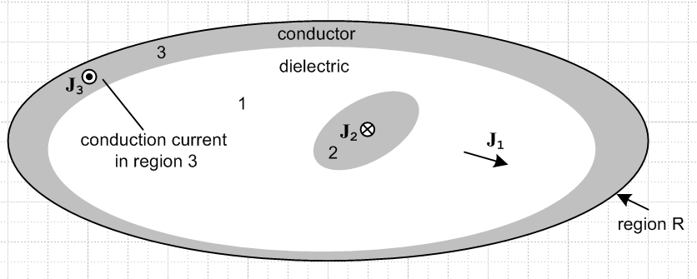 Fig 1.5

The gray regions 2 and 3 are conductors, while the white region 1 is the (possibly conducting) dielectric. Currents J1, J2 and J3 are conduction currents.

We start by selecting the King gauge for region 1 and we apply it to all three regions,

div A = - μ1ε1 ∂tφ - μ1σ1φ // ≡ King gauge, applied to all of R . (1.3.18)

We first obtain the wave equation for A in region 1. Start with (1.3.3) which gives the wave equation for A before any gauge choice is made,

(∇2 - μ1ε1 ∂t2) A = grad [μ1ε1 ∂tφ + divA ] - μ1J . // region 1 (1.3.3)

Now insert the King gauge (1.3.18) to get

(∇2 - μ1ε1 ∂t2) A = grad [μ1ε1 ∂tφ + (- μ1ε1 ∂tφ - μ1σ1φ) ] - μ1J

= - μ1σ1 grad φ - μ1J

= - μ1σ1 (-E -∂tA) - μ1(σ1E) . // from (1.3.1) and J = σ1E

= - μ1σ1 ( -∂tA) .

Thus the wave equation for A in region 1 is

(∇2 - μ1ε1 ∂t2 - μ1σ1∂t) A = 0 // region 1 (1.3.19)

This is a damped wave equation with no driving source; the equation is homogeneous.

Now we start over with (1.3.3) for region 2:

(∇2 - μ2ε2 ∂t2) A = grad [μ2ε2 ∂tφ + divA ] - μ2J2 // region 2 (1.3.3)

As before, we insert the region-1 King gauge expression (1.3.18) for div A, even though we are now working in region 2, and we make an assumption that conductor 2 is a "good conductor".

(∇2 - μ2ε2 ∂t2) A = grad [μ2ε2 ∂tφ + (- μ1ε1 ∂tφ - μ1σ1φ) ] - μ2J2

= [μ2ε2 ∂t + (- μ1ε1 ∂t - μ1σ1) ] gradφ - μ2J2

= [ (μ2ε2 - μ1ε1) ∂t - μ1σ1) ] gradφ - μ2J2

= [ (μ2ε2 - μ1ε1) ∂t - μ1σ1) ] (-E-∂tA) - μ2J2 // using (1.3.1)

= [ (μ2ε2 - μ1ε1) ∂t - μ1σ1) ] (-J2/σ2-∂tA) - μ2J2 // J2 = σ2E

≈ [ (μ2ε2 - μ1ε1) ∂t - μ1σ1) ] (-∂tA) - μ2J2 // since σ2 is very large in conductor 2

= - [ (μ2ε2 - μ1ε1) ∂t2 - μ1σ1∂t ] A - μ2J2 .

Notice that we have chosen not to set J2 = σ2E in region 2 for the last term, we just leave it as J2. Moving the first term on the right to the left we get

( ∇2 - μ2ε2 ∂t2 + [ (μ2ε2 - μ1ε1) ∂t2 - μ1σ1∂t ] ) A = - μ2J2
or
( ∇2 - μ1ε1 ∂t2 - μ1σ1∂t ) A = - μ2J2 . // region 2 (1.3.20)

On the left side we see the same region-1 damped wave operator although we are in region 2, and J2 is the conduction current density in region 2. A similar result applies for region 3. Thus we have shown that

(∇2 - μ1ε1 ∂t2 - μ1σ1∂t ) A = 0 region 1
(∇2 - μ1ε1 ∂t2 - μ1σ1∂t ) A = - μ2J2 region 2
(∇2 - μ1ε1 ∂t2 - μ1σ1∂t ) A = - μ3J3 region 3 (1.3.21)

We combine these into a single equation which is then valid over all of region R,

(∇2 - μ1ε1 ∂t2 - μ1σ1) A = - μ2J2 - μ3J3 all of region R (1.3.22)

with the understanding that the conduction current in region 1 has already been accounted for and Ji represents conduction currents in conductor i .We could generalize this result for a region R containing any number N of conductors labeled i = 2,3...N+1

(∇2 - μ1ε1 ∂t2 - μ1σ1) A = - Σi=2N+1μiJi . all of region R (1.3.23)

Wave equation for φ

We first obtain the wave equation for φ in region 1. Start with (1.3.2) which gives the wave equation for φ before any gauge choice is made

∇2φ + ∂t[div A] = -ρ/ε1 . (1.3.2)

Now use the same global region-R King gauge (1.3.18) for div A,

∇2φ + ∂t[- μ1ε1 ∂tφ - μ1σ1φ] = - ρ1/ε1

(∇2 - μ1ε1 ∂t2 - μ1σ1∂t)φ = - (1/ε1)ρ1 . // region 1 (1.3.24)

Again the same damped region-1 wave operator appears on the left side. Since the King gauge is the same in all three regions, we can write

(∇2 - μ1ε1 ∂t2 - μ1σ1∂t)φ = - (1/ε1)ρ(1) // region 1
(∇2 - μ1ε1 ∂t2 - μ1σ1∂t)φ = - (1/ε2)ρ(2) // region 2
(∇2 - μ1ε1 ∂t2 - μ1σ1∂t)φ = - (1/ε3)ρ(3) // region 3 (1.3.25)

where ρ always means free charge. The three equations are basically the same because the pre-gauge equation (1.3.2) has no region-specific parameters apart from ε1, in contrast with (1.3.3) quoted above.

Now the only actual free charge present is the surface charge on the outside surfaces of the conductors and we shall regard all these charge densities as residing in region 1, the dielectric (just inside the boundaries of region 1). Thus, write

ρ(1) = ρ2 + ρ3 // = Σi=2N+1ρi
ρ(2) = 0
ρ(3) = 0 (1.3.26)

where ρi is the surface charge density on conductor i. Then combine the above three equations into a single equation for all of region R

(∇2 - μ1ε1 ∂t2 - μ1σ1∂t)φ = - (1/ε1) Σi=2N+1ρi . all of region R (1.3.27)

Conclusion for wave equations in the King gauge

Here then are the wave equations for φ and A in region R using the region-1 King gauge:

Potential Wave Equations in the King Gauge (1.3.28)
(∇2 - μ1ε1 ∂t2 - μ1σ1∂t)φ = - (1/ε1) Σi=2N+1ρi all of region R (1.3.27)
(∇2 - μ1ε1 ∂t2 - μ1σ1∂t)A = - Σi=2N+1 μiJi all of region R (1.3.23)
div A = - μ1ε1 ∂tφ - μ1σ1φ King gauge (1.3.18)

1 = dielectric 2,3,4.... N+1= conductors (there are N conductors)
ρi = free surface charge density on conductor i
Ji = free current density in conductor i (J1 in the dielectric exists but does not appear in ΣiμiJi)

To reduce clutter, we now make the change that the dielectric region has no subscript, and we renumber the conductors 1 to N instead of 2 to N+1. The above box then becomes

Potential Wave Equations in the King Gauge (1.3.29)

(∇2 - με ∂t2 - μσ∂t)φ = - (1/ε) Σiρi all of region R
(∇2 - με ∂t2 - μσ∂t)A = - ΣiμiJi all of region R
div A = - με ∂tφ - μσφ King gauge

μ,ε,σ = dielectric 1,3,4.... N = conductors Σi = Σi=1N μi = for conductor i
ρi = free surface charge density on conductor i
Ji = free current density in conductor i (J in the dielectric exists but does not appear in ΣiμiJi)

The word "free" is used above to emphasize the fact that possible polarization charge densities and magnetization current densities are not included in these ρi and Ji.

King never writes these wave equations in his transmission-line theory book, so it is difficult to find verification of our logic pathway in his book. However, Panofsky and Phillips do show the equations and we quote the relevant section from p 241 of their book:

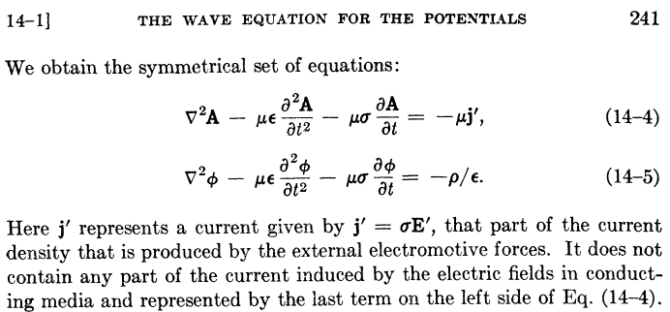

Their last sentence says that J = σE in the conducting dielectric has been incorporated into the -μσ∂tA term in their first equation, just as we have done above. These authors have assumed that the μ's of the dielectric and the conductors are all the same (normally μ = μ0). In order to obtain the above equations, Panofsky and Phillips use the King gauge (1.3.18) but they refer to this gauge simply as "the Lorentz condition" (illustrating Comments 1and 2 above). From their page 240,

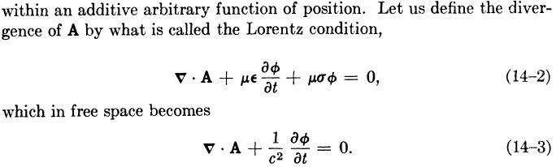

LORENZ GAUGE

If we carry out the exact same program with respect to Fig 1.5 using a region-1 global Lorenz gauge for all of R,

divA = - μ1ε1∂tφ , (1.3.30)

we obtain these results for A, where in region 1 the conduction current is not absorbed into a damping term on the left side,

(∇2 - μ1ε1 ∂t2)A = - μ1J1 region 1
(∇2 - μ1ε1 ∂t2)A = - μ2J2 region 2
(∇2 - μ1ε1 ∂t2)A = - μ3J3 . region 3

As before, all three equations have the same wave operator on the left side. Again assuming N conductors, we combine these into a single equation as follows

(∇2 - μ1ε1 ∂t2)A = - Σi=1N+1 μiJi all of region R (1.3.31)

Meanwhile, the results for φ are

(∇2 - μ1ε1 ∂t2)φ = -ρ(1)/ε1 region 1
(∇2 - μ1ε1 ∂t2)φ = -ρ(2)/ε2 region 2
(∇2 - μ1ε1 ∂t2)φ = -ρ(3)/ε3 region 3

so that with the same comments made earlier in (1.3.26) this becomes

(∇2 - μ1ε1 ∂t2)φ = -(1/ε1) Σi=2N+1 ρi all of region R (1.3.32)

We then make the same notational change made above to get these Lorenz-gauge results:

(∇2 - με ∂t2)φ = -(1/ε) Σi=1N ρi all of region R (1.3.33)
(∇2 - με ∂t2)A = - Σi=1N μiJi - μJ all of region R (1.3.34)

Notice that no conductivities appear in these equations.

COMPARISON

We can now do a side-by-side comparison, where Σi is a sum over the conductors i = 1,2..N

King Gauge:
(∇2 - με ∂t2 - μσ∂t)φ = - (1/ε) Σiρi all of region R (1.3.29)
(∇2 - με ∂t2 - μσ∂t)A = - ΣiμiJi all of region R (1.3.29)
div A = - με ∂tφ - μσφ King gauge (1.3.29)

Lorenz Gauge:
(∇2 - με ∂t2)φ = -(1/ε) Σiρi all of region R (1.3.33)
(∇2 - με ∂t2)A = - Σi μiJi - μJ all of region R (1.3.34)
divA = - με ∂tφ Lorenz gauge (1.3.30)

In the Lorenz gauge, we get undamped wave operators, but the sum on the right of the A equation includes the current J in the dielectric, whereas this is not the case in the King gauge. In a situation where we have prescribed currents Ji in the conductors, it is inconvenient to have to worry about the dielectric conduction current J which complicates the solution of the problem. In the King gauge, we get damped wave operators but we have to include only the current in the conductors since the current in the dielectric has been incorporated into the damping term. When we transform to the frequency domain and write the Helmholtz equation for A and its Helmholtz Integral solution, we need only integrate over the conductors which makes life easier. This then is the motivation for the King gauge. Of course for a non-conducting dielectric both gauge conditions are the same since σ = 0.

E AND B WAVE EQUATIONS

Meanwhile, the E and B field wave equations of course don't know anything about gauges and from (1.2.1) and (1.2.2) we have, with respect to Fig 1.5, ( ρs = ρ2+ρ3 = Σi=2N+1ρi)

(∇2 - μ1ε1 ∂t2)E = μ1∂tJ1 + (1/ε1) grad ρ(1) = μ1∂tJ1 + (1/ε1) grad ρs // region 1
(∇2 - μ2ε2 ∂t2)E = μ2∂tJ2 + (1/ε2) grad ρ(2) = μ2∂tJ2 // region 2
(∇2 - μ3ε3 ∂t2)E = μ3∂tJ3 + (1/ε3) grad ρ(3) = μ3∂tJ3 // region 3
(1.3.35)
(∇2 - μ1ε1 ∂t2)B = - μ1 curl J1 // region 1
(∇2 - μ2ε2 ∂t2)B = - μ2 curl J2 // region 2
(∇2 - μ3ε3 ∂t2)B = - μ3 curl J3 // region 3

where Ji = σiE . We cannot unify each group of three equations into a single region R equation as we could in the potential case since the wave operators are different in each region. Using Ji = σiE and curl E = - ∂tB and (1.3.26) the above equations can be rewritten as,

(∇2 - μ1ε1 ∂t2 - μ1σ1∂t)E = (1/ε1) Σi=2N+1 grad ρi // region 1
(∇2 - μ2ε2 ∂t2 - μ2σ2∂t)E = 0 // region 2
(∇2 - μ3ε3 ∂t2 - μ3σ3∂t)E = 0 // region 3
(1.3.36)
(∇2 - μ1ε1 ∂t2 - μ1σ1∂t)B = 0 // region 1
(∇2 - μ2ε2 ∂t2 - μ2σ2∂t)B = 0 // region 2
(∇2 - μ3ε3 ∂t2 - μ3σ3∂t)B = 0 // region 3

Again the three damped wave operators are different. The solution of these equations requires solving the first equation for the particular solution in region 1, finding all possible homogenous solutions to all 6 equations in their regions using appropriate harmonic forms with "constants to be determined", then matching these conditions at the two boundaries to evaluate the constants. In contrast, in the potential problem of (1.3.28),

(∇2 - μ1ε1 ∂t2 - μ1σ1∂t)φ = - (1/ε1) Σi=2N+1ρi all of region R (1.3.26)
(∇2 - μ1ε1 ∂t2 - μ1σ1∂t)A = - Σi=2N μiJi all of region R (1.3.23)
div A = - μ1ε1 ∂tφ - μ1σ1φ King gauge (1.3.18) (1.3.28)

one worries about a single unified region R and there is only one damped wave operator. The method of solution is to find the particular solutions of the φ and A equations, add in homogenous solutions and match boundary conditions.

1.4 Retarded Solutions in the Lorenz gauge: Propagators

In a medium where μ and ε are time-independent, the Lorenz gauge equations (1.3.4) and (1.3.5) apply,

(∇2 - με ∂t2)φ = - (1/ε)ρ (1.3.4)
(∇2 - με ∂t2)A = - μJ . (1.3.5)

One approach to solving these equations for A and φ is the method of retarded solutions. We seek to solve an equation of this form

(∇2 - με ∂t2) u = - f , (1.4.1)

where for example in (1.3.4) u = φ and f = ρ/ε. Since με = 1/v2 where v is the wave velocity in the medium, write (1.4.1) as

(∂t2 - v2∇2) u = v2f
or
u = f where ≡ $\frac{1}{v2}$∂t2 - ∇2 . (1.4.2)

This last equation is similar to (A.7.2) of Appendix A and can be solved it in the same manner. Define a Green's function g as the solution of

v2 g(x,t; x',t') = δ(x-x')δ(t-t') with g = 0 when |x-x'|→∞ . (1.4.3)

This is just (A.7.3) with c = v. As (A.7.4) shows, the solution is given by

v2 g(x,t; x',t') = (1/4πR)δ(t-t'-R/v) with R = |x-x'| . (1.4.4)

The delta function only gets a hit if t = t'+R/v, so there is never a hit if t < t'. In other words, g = 0 for t<t', and g is often referred to as a "causal" Green's function. Jackson (6.41) and (6.44) uses G(+) = 4πv2g with v = c and refers to the solution as a "retarded Green function". See also Stakgold references in Appendix A. The solution to (1.4.1) is then

u(x,t) = ∫d3x' ∫dt' v2 g(x,t; x',t') f(x',t') (1.4.5)

as can be verified by applying to both sides and making use of (1.4.3). The Green's Function g(x,t; x',t') is the free-space fundamental solution (propagator) of the wave equation. Inserting (1.4.4) then gives

u(x,t) = ∫d3x' ∫dt' (1/4πR)δ(t-t'-R/v) f(x',t') = ∫d3x' (1/4πR) f(x', t-R/v)

= $\frac{1}{4π}$ ∫d3x' $\frac{f(x',t-R/v)}{R}$ . (1.4.6)

Thus, the solutions to (1.3.2) and (1.3.3) are (Lorenz gauge) :

φ(x,t) = $\frac{1}{4πε}$ ∫d3x' $\frac{ρ(x',t-R/v)}{R}$ (1.4.7)

A(x,t) = $\frac{μ}{4π}$ ∫d3x' $\frac{J(x',t-R/v)}{R}$ . R = |x-x'| (1.4.8)

The potentials at time t are generated by the values the sources had at time t - R/v since the influence of the sources travels at finite velocity v through the medium. These last equations agree with Jackson p 246 (6.48). Note that 1/R is the free-space propagator of the Poisson equation. It describes how a source at location x' and earlier time t-R/v propagates its influence into the potential at observation point x and current time t. Compare (1.4.6) to (A.0.2) which is the solution to the electrostatic Poisson equation, where the source has no time dependence (it is static).

Jumping the gun slightly, it is interesting now to Fourier Transform the above equations. First, write

ρ(x',t-R/v) = $^{\int_{-∞}^{∞}{}}$dt' δ(t'-[t-R/v]) ρ(x',t') . (1.4.9)

Then using the Fourier Integral Transform (1.6.8),

φ(x,ω) = $^{\int_{-∞}^{∞}{}}$dt φ(x,t)e-jωt // (1.6.8a)

= $^{\int_{-∞}^{∞}{}}$dt [$\frac{1}{4πε}$ ∫d3x' $\frac{ρ(x',t-R/v)}{R}$] e-jωt // insert φ from (1.4.7)

= $\frac{1}{4πε}$$^{\int_{-∞}^{∞}{}}$dt ∫d3x' $\frac{1}{R}$ $^{\int_{-∞}^{∞}{}}$dt' δ(t'-[t-R/v]) ρ(x',t') e-jωt // insert ρ(x',t-R/v) from (1.4.9)

= $\frac{1}{4πε}$ ∫d3x' $\frac{1}{R}$ $^{\int_{-∞}^{∞}{}}$dt' ρ(x',t') e-jω[t'+R/v] // do the dt integration

= $\frac{1}{4πε}$ ∫d3x' $\frac{e-jβR}{R}$ $^{\int_{-∞}^{∞}{}}$dt' ρ(x',t') e-jωt' // let β ≡ ω/v

= $\frac{1}{4πε}$ ∫d3x' $\frac{e-jβR}{R}$ ρ(x',ω) . // (1.6.8a)

Thus, in the frequency domain the retarded potential solutions appear as

φ(x,ω) = $\frac{1}{4πε}$ ∫d3x' $\frac{e-jβR}{R}$ ρ(x',ω) (1.4.10)

A(x,ω) = $\frac{μ}{4π}$ ∫d3x' $\frac{e-jβR}{R}$ J(x',ω) . R = |x-x'| β = ω/v (1.4.11)

These are the single-region expressions of the Helmholtz integrals we shall obtain in the next section by a somewhat different path using a different gauge. These integrals then are the ω-domain versions of the retarded potential solutions in the time domain. The factor e-jβR/R is the ω-space 3D Helmholtz propagator discussed below and in Appendix H. It describes how the ω-domain source (ρ or J) at location x' propagates to its potential at location x.
These last two equations have the general form

f1(x) = ∫k(x,x')f2(x')d3x' (1.4.12)

and the propagator k(x,x') is sometimes called "the kernel" and defines an integral operator K. Then the above equation is written f1 = Kf2 which is a mapping from one function to another in a Hilbert Space of functions. Similarly, equation (1.4.5) has the form

f1(x,t) = ∫∫k(x,t; x',t') f2(x',t') d3x' dt' (1.4.13)

where now the kernel k(x,t; x',t') is a spacetime propagator describing how f2 at x' and t' contributes to f1 at x and t. The total function f1 is the sum of all these propagated contributions. For the particular propagator shown in (1.4.5), f1(x,t) would only get contributions from f2(x',t') at past times t', so that k is a causal propagator. The same notion of f1 = Kf2 applies.

Comment: The word "propagator" is commonly used in quantum mechanics where the entity being propagated is a probability amplitude, and the total amplitude for some "event" is the sum of all the propagated contributions. This viewpoint was promoted by Richard Feynman, and the graphical representation of equations like (1.4.12) is called a Feynman Diagram :

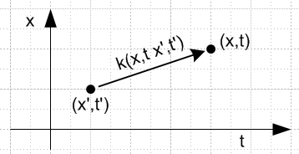 Fig 1.6

1.5 The Wave Equations in the Frequency Domain

(a) The Transformed Wave Equations

A standard method of solving wave equations involves transforming the equations from the time domain to the frequency ω domain using the Fourier Integral Transform, assuming that the μ, ε and σ are constants (possibly complex). As an example, we start with the φ equation in (1.3.29) and expand φ(x,t) and ρs(x,t) onto their Fourier components using (1.6.8) [ the overloaded notation is explained in Section 1.6 (f) ]

(∇2 - με ∂t2 - μσ∂t) φ(x,t) = - (1/ε) Σiρi(x,t) (1.3.26)

(∇2 - με ∂t2 - μσ∂t) [(1/2π)$^{\int_{-∞}^{∞}{}}$dω e+jωt φ(x,ω)] = - (1/ε) [(1/2π)$^{\int_{-∞}^{∞}{}}$dω e+jωt Σiρi(x,ω) ]

$^{\int_{-∞}^{∞}{}}$dω (∇2 - με ∂t2 - μσ∂t) e+jωt φ(x,ω) = - (1/ε) $^{\int_{-∞}^{∞}{}}$dω e+jωt Σiρi(x,ω)

$^{\int_{-∞}^{∞}{}}$dω (∇2 + μεω2 -jω μσ) e+jωt φ(x,ω) = - (1/ε) $^{\int_{-∞}^{∞}{}}$dω e+jωt Σiρi(x,ω)

$^{\int_{-∞}^{∞}{}}$dω e+jωt [(∇2 + μεω2 - jω μσ) φ(x,ω)] = $^{\int_{-∞}^{∞}{}}$dω e+jωt [- (1/ε) Σiρi(x,ω)] .

At this point we invoke the completeness of the set of functions {ejωt} on the interval (-∞,∞) to claim that the integrands must be equal, giving (1.3.26) transformed to the frequency domain,

(∇2 + μεω2 - jω μσ) φ(x,ω) = - (1/ε1) Σiρi(x,ω) .
or
(∇2 + β2) φ(x,ω) = - (1/ε) Σiρi(x,ω)

where β2 is the following complex "Helmholtz parameter" [of Helmholtz operator (∇2 + β2) ],

β2 = μεω2 - jωμσ = ω2μ ( ε - jσ/ω) = ω2μ ξ ξ ≡ ε - jσ/ω . (1.5.1)

Here ξ(ω) is the "complex dielectric constant", nothing more or less than the expression shown.

Note: Hermann von Helmholtz (1821-1894) was an early electromagnetic researcher and equations of the form (∇2+k2)f = g bear his name. As we have just seen, his equation arises from a temporal Fourier or Laplace transform of a wave equation. Since k will have another meaning in Chapter 5, and to be consistent with King p 10 (15a,b,c), we define the quantity in (1.5.1) as β2 instead of k2. King bolds parameters when they are complex, but we do not, so we have β2 instead of β2.

Examination of the above transformation shows that any equation can be transformed from the time domain to the frequency domain using these simple rules,

∂t → +jω ∂t2 → -ω2 F(x,t) → F(x,ω) . (1.5.2)

where it is understood (Section 1.6) that F(x,t) and F(x,ω) are different functions.

Thus, the frequency-domain representations of the King-gauge potential wave equations shown in (1.3.28) are:

Potential Wave Equations in the King Gauge (ω domain)

(∇2 + β2)φ = - (1/ε) Σiρi all of region R (1.5.3)
(∇2 + β2)A = - Σi μiJi all of region R (1.5.4)
div A = - μεjωφ - μσφ = -jωμ(ε+σ/jω)φ = -jωμξφ = -j(β2/ω) φ King gauge (1.5.5)

β2 = μεω2 - jωμσ = ω2μ ( ε - jσ/ω) = ω2μ ξ ξ ≡ ε - jσ/ω parameter β (1.5.1)
μ,ε,σ = dielectric 1,3,4.... N = conductors Σi = Σi=1N μi = for conductor i

ρi = free surface charge density on conductor i
Ji = free current density in conductor i (J in the dielectric exists but does not appear in ΣiμiJi)

In these equations, all mathematical fields φ, A, ρi, Ji are functions of x and ω. Note from (1.5.5) that in the ω domain, the King gauge is the Lorenz gauge with ε → ξ.

(b) The Helmholtz Integrals in the King Gauge

The next step is to solve the above equations for φ and A. The method was demonstrated in Appendix A.0 and is applied again here. We first define the free-space Green's Function g by this boundary value problem,

- (∇2 + β2)g(x,x') = δ(x-x') where lim|x|→∞ g(x,x') = 0 . (1.5.6)

As shown in (H.1.5), the solution to problem (1.5.6) is

g(x,x') = $\frac{1}{4π}$ $\frac{e-jβR}{R}$ R = |x - x'| . (1.5.7)

As (1.5.1) shows, in a conducting dielectric β2 has a small negative phase, so β has half this negative phase and β then has a small negative imaginary part. Then e-jβR → 0 for large R, as required by the condition of problem (1.5.6). This is why e+jβR/R is a rejected solution.

The Helmholtz equations (1.5.3) and (1.5.4) have the following particular solutions (dV' = d3x'),

φ(x,ω) = $\frac{1}{4πε}$ Σi∫ρi(x',ω) $\frac{e-jβR}{R}$dV' R = |x - x'| (1.5.8)
A(x,ω) = $\frac{1}{4π}$ Σi∫μiJi(x',ω) $\frac{e-jβR}{R}$dV' R = |x - x'| . (1.5.9)

In these equations, β is a function of ω, namely β = ω2μξ as in (1.5.1), and Σi = Σi=1N is over the conductors. Since (∇2 + β2) is the Helmholtz operator, solutions of the form (1.5.8) and (1.5.9) are sometimes called "Helmholtz integrals".

To verify that the φ of (1.5.8) solves (1.5.3) we write

φ(x,ω) = ∫ [Σiρi(x',ω)/ε] g(x,x') dV'

so that,

- (∇2 + β2) φ(x,ω) = ∫[ Σiρi(x',ω)/ε] { - (∇2 + β2)g(x,x') } dV'
= ∫[ Σiρi(x',ω)/ε] {δ(x-x')} d3x' = Σiρi(x,ω)/ε .

In the limit ω→ 0 we find from (1.5.1) that β(ω) → 0 and then (1.5.9) is the same as (A.0.2) obtained from electrostatics and Poisson's Equation.

In (1.5.8) the volume density function ρs(x',ω) ≡ Σiρi(x',ω) represents a surface charge density, so it is convenient to represent φ as a surface integral over the corresponding surface charge density ns(x',ω),

φ(x,ω) = $\frac{1}{4πε}$∫ns(x',ω)$\frac{e-jβR}{R}$dS' . R = |x - x'| (1.5.10)

Comments on n, σ and Dirichlet : Usually one uses σ for a surface charge, but σ is already used for conductivity so we use n. To further complicate things, in his potential theory discussion of Chapter 6, Stakgold uses σ to represent our surface S enclosing a volume V (his region R) as in our Fig 1.2. Stakgold uses n to indicate a normal derivative, as in this Dirichlet problem solution of the Poisson equation -∇2φ(x) = q(x),

φ(x) = ∫R dx' g(x|x') q(x') – ∫σ dSξ f(ξ) ∂ξng(x|ξ) // Stakgold (6.81) . (1.5.11)

Here ∂ξn = ∂/∂nξ where nξ is a local coordinate on the surface σ at point ξ which is normal to the surface. In this equation, q(x) is the Poisson source (think ρ(x)/ε0), g(x|ξ) is the full Green's function, meaning g = 0 on boundary σ, and f(ξ) is the Dirichlet prescribed potential on the enclosing boundary σ. Stakgold also uses n for number of dimensions and his work is always done in n spatial dimensions.
In (1.5.11), the first term is the particular solution, like our Helmholtz integral, while the second term is a homogenous solution to -∇2φ(x) = 0 which, when added in, makes things work at boundaries. Our Helmholtz integral, however, uses the free-space Green's Function, so we cannot just add on Stakgold's Dirichlet term to get a solution.
The above Poisson Dirichlet solution (1.5.11) seems mysterious at first viewing, but is easily derived using -∇2g(x|x') = δ(x-x') , -∇2φ(x) = q(x) [ = ρ(x)/ε ], and the famous Green's 2nd "symmetric" identity, where ∂φ/∂n = • ∇φ = the same normal derivative ∂ξn discussed above,

∫V dV ψ ∇2φ = ∫S dS ψ( ∂φ/∂n) – ∫V dV (∇ψ • ∇φ) Green #1
∫V dV [ ψ ∇2φ – φ ∇2ψ ] = ∫S dS [ ψ(∂φ/∂n) – φ(∂ψ/∂n) ] . Green #2 (1.5.12)

Here #2 = #1(ψ,φ) - #1(φ,ψ) and #1 is derived from the divergence theorem (1.1.30) with F = ψ∇φ and vector identity ∇• (ψ∇φ) = ∇ψ • ∇φ + ψ ∇2φ and dS = dS . Green was a busy man. Equation (1.5.11) is then obtained by setting ψ = g in (1.5.12), recalling that g = 0 on σ.
Since Green #2 is also valid if we replace ∇2→ (∇2+k2), (1.5.11) is also formally valid for a Helmholtz Dirichlet problem where then g is the full Helmholtz Green's function.

(c) King's leading factor (1/4πξ) and the final Helmholtz Integrals

This is a somewhat subtle point and something that King never discusses much in his transmission-line theory book. The issue is that there are two different entities ns and nc which have units charge/area, and they are related by ns = (ε/ξ) nc where ξ = ε + σ/jω is the complex dielectric constant (in the dielectric) which incorporates the effect of possible dielectric conductivity. In a transmission line problem, it is nc that is specified by the boundary conditions and not ns (which is the actual surface charge density). For that reason, one replaces (1.5.10) with,

φ(x,ω) = $\frac{1}{4πξ}$∫nc(x',ω) $\frac{e-jβR}{R}$dS' R = |x - x'| (1.5.13)

which explains the leading factor $\frac{1}{4πξ}$ which appears every time King writes down the Helmholtz integral for φ in his books. In the discussion below we describe nc and its relation to ns, and then we show how this relation works in the simple example of a parallel plate capacitor.

Consider the situation at a general boundary between dielectric (region 1) and conductor (region 2) where there exists a surface charge density ns :

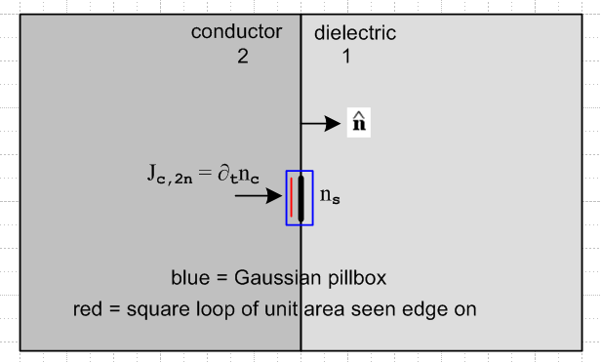 Fig 1.7

In (1.1.18) it was shown that div [Jd + Jc] = 0 where Jc = σE is the conduction current and Jd the displacement current ∂tD = ε∂tE. The divergence theorem (1.1.30) then says

0 = ∫V div [Jd + Jc] dV = ∫S [Jd + Jc] • dA .

Applied to the blue pillbox which straddles the boundary in the figure, we find

Jd1n + Jc1n = Jd2n + Jc2n

where n means normal component. Writing this out,

ε1∂tE1n + σ1E1n = ε2∂tE2n + σ2E2n ≈ σ2E2n = Jc2n

since σ2 is huge inside the conductor. Therefore,

Jc2n = σ1E1n + ε1∂tE1n . (1.5.14)
Meanwhile, Gauss's Law (1.1.33) states that

div (εE) = ρ ⇔ ∫V ρ dV = ∫S εE • dA . (1.1.33)

Applied to the same blue pillbox we find

ns = ε1En1 - ε2En2 ≈ ε1En1

since En2 ≈ 0 inside the conductor. Thus,

En1 = ns/ε1 and then Jcn1 = σ1En1 = ns(σ1/ε1) . (1.5.15)
Then (1.5.14) can be written as

Jc2n = σ1E1n + ε1∂tE1n = (σ1 + ε1∂t)E1n = (1/ε1)(σ1 + ε1∂t)ns

or, writing out the arguments,

Jc2n(x,t) = (1/ε1)(σ1 + ε1∂t)ns(x,t) .

In the frequency domain with rules (1.5.2) this becomes

Jc2n(x,ω) = (1/ε1)(σ1 + ε1jω)ns(x,ω)

= (1/ε1) (jω)(ε1 + σ1/jω) ns(x,ω)

= (ξ1/ε1) (jω) ns(x,ω) . ξ1 ≡ ε1 + σ1/jω = complex dielectric constant (1.5.16)

If we observe the conduction current Jc2n flowing through a unit-area loop (red in figure), we can write Jc2n = ∂tnc where nc is the total amount of conduction charge flowing through that unit-area loop per unit time. Thus we have

∂tnc(x,t) = (1/ε1)(σ1 + ε1∂t)ns(x,t)
or
jω nc(x,ω) = (ξ1/ε1) (jω) ns(x,ω)
or
nc(x,ω) = (ξ1/ε1) ns(x,ω) . (1.5.17)

where is our result claimed at the start that ns = (ε/ξ) nc. Note that:

• The quantity ns is the amount of free charge per unit area on the conductor surface.
• The quantity nc does not represent any kind of surface charge anywhere (free or otherwise).

nc is related to the transport of conduction charge carriers through the charge-neutral interior of the conductor just below the surface. There is no unit-area surface which holds nc amount of charge, but both ns and nc have the dimensions of charge/area so both can therefore be called "surface charge".

These two areal charge densities are different simply because the dielectric leaks charge off the surface. We are now going to rederive (1.5.17) a different way. We can write, using the blue pillbox and continuity relation (1.1.25),

div Jc = - ∂tρfree ⇔ -∂t[∫V ρfree dV] = ∫S Jc • dA . (1.1.25)

=> - ∂t[∫V ns dA] = ∫S Jc • dA

=> -∂tns = Jcn1 - Jcn2 = σ1(ns/ε1) - ∂tnc // see above: Jcn1 = σ1(ns/ε1), Jcn2 = ∂tnc
so
∂tns = ∂tnc - σ1(ns/ε1) // change in ns = flow in - flow out
or
jωns = jωnc - σ1ns/ε1 => (jω+ σ1/ε1)ns = jωnc => (jωε1+ σ1)ns = jωε1nc

=> (ε1+σ1/jω)ns = ε1nc => ξ1 ns = ε1 nc => nc = (ξ1/ε1)ns

which is the same as (1.5.17). Note that surface charge ns is real, while nc is complex.

It is useful at this point to examine the simple case of a parallel plate capacitor to see the meaning of ns and nc. The plate separation s is meant to be very small compared to the transverse dimensions of the plates, so the picture is distorted. We drop the subscript 1 on dielectric properties.

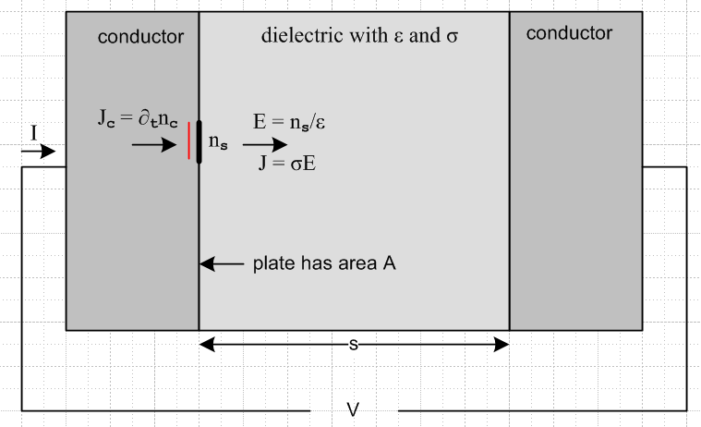 Fig 1.8

First off, a DC analysis of the above device shows that the capacitor has resistance R,

R = $\frac{V}{I}$ = $\frac{V}{JA}$ = $\frac{Es}{σEA}$ = (s/σA) . (1.5.18)

Now we assume an AC voltage V. The total current entering the conducting capacitor is I = JcA. If we think of I = ∂tQ then Q is the amount of charge passing through the external wire per unit time. Q is not the total charge on the left plate surface which in fact is Qs = nsA. Since I = JcA we have ∂tQ = (∂tnc) A and therefore Q = ncA.
Meanwhile, the voltage V between the plates is V = Es, and we know that E = ns/ε from Gauss's law. Thus V = (s/ε)ns.
If we define the (complex) capacitance by Q = C'V, then

C' = $\frac{Q}{V}$ = $\frac{ncA}{(s/ε)ns}$ = $\frac{nc}{ns}$ (Aε/s) = (ξ/ε) (Aε/s) = (ξ/ε) C = (Aξ/s) . (1.5.19)

The capacitance C' is complex because it accounts for both the capacitance and conductance of the dielectric,

C' = $\frac{ε + σ/jω}{ε}$ (Aε/s) = (Aε/s) + (σA/s)/(jω) = C + 1/(jωR) (1.5.20)
or
jωC' = jωC + 1/R
or
$\frac{1}{Z}$ = $\frac{1}{Xc}$ + $\frac{1}{R}$ Z = Xc' = $\frac{1}{jωC'}$ Xc = $\frac{1}{jωC}$ (1.5.21)

which is the rule for computing an impedance Z for a capacitor and resistor in parallel

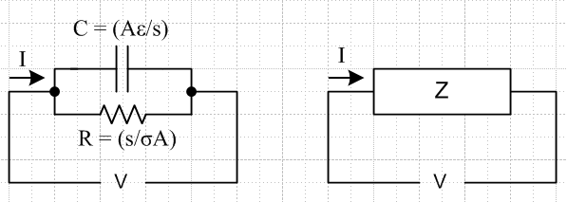 Fig 1.9

Looking back at this example, it is clear that if one wants to compute the complete impedance of the conducting capacitor, one uses C' = Q/V where Q = Anc. The ratio Qs/V gives only the capacitance C.

$\frac{Qs}{V}$ = $\frac{nsA}{(s/ε)ns}$ = (Aε/s) = C . (1.5.22)

In this conducting capacitor problem, the boundary conditions are the voltage V or the total current I. Specification of the current I = ∂t(ncA) is really a specification of nc since in the frequency domain we then have I = jωAnc. In analyzing the problem in full, we are thus interested in working with nc and not ns.

So recalling now the King gauge Helmholtz integral for φ ,

φ(x,ω) = $\frac{1}{4πε}$∫ns(x',ω)$\frac{e-jβR}{R}$dS' R = |x - x'| , (1.5.10)

since it will be more convenient to have nc in the integrand, we use (1.5.17) that ns = (ε/ξ) nc to rewrite the above expression as

φ(x,ω) = $\frac{1}{4πξ}$∫nc(x',ω) $\frac{e-jβR}{R}$dS' R = |x - x'| (1.5.13)

which is just (1.5.13) stated earlier.
So here are our final forms of the Helmholtz integrals of interest, where now write nc = Σinci,
φ(x,ω) = $\frac{1}{4πξ}$ Σi∫nci(x',ω)$\frac{e-jβR}{R}$dS' R = |x - x'| (1.5.13)
A(x,ω) = $\frac{1}{4π}$ Σi∫μiJi(x',ω) $\frac{e-jβR}{R}$dV' R = |x - x'| (1.5.9)

β2 = μεω2 - jωμσ = ω2μ ( ε - jσ/ω) = ω2μ ξ ξ ≡ ε - jσ/ω (1.5.1)

where the sum Σi is over all conductors. If all conductor have the same μi = μc, (1.5.9) simplifies to

A(x,ω) = $\frac{μc}{4π}$ Σi∫Ji(x',ω) $\frac{e-jβR}{R}$dV' R = |x - x'| . (1.5.9)'

We now quote directly from King's Transmission-Line Theory book to show how he presents the Helmholtz integrals for φ and A. What we call the King gauge appears as (2b) below. His symbols σ, ε, μ, ξ and β apply to the dielectric.

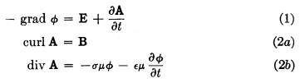 // page 8
// page 9
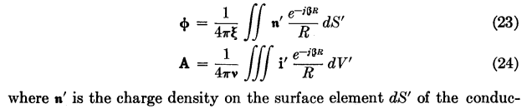 // page 11

Comments:

(1) King's (23) and (24) are for one conductor, while our (1.5.13) and (1.5.9) are for several conductors.

(2) Due to time lag effects, ε and σ may be complex, so ε = ε'-jε" and σ = σ'-jσ". In this case

ξ ≡ ε - jσ/ω = (ε'-jε") - j(σ'-jσ")/ω = [ε'- σ"/ω] - j [σ' + ωε"]/ω = εeff - jσeff/ω

so one would replace ε → εeff and σ → σeff in all equations (see King p 9 footnote).

(3) In the same way, time lag effects can cause μ = μ' - jμ" (hysteresis).

(4) King uses bold font for vectors and for quantities which are complex. For example his ξ of ξ = ε - jσ/ω is bolded. Similarly, our (1.5.1) that β2 = ω2μξ becomes his equation (10) above, β2 = ω2μξ .

(5) King assumes that all conductors and the dielectric have the same μ, something we did not assume. In order to make (23) and (24) look as similar as possible, he defines ν ≡ 1/μ. Since these parameters can both be complex, he writes them as μ and ν. This then explains the factor 1/(4πν) appearing in his (24) which then agrees with our (1.5.9)'.

(6) He shows his equation (23) charge density n' in bold, indicating it is complex. His n' is our nc, also complex. He refers to n' as "charge density on the surface" but he really means it to be nc as we have discussed at length above, and this is how he uses it in his calculations.

King uses these Helmholtz integrals (23) and (24) for φ and A extensively in his book to compute the parameters of various complicated transmission line geometries and interfaces. We shall pursue this subject more in Chapter 4 for some simple cases.

We should point out that King makes no attempt to derive his equations (23) and (24) and more or less just pulls them out of a hat. We spent some time perusing several of King's other 11 books looking for some kind of derivation but were unsuccessful. The equations do appear in more or less the same form in his earliest book Electromagnetic Engineering (1945). So in some sense, we have spent the first 40 pages of this document deriving his equations (23) and (24). For that reason, it is worth gathering up the results in a summary box:

Potential Solutions for φ and A in the King Gauge (ω space) (1.5.23)
φ(x,ω) = $\frac{1}{4πξ}$ Σi∫nci(x',ω)$\frac{e-jβR}{R}$dS' R = |x - x'| (1.5.13)
φ(x,ω) = $\frac{1}{4πξ}$ Σi∫ρci(x',ω)$\frac{e-jβR}{R}$dV' // using volume charge representation ρcdV' = ncdS'
A(x,ω) = $\frac{1}{4π}$ Σi∫μiJi(x',ω) $\frac{e-jβR}{R}$dV' (1.5.9)
A(x,ω) = $\frac{μ}{4π}$ Σi∫Ji(x',ω)] $\frac{e-jβR}{R}$dV' // if all μi = μ (1.5.9)'

μ,σ,ε = dielectric; μi = inside conductor i ;

β2 = μεω2 - jωμσ = ω2μ ( ε - jσ/ω) = ω2μ ξ ξ ≡ ε - jσ/ω = ε + σ/jω (1.5.1)

div A = - μεjωφ - μσφ = -jωμ(ε+σ/jω)φ = -jωμξφ // King gauge (1.5.5)

B = curl A E = - grad φ - ∂tA (1.3.1)

The Helmholtz integrals are just "particular solutions" to the potential wave equations. In order to solve a problem, one must add to these particular solutions whatever homogeneous solutions are necessary in order to match all boundary conditions.

(d) Frequency domain wave equations for fields and potentials in the Lorenz Gauge

We now use the earlier notation with reference to Fig 1.5 where dielectric = 1 and conductors = 2,3...N+1 for N conductors. The Lorenz gauge is given by (1.3.30) transformed to the ω domain,

divA = - μ1ε1jωφ . (1.5.24)

Undamped Lorenz-gauge potential wave equations (1.3.32) and (1.3.31) : k12 = ω2μ1ε1

(∇2+k12)φ = - (1/ε1) Σi=2N+1 ρi all of region R
(∇2+k12)A = - Σi=1N+1 μiJi all of region R (1.5.25)

In the Lorenz gauge, the potential wave equations don't have damped operator versions. However, for the field wave equations (which know nothing of gauge) we can write both undamped and damped versions:

Undamped field wave equations (1.3.35) : ki2 = ω2μiεi

(∇2+k12)E = μ1jωJ1 + (1/ε1) Σi=2N+1 grad ρi (∇2+k12)B = - μ1 curl J1 // region 1
(∇2+k22)E = μ2jωJ2 (∇2+k22)B = - μ2 curl J2 // region 2
(∇2+k32)E = μ3jωJ3 (∇2+k32)B = - μ3 curl J3 // region 3 (1.5.26)
Damped field wave equations (1.3.36) : βi2 = ω2μiξi

(∇2+β12)E = (1/ε1) Σi=2N+1grad ρi (∇2+β12)B = 0 // region 1
(∇2+β22)E = 0 (∇2+β22)B = 0 // region 2
(∇2+β32)E = 0 (∇2+β32)B = 0 // region 3 (1.5.27)

These last equations follow from the previous set using Ji = σiE and curl Ji = σi curl E = -jωσiB.

The solution method was outlined earlier: for each inhomogeneous equation compute the particular solution as a Helmholtz integral, then for all equations identify generic homogeneous solutions with unknown constants, and finally determine those constants using boundary conditions from box (1.1.50). The potential approach has the advantage of a single wave operator and only two equations, while the damped field approach has the advantage of not involving any currents, but the disadvantage of having three times more equations and requiring computation of grad ρi. There is a lot more to keep track of. These are all of course vector Helmholtz equations.

In a problem having only a single region (having μ,ε,σ) containing current density J and charge density ρ (perhaps inside the region, perhaps just on the surface), the Lorenz-gauge potential wave equations above in (1.5.25) may be written

(∇2+k2)φ = -(1/ε) ρ k2 = ω2με all of region R
(∇2+k2)A = - μJ . k2 = ω2με all of region R (1.5.28)

These equations may be derived directly from the single-region field wave equations (1.2.1) and (1.2.2) converted to the frequency domain,

(∇2 + k2)E = jωμJ + (1/ε) grad ρ k2 = ω2με
(∇2 + k2)B = - μ curl J . (1.5.29)
Each of these last four equations has its own Helmholtz integral,
φ(x,ω) = $\frac{1}{4πε}$∫ρ(x',ω)$\frac{e-jkR}{R}$dV' R = |x - x'| k2 = ω2με
A(x,ω) = $\frac{μ}{4π}$∫J(x',ω) $\frac{e-jkR}{R}$dV' (1.5.30)

E(x,ω) = - $\frac{1}{4π}$∫[ jωμJ(x',ω) + (1/ε) grad ρ(x',ω) ] $\frac{e-jkR}{R}$dV'
B(x,ω) = $\frac{μ}{4π}$∫[ curl J(x',ω)] $\frac{e-jkR}{R}$dV' (1.5.31)

The A(x,ω) Helmholtz integral (1.5.30) appears on Jackson p 408, Eq. (9.3), with j → -i and μ→ μ0.

For this same single-region problem, the damped wave equation (1.5.27) becomes

(∇2+β2)E = (1/ε) grad ρ β2 = ω2μξ
(∇2+β2)B = 0 (1.5.32)

where again ρ might be in the volume and/or on the surface of the volume. This follows directly from (1.5.29) using the methods above.

(e) Self Consistency of Helmholtz Integral Solutions

The various Helmholtz partial differential equations encountered in the previous sections have solutions expressed as "Helmholtz integrals". In particular, our King gauge Helmholtz integrals for the potentials have this form,

φ(x,ω) = $\frac{1}{4πξ}$ Σi∫nci(x',ω)$\frac{e-jβR}{R}$dS' R = |x - x'| (1.5.13)
A(x,ω) = $\frac{1}{4π}$ Σi∫μiJi(x',ω) $\frac{e-jβR}{R}$dV' . (1.5.9)

These equations sometimes give the impression that one can willy-nilly specify an arbitrary charge distribution nci and an arbitrary current distribution Ji for a set of transmission line conductors and then these Helmholtz integrals will generate the correct potentials A and φ from which the correct fields E and B may be obtained using (1.3.1),

B = curl A E = - grad φ - jωA . (1.3.1)

This is a false impression for one to infer from the discussion of the previous sections.

For example, in a "fat twinlead" transmission line of the kind to be mentioned in Section 2.5 below,

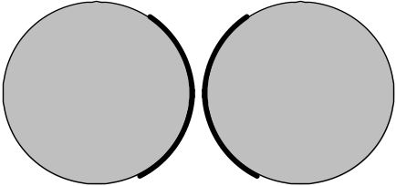
Fat twinlead Fig 2.16

the charge and current densities are extremely non-uniform. One cannot arbitrarily specify for this problem a uniform n and Jz distribution in each conductor and expect the resultant E and B fields to be correct.
The issue here is that solutions have to be self-consistent. Suppose one were to specify for the above fat twin-lead problem a uniform n and Jz. That is to say, one specifies that surface charge n is uniform around each circular cross section perimeter, and Jz is uniform across each disk area. The Helmholtz integrals shown above would then yield some A and φ and that in turn would yield some E and B for the fields in the dielectric between the conductors. One could then compute from the E field the value of surface charge n on each conductor using (1.1.47) n = εEn, where En is the normal E field just above the conductor surface. Similarly, one could compute conduction currents in the conductors perhaps from J = (1/μ)curl B - jωεE which is Maxwell (1.1.1). One would find, unfortunately, that the resulting n and J did not agree with the initially assumed values of n and J. Such a "solution" is then meaningless because it is not self-consistent.
All real-world Maxwell equation problems tend to have this circular aspect which makes solutions more difficult than the solution of idealized problems. A problem mentioned elsewhere in this document is that of a radiating dipole antenna. One can assume a certain sine shaped current pattern in the antenna, compute from it the potentials and fields, and one will find when the antenna current is back-computed from those fields that the pattern is not quite a sine pattern unless the wire is infinitely thin.
There are then two useful conclusions to be drawn here.
First, if transmission line conductors are very thin relative to their spacing, it is probably just fine to assume a uniform charge and current distribution in those wires, since the actual non-uniformity will have only a small effect on the solutions.
Second, a general method of solution is to start with some charge and current distributions that seem reasonable based on one's general analysis of a problem. One can then find the back-computed charges and currents, and adjust the input model accordingly. This would be the basis of either an analytic iterative procedure, where the model has some adjustable parameters, or of a numerical procedure where the model is the set of values that comprise the charge and current distribution and some kind of iterative "relaxation" method then produces self-consistent solutions.
We note that the exact solution of the "fat twin lead" transmission line is derived in Chapter 6 by a method which bypasses this iterative process, and which works only due to the simple nature of the geometry.

1.6 Reinterpretation of all equations in terms of complex functions

It seemed useful to defer the topics of this section to avoid cluttering up the preceding five sections. The Fourier Transform has already been used in the previous two sections, and here we discuss it more formally as a motivating factor in changing our point of view from real to complex functions. The general nature of the Fourier Transform of complex monochrome (ejωt) fields sets the stage for the analysis of the round wire in Section 2.

(a) Complex Functions

Up to this point, we have been regarding the following fields as representing real physical quantities,

H(x,t) D(x,t) J(x,t) A(x,t)
B(x,t) E(x,t) ρ(x,t) φ(x,t) . (1.6.1)

The fields, potentials and sources exist in the real physical world and are related by equations involving real operators like curl and ∂/∂t. We can represent such an equation as Lx,tf(x,t) = g(x,t) where Lx,t is some real differential operator and f and g are real fields.
One can extend f and g such that f and g are either both the real or both the imaginary parts of complex functions F and G. Then the equation Lx,tF(x,t) = G(x,t) represents two distinct physical equations which we can write as

Lx,tF(x,t) = G(x,t) => Lx,t[f(x,t) + jf '(x,t)] = [g(x,t) + jg'(x,t)] =>

Lx,t f(x,t) = g(x,t) F(x,t) = f(x,t) + jf '(x,t)
Lx,t f '(x,t) = g'(x,t) G(x,t) = g(x,t) + jg'(x,t) . (1.6.2)

It is convenient to regard all the mathematical fields listed above in (1.6.1) as complex fields like F and G. For example, we might write the Maxwell curl E equation (1.1.2) in this manner

curl E(x,t) = - ∂B(x,t)/∂t E(x,t) = e(x,t) + j e'(x,t)
B(x,t) = b(x,t) + j b'(x,t) . (1.6.3)

where e = Re(E) and e' = Im(E) and similarly for the B field.

The single left equation of (1.6.3) then represents these two different physical equations with real fields

curl e(x,t) = - ∂b(x,t)/∂t
curl e'(x,t) = - ∂b'(x,t)/∂t . (1.6.4)

Thus, one can regard one's physical fields as either the real or imaginary parts of the complex fields.

(b) Monochrome time

The classic application of this idea is the assumption that some complex field is "monochrome" (monochromatic) in its time dependence, meaning for example,

Ei(x,t) = ej[ω$_{1}$t+φ$_{i}$(x,ω$_{1}$)] Ei(x,ω1) = ejω$_{1}$t ejφ$_{i}$(x,ω$_{1}$) Ei(x,ω1) , (1.6.5)

where Ei(x,ω1) = | Ei(x,t) | is real. Index i denotes a field component in an arbitrary coordinate system, not just Cartesian coordinates. All time dependence is in the ejω$_{1}$t factor and all spatial dependence is in the factor [ejφ$_{i}$(x,ω$_{1}$) Ei(x,ω1)] -- separation of variables. This monochrome field might be regarded as a probe or driver of some system and the solution fields Ei(x,t) and phases φi(x,ω1) might depend parametrically on the probe frequency ω1 as well as on position x.

For (1.6.5) the corresponding physical field assumption is either of these equations,

ei(x,t) = Re{ Ei(x,t)} = cos[ω1t + φi(x,ω1)] Ei(x,ω1)
e'i(x,t) = Im{ Ei(x,t)} = sin[ω1t + φi(x,ω1)] Ei(x,ω1) . (1.6.6)

We stress again that the phase φi(x,ω1) might depend on both x and ω1. A good prototype 1D example for the ω1 dependence of phase φ1(x,ω1) is a damped harmonic oscillator with resonant frequency ω0 which is driven at frequency ω1. The solution is:

x(t) = x(0) sin[ω1t + φ(ω1)] tan φ(ω1) = -(ω1/τ)/(ω02- ω12) .

Of course the solution function x(t) is not a field over R3, so in this case the phase φ has no x dependence.

Comments:

1. The assumed form (1.6.5) is the most general form one can have for a monochrome field. One can always assume a more restrictive form for a certain type of problem and see where it leads. Such a restricted form is an "ansatz" form meaning that one assumes that restricted form and then one tries to find the solution to a specific problem with the E field so restricted. If a solution is found which satisfies Maxwell's equations, then the ansatz form is justified. For example, one might use the more restrictive ansatz where φi(x,ω) = φi(ω), or even more restrictive with φi(x,ω) = φi, a constant.

2. For a wave problem, one might try the following ansatz form which is a restriction of (1.6.5),

Ei(x,y,z,t) = ej(ω$_{1}$t-kz) ejφ$_{i}$(x,y,ω$_{1}$)] Ei(x,y,ω1) (1.6.7)

where Ei(x,y,ω1) is real. In this form the entire dependence on t and z is exposed in the first factor, so the solution then represents a wave traveling in the z direction.

3. Note in (1.6.5) that the phase function φi(x,ω1) can be different for different components Ei(x,t). Appendix D studies the fields inside a round wire and the three field components Ez, Er and Eθ do indeed have different phases for that problem.

(c) Why complex fields: The Fourier Transform

The reason for using a complex field like E(x,t) instead of the real field e(x,t) has to do with the Fourier Transform (or the Laplace Transform). This transform is almost always needed to solve a non-trivial problem involving Maxwell's equations, and we saw it in action in Section 1.5. With the convention that the (1/2π) goes in the expansion formula along with e+jωt, we write the Fourier Integral Transform as :
[ for want of a better notation, f^(ω) is the transform of f(t) ]

E^(x,ω) = $^{\int_{-∞}^{∞}{}}$dt E(x,t) e-jωt projection = transform (1.6.8a)

E(x,t) = (1/2π)$^{\int_{-∞}^{∞}{}}$dω E^(x,ω) e+jωt . expansion = inverse transform = recovery (1.6.8b)

Here E(x,t) is the original complex field whose real and imaginary parts are physical fields as in (1.6.3) or (1.6.6), while E^(x,ω) is the Fourier Transform of E(x,t).
As (1.6.8) shows, the dimensional units of the Fourier transform of some quantity have an extra sec factor. For example, since dim[E(x,t)] = volt/m, it follows that dim[E^(x,ω)] = volt-sec/m.
An obvious property of the Fourier Transform is this:

∂tE(x,t) = (1/2π)$^{\int_{-∞}^{∞}{}}$dω E^(x,ω) ∂t e+jωt = (1/2π)$^{\int_{-∞}^{∞}{}}$dω [jω E^(x,ω)] e+jωt

which we can write as ( symbol ↔ means "corresponds to")

E(x,t) ↔ E^(x,ω) ⇔ ∂tE(x,t) ↔ jω E^(x,ω) (1.6.9)

which is just another way to state our rule (1.5.2).
In the case of assumed monochrome time dependence of the form (1.6.5) ( reflected in (1.6.6) ) one finds that

Ei(x,t) = ej[ω$_{1}$t+φ$_{i}$(x,ω$_{1}$)] Ei(x,ω1) (1.6.5)

E^i(x,ω) = $^{\int_{-∞}^{∞}{}}$dt [ejω$_{1}$t ejφ$_{i}$(x,ω$_{1}$)Ei(x,ω1)] e-jωt = Ei(x,ω1) ejφ$_{i}$(x,ω$_{1}$)$^{\int_{-∞}^{∞}{}}$dt ej(ω$_{1}$-ω)t

= [Ei(x,ω1) ejφ$_{i}$(x,ω$_{1}$)] 2πδ(ω-ω1) (1.6.10)
or
E^(x,ω) = E(x,0) 2πδ(ω-ω1) . (1.6.11)

It is this very simple single-δ-function form that motivates the use of complex fields as carriers of the real physical fields. One can of course Fourier-transform the monochrome physical field directly, but the result is clumsy to deal with. For example,

ei(x,t) = Re{ Ei(x,t)} = cos[ω1t + φi(x,ω1)] Ei(x,ω1)
e'i(x,t) = Im{ Ei(x,t)} = sin[ω1t + φi(x,ω1)] Ei(x,ω1) . (1.6.6)

e^i(x,ω) = $^{\int_{-∞}^{∞}{}}$dt { cos[ω1t + φi(x,ω1)] Ei(x,ω1) }e-jωt
= Ei(x,ω1) (1/2) $^{\int_{-∞}^{∞}{}}$dt { ej[ω$_{1}$t+φ$_{i}$(x,ω$_{1}$)] + e-j[ω$_{1}$t+φ$_{i}$(x,ω$_{1}$)] } e-jωt

= Ei(x,ω1) [ejφ$_{i}$(x,ω$_{1}$)πδ(ω-ω1) + e-jφ$_{i}$(x,ω$_{1}$)πδ(ω+ω1) ] . (1.6.12)
or
e^(x,ω) = [e(x,0) + je'(x,0)] π δ(ω-ω1) + [e(x,0) - je'(x,0)] π δ(ω+ω1) . (1.6.13)

This lacks the friendliness of (1.6.11) in that the real and imaginary parts of E(x,0) both appear on the right, and two different ω-space delta functions are required. One could by fiat set e' = 0, for example, but the two delta functions still remain.

A directly related benefit of using the complex function approach is the fact that math with exponentials is so much simpler than the corresponding math with trig functions, as for example

ej(ωt+φ) e-j(ω't+φ') = ej(ω-ω')t ej(φ-φ') // dependence on t isolated to one factor
versus
cos(ωt+φ)cos(ω't+φ') = (1/2) { cos[ (ω-ω')t + (φ-φ')] + cos[ (ω+ω')t + (φ+φ')] } .

Comment: Using the real cosine form shown as the first line of (1.6.6) along with the Fourier Cosine Transform is not viable because cos[ω1t + φi(x,ω1)] Ei(x,ω1) is not an even function of t.

(d) Monochrome E and B fields

One might seek to solve a system using monochrome fields of the form (1.6.5) for both the electric and magnetic fields. Those forms would be (E and B are real)

Ei(x,t) = ej[ω$_{1}$t+φ$_{ei}$(x,ω$_{1}$)] Ei(x,ω1)
Bi(x,t) = ej[ω$_{1}$t+φ$_{bi}$(x,ω$_{1}$)] Bi(x,ω1) (1.6.14)

where we assume the same frequency ω1 for both fields, but allow the fields to have different phase functions φei and φbi. In this case (1.6.10) becomes

E^i(x,ω) = Ei(x,ω1) ejφ$_{ei}$(x,ω$_{1}$) 2πδ(ω-ω1)
B^i(x,ω) = Bi(x,ω1) ejφ$_{bi}$(x,ω$_{1}$) 2πδ(ω-ω1) . (1.6.15)

The ratio of Ei over Bj is then given by

$\frac{E^i(x,ω)}{B^i(x,ω)}$ = $\frac{Ei(x,ω1)}{Bi(x,ω1)}$ ej[φ$_{ei}$(x,ω$_{1}$)- φ$_{bj}$(x,ω$_{1}$)] . (1.6.16)

Since Ei and Bj are real, the phase of the ratio E^i/ B^j is determined by the last factor and will in general be a function of both position x and frequency ω1. We shall see this situation arise in Chapter 2 when we calculate the fields inside a conducting round wire.

(e) A Pitfall to Avoid

Notice that

E(x,t) = e(x,t) + j e'(x,t) =>

E^(x,ω) = $^{\int_{-∞}^{∞}{}}$dt E(x,t) e-jωt = $^{\int_{-∞}^{∞}{}}$dt [e(x,t) + j e'(x,t)] e-jωt

= e^(x,ω) + j e'^(x,ω) . (1.6.17)

Whereas e(x,t) and e'(x,t) are the real and imaginary parts of E(x,t), the functions e^(x,ω) and e'^(x,ω) are not the real and imaginary parts of E^(x,ω) since in general e^(x,ω) and e'^(x,ω) are both complex functions. In this document we shall never deal with transforms of the type e^(x,ω) or e'^ (x,ω).

(f) Overloaded Notation and Maxwell's Equations in ω space

In this section we have carefully denoted the Fourier Transform of f(t) as f^(ω) which is a notation used by Stakgold and others (though Stakgold has our (1.6.8) phases negated as in his equation (5.32)). In the rest of this document, however, we represent the Fourier Transform of f(t) as f(ω) to avoid a proliferation of hat ^ symbols. Since the functions f(t) and f(ω) are completely different functions, the symbol f is "overloaded" (in the sense of overloaded variable names in computer languages) and we trust the reader to understand that f(ω) always means f^(ω). It is the presence of the argument ω that cues the reader to this fact. This overloaded notation has already been used in Section 1.5 and we continue it right here:

In the Maxwell and related equations which include the ∂t operator, if the fields are expanded onto their Fourier transformed components using (1.6.8b), then using the rule (1.6.9) one may instantly write the frequency-domain version of these equations, just as in the example of Section 1.5. For example,

curl H(x,ω) = jωD(x,ω) + J(x,ω) (1.6.18)

curl E(x,ω) = -jωB(x,ω) (1.6.19)

div J(x,ω) = -jωρ(x,ω) . (1.6.20)

Other equations in the Section 1.1 list have the same form but in terms of the frequency-domain functions. For example,

J(x,ω) = σ(x) E(x,ω) (1.6.21)

where we momentarily allow σ(x) to have spatial dependence but not time dependence.

Chapter 2: The Round Wire and the Skin Effect

Chapter 1 dealt with the generalities of electromagnetic theory. Maxwell's equations were stated ex machina, as it were, and wave equations for the fields and potentials were then derived. Formal integral solutions of the potential wave equations were also derived using the Green's Function method. It was noted that the potentials φ and A are parts of the same Lorentz 4-vector.
Whereas the approach of Chapter 1 was very general and abstract, the discussion of this chapter is highly specific. The goal here is to learn about the properties of a very simple object -- an infinite straight round wire.
Although transmission lines are not always made out of round wires, there is a wealth of useful practical information that arises from the study of this simple example which applies to more general geometries.
The major issue here is called the "skin effect". At high frequencies, current is forced away from the central regions of a conductor and concentrates at the surface in a thin layer that has a characteristic depth called δ, the skin depth. In this chapter it will be shown exactly why this occurs. The significance of the effect is that the resistance (impedance) of a wire increases drastically at high frequency since the current is forced to flow only in this thin shell below the wire surface. This effect is manifested in a property of a wire called its surface impedance which is studied below in Section 2.4 and qualitatively in Section 2.5.
Our development is an extension of the excellent discussion of Matick's Chapter 4. It is fastest to solve the round wire problem starting with the ω-domain damped wave equation (1.5.32) which, inside the wire where there is no free charge, says (∇2 + β2)E = 0 with β2 = ω2μξ where μ and ξ apply to the conductor. Instead, we have chosen to start from the basic Maxwell curl equations and use simple "math loops" to derive the basic (first order differential) equations relating E and B fields. The general technique of putting loops in opportune places is extremely useful in analyzing the more complicated situation which arises in a transmission line. This method is carried out in Section 2.2 and the wire's interior solutions are then studied in Section 2.3.
In the work done below, we shall assume axial symmetry for the fields in the round wire. The problem is treated more generally in Appendix D where the Helmholtz equation (∇2 + β2)E = 0 is directly solved. The partial wave m = 0 solution of Appendix D corresponds to the analysis below.

2.1 The Implicit Wave Context and the Skin Effect

In the sections below we don't explicitly consider the notion that a wave is traveling down our round wire, but that is in fact what is happening and this fact deserves a few comments before we delve into the interior solution of the wire. Specifically, imagine that E has the following traveling-wave form,

E(x,y,z,t) = ej(ωt-kz) E(x,y,ω) . (2.1.1)

where E(x,y,ω) might have dependence on ω and might be complex. Inside the wire this field must satisfy the damped wave equation (1.3.36),

(∇2 - με ∂t2 - μσ∂t) E(x,y,z,t) = 0 . (2.1.2)

When the form (2.1.1) is inserted into (2.1.2), the result is, using ∇2 = ∇2D2 + ∂z2,

(∇2D2 + ∂z2 - με ∂t2 - μσ∂t) { ej(ωt-kz) E(x,y,ω)} = 0
or
(∇2D2 - k2 + με ω2 - jμσω) { ej(ωt-kz) E(x,y,ω)} = 0
or
(∇2D2 - k2 + β2) { ej(ωt-kz) E(x,y,ω)} = 0
or
(∇2D2 + β2 - k2) E(x,y,ω) = 0 (2.1.3)

where

β2 = μεω2 - jωμσ = ω2μ (ε - jσ/ω) = ω2μ ξ . ξ ≡ ε - jσ/ω (1.5.1)

Comment: E(x,y,ω) is proportional to the Fourier Transformed ω-domain version of E(x,y,z,t) :

E^(x,y,z,ω') ≡ FT{ E(x,y,z,t), ω'} = e-jkz E(x,y,ω) 2πδ(ω-ω') . // see (1.6.11)

A similar equation applies just outside the round wire in the dielectric medium in which it is embedded, and this medium has its own β which we call βd. Thus we have

( ∇22D + β2 - k2) E(x,y,ω) = 0 inside wire β = (j - 1) $\sqrt{ωμσ/2}$ = complex (2.1.4a)
( ∇22D + βd2 - k2) E(x,y,ω) = 0 outside wire βd = ω $\sqrt{μdεd}$ = ω/vd ≈ real . (2.1.4b)

We have assumed that
• the dielectric is non-conducting or only slightly conducting so ξd ≈ εd.
• the conductor is a good one, so β2 ≈ (- j) ωμσ and then β = $\sqrt{-j}$$\sqrt{ωμσ}$. As will be shown below, the choice for $\sqrt{-j}$ is ej3π/4 = (j-1)/$\sqrt{2}$ which then gives β = (j - 1) $\sqrt{ωμσ/2}$ as in (2.1.4a).

In (2.1.4b) we then make the ansatz assumption that

k = βd (2.1.5)

which basically says that the wave form ej(ωt-kz) E(x,y,ω) really does describe a wave traveling down the wire with k = βd. This k = βd = ω/vd is then related to the speed of light in the dielectric and is the expected value of k for, say, a radio or light wave travelling through the dielectric with no wire present. Once we have assumed ej(ωt-β$_{d}$z) for the dielectric solution, the boundary conditions (1.1.50) on field components at the wire surface will force this same dependence on the solution inside the wire.
In (2.1.4a), since the conductor has such a large σ, |β| is a large number and |β| >> βd (unless ω is very large), so k2 can be ignored in (2.1.4a). We then have

( ∇22D + β2) E(x,y,ω) ≈ 0 inside wire β = (j - 1) $\sqrt{ωμσ/2}$ = complex (2.1.6a)
∇22D E(x,y,ω) = 0 outside wire (2.1.6b)

The second equation says that the E field outside the wire must solve the 2D vector Laplace equation. See Appendix D.7 for comments on the general exterior solution. Appendix D uses β'2 ≡ β2 - βd2 and does not make the approximation that β' ≈ β, but we make that approximation here.
To put our "isolated" round wire into a physical context, it helps to think of it as the round central conductor of a coaxial cable whose shield cylinder radius is very large compared to the central wire radius. Then this central round wire is really part of a transmission line and we expect such a transmission line to carry a wave with ej(ωt-β$_{d}$z) time and z dependence. Moreover, we expect the field solution inside such a coaxial cable central wire to have the axial symmetry that appears in our assumption list below.
It is equation (2.1.6a) for the wire interior that we shall encounter below, and hopefully we have now put that equation into the context of a wave travelling down the wire.
If βd has a small negative imaginary part due to conductivity of the dielectric (see (1.5.1)), the factor e-jβ$_{d}$z says that the wave slowly damps out as it travels down the wire due to dielectric ohmic loss, as it well should. (In a laser inverted medium βd has a positive imaginary part so the wave grows instead.)
On the other hand, β is huge and has equal real and imaginary parts. Due to our axial symmetry, (2.1.6a) really says (∇22D + β2) E(r,ω) = 0 which can be thought of as a "wave equation" in the radial direction. Of course it is a damped wave equation of a very extreme sort. As one moves in from the surface of the wire toward the center, we show later that over a distance in which the "wave" phase changes by about π/2, the amplitude is already down by a factor 1/e, so one can roughly say that the wave basically damps out before it even goes 1/2 wavelength. This is the skin effect described below.
To understand this effect, it is useful to consider a 1D version of the situation. Imagine zooming the camera in very close to the left surface of the round wire's cross section, so that we see a half space of conductor on the right and a half space of dielectric on the left. Let the radial direction be called x which increases into the conductor with x = 0 at the interface. Then the inside-wire wave equation above says

(∂x2 + β2) E(x,ω) = 0 . (2.1.7)

The solution to this equation is (we select a particular sign for the phase, and see (2.1.6a) for β)

E(x,ω) = E(0,ω) e+jβx = E(0,ω)exp{ j [(j - 1) $\sqrt{ωμσ/2}$] x}

= E(0,ω) exp{- $\sqrt{ωμσ/2}$x} exp{ -j $\sqrt{ωμσ/2}$x}

= E(0,ω) exp{- x/δ} exp{ -j x/δ} δ ≡ $\sqrt{2/(ωμσ)}$

= E(0,ω) e-x/δ e-jx/δ . (2.1.8)

Thus one moves from x=0 to the right into the conductor, in distance δ the E field amplitude drops to 1/e and the phase has changed by π/2. Quantity δ is called the skin depth, and this is probably the most basic way to understand the notion of the skin effect. It is a result dictated by the Helmholtz equation having a complex parameter β of the type shown. Based on this argument, the skin effect occurs at any conductor surface regardless of its cross-sectional shape. Below we see in the round wire example how the Helmholtz equation (2.1.6a) is in turn a result of the two Maxwell curl equations each of which relates E and B. Of course this is how the Helmholtz equation was derived in the first place starting with (1.2.1).

2.2 Derivation of E(r), B(r) and J(r) for a round wire

We convert (1.1.38) and (1.1.36) to the ω domain using rule (1.5.2),

curl B = μ (jωε E + J ) ⇔ C B • ds = μ∫S [jωεE + J ] • dS (2.2.1)
curl E = − jωB ⇔ C E • ds = -jω∫S B • dS . (2.2.2)

The two terms on the right side of (2.2.1) have names (we sometimes omit the word "density")

jωεE = displacement current (density) // amps/m2
J = σE = conduction current (density) // amps/m2 .

The sum of both currents may be written as

( jωε + σ) E(x,ω) .

For any metal conductor such as copper, the displacement term is completely negligible as long as ωε << σ. The value of ε for a metal is not very obvious and is likely in fact to be negative at frequencies below optical frequencies (free electron gas, plasma frequency, Drude model, etc), so we will follow Matick p 118 and blindly set ε = ε0 for a crude comparison. The condition for negligible displacement current
ωε << σ then becomes f << σ/[2πε0]. Using σ = 5.81 x 107 mho/m and ε0 = 8.85 x 10-12 F/m, one gets

f << (σ/2πε ) = 1.04 x 1018 Hz ≈ one billion GHz

Therefore, the displacement current is always ignored inside a conductor for any conventional transmission line application. Whatever ε really is, we shall ignore jωε compared to σ. All the current inside a conductor is conduction current. With respect to (1.5.1), this same approximation means that inside a conductor,

ξ ≈ - jσ/ω β2 ≈ - jωμσ // f << 1018 H (2.2.3)

At this point we make a set of assumptions:

(a) the round wire conductor medium is uniform and isotropic (2.2.4)
(b) the current pattern in the wire is axially symmetric (no dependence on azimuth θ;
it is invariant under any rotation of the wire about its center line)
(c) the current is axial (longitudinal), so J = J , so J = Jz
(d) the E field is also axial so E = E ( this follows from (c) and J = σE ), so E = Ez
(e) The B field lines go around in circles centered at the wire axis. The relation between the direction of B and the current flow J is given by the right hand rule. If J = Jz > 0, then B = Bθ > 0.

Thus, we represent Jz(x,y,ω) = J(r), Ez(x,y,ω) = E(r), and Bθ(x,y,ω) = B(r) -- no dependence on θ or z. The fields like Ez(x,y,ω) are of the type shown on the right of (2.1.3) where the z dependence has already been extracted. Fields E(x,y,ω), B(x,y,ω) and J(x,y,ω) are complex, so E(r), B(r) and J(r) are all complex. They all depend on ω, but we suppress the ω arguments. As noted above, E = E(r) and B = B(r) .
Here is another way to state assumption (b). We search for an axially symmetric solution of Maxwell's equations for the round wire, and if we find one, we accept it as a possible way fields and currents could exist in the wire. If the wire were in idealized perfect isolation with an axially symmetric source and load, the invariance of the physical situation with regard to rotation about the wire axis would require (b) to be valid. This symmetry is also implied by our "fat" coaxial cable context noted earlier.

Consider now the thin (width is dr) red loop shown in Fig 2.1:

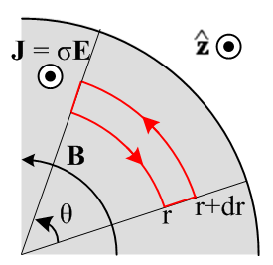 Fig 2.1
Cross section view of wire, current flowing in direction toward viewer

According to (2.2.1) with J = σE and no displacement current,

C B • ds = (μσ) ∫S E • dS . (2.2.5)

For the CCW loop shown, the "right hand rule" says area dS points out of the plane of paper. The two sides of this equation can be easily evaluated (B = Bθ and E = Ez)

[ B(r+dr) (r+dr) - B(r) r] θ = (μσ) E(r) [ rθ dr ] (2.2.6)

which simplifies to

$\frac{∂ [r B(r)]}{∂r}$= (μσ) [r E(r) ] . (2.2.7)

Comment: When one says in Fig 2.1 that "J points in the direction", one interpretation might be that the vector J has the form J = Jz and that Jz > 0. That is not the correct interpretation for our pictures. The quoted phrase just means that J = Jz and nothing is implied about the "sign" of Jz. In our case, Jz = J(r) is a complex number which has no "sign". If we said "J points in the - direction" we would just mean that J = Jz(-) = -Jz. Our only interest in clarifying these "directions" is to get the signs right in our application of Stokes's law. The same comment applies to the direction of B in the next figure. By saying that "B points out of the plane of paper", we just mean that B = +B(r) which is consistent with the fact that J = +Jz according to the right hand rule: thumb in the "direction" of J at the wire axis, curled fingers are in the "direction" of B.

Now consider the thin red loop shown in Fig. 2.2,

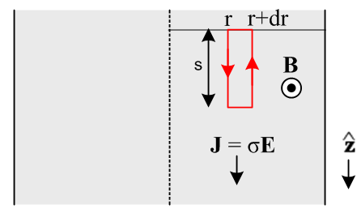 Fig 2.2
Top view of wire's central plane, current flowing in direction (down)

According to (2.2.2),

C E • ds = -jω∫S B • dS . (2.2.2)

where, for the CCW loop shown, the right hand rule puts dS pointing to the viewer (aligned with B which points to the viewer due to its right hand rule with J ). The two sides of this equation are easily evaluated (the first term on the left is negative because points down while the red arrow points up)

[ - E(r+dr) + E(r)] s = -jωB(r) [ s dr ] (2.2.8)

which simplifies to

$\frac{∂E(r)}{∂r}$= jωB(r) . (2.2.9)

This equation says that E(r) changes with radius as long as ω ≠ 0 and B(r) ≠ 0. Since everything is complex, we cannot really tell from (2.2.9) that |E(r)| increases with radius, but we shall see below that it does, and this fact gives rise to the "skin effect" where current is maximum at the wire surface.

Reader exercise: Why can't one take the absolute value of both sides of (2.2.9) and reach the conclusion that ∂r|E(r)| = ω|B(r)| > 0 and conclude that |E(r)| increases with r? Answer: ∂x|f| ≠ |∂xf|

Now solve (2.2.9) for B(r) and put this into (2.2.7) to get

$\frac{1}{r} \frac{∂}{∂r} (r \frac{∂E(r)}{∂r})$= (jωμσ) E(r) = - β2 E(r) (2.2.10)

where β2 = - jωμσ from (2.2.3). The operator on the left is ∇2 in cylindrical coordinates for a function that does not depend on θ or z. For such functions, ∇2 = (∂z2 + ∇22D) and ∇22D are equivalent. Thus, (2.2.10) is really a special case of the following

[ ∇22D + β2 ] E(r) = 0 . (2.2.11)

This in turn is a special case of the E field wave equation (2.1.6a),

( ∇22D + β2) E(x,y,ω) = 0. (2.1.6a)

The Helmholtz parameter β2 is given by (1.5.1) ,

β2 = μεω2 - jωμσ = ω2μ ( ε - jσ/ω) ≈ -jωμσ . (1.5.1)

The ε term in β2 has been neglected since σ is very large. Parameter β = 2π/λ is a "wavenumber" and has dimensions of m-1. If λ were real (it is not), then β would be the number of wave radians per meter just as ω is the number of wave radians per second.

The complex number -j has two square roots which are ej3π/4 and e-jπ/4,

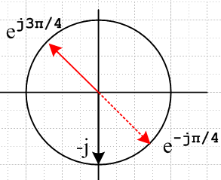 Fig 2.3
and we specify the upper red arrow as the square root in the definition of β,

β ≡ ej3π/4 $\sqrt{ωμσ}$ . // β = (j - 1) $\sqrt{ωμσ/2}$ (2.2.12)

We could have started out with (2.2.11) and skipped all the above analysis of loops, but this method of using loops emphasizes the action of Maxwell's equations and seems instructive.

Comment: One could of course take the other square root of -j and develop things that way. Historically the root selected above has been used. Taking the other root means β → -β. A review of the solutions obtained below shows that they are invariant under β → -β. Such a review can use the facts that J0(-z) = J0(z), and J1(-z) = -J1(z). In general Jν(z) is analytic at z = 0 for Reν ≥ 0 and the rules just stated follow from the series representations of J0 and J1 as shown for example in Spiegel 24.5 and 25.6. In "exterior" problems involving the Hankel functions, there is significance as to whether z = βr is in the upper or lower z-plane in terms of convergence for large r. For example, if β is in the upper half plane, then H(1)(βr) is the function that converges as r→∞ and H(2)(βr) blows up:

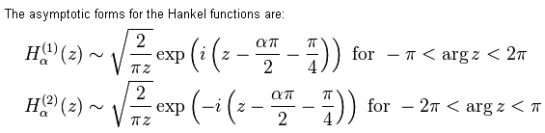 http://en.wikipedia.org/wiki/Bessel_function
The next step is to expand (2.2.10) as follows:

$\frac{∂2E(r)}{∂r2}$ + $\frac{1}{r} \frac{∂E(r)}{∂r}$ + β2 E(r) = 0
or
r2 $\frac{∂2E(r)}{∂r2}$ + r $\frac{∂E}{∂r}$ + r2β2 E(r) = 0 . (2.2.13)

Change variables to dimensionless x = βr. Then

r = x/β x = βr ∂x/∂r = ∂rx = β

∂rE = $\frac{∂E}{∂r}$= $\frac{∂E}{∂x}$ $\frac{∂x}{∂r}$ = β $\frac{∂E}{∂x}$ (2.2.14)

$\frac{∂2E}{∂r2}$ = ∂r2E = ∂r(∂rE) = ∂r(β∂xE) = β∂x(∂rE) = β∂x(β∂xE) = β2∂x2E = β2 $\frac{∂2E}{∂x2}$ . (2.2.15)

Inserting these quantities into (2.2.13) gives

r2β2 $\frac{∂2E}{∂x2}$ + r β $\frac{∂E}{∂x}$ + r2β2E = 0
or
x2 $\frac{∂2f(x)}{∂x2}$ + x $\frac{∂f(x)}{∂x}$ + x2f(x) = 0 (2.2.16)

where f(x) = E(x/β). Now (2.2.16) happens to be Bessel's Equation with ν = 0 [NIST 10.2.1], and the solution must therefore be a linear combination of this form, where C and D are constants,

f(x) = C J0(x) + DY0(x) . (2.2.17)

So far, we still don't know which way ∂E/∂r in (2.2.9) is changing, but we are about to find out. Since f(x) represents the current and the electric field, we know f(0) cannot be infinite. But Y0(x) blows up at x=0 [NIST 10.8.2] , therefore constant D = 0. We now have an exact solution for the electric field in the wire:

E(r) = f(x) = C J0(βr) (2.2.18)
where
β = ej3π/4 $\sqrt{ωμσ}$ = (j - 1) $\sqrt{ωμσ/2}$ . (2.2.19)

The following definition is usually made (factor of 2 explained later)

δ ≡ $\sqrt{2/ωμσ}$ = skin depth // ωμσ = 2/δ2 (2.2.20)

so that

β = ej3π/4 ($\sqrt{2}$/δ) and β2 = -2j/δ2 . (2.2.21)

It is convenient to divide (2.2.18) by itself evaluated at r=a which we shall assume is the radius of our round wire, so (plots coming soon),

E(r) = E(a) $\frac{J0(βr)}{J0(βa)}$ . (2.2.22)

According to (2.2.9) which says ∂rE(r) = jωB(r) we can write

B(r) = (1/jω)∂rE(r) = (1/jω) E(a) $\frac{∂r[J0(βr)]}{J0(βa)}$ = (1/jω) E(a) $\frac{βJ0'(βr)}{J0(βa)}$ = (β/jω) E(a) $\frac{J0'(βr)}{J0(βa)}$ .

Since J0'(x) = -J1(x) [ NIST 10.6.2 ] this gives,

B(r) = -(β/jω) E(a) $\frac{J1(βr)}{J0(βa)}$ (2.2.23)

which when evaluated at r = a gives

B(a) = -(β/jω) E(a) $\frac{J1(βa)}{J0(βa)}$ => E(a) = - (jω/β) $\frac{J0(βa)}{J1(βa)}$B(a) . (2.2.24)

which relates the two surface values B(a) and E(a). An alternative way to write B(r) is

B(r) = B(a) $\frac{J1(βr)}{J1(βa)}$ = {-(β/jω) E(a) $\frac{J1(βa)}{J0(βa)}$} $\frac{J1(βr)}{J1(βa)}$ = -(β/jω) E(a) $\frac{J1(βr)}{J0(βa)}$ . (2.2.25)

Ampere's law with a circular loop just below the surface gives, where I is the total wire current,

2πaHθ = I => 2πaBθ/μ = I => B(a) = $\frac{μI}{2πa}$ (2.2.26)

from which we find from (2.2.24) that

E(a) = - (jω/β) $\frac{μI}{2πa}$ $\frac{J0(βa)}{J1(βa)}$ . (2.2.27)

Using (2.2.26) for B(a) in (2.2.25) gives

B(r) = $\frac{μI}{2πa}$ $\frac{J1(βr)}{J1(βa)}$ (2.2.28)

and using (2.2.24) for E(a) in (2.2.22) gives

E(r) = E(a) $\frac{J0(βr)}{J0(βa)}$ = {- (jω/β) $\frac{μI}{2πa}$ $\frac{J0(βa)}{J1(βa)}$ } $\frac{J0(βr)}{J0(βa)}$ = - (jω/β) $\frac{μI}{2πa}$ $\frac{J0(βr)}{J1(βa)}$ . (2.2.29)

Let us gather up all the main results obtained so far and put them in a box:

Interior Field Solution of a Round Wire (2.2.30)

$\frac{∂ [ rB(r)]}{∂r}$= (μσ) [ r E(r) ] (2.2.7) $\frac{∂E(r)}{∂r}$ = jωB(r) (2.2.9)

B(r) = $\frac{μI}{2πa}$ $\frac{J1(βr)}{J1(βa)}$ (2.2.28) B(a) = $\frac{μI}{2πa}$ (2.2.26)

E(r) = $\frac{μI}{2πa}$ $\frac{J0(βr)}{J1(βa)}$ (-jω/β) (2.2.29) E(a) = $\frac{μI}{2πa}$ $\frac{J0(βa)}{J1(βa)}$ (-jω/β) (2.2.27)

J(r) = $\frac{μI}{2πa}$ $\frac{J0(βr)}{J1(βa)}$ (-jωσ/β) from J(r) = σE(r)

β = ej3π/4 ($\sqrt{2}$/δ) = ej3π/4 $\sqrt{ωμσ}$ = (j - 1) $\sqrt{ωμσ/2}$ and β2 = -2j/δ2 (2.2.19), (2.2.21)

δ ≡ $\sqrt{2/ωμσ}$ = skin depth (2.2.20)

The reader is reminded once again that E(r), B(r) and J(r) are complex functions of r and ω since they are components of the Fourier Integral Transform of the time-domain fields and current density. Since β is complex, the various Jν(βr) are also complex. Thus, the nature of the solutions in the above box is not very obvious at this point.

Comment: Appendix D (where θ is called φ) does an exact calculation of the E and B fields inside a round wire using a partial wave analysis with index m. The solution for the problem considered here in Chapter 2 corresponds to the partial wave m = 0 and is stated in summary box (D.6.1). It is shown that the Ez and Bθ fields there match those obtained here, but in addition there are extra field components which are very small in the ratio |βd/β|. The reason our calculation here failed to discover these smaller field components was that we assumed E = E(r) and B = B(r) . An implication of Er ≠ 0 is that Er(r=a) ≠ 0 which, as shown in (D.2.24), implies the existence of a surface charge on the round wire. This then fits with our context model of the round wire as the central conductor of a fat coaxial transmission line as discussed in Section 2.1.

2.3 A study of the solution of a round wire

(a) Kelvin Functions

The reader may be aware of the so-called first-kind modified Bessel function defined by

Iν(x) ≡ e-jπν/2 Jν(ejπ/2x) ,

where the Jν function argument has phase π/2. Unfortunately, our Jν(βr) functions have phase 3π/4 so the Iν functions are not particularly useful.
The real and imaginary parts of a Bessel function having an argument with phase (3/4)π have the following historic names (bessel real and bessel imaginary) called Kelvin functions [ NIST 10.61.1 ],

Jν(ej3π/4z) = berν(z) + j beiν(z) . (2.3.1)

In our application ej3π/4z = βr = ej3π/4($\sqrt{2}$/δ) r so that z = $\sqrt{2}$(r/δ). Thus, the solution E(r) in (2.2.22) may be written as,

E(r) = E(a) $\frac{ber0[\sqrt{2}(r/δ)] + j bei0[\sqrt{2}(r/δ)]}{ber0[\sqrt{2}(a/δ)] + j bei0[\sqrt{2}(a/δ)]}$ . z = $\sqrt{2}$(r/δ) (2.3.2)

The Kelvin functions are real when the arguments are real and positive. This is the case for almost all special functions (they are "real analytic"), though derived functions like Hn(1)(z) are an exception. Similar functions kerν and keiν are associated with Kν(ej3π/4z ) where Kν is the second-kind modified Bessel function. Since J(r) = σ E(r), we could replace E with J on both sides of (2.3.2). This equation for J appears in Matick as p 101 (4-18).

Note: Lord Kelvin (William Thomson) introduced the ber and bei notation for these functions while considering the same problem we are dealing with here. The functions appear in the Appendix of his 34 page 1889 inaugural address used when he became president of the Institute of Electrical Engineers (see Refs) :

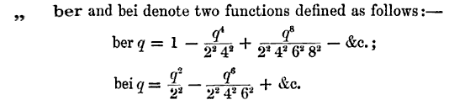

We can verify using Maple (which Kelvin would have enjoyed) that these are the ber0 and bei0 functions:

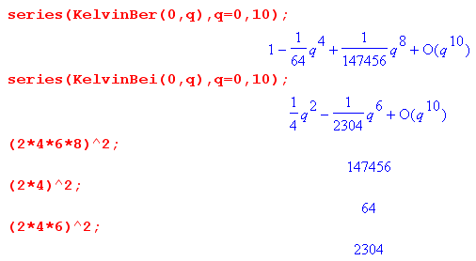

Some authors, not liking Kelvin's notation, use Ber, Bei, Ker, Kei for ber, bei, ker, kei. Perhaps the idea is that Be is more obviously Bessel and perhaps Ke is then for Kelvin.

Since these Bessel forms occur a lot, there are standard functions for their magnitude and phase [ NIST 10.68.1 ]

Jν(ej3π/4z) = Mν(z) ejθ$_{ν}$(z) . (2.3.3)

Of particular interest is the magnitude of E(r). Applying (2.3.3) to the E(r) in (2.2.22) gives

|E(r)| = |E(a)| $\frac{M0[\sqrt{2} (r/δ)]}{M0[\sqrt{2} (a/δ)]}$ . (2.3.4)

(b) Plots of |E(r)/E(a)| for various δ values

Finally we are in a position to make some plots to see how the electric field magnitude varies with radius in a round wire as a function of the skin depth parameter δ ≡ $\sqrt{2/ωμσ}$. As ω increases, δ decreases. Our aging Maple V knows about the Kelvin functions but not M, so here is the code

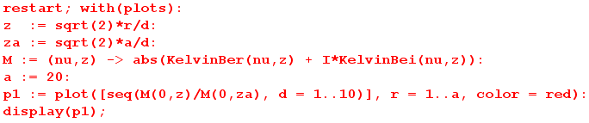

and here are plots of |E(r)| / |E(a)| for a = 20 and δ = 1 to 10, The steepest curve is for δ = 1:

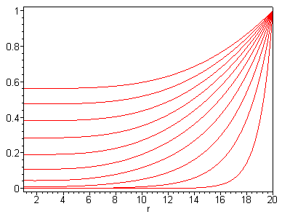 Fig 2.4

The same plots apply to |J(r)| / |J(a)|. One sees clearly how the current and electric field magnitude drop off quickly moving in from the edge of the round wire (right edge of graph) toward the wire axis when δ is small relative to radius a.

Asymptotic expansions for Mn(z) and θn(z) for large z are given by NIST 10.68.16 and 10.68.18,

Mν(z) ≈ $\frac{exp(z/\sqrt{2})}{\sqrt{2πz}}$[ 1 - $\frac{ν-1}{8\sqrt{2} z}$+ O(1/z2) ]
θν(z) ≈ (z/$\sqrt{2}$) + (π/2) [ ν - 1/4 ] + $\frac{ν-1}{8\sqrt{2} z}$ + O(1/z2) . (2.3.5)

For ν = 0 we find

M0(z) ≈ $\frac{exp(z/\sqrt{2})}{\sqrt{2πz}}$[ 1 + $\frac{1}{8\sqrt{2} z}$ ]
θ0(z) ≈ (z/$\sqrt{2}$) - (π/8) – $\frac{1}{8\sqrt{2} z}$ . (2.3.6)

For z > 3 the correction term $\frac{1}{8\sqrt{2} z}$ in M0(z) is less than .03 so we can ignore it for rough estimates. In this case one gets

|E(r)| = |E(a)|$\frac{M0[\sqrt{2} (r/ δ)]}{M0[\sqrt{2} (a/ δ)]}$ = |E(a)| $\frac{M0(z)}{M0(za)}$ z = $\sqrt{2}$(r/δ) za = $\sqrt{2}$(a/δ)

≈ |E(a)| $\sqrt{2}$$\sqrt{2}$ $\sqrt{2πza}$$\sqrt{2πz}$ = |E(a)| exp([z-za]/$\sqrt{2}$) $\sqrt{za/z}$ .

But [z-za]/$\sqrt{2}$ = (r/δ)-(a/δ) = (r-a)/δ and $\sqrt{za/z}$ = $\sqrt{a/r}$. Thus we find that

$\frac{|E(r)|}{|E(a)|}$= $\sqrt{\frac{a}{r}}$e(r-a)/δ r/δ > 3/$\sqrt{2}$= 2.1 . (2.3.7)

This is the famous skin depth result as it appears for a round wire. This ratio is 1 at the surface and then drops off exponentially with characteristic distance δ moving inside the wire. One sees now why the $\sqrt{2}$was included in the definition of δ: there is then no $\sqrt{2}$ in equation (2.3.7). Comparing (2.3.7) to the one-dimensional skin depth formula (2.1.8) one sees an extra $\sqrt{a/r}$ factor arising from the cylindrical geometry.

Equation (2.3.7) is valid down to within about 2 skin depths of the center axis of the wire. In general, one can assume the field E(r) is zero for all practical purposes perhaps 5 skin depths in from the surface (if a > 5δ). Here are plots of |E(r)|/|E(a)| using the approximate formula (2.3.7) for the same ten δ values as our previous plots,

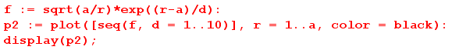
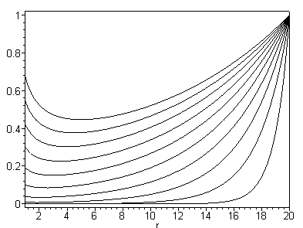 Fig 2.5
Previous plot using a certain approximation discussed above

and here are the two sets of plots superimposed with some notations added:

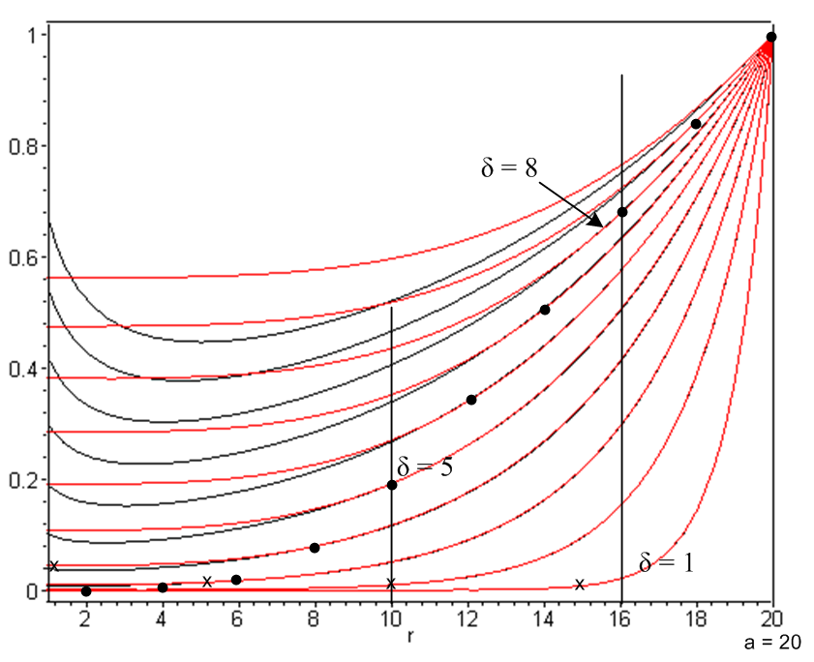 Fig 2.6

The wire radius is a = 20, and the curves are for δ = 1 to 10, with δ = 1 being the rightmost and steepest curve. The red (exact) and black (approximate) curves for δ = 1 agree down to r = 2 at least. The δ = 5 red/black pair of curves start to pull apart around r = 10 which is 2 skin depths from the center. The δ = 8 red/black pair of curves start to pull apart around r = 16. We thus verify the claim made above that each red/black pair of curves agree starting at r = a and moving in to about 2 skin depths from the center line (the pull-apart points are marked by dots). One can also see that the electric field is roughly zero about 5 skin depths in from the surface (marked by x's).

Here are some skin depth values in copper based on (2.2.20) δ = $\sqrt{2/(ωμσ)}$ with σ = 5.81 x 107mho/m, and μ = μ0 = 4π x 10-7 H/m. Selecting a reference point of 1 GHz, we have,

δ = $\sqrt{2/(2πfμ0σ)}$ = $\sqrt{1/(πfμ0σ)}$ = $\sqrt{1/f} \sqrt{1/(π 109μ0 σ)}$= 2.09 x $\sqrt{1/f(GHz)}$ μ (2.3.8)

Here then is a table of copper skin depths (μ = microns),

f δ f δ
100 GHz 0.21μ 100 KHz 209μ
10 GHz 0.66μ 10 KHz 661μ
1 GHz 2.09μ 1 KHz 0.21 cm
100MHz 6.61μ 100 Hz 0.66 cm
10 MHz 20.9μ 10 Hz 2.09 cm
1 MHz 66.1μ 1 Hz 6.61 cm (2.3.9)

The radius of the center conductor of Belden 8281 coax is 15.5 mil = 394 μ, so the skin effect restriction occurs for f ≈ 1 MHz and above. At 1 GHz δ is about 1/200th the radius.

As we get into the lower frequencies, the exponential decay no longer applies for Belden 8281. For very low frequencies, we can use the small z limit of J0(z) to see how the distortion begins at low frequency,

J0(z) = 1 - z2/4 z << 1 // Spiegel 24.5 z = $\sqrt{2}$(r/δ) .

Using the expression for E(r) and β2 in box (2.2.26) we find

$\frac{E(r)}{E(a)}$ = $\frac{1 + j (r/δ)2/2}{1 + j (a/δ)2/2} \frac{|E(r)|}{|E(a)|}$ = $\frac{1 + (r/δ)4/4}{1 +(a/δ)4/4}$ . (2.3.10)

This shows the very early phase of the skin effect happening at low frequencies. Eq. (2.3.10) would apply for example in Belden 8281 at 1 KHz and below where δ/a ≥ 5. There is a very slight dip in the E(r) and J(r) distribution at r=0 compared to r=a. For example, with a = 20 and δ = 100 one has z ≤ $\sqrt{2}$(a/δ) = $\sqrt{2}$(1/5) = .28 for all values of r, so z is "small" in the whole range. Below is a plot of |E(r)/E(a)| in this case. Notice the offset zero so the drop is only 2 parts in 10,000.

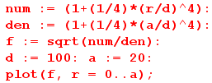

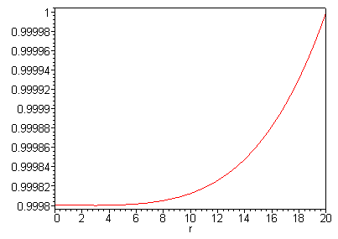 Fig 2.7
Slight dip in E(r) or J(r) moving from surface to center for a round wire
in the low frequency limit. In this case radius a = 20 and skin depth δ = 200.

(c) Review of the round wire solution

To conclude this section, we state in full notation the solution of the round wire as outlined above, using ω rather than δ as the argument of interest, where recall δ = $\sqrt{2/ωμσ}$ so z = $\sqrt{2}$(r/δ) = r $\sqrt{ωμσ}$. The following two expressions are (2.2.22) and (2.2.25) with (β/jω) = ejπ/4$\sqrt{ωμσ}$/ω as in (2.2.12):

E(r,ω) = E(a,ω) $\sqrt{ωμσ}$$\sqrt{ωμσ}$$\sqrt{ωμσ}$$\sqrt{ωμσ}$ (2.3.11)

B(r,ω) = E(a,ω) $\sqrt{ωμσ}$$\sqrt{ωμσ}$$\sqrt{ωμσ}$$\sqrt{ωμσ}$ (-ejπ/4$\frac{μσ}{ω}$) (2.3.12)

The ratio is then

$\frac{B(r,ω)}{E(r,ω)}$ = $\sqrt{ωμσ}$$\sqrt{ωμσ}$$\sqrt{ωμσ}$$\sqrt{ωμσ}$(-ejπ/4$\frac{μσ}{ω}$) . (2.3.13)

The time-domain fields are, from (2.1.1) and our assumptions (2.2.4) (d) and (e),

E(x,y,z,t) = ej(ωt-β$_{d}$z) E(r,ω)
B(x,y,z,t) = ej(ωt-β$_{d}$z) B(r,ω) (2.3.14)

so that, in terms of the complex value E(a,ω),

E(x,y,z,t) = ej(ωt-β$_{d}$z) E(a,ω) $\sqrt{ωμσ}$$\sqrt{ωμσ}$$\sqrt{ωμσ}$$\sqrt{ωμσ}$
(2.3.15)
B(x,y,z,t) = - ej(ωt-β$_{d}$z) E(a,ω) ejπ/4$\frac{μσ}{ω}$ $\sqrt{ωμσ}$$\sqrt{ωμσ}$$\sqrt{ωμσ}$$\sqrt{ωμσ}$ .

In the notation of Section 1.6 (d) this can be written

E(x,y,z,t) = ej(ωt-β$_{d}$z) ejφ$_{ez}$(r,ω) E(r,ω) E(r,ω) = ejφ$_{ez}$(r,ω) E(r,ω)
B(x,y,z,t) = ej(ωt-β$_{d}$z) ejφ$_{bθ}$(r,ω) B(r,ω) B(r,ω) = ejφ$_{bθ}$(r,ω) B(r,ω) (2.3.16)

where E(r,ω) = |E(r,ω)| and B(r,ω) = |B(r,ω)| are real. As shown in (1.6.6), the physical fields could be taken as either of the following pairs

Ephys(x,y,z,t) = Re{ E(x,y,z,t) } = cos[ωt - βdz + φez(r,ω) ] E(r,ω)
Bphys(x,y,z,t) = Re{ B(x,y,z,t) } = cos[ωt - βdz + φbθ(r,ω) ] B(r,ω) (2.3.17)
or
Ephys(x,y,z,t) = Im{ E(x,y,z,t) } = sin[ωt - βdz + φez(r,ω) ] E(r,ω)
Bphys(x,y,z,t) = Im{ B(x,y,z,t) } = sin[ωt - βdz + φbθ(r,ω) ] B(r,ω) (2.3.18)

(d) Plots of the round wire solution for Belden 8281 at 5 MHz.

Here is some Maple code to generate various plots, where we arbitrarily set E0 = E(a,ω) = 1 volt/m, μ = μ0 = 4π x 10-7, σcopper = 5.81*107, ω = 2π [ 5 MHz ], and a = 394 μ -- all as appropriate for the center conductor of Belden 8281 coaxial cable. Notice that the factor

$\frac{μσ}{ω}$ = $\sqrt{4π*5.81/2π 106}$ = 10-3 $\sqrt{2*5.81}$ = 3.4 x 10-3

causes B to be small even at the surface r = a. We first set in the parameters just quoted,

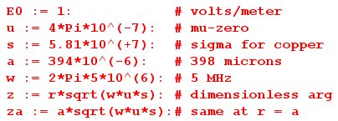

and then do the plots as follows, using (2.3.11) for E and (2.3.12) for B ( j = I in Maple)

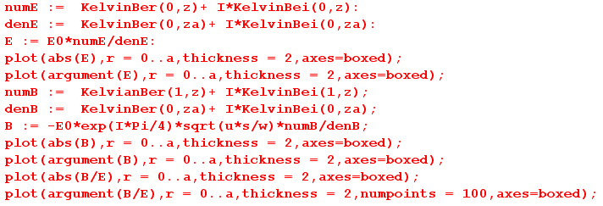

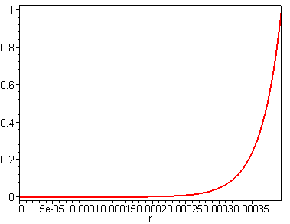 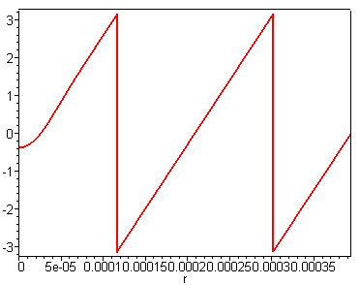 Fig 2.8
E = Magnitude of E φez = Phase of E

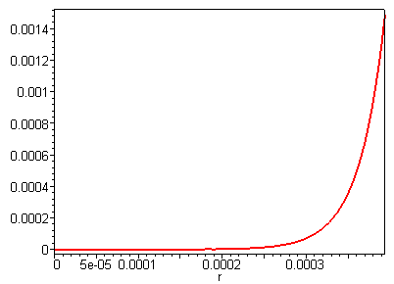 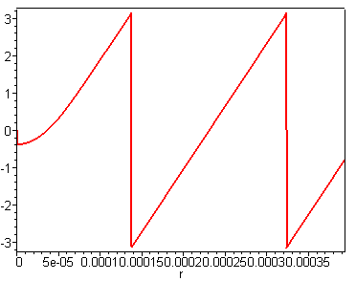 Fig 2.9

B = Magnitude of B φbθ = Phase of B

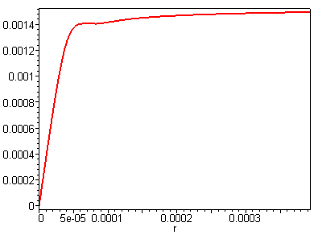 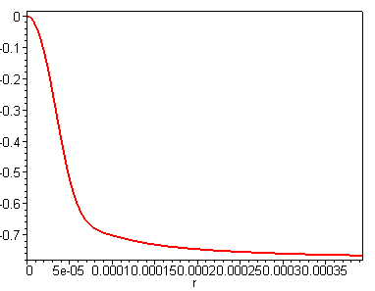 Fig 2.10
B/E = Magnitude of B/E φbθ-φez = Phase of B/E

Regarding the fast cycling of the phases of E and B, recall the discussion above (2.1.7) concerning the notion of the field being a highly damped radial wave, and below (2.1.7) where it was noted that in the 1D analog, the amplitude drops to 1/e when that radial wave has progressed a mere π/2 worth of phase. We see that happening here for both E and B.

The nature of these plots for moderate to large z = r $\sqrt{ωμσ}$ can be obtained from the large z limit of the Jν functions as noted earlier,

Jν(ej3π/4z) = Mν(z) ejθ$_{ν}$(z) . z = r $\sqrt{ωμσ}$ (2.3.3)
Mν(z) ≈ $\frac{exp(z/\sqrt{2})}{\sqrt{2πz}}$ θν(z) ≈ (z/$\sqrt{2}$) + (π/2) [ ν - 1/4 ] . (2.3.5)

Example: For the electric field in (2.3.16) we have this large z limit,

E0 $\sqrt{ωμσ}$$\sqrt{ωμσ}$ = E0 $\sqrt{ωμσ}$$\sqrt{ωμσ}$ $\sqrt{ωμσ/2}$$\sqrt{ωμσ/2}$
≈ E0 $\sqrt{2}$$\sqrt{2}$ $\sqrt{2πza}$$\sqrt{2πz}$ ej(r-a)$\sqrt{ωμσ/2}$
≈ E0 exp[- (a-r) $\sqrt{ωμσ/2}$] $\frac{a}{r}$ e-j(a-r)$\sqrt{ωμσ/2}$
≈ E0 exp[- (a-r)/δ] $\frac{a}{r}$ e-j(a-r)/δ δ ≡ $\sqrt{2/(ωμσ)}$

which shows both the exponential decay in magnitude and the phase linear in r,

φez(r,ω) ≈ -(a-r)/δ .

Again, this is reminiscent of the 1D skin depth solution shown in (2.1.8).

E(x,ω) = E(0,ω) e-x/δ e-jx/δ . (2.1.8)

2.4 The Surface Impedance Zs(ω) of a Round Wire

A piece of round wire can be thought of as a resistor. Consider Fig. 2.11:

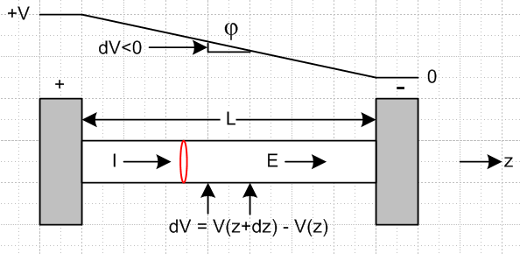 Fig 2.11
Here a piece of finite-σ wire is attached to a pair of σ = ∞ contacts. The total impedance of the wire is then determined by Z = V/I ohms where V is the voltage applied to the contacts and I is the total current through the wire.
Alternatively, one could probe the wire along its surface as shown by the two arrows separated by dz. There is some voltage dV between the probes due to the field Ez(a) ≡ E(a) at the surface of the wire. By definition, the surface impedance per unit length is

Zs ≡ (- dV/dz)/I = E(a) / I ohms/m . (2.4.1)

Since the fields and currents derived under the assumptions (2.2.4) vary only with r, Zs is independent of z and we get

V = V(0) - V(L) = - $^{\int_{0}^{L}{}}$dV = - $^{\int_{0}^{L}{}}$(dV/dz) dz = $^{\int_{0}^{L}{}}$ I Zs dz = I Zs L = I Z (2.4.2)
so
Z = Zs L . (2.4.3)

Our analysis above of course treats the infinitely long wire, so one must imagine L here as very large compared to the wire radius a, so that end effects influencing Zs can be ignored.

As one might expect, Zs plays a role in transmission line attenuation.

(a) Expressions for Surface Impedance

To compute the surface impedance of the round wire, we have to make a connection to the total current I in the wire. This time, our "loop" is a circular ring lying just below the wire surface as shown in red in Fig 2.8. Apply (2.2.1) to this loop (with ε = 0) to get:

2πaB(a) = μI . (2.4.4)

Thus, from the Zs definition (2.4.1),

Zs = E(a)/I = E(a) μ/[2πaB(a)] = (μ/2πa) E(a)/B(a) . (2.4.5)

Recalling from (2.2.24) that

E(a) = - (jω/β) $\frac{J0(βa)}{J1(βa)}$B(a) . (2.2.24)

we find that

Zs = Zs(ω) = - (μ/2πa) (jω/β) $\frac{J0(βa)}{J1(βa)}$
or
Zs(ω) = $\frac{-jωμ}{2πaβ}$ $\frac{J0(βa)}{J1(βa)}$ (2.4.6)

where β = ($\sqrt{2}$/δ) ej3π/4 and δ ≡ $\sqrt{2/ωμσ}$ as in box (2.2.30). Using these last two facts and the fact that ej3π/4 is a square root of -j, the leading factor may be written

$\frac{-jωμ}{2πaβ}$ = $\sqrt{2}$ = $\sqrt{2}$

giving this alternate form for (2.4.6) in which ω does not explicitly appear,

Zs(ω) = $\sqrt{2}$ $\frac{J0(βa)}{J1(βa)}$ β = ($\sqrt{2}$/δ) ej3π/4 . (2.4.7)

Below we shall use form (2.4.7) to plot Zs(ω) as a function of skin depth δ.
Equation (2.4.7) is, as expected, rather complex. In terms of the Kelvin functions defined in (2.3.1) we may write (2.4.6) as

Zs(ω) = $\sqrt{2}$ $\frac{ber0[\sqrt{2}(a/δ)] + j bei0[\sqrt{2}(a/δ)]}{ber1[\sqrt{2}(a/δ)] + j bei1[\sqrt{2}(a/δ)]}$ . (2.4.8)

According to (2.3.1) one finds, with α ≡ ej3π/4, that

berν'(z) + j beiν'(z) = $\frac{dJν(αz)}{dz}$ = $\frac{dJν(αz)}{d(αz)}$ $\frac{d(αz)}{dz}$ = αJν'(αz) = ej3π/4 Jν'(ej3π/4z) . (2.4.9)

Then since J0'(x) = -J1(x) one gets

ber0'(z) + j bei0'(z) = ej3π/4J0'(ej3π/4z) = - ej3π/4 J1(ej3π/4z)

= - ej3π/4 [ber1(z) + j bei1(z)] . (2.4.10)

Then (2.4.8) may be rewritten as

Zs(ω) = $\sqrt{2}$ $\frac{ber0[\sqrt{2}(a/δ)] + j bei0[\sqrt{2}(a/δ)]}{ber0'[\sqrt{2}(a/δ)] + j bei0'[\sqrt{2}(a/δ)]}$ (2.4.11)

and this form for Zs(ω) appears in Matick p 104 (4-28).

(b) Low frequency limit of Zs(ω)

Small ω => large δ => small β, so we expand both Bessel functions of (2.4.7) for small argument:
[ Spiegel 24.5 and 24.6 ]

J0(x) ≈ 1 - x2/4

J1(x) ≈ (x/2)(1 - x2/8) ⇒ 1/J1(x) ≈ (2/x) (1 + x2/8)

=> J0(x)/J1(x) ≈ (2/x) (1 + x2/8) (1 - x2/4) ≈ (2/x)(1-x2/8) = 2/x - x/4

=> J0(βa)/J1(βa) ≈ 2/(βa) - (βa)/4 .

Then from (2.4.6)

Zs(ω) = $\frac{-jωμ}{2πaβ}$ $\frac{J0(βa)}{J1(βa)}$ ≈ $\frac{-jωμ}{2πaβ}$ [2/(βa) - (βa)/4 ] = $\frac{-jωμ}{πa2β2}$ + $\frac{jωμ}{8π}$
= $\frac{-jωμ}{πa2[-jωμσ]}$ + $\frac{jωμ}{8π}$ // β2 from (2.2.3)
or
Zs(ω) = $\frac{1}{σπa2}$ + jω $\frac{μ}{8π}$ = Rs + jωLs // low frequency limit (2.4.12)

The first term is the uniform DC resistance of the wire per unit length, normally written ρ/A as in (C.2.3) of Appendix C. The second term is jω times the DC internal inductance Li = (μ/8π) H/m, as derived in (C.3.10). Recall that this is exactly 50 nH/m if μ=μ0, quite small, and independent of radius.

(c) High frequency limit of Zs(ω)

We first use (2.3.3) to write (2.4.6) as

Zs(ω) = (-jωμ/2πaβ) [ M0($\sqrt{2}$a/δ) / M1($\sqrt{2}$a/δ) ] exp[ j{θ0($\sqrt{2}$a/δ) - θ1($\sqrt{2}$a/δ)}] . (2.4.13)

Since large ω ⇒ small δ ⇒ large arguments for the functions in (2.4.13), we use these large z limits which can easily be obtained from (2.3.5) using ν = 0 and 1,

M0(z) / M1(z) = [ 1 + $\frac{1}{8\sqrt{2} z}$+ O(1/z2) ]
θ0(z) - θ1(z) = - [ (π/2) + $\frac{1}{8\sqrt{2} z}$+ O(1/z2) ] . (2.4.14)

Insertion of these large-argument expressions into (2.4.13) with z = $\sqrt{2}$δ/a gives

Zs(ω) = (-jωμ/2πaβ) (1 + $\sqrt{2}$ ) exp(-j [π/2 + $\sqrt{2}$ ])

= (-jωμ/2πaβ) [ 1 + δ/(16a) ] exp(-j [π/2 + δ/(16a) ])

= $\sqrt{2}$ [ 1 + δ/(16a) ] e-jπ/2 e-jδ/(16a) . // -j = e-jπ/2

The phasor factors combine to give

e-jπ/2 e-j3π/4 e-jπ/2 = e-jπ[1+3/4] = e-jπ[2-1/4] = e-jπ2 ejπ/4 = ejπ/4 = (1+j)/$\sqrt{2}$

and then

Zs(ω) = $\frac{ωμ}{4π(a/δ)}$ (1+j) [ 1 + δ/(16a) ] e-jδ/(16a) . (2.4.15)

Then if δ << 16a the last two factors are unity and we have

Zs(ω) ≈ $\frac{ωμ}{4π(a/δ)}$(1+j) = $\frac{ωμδ2}{4πaδ}$(1+j) = $\frac{ωμ[2/ωμσ]}{4πaδ}$(1+j) // using δ2 = 2/ωμσ from (2.2.20)

≈ $\frac{1}{σ(2πa)δ}$ (1+j) δ << 16a . (2.4.16)

Writing this as the sum of a resistive and inductive part,

Zs(ω) = Rs(ω) + jω Ls(ω) (2.4.17)

we find

Rs(ω) = $\frac{1}{σ(2πa)δ}$ = ω Ls(ω) = XLs(ω) . (2.4.18)

The inductance can be written several ways,

Ls(ω) = $\frac{1}{ωσ(2πa)δ}$ = $\sqrt{2/ωμσ}$ = $\frac{1}{2πa} \sqrt{\frac{μ}{2σω}}$ . (2.4.19)

The resistance has a simple interpretation. It is R = 1/(σA) where area A = (2πa)δ . This is the area of a thin washer at the periphery of the wire of thickness δ.
The inductance is harder to understand. Its origin can be traced back to (2.4.5) above which shows that the phase of Zs is equal to the phase of the ratio E(a)/B(a). It is a result of Maxwell's curl equations that the phase of this ratio as seen in (2.4.16) is π/4 at the surface of a conductor in the skin effect limit. The inductive reactance is the same as the resistance, but the inductance itself increases as frequency decreases, behaving as L ~ 1/$\sqrt{ω}$ as shown.
Quantity Rs(ω) in (2.4.18) is called Rhf by Matick p 105 in his (4-35), and (2.4.16) appears as (4-36).

(d) Plots of Zs(ω) versus skin depth δ

From (2.4.7) we found that

Zs(ω) = $\sqrt{2}$ $\frac{J0(βa)}{J1(βa)}$ β = ($\sqrt{2}$/δ) ej3π/4 δ ≡ $\sqrt{2/ωμσ}$ . (2.4.7)

This is in SI units, but we will use a = [a(μ)10-6] m and δ = [δ(μ) 10-6] m and σ = 5.81 x 107mho/m for copper, where a(μ) and δ(μ) means the wire radius and skin depth in microns. Then:

Zs(ω) = $\sqrt{2}$ $\frac{J0(βa)}{J1(βa)}$ ohms/m N = 1012

The two limits obtained above were :

Zs(ω) ≈ $\frac{1}{σπa2}$ + jω $\frac{μ}{8π}$ = $\frac{1}{σπa2}$ + j $\frac{1}{4πσδ2}$ small ω, large δ (2.4.12)
Real part goes to a constant, imaginary part decays as 1/δ2

Zs(ω) ≈ $\frac{1}{σ(2πa)δ}$ (1+j) = $\frac{1}{σ(2πa)δ}$ + j $\frac{1}{σ(2πa)δ}$ large ω, small δ (2.4.16)
Real and Imaginary part are the same and blow up as 1/δ

In our units above, the low frequency constant limit is RLF ≡ $\frac{1}{σπa2}$ = $\frac{N}{σπa(μ)2}$ .

Example: For a = 1000μ, the DC resistance is RLF = 1/(σπa2) = .00548 Ω/m. Since a = 1000/25.4 = 39.37 mils, 2a = 78.74 mils. From the following British units graphic, 12 gauge house wire has 2a = 80.808 mils and has R =.001588 Ω/ft which is .005210 Ω/m )

Here is Maple code which plots the real (red) and imaginary (black) part of ln Zs(ω) as a function of δ, and also computes the constant limit (gray) just mentioned. The copper wire radius is set to a=1000 μ.

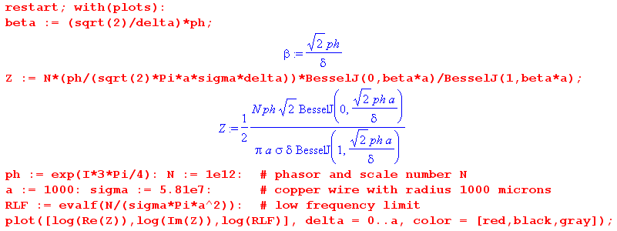

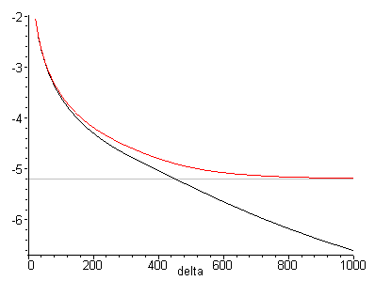 Fig 2.12
Plot of surface impedance ln Zs as function of skin depth δ ≈ 40 to 1000 μ
for a copper wire of radius 1000 μ. Red is real part, black is imaginary.

The general idea is that surface impedance goes up as δ goes down (left end of graph).

Here is the same plot for δ = 100 to 1000 without the natural logs (ln = "log" in Maple) :

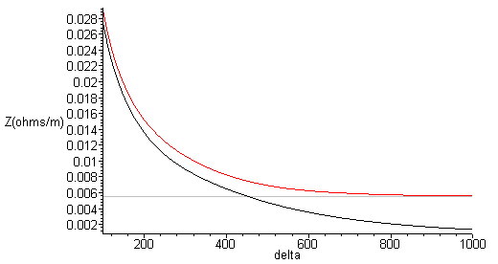 Fig 2.13
Plot of surface impedance Zs as function of skin depth δ = 100 to 1000 μ
for a copper wire of radius 1000 μ. Red is real part, black is imaginary.

Either plot type realizes the two limits discussed above.
For the limited range δ = 1 to 10 μ the above plot has this appearance ( the red and black curves are superposed and the gray constant line at .0055Ω/m is indistinguishable from the x axis) :

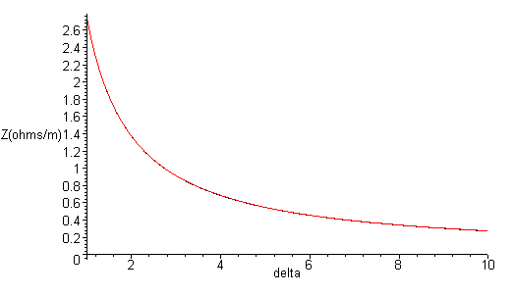Fig 2.14
Plot of surface impedance Zs as function of skin depth δ = 1 to 10 μ
for a copper wire of radius 1000 μ. Red is real part, black is imaginary.

The resistance of our near-12-gauge house wire at δ = 1 micron (4.37 GHz) is about 2.7 Ω/m, which is about 500 times larger than the DC resistance.

2.5 Surface Impedance for a Transmission Line

What is the surface impedance of an arbitrary conductor? As we have seen, a significant amount of work was needed to obtain the exact result even for the simple geometry of a round wire with a symmetric current distribution. One can repeat this calculation for other geometries such as a stripline. The general nature of the result is always the same when δ is much smaller than the depth of the conductor. That result is this (with comparison)

Zs(ω) ≈ $\frac{1}{σDδ} (1 + j)$ // general case (2.5.1)
Zs(ω) ≈ $\frac{1}{σ(2πa)δ}$ (1+j) δ << 16a . // round wire (2.4.16)

where D is the effective distance around the cross-sectional surface of a conductor where significant current flows. For the round wire this was D = 2πa, the circumference. For a thick stripline of width w, D = w. Consider these two possible transmission line cross sections:

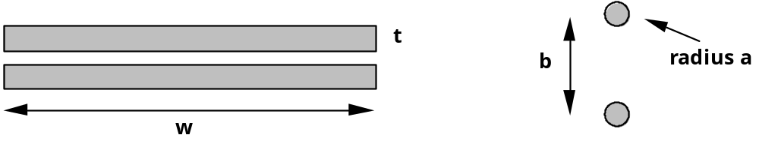
Fig 2.15

Cross section of a stripline Cross section of a twin-lead

In both cases we assume a frequency ω such that skin depth δ is small compared to the thickness of the conductors. Although the total cross sectional perimeter of one of the stripline strips is 2w + 2t, it seems clear that the length of the "active surface" is only w, and one sets D = w in the surface impedance formula. For the twin lead case with leads assumed far apart (b >> a), both conductors are immersed in roughly uniform active fields, so the full D = 2πa is applicable.
As the two round wires are brought very close together, certainly there will develop an asymmetry so that the currents are largest on the parts of the wires closest to the other wire. In this case, one must make an estimate of the "effective distance" D . Here is a picture,

Fat twinlead Fig 2.16

where we have indicated a crude graphical estimate of the "active region" of current flow.
King [p 30 Eq (45)] quotes an approximate surface impedance result for the case of Figure 2.16. The effective distance is,

D = 2π a $\sqrt{1 - (2a/b)2}$ . a = wire radius, b = center line separation (2.5.2)

If the gap between the conductors is a/6, a rough estimate for Fig 2.16, then the radical in this formula becomes .38, so the dark lines shown should cover 38% of the circumference. If the conductors almost touch, then D becomes extremely small.
King makes the interesting remark (p 30) that "accurate formulas for the internal (i.e., surface) impedance of one cylindrical conductor in the presence of another with different radius are not available."
From the potential results of Chapter 6 below one can obtain the surface charge density in terms of ∂nφ on such cylindrical conductors and thus the charge partial wave moments ηm used in Appendix D. From these one could find Ez at the conductor surfaces using (D.4.9) and that would seem to determine Zs.
In general, the high frequency skin current will be large where the E and B fields are large. These fields are large where the electric field would be large in a capacitor whose "plates" are the two conductors in cross section. Recall that such a 2D capacitor problem seeks potential φ as a solution of the equation ∇22Dφ(x,y) = 0. In regions where φ is very large, E = -∇φ will also be large. This subject is addressed in Chapter 5 below.
There is an interesting transmission line "paradigm shift" which occurs as one moves from the low frequency domain to that of high frequency. For small ω, one thinks of the currents in the two conductors of a transmission line as being there because they are "applied" by some external agency. The current then creates a B field around each wire which, since it is changing, creates an E field.
In the high frequency skin-effect limit, it is easier to think of the currents in the conductor surfaces as being generated by the field activity near the surfaces. The E and B fields just outside the conductors force themselves slightly into the surface. The resulting E field in the surface layer is then what creates the current.
Matick's Chapter 4 computes the surface impedance for the round wire and for some strip line conductors.

Chapter 3: Transmission Line Preliminaries

3.1 Why is there no free charge inside a conductor or a dielectric?

Imagine that at time t = 0 there were some free charge ρ inside a medium having conductivity σ. What would this free charge do? Intuition suggests that the individual charges in the little charge cloud would repel each other and the cloud would spread out until it encountered boundaries. In this Section we put that intuition on a more technical footing.

As discussed in Appendix E, for a non-neutral medium, Ohm's Law takes the form

J = σE - D grad ρ (3.1.1)

where J is conduction current and the second term, associated with Fick's Law, is non-zero when the free charge density ρ is non-zero. This second term is a diffusion term, D is the (electron) diffusion constant for the medium at hand, and the diffusion current flows from a region of high charge density to one of lower density, hence the minus sign. Taking the divergence of the above equation, one finds

div J = σ div E - D ∇2 ρ
or
-∂tρ = σ ρ/ε - D ∇2 ρ // using (1.1.25) for div J, and (1.1.3) with (1.1.6) for div E
or
∂tρ - D ∇2 ρ + (σ/ε)ρ = 0 (3.1.2)
or
∂tρ - a∇2ρ - bρ = 0 a = D, b = - (σ/ε) . (3.1.3)

Now let ρ' = ρ e-bt be an "adjusted" charge density. Then, since ρ = ρ'ebt, (3.1.3) becomes

[(∂tρ')ebt + ρ'bebt] - a ebt∇2ρ' - bebtρ' = 0
or
∂tρ' - a∇2ρ' = 0 (3.1.4)

which is the standard heat/diffusion equation. If one starts at t = 0 with a point charge ρ' = q δ(r) at the origin, and if one assumes an infinite isotropic medium, one finds that at time t the charge density is given by

ρ'(r,t) = q exp(-r2/4at) / (4πat)3/2 . t ≥ 0 (3.1.5)

This is the 3D causal free-space propagator (Green function) for the heat equation. It is the solution of

(∂t - a ∇2) ρ'(r,t) = δ(r)δ(t) ρ'(r,t) = 0 for t<0 . (3.1.6)

See Stakgold (5.133) and (5.136). In n spatial dimensions, the propagator is as in (3.1.5) with 3/2 → n/2 and is derived in the text leading up to Stakgold (5.140).
Therefore, if we consider (3.1.3) for charge density ρ

(∂t - a∇2 - b)ρ(r,t) = δ(r)δ(t) (3.1.7)

replacing ρ = ρ'ebt gives

∂tρ' - a∇2ρ' = δ(r)δ(t)e-bt = δ(r)δ(t)

which is the same as (3.1.6). Therefore, the solution of (3.1.7) is

ρ(r,t) = ρ'ebt = q ebtexp(-r2/4at) / (4πat)3/2 ρ(r,0) = q δ(r)
or
ρ(r,t) = q e-(σ/ε)texp(-r2/4Dt) / (4πDt)3/2 ρ(r,0) = q δ(r) . (3.1.8)

The first factor e-(σ/ε)t says that ρ(r,t) decays exponentially in time in a uniform manner over space, while the second term says that the rough radius of the diffusing charge cloud is given by r = $\sqrt{4at}$.
The main point of all this math is the following: if there is any free charge in a medium, it goes away in a timely manner. In our idealized analysis above, it runs off to r = ∞, but in a finite medium it runs off to the boundary surface of the medium and becomes surface charge.

Let's now look at two extreme cases.

For a good conductor with a low diffusion rate, equation (3.1.2) becomes

∂tρ + (σ/ε)ρ = 0 (3.1.9)

which has the obvious solution ρ(r,t) = ρ(r,0) e-(σ/ε)t which replicates the first factor of (3.1.8). The charge just "flows away" due to the large σ.

For a dielectric with a very small conductivity, equation (3.1.2) instead becomes

D∇2ρ - ∂tρ = 0 (3.1.10)

which is just the heat equation whose impulse response solution is (3.1.8) with σ = 0, as was shown in (3.1.5). In this case, the charge at least has time to diffuse out before it goes away!

There are then two time constants involved. The first is for the e-(σ/ε)t factor where τ = ε/σ. We can estimate this time constant for a conductor and dielectric using ε ≈ ε0, and

copper σ = 5.81 x 107 mho/m
ε0 = 8.8541877 x 10-12 farad/m (from 1.1.28)

τ = ε/σ ≈ 10-11 / 108 ≈ 10-18 sec (3.1.11)

so in copper, free charge runs off to the surface in one thousandth of a femtosecond, so we don't worry about the diffusion time constant.

For a dielectric with σ = 10-15 mho/m we get τ larger by 1023 which is then 105 seconds or about a day. But in this case, the diffusion mechanism wins out. As an example, for pure silicon, D ≈ 40 cm2/sec = 4x10-3 m2/sec. The time to diffuse from a delta function out to say r = 1 mm is given by

r = $\sqrt{4Dt}$ = t = r2/(4D) = (10-3m)2 / (4*10-3 m2/sec) = (1/4) x 10-3 sec (3.1.12)

so in this case the charge is pretty much gone in a quarter of a millisecond.

We arrive then at this fact:

Fact 1: In a transmission line, charge exists only on the surface of conductors. (3.1.13)

Comment: If one wants an initial charge distribution ρ'(r,0) to be something other than a delta function, one may use this solution to the heat equation (3.1.4),

ρ'(r,t) = [2r$\sqrt{πat}$]-1 $^{\int_{0}^{∞}{}}$r'dr' ρ'(r',0) { exp[-(r-r')2/4at] - exp[-(r+r')2/4at] } (3.1.14)

which appears in Polyanin 1.2.3-10. Setting ρ'(r',0) = q δ(r') = q δ(r')/(4πr'2) then replicates the earlier result (3.1.5), after using L'Hpital's Rule on the integrand. The reason δ(r) = δ(r)/4πr2 is that it makes ∫dV δ(r) = 1 when integrated over a sphere of any radius.

3.2 How thick is the surface charge layer on a conductor?

This is a fascinating subject and the interested reader will find an analysis in Appendix E from which we now quote. Since there is no free charge in the dielectric outside the conductor, and since electrons at normal temperatures cannot jump off the conductor due to its so-called work function, the surface charge is actually a layer just below the nominal surface of the conductor, but can essentially be regarded as being right at the surface. The situation is much different when a conductor is immersed in a solution of charge-carrying ions or molecules.

It turns out that the charge density decays exponentially away from the surface into the conductor and drops to 1/e of its surface value at a distance called the Debye length. For copper, this distance is roughly 0.6A (Angstroms), which is 6 x 10-11 m. The crystal spacing for copper is 3.6A, and the copper atom radius is about 1.3A. Thus,

Fact 2: The thickness of the surface charge density on the surface of a conductor is incredibly small. For copper, it is less than the radius of one copper atom, and the general result applies to any metal. (3.2.1)

Table (2.3.9) shows that the skin depth δ for copper at 100 GHz is about 0.2 microns which is
2x10-7 m ≈ 2000A. Even at this huge frequency, the skin depth is still about 4000 times larger than the thickness of the surface charge layer. At 1 GHz this ratio is 40,000.

Fact 3: Whereas current can exist "deep" under the surface of a conductor, even when the skin effect is dominant, the surface charge can always be thought of as being exactly at the surface. (3.2.2)

3.3 How does loss tangent affect dielectric conductivity?

The total current in a dielectric may be written, as noted in (2.2.1),

Jtot = jωεE + σE . (3.3.1)

The first term is the displacement current and the second term is the conduction current. At high frequencies (say 1 GHz), the dielectric constant ε acquires a small imaginary part due to the presence of absorption resonances in the medium at infrared frequencies. One can write,

ε = ε' - jε" = ε' [ 1 - j (ε"/ε') ] = ε' [1 - j tanL] , tanL ≡ (ε"/ε') . (3.3.2)

If one plots ε in the complex plane, tanL (called the loss tangent, aka tanδ) is the tangent of the small angle θL of the triangle whose perpendicular sides have length ε' and ε" where ε" is normally very small. That is to say, the loss tangent is (minus) the ratio of the small imaginary part to the dominant real part of ε. tanL is commonly referred to as the dissipation factor. When this expression is inserted into (3.3.1) the result is,

Jtot = jωε E + σE = jωε' [1 - j tanL]E + σE

= jωε' E + ( σ + ωε' tanL) E

= jωε' E + σeff E . (3.3.3)

In effect, the dielectric has now acquired an effective conductivity,

σeff = ( σ + ωε' tanL) . (3.3.4)

Because the DC conductivity of a good dielectric is so small, the loss tangent contribution to σeff dominates even at quite low frequencies. For polyethylene we can use these ballpark numbers,

σ ≈ 10-15 mho/m ε' ≈ 2.3 tanL ≈ 2 x 10-4 (3.3.5)

taken from the following 2008 studies of Low and High Density Polyethylene done by Eaton and Kmiec,

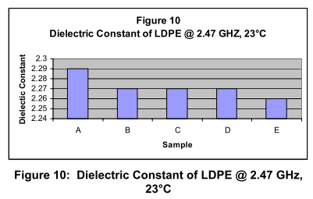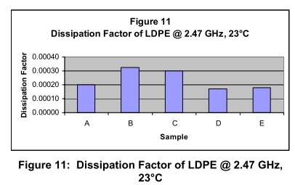
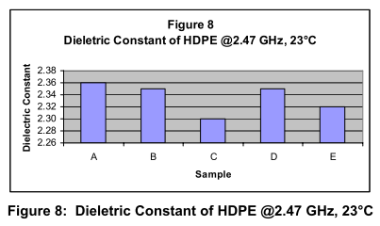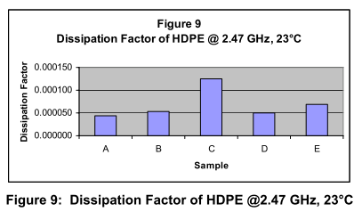

and for conductivity, Fig 3.1
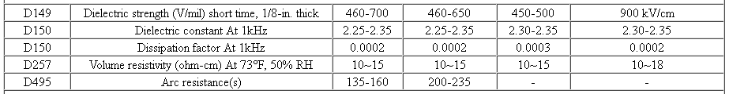
http://www.sdplastics.com/polyeth.html San Diego Plastics, Inc.

Note: This table claims ρ = 1015 ohm-cm = 1013 ohm-m, but most other sources give larger values. We assume ρ ~ 1017 ohm-cm = 1015 ohm-m and therefore σ ~ 10-15 mho/m. It does not matter much!

Even at 1 Hz, the loss tangent contribution dominates in (3.3.4). Using the above figure for tanL, here are a few values of σeff versus frequency: (f = .0 is really 100 = 1 Hz)

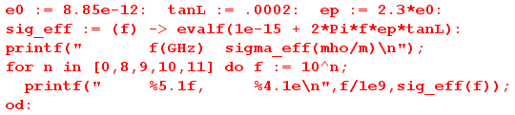
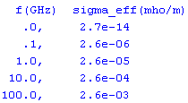 // = 2.6 x 10-3 (3.3.6)

Thus, in a transmission line, although the nominal DC dielectric conductance might be 10-15 mho/m, at operating frequencies the effective σ is much larger, being for example 2.6 x 10-5 mho/m in polyethylene at 1 GHz. However, even if we replace σ by the much larger σeff in the complex dielectric constant ξ,

ξ = ε' + σeff/jω = ε' + [σ + ωε' tanL]/jω ≈ ε' + [ωε' tanL]/jω

= ε' [1 +tanL/j] ≈ ε' ≈ ε (3.3.7)

we still find for a material like polyethylene that

ξ ≈ ε (3.3.8)

at least to 2.5 GHz. It is not hard to write an expression for tanL as a function of frequency since it involves the real and imaginary parts of the dielectric constant ε(ω) which has infrared resonances dependent on the medium. Since RF frequencies up to perhaps 10 GHz are much less than infrared frequencies, although tanL does increase somewhat with ω in this range, one still has tanL << 1. Advanced dielectrics typically have tanL in the range .002 or less at 10 GHz.

3.4 Size of E fields in conductor and dielectric; conservation of total current at a boundary

We know from (1.1.48) that the following E field condition applies at a boundary between two media, where n refers to the normal component,

ξ1En1 = ξ2En2 // frequency domain (1.1.28)
or
(ε1 + σ1/jω) En1 = (ε2 + σ2/jω) En2 . (3.4.1)

Let 1 = dielectric and 2 = conductor. From (3.3.8) we set ξ1 ≈ ε1 (at least for f < 10GHz), and from (2.2.3) we set ξ2 ≈ σ2 /jω for f << 109 GHz (for polyethylene and copper), so (3.4.1) then reads

ε1 En1 ≈ (σ2/jω) En2 => ratio = $\frac{En1}{En2}$ ≈ $\frac{σ2}{ωε1}$ . (3.4.2)

We can look at some typical numbers,

ε1 = 2.3 ε0 (polyethylene) (3.4.3)
σ2 = 5.81 x 107 mho/m (copper)
ε0 = 8.85 x 10-12 farad/m
so
$\frac{σ2}{ωε1}$ = $\frac{5.81 x 107}{2πf 2.3 8.85 x 10-12}$ ≈ (1/2)1018/f ≈ 109/[2f(GHz)] (3.4.4)

At a high frequency of f ≈ 500GHz the ratio in (3.4.2) is ~ 106, and at lower frequencies the ratio only increases. Thus, we arrive at these useful facts:

Fact 1: The total current in a dielectric is dominated by displacement current, while that in a conductor is dominated by conduction current. (3.4.5)

Fact 2: At a boundary between a good dielectric and a good conductor, the normal E field is at least 1 million times larger in the dielectric than it is in the conductor for frequencies under 500 GHz. (3.4.6)

Fact 3: This large jump in En at the boundary must be supported by a significant surface charge density n on the boundary since, according to (1.1.47), n = ε1En1 - ε2En2 ≈ ε1En1. (3.4.7)

Imagine now a tiny patch of area (bordered in red) on the surface between a conductor and a dielectric,

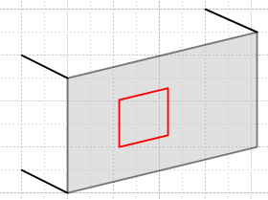 Fig 3.2

Defining a total current Jtot,n ≡ jωεEn + σEn, as in (2.2.1), we have shown that this total current flows right through the area patch but changes its nature from mostly conduction current on one side to mostly displacement current on the other side. In the next section, we identify the normal direction with the local radial direction. Then the total current passing through a tiny square patch like that in Fig 3.2 can be regarded as being "fed" by the radial current Jr just inside the conductor where Jr = σEr .

3.5 The TEM mode fields and currents for an ideal transmission line

In this and the next section, we take a crude qualitative look and the various E,B and J components first for an ideal transmission line, then for a practical one. An example is repeatedly used in which the conductor of interest is the round center conductor (radius a = 1 mm) of a properly terminated 75 Ω coaxial cable driven by 7.5 volts, and thus having a current of 100 mA. The two tables obtained (one ideal, one practical) mainly serve as an exercise in applying the various concepts reviewed in previous sections.

By "ideal" we mean that the conductors have near infinite conductivity and the dielectric has zero conductivity. Consider a cross sectional view of one conductor of a transmission line having arbitrarily shaped conductors (the shape is uniform in the z direction). At some point on the surface, define a local coordinate system where

r = radial direction = the normal outward from the surface (local x)
φ = azimuthal direction = tangential to the surface in the cross section plane (local y)
z = tangential to the surface along the transmission line (local and global z)

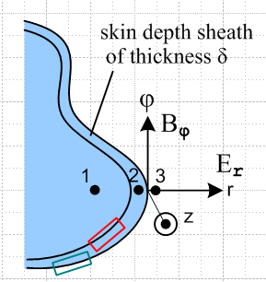 Fig 3.3

The following table shows the qualitative sizes of various components of E,B and J (conduction current) near the surface of a transmission line conductor. Several regions of space are of interest:

1. Deep in the conductor, under the surface charge layer and under any current layer.
2. In the conductor, just under the surface charge layer, and in the skin current layer.
3. In the dielectric, just outside the super-thin surface charge layer.

The reader is warned that the rest of this section and Section 3.6 make very tedious reading because an argument must be made for the general size of every single item in the two large Tables. The reader might consider just perusing the two Tables and then skipping to Section 3.7.

First is the Table for the ideal transmission line conductor (comments follow):

Table 1: E,B,J for an ideal transmission line

Region 1. Deep in the conductor, under the surface charge layer and under any current layer.

Er = 0 Br = 0 Jr = 0
Eφ = 0 Bφ = 0 Jφ = 0
Ez = 0 Bz = 0 Jz = 0

Region 2. In the conductor, just under the surface charge layer, and in the current layer.

Er = small Br = 0 Jr = small
Eφ = 0 Bφ = large Jφ = 0
Ez = small Bz = small Jz = very large

Region 3. In the dielectric, just outside the super-thin surface charge layer (explanations below):

Er = large Br = 0 Jr = 0
Eφ = 0 Bφ = large Jφ = 0
Ez = small Bz = small Jz = 0 (3.5.1)

Region 1: (the interior) In the interior we know that E must satisfy the Helmholtz equation (2.1.6a). Due to the powerful exponential effect of this equation (see (2.1.8) and (2.3.7) for the round wire), we know that E fields cannot exist deep inside the conductor, and can exist only in the skin depth region. Maxwell (1.1.2) says curl E = -jωB in the ω domain, so if E = 0 in the interior, so also is B. A "perfect conductor" has σ = extremely large, and δ = extremely small since δ = $\sqrt{2/μσω}$ . Thus, conductor E and B fields can only exist very close to the surface. In region 1 of the above table, we show all fields as being 0 underneath the very thin current sheath. Since E = 0 in the perfect conductor interior, it follows from J = σE that J = 0 there as well (region 1). Thus, all current is confined to the thin current sheath of regions 2. Everything is quiet in Region 1.

Region 2: (the current sheath) As just noted, all currents flow in a very thin sheath at the surface of thickness δ. Since the thickness is tiny, the current density Jz there is "very large" as marked in the table. Imagine a total current I flowing down the conductor, but it is restricted to flow only in the thin sheath.
In this thin layer, there is some radial pumping of charge to the surface to "feed" the surface charge which is always changing in time, so we indicate a small Jr term. As noted in Section 3.4, this same Jr is "feeding" the total current flow through the surface, and the surface converts this total current from conduction current on the inside to displacement current on the outside. An argument will given below for why Jr is small compared with Jz and we duly mark Jr as "small" in region 2.
Application of Ampere's Law (1.1.37) to the small red loop in Fig 3.3 (Bφ = 0 on the left long edge) shows that the large Jz sheath current creates a "large" Bφ field in the sheath which grows from 0 on the sheath's inner boundary to some large value at the conductor surface. Ignoring dramatic μ differences, this Bφ then exists just outside the surface as well according to (1.1.42). We thus mark Bφ as "large" in both regions 2 and 3. If I = 100 mA and a = 1 mm for a round conductor, then Bφ = μ0I/(2πa) = 20 μT at the wire surface. (Earth field is 32 μT) . This is a large value for Bφ in our current context.
Since E = J/σ, even though Jz is very large, σ is extremely large, so we shall mark Ez as being "small". And since Jr is already marked "small", we mark Er also as "small". The small radial current Jr might create some small Bz, so we throw in a small Bz entry as well (see Region 3 below).
The remaining three entries (Br, Eφ, Jφ) in region 2 we leave at 0, though they might have some very tiny values.

Region 3: (the dielectric) Since we are now outside the surface charge layer, (1.1.47) says there is a large radial electric field Er which is supported by this charge density (Gauss's Law), so we mark Er as "large" in region 3. The tangential electric fields are continuous through the boundary according to (1.1.41). Therefore, we give Eφ and Ez the same values they had in region 2.
We already observed that Bφ continues being "large" just above the surface.
It was noted above that there is a radial pumping current Jr inside the conductor. This pumps charge onto the conductor surface, and this Jr is converted to displacement current in the dielectric as discussed above in Section 3.4 (think of a simple parallel plate capacitor where this also happens). This displacement current and Jr are relatively small currents and they create a small Bz field as we now crudely demonstrate. Consider a very tall and thin (small w) red math loop whose one edge lies parallel to the z direction between the conductors and whose top edge is very distant.

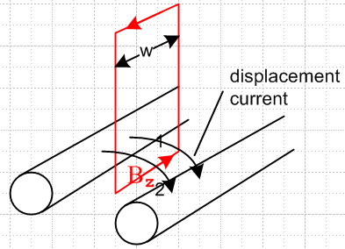 Fig 3.4

Consider Ampere's law (1.1.37) relative to this loop and with respect to the displacement current flowing through the loop between the conductors,

H • ds = ∫S ∂tD • dA . (1.1.37)

Integration of the small displacement current ∂tD passing through the loop gives some small non-zero value for the area integral on the right. Meanwhile, the line integral on the left has cancelling contributions from the vertical loop sides (w is very small), while the loop top is far away so contributes nothing. The result is some small Hz and hence small Bz in the region between the conductors. Since Bz is a tangential field, it will exist also just inside the conductor surface, as indicated by (1.1.42). Both these Bz fields are marked "small" in the table for regions 2 and 3. As a crude estimate, a loop of width w = λ/2 would capture a full I worth of displacement current, so our thin loop captures ~ I w/(λ/2). If I ~ 100 mA and λ ≈ 1 m, then Ampere's law above says (Bz/μ0)w = I w/(λ/2) so Bz ≈ μ0 I(λ/2) = 4π x 10-7(0.1)(1/2) ≈ 6.3 x 10-8 = .06 μT, which is small compared to our 20μT estimate for Bφ.
Since the dielectric has zero conductivity, the conduction current components are all set to zero.
In the dielectric, if we ignore the small Ez and Bz field components relative to the large Er and Bφ, we find that (see Fig 3.3) just outside the surface, the E and B fields are perpendicular and are both transverse to the z direction. Hence this is a TEM (Transverse Electric and Magnetic) mode of the transmission line. Their cross product is the Poynting vector (1/μ) E x B which is in the +z direction coming at the viewer in Fig 3.3. This is the direction of power flow along the transmission line. (Jackson 6.109: S = E x H in SI units)
The remaining two entries (Br, Eφ) in the region 3 we leave at 0, though they might have some very tiny values.

3.6 The TEM mode fields and currents for a practical transmission line

We now "turn on" the imperfections of the transmission line. As soon as σ in the conductor becomes large but finite, the infinitely thin current sheath spreads out over some reasonable skin depth δ. At very low frequencies, the current Jz is spread across the entire conductor and there is no Region 1. At higher ω there still is a Region 1, but we shall ignore it from now on. We are still interested in region 2 which is just below the surface charge layer. Recall from Section 3.2 that the surface charge layer remains nearly infinitely thin even for a non-perfect conductor.
So here is the new table. The superscripts refer to descriptive sections below. Other values are just carried from the previous table. In order to make ballpark magnitude estimates, we again assume that the transmission line is 75 ohms, is properly terminated, and is driven by a voltage of amplitude 7.5 volts, so the current is 100 mA.

Table 2: E,B,J for a practical transmission line

Region 2. In the conductor, just under the surface charge layer, and in the current layer.

Er = small [c] Br = 0 Jr = small
Eφ = 0 Bφ = large Jφ = 0
Ez = small [a] Bz = small Jz = large [a]

Region 3. In the dielectric, just outside the super-thin surface charge layer.

Er = large [a] Br = 0 Jr = small [b]
Eφ = 0 Bφ = large Jφ = 0
Ez = small [a] Bz = small Jz = leakage [b] (3.6.1)

[a] Ez and Jz in the conductor; Ez and Er outside the conductor

Inside the conductor, a non-zero Ez exists due to the current flow in the z direction and the finite conductivity of the conductor. As an estimate for a round wire not too close to the other conductor, assume that the wire has diameter 1 mm, and is operating at 1 GHz with a skin depth δ = 2 microns as in (2.3.9). The cross sectional area for current flow is then about 2πrδ = 4π x 10-9 m2. If 100 mA flows through this wire, then Jz = 0.1/(2πrδ) = 8 x 106 amps/m2, and this Jz is marked "large" for region 2 in the above table. Then Ez = Jz/σ = 8 x 106 / 5.81 x 107 = 0.14 volts/meter. This Ez is marked "small" in the region 2 part of the above table. At lower frequencies where skin depth is larger, Ez is less.
Since Ez is a tangential (parallel to conductor surface) E field, according to (1.1.41) it has the same value in region 3, so that is also marked "small" above.
In contrast, if the conductor separation is 0.5 cm, and if we crudely assume the E field is constant between the conductors, then Er between the conductors is 7.5 volts/ 5 x 10-3 m = 1500 volts/m. This is marked "large" in region 3 above. So in region 3 just outside the conductor,

Er ~ 1500 V/m Ez ~ 0.14 V/m ratio (Ez/ Er) ≤ 10-4 (3.6.2)

[b] Leakage: Jr, Ez and Jz in the dielectric

By "leakage" is meant conduction through the dielectric. As shown in (3.3.4), the effective conductivity in the dielectric is given by

σeff = ( σ + ωε' tanL) . (3.3.4)

For polyethylene, σ ~ 10-15 and can be ignored, while ε' ≈ 2.3 ε0 and tanL ≈ 2x10-4 as in (3.3.5). For a frequency of 1 GHZ, we then find

σeff ≈ ωε' tanL ≈ 2π 109 * [2.3 * 8.85 x 10-12] * 2 x 10-4 ≈ 2.6 x 10-5 . (3.6.3)

This is 12 orders of magnitude smaller than the σ of copper ~ 107, but it is 10 orders of magnitude larger than the DC conductivity of the dielectric ~ 10-15.
To estimate the significance of this leakage at high frequencies, we can compare the ratio of the leakage current to the displacement current in the dielectric (the currents flow through the same area so ratio is Jleak/Jdisp)

| $\frac{I(leakage)}{I(displacement)}$ | ≈ | $\frac{(σ + ωε tanL)E}{jωε E}$| ≈ tanL ≈ 2 x 10-4 . (3.6.4)

Thus, even at high frequencies, the effect of leakage on the current flowing through the dielectric is quite small compared to the displacement current. The "radial" current Jr has to support both the leakage current and the more significant displacement current, and we have just seen that the leakage part can be ignored. We carry region 3 "small" Jr from the previous table since the leakage does not alter this fact.
Finally, we already noted a small Ez just outside the conductor, and since the dielectric has some very small leakage (σeff), there will be some small Jz in region 3 which we have marked "leakage".

[c] Er and Jr inside the conductor

We have already estimated that Er inside the conductor surface is less than 10-6 what it is outside the surface, see Section 3.4 Fact 2. Thus, if Er outside is 1500 volts/m as in our section (a) example, Er inside is less than 1.5 mV/m at 500 GHz, and is proportionally less than this at lower frequencies, so Er in region 2 is marked "small". In the example above we found Ez ≈ .14 V/m inside the conductor. Thus we have Er << Ez inside the conductor which in turn means Jr << Jz . Below we shall provide more support for the idea that Jr << Jz .

3.7 The general shape of fields, charges, and currents on a transmission line

(a) Facts about field structure

Based on the information in Table 2 (3.6.1) above, we are in a position to draw the general field structure for a real transmission line. Some general rules are now apparent:

Fact 1: In a cross sectional sketch of a transmission line, the E field lines land on the conductors at right angles to the conductor surface. This is exactly true for the TEM mode, and applies to all points on the conductor surfaces. (3.7.1)

Proof: There are no transverse surface currents in the TEM mode, so Eφ = 0 exactly. Even if this were not true, we would expect the right angle rule to be very nearly exact, since transverse E fields must in any event be miniscule. See Fact 2 following as well as the discussion of Appendix D.8.

Fact 2: In a longitudinal sketch of a transmission line, the E fields still land on the conductors at very close to right angles. (3.7.2)

Proof: The deviation from π/2 is less than 10-4 radians according to (3.6.2), and the deviation is in the direction of current flow at each conductor. This causes a very slightly warping of the otherwise planar cross-sectional field line grid.

Fact 3: Apart from an overall scale factor, the cross-sectional field shape of a TEM wave on a transmission line is independent of position z along the transmission line, and is independent of time t. The shape is also independent of ω. (3.7.3)

Proof: As we shall see below, the TEM form of any field or current is F(x,y,z,t) = ej[ωt-kz+φ$_{F}$(ω)]F(x,y) where F(x,y) is real, so all t and z dependence is in the exponential. We can take the physical field to be the real part as discussed in Section 1.6 so Fphysical(x,y,z,t) = cos[ωt-kz+φF(ω)] F(x,y). Thus, the cross sectional shape of the field is determined by F(x,y) and is the same at all values of z apart from an overall scale factor cos[ωt-kz+φF(ω)]. This scale factor varies between +1 and -1 as one moves down the line in z at some fixed t, or as one observes at some fixed z as time varies. Later we will see that this shape F(x,y) can be found by solving a certain 2D Helmholtz equation, and we find that the shape is determined entirely by the shape of the boundaries of the conductors. Different vector fields (e.g., J and E) might have different phases in this wave motion which we indicate by φF(ω) for F(x,y,z,t).

Fact 4: In a cross sectional sketch of a transmission line operating at high frequency, the E and B field lines are perpendicular at every point in the dielectric. (3.7.4)

Proof: From Maxwell's curl E equation (1.1.2) in the ω domain we have

curl E = - jωB . (1.1.2)

Then

B • E = (-jω)-1 curl E • E

= (-jω)-1 [ ( ∂xEy - ∂yEx)Ez + ( ∂yEz - ∂zEy)Ex + ( ∂zEx - ∂xEz)Ey ] . (3.7.5)

To the extent that Ez << Ex and Ey, we set Ez ≈ 0 (and ∂yEz and ∂xEz) to get

B • E = (-jω)-1 [- (∂zEy)Ex + (∂zEx)Ey ] + (-jω)-1 [ correction terms ]

where "correction terms" accounts for the fact that the dismissed terms are not exactly zero. Then

B • E = (-jω)-1 [Ey2 ∂z(Ex/Ey)] + (-jω)-1 [ correction terms ] . (3.7.6)

However, we argued in Fact 3 that the shape of fields does not vary with z. Thus, the ratio of two components like Ex/Ey cannot vary with z. Thus ∂z(Ex/Ey) = 0 so

B • E = (-jω)-1 [ correction terms ] .

Letting α be the angle between B and E, we can write

|B| |E| cosα = (ω)-1 | correction terms |

so then

cosα = (ω)-1 | correction terms | / (|B| |E|) . (3.7.7)

Since the correction terms involve Ez which is very small, the correction terms are presumably small compared to (|B| |E|) and we then conclude that cosα ≈ 0 and α ≈ π/2 and then B•E = 0 .
However, for sufficiently small ω the right side of (3.7.7) blows up and our conclusion is no longer valid. A condition for validity would then be

cosα << 1
or
(ω)-1 | correction terms | / (|B| |E|) << 1
or
ω >> | correction terms | / (|B| |E|)

In particular, this condition is violated when ω ≈ 0.

Example: In Figure C.2 we can imagine the rectangular conductor shown to be the center conductor of a very large radius coaxial transmission line operating at very low frequency. Fact 1 tells us that E is normal to the conductor surface, but clearly H is not normal, so E•B ≠ 0.

Reader Exercise: Find a ballpark expression for ω1 such that ω >> ω1 gives cosα ≈ 0 so B • E = 0. Perhaps calculate a value for ω1 for the transmission line considered in Chapter 6.

Fact 5: In a cross sectional sketch of a transmission line operating above very low frequencies, the B field lines just outside the conductor surfaces are parallel to the surface, so B = Bφ in Fig 3.3. Thus, Br = 0 at the surface. (3.7.8)

Proof: We have shown in Fact 4 that above very low frequencies, the B lines must be perpendicular to the E lines everywhere in the dielectric, and this includes just outside the conductor. But from Fact 1 we know that E = Er at the surface. Therefore B = Bφ and Br = 0. This then is the justification for maintaining the condition Br = 0 in Table 2 where we have a non-perfect conductor.

Comment: Fact 5 is a non-trivial and non-obvious fact, and applies to arbitrarily shaped conductor cross sections, as do all our facts here. The result seems obvious for round wires, but is in fact non-obvious even in that case. If a transmission line is made of two fat round conductors closely spaced, one imagines that the B lines due to current in one conductor are perfectly circular about the center of that conductor. In fact this must be false, because we are claiming in Fact 5 that the vector sum of both conductor's B fields (ie, the total or actual B field) has a round contour line at the surface of each conductor. Thus, the B field contours due to one conductor alone must not be circular. In fact, the current density inside each conductor is non-uniform by just the right amount to make this work out. For widely spaced round conductors, the effect is not very noticeable because the effect of one conductor's B field at the surface of the other conductor is so small.

(b) Drawings of the fields

We are now in a position to draw some sketches of fields on a transmission line. Let's start with the transverse or cross section picture:

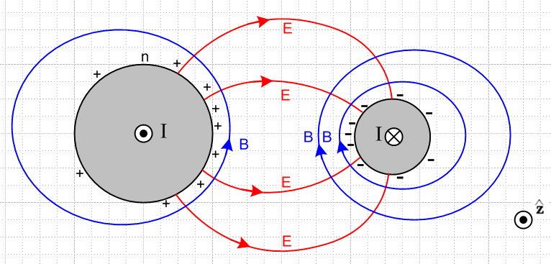 Fig 3.5
Fig 3.5: Cross section view

Although this figure is drawn for two round conductors, its general features apply to any conductors. The figure is a snapshot at one instant in time. The • and ⊗ indicate current flow direction in the conductors. Positive charge exists on the surface of the left conductor, and is strongest on the face of that conductor which is closest to the other conductor. Negative surface charge lies on the right conductor. The electric fields are as shown and are strongest in the region between the conductors. The magnetic field directions derive from the right hand rule relative to the current in each conductor. The lines of E and B always intersect at right angles as noted in (3.7.4).
The magnitude of the E field is determined by the potential difference between the conductors and the geometry. It is independent of frequency. Similarly, the magnitude of the B field is determined by the size of the current in either conductor and is also independent of frequency.
Consider a 75 Ω transmission line that is properly terminated and is driven by a 7.5 volt amplitude sine wave. Regardless of frequency ω, the magnitude of the current in this transmission line is 100 mA, and the magnitude of the potential difference is 7.5 volts. Of course both these quantities have sinusoidal time dependence. At some instant in time, the fields and currents are as in Fig 3.5.
We have just argued then that not much happens in the transverse directions x and y as frequency sweeps from very low to very high. Of course the rate at which the pattern oscillates back and forth increases, but the shape of things does not change. At the peak of each cycle, things look like Fig 3.5 regardless of ω.
This may seem contradictory. In general, one is used to ω affecting things due to equations like

curl E = -jωB Maxwell curl E equation (1.1.2)

The resolution is that all the spatial variation happens in the longitudinal direction. Here then is a top view of the same transmission line:

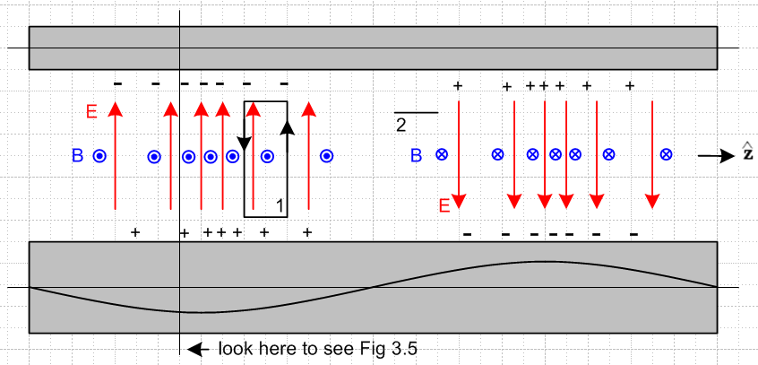

Fig 3.6: Top view of transmission line Fig 3.6

The red E arrows are all of unit length and serve to mark the direction and density of electric field lines lying in the plane containing the center lines of the conductors. The blue B arrows are seen end-on and indicate the same for the magnetic field. On the left they come out of the plane of paper and on the right they go into it. Later we shall learn about the "transmission line limit" in which the wavelength λ of the wave propagating down a transmission line is assumed to be much larger than all transverse dimensions of the line. The reader should understand the above picture as being in that limit, but one would have to stretch the picture at least 10X horizontally to make it be reasonable. At all places ExB points to the right, so we have a wave propagating to the right (+z).

Now apply the Maxwell curl equations using the two loops shown. Loop 1 is positioned to pick up magnetic flux, so we use (1.1.36) which in the frequency domain says

curl E = -jωB ⇔ E • ds = -jω[∫S B • dS] (3.7.9)

Notice the ω sitting on the right side. We argued in the last section that the amplitude of the B field does not change as ω changes. Thus, the right side of (3.7.2) is proportional to ω. As ω increases, the line integral of the E field around loop 1 must increase. Thus, the rate of change of E must increase in the z direction! In other words, as ω increases, the whole pattern of Fig 2 contracts in the z direction, which causes all z derivatives to increase, thus increasing E•ds for the same fixed loop 1. Remember that the strength of the E field is indicated in Fig 2 by the density of the red arrows, not by the length of the red arrows.
A similar argument applies to loop 2. This loop appears end-on in Fig 2. It is set up to sense the electric field flux. The appropriate curl equation is (1.1.38) which says

curl B = μεjωE + μJc ⇔ B • ds = μ ∫S [εjωE + Jc] • dA
≈ jωμε ∫E•dA . (3.7.10)

Since we are now in the dielectric, we have ignored the small leakage conduction current, and have kept the dominant displacement current. Again there is a factor of ω on the right side, arising from a time derivative. As ω increases, the line integral of the B field must increase. Thus, the B field must change faster in the z direction. As ω increases, the curl equation (3.7.2) is satisfied by having the entire pattern contract in the z dimension.
If the frequency ω doubles, the wavelength λ goes to half. This of course is no surprise, since ω and λ are related by the speed of light ν in the dielectric,

λ = v/f = 2πv/ω . (3.7.11)

The main point of the above discussion is to show how the Maxwell curl equations force the field pattern to contract in the z direction as ω increases. In the transverse direction, the field pattern shape stays constant.

(c) More on the field and current structure

Here we explore in more detail the general distribution of fields and currents in a transmission line. The goal is to establish the phase relationships among the electromagnetic fields and various currents. Once this is done, it is possible to make an estimate of the ratio Jr/Jz and that is done in the following section.

Consider the following more elaborate version of Figure 3.6 :

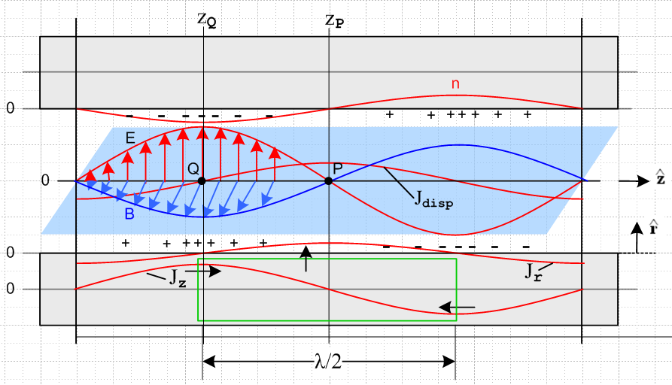

Tilted overhead view of a transmission line Fig 3.7

The picture is quite complicated and deserves clarifying comments:

(1) Unlike in Fig 3.6, the E and B arrows indicate the E and B vectors, and are not just field direction and field line density indicators.

(2) The E and B field vectors are shown along some line which lies in the plane of the center lines of the two conductors and which points in the direction, as do those center lines.

(3) The blue B field arrows lie in the blue plane which is meant to be perpendicular to the plane of the conductor center lines, which is the plane of paper. The red E field arrows are in the plane of paper.

(4) Looking at E x B, we see that the wave is traveling to the right in the direction.

(5) The E field arrows point from positive charge to negative charge, so this is why the + and - signs are distributed as shown.

(6) The conductors are fixed to the paper, everything else is moving to the right at velocity v. This includes the E and B arrows and their curves, the charge density and its curve n, and the two current curves drawn on the bottom conductor.

(7) At point Q on plane z = zQ, since B is coming out of paper to the viewer, the longitudinal current Jz in the lower conductor must be pointing to the right. This is why Jz is shown positive at this point in the lower conductor, and this calibrates the position of the Jz curve. Maximum Jz occurs with maximum B.

(8) There exists a displacement current Jdisp = ∂tD = ε ∂tE in the dielectric whose magnitude is shown as a red curve. For an observer sitting at fixed point P, since the wave is moving to the right, the value of
∂tE is at its instantaneous maximum positive value. This is why the red Jdisp curve has a positive maximum at point P.

(9) As discussed in Section 3.4, the displacement current is "fed" by the radial current Jr inside the lower conductor, so the Jr curve also has its maximum positive value at point P. This Jr current is busily radially pumping positive charge to the surface of the lower conductor at point P so that charge will be there when the wave has moved λ/4 to the right. Of course this radial Jr is doing this charge pumping all around the lower conductor, but we only show it in the plane of paper.

(10) We have glossed over the fact that the E and B fields track each other in magnitude. For example, they are both maximal at the same longitudinal position zQ. B is maximum there because Jz is maximum, but it is not quite clear why E is maximal at the same point. We know this alignment occurs in a plane wave, but a transmission line TEM mode is not just a plane wave. Various arguments can be ginned up for the alignment of the E and B maximums. One simple argument involves the green cylindrical Gaussian box drawn inside the lower conductor, and we reverse the discussion above. Note that this box lies entirely inside the conductor and so does not enclose any surface charge. Since there can be no charge inside a conductor, this box has Qenclosed = 0. Thus, the total current flowing into this box must be zero. Since the Jz current flows into both ends of this box (black arrows), the Jr current has to flow out on the cylinder's curved surface. By considering shorter green boxes one can show that Jr is maximal at zP (as drawn). Thus Jdisp is maximum at zP which means ∂tE must be maximum there, which means E = 0 at zP which means E has its maximum in alignment with the maximum of B.

(d) Estimate of the ratio Jr/Jz

Having drawn and described this elaborate picture, we now consider again the green Gaussian box. At the instant in time for which Fig 3.7 is drawn, the total current flowing into the endcaps of the box is 2I, where I is the peak longitudinal current -- the magnitude of the longitudinal sine wave. Therefore, the total Jr integrated over the sides of the green cylinder must also be 2I.
To obtain a ballpark estimate of the situation, we first assume that the two round conductors are far apart compared to their radii, in which case Jr is roughly symmetric around the conductor surface. Then the total radial current emitted by the curved surface of the green Gaussian cylinder is:

radial current total = [ (2/π)Jr ]* 2πa * (λ/2) = 2I

Since Jr is a longitudinal sine wave, we have added a factor 2/π to get its value averaged over the length of the Gaussian box. In a more general case, we can replace 2πa with distance p which represents the active portion of the conductor perimeter, as illustrated in Fig 2.14. Then we have

[ (2/π)Jr ]*p * (λ/2) = 2I =>

Jr = 2πI / (λp) . (3.7.12)

On the other hand, for a round conductor operating in the skin effect regime where δ < a,

Jz ≈ I/(pδ) (3.7.13)

where p is the same active perimeter just mentioned. So

Jr/Jz ≈ 2π (δ/λ) . (3.7.14)

For δ we had

δ ≡ $\sqrt{2/ωμσ}$ . (2.2.20)

From (3.7.11) we have λ = v/f = 2πv/ω where v is the wave phase velocity. Then

(δ/λ) = $\frac{2}{ωμσ}$ $\frac{ω}{2πv}$ = $\frac{2ω}{μσ}$ $\frac{1}{2πv}$ = $\frac{4πf}{μσ}$ $\frac{1}{2πv}$ . (3.7.15)

Setting v ≈ c and μ = μ0 = 4π x 10-7 and σ = 5.81 x 107 (copper) and f = 109f(Ghz) we get

(δ/λ) ≈ $\frac{4πf}{μσ}$ $\frac{1}{2πv}$ = $\frac{4π 109 f(GHz)}{4π x 10-7 x 5.81 x 107}$ $\frac{1}{2π}$ $\frac{1}{3 x 108}$

= $\frac{1010 f(GHz)}{58.1}$$\frac{1}{2π}$ $\frac{1}{3 x 108}$ = $\frac{f(GHz)}{58.1}$ $\frac{1}{6π}$ 10-3 = 7 x 10-6 $\sqrt{f(GHz)}$
and so

Jr/Jz ≈ (2π) (δ/λ) ≈ 4.4 x 10-5 $\sqrt{f(GHz)}$ . (3.7.16)

For f ≤ 10 GHz we then find

Jr/Jz ≤ 1.4 x 10-4 . f ≤ 10 GHz skin-effect regime (3.7.17)

showing that the radial charge-pumping current density Jr is much smaller than the longitudinal current density Jz in the conductor sheath.

What about the low-frequency situation with no skin-effect sheath? For simplicity, we assume now two round conductors of radius a which are widely spaced. No skin effect means roughly δ > a which means

$\sqrt{2/ωμσ}$ > a => ω < 2/(μσa2) or ωa/2 < 1/(μσa) . (3.7.18)

In this low frequency regime we must replace (3.7.13) by

Jz ≈ I/(πa2) . (3.7.19)

Since (3.7.12) is still valid, we find now that

Jz ≈ I/(πa2)
Jr ≈ 2πI/(pλ) ≈ 2πI/(2πaλ) ≈ I/(aλ)
so
Jr/Jz ≈ π(a/λ) ≈ (πa)(ω/2πv) ≈ ωa/2v = (ωa/2)(1/v) . (3.7.20)

Using (3.7.18) for ωa/2 we get

Jr/Jz < 1/(μσav) . (3.7.21)

With μ = μ0 = 4π x 10-7, σ = 5.81 x 107 (copper) and v = c = 3 x 108 we find for a wire of radius 1 mm,

Jr/Jz < $\frac{1}{4π * 5.81 * 10-3 * 3 * 108}$ = $\frac{10-5}{4π * 5.81 * 3}$ = 4.6 x 10-8. low frequency (3.7.22)

The conclusion is that in general Jr << Jz under 10 GHz and finally we justify entries made in the tables of Sections 3.5 and 3.6. The basic fact is that the green cylinder is long, so the surface area through which Jr flows is much larger than the area through which Jz flows.

3.8 Transmission Line Preliminaries

A transmission line normally has two conductors. The cross sectional shape of these conductors is assumed constant in the direction z along the transmission line. The transverse directions are x and y.
A wave propagates down a transmission line in what is called the TEM mode. TEM means that the electric and magnetic fields of a wave traveling down the guide are transverse, as in Figures 3.5-7. What this really means is that an electromagnetic wave goes straight down the conductors as guides with no surface reflections, unlike what happens in a waveguide, see Appendix F. Apart from a small drag on the wave due to losses in the conductors, the wave proceeds with wavenumber β and velocity ν as it would in an open medium. The conductors shape the E and B fields, so the wave is not a "plane wave". Nevertheless, at each point in the dielectric, E and B are perpendicular and E x B points down the transmission line.

We now summarize a set of basic facts about this TEM mode:

Fact 1: The major current for the TEM mode is the longitudinal current Jz. We just showed in the last section that Jr << Jz. There are no azimuthal tangential currents Jφ. (3.8.1)

Fact 2: There is no cutoff frequency one has to operate above. The TEM mode works all the way down to DC (although at low frequencies, the attenuation per wavelength may become large). See Appendix F for why this is not true in a waveguide. (3.8.2)

Corollary 2: If one operates a transmission line below the cutoff of the lowest waveguide mode, the TEM mode is the only possible way of moving energy down the line. (3.8.3)

Fact 3: The simplest expression of the boundary conditions are in terms of potentials, not fields, so the potential wave equations are used to solve problems. For example, a boundary condition might be that the electric potential between the two conductors is 7.5 volts at the driving end. (3.8.4)

Fact 4: The transverse components of the vector potential A can be neglected, so Az is the only component of A we have to worry about. (3.8.5)

Proof: Consider equation (1.5.9) where both conductors have the same μ,

A(x,ω) = $\frac{μ}{4π}$∫J(x',ω)$\frac{e-jβR}{R}$dV' (3.8.6)

Here, J represents the currents in the conductors and the volume integration is over both conductors in x,y and z, and R = |x-x'|. There is clearly going to be a strong Az component since the predominant conductor currents are in the longitudinal direction. According to Fact 1 above, transverse currents are very small, so the corresponding transverse components of A will also be very small and we shall completely neglect them.
When we compute A in the above integral, we can still decompose A into Az, Ar and Aφ . These components are, however, with respect to some fixed coordinate system located perhaps on some approximate center line between the two conductors. Thus, each potential of the pair Ar and Aφ will feel the effect of both Jr and Jφ , but these are both very small. Moreover, there is considerable cancellation which takes place as pieces of Jr and Jφ are added up in the integration. We rely mainly on the fact that Jr and Jφ are very small to conclude that Ar and Aφ may be safely neglected.
This is very different from what happens with Az. In the region of one conductor, the summation is additive for all nearby pieces of current Jz in that conductor, assuming that the wavelength λ of longitudinal propagation is much larger than any transverse dimension. The only place Az is small is on a longitudinal line between the conductors where their contributions cancel.
We conclude then that Ar and Aφ can be neglected relative to Az.

Fact 5: The potential φ(x) can be identified with the transverse "voltmeter voltage" . (3.8.7)

Proof: This is not immediately obvious. The thing one measures as "voltmeter voltage" is the line integral of the electric field between two points. If E = - ∇φ, one can identify φ with this voltmeter voltage, but according to Eq. (1.3.1), we have an extra term to worry about,

E = - ∇φ - ∂A/∂t . (3.8.8)

However, according to Fact 4 of (3.8.5), the transverse components of A are negligible, so

Et = -∇t φ where ∇t ≡ ∂/∂x + ∂/∂y . (3.8.9)

If one line-integrates Et from one conductor to the other (keeping z fixed), one gets φ1 - φ2 which is a voltage that a voltmeter would measure.

Fact 6: The potential φ is constant over the surface of either conductor at a fixed z. (3.8.10)

Proof: This follows from the Section 3.6 Table 3 assumption that Eφ = 0. Since there is no azimuthal component of electric field at the surface, we get zero doing a line integral of E between any two points on the surface of a conductor in a cross section slice. According to Fact 5, this gives not only the voltmeter voltage between the start and end of such an integration, but it also gives the potential difference ∆φ between these two points. Since the integration must give 0, we conclude that ∆φ = 0 between any two points, so φ must be constant over the surface at fixed z.
But how do we know that Eφ = 0 on a conductor surface? This somewhat delicate issue is discussed in sections (a) and (b) of Section D.8 in the context of a round wire. We shall assume it is true, even though this may depend on details of how the transmission line is "driven" at its source, and even though it might only be approximately true in that Eφ is extremely small and little error is created by setting it to zero.

Fact 7: The potential Az is constant over the surface of either conductor at a fixed z. (3.8.11)

Proof A: Consider putting a narrow sensing math loop in Fig. 3.5 perpendicular to the plane of paper. When such a loop is parallel to the B lines, there is no threading B flux. Since B = curlA, this means from (1.1.39) that C A • ds = 0 so that that Az is then constant on both long sides of such a loop. In other words, since B = curlA, the B field lines represent contours of constant Az.
According to (3.7.8) the B field lines just above the surface of a conductor run parallel to the surface, regardless of the cross sectional shape. These B lines cannot "dip" into the surface. Thus, since B field lines are surfaces of constant Az, we conclude that Az must be constant on either conductor surface in a slice at fixed z.
Fact 7 is true regardless of that fact that there can be considerable non-uniformity of the current density Jz inside a conductor, see the Comment below (3.7.8).

Proof B: Since Fact 7 is important, and is non-obvious, we give here another proof. According to (1.5.5), the King gauge condition divA = -j(β2/ω)φ relates A and φ. We have argued in Fact 4 that, at least in the dielectric region between the conductors, we can neglect all components of A except Az. In this case, the gauge condition reads ∂zAz = -j(β2/ω)φ. Now, as we will soon be doing in Chapter 4, assume a separation of variables so that

Az(x,y,z) = (μ/2π) i(z) Azt(x,y) . (3.8.12)

This separation is justified in the "transmission line limit" to be discussed in Chapter 4. If we insert this separated form into ∂zAz = -j(β2/ω)φ, we end up with,

∂zAz = (μ/2π) ∂zi(z) Azt(x,y) = ∂zi(z) [Az / i(z) ]
so
[∂zi(z) / i(z)] Az(x,y,z) = -j(β2/ω) φ(x,y,z) . (3.8.13)

Thus, since φ is constant over a cross section conductor surface according to Fact 6, we conclude that Az must also be constant over the same surface, since there are no other functions of (x,y) in the above equation. This concludes Proof B.

Proof C: Here is one more proof, a variant of Proof A. We know that B = curl A. We can construct a cylindrical coordinate system in Fig 3.3 based on a center line that matches the curvature of the surface at the point shown. Let the surface point be distance r from the coordinate system axis. In this system we find that

Br = [curl A]r = (1/r)∂φAz - ∂zAφ ≈ (1/r)∂φAz . (3.8.14)

But, according to (3.7.8) Br = 0. Thus, ∂φAz = 0. This says that Az does not change as one moves along the cross section surface of a conductor, since this is locally always the φ direction. Thus, Az is constant over the surface at fixed z.

Chapter 4: Transmission Line Equations

In this Chapter we use the potential integral expressions derived in Chapter 1 to derive the classic transmission line equations. We learn that most transmission line parameters are determined by a single geometric integral K. The approximations are clearly stated.

4.1 Computation of potential φ due to one conductor of a transmission line

Our starting point is the potential φ expression given in box (1.5.23) for the potential at some arbitrary point x in the dielectric due to conductor C1 of a transmission line,

φ1(x,ω) = $\frac{1}{4πξ}$∫$_{}^{}$ ρ1(x',y',z',ω)$\frac{e-jβR}{R}$dx'dy'dz' . R = |x - x'| (4.1.1)

Here the point x' = (x',y',z') runs over the surface of C1 and R is the distance between the observation point x in the dielectric and the integration point x'. Parameters β and ξ are for the dielectric.

Comments on ρ1:

1. ρ1 is the volume charge density associated with "surface charge" n1 according to ρ1dV' = n1dS' .

2. ρ1 is a distribution. For example, for a round wire of radius a we expect ρ1 to be proportional to δ(r'-a) where r' = $\sqrt{x'2+y'2}$. Perhaps ρ1 = f(θ')δ(r'-a) where (r',θ',z') are cylindrical coordinates with axis at the round wire center.

3. Recall from Section 1.5 (c) and (1.5.17) the fact that there are two distinct areal charge distributions called nc and ns which are related by nc = (ξ/ε)ns. Here ns is the actual surface charge distribution, whereas nc is an adjusted charge density which is directly associated with the current I in the conductor and which accounts for possible leakage in the dielectric. Our n1 and ρ1 are associated with this nc adjusted charge distribution, not with ns. That is why the external factor in (4.1.1) is 1/4πξ instead of 1/4πε.

Consider now this charge density ρ1(x). Following a standard methodology, we make the assumption that its functional form may be factored in the following manner,

ρ1(x,y,z) = α1(x,y) q1(z) . (4.1.2)
C/m3 1/m2 C/m

The dimensions of the functions in this factorization are as indicated, so the charge goes with q1. Moreover, without any loss of generality we select the relative scale of the two factors such that the integral of α1(x,y) over a slice of conductor C1 at any z is unity,

$^{\int_{C1}^{}{}}$dx dy α1(x,y) = 1 . (4.1.3)

Therefore, we can interpret q1(z) as the total charge per unit length on C1 at location z :

$^{\int_{C1}^{}{}}$dx dy ρ1(x,y,z) = q1(z) $^{\int_{C1}^{}{}}$dx dy α1(x,y) = q1(z) • 1 = q1(z) .

Assume that q2(z) is the charge on the other conductor C2 of a two-conductor transmission line. If q1(z) + q2(z) ≠ 0, then we have a net charge per unit length and the transmission line is acting as a radiating antenna as well as a transmission line. From now on, we ignore this superposed radiation problem and assume that at each value of z, the net charge on both conductors is 0 -- the line is "balanced". This means that

q2(z) = - q1(z) ≡ -q(z) . (4.1.4)

To simplify notation, we now dispense with the subscript and denote q1(z) = q(z). However, we maintain the subscript on α1(x,y) to emphasize that the two conductors can have completely different cross sectional shapes. The shape of the transverse distribution of charge on C1 is determined by α1(x,y), but the total charge is q(z) per unit length.

How can we justify assumption (4.1.2)? This is "separation of variables". The idea is that we assume it without any justification, and then we try to find a solution to our problem which is consistent with the assumption. All we really want is to find a solution to our basic differential equations with their boundary conditions, and any assumptions we make can be justified in the end once we have found a solution. On the other hand, if an assumption like (4.1.2) does not lead to a solution, then it must have been a bad assumption. We have seen earlier how the expected EM field pattern on a transmission line has a constant transverse "shape" and this certainly motivates the assumption (4.1.2).

Now insert (4.1.2) into (4.1.1) to get,

φ1(x,y,z) = $\frac{1}{4πξ}$$^{\int_{-∞}^{∞}{}}$dz' q(z') $^{\int_{C1}^{}{}}$dx' dy' α1(x',y') $\frac{e-jβR}{R}$ (4.1.5)

R2 = (x-x')2 + (y-y')2 + (z-z')2 .

4.2 Computation of potential φ due to both conductors of a transmission line

Let us now write the potential at an arbitrary point x in the dielectric due to both conductors C1 and C2 :

φ12(x) = φ1(x) + φ2(x) =

$\frac{1}{4πξ}$$^{\int_{-∞}^{∞}{}}$dz' q(z'){ $^{\int_{C1}^{}{}}$dx1' dy1' α1(x1',y1') $_{1}$ – $^{\int_{C2}^{}{}}$dx2' dy2' α2(x2',y2') $_{2}$ }

R12 = (x-x1')2 + (y-y1')2 + (z-z')2 = s12 + (z-z')2 s12 = (x-x1')2 + (y-y1')2 (4.2.1)
R22 = (x-x2')2 + (y-y2')2 + (z-z')2 = s22 + (z-z')2 s22 = (x-x2')2 + (y-y2') .

The minus sign between the terms is due to (4.1.4). Each conductor has its own arbitrary transverse charge distribution αi. The transverse integration variables on C1 are dx1' dy1', while those on C2 are instead dx2' dy2'. In the last two lines we introduce certain transverse distances s1 and s2 as shown. The same dz' integration variable is used for both conductors. The following drawing shows an arbitrary dielectric point x = (x,y,z) located in the z = z plane. The point x1' = (x1',y1',z') lies on C1 at some point of the C1 integration and similarly for x2' = (x2',y2',z'). The full distances R1 and R2 and the transverse distances s1 and s2 are shown.

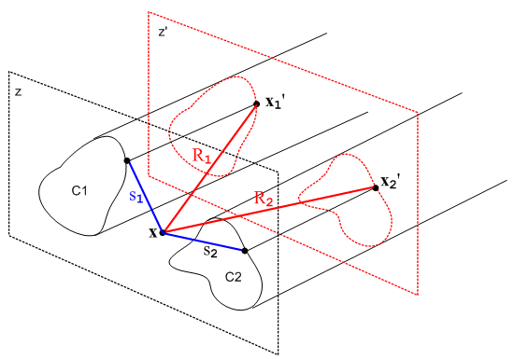 Fig 4.1

One can imagine an expression similar to (4.2.1) for a transmission line consisting of N conductors with some relationship among the qi(z) on each conductor, but we shall restrict our interest to N = 2.

4.3 The Transmission Line Limit

Consider again the potential at x due to both conductors shown in (4.2.1),

φ12(x) = $\frac{1}{4πξ}$$^{\int_{-∞}^{∞}{}}$dz' q(z'){ $^{\int_{C1}^{}{}}$dx1' dy1' α1(x1',y1') $_{1}$ – $^{\int_{C2}^{}{}}$dx2' dy2' α2(x2',y2') $_{2}$ }
(4.3.1)

As the red-dashed z = z' plane shown in Fig 4.1 is pushed back far from the z = z plane, the vectors which are labeled by distances R1 and R2 become more aligned, and both R1 and R2 become larger. During the transverse integrations over x1' and x2', these Ri vectors then don't vary much. One could then replace the transverse charge density α1(x1',y1') with a point charge at the "center of the conductor" and not make much difference in the R1 vector and its length R1. In this situation, the {...} integrand of the above integral has this form

{ $_{1}$ – $_{2}$ } . // when |z-z'| is large (4.3.2)

If we then expand the exponentials showing the first few terms, this becomes

{ $\frac{1-jβR1+(jβ)2R12/2}{R1}$ – $\frac{1-jβR2+(jβ)2R22/2}{R2}$ } = { [ $\frac{1}{R1}$ - $\frac{1}{R2}$ ] + [-jβ + jβ ] + (jβ)2/2 [R1-R2] + ... }
= { [ $\frac{1}{R1}$ - $\frac{1}{R2}$ ] - β2/2 [R1-R2] + order(β3) } (4.3.3)

Since R1 ≈ R2 for large |z-z'| as just discussed, both the leading term and the β2 term are small in an absolute sense as long as β2 is not huge. When |z-z'| is large, both R1 and R2 are large and thus both 1/R1 and 1/R2 are small, and [ 1/R1 - 1/R2] is smaller still due to cancellation between the terms.
So our first point is that, in the dz' integration, the main contribution to φ12(x) comes from regions of z' for which |z-z'| is small.
Given then that the dz' integration in (4.3.1) is dominated by that part for which |z-z'| is small, we can see that for this controlling integration region the size of distances R1 and R2 will be on the order of the transverse dimension of the transmission line, assuming that we select the point x somewhere between the two conductors. If we vaguely define the transmission line's transverse extent as distance D, then suppose we make the following assumption concerning β :

βD << 1 "small β" . (4.3.4)

In this case, we can replace e-jβR$_{1}$ = 1 and e-jβR$_{2}$ = 1 in the integration without significantly changing the result. Then as shown in (4.3.3) there will be a correction term that is order β2 which we shall neglect, as well as higher terms of order βn with n> 2.
Notice that the linear β term vanished exactly in our large |z-z'| analysis. This linear term also vanishes in the full analysis since the αi transverse charge functions are normalized to unity:

{ $^{\int_{C1}^{}{}}$dx1' dy1' α1(x1',y1') $\frac{-jβR1}{R1}$ – $^{\int_{C2}^{}{}}$dx2' dy2' α2(x2',y2') $\frac{-jβR2}{R2}$ }
= (-jβ) {$^{\int_{C1}^{}{}}$dx1' dy1' α1(x1',y1') - $^{\int_{C1}^{}{}}$dx1' dy1' α1(x1',y1') ) = (-jβ) {1 - 1} - 0. (4.3.5)

Thus, by setting β = 0 in (4.3.1) we are ignoring corrections on the order of β2 and higher, and if β is small, these corrections are very small.
The Helmholtz parameter β for the dielectric is 2π/λ where λ is the wavelength of a wave passing down the transmission line. Thus, our "small β" assumption stated above can also be written

λ >> D (4.3.6)

which says the wavelength is much longer than the size of the transmission line transverse dimensions. This assumption is called the Transmission Line Limit. If we operate within this limit, then (4.3.1) may be approximated as

φ12(x) = $\frac{1}{4πξ}$$^{\int_{-∞}^{∞}{}}$dz' q(z'){ $^{\int_{C1}^{}{}}$dx1' dy1' α1(x1',y1') $\frac{1}{R1}$– $^{\int_{C2}^{}{}}$dx2' dy2' α2(x2',y2') $\frac{1}{R2}$ } (4.3.7)

We shall now use the small β assumption one more time. We assume that the linear charge density q(z') has the characteristics of a wave traveling down the transmission line ( see also Chapter 5),

q(z) = q(0) e-jβz // q(z,t) = q(0,0) ej(ωt-βz) (4.3.8)

so that

q'(z) = -jβ q(z)
q"(z) = (-jβ)2q(z) and so on.

We can then write a Taylor expansion for charge density q(z') which appears in our integration,

q(z') = q(z) + (z'-z) q'(z) + (1/2) (z'-z)2 q"(z) + ...
= q(z) + (-jβ) q(z) (z'-z) + (1/2) (-jβ)2 q(z) (z'-z)2 + ...
= q(z) [ 1 + (-jβ) (z'-z) + (1/2) (-jβ)2(z'-z)2 + ... ] . (4.3.9)

Since both R1 and R2 are even functions of the quantity (z'-z), and since there is no other (z'-z) dependence in the (4.3.7) integrand, the (-jβ) term in (4.3.9) contributes nothing (this is also true more generally for (4.3.1)). Thus, if we assume small β, we can approximate q(z') ≈ q(z) where we are then ignoring a β2 size term. Once again, if β is small, β2 is very small so our error in replacing q(z') by q(z) is very small. We are only interested in the contributing region where |z-z'| is on the order of transverse dimension D, so the same βD << 1 is being assumed as earlier.
We arrive then at our final result for the potential at a point x between the conductors,

φ12(x) = $\frac{1}{4πξ}$ q(z) $^{\int_{-∞}^{∞}{}}$dz'{ $^{\int_{C1}^{}{}}$dx1' dy1' α1(x1',y1') $\frac{1}{R1}$– $^{\int_{C2}^{}{}}$dx2' dy2' α2(x2',y2') $\frac{1}{R2}$ } (4.3.10)

where we have thrown out terms of order β2 and higher. In this transmission line limit approximation, our Helmholtz integral (4.3.1) has been reduced to essentially an electrostatics Coulomb integral where we just sum over the contribution of each piece of charge to the total potential. As noted earlier, q(z) has the normalization of nc and not ns as discussed in Section 1.5 (c) which explains why the leading factor is $\frac{1}{4πξ}$ and not $\frac{1}{4πε}$. This allows for the dielectric to have some conductance.
It should be noted that the integral of (4.3.10) converges due to the subtraction of the two terms which in turn results from the two conductors having opposite longitudinal charge densities. The individual terms in (4.3.10) do not converge and are in fact each logarithmically divergent in the sense
$^{\int_{-∞}^{∞}{}}$dz' (1/z') = ∞ .

4.4 General Calculation of V(z)

We now introduce two new points x1 and x2. The point x1 lies on C1 in the z = z plane, while x2 lies on C2 in this same plane. We then evaluate φ12(x) at x = x1 and subtract from that φ12(x) at x = x2 and in this way we obtain the potential difference between the surfaces of the two conductors at z = z. Recall,

Fact 6: The potential φ is constant over the surface of either conductor at a fixed z. (3.8.10)

Thus, the potential difference will be independent of the locations of x2 and x1 as long as they are on their respective surfaces and both have z = z. For this reason, the potential difference is a function only of z. Thus we write, using two copies of (4.3.10),

V(z) ≡ φ12(x1) - φ12(x2)

= $\frac{1}{4πξ}$ q(z) $^{\int_{-∞}^{∞}{}}$dz' { $^{\int_{C1}^{}{}}$dx1' dy1' α1(x1',y1') $\frac{1}{R11}$– $^{\int_{C2}^{}{}}$dx2' dy2' α2(x2',y2') $\frac{1}{R12}$ }
– $\frac{1}{4πξ}$ q(z) $^{\int_{-∞}^{∞}{}}$dz' { $^{\int_{C1}^{}{}}$dx1' dy1' α1(x1',y1') $\frac{1}{R21}$ – $^{\int_{C2}^{}{}}$dx2' dy2' α2(x2',y2') $\frac{1}{R22}$ } (4.4.1)
where

R112 = (x1-x1')2 + (y1-y1')2 + (z-z')2 = s112 + (z-z')2 s112 = (x1-x1')2 + (y1-y1')2
R122 = (x1-x2')2 + (y1-y2')2 + (z-z')2 = s122 + (z-z')2 s122 = (x1-x2')2 + (y1-y2')2
R222 = (x2-x2')2 + (y2-y2')2 + (z-z')2 = s222 + (z-z')2 s222 = (x2-x2')2 + (y2-y2')2
R212 = (x2-x1')2 + (y2-y1')2 + (z-z')2 = s212 + (z-z')2 s212 = (x2-x1')2 + (y2-y1')2 . (4.4.2)

The vector R12 points from our new point x1 to an integration point x2' on C2. Here is a drawing of our new and more complicated situation:
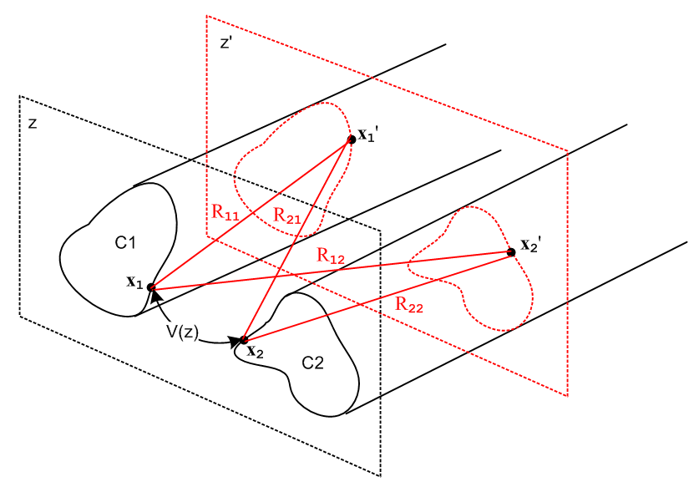 Fig 4.2
We next rearrange the four terms in (4.4.1) to get

V(z) (4.4.3)
= q(z) $\frac{1}{4πξ}$$^{\int_{-∞}^{∞}{}}$dz' {$^{\int_{C1}^{}{}}$dx1' dy1' α1(x1',y1')( $\frac{1}{R11}$- $\frac{1}{R21}$) -$^{\int_{C2}^{}{}}$dx2' dy2' α2(x2',y2') ( $\frac{1}{R12}$- $\frac{1}{R22}$) } .

It is now possible to carry out the dz' integrations. The integral of interest is the following,

$^{\int_{-∞}^{∞}{}}$dx { $\sqrt{a2+ x2}$ - $\sqrt{b2+ x2}$ } = ln(b2/a2) . (4.4.4)

Since this is quite important, we confirm with Maple,

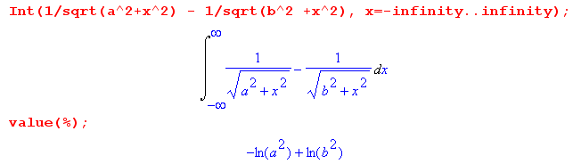

The separate integrals here are logarithmically divergent, but the combination converges. Thus,

$^{\int_{-∞}^{∞}{}}$dz' ( $\frac{1}{R11}$- $\frac{1}{R21}$) = $^{\int_{-∞}^{∞}{}}$dz' ($\sqrt{s112 + (z-z')2}$ - $\sqrt{s212 + (z-z')2}$) = ln(s212/s112)
and
$^{\int_{-∞}^{∞}{}}$dz' ( $\frac{1}{R12}$- $\frac{1}{R22}$) = ln(s222/s122) (4.4.5)

so that

V(z) = q(z) $\frac{1}{4πξ}$ {$^{\int_{C1}^{}{}}$dx1' dy1' α1(x1',y1') ln(s212/s112) -$^{\int_{C2}^{}{}}$dx2' dy2' α2(x2',y2') ln(s222/s122) }

s212 = (x2-x1')2 + (y2-y1')2 s222 = (x2-x2')2 + (y2-y2')2 (4.4.6)
s112 = (x1-x1')2 + (y1-y1')2 s122 = (x1-x2')2 + (y1-y2')2 .

The four transverse distances are shown in this figure,

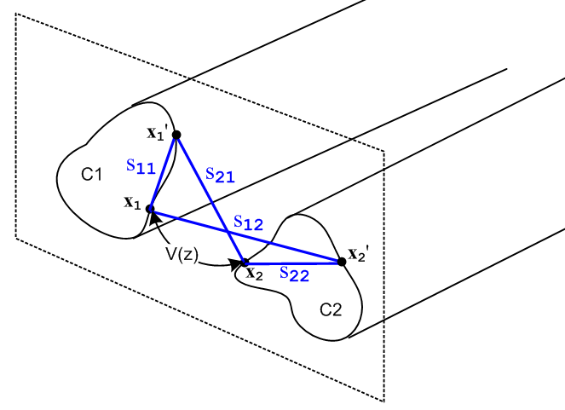 Fig 4.3

Equation (4.4.6) expresses the potential between the two transmission line conductors at some plane z in terms of the charge distributions on the conductors αi. In general, these charge distributions are not known, so one cannot regard (4.4.6) as a general purpose silver bullet to solve transmission line problems. On the other hand, as we shall see, equation (4.4.6) is one of a group of equations which will allow us to express several different transmission line parameters in terms the same integral, and one then obtains a relation between these parameters.
For example, in analogy to what we did with a parallel plate capacitor in (1.5.19), we may define the complex capacitance C' per unit length of our transmission line using (4.4.6) as follows:

$\frac{1}{C'}$ = $\frac{V(z)}{q(z)}$ = $\frac{1}{4πξ}$ {$^{\int_{C1}^{}{}}$dx1' dy1' α1(x1',y1') ln(s212/s112) -$^{\int_{C2}^{}{}}$dx2' dy2' α2(x2',y2') ln(s222/s122) }

= $\frac{1}{4πξ}$ K and V(z) = q(z) $\frac{1}{4πξ}$ K (4.4.7)

where K is a dimensionless real number obtained from a geometric integral of the normalized transverse charge distributions αi (recall that αi is has dimensions 1/m2 in (4.1.2)),

K ≡ $^{\int_{C1}^{}{}}$dx1' dy1' α1(x1',y1') ln(s212/s112) -$^{\int_{C2}^{}{}}$dx2' dy2' α2(x2',y2') ln(s222/s122) . (4.4.8)

Recall from (1.5.20) that (C', C and G are discussed further in Section 4.11 below)

C' = C + 1/(jωR) = C + G/(jω) (4.4.9)

where conductance (per unit length) G is associated with the imaginary part of C'. We then have

4πξ/K = C' = C + G/jω
or
4π(ε+σ/jω)/K = C + G/jω // (1.5.1) for ξ

so that

C = 4πε/K capacitance per unit length of the transmission line

G = 4πσ/K conductance per unit length of the transmission line
so
C/G = ε/σ . (4.4.10)

Here G = 1/R' is the conductance across the dielectric between a unit length of the two conductors. This is unrelated to the longitudinal resistance R of the conductors themselves, though that parameter will arise later on in the form of surface impedance Zs. We only have G ≠ 0 if the dielectric has some conductance σ ≠ 0.

Note from above and (1.2.8) that dim(C) = dim(ε) = farad/m and dim(G) = dim(σ) = mho/m .

We will show below in Section 4.11 that the external inductance per unit length of our transmission line is also related to this same constant K,

Le = (μ/4π)K . (4.4.11)

As shown in Appendix K, the (complex) characteristic impedance of a transmission line is given by

Z0 = $\frac{R + jωL}{G + jωC}$ . (4.4.12)

At sufficiently large ω we can neglect the R and G terms to get this real value,

Z0 = $\frac{L}{C}$. // large ω (4.4.13)

As shown later in (4.11.32), for large ω L → Le so

Z0 = $\frac{Le}{C}$ = $\frac{(μ/4π)K}{4πε/K}$ = (1/4π) K $\sqrt{μ/ε}$ = (1/4π) K Zm (4.4.14)

where Zm = $\sqrt{μ/ε}$ is the "impedance of the dielectric medium" having μ and ε. Recall that for free space we had in (1.1.29)

Zfs = $\sqrt{μ0/ε0}$ = 376.73032 ohms => Zfs /4π = 29.97948 ≈ 30 Ω . (4.4.15)

Typically one has μ = μ0 so then (note that εrel and K are dimensionless),

Z0 ≈ (K /$\sqrt{εrel}$) 30Ω εrel ≡ ε/ε0 . (4.4.16)

We then summarize the parameters of a transmission line in terms of dimensionless real integral K :

C = 4πε/K capacitance per unit length (4.4.17)

G = 4πσ/K transverse conductance per unit length

Le = (μ/4π) K external inductance per unit length

Z0 ≈ (K /$\sqrt{εrel}$) 30Ω characteristic impedance μ = μ0, εrel ≡ ε/ε0

R = Re(Zs1+Zs2) resistance of conductors, see (4.11.30)

L = Le + (1/ω) Im(Zs1+ Zs2) total inductance, see (4.11.30)

Zsi = conductor surface impedance due to possible skin effect at frequency ω (Chapter 2)

The last three items are not determined by integral K and we just mention them for completeness's sake. All these equations will be more fully developed in Section 4.11 below, but we jump the gun a bit in order to display two important examples.

4.5 Example: Transmission line with widely-spaced round wires of unequal diameters

Consider a transmission line made from two round wires of radii a1 and a2 and center line spacing b. In the case that b >> a1 and a2, the charge distribution on each round wire is symmetric about the wire and in this situation ( a rare one admittedly) we know the two charge distributions:

α1(x,y) = α1(r,θ) = δ(r - a1)/(2πa1)
α2(x,y) = α2(r,θ) = δ(r - a2)/(2πa2) . (4.5.1)

The 1/(2πa1) factor is required so that the integral of α1 is unity as required by (4.1.3),

$^{\int_{C1}^{}{}}$dx dy α1(x,y) = $^{\int_{0}^{2π}{}}$dθ $^{\int_{0}^{∞}{}}$rdr α1(r,θ) = $^{\int_{0}^{2π}{}}$dθ $^{\int_{0}^{∞}{}}$rdr δ(r - a1)/(2πa1)

= $^{\int_{0}^{2π}{}}$dθ a1/(2πa1) = 2π a1/(2πa1) = 1 . (4.5.2)

Note: The reason the αi are symmetric is that the two conductors are so far apart that each one is essentially "in isolation" and so the charge assumes an axially symmetric distribution. An analogy would be that for two point charges far apart, the E field close to either point charge is spherically symmetric because close to one charge the field of the other can be neglected.

Our task is then to compute the integral K shown in (4.4.8),

K = $^{\int_{0}^{2π}{}}$dθ1 $^{\int_{0}^{a1}{}}$r1dr1 [δ(r1 - a1)/(2πa1)] ln(s212/s112)
-$^{\int_{0}^{2π}{}}$dθ2 $^{\int_{0}^{a2}{}}$r2dr2 [δ(r2 - a2)/(2πa2)] ln(s222/s122) .

= $^{\int_{0}^{2π}{}}$dθ1 1/(2π) ln(s212/s112)
-$^{\int_{0}^{2π}{}}$dθ2 1/(2π) ln(s222/s122)

= 1/(2π) { $^{\int_{0}^{2π}{}}$dθ1 [ln(s212) - ln(s112)] - $^{\int_{0}^{2π}{}}$dθ2 [ln(s222) - ln(s122)] } (4.5.3)

where we then have four integrals to evaluate.

We shall choose our V(z) potential-determining reference points x1 and x2 as shown in this drawing,

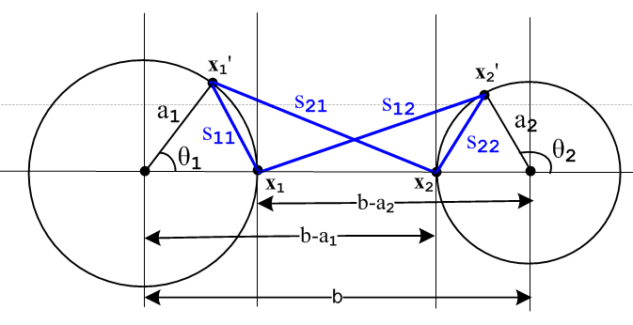 Fig 4.4

The four sij distances can be read off from the drawing using the law of cosines,

s212 = a12 + (b-a1)2 - 2 a1(b-a1) cos(θ1)

s112 = a12 + a12 - 2 a1 a1 cos(θ1) = 2a12(1 - cos(θ1))

s222 = a22 + a22 - 2 a2 a2 cos(π-θ2) = 2a22(1 + cos(θ2))

s122 = a22 + (b-a2)2 + 2 a2(b-a2) cos(θ2) . (4.5.4)

We then invoke the following integral from p 531 of GR7,

which we rewrite as

$^{\int_{0}^{2π}{}}$dθ ln (A ± Bcosθ) = 2π ln[(1/2)(A + $\sqrt{A2-B2}$ )] . (4.5.5)

The four integrals are then easily evaluated:

$^{\int_{0}^{2π}{}}$dθ1 ln(s212) = $^{\int_{0}^{2π}{}}$dθ1ln([a12 + (b-a1)2 - 2 a1(b-a1) cos(θ1)]

A = a12 + (b-a1)2 B = 2 a1(b-a1)

A2-B2 = [a12 + (b-a1)2]2 - 4 a12(b-a1)2 = [a12 - (b-a1)2]2 => $\sqrt{A2-B2}$= (b-a1)2- a12 > 0 b >> a1

=> $^{\int_{0}^{2π}{}}$dθ1 ln(s212) = 2π ln[(1/2)( a12 + (b-a1)2 + (b-a1)2 - a12 ) = 2π ln[(b-a1)2] .

The fourth integral is the same with 1↔ 2, and the different sign of the second term in s122 makes no difference,

$^{\int_{0}^{2π}{}}$dθ2 ln(s122) = 2π ln[(b-a2)2] .

The second integral is

$^{\int_{0}^{2π}{}}$dθ1 ln(s112) = $^{\int_{0}^{2π}{}}$dθ1ln([2a12(1 - cos(θ1))] A = B = 2a12 , A2-B2 = 0

= 2π ln[(1/2) 2a12] = 2π ln(a12) .

The third integral is similar giving

$^{\int_{0}^{2π}{}}$dθ2 ln(s222) = 2πln(a22) .

To summarize:

$^{\int_{0}^{2π}{}}$dθ1 ln(s212) = 2π ln[(b-a1)2]
$^{\int_{0}^{2π}{}}$dθ1 ln(s112) = 2π ln(a12)
$^{\int_{0}^{2π}{}}$dθ2 ln(s222) = 2πln(a22)
$^{\int_{0}^{2π}{}}$dθ2 ln(s122) = 2π ln[(b-a2)2] . (4.5.6)

Then from (4.5.3) we find

K = 1/(2π) { $^{\int_{0}^{2π}{}}$dθ1 [ln(s212) - ln(s112)] - $^{\int_{0}^{2π}{}}$dθ2 [ln(s222) - ln(s122)] }
= ln[(b-a1)2] - ln(a12) - ln(a22) + ln[(b-a2)2] = ln [$\frac{(b-a1)2(b-a2)2}{a12a22}$]
= 2 ln [$\frac{(b-a1)(b-a2)}{a1a2}$] = 2 ln [$\frac{b2}{a1a2}$] // since we assumed at the start that b >> a1, a2
= 4 ln(b/$\sqrt{a1a2}$) . (4.5.7)
Therefore the transmission line parameters from (4.4.17) are,

K = ln(b/$\sqrt{a1a2}$)
C = 4πε/K = πε / ln(b/$\sqrt{a1a2}$)
G = 4πσ/K = πσ / ln(b/$\sqrt{a1a2}$)
Le = (μ/4π) $\sqrt{KKL}$ = (μ/π) ln(b/$\sqrt{a1a2}$)
Z0 = ($\sqrt{KKL}$ /$\sqrt{εrel}$) 30Ω = (1/$\sqrt{εrel}$) ln(b/$\sqrt{a1a2}$) 120Ω . (4.5.8)

Sometimes these formulas are written in terms of wire diameters di = 2ai in which case

K = 4 ln[b/$\sqrt{a1a2}$] = 4 ln[2b/$\sqrt{d1d2}$] = 2 ln[4b2/d1d2] . (4.5.9)

Since we are assuming b >> d1,d2 we know that x ≡ 2b2/d1d2 >> 1. Therefore

ch-1x = ln[x + $\sqrt{x2-1}$] ≈ ln(2x) // an identity Siegel 8.56, then an approximation (4.5.10)
so
ch-1(2b2/d1d2) ≈ ln(4b2/d1d2) .

Then we can write K as

K = 2 ln[4b2/d1d2] = 2 ch-1(2b2/d1d2) (4.5.11)

and so

Z0 = (K /$\sqrt{εrel}$) 30Ω = (1/$\sqrt{εrel}$) ch-1(2b2/d1d2) 60Ω . (4.5.12)

It is not easy to find expressions for C,G and Le for the unequal radii geometry, but Z0 does appear for example in Reference RDE page 29-23 where we find:

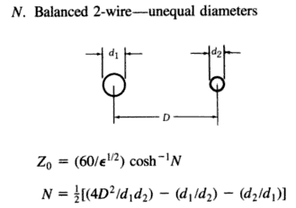 Fig 4.5

with D = our b. For D >> d1,d1 this shows N = 2D2/(d1d2), and this then agrees with (4.5.12). This quoted result is in fact correct (with the two extra terms shown in N) even when D is not large. We shall derive this full result in Chapter 6, equation (6.3.12).

In the special case that a1 = a2 ≡ a we get,

K = 4 ln(b/a)
C = 4πε/K = πε/ ln(b/a)
G = 4πσ/K = πσ/ ln(b/a)
Le = (μ/4π) K = (μ/π) ln(b/a)
Z0 = (K /$\sqrt{εrel}$) 30Ω = (1/$\sqrt{εrel}$) ln(b/a) 120Ω
= (1/$\sqrt{εrel}$) ln(2b/d) 120Ω d = 2a . (4.5.13)

The first three results agree with King TLT p17 (30b),

The expression for Z0 agrees with the RDE source quoted above,

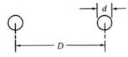 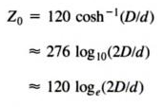 Fig 4.6

where again D = b and for "air" εrel= 1.

Power Transmission Lines

Ignoring proximity effects of the ground and possible ground wires, one can consider a single phase power transmission line as fitting into this example. The first interesting number is skin depth. For aluminum at f = 60 Hz we find

σaluminum = 3.7 x 107 mho/m // recall σcopper ≈ 5.8 x 107 (annealed)
μ0 = 4π x 10-7 henry/m

δ ≡ $\sqrt{2/(ωμσ)}$ ≈ $\sqrt{2/(2πfμ0σ)}$ = $\sqrt{1/(πfμ0σ)}$

So δ ≈ 1 cm. Thus, skin effect could be significant for a very large diameter wire. Typically the individual strands of a 1500 amp cable are 1/6" in diameter or 0.2 cm in radius, so there is some slight non-uniformity in the current distribution. Perhaps one should think of this more in terms of the total cable diameter including all strand layers which might be 1".
Usually the requirement of low power loss requires that R be relatively small compared to ωL. The 1500A cable just noted has R = .02Ω per thousand feet. Similarly, the conductance G (mostly from insulator leakage) is very small compared to ωC. Thus, (4.4.12) leads to (4.4.16) stating Z0 ≈ K 30Ω . If the full cable is 1" in diameter and the two lines are spaced 1 m apart, we can compute K from (4.5.13),

K = 4 ln(b/a) = 4 ln( 1m/0.5") = 4 ln(39.37*2) = 17.5

so then from (4.4.16),

Z0 ≈ K 30Ω = 17.5 * 30 Ω = 524Ω

Rajput (p 554) claims power lines typically range from 400 to 600 Ω. See southwire.com for data on transmssion line cables.

4.6 Example: A coaxial cable

A coaxial cable is the other transmission line where we know the surface charge distribution is that given by (4.5.1). The analysis of the previous section resulting in (4.5.3) is then unchanged, and we find that K is still given by (4.5.3),

K = 1/(2π) { $^{\int_{0}^{2π}{}}$dθ1 [ln(s212) - ln(s112)] - $^{\int_{0}^{2π}{}}$dθ2 [ln(s222) - ln(s122)] } . (4.5.3)

What is different is that we have a different picture describing the various sij distances. The new picture is this, where the cross section circles have radii a2 > a1 :

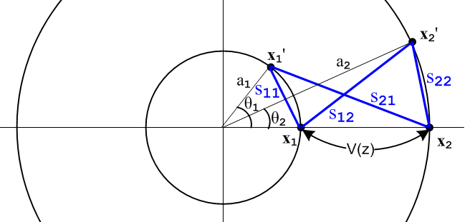 Fig 4.7

As we did in the previous section, we "read off" the sij expressions using the law of cosines:

s212 = a12 + a22 - 2 a1a2cos(θ1)

s112 = a12 + a12 - 2 a1 a1 cos(θ1) = 2a12(1 - cos(θ1))

s222 = a22 + a22 - 2 a2 a2 cos(θ2) = 2a22(1 - cos(θ2))

s122 = a22 + a12 - 2 a1a2 cos(θ2) . (4.6.1)

Recalling,

$^{\int_{0}^{2π}{}}$dθ ln (A ± Bcosθ) = 2π ln[(1/2)(A + $\sqrt{A2-B2}$ )] . (4.5.5)

we find,

$^{\int_{0}^{2π}{}}$dθ1 ln(s212) = $^{\int_{0}^{2π}{}}$dθ1 ln[a12 + a22 - 2a1a2cos(θ1)] A = a12 + a22 B = 2a1a2

A2-B2 = (a12 +a22)2 - 4a12a22 = (a12 -a22)2 => $\sqrt{A2-B2}$ = (a22 -a12) > 0 since a2 > a1
so
$^{\int_{0}^{2π}{}}$dθ1 ln(s212) = 2π ln[(1/2)( a12 + a22 + (a22 -a12) ) = 2πln(a22) .

Similarly

$^{\int_{0}^{2π}{}}$dθ2 ln(s122) = 2π ln[(1/2)( a12 + a22 + (a22 -a12) ) = 2πln(a22) = same as above .

The other two integrals are,

$^{\int_{0}^{2π}{}}$dθ1 ln(s112) = $^{\int_{0}^{2π}{}}$dθ1 ln[2a12(1 - cos(θ1))] A = B = 2a12
= 2π ln[(1/2)2a12] = 2πln(a12)

$^{\int_{0}^{2π}{}}$dθ2 ln(s222) = $^{\int_{0}^{2π}{}}$dθ1 ln[2a22(1 - cos(θ2))] A = B = 2a22
= 2π ln[(1/2)2a22] = 2πln(a22) .
To summarize:

$^{\int_{0}^{2π}{}}$dθ1 ln(s212) = 2πln(a22)
$^{\int_{0}^{2π}{}}$dθ1 ln(s112) = 2π ln(a12)
$^{\int_{0}^{2π}{}}$dθ2 ln(s222) = 2π ln(a22)
$^{\int_{0}^{2π}{}}$dθ2 ln(s122) = 2π ln(a22) . (4.6.2)

Then from (4.5.3) we find

K = 1/(2π) { $^{\int_{0}^{2π}{}}$dθ1 [ln(s212) - ln(s112)] - $^{\int_{0}^{2π}{}}$dθ2 [ln(s222) - ln(s122)] }

= ln(a22) - ln(a12) - ln(a22) + ln(a22) = ln(a22/a12) = 2 ln(a2/a1) . (4.6.3)

The coaxial transmission line parameters are then given by,

C = 4πε/K = 2πε / ln(a2/a1)
G = 4πσ/K = 2πσ / ln(a2/a1)
Le = (μ/4π)K = (μ/2π) ln(a2/a1)
Z0 = (K /$\sqrt{εrel}$) 30Ω = (1/$\sqrt{εrel}$) ln(a2/a1) 60Ω (4.6.4)

We verify the C and Le parameters from http://en.wikipedia.org/wiki/Coaxial_cable ,

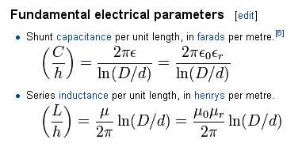 Fig 4.8

To verify the Z0 value, first recall that (the positive square root is implied here)

ch-1x = ln[x + $\sqrt{x2-1}$] // Siegel identity 8.56, valid for x ≥ +1 (4.6.5)

If we set x ≡ $\frac{1}{2}$( $\frac{a}{b}$ + $\frac{b}{a}$) = $\frac{1}{2}$$\frac{a2+b2}{ab}$ and we assume a > 0 and b > 0, then

x2 - 1 = $\frac{1}{4}$$\frac{(a2+b2)2}{a2b2}$ - 1 = $\frac{1}{4}$ { $\frac{(a2+b2)2 - 4a2b2}{a2b2}$} = $\frac{1}{4}$$\frac{(a2-b2)2}{a2b2}$
=> $\sqrt{x2-1}$= $\frac{1}{2}$$\frac{|b2-a2|}{ab}$ = sign(b-a) $\frac{1}{2}$($\frac{b}{a}$- $\frac{a}{b}$)

=> x + $\sqrt{x2-1}$ = $\frac{1}{2}$($\frac{a}{b}$ + $\frac{b}{a}$) + sign(b-a) $\frac{1}{2}$($\frac{b}{a}$- $\frac{a}{b}$) =

=> ln [x + $\sqrt{x2-1}$] = ln [ ] = sign(b-a) ln(b/a) .

Thus we have shown that (note that both sides are invariant under a ↔ b )

ch-1[$\frac{1}{2}$($\frac{a}{b}$ + $\frac{b}{a}$)] = sign(b-a)ln $\frac{b}{a}$ . a > 0 and b > 0 (4.6.6)

With this rather elaborate fact, and since we have b > a, we can rewrite Z0 above as

Z0 = (1/$\sqrt{εrel}$) ch-1[$\frac{1}{2}$($\frac{a}{b}$ + $\frac{b}{a}$)] 60 Ω . (4.6.7)

Again we quote from reference RDE page 29-24

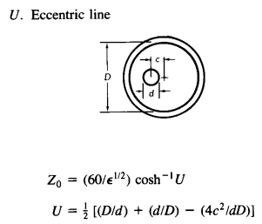 Fig 4.9

In our centered case c = 0 so U = (1/2)(D/d+d/D) and we have agreement. The full off-center result is derived later in Chapter 6, equation (6.3.15).

Comment: In the examples of Sections 4.5 and 4.6, the current distributions in the involved round wires are axially symmetric. Therefore all the results of Chapter 2 apply. In particular, Chapter 2 calculates the surface impedance Zs for a round wire in complete detail, including its limits for large and small ω. For example, at low frequency for a wire of radius a,

Zs(ω) = $\frac{1}{σπa2}$ + jω $\frac{μ}{8π}$ = Rs + jωLs // low frequency limit (2.4.12)

and one sees that Rs is the expected DC resistance and Ls is the internal impedance Li as computed in Appendix C equation (C.3.5).

Having presented our two Examples, we now resume development of the transmission line equations.

4.7 Computation of Az due to one conductor of a transmission line

In summary box (1.5.23) we state the following Helmholtz integral for the vector potential arising from currents in a set of conductors,

A(x,ω) = $\frac{1}{4π}$ Σi∫μiJi(x',ω) $\frac{e-jβR}{R}$dV' (1.5.23)

where the sum Σi is over the conductors and μi is the permeability of conductor i.
In our transmission line context, and as discussed in Chapter 3, the dominant current is in the z (longitudinal) direction, while transverse currents are very small. For example, in the estimate of Section 3.7 (s) we found that Jr/Jz < 1.4 x 10-4 below 10 GHz and Jr/Jz < 4.6 x 10-8 at low frequency. Looking at the above Helmholtz solution to the Helmholtz equation, if we neglect these transverse currents, we are then in effect neglecting the transverse components of A, and this is what we shall do from now on:

Fact: The transverse components Ax and Ay can be neglected so that A = Az. (4.7.1)

Our starting point then is the following expression for the potential Az at some arbitrary point x in the dielectric due to conductor C1 of a transmission line,

Az1(x,ω) = $\frac{μ1}{4π}$∫$_{}^{}$ Jz1(x',y',z',ω)$\frac{e-jβR}{R}$dx'dy'dz' . R = |x - x'| (4.7.2)

Here the point x' = (x',y',z') runs over the volume of C1 and R is the distance between the observation point x in the dielectric and the integration point x'. Parameter β is for the dielectric while μ1 is for the conductor.

In the analogous φ solution (4.1.1) everything has the same form as (4.7.2) but in (4.1.1) the charge density exists only on the conductor surface. Nevertheless, we represented that charge density as a volume density, and only later in examples set that volume density to a surface distribution. Thus, the parallel between the φ and the Az analysis is very close, not surprising in light of (1.3.11). Another difference is that for φ the leading factor is 1/(4πξ) where ξ was the complex dielectric constant of the dielectric. In (4.7.2) this factor is replaced by (μ1/4π) where μ1 is the magnetic permeability of the conductor.

We next make the same assumption of separation of variables to write

Jz1(x,y,z) = b1(x,y) i1(z)
A/m2 1/m2 A (4.7.3)

where i1 is scaled such that

$^{\int_{C1}^{}{}}$dx dy b1(x,y) = 1 . (4.7.4)

Here b1(x,y) describes the distribution of the current density across the conductor C1 cross section. At DC this density is a uniform constant, but at higher ω the density becomes non-uniform in two ways. First, it becomes concentrated away from the central region due to the skin effect. Second it is non-uniform in that it tends to concentrate on the portion of conductor C1 which is closest to conductor C2. In the corresponding equation ρ1(x,y,z) = α1(x,y) q1(z) of (4.1.2), α1(x,y) exists only on the conductor surface, and is generally non-uniform in the second sense noted above for b1(x,y).

As before, we can now interpret i1(z) as the total current in C1 at z. Again assuming that there is no net superposed radiating antenna current, we have equal and opposite currents in the two conductors so the line is a balanced line, and then

i2(z) = - i1(z) = -i(z) . (4.7.5)

This then leads to

Az1(x,y,z) = $\frac{μ1}{4π}$$^{\int_{-∞}^{∞}{}}$dz' i(z') $^{\int_{C1}^{}{}}$dx' dy' b1(x',y') $\frac{e-jβR}{R}$ . (4.7.6)

Comments regarding μ

This is a subtle subject and is not discussed in King's transmission line theory book.
If the conductor and dielectric have the same permeability so that μ1 = μ, then there exists no "magnetic boundary" between the conductor and dielectric. The solution (4.7.2) is then smooth at this boundary, and so Az1(x,y,z) "naturally" satisfies these two boundary conditions,

Az1(x+) = Az1(x-)
(1/μ)∂nAz1(x+) = (1/μ1) ∂nAz1(x-) (4.7.7)
where x+ is just outside the conductor surface and x- is just inside. The second equation here is just (1.1.46) in the case that there is no free surface current Kfree flowing on the boundary, and indeed in our example at hand there is no such free surface current. Since we have assumed that μ = μ1, this second boundary condition just says ∂nAz1(x+) = ∂nAz1(x+). Since there is no magnetic boundary at the conductor/dielectric interface, the solution (4.7.2) is continuous and all its derivatives are also continuous at the boundary, since nothing special happens at that boundary. Thus, the Helmholtz integral solution provides the whole solution for Az1 since it meets both "boundary conditions" at this pseudo boundary.
If on the other hand we have μ1 ≠ μ, then there is a magnetic boundary between conductor and dielectric which we have to worry about. In this case, (4.7.2) cannot possibly satisfy the second boundary condition of (4.7.7) since, as already noted, the Az1 of (4.7.2) satisfies ∂nAz1(x+) = ∂nAz1(x+). Thus, in this case (4.7.2) is not the full solution for Az1. One must add a homogeneous Helmholtz equation solution to (4.7.2) in order to have a proper solution for Az1 that satisfies both equations in (4.7.7).
It turns out that the correct total Az1 solution can be generated by adding a certain fictitious surface current term to μ1Jz1 in (4.7.2). Since such a surface current vanishes on both sides of the boundary between μ and μ1, the Helmholtz solution due just to this surface current term is in fact a homogeneous solution to the Helmholtz equation in both the conductor and dielectric regions, away from that boundary. It turns out moreover that the correct fictitious surface current to add is in fact the magnetization surface current Jm which is created at the boundary between μ ≠ μ1. Adding this surface current is just a "trick" in order to generate the correct homogeneous adder solution so that the resulting total Az1 satisfies both boundary conditions in (4.7.7). Formally speaking, the Ji appearing in (1.5.4) and then Jz1 in (4.7.2) should not include such magnetization currents since this J is really the J in Maxwell's equation curl H = ∂tD + J, and this J does not include magnetization currents -- it includes only normal conduction currents.
In our current Chapter 4, we want (4.7.2) to represent the complete solution for Az1 and for that reason we must restrict our analysis to the situation where dielectric and all conductors have the same permeability which we shall just call μ. In practice, one normally has μ = μ1 = μ0. In order to handle the more general case of μ ≠ μ1, we have to deal with the inhomogeneous adder solutions or equivalently with the abovementioned fictitious surface current, and this complicates our analysis which is already quite complicated. So, for the moment, we now make the same assumption made by King and other authors:

Fact: From now on, conductors and dielectric must have the same permeability μ. (4.7.8)

After fully developing this special case, we shall then extend the theory in Section 4.12 to allow for μ ≠ μ1.

Appendix G shows for the round wire how the inhomogeneous adder solution is found and how it then causes the boundary conditions (4.7.7) to be met when μ1 ≠ μ.

Appendix B shows how the addition of a fictitious surface current term μ0Jm provides an alternate and simpler solution to the same problem of meeting boundary conditions (4.7.7) when μ1 ≠ μ. It then shows exactly how this works in the special case of a round wire.

Having now mentioned that the Helmholtz integral might not provide a total solution, the reader might fairly ask why it is that the Helmholtz integral solution φ1(x,ω) of (4.1.1) provides a complete and viable solution to the φ Helmholtz equation, given that in general the conductor (ε1) and dielectric (ε) have different ε values, so there should be an "electric boundary" where ε meets ε1. The reason is that, according to (1.1.47), the boundary condition corresponding to the second line of (4.7.7) reads

[ε1En(x+) - εEn(x+)] = nfree(x) .

Since we are neglecting transverse A components as stated in (4.7.1), and since our notation ∂n indicates a normal conductor derivative which is transverse (to z), we have

E = - grad φ - ∂tA => En = -∂nφ (4.7.9)

so we have then this set of boundary conditions for φ1,

φ1(x+) = φ1(x-)
[ε1∂nφ1(x+) - ε∂nφ1(x-)] = nfree(x). (4.7.10)

These look a bit like (4.7.7) for Az1. The big difference is that in this case there does exist a free surface charge nfree and it simply adjusts itself to make (4.7.10) be true. Thus, the Helmholtz integral (4.1.1) does in fact meet the required electrical boundary conditions without the need for a homogeneous solution adder term. A less formal way to state this is that, in the electrical case, we can regard the surface charge as in fact lying on the dielectric side of the boundary, and then the boundary is of no interest in our problem of analyzing fields in the dielectric.

4.8 Computation of potential Az due to both conductors of a transmission line

Let us now write the potential at an arbitrary point x in the dielectric due to both conductors C1 and C2. We accept the requirement of (4.7.8) and require that all conductors have the same μ as the dielectric, so then μ1 = μ and μ2 = μ. Then,

Az12(x) = Az1(x) + Az2(x) =

$\frac{μ}{4π}$$^{\int_{-∞}^{∞}{}}$dz' i(z') { $^{\int_{C1}^{}{}}$dx1' dy1' b1(x1',y1') $_{1}$ – $^{\int_{C2}^{}{}}$dx2' dy2' b2(x2',y2') $_{2}$ }

R12 = (x-x1')2 + (y-y1')2 + (z-z')2 = s12 + (z-z')2 s12 = (x-x1')2 + (y-y1')2 (4.8.1)
R22 = (x-x2')2 + (y-y2')2 + (z-z')2 = s22 + (z-z')2 s22 = (x-x2')2 + (y-y2') .

The picture going with the above equation is identical to Fig 4.1 below (4.2.1) except the points x1' and x2' can be in the interior of the conductors, not just on the boundary of the conductor.

4.9 Transmission Line Limit Revisited

In Section 4.3 we discussed the so-called transmission line limit of small β in the context of the scalar potential φ. We could (but won't) repeat the discussion verbatim here making the following substitutions:

q(z) → i(z) αi → bi φ12 → Az12 $\frac{1}{4πξ}$ → $\frac{μ}{4π}$ .

The conclusion is that in the transmission line limit (small β, long wavelength λ = 2π/β) we may write

Az12(x) = $\frac{μ}{4π}$ i(z) $^{\int_{-∞}^{∞}{}}$dz'{ $^{\int_{C1}^{}{}}$dx1' dy1' b1(x1',y1') $\frac{1}{R1}$– $^{\int_{C2}^{}{}}$dx2' dy2' b2(x2',y2') $\frac{1}{R2}$ } (4.9.1)

which is analogous to (4.3.7).

4.10 General Calculation of W(z)

We now introduce two new points x1 and x2. The point x1 lies on C1 in the z = z plane, while x2 lies on C2 in this same plane. We then evaluate Az12(x) at x = x1 and subtract from that Az12(x) at x = x2 and in this way we obtain the Az potential difference between the surfaces of the two conductors at z = z which we shall call W(z). Recall,

Fact 7: The potential Az is constant over the surface of either conductor at a fixed z. (3.8.11)

Thus, the Az potential difference will be independent of the locations of x2 and x1 as long as they are on their respective surfaces and both have z = z. For this reason, the Az potential difference is a function only of z. Thus we write, using two copies of (4.9.1),

W(z) ≡ Az12(x1) - Az12(x2)

= $\frac{μ}{4π}$ i(z) $^{\int_{-∞}^{∞}{}}$dz' { $^{\int_{C1}^{}{}}$dx1' dy1' b1(x1',y1') $\frac{1}{R11}$– $^{\int_{C2}^{}{}}$dx2' dy2' b2(x2',y2') $\frac{1}{R12}$ }
– $\frac{μ}{4π}$ i(z) $^{\int_{-∞}^{∞}{}}$dz' { $^{\int_{C1}^{}{}}$dx1' dy1' b1(x1',y1') $\frac{1}{R21}$ – $^{\int_{C2}^{}{}}$dx2' dy2' b2(x2',y2') $\frac{1}{R22}$ } (4.10.1)
where

R112 = (x1-x1')2 + (y1-y1')2 + (z-z')2 = s112 + (z-z')2 s112 = (x1-x1')2 + (y1-y1')2
R122 = (x1-x2')2 + (y1-y2')2 + (z-z')2 = s122 + (z-z')2 s122 = (x1-x2')2 + (y1-y2')2
R222 = (x2-x2')2 + (y2-y2')2 + (z-z')2 = s222 + (z-z')2 s222 = (x2-x2')2 + (y2-y2')2
R212 = (x2-x1')2 + (y2-y1')2 + (z-z')2 = s212 + (z-z')2 s212 = (x2-x1')2 + (y2-y1')2 . (4.10.2)

The picture going with the above equation is identical to Fig 4.2 below (4.4.2) except, once again, the points x1' and x2' can be in the interior of the conductors, not just on the surface of the conductors. Also, we replace the figure's double arrow label V(z) with W(z). We then reorder the four terms to get

W(z) (4.10.3)
= $\frac{μ}{4π}$ i(z)$^{\int_{-∞}^{∞}{}}$dz' {$^{\int_{C1}^{}{}}$dx1' dy1' b1(x1',y1')( $\frac{1}{R11}$- $\frac{1}{R21}$) -$^{\int_{C2}^{}{}}$dx2' dy2' b2(x2',y2') ($\frac{1}{R12}$- $\frac{1}{R22}$) } .

The dz' integrals are the same as those done in Section 4.4 and we then arrive at

W(z) = i(z) $\frac{μ}{4π}$ {$^{\int_{C1}^{}{}}$dx1' dy1' b1(x1',y1') ln(s212/s112) -$^{\int_{C2}^{}{}}$dx2' dy2' b2(x2',y2') ln(s222/s122) }

s212 = (x2-x1')2 + (y2-y1')2 s222 = (x2-x2')2 + (y2-y2')2 (4.10.4)
s112 = (x1-x1')2 + (y1-y1')2 s122 = (x1-x2')2 + (y1-y2')2

which is analogous to (4.4.6) for V(z). The corresponding drawing is analogous to Fig 4.3 where, once again, the integration points x1' and x2' are inside the conductor :

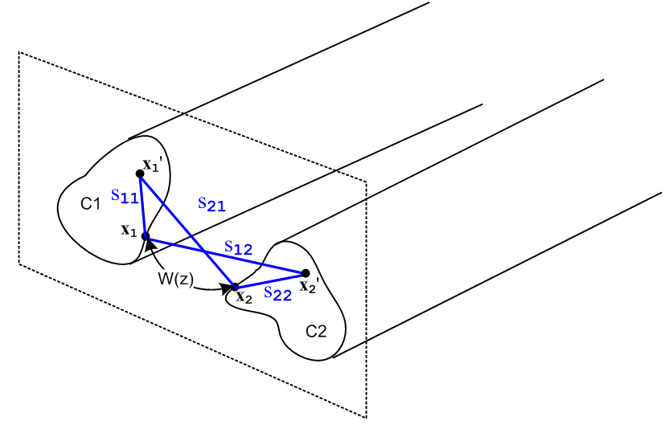 Fig 4.10
Equation (4.10.4) expresses the Az potential between the two transmission line conductors at some plane z in terms of the current distributions bi within the conductors.

Now, the Stokes theorem applied to B = curl A says

curl A = B ⇔ A • ds = ∫S B • dA . (1.1.39)

Consider the red loop shown in this top view of the two transmission line conductors. The loop is intended to have a tiny width dz, and the top view obscures the fact that each conductor has an arbitrary cross section. The loop makes contact with the points x1 and x2 shown in the previous figure,

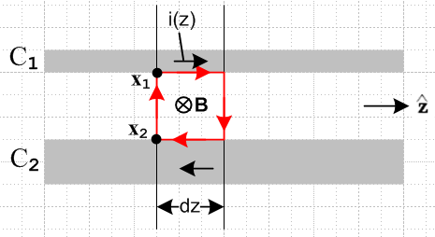 Fig 4.11

Since we neglect any transverse components of A, the Stokes theorem says

[Az1(top) - Az2(bottom) ] dz = [ magnetic flux through red loop] = ∫S B • dA . (4.10.5)

If we regard the two short dz length conductor pieces as forming a tiny "inductor", closed on the ends by the vertical red lines, we can use this definition of inductance to compute the inductance of that inductor:

[magnetic flux through red loop] = (Ledz) i(z) . (4.10.6)

Here (Ledz) is the inductance of our tiny loop, so Le is the transmission line inductance per unit length. We know (as in Appendix C) that there will be magnetic flux inside the conductors as well as between them, and for that reason Le as defined here only accounts for the "external" inductance of the transmission line, again see Appendix C.
Since [Az1(top) - Az2(bottom) ] = W(z) according to (4.10.1), we may combine (4.10.5) and (4.10.6) to obtain

W(z) = Le i(z) . (4.10.7)

Therefore from (4.10.4) we have found that

Le = $\frac{W(z)}{i(z)}$ = $\frac{μ}{4π}$ KL (4.10.8)

where KL is the following dimensionless real number,

KL ≡ $^{\int_{C1}^{}{}}$dx1' dy1' b1(x1',y1') ln(s212/s112) -$^{\int_{C2}^{}{}}$dx2' dy2' b2(x2',y2') ln(s222/s122) . (4.10.9)

This number is reminiscent of the number K obtained in Section 4.4,

K ≡ $^{\int_{C1}^{}{}}$dx1' dy1' α1(x1',y1') ln(s212/s112) -$^{\int_{C2}^{}{}}$dx2' dy2' α2(x2',y2') ln(s222/s122) . (4.4.8)

In the next section it will be shown that these two dimensionless numbers are exactly the same.

4.11 The Classic Transmission Line Equations

The results of the previous sections of this chapter may be succinctly summarized as:

(4.11.1)
$\frac{1}{C'}$ = $\frac{V(z)}{q(z)}$ = $\frac{1}{4πξ}$ K (4.4.7)
Le = $\frac{W(z)}{i(z)}$ = $\frac{μ}{4π}$ KL (4.10.8)

K ≡ $^{\int_{C1}^{}{}}$dx1' dy1' α1(x1',y1') ln(s212/s112) -$^{\int_{C2}^{}{}}$dx2' dy2' α2(x2',y2') ln(s222/s122) (4.4.8)
KL ≡ $^{\int_{C1}^{}{}}$dx1' dy1' b1(x1',y1') ln(s212/s112) -$^{\int_{C2}^{}{}}$dx2' dy2' b2(x2',y2') ln(s222/s122) (4.10.9)

Notice that we have made no assumptions whatsoever about the cross-sectional shape of the transmission line. We have only assumed that the transverse dimensions are small compared to the wavelength λ that corresponds to β -- this was the transmission line limit.

There are several equations from Chapter 1 we shall now press into service:

E = - grad φ - ∂tA (1.3.1)
div A = - με ∂tφ - μσφ . // the King gauge (1.3.18)

In the frequency domain these become,

E = - grad φ - jωA
div A = - j (β2/ω) φ . // the King gauge, see (1.5.1) and (1.5.5) re β2 (4.11.2)

According to the Fact stated in (4.7.1), potential A has only component Az, so these equations become

Ez(x) = - ∂zφ(x) - jωAz(x)
∂zAz(x) = - j (β2/ω) φ(x) . (4.11.3)

The potentials in the above equations are those due to both conductors and were denoted as φ12 and Az12 in the previous sections. We then rewrite the above as

Ez12(x) = - ∂zφ12(x) - jωAz12(x)
∂zAz12(x) = - j (β2/ω) φ12(x) (4.11.4)

where of course Ez12(x) is the z-directed electric field at some point x in the dielectric due to both conductors. Recall now the conductor-surface-located points x1 and x2 as shown for example in Fig 4.10. If we evaluate each of the above equations at x = x1 and then x = x2 and then subtract, we get

Ez12(x1) - Ez12(x2) = -∂z[φ12(x1) - φ12(x2)] - jω[Az12(x1) - Az12(x2)]
∂z[Az12(x1) - Az12(x2)] = - j (β2/ω)[φ12(x1) - φ12(x2)] . (4.11.5)

Then using these definitions

V(z) ≡ φ12(x1) - φ12(x2) (4.4.1)
W(z) ≡ Az12(x1) - Az12(x2) (4.10.1)

Ez1 ≡ Ez12(x1)
Ez2 ≡ Ez12(x2) (4.11.6)

we may rewrite (4.11.5) in this simple manner,

Ez1 - Ez2 = - ∂zV - jωW
∂zW = - j (β2/ω) V . (4.11.7)

The quantity Ez1 is the longitudinal electric field at the surface of conductor C1. It is related to the conductor's at-the-surface current density by Jz = σ Ez. If the conductor were "perfect", we would have σ = ∞ and Ez1 = 0. Real conductors are of course not perfect. As shown in (2.4.1), Ez1 can be related to the total current in the conductor i(z) by a quantity known as the surface impedance Zs, so

Ez1 = Zs1 i1(z) Ez2 = Zs2 i2(z) . (4.11.8)

The surface impedance of a perfect conductor is zero. Since i1(z) = -i2(z) = i(z), we rewrite (4.11.7) as,

(Zs1 + Zs2) i(z) = - ∂zV(z) - jωW(z)
∂zW(z) = - j (β2/ω) V(z) . (4.11.9)

The circle now closes when we insert into (4.11.9) the fact that W = Le i(z) from (4.11.1),

(Zs1 + Zs2) i(z) = - ∂zV - jω Le i(z)
Le ∂z i(z) = - j (β2/ω) V

which we then rearrange as

∂zV(z) = - [ Zi1+ Zi1+ jωLe] i(z)
∂z i(z) = - [ jβ2/(ωLe)] V(z) . (4.11.10)
These are the classic transmission line equations. They are usually written in this form:

$\frac{∂V(z)}{∂z}$= - z i(z) $\frac{∂i(z)}{∂z}$= - y V(z) (4.11.11)

where

z = R + jωL y = G +jωC . (4.11.12)

Note: We have been using bold notation only for vectors, and we now break that guideline by bolding these complex quantities z and y. Our purpose for this bolding is to distinguish them from Cartesian coordinates z and y which typically appear in the same problem. In King's books, all complex parameters are put in bold font, but we do this only for z and y.

Here, z and y are called the transmission line impedance and admittance, and the four numbers R,L,G,C are defined to be the appropriate real and imaginary parts. Comparing (4.11.10) and (4.11.11), we may therefore conclude that:

z = R + jωL = Zs1 + Zs2 + jωLe (4.11.13)

y = G + jωC = jβ2/(ωLe) . (4.11.14)

The expression for z seems quite reasonable since ωLe = XL = inductive reactance, but the expression for y seems a bit unusual. This is because we still have more work to do.

There is one more equation we have not yet utilized. Recall from Chapter 1 the integral form of the equation of continuity, which in the frequency domain takes this form,

div J = - jωρ ⇔ -jω[∫V ρ dV] = ∫S J • dS . (1.1.35)

We now apply this to a Gaussian box (blue) whose faces have the same shape as the conductor cross section but are slightly larger than that cross section so as to include the conductor surface charge :

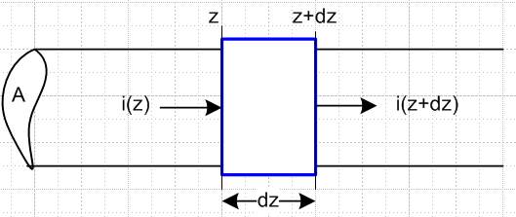 Fig 4.12

Ignoring transverse current out the sides of the box (since dz is tiny), we get

-jω[q(z)dz] = i(z+dz) - i(z) = total current flowing out of the box

which then says

∂z i(z) = -jωq(z) . (4.11.15)

From summary box (4.11.1) recall that q(z) = C'V(z) so we get

∂z i(z) = - [ jωC'] V(z) . (4.11.16)

Comparison with the second equation of (4.11.10) we find the following identity,

- [ jβ2/(ωLe)] = - [ jωC']
or
LeC' = β2/ω2 = μξ . // see (1.5.1) regarding β2 (4.11.17)

Then we can write (4.11.14) as

y = G + jωC = jβ2/(ωLe) = j (β2/ω2) (ω/Le) = j (LeC') (ω/Le) = jωC' . (4.11.18)

Thus, the line capacitance C is the real part of complex capacitance, C = Re(C'), and G = - ω Im(C').

Digression on the meaning of C'

Back in Section 1.5 (c) we discussed the fact that nc = (ξ/ε) ns which relates actual surface charge ns to the adjusted surface charge density nc which allows for dielectric leakage. This relationship (1.5.17) was derived in two different ways. As noted in Comment 3 at the start of Section 4.1, and looking at (4.1.1) and (4.1.2), one sees that the linear charge density q(z) which appears in all our equations is in fact related to nc and not ns, so we momentarily shall refer to q(z) as qc(z). Then qc(z) = ∫nc dxdy = an integral over the conductor surface for length dz. The actual charge on the surface of this piece of conductor is qs(z) ≡ ∫ns dxdy and therefore qc/qs = nc/na = (ξ/ε). The capacitance C per unit length of our transmission line is defined by qs = C V(z) . The complex capacitance C', which includes the effect of dielectric leakage current, is defined by qc = C' V(z). Therefore

C'/C = qc/qs = (ξ/ε) . (4.11.19)

and so then from (4.11.18), (4.11.19) and (1.5.1),

y = G + jωC = jωC' = jω(ξ/ε)C = jω (1 - jσ/εω)C = jωC + (σ/ε)C (4.11.20)

so that

G = (σ/ε)C . (4.11.21)

We saw an example of (4.11.19) in (1.5.19) for a parallel plate capacitor, and more generally in (4.4.10).
We may now rewrite the first equation in summary box (4.11.1) as

$\frac{1}{C'}$ = $\frac{1}{4πξ}$ K => $\frac{1}{C}$ = $\frac{1}{4πε}$ K . (4.11.22)

Next, combining (4.11.17) and (4.11.19) we find that

LeC' = μξ (4.11.23)

LeC = με = 1/v2 (4.11.24)

where v is the speed of light in the dielectric. Now the second equation in (4.11.1) says that

Le = $\frac{μ}{4π}$ KL . (4.11.25)

Inserting (4.11.25) for Le and (4.11.22) for C' into (4.11.23) gives

($\frac{μ}{4π}$ KL ) (4πξ/K) = μξ
or
KL = K . (4.11.26)

This is a remarkable connection between our two seemingly unrelated constants K and KL,

K ≡ $^{\int_{C1}^{}{}}$dx1' dy1' α1(x1',y1') ln(s212/s112) -$^{\int_{C2}^{}{}}$dx2' dy2' α2(x2',y2') ln(s222/s122) (4.4.8)
KL ≡ $^{\int_{C1}^{}{}}$dx1' dy1' b1(x1',y1') ln(s212/s112) -$^{\int_{C2}^{}{}}$dx2' dy2' b2(x2',y2') ln(s222/s122) . (4.10.9)

Since K involves a line integral of linear surface charge densities αi whereas KL involves a full cross sectional area integral of the current densities bi, it seems unlikely these integrals would be equal, but they are equal.

An example of K = KL

The equality even seems unlikely in a case with symmetric densities on round wires, so let's do a check using our Section 4.5 example with widely-space round wires of unequal diameters. The first thing we need is a new picture to display the "kinematics" of the KL integral ( since densities are symmetric, one should regard this picture as having b much larger than shown relative to a1 and a2),

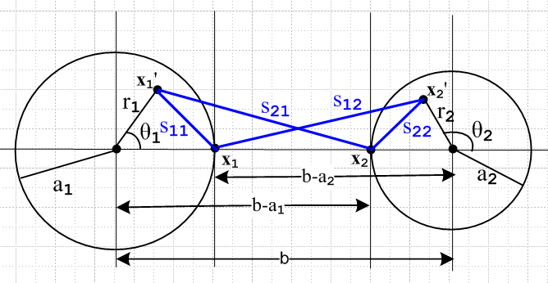 Fig 4.13

As before, we read off the four distances of interest using the law of cosines. The new distances are of course all different than they were before since x1' and x2' are now each integrated over their respective disks instead of the bounding circles.

s212 = r12 + (b-a1)2 - 2 r1(b-a1) cos(θ1)
s112 = r12 + a12 - 2 r1 a1 cos(θ1)
s222 = r22 + a22 + 2 r2 a2 cos(θ2)
s122 = r22 + (b-a2)2 + 2 r2(b-a2) cos(θ2) .

The integration rule is still

$^{\int_{0}^{2π}{}}$dθ ln (A ± Bcosθ) = 2π ln[(1/2)(A + $\sqrt{A2-B2}$ )] . (4.5.5)

The first integral is:

$^{\int_{0}^{2π}{}}$dθ1 ln(s212) = $^{\int_{0}^{2π}{}}$dθ1ln([r12 + (b-a1)2 - 2 r1(b-a1) cos(θ1)]

A = r12 + (b-a1)2 B = 2 r1(b-a1)

A2-B2 = [r12 + (b-a1)2]2 - 4 r12(b-a1)2 = [r12 - (b-a1)2]2 => $\sqrt{A2-B2}$= (b-a1)2- r12 > 0 b >> a1

=> $^{\int_{0}^{2π}{}}$dθ1 ln(s212) = 2π ln[(1/2)( r12 + (b-a1)2 + (b-a1)2 - r12 ) = 2π ln[(b-a1)2]

But this integral is the same as before! The s112 integral is obtained from the above with b-a1→a1

$^{\int_{0}^{2π}{}}$dθ1 ln(s112) = 2π ln(a12)

which is also the same as before. The other two integrals are found from 1→ 2. Our integral summary is then exactly the same as (4.5.6),

$^{\int_{0}^{2π}{}}$dθ1 ln(s212) = 2π ln[(b-a1)2]
$^{\int_{0}^{2π}{}}$dθ1 ln(s112) = 2π ln(a12)
$^{\int_{0}^{2π}{}}$dθ2 ln(s222) = 2π ln(a22)
$^{\int_{0}^{2π}{}}$dθ2 ln(s122) = 2π ln[(b-a2)2] . (4.5.6)

We now assume that the current densities bi each have radial symmetry ("widely spaced wires") ,

b1(r1,θ1) = b1(r1) (4.11.27)

where b1(r1) is a completely arbitrary function, with the following normalization of (4.7.4),

$^{\int_{0}^{2π}{}}$dθ1 $^{\int_{0}^{a1}{}}$r1dr1 b1(r1) = 1 => $^{\int_{0}^{a1}{}}$r1dr1 b1(r1) = 1/2π . (4.11.28)

We now proceed to calculate the constant KL

KL = $^{\int_{0}^{2π}{}}$dθ1 $^{\int_{0}^{a1}{}}$r1dr1 b1(r1) ln(s212/s112) -$^{\int_{0}^{2π}{}}$dθ2 r2dr2 b2(r2) ln(s222/s122)

= $^{\int_{0}^{a1}{}}$r1dr1 b1(r1) $^{\int_{0}^{2π}{}}$dθ1 ln(s212/s112) - $^{\int_{0}^{a2}{}}$r2dr2b2(r2) $^{\int_{0}^{2π}{}}$dθ2 ln(s222/s122)

= 2π $^{\int_{0}^{a1}{}}$r1dr1 b1(r1) [ln[(b-a1)2]- ln(a12)] - $^{\int_{0}^{a2}{}}$r2dr2b2(r2) [ ln[(b-a2)2] - ln(a22)]

= 2π [ln[(b-a1)2/a12] $^{\int_{0}^{a1}{}}$r1dr1 b1(r1) - 2π [ln[(b-a2)2/a22] $^{\int_{0}^{a2}{}}$r2dr2 b2(r2)

= [ln[(b-a1)2/a12] - [ln[(b-a2)2/a22]

= ln [$\frac{(b-a1)2(b-a2)2}{a12a22}$]

= K as obtained in (4.5.7) (4.11.29)

and we have then shown KL = K for this particular example. The key fact is that the dθ integrals appear to be functions of ri , but the ri2 terms cancel and so the dθ integrals are independent of ri.

We now summarize our results:

Classical Transmission Line Equations and Parameters (4.11.30)

K ≡ $^{\int_{C1}^{}{}}$dx1' dy1' α1(x1',y1') ln(s212/s112) -$^{\int_{C2}^{}{}}$dx2' dy2' α2(x2',y2') ln(s222/s122) (4.4.8)
KL ≡ $^{\int_{C1}^{}{}}$dx1' dy1' b1(x1',y1') ln(s212/s112) -$^{\int_{C2}^{}{}}$dx2' dy2' b2(x2',y2') ln(s222/s122) , (4.10.9)

K = KL real and dimensionless (4.11.26)

$\frac{∂V(z)}{∂z}$ = - z i(z) where z = R + jωL transmission line equations
$\frac{∂i(z)}{∂z}$ = - yV(z) (4.11.11) y = G +jωC (4.11.12)

z = Zs1 + Zs2 + jωLe (4.11.13) XL ≡ ωLe , XC ≡ 1/(ωC)
y = jωC' = jωC + (σ/ε)C (4.11.20) G = (σ/ε)C (4.11.21)

R = Re(Zs1+ Zs2) L = Le + (1/ω) Im(Zs1+ Zs2)

Le = $\frac{μ}{4π}$ K (4.11.25) and (4.11.26)

C' = 4πξ/K (4.11.22) C' = (ξ/ε)C (4.11.19)
C = 4πε/K (4.11.22)
G = 4πσ/K (4.11.22) + (4.11.21)

LeC' = μξ (4.11.23)
LeC = με = 1/v2 (4.11.24)

Z0 = $\frac{R + jωL}{G + jωC}$ = $\frac{z}{y}$ // this is derived in Appendix K (K.11)
Z0 (large ω) ≈ $\frac{L}{C}$ ≈ $\frac{Le}{C}$ = (1/4π) K $\sqrt{μ/ε}$ = (K/4π) Zm // See comments below

λ >> D (4.3.6) assumed transmission line limit where β = 2π/λ

β2 = μεω2 - jωμσ = ω2μ ( ε - jσ/ω) = ω2μ ξ ξ ≡ ε - jσ/ω . (1.5.1)

Comments:

1. In Chapter 2 we computed the surface impedance Zs for a round wire (radius a, μc, σc) in the case of axially symmetric current and we found that, for large ω,

Zs(ω) ≈ $\frac{1}{σc(2πa)δ}$ (1+j) (2.4.16)

δ ≡ $\sqrt{2/ωμcσc}$ = skin depth (2.2.20)

so that
Zs(ω) ≈ $\frac{1}{2π}$ $\frac{μc}{2a2σc}$ (1+j) $\sqrt{ω}$ . (4.11.31)

Presumably the result will be Zs(ω) ~ $\sqrt{ω}$ for any conductor cross section shape. Then

L = Le + (1/ω) Im(Zs1+ Zs2) = Le + (stuff) 1/$\sqrt{ω}$ → Le for large ω (4.11.32)

For this reason, the high frequency characteristic impedance Z0 can be written as shown above.

2. Conductors have internal inductance Li as well as external inductance Le. In Appendix C.3 (a) we compute the low frequency internal inductance of a round wire to be Li = μc/8π = (μc/μ0) * 50 nH/m . Our Chapter 4 transmission line development makes no mention of Li. This can be traced to Figure 4.11 where only the external magnetic flux is involved. In fact, Li is accounted for in the imaginary part of the surface impedance Zs . For example, we found that for our round wire situation,

Zs(ω) = $\frac{1}{σcπa2}$ + jω $\frac{μc}{8π}$ = Rs + jωLs // low frequency limit (2.4.12)

and here one sees that Ls = $\frac{μc}{8π}$ = Li .

3. We have assumed that ε and μ are real. If not, the usual adjustments can be made in (4.11.30) for the interpretations of R,L,G and C. See for example (3.3.4) concerning σ being replaced by σeff if ε has an imaginary part.

4. Apart from the symmetric cases like the examples of Section 4.5 and 4.6, we do not yet have a way to compute K and the transmission line parameters since the charge and current distributions αi and bi are not known. This matter will be remedied in Chapter 5.

5. A strip transmission line of width w and separation s with s << w is the simplest example of the above summary:

E = V/s n = εE = εV/s q = nw C = q/V = εw/s => K = 4πε/C = 4π(s/w)
so
C = 4πε/K = ε (w/s) K = 4π (s/w)
G = 4πσ/K = σ (w/s)
Le = (μ/4π) K = μ (s/w)
Z0 ≈ (K /$\sqrt{εrel}$) 30Ω = 4π (s/w) (1/$\sqrt{εrel}$) 30Ω = (s/w) (1/$\sqrt{εrel}$) 377Ω

4.12 Modifications to account for μ ≠ μ1 ≠ μ2.

These modifications only affect the Az and W(z) part of this chapter, not the first six sections which are concerned with φ and V(z). So changes start with Section 4.7.
If the equality μ = μ1 = μ2 assumed in Section 4.7 is broken, the result is that surface magnetization currents appear on one or both of the conductor surfaces and these cause an alteration of the theory. Thanks to the "Jm Theorem" proven in Appendix B, this alteration can be carried through with a very minimal impact, as we now show.
In Appendix B conductor magnetization surface currents are studied in some detail. The reader interested in how the magnetic modification is carried out would do well to read Appendix B at this point. A reader less interested can accept the Appendix B results and then learn below that basically nothing changes!

So imagine starting with μ = μ1 = μ2 and then changing μ1 and μ2 to new values. The question is: how do the various parameters and equations of the theory change? The first modification arises in Section 4.7. As described in Appendix B.6, the modified version of (4.7.2) is this,

Az1(x) = $\frac{μ1}{4π}$∫$_{}^{}$ [ Jz1(x') + $\frac{μ0}{μ1}$ Jzm1(x') ] $\frac{e-jβR}{R}$dx'dy'dz' . R = |x - x'| (4.7.2)'

where Jzm1 includes only the surface component of the magnetization current on conductor C1. Appendix B.6 shows how this Jzm1 adder term in effect adds a certain homogeneous solution to the particular solution (first term above) of the Az Helmholtz equation such that the Az boundary conditions are duly satisfied at the magnetic conductor C1 boundary. According to (B.1.10), the surface current Jzm1 when expressed in surface rather than volume notation is given by Kz = - ( $\frac{μ1}{μ0}$ - $\frac{μ}{μ0}$ ) Hθ and thus vanishes when μ1 = μ, resulting in the unmodified version of (4.7.2).

We maintain the next two equations of Section 4.7 as is, involving separation of variables,

Jz1(x,y,z) = b1(x,y) i1(z)
A/m2 1/m2 A (4.7.3)

where i1 is scaled such that

$^{\int_{C1}^{}{}}$dx dy b1(x,y) = 1 . (4.7.4)

This i1(z) is still the total conduction current in C1. But we now add two new equations,

Jz1m(x,y,z) = b1m(x,y) i1m(z)
A/m2 1/m2 A (4.12.1)

where i1m is scaled such that

$^{\int_{C1}^{}{}}$dx dy b1m(x,y) = 1 . (4.12.2)

It is understood here that b1m(x,y) is a distribution which is restricted to the surface of C1, but we continue to write it as if it existed at all points in the cross section of C1. The integration in (4.12.2) is of course meant to include this surface distribution.

We know from (B.1.11) and (B.1.12) that, for an arbitrarily shaped conductor C1,

i1m(z) ≡ - ( $\frac{μ1}{μ0}$ - $\frac{μ}{μ0}$ ) i(z) [ μ1 = conductor C1, μ = dielectric ], (4.12.3)

and that the current ratio is therefore given by,

f1m ≡ i1m(z)/ i(z) = - ( $\frac{μ1}{μ0}$ - $\frac{μ}{μ0}$ ) . (4.12.4)

With the above definitions, our modified (4.7.6) becomes

Az1(x,y,z) = $\frac{μ1}{4π}$$^{\int_{-∞}^{∞}{}}$dz' i(z') $^{\int_{C1}^{}{}}$dx' dy' [ b1(x',y') + $\frac{μ0}{μ1}$f1m b1m(x',y') ] $\frac{e-jβR}{R}$

= $\frac{μ}{4π}$$^{\int_{-∞}^{∞}{}}$dz' i(z') $^{\int_{C1}^{}{}}$dx' dy' [ $\frac{μ1}{μ}$b1(x',y') + $\frac{μ0}{μ}$f1m b1m(x',y') ] $\frac{e-jβR}{R}$ . (4.12.5)

This leads us to define a new effective transverse current density,

b'1(x,y) ≡ $\frac{μ1}{μ}$b1(x',y') + $\frac{μ0}{μ}$f1m b1m(x',y')

= $\frac{μ1}{μ}$ b1(x',y') + [1-$\frac{μ1}{μ}$] b1m(x',y') . (4.12.6)

This new transverse density b'1 is still normalized to unity, using (4.7.4) and (4.12.2) above,

$^{\int_{C1}^{}{}}$dx dy b'1(x,y) = $\frac{μ1}{μ}$$^{\int_{C1}^{}{}}$dx dy b1(x,y) + [1-$\frac{μ1}{μ}$]$^{\int_{C1}^{}{}}$dx dy b'1m(x,y)

= $\frac{μ1}{μ}$ * 1 + [1-$\frac{μ1}{μ}$] * 1 = 1 . (4.12.7)

How does b'1 differ from b1? The difference is that b1 does not include a surface current and b'1 does. We can represent equation (4.12.6) in this symbolic graphic manner:

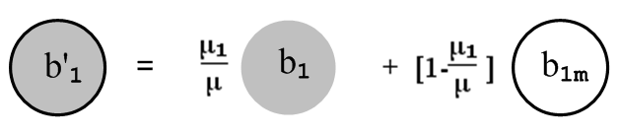 (4.12.6)

Thus, from (4.12.5) and (4.12.6) we have this new version of (4.7.6),

Az1(x,y,z) = $\frac{μ}{4π}$$^{\int_{-∞}^{∞}{}}$dz' i(z') $^{\int_{C1}^{}{}}$dx' dy' b'1(x,y) $\frac{e-jβR}{R}$ . (4.7.6)'

The differences are that the leading factor is μ instead of μ1, and b1 is replaced by b'1.

Moving into Section 4.8 we have this new version of (4.8.1),

Az12(x) = Az1(x) + Az2(x) =

$\frac{μ}{4π}$$^{\int_{-∞}^{∞}{}}$dz' i(z') { $^{\int_{C1}^{}{}}$dx1' dy1' b'1(x1',y1') $_{1}$ – $^{\int_{C2}^{}{}}$dx2' dy2' b'2(x2',y2') $_{2}$ }
(4.8.1)'

which is identical to (4.8.1) except bi → b'i. Then in the transmission line limit, we get this new version of (4.9.1),

Az12(x) = $\frac{μ}{4π}$ i(z) $^{\int_{-∞}^{∞}{}}$dz'{ $^{\int_{C1}^{}{}}$dx1' dy1' b'1(x1',y1') $\frac{1}{R1}$– $^{\int_{C2}^{}{}}$dx2' dy2' b'2(x2',y2') $\frac{1}{R2}$ } (4.9.1)'

From this point onward, all equations are the same apart from bi → b'i. Here are some of those equations after modification:

W(z) ≡ Az12(x1) - Az12(x2) (4.10.1)'

= $\frac{μ}{4π}$ i(z) $^{\int_{-∞}^{∞}{}}$dz' { $^{\int_{C1}^{}{}}$dx1' dy1' b'1(x1',y1') $\frac{1}{R11}$– $^{\int_{C2}^{}{}}$dx2' dy2' b'2(x2',y2') $\frac{1}{R12}$ }
– $\frac{μ}{4π}$ i(z) $^{\int_{-∞}^{∞}{}}$dz' { $^{\int_{C1}^{}{}}$dx1' dy1' b'1(x1',y1') $\frac{1}{R21}$ – $^{\int_{C2}^{}{}}$dx2' dy2' b'2(x2',y2') $\frac{1}{R22}$ }

W(z) (4.10.3)'
= $\frac{μ}{4π}$ i(z)$^{\int_{-∞}^{∞}{}}$dz' {$^{\int_{C1}^{}{}}$dx1' dy1' b'1(x1',y1')( $\frac{1}{R11}$- $\frac{1}{R21}$) -$^{\int_{C2}^{}{}}$dx2' dy2' b'2(x2',y2') ($\frac{1}{R12}$- $\frac{1}{R22}$) } .

W(z) = i(z) $\frac{μ}{4π}$ {$^{\int_{C1}^{}{}}$dx1' dy1' b'1(x1',y1') ln(s212/s112) -$^{\int_{C2}^{}{}}$dx2' dy2' b'2(x2',y2') ln(s222/s122) }
(4.10.4)'
KL ≡ $^{\int_{C1}^{}{}}$dx1' dy1' b'1(x1',y1') ln(s212/s112) -$^{\int_{C2}^{}{}}$dx2' dy2' b'2(x2',y2') ln(s222/s122) (4.10.9)'

Le = $\frac{W(z)}{i(z)}$ = $\frac{μ}{4π}$ KL // no change (4.10.8)

We then enter Section 4.11. The derivation of the transmission line equations (4.11.11) is unaffected by the above modifications; the only change is that the b'i appear in the integral KL in place of the bi. The derivation of the fact that K = KL ending in (4.11.26) is also unchanged! This at first seems strange since K has not changed, but we have apparently altered KL by the replacements bi → b'i. But KL is not an evaluation -- it is an integral equation relating KL to the b'i. In the self-consistent solution, the new functions (distributions) b'i adjust themselves so that KL does not change. KL cannot change because (4.11.26) says it must remain equal to K which is determined by the electrostatic side of the problem. It is perhaps helpful to look at (4.11.25) which says Le = $\frac{μ}{4π}$ KL . We know that if the dielectric μ value does not change, the external inductance Le of the transmission line cannot change so KL stays fixed. Changing μ1 and/or μ2 away from the value μ will of course change the internal inductances of the conductors, and this is duly noted below in terms of surface impedances. As μ1 is increased, the B field inside conductor C1 increases (H stays the same) so the stored B field increases, and Li increases.
Finally, if we look at the example associated with Fig 4.13, we still find explicitly that KL= K because the calculation leading to (4.11.29) is unchanged when bi are replaced with b'i, since the b'i are still normalized to unity as shown in (4.12.7).

The happy bottom line is that all of summary box (4.11.30) is unchanged except bi → b'i in the KL integral. The constant K can still be evaluated using the "capacitor problem" of Section 5.5 below and it is unaffected by conductors having μi ≠ μ.

Having said this, let us now consider what happens to an operating transmission line which starts off with μ1 = μ2 = μ = μ0 and we then gradually turn a magic "permeability knob" so that μ1 gradually increases from μ0 to some value μ1 > μ0. That is to say, we gradually cause conductor C1 to become magnetic. The constant K (and therefore KL = K) does not change at all. This K is determined by the potential φ part of the problem in Section 4.4 and does not even know about the magnetic modification. Thus, looking at (4.11.30), C', C, G and Le do not change. In particular, Le does not change because we have not altered μ of the dielectric. The following two items shown in box (4.11.30) do change :

R = Re(Zs1 + Zs2) L = Le + (1/ω) Im(Zs1 + Zs2)

where Zsi is the surface impedance of conductor Ci. The non-Le term in L can be interpreted as the internal inductance of the conductors. R and L change because Zs1 changes if we change μ1. This is so because Zs1 is always a function of the skin depth δ1, and δ1 ≡ $\sqrt{2/(ωμ1σ1)}$ from (2.2.20). In the special case that C1 is a round wire of radius a1 with an axially symmetric current distribution (such as the center wire of a coaxial cable), we showed in (2.4.11) that the surface impedance is given by

Z1s(ω) = $\sqrt{2}$ $\frac{ber0[\sqrt{2}(a1/δ1)] + j bei0[\sqrt{2}(a1/δ1)]}{ber0'[\sqrt{2}(a1/δ1)] + j bei0'[\sqrt{2}(a1/δ1)]}$, (2.4.11)

so certainly this Zs(ω) is a function of μ1 both due to the leading constant and through the five occurrences of δ1. Both the real and imaginary parts of Z1s(ω) will change as μ1 changes, so the transmission line parameters R and L both change. In the high frequency limit ,

Z1s(ω) ≈ $\frac{1}{σ1(2πa1)δ1}$ (1+j) δ << 16a . (2.4.16)

so now the variation with μ1 is through the single δ1 factor shown. Again, both real and imaginary parts of Z1s(ω) vary with μ1.

Since R and L change as noted above, the transmission line characteristic impedance will also change,

Z0 = $\frac{R + jωL}{G + jωC}$ = $\frac{z}{y}$ (K.11)

This means, for example, if we drive a semi-infinite transmission line with some fixed voltage V(z), the driving current i(z) will vary in amplitude and phase as we turn our "permeability knob" for conductor C1. This is simply because i(z) = V(z)/Z0.

So the good news is that the theory of Chapter 4 is easily extended to allow for magnetic conductors and or dielectric. Once again, the summary box (4.11.30) is unchanged when μ1 = μ2 = μ is broken except for the appearance of b'i in the KL integral, and except for the fact that Zs1 and Zs2 change as noted above, causing changes in R, L and Z0. At very high frequency, one will have Z0 = $\sqrt{(Le/C)}$ and in this case Z0 is not altered, see (4.11.32).

Chapter 5: The Transverse Problem

In this Chapter we define a certain "transverse" potential theory problem and a prescription for the solution of that problem to obtain K and the transmission line parameters C, G and Le.

In this chapter μ, ε, ξ, β, σ are all parameters of the dielectric.

5.1 Separation of φ

Let φ ≡ φ12(x) of Section 4.2. Then in the transmission line limit we found in (4.3.10) that,

φ(x) = $\frac{1}{4πξ}$ q(z) $^{\int_{-∞}^{∞}{}}$dz'{ $^{\int_{C1}^{}{}}$dx1' dy1' α1(x1',y1') $\frac{1}{R1}$– $^{\int_{C2}^{}{}}$dx2' dy2' α2(x2',y2') $\frac{1}{R2}$ } . (4.3.10)

Rewrite the above equation as,

φ(x,y,z) = $\frac{1}{4πξ}$ q(z) φt(x,y) (5.1.1)

φt(x,y) = $^{\int_{-∞}^{∞}{}}$dz'{ $^{\int_{C1}^{}{}}$dx1' dy1' α1(x1',y1') $\frac{1}{R1}$– $^{\int_{C2}^{}{}}$dx2' dy2' α2(x2',y2') $\frac{1}{R2}$ } (5.1.2)

where R1 = |x-x1'|, R2 = |x-x2'|, and x is a point in the dielectric. We thus identify φt as a dimensionless "transverse potential" associated with the full potential φ.

Recall that x1 and x2 are points on the surfaces of conductors C1 and C2 at the same z. Evaluate (5.1.1) at x1 then at x2 and then subtract to get the right equation below,

V(z) = φ(x1) - φ(x2) = $\frac{1}{4πξ}$ q(z) [φt(x1,y1) - φt(x2,y2)] .

The left side is just V(z) according to (4.4.1). Recalling now from (4.4.7) that

V(z) = q(z) $\frac{1}{4πξ}$ K (4.4.7)

we conclude that

φt(x1,y1) - φt(x2,y2) = K. (5.1.3)

The Helmholtz equation for φ is given by (1.5.3) for a region including dielectric and conductors,

(∇2 + β2)φ(x,y,z) = - (1/ε) ρ(x,y,z) (1.5.3) (5.1.4)

where ρ(x,y,z) exists on the boundary of the dielectric region (ie, on the conductor surfaces). Inside the dielectric there is no ρ so we then have

(∇2 + β2)φ(x,y,z) = 0 . // dielectric region (5.1.5)

Inserting (5.1.1) into (5.1.5) yields,

(∇2 + β2) $\frac{1}{4πξ}$ q(z) φt(x,y) = 0
or
(∇t2 + ∂z2 + β2) $\frac{1}{4πξ}$ q(z) φt(x,y) = 0 // ∇t2 = ∇2D2 = ∇2 - ∂z2
or
∇t2φt(x,y) q(z) + φt(x,y) ∂z2q(z) + β2 φt(x,y) q(z) = 0 .

Divide through by φt(x,y) q(z) to get

$\frac{∇t2φt(x,y)}{φt(x,y)}$ + $\frac{∂z2 q(z)}{q(z)}$ + β2 = 0
or
[ $\frac{∇t2φt(x,y)}{φt(x,y)}$ ] + $\frac{∂z2 q(z)}{q(z)}$ = - β2 (5.1.6)

which has the general form,

[ h(x,y) ] + g(z) = - β2 .

The only way this can be true for all x,y,z in a region is if g(z) = some constant, which call - kφ2. Then,

$\frac{∂z2 q(z)}{q(z)}$= - kφ2 $\frac{∇t2φt(x,y)}{φt(x,y)}$ = - β2 + kφ2 . (5.1.7)

We can rewrite these equations as

[ ∇t2 + (β2 - kφ2)] φt(x,y) = 0 (5.1.8)

[ ∂z2 + kφ2] q(z) = 0 . (5.1.9)

According to Fact (3.8.10) and (5.1.1), for a particular z value, we expect φt(x,y) to have some constant value K1 on the entire perimeter of a cross section of conductor C1, and some other constant value K2 on the entire perimeter of a cross section of conductor C2, These facts act as boundary conditions for (5.1.7).

φt(C1) = K1 φt(C2) = K2 K1 - K2 = K (5.1.10)

so that (5.1.3) is realized.

The second equation (5.1.9) has the following solution

q(z) = q(0) e-jk$_{φ}$z => q(z,t) = q(0) ej(ωt-k$_{φ}$z) (5.1.11)

and we find that q(z) has the form of a wave traveling down the transmission line with wavenumber kφ.

The reader of Chapter 2 or of Appendix D will recognize this as the form assumed for the electric field in (2.1.1) or (D.1.1) where it was assumed as an ansatz without much a priori justification. For example,

E(r,φ,z,t) = ej(ωt-β$_{d}$z) E(r,φ) . (D.1.1)

where βd of Appendix D is the dielectric's β in our current context. When the dust settles below, for a low-loss transmission line we shall in fact end up with kφ = β so that (D.1.1) has the same traveling wave form as (5.1.11).

5.2 Separation of Az

Let Az ≡ Az12(x) of Section 4.8. Then in the transmission line limit we found in (4.9.1) that

Az(x) = $\frac{μ}{4π}$ i(z) $^{\int_{-∞}^{∞}{}}$dz'{ $^{\int_{C1}^{}{}}$dx1' dy1' b1(x1',y1') $\frac{1}{R1}$– $^{\int_{C2}^{}{}}$dx2' dy2' b2(x2',y2') $\frac{1}{R2}$ } . (4.9.1)

Rewrite the above equation as,

Az(x,y,z) = $\frac{μ}{4π}$ i(z) Azt(x,y) (5.2.1)

Azt(x,y) = $^{\int_{-∞}^{∞}{}}$dz'{ $^{\int_{C1}^{}{}}$dx1' dy1' b1(x1',y1') $\frac{1}{R1}$– $^{\int_{C2}^{}{}}$dx2' dy2' b2(x2',y2') $\frac{1}{R2}$ } (5.2.2)

where R1 = |x-x1'|, R2 = |x-x2'|, and x is a point in the dielectric. We thus identify Azt as a dimensionless "transverse vector potential" associated with the full vector potential Az.

Recall that x1 and x2 are points on the surfaces of conductors C1 and C2 at the same z. Evaluate (5.2.1) at x1 then at x2 and then subtract to get the right equation below,

W(z) = Az(x1) - Az(x2) = $\frac{μ}{4π}$ i(z) [Azt(x1,y1) - Azt(x2,y2)] .

The left side is just W(z) according to (4.10.1). Recalling now

Le = $\frac{W(z)}{i(z)}$ = $\frac{μ}{4π}$ KL => W(z) = $\frac{μ}{4π}$ i(z) KL (4.10.8)

we conclude that

Azt(x1,y1) - Azt(x2,y2) = KL.

But (4.11.26) says KL = K, so write this last as

Azt(x1t) - Azt(x2t) = K . (5.2.3)

The Helmholtz equation for Az is given by (1.5.4) for a region including dielectric and conductors,

(∇2 + β2)Az(x,y,z) = - Σi=2N μiJi . (1.5.4) (5.2.4)

These Ji are currents inside the conductors. Although there is small conduction current in the dielectric, it has been absorbed into β2 as shown in (1.3.21) in the time domain with the use of the King gauge. If we take our region of interest to be the dielectric alone, we then have

(∇2 + β2)Az(x,y,z) = 0 . // dielectric region (5.2.5)

Inserting (5.2.1) into (5.2.5) yields,

(∇2 + β2) $\frac{μ}{4π}$ i(z) Azt(x,y) = 0
or
(∇t2 + ∂z2 + β2) $\frac{μ}{4π}$ i(z) Azt(x,y) = 0
or
∇t2Azt(x,y) i(z) + Azt(x,y)∂z2i(z) + β2 Azt(x,y) i(z) = 0 .

Now divide through by Azt(x,y) i(z) to get

[$\frac{∇t2 Azt(x,y)}{Azt(x,y)}$] + $\frac{∂z2 i(z)}{i(z)}$+ β2 = 0 (5.2.6)

which has the general form,

[ h(x,y) ] + g(z) = - β2 .

The only way this can be true for all x,y,z in a region is if g(z) = some constant, which call -kA2. Then,

$\frac{∂z2 i(z)}{i(z)}$= - kA2 $\frac{∇t2 Azt(x,y)}{Azt(x,y)}$ = - β2 + kA2 . (5.2.7)

We can rewrite these equations as

[ ∇t2 + (β2 - kA2)] Azt(x,y) = 0 (5.2.8)

[ ∂z2 + kA2] i(z) = 0 . (5.2.9)

According to Fact (3.8.11) and (5.2.1), for a particular z value, we expect Azt(x,y) to have some constant value W1 on the entire perimeter of a cross section of conductor C1, and some other constant value W2 on the entire perimeter of a cross section of conductor C2, These facts act as boundary conditions for (5.1.7). Since a potential has an arbitrary zero, we shall set

Azt(C1) = W1 Azt(C2) = W2 W1 - W2 = K (5.2.10)

so that (5.2.3) is realized.

The second equation (5.2.9) has the following solution

i(z) = i(0) e-jk$_{A}$z => i(z,t) = i(0) ej(ωt-k$_{A}$z) (5.2.11)

and we find that i(z) has the form of a wave traveling down the transmission line with wavenumber kA.

Comparing (5.2.11) with (5.1.11), it would certainly seem odd if q(z) and i(z) had the form of traveling waves with different wavenumbers kφ ≠ kA. We will formally show in the next section that kφ = kA.

5.3 Development of the Transverse Problem

(a) kφ = kA and the transverse equations

The longitudinal equations from the previous two sections are these:

[ ∂z2 + kφ2 ] q(z) = 0 (5.1.8)
[ ∂z2 + kA2 ] i(z) = 0 . (5.2.8)

But,
φ(x,y,z) = $\frac{1}{4πξ}$ q(z) φt(x,y) (5.1.1)
Az(x,y,z) = $\frac{μ}{4π}$ i(z) Azt(x,y) . (5.2.1)

Therefore,

[ ∂z2 + kφ2 ] φ(x,y,z) = 0
[ ∂z2 + kA2 ] Az(x,y,z) = 0 . (5.3.1)

Recall that x1 and x2 are points on the surfaces of conductors C1 and C2. If we write equations (5.3.1) first at x1 and then at x2 and then subtract, we get longitudinal equations for V(z) and W(z),

[ ∂z2 + kφ2 ] V(z) = 0 // V(z) = φ(x1) - φ(x2)
[ ∂z2 + kA2 ] W(z) = 0 // W(z) = Az(x1) - Az(x2) (5.3.2)

where we have used the definitions V(z) and W(z) from (4.4.1) and (4.10.1). Recall now the transmission line equations (4.11.11),

∂zV(z) = - z i(z) ∂zi(z) = - yV(z) . (4.11.11)

Apply ∂z to each equation and move the right side to the left side,

∂z2V(z) + z ∂z i(z) = 0 ∂z2i(z) + y ∂zV(z) = 0 .

Now reuse (4.11.11) to replace ∂z i(z) = - yV(z) and ∂zV(z) = - z i(z) to get,

[∂z2 - zy ]V(z) = 0 [∂z2 - zy ] i(z) = 0 .

Finally, use (4.10.8) to replace i(z) = W(z)/Le to get,

[∂z2 - zy ]V(z) = 0
[∂z2 - zy ]W(z) = 0 . (5.3.3)

Comparison of (5.3.3) with (5.3.2) shows that

kφ2 = kA2 ≡ k2 = -zy (5.3.4)

which fulfills the expectation earlier that we should have kφ = kA .

Recall from box (4.11.30) that

z = Zs + jωLe = Zs + jω$\frac{μ}{4π}$ K Zs ≡ Zs1 + Zs2
y = jωC' = jω 4πξ/K (5.3.5)
so
k2 = -zy = -[Zs + jω$\frac{μ}{4π}$ K] jω 4πξ/K

= -Zs jω 4πξ/K + ω2μξ

= - jω Zs 4πξ/K + β2 . // see (1.5.1) for β2 (5.3.6)

Therefore

(β2 - k2) = jω Zs 4πξ / K = $\frac{jω Zs 4πξ}{K}$ . (5.3.7)

The transverse equations (5.1.8) and (5.2.8) and boundary conditions (5.1.10) and (5.2.10) may now be summarized:

[ ∇t2 + (β2-k2)] φt(x,y) = 0 φt(C1) = K1 φt(C2) = K2 K1- K2 = K (5.3.8)
[ ∇t2 + (β2-k2)] Azt(x,y) = 0 Azt(C1) = W1 Azt(C2) = W2 W1- W2 = K (5.3.9)

where (β2- k2) = $\frac{jω Zs 4πξ}{K}$ .

(b) The scaling boundary condition on φt(x)

There exists another boundary condition on φt in the case that the dielectric extends transversely to infinity. Recall (5.1.2) for φt(x,y) = φt(x),

φt(x) = $^{\int_{-∞}^{∞}{}}$dz'{ $^{\int_{C1}^{}{}}$dx1' dy1' α1(x1',y1') $\frac{1}{R1}$– $^{\int_{C2}^{}{}}$dx2' dy2' α2(x2',y2') $\frac{1}{R2}$ } (5.1.2)

R12 = (x-x1')2 + (y-y1')2 + (z-z')2 = s12 + (z-z')2 s12 = (x-x1')2 + (y-y1')2 (4.2.1)
R22 = (x-x2')2 + (y-y2')2 + (z-z')2 = s22 + (z-z')2 s22 = (x-x2')2 + (y-y2') .

If we take the point x transversely far away from the conductors, the following drawing shows the distances R1 and R2 which appear in the above integration,

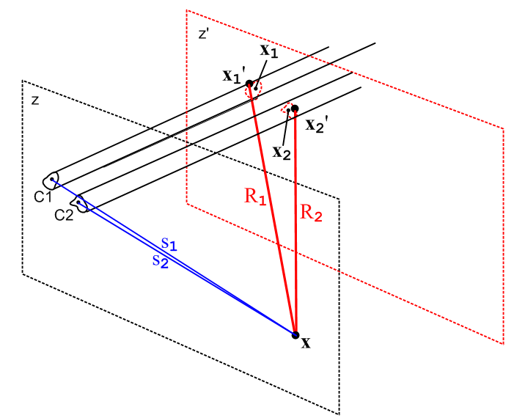 Fig 5.1

During the transverse integration $^{\int_{C1}^{}{}}$dx1' dy1', distance R1 does not vary much and can be replaced with a distance from x to the "center" of conductor C1 without changing the integral significantly. The same can be said for R2. We shall refer to these "center points" as x1 and x2 (this is a new and different use for these variable names). In this case, we obtain

φt(x) ≈ $^{\int_{-∞}^{∞}{}}$dz' { $\frac{1}{R1}$ $^{\int_{C1}^{}{}}$dx1' dy1' α1(x1',y1') – $\frac{1}{R2}$$^{\int_{C2}^{}{}}$dx2' dy2' α2(x2',y2') }

= $^{\int_{-∞}^{∞}{}}$dz' { $\frac{1}{R1}$ - $\frac{1}{R2}$ } = $^{\int_{-∞}^{∞}{}}$dz' ($\sqrt{s12 + (z-z')2}$ - $\sqrt{s22 + (z-z')2}$) (5.3.10)

where we have used the fact (4.1.3) that the transverse charge densities are normalized to unity. The dz' integral was done in (4.4.5) and equals ln(s22/s12), so then

φt(x) ≈ ln(s22/s12) // limiting form as point x = (x,y) moves far from the conductors
(5.3.11)
s12 = (x-x1)2 + (y-y1)2
s22 = (x-x2)2 + (y-y2)2 .

Whatever the exact solution φt(x) might be, in the limit discussed above one must obtain φt(x) ≈ ln(s22/s12). Of course as one continues to move x away to infinity, s1 ≈ s2 and then φt(x) ≈ ln(1) = 0. Basically (5.3.11) is a boundary condition on the "scale" of the solution φt(x). If someone were to propose a possible solution φt(x) = 2.6 ln(s22/s12) for some conductor geometry, we could instantly rule out that solution since it violates the boundary condition (5.3.11). The scale of φt is restricted in this manner because the charge distributions αi appearing in (5.3.10) are normalized to unity.

By the exact same argument presented above, we have

Azt(x) ≈ ln(s22/s12) // limiting form as point x = (x,y) moves far from the conductors (5.3.12)

We shall give an interpretation of these limiting forms in Section 5.4 (b) below.

5.4 The "low-loss" approximation

(a) Transverse Equations for a Low-Loss transmission line

In this approximation, we take the conductor surface impedance Zs ≈ 0. Recall from (5.3.6) that

k2 = β2 - jω Zs 4πξ/K . (5.3.6)

Our definition of a "low-loss" transmission line is one for which k2 ≈ β2 and in this case the longitudinal wave number k as shown in (5.1.11) and (5.2.11) is k = β which is the just the β value of the dielectric. So our low-loss condition is (using (1.5.1) for β2),

| jω Zs 4πξ/K| << |β2|
or
|Zs| << (1/4π) | β2/(ωξ)| K = (1/4π) ω | β2/(ω2ξ)| K = (1/4π) ωμ K . (5.4.1)

For a symmetric-environment round wire of radius a we found in (2.4.12) that for large ω,

Zs ≈ $\frac{1}{σ(2πa)δ}$ (1+j) for δ << 16a δ2 = 2/ωμσ . (2.4.16)

Our low-loss condition is then

$\frac{1}{σ(2πa)δ}$$\sqrt{2}$ << ωμ (K/4π)
or
$\frac{1}{(2πa)δ}$$\sqrt{2}$ << ωμσ (K/4π) = (2/δ2) (K/4π)
or
(δ/a) << K/$\sqrt{2}$ . (5.4.2)

We saw in the Example of Section 4.6 that K = 2 ln(a2/a1) for a coaxial cable. Even for a very large radius ratio of 100 this would be K = 2 ln(100) = 9.2. For a more typical ratio of perhaps 5, K ≈ 3.2. Then our inequality above says roughly

(δ/a) << 2

which is then our ball-park estimate for applicability of the "low-loss transmission line" condition. We showed in Section 2.5 how Zs can be modified for some other geometry. Basically this says we are in the low-loss limit if the skin depth is much smaller than the wire's transverse dimensions.
If we assume this low-loss limit is in effect, then

β2-k2 = jω Zs 4πξ/K ≈ 0

and our transverse equations (5.3.8) and (5.3.9) become 2D Laplace equations,

∇t2φt(x,y) = 0 φt(C1) = K1 φt(C2) = K2 K1- K2 = K (5.4.3)
∇t2Azt(x,y) = 0 Azt(C1) = W1 Azt(C2) = W2 W1- W2 = K (5.4.4)

As commented earlier, the parallelism between φt and Azt should not be surprising in light of Section 1.3 (b) where it was noted that A and φ are components of the same relativistic 4-vector.

(b) The scaling boundary condition (5.3.11) revisited

First, a quick review.

In 3D the potential (SI units) of a point charge q located at x1 is φ(x) = (q/4πε|x-x1|) = q/(4πεR1).
In 2D the potential of a point charge q located at x1 is φ(x) = -(q/2πε)ln|x-x1| = -(q/2πε)lns1.

The 3D φ(x) is the solution of -∇2(φ) = (q/ε)δ3)(x-x1) as shown in (H.1.4) and as proven in Appendix H.
The quantity 1/4πR1 is the 3D free-space propagator of the 3D Laplace equation. It is the Green's function of the equation -∇2g(x|x1) = δ(3)(x-x1) .

The 2D φ(x) is the solution of -∇22D(φ) = (q/ε)δ(2)(x-x1) as shown in (I.1.4) and as proven in Appendix I. The quantity -2πlns1 is the 2D free-space propagator of the 2D Laplace equation. It is the Green's function of the equation -∇22Dg(x|x1) = δ(2)(x-x1).

With this brief review, we now examine a 2D cross section view of the transmission line of Fig 5.1 at a scale that makes the two conductors appear very small and very close together, and at the same time we imagine more elaborate cross section shapes. The dielectric is assumed non-conducting, so ξ = ε. The three points indicated by the three dots on the right all lie in the plane of paper, this is just a 2D drawing and for example x = (x,y).

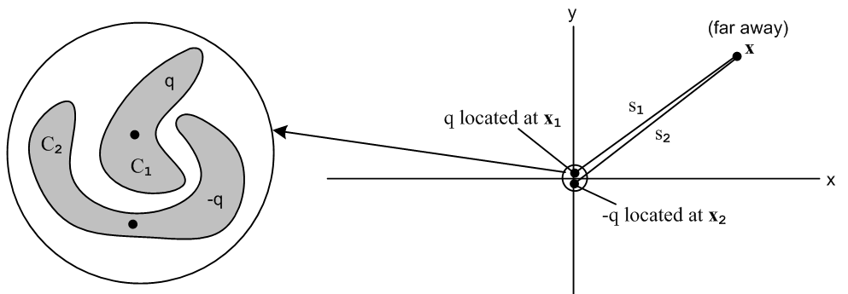
Fig 5.2

The dots on the left indicate the "center of charge" for each conductor and these dots appear also on the right. The claim is that when x is very far away, the variation in s1 as it moves over the perimeter of the conductor C1 cross section is so small that we can replace s1 with a distance to the center of charge of C1 and similarly for R2. Thus, on the right we end up with the 2D potential of two point charges which form a 2D electric dipole. Using the results just quoted in the above review, we find that

φ(x) = φ1(x) + φ2(x) = -(q/2πε)ln|x-x1| -(-q/2πε)ln|x-x2| = -(q/2πε) lns1+(q/2πε) lns2

= (q/2πε) ln(s2/s1) = (q/4πε)ln(s22/s12) .

Recalling for ξ = ε that

φ(x,y,z) = $\frac{1}{4πε}$ q(z) φt(x,y) (5.1.1)

we find that

φt(x,y) = ln(s22/s12) . // for r far away

Thus we have an alternate derivation and 2D dipole interpretation of our earlier "scaling boundary condition" (5.3.11).

5.5 The Capacitor Problem

We have now boiled down the computation of transmission line parameters (in the transmission line limit and in the low-loss limit) to the problem of computing the capacitance of a section of transmission line. Here we assume the dielectric is non-conducting so ξ = ε and we don't have to worry about the distinction between charge densities qc and qs as discussed in (4.11.19).

Solving the capacitor problem using φ

A standard approach to a general 2D electrostatics capacitor problem is as follows. Start with

∇2D2φ(x,y) = 0 φ(C1) - φ(C2) = V = voltage between conductors (5.5.1)

where we now (arbitrarily) use notation ∇22D in place of ∇2t.
Since the dielectric presumably fills the region between the conductors, the dielectric is the official "region" of a Green's function problem. If we put a unit positive point charge at some location (x',y') in the dielectric region we can then formally (!) solve this 2D Green's function problem,

− ∇2D2g(x,y|x',y') = δ(x-x')δ(y-y') g(x,y|x',y') = 0 for (x,y) on both C1 and C2
g(x,y|x',y') = 0 for (x,y) = ∞ (if appropriate) (5.5.2)

Here g(x,y|x',y') is specific to our geometry; it is not the 2D free-space Green's function - ln(1/R)/2π shown in (I.1.4). The free-space solution has only the lower boundary condition stated above. We assume now that this Green's function problem has been solved, either analytically, approximately, or numerically, so that g(x,y|x',y') is known (example coming in Chapter 6).

In very general notation, if a region contains some sources q(x) and if the potential φ is prescribed on the entire closed boundary surrounding the region by a function f, then the solution to (5.5.1) is given in Stakgold notation as (1.5.11) (which we derive in the lines following (1.5.11) for both Laplace and Helmholtz equations ),

φ(x) = ∫R dx' g(x|x') q(x') – ∫σ dSξ f(ξ) ∂ξng(x|ξ) // Stakgold (6.81) . (1.5.11)

where σ represents the closed boundary of the region of interest, dSξ is an integration over this boundary, and ∂ξng(x|ξ) is the derivative of the Green's function in a direction locally normal to the boundary surface. In potential theory, this type of problem is known as "the Dirichlet Problem". In our case the boundary consists of C1, C2 and the Great Circle at ∞. Stakgold deals in an arbitrary number of spatial dimensions, but of course we have only 2 dimensions here, so dSξ is a line integral around the boundary. A picture is in order, showing a cross section of the transmission line,

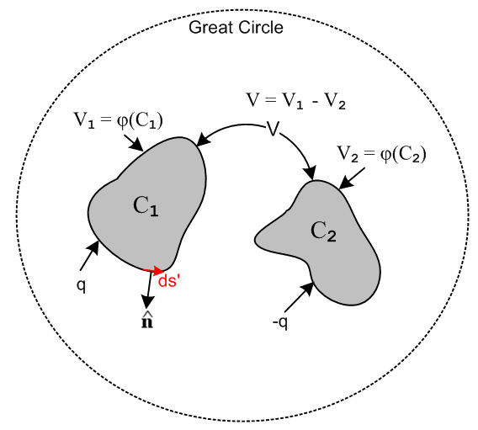 Fig 5.3

We know that on the great circle φ = 0, so there will be no contribution from that part of the Dirichlet boundary. What we do not know are V1 and V2 which are the constant potentials on C1 and C2. If it happened that the picture had mirror symmetry in a plane separating the two conductors, we would know that V1 = V/2 and V2 = -V/2, but in the general case we don't know V1 and V2 a priori. For the moment, we leave them as to-be-determined quantities.

In our application of (1.5.11) there are no charges q(x) in the dielectric region. We put one there temporarily to obtain the Green's function, but it is now gone. Thus (1.5.11) reads

φ(x,y) = – C1 ds' f(C1) ∂ng(x,y|x',y') – C2 ds' f(C2) ∂ng(x,y|x',y') - GC ds' f(∞) ∂ng(x,y|x',y')

= – C1 ds' V1 ∂ng(x,y|x',y') – C2 ds' V2 ∂ng(x,y|x',y') – GC ds' (0) ∂ng(x,y|x',y')

= -V1 C1 ds' ∂ng(x,y|x',y') – V2 C2 ds' ∂ng(x,y|x',y') }.

= V1 F1(x,y) + V2F2(x,y) (5.5.3)

where the Fi(x,y) are determined by doing the line integrals for a given geometry. If y = y1(x) describes a piece of the C1 perimeter, then

ds' = $\sqrt{dx'2 + dy'2}$= $\sqrt{1 + ∂x'y1(x')}$ dx' (5.5.4)

which gives a candidate ds' for doing the line integral over that piece of the perimeter.

Once φ(x,y) is known, one can compute the normal electric field En at the conductor surfaces,

En(x) = - ∂n1φ(x) = -V1 [∂n1F1(x)] - V2 [∂n1F2(x)] ≡ V1 G11(x) + V2 G12(x) x on C1
En(x) = - ∂n2φ(x) = -V1 [∂n2F1(x)] - V2 [∂n2F2(x)] ≡ V1 G21(x) + V2 G22(x) . x on C2
(5.5.5)

Since the conductors are different, the resulting four functions Gij will in general be different. For example, we are taking normal derivatives of the Fi at different points in space on different (1D) surfaces.

We may now compute the (linear) surface charge density using (1.1.47) assuming En = 0 inside the conductor,

n1(x,y) = εEn(x,y) = εV1 G11(x) + εV2 G12(x) x on C1
n2(x,y) = εEn(x,y) = εV1 G21(x) + εV2 G22(x) x on C2 (5.5.6)

where ε is of course for the dielectric. One can then integrate over the boundaries of the conductors to get the total charges q1 and q2 residing on the conductors,

q1 = C1 ds' n1(x',y') = εV1H11 + εV2H22
q2 = C2 ds' n2(x',y') = εV1H21 + εV2H22 (5.5.7)

where the Hij are now four constants which we have computed by doing the above process. Since it turns out that H12 = H21 as shown below, we can ignore H21, G21(x), and ∂n2F1(x) in the above set of calculations.

We now define some new constants cij = εHij and write the above as

q1 = c11V1 + c12V2
q2 = c21V1 + c22V2 . (5.5.8)

Comment: The coefficients cij are dimensionally capacitance, but they are a little strange. If we start off with the conductors holding charges q1 and q'2 and then we ground C2 to the great circle (thin wire, V2= 0), and then we measure V1 relative to the great circle, we find that V1 = q1/c11 and q2 = c21V1. So c11 is the capacitance of C1 in the presence of a grounded C2 (which is not the same as the capacitance of C1 in isolation). And c21 determines how much charge q2 is "induced" onto C2 by the presence of charged C1. Smythe (p 37) and Oughstun (p 23) refer to the cij both as "coefficients of capacitance" and "coefficients of induction". This should be distinguished from the notion of conductors C1 and C2 each having a "self-capacitance" (each in isolation) and having a "mutual capacitance" ( to be called C below).

Writing the above pair of equations in matrix notation we get,

$\left(\begin{matrix}q1 \\ q2\end{matrix}\right)$ = $\left(\begin{matrix}c11 & c12 \\ c21 & c22\end{matrix}\right)$$\left(\begin{matrix}V1 \\ V2\end{matrix}\right)$ or q = c V . (5.5.9)

We know all the cij because we computed them above. Then invert to get

$\left(\begin{matrix}V1 \\ V2\end{matrix}\right)$ = $\left(\begin{matrix}s11 & s12 \\ s21 & s22\end{matrix}\right)$$\left(\begin{matrix}q1 \\ q2\end{matrix}\right)$ or V = sq (5.5.10)

where matrix s = c-1 is called the "mutual elastance" matrix by Smythe (p 36), and the "coefficients of potential" by Oughstun (p 21). Both authors deal with an arbitrary number of conductors.
The reader will not be surprised to learn that in general cij = cji and sij = sji so the matrices c and s are in fact symmetric matrices. Smythe shows this on pages 36-37 based on what he calls "Green's Reciprocation Theorem" on page 34 (George Green once again!). This theorem can be a lifesaver in certain electrostatic problems.
Now our problem as shown in Fig 5.3 is to compute the potential φ when C1 has charge q and C2 has charge -q. We then finally arrive at the appropriate values of V1 and V2 for our problem, which we said above were "to be determined". Here they are:

$\left(\begin{matrix}V1 \\ V2\end{matrix}\right)$ = $\left(\begin{matrix}s11 & s12 \\ s21 & s22\end{matrix}\right)$$\left(\begin{matrix}q \\ -q\end{matrix}\right)$ = q $\left(\begin{matrix}s11 & s12 \\ s21 & s22\end{matrix}\right)$$\left(\begin{matrix}1 \\ -1\end{matrix}\right)$ (5.5.11)

so that

V1 = q (s11- s12)
V2 = q (s21- s22)

V = V1 - V2 = q [s11+ s22 - 2s12] . // s12 = s21 as noted above (5.5.12)

Finally, we have computed the (inverse) capacitance of our transmission line section,

1/C = V/q = s11 + s22 - 2s12 .

But we know how to invert a simple 2x2 matrix (T = transpose, cof = cofactor, det(c) = |c| )

s = c-1 = cof(cT)/det(c)

so that

s = $\left(\begin{matrix}s11 & s12 \\ s21 & s22\end{matrix}\right)$ = $\left(\begin{matrix}c22 & -c12 \\ -c21 & c11\end{matrix}\right)$/det(c) . (5.5.13)

Then

1/C = s11 + s22 - 2s12 = ( c22 + c11 +2c12)/det(c) = $\frac{c11+ c22 + 2c12}{c11c22 - c122}$

and finally

C = $\frac{c11c22 - c122}{c11+ c22 + 2c12}$ . (5.5.14)

We have found verification of this result on the web from Oughstun page 27,

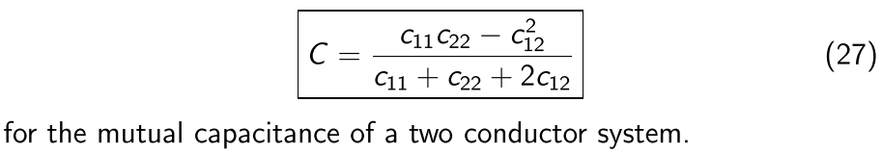

Once we have C, we know from (4.11.30) that

K = 4πε/C = 4πε $\frac{c11+ c22 + 2c12}{c11c22 - c122}$ . (5.5.15)

Thus, we have solved "the capacitor problem" to obtain K for the transmission line. The other line parameters are then given as in (4.11.30)

G = 4πσ/K Le = $\frac{μ}{4π}$ K .

Statement of the capacitor problem in terms of φt

To show that our capacitor problem is the same as (5.4.3), we first quote the capacitor problem (5.5.1),

∇2D2φ(x,y) = 0 φ(C1) - φ(C2) = V . (5.5.1)

Then use (5.1.1) that φ(x,y,z) = $\frac{q(z)}{4πε}$ φt(x,y) to get

∇2D2φt(x,y) = 0 $\frac{q(z)}{4πε}$ φt (C1) - $\frac{q(z)}{4πε}$ φt(C2) = V
or
∇2D2φt(x,y) = 0 φt (C1) - φt(C2) = V $\frac{4πε}{q(z)}$
or
∇2D2φt(x,y) = 0 φt(C1) - φt(C2) = K

which is (5.4.3). In the last step we used (4.4.7) that V(z) = $\frac{q(z)}{4πε}$ K. The potentials V1 and V2 are related to constants K1 and K2 by

V1 = $\frac{q(z)}{4πε}$ K1 V2 = $\frac{q(z)}{4πε}$ K2 (5.5.16)

Solution of the capacitor problem using φt

Here we just repeat the above analysis, showing how things differ. We leave out the words. The main differences are that the Vi are replaced by Ki and the factor $\frac{q(z)}{4πε}$appears on the lines where ni are computed. As before, we now start off with K1 and K2 unknown, but we find them in the end:

φt(x,y) = – C1 ds' K1 ∂ng(x,y|x',y') – C2 ds' K2 ∂ng(x,y|x',y')

= K1 F1(x,y) + K2F2(x,y)

En(x,y) = - ∂n1φ = - $\frac{q(z)}{4πε}$∂n1φt(x,y) = $\frac{q(z)}{4πε}$ { K1 G11(x) + K2 G12(x) } x on C1
En(x,y) = - ∂n1φ = - $\frac{q(z)}{4πε}$∂n2φt(x,y) = $\frac{q(z)}{4πε}$ {K1 G21(x) + K2 G22(x) } x on C2

n1(x,y) = εEn(x,y) = $\frac{q(z)}{4πε}$εK1 G11(x) + $\frac{q(z)}{4πε}$εK2 G12(x) x on C1
n2(x,y) = εEn(x,y) = $\frac{q(z)}{4πε}$εK1 G21(x) + $\frac{q(z)}{4πε}$εK2 G22(x) x on C2

q1 = C1 ds' n1(x',y') = $\frac{q(z)}{4πε}$ [εK1H11 + εK2H22] = $\frac{q(z)}{4πε}$ [ c11V1 + c12V2 ]
q2 = C2 ds' n2(x',y') = $\frac{q(z)}{4πε}$ [εK1H21 + εK2H22] = $\frac{q(z)}{4πε}$ [ c21V1 + c22V2 ]

$\left(\begin{matrix}q1 \\ q2\end{matrix}\right)$ = $\frac{q(z)}{4πε}$$\left(\begin{matrix}c11 & c12 \\ c21 & c22\end{matrix}\right)$$\left(\begin{matrix}K1 \\ K2\end{matrix}\right)$ or q = $\frac{q(z)}{4πε}$c K .

$\left(\begin{matrix}K1 \\ K2\end{matrix}\right)$ = $\frac{4πε}{q(z)}$ $\left(\begin{matrix}s11 & s12 \\ s21 & s22\end{matrix}\right)$$\left(\begin{matrix}q1 \\ q2\end{matrix}\right)$ or K = $\frac{4πε}{q(z)}$sq

$\left(\begin{matrix}K1 \\ K2\end{matrix}\right)$ = $\frac{4πε}{q(z)}$ $\left(\begin{matrix}s11 & s12 \\ s21 & s22\end{matrix}\right)$$\left(\begin{matrix}q(z) \\ -q(z)\end{matrix}\right)$ = 4πε $\left(\begin{matrix}s11 & s12 \\ s21 & s22\end{matrix}\right)$$\left(\begin{matrix}1 \\ -1\end{matrix}\right)$

K1 = 4πε (s11- s12)
K2 = 4πε (s21- s22)

K = K1 - K2 = 4πε [s11+ s22 - 2s12]
so
K = 4πε $\frac{c11+ c22 + 2c12}{c11c22 - c122}$ (5.5.17)
Then the same capacitance shown in (5.5.14) is recovered,

C = 4πε/K = $\frac{c11c22 - c122}{c11+ c22 + 2c12}$.

For arbitrary conductor shapes, carrying out the Green's function program just outlined is quite difficult and usually requires expanding the Green's function in some complete set of eigenfunctions and then making various approximations. Perhaps conformal mapping is helpful in certain cases. Our point is that the capacitor problem is a well-posed problem and has a solution value K. Numerical evaluations are always possible as noted earlier.

If the conductors are round, the problem can be solved exactly as we shall show in Chapter 6.

5.6 What happens if low-loss is not assumed?

Let's go back to our equation before the low-loss assumption that Zs= 0,

[ ∇t2 + $\frac{jω Zs 4πξ}{K}$] φt(x,y) = 0 φt(C1) = K/2 φt(C2) = - K/2 (5.3.8)

This is now a Helmholtz equation with Helmholtz parameter $\frac{jω Zs 4πξ}{K}$, whereas with Zs = 0 we had the simpler Laplace Equation. Treating Zs as some given value ≠ 0, we could go ahead and find the Green's function for the above equation and it would be a function of K since K appears in the Helmholtz parameter. Call this Helmholtz Green's function gK(x,y|x',y'). We still have φ = $\frac{1}{4πε}$ q(z) φt being the full potential from which the electric field is obtained as En = -∂nφ [ recall that transverse A components are zero so this is consistent with E = - grad φ - ∂tA ]. The solution of the above PDE system then starts off

φt(x,y) = – C1 ds' K1 ∂ngK(x,y|x',y') – C2 ds' K2 ∂ngK(x,y|x',y')

= K1 F1(x,y,K) + K2F2(x,y,K) . (5.6.1)

From this point on, every function and constant acquires and argument K: Gij(x,K), Hij(K) and then cij(K). We end up then with

K = 4πε $\frac{c11(K) + c22(K) + 2c12(K)}{c11(K)c22(K) - [c12(K)]2}$ . (5.6.2)

The new feature is that K appears on both sides of the last equation. This probably-complicated equation then has to be solved for K, and sometimes this is referred to as "an eigenvalue problem" for K. For example, if Zs is very small but non-zero, we would expect the solution for K to be slightly different from the value obtained with Zs = 0 and one could perhaps approach the problem using perturbation theory where the Helmholtz parameter is a "smallness parameter".

Recall that

k2 = β2 - jω Zs 4πξ/K (5.3.6)

where now K is the "eigenvalue" of our solution above. If Zs is very small but not zero, we end up then with

k = β - Δ

where Δ is a small complex number. The longitudinal transmission line behavior of all z-dependent functions like φ, Azt, q, V, W, E, B is then given by (5.1.11),

q(z,t) = q(z,t) = q(0) ej(ωt-kz) = q(0) ej(ωt-[β-Δ]z)

= q(0) ej(ωt-[β-Re(Δ)]z) e–Im(Δ)z

The real part of Δ causes a shift in the wavenumber k so the wave no longer propagates with the normal dielectric wavenumber β. Since v = ω/k, we will find that the wave is "slowed down" due to the drag effect of the non-zero surface impedance of the conductors. The imaginary part of Δ then causes an exponential decay of the wave magnitude due to ohmic losses at the conductor surface. In our Chapter 2 analysis of the round wire we found that in general Zs is itself complex, so computation of Δ is a somewhat complicated problem which we shall not attempt here.

The problem of lossy transmission lines is usually approached using E and B fields, rather than potentials φ and Az, and the analysis is then similar to the way waveguides in general are treated. Due to the skin effect, the E and B fields penetrate a distance ~δ into the conductor surfaces and this results in ohmic losses and a "drag" on the propagating wave. In this approach, one ends up again with an eigenvalue problem to solve, not directly for K but for some other related parameter like k.

In the 12-page Section 4.5 of his book, Matick studies a lossy-transmission line in the simplest possible case which is a strip geometry whose gap S is small compared to the width and whose metal strips are much thicker than the skin depth δ. His parameter γ is related to our parameter k by γ = jk, and his longitudinal direction is x instead of our z. He ends up with a transcendental "eigenvalue equation" (4-66) for γ, but if loss is very small, he can approximately solve for γ with these results

Im(γ) = β(1+δ/2S) Re(γ) = β (δ/2S) // Matick (4-75,76,77) p 115

which with γ = jk we translate to

Im(k) = - Re(γ) = - β (δ/2S)
Re(k) = Im(γ) = β(1+δ/2S)

k = β(1+δ/2S) -j β (δ/2S) = β - [-(δ/2S) + j(δ/2S)]
so
Δ = -(δ/2S) + j(δ/2S) .

Thus, for such a thick strip transmission line, the longitudinal dependence of all functions has this form,

q(z,t) = ej(ωt-[β-Re(Δ)]z) e–Im(Δ)z

= ej(ωt-[β+δ/2S]z) e–(δ/2S)z

which shows the exponential loss factor and an increased wavenumber β+δ/2S which corresponds to a decreased wavelength λ and a decreased wave velocity v = ω/k = ωλ/2π = fλ, the "drag effect".
Matick has an errata in this section which is a bit confusing, so we repair it right here. His equation (4-50) p 110 should read

∇2E = ($\frac{∂2Ex}{∂x2}$ + $\frac{∂2Ex}{∂z2}$) + ($\frac{∂2Ez}{∂x2}$ + $\frac{∂2Ez}{∂z2}$) = (jωμσ - ω2με)(Ex + Ez) Matick (4-50)

Chapter 6: Transmission Lines with Two Circular Conductors

6.1 A candidate transverse potential φt

In the previous chapter (both Section 5.3 (b) and Section 5.4 (b)) we showed that the transverse potential of a 2-conductor balanced transmission line must have this form when viewed from far away,

φt(x) ≈ ln(s22/s12) // limiting form as point x = (x,y) moves far from the conductors
(5.3.11)
s12 = (x-x1)2 + (y-y1)2 = |x - x1|2
s22 = (x-x2)2 + (y-y2)2 = |x - x2|2 (6.1.1)

where the points x1 and x2 are the "center of charge" points for the C1 and C2 conductor cross sections.

Suppose now we take as a candidate dimensionless transverse potential φt exactly the above limiting expression. Our candidate φt is

φt(x) = ln(s22/s12) . for all values of r, close and far (6.1.2)

where we specify that our center of charge points are x1 = (d,0) and x2 = (-d,0).

Certainly this meets our limiting form boundary condition (5.3.11)! We know also that this potential is a valid solution of the 2D Laplace equation, since ln(s1) and ln(s2) are each valid solutions. This fact was shown at the start of Section 5.4 (b). Since -2πlns1 is the 2D free-space propagator, it follows that
-2πlns1 is a solution of ∇22D(φ) = 0 away from the point where s1 = 0, and then so is lns1. Then by superposition, 2lns2 - 2lns1 is also a valid solution, and thus so is ln(s22/s12). Thus, our φt is a valid candidate for a lossless transmission line since for such a transmission line φt satisfies the 2D Laplace equation according to (5.4.3),

∇t2 φt(x,y) = 0 φt(C1) = K1 φt(C2) = K2 K1-K2 = K . (5.4.3)

The question then becomes: what are the surfaces Ci in 2D space on which this candidate φt is a constant? Such surfaces can then serve as possible conductor cross sections for a transmission line.

6.2 Ancient Greece circa 230 BC
Fig
Apollonius of Perga (262BC-190BC) [ like Joe of Chicago ] was a pretty smart guy as wiki explains. He did astronomy and therefore he did geometry. Besides giving conic sections their current names and writing eight books about them, he learned about what are now called the Apollonian Circles. These circles form the "level surfaces" for 2D bipolar (orthogonal) coordinates as shown in this picture
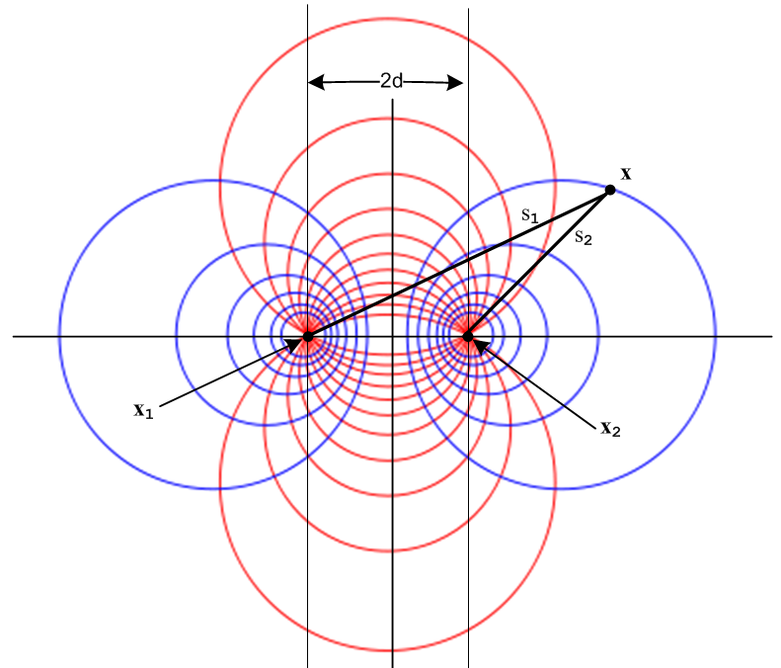 Fig 6.1
http://en.wikipedia.org/wiki/Apollonian_circles

When this picture is rotated around its vertical axis, the blue level circles become toroids and one then arrives at 3D toroidal coordinates, but that is another story. Our interest is in the 2D blue circles.

It turns out, as the reader may suspect, that the blue circles have the following simple property,

s2/s1 = constant ,

which we shall prove in a moment. Calling this constant e-B we get

s2/s1 = e-B => ln(s2/s1) = - B . (6.2.1)

Thus, since φt(x) = ln(s22/s12) = 2 ln(s2/s1), the blue circles are candidate equipotential surfaces for our potential φt(x) !

To show that s2/s1 = e-B describes a circle, consider:

|x-x2| / |x-x1| = e-B

|x-x2|2 = e-2B |x-x1|2

(x-x2)2 + (y-y2)2 = e-2B [(x-x1)2 + (y-y1)2 ] .

This equation has the following form

A(x2 + y2) + Bx + Cy + D = 0 A = (1-e-2B)
or
x2 + y2 + αx + βy + γ = 0 .

One can then "complete the squares" to obtain the equation of a circle of radius r centered at (xc,yc) ,

(x - xc)2 + (y - yc)2 = r2

where -2xc = α -2yc = β xc2 + yc2 - r2 = γ . (6.2.2)

For our particular locations of x1 and x2 shown in Fig 6.1, we have

x1 = -d x2 = d y1 = y2 = 0
s12 = (x+d)2 + y2 s22 = (x-d)2 + y2 (6.2.3)
so
s2/s1 = e-B => s1/s2 = eB => e2Bs22 = s12 => (eB/2) s22 = (e-B/2) s12 =>

(eB/2) [x2 - 2dx + d2 + y2] = (e-B/2) [x2 + 2dx + d2 + y2]

shB (x2+d2+y2) + chB(-2dx) = 0 // shB = (eB-e-B)/2, chB = (eB+e-B)/2

(x2+d2+y2) + cothB (-2dx) = 0

x2 - 2d x cothB + y2 = -d2

x2 - 2d x cothB + d2coth2B + y2 = -d2+ d2coth2B // complete the square

(x - dcothB)2 + y2 = d2csch2B . (6.2.4)

We conclude that our blue equipotential circles have this simple form

(x - xc)2 + y2 = r2 xc = d cothB r = |d cschB| . (6.2.5)

Using d = 5, here is a plot of these circles for 10 different B values:

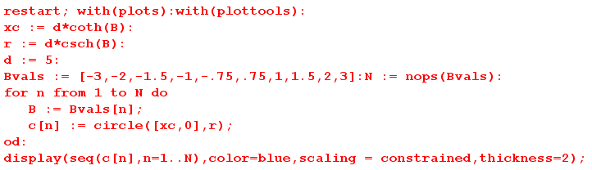

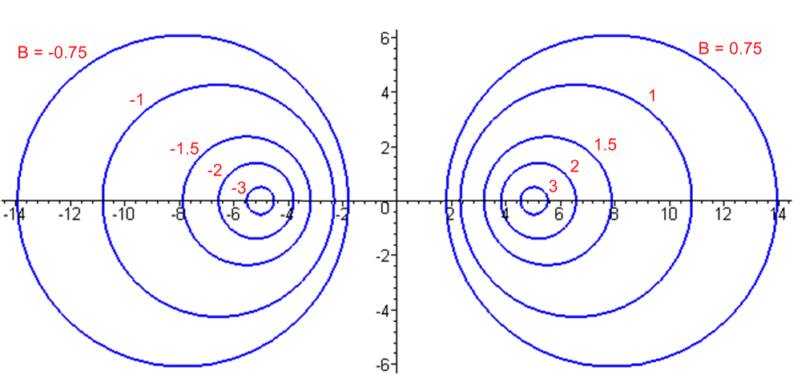 Fig 6.2

Since xc = d cothB, the right side curves have B > 0 while the left side have B < 0. The value B = 0 corresponds to the vertical y axis, while B = ±∞ correspond to the two focal points at d = ± 5.

6.3 Back to the Future: Calculation of K

We select C2 to be a circle on the right side, so that B2 > 0.
For C1 we select a second circle from either the left or the right, so B1 can have either sign.

If we select C1 from the left side, we have a two-wire transmission line(dielectric = gray),

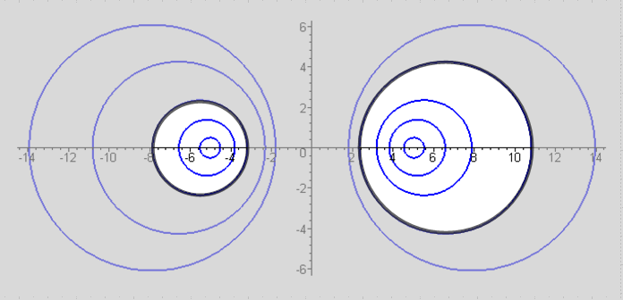 Fig 6.3

If we select C2 from the right, we have an off-center coaxial transmission line.

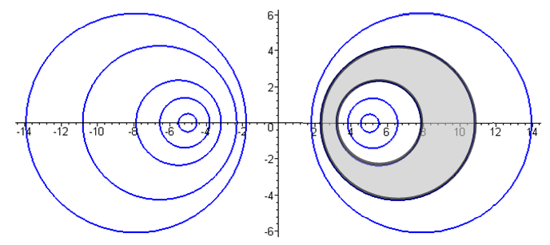 Fig 6.4

Fig 6.3 shows a transmission line cross section where the two conductors are round wires with unequal radii a1 and a2. Treated as a 2D capacitor, one's intuition at least suggests that the two focal points might be the conductor "centers of charge". The gray dielectric is of course outside the two conductors and it is possible to select a point in the dielectric that is "far away" from both conductors, so our limiting form discussion applies and the points x1 and x2 should be the centers of charge.

Figure 6.4 shows an off-center coaxial transmission line for which the dielectric is the region between the two black circles. In this case, one cannot take a point in the dielectric that is "far away" from both conductors, so the limiting form discussion does not apply. Here it appears that both conductors have the same center of charge located at x2.

We shall now determine K and therefore the 2D capacitance C = 4πε/K for the above cases.

Let σ1 = sign(B1). We then have from (6.1.2) and (6.2.1),

φt(x) = ln(s22/s12) = 2 ln(s2/s1)

φt(C1) = 2 ln(s2/s1)|C1 = -2B1
φt(C2) = 2 ln(s2/s1)|C2 = -2B2 . (6.3.1)

Recall from (5.1.3) that φt(C1) - φt(C2) = K. Therefore,

K = 2(B2-B1) = 2 (|B2| -σ1|B1|). (6.3.2)

Once we know K, we know C, G and Le for the transmission line from box (4.11.30).

We must now do some slightly painful algebra. First, we know from (6.2.5) that

a1 = d |cschB1| => (d/a1) = sh(|B1|) => |B1| = sh-1(d/a1)
a2 = d |cschB2| => (d/a2) = sh(|B2|) => |B2| = sh-1(d/a2) . (6.3.3)

The separation of the centers of the two round wires is b, where, again using (6.2.5),

b = |xc2 - xc1| = |d cothB2 - dcothB1| = d |cothB2 - cothB1| . (6.3.4)

From (6.3.2) we write

ch(K/2) = ch [|B2| -σ1|B1|]

= ch|B2| ch|B1| - σ1 sh|B2| sh|B1|

= $\sqrt{1+sh2B2}$$\sqrt{1+sh2B1}$ - σ1 sh|B2| sh|B1|

= $\sqrt{1+(d/a2)2}$$\sqrt{1+(d/a1)2}$ - σ1 (d/a2) (d/a1) . (6.3.5)

Meanwhile,

b = d |cothB2 - cothB1| = |d [ chB2/shB2 - chB1/shB1] | = |d [ ch|B2|/sh|B2| - σ1ch|B1|/sh|B1|] |

= | d [ch|B2| sh|B1| - σ1 ch|B1| sh|B2| ] / sh|B1| sh|B2| |

= | d [$\sqrt{1+(d/a2)2}$(d/a1) - σ1 $\sqrt{1+(d/a1)2}$ (d/a2) ] / (d/a2) (d/a1) |

= | [$\sqrt{1+(d/a2)2}$(1/a1) - σ1 $\sqrt{1+(d/a1)2}$ (1/a2) ] / (1/a2) (1/a1) |

= | [a2 $\sqrt{1+(d/a2)2}$- σ1 a1 $\sqrt{1+(d/a1)2}$ ] | . (6.3.6)

Square this to get

b2 = a22[1+(d/a2)2] + a12[1+(d/a1)2] - 2σ1a1a2$\sqrt{1+ (d/a2)2}$$\sqrt{1+ (d/a1)2}$
so
2 σ1a1a2$\sqrt{1+ (d/a2)2}$$\sqrt{1+ (d/a1)2}$ = a22[1+(d/a2)2] + a12[1+(d/a1)2] - b2

= a22 + d2 + a12 + d2 - b2 = a12 + a22 + 2d2 - b2 .

The purpose of doing this is to obtain the following expression for the radical product,

$\sqrt{1+ (d/a2)2}$$\sqrt{1+ (d/a1)2}$ = (a12 + a22 + 2d2 - b2) / (2 σ1a1a2 ) . (6.3.7)

We now install this into our expression (6.3.5) above for ch(K/2) to get

ch(K/2) = $\sqrt{1+(d/a2)2}$$\sqrt{1+(d/a1)2}$ - σ1 (d/a2) (d/a1)

= (a12 + a22 + 2d2 - b2) / (2 σ1a1a2 ) - 2d2/ (2σ1a2a1)

= (a12 + a22 - b2) / (2σ1a2a1) = σ1 (1/2) (a12 + a22 - b2)/(a1a2)

= σ1 (1/2) [ (a1/a2) + (a2/a1) - (b2/a1a2) ] (6.3.8)

and the focal distance d has vanished from our expression. Therefore

K = 2 ch-1 { σ1 (1/2) [ (a1/a2) + (a2/a1) - (b2/a1a2) ] } (6.3.9)

Notice that the result is symmetric under a1 ↔ a2 .

We now distinguish our two cases of interest. For the unequal twin-lead type transmission line of Fig 6.3 we know that B1 < 0 since the C1 circle is on the left, so σ1 = sign(B1) = - 1 and then

K = 2 ch-1 { (1/2) [ (b2/a1a2) - (a1/a2) - (a2/a1)] } // Fig 6.3 (6.3.10)

which is an amazingly simple result. Recall from (4.4.16) that

Z0 = (K /$\sqrt{εrel}$) 30Ω (4.4.16)

so then

Z0 = ch-1 { (1/2) [ (b2/a1a2) - (a1/a2) - (a2/a1)] } (1/$\sqrt{εrel}$) 60 Ω . (6.3.11)

If the wires have diameters d1 = 2a1 and d2 = 2a2 this becomes

Z0 = ch-1 { (1/2) [ (4b2/d1d2) - (d1/d2) - (d2/d1)] } (1/$\sqrt{εrel}$) 60 Ω . (6.3.12)

For verification, we quote again from Reference RDE page 29-23,

where our b is called D.

On the other hand, if we are interested in an off-center coaxial transmission line as in Fig 6.4, we select C1 from the right side of Fig 6.2 and then σ1 = sign(B1) = +1 and we find

K = 2 ch-1 { (1/2) [ (a1/a2) + (a2/a1) - (b2/a1a2) ] } // Fig 6.4 (6.3.13)

Z0 = ch-1 { (1/2) [ (a1/a2) + (a2/a1) - (b2/a1a2) } (1/$\sqrt{εrel}$) 60 Ω (6.3.14)

Z0 = ch-1 { (1/2) [ (d1/d2) + (d2/d1) - (4b2/d1d2) } (1/$\sqrt{εrel}$) 60 Ω (6.3.15)

For verification, we quote again from Reference RDE page 29-24,

where we may take d = our d1 and D = our d2 and c = our b = the center-line separation.

There is one more case of interest that falls out from this analysis. If we take B1 = 0 we have

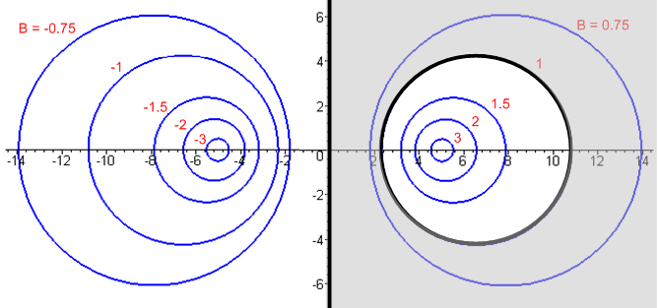 Fig 6.5

which is a transmission line consisting of a round wire above an infinite flat plane. This is a tricky limit of (6.3.10) where both a1→∞ and b→∞, so we ignore (6.3.10) and work from scratch. Since B1 = 0 we find from (6.3.2) that

K = 2B2 . (6.3.16)

We know from (6.2.5) that

x2c = d coth B2 = d chB2/shB2
a2 = d/sh(B2) . (6.3.17)

Therefore

x2c/a2 = chB2 => B2 = ch-1(x2c/a2) => K = 2 ch-1(x2c/a2) . (6.3.18)

Here x2c is the distance from the wire center line to the ground plane. If we call this h and the wire radius a, we then have the following extremely simple and exact result,

K = 2 ch-1(h/a) // wire radius a with center h over ground plane, exact
Z0 = (K /$\sqrt{εrel}$) 30Ω = ch-1(h/a) (1/$\sqrt{εrel}$) 60 Ω (6.3.19)

where of course we must have h > a to keep the wire from touching the ground plane. Using the identity ch-1x = ln(x + $\sqrt{x2-1}$) for x ≥ 1 we can write the above as

K = 2 ln [ (h/a) + $\sqrt{(h/a)2-1}$] // wire radius a with center h over ground plane, exact
Z0 = ln [ (h/a) + $\sqrt{(h/a)2-1}$] (1/$\sqrt{εrel}$) 60 Ω (6.3.20)

For h >> a this becomes ("thin wire")

K = 2 ln(2h/a) // wire radius a center h over ground plane, h>> a
Z0 = ln(2h/a) (1/$\sqrt{εrel}$) 60 Ω . (6.3.21)

For verification, we found the following web offering (where log means ln ),

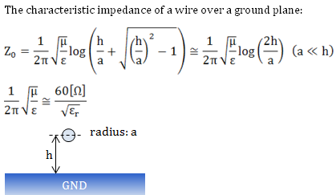

http://members3.jcom.home.ne.jp/zakii/tline_e/14_microstripline_z0.htm

which results are derived using an image method to handle the ground plane.

For some odd reason, our usual RDE source on this subject only gives the result for h >> a . Taking d to be the wire diameter,

Z0 = ln(4h/d) (1/$\sqrt{εrel}$) 60 Ω

= ln(10) log (4h/d) (1/$\sqrt{εrel}$) 60 Ω

≈ log (4h/d) (1/$\sqrt{εrel}$) 138.2 Ω (6.3.22)

which then compare to RDE p 29-22 ,

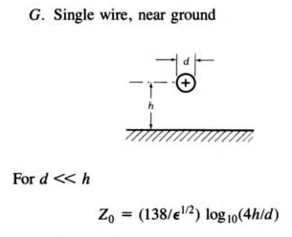

Reader Exercise: Given φ(x) = ln(s22/s12), compute E = -∇φ , compute En = E • as the normal electric field at the surface of C2, compute n = εEn as the linear charge density on C2, then using that n, find the "center of charge" <x> = [ ∫C2 ds x n(x) ds / ∫C2 ds n(x) ] and see if <x> = d. Decide whether or not it is worth while learning how to work in bipolar coordinates to carry out this exercise.

6.4 Summary of Results

Summary for Transmission Line with Two Round Conductors (6.3.23)

Identities: ch-1x = ln(x + $\sqrt{x2-1}$) , x ≥ 1 ch-1x ≈ ln(2x), x >>
ch-1[ $\frac{1}{2}$($\frac{b}{a}$+$\frac{a}{b}$) ] = ln $\frac{b}{a}$ b > a > 0 (4.6.6)
Line Properties: C = 4πε/K, G = 4πσ/K, Le = $\frac{μ}{4π}$ K ε,σ,μ for dielectric (4.11.30)
_____________________________________________________________________________________
dielectric is gray
K = 2 ch-1 { (1/2) [ (b2/a1a2) - (a1/a2) - (a2/a1)] }
ai = radii b = center separation
Special case a1 = a2 = a: K = 2 ch-1 [ (b2/2a2) - 1] (twin-lead)
Special case b >> a1,a2: K = 4 ln(b/$\sqrt{a1a2}$)
Special case b >> a1=a2=a: K = 4 ln(b/a)

_____________________________________________________________________________________
K = 2 ch-1 { (1/2) [ (a1/a2) + (a2/a1) - (b2/a1a2) ] }
ai = radii b = center separation
Special case b = 0 and a2> a1: K = 2 ln(a2/a1) (centered coaxial)
_________________________________________________________________________________

K = 2 ch-1(h/a) = 2 ln [ (h/a) + $\sqrt{(h/a)2-1}$]
a = radius h = height of center over plane
Special case h >> a: K = 2 ln(2h/a) (thin wire)

Appendix A: Gauge Invariance

Here we show why it is that, in choosing potentials φ and A, one is allowed to set the divergence of the vector potential A equal to an arbitrary function. Roughly speaking, this freedom of setting div A is called gauge invariance. Our step-by-step approach here is somewhat unconventional and brings in the notion of a Green's function and the particular solution of the Poisson Equation. Some extracurricular topics are brought up which may or may not interest the reader. Each section builds on the previous section.

A.0 The Poisson Equation and its Solution

Fact 0: The Poisson Equation -∇2φ = ρ/ε0 with φ(∞) = 0 has a unique solution as stated below. (A.0.0)

For electrostatics in an isotropic medium equations (1.1.3) and (1.1.6) indicate that div E = ρ/ε while (1.1.2) says that curl E = 0. Since curl grad f = 0 for any function f, if one lets E = - grad φ, then

curl E = -curl grad φ = 0

ρ/ε = div E = - div grad φ = -∇2φ => -∇2φ = ρ/ε ,

an equation known as the Poisson Equation. The problem of electrostatics ("potential theory") is then to solve -∇2φ = ρ/ε for the potential φ, and then E = - grad φ produces the resulting electric field. For a static physical situation (nothing varies with time t), the electrostatic potential φ matches the scalar potential φ appearing in (1.3.1). Here ρ(x) refers to the electric charge density.

(a) Imagine some static charge distribution ρ(x) that is constrained to a localized region near the origin within infinite space. The distribution ρ(x) includes all charges in this region. Here are some types of charges which would be included in ρ(x):

• point charges which are "glued down" to certain points in space.
• linear continuous charge densities that are glued down along curved filaments in space or which are stable on conducting filaments.
• surface charge densities that are either glued to certain surfaces, or which are stable because they lie on the surfaces of pieces of conductor (like metal).
• 3D continuous charge densities that are glued down in 3D space so they cannot move, or which manage to achieve a stable configuration as free charge (if that is possible!)
• surface polarization charge densities not already accounted for by the ε in -∇2φ = ρ/ε .

By including all these types of charge in ρ, we are able to avoid the complicating issue of "boundary surfaces" in our discussion below, and our only boundary of interest is The Great Sphere which is a sphere of infinite radius surrounding our localized region of interest.

From Coulomb's Law (in SI units, and in an isotropic medium of dielectric constant ε) we know that the electric potential φ of a point charge q located at point x' is φ(x) = q/[4πεR] where R = |x-x'| is the distance between charge q at x' and an observation point x. Such a point charge is described by ρ(x) = qδ(x-x'). The general equation which relates φ(x) to ρ(x) is the Poisson Equation,

-∇2φ(x) = ρ(x)/ε φ(∞) = 0 . (A.0.1)

By including the condition φ(∞) = 0, we are really describing a Poisson "boundary value problem". We add φ(∞) = 0 because we are assuming that ρ(x) is localized as just noted.

Both the PDE and the boundary condition are linear. Letting φ = αφ1+ βφ2, and ρ = αρ1+ βρ2,

∇2φ = ∇2(αφ1+ βφ2) = α∇2φ1 + β∇2φ2 = α ρ1(x)/ε +β ρ2(x)/ε = [α ρ1(x) +β ρ2(x)]/ε = ρ/ε

φ(∞) = αφ1(∞) + βφ2(∞) = 0 + 0 = 0. // boundary condition is linear

Therefore, we may superpose the potentials of multiple charges to get the potential resulting from a distribution of charges. Thus, we at once obtain this superposed version of Coulomb's Law,

φ(x) = $\frac{1}{4πε}$∫d3x' $\frac{ρ(x')}{|x-x'|}$ . (A.0.2)

Here d3x' ρ(x') = dq(x') is a differential chunk of charge located at x' contained in tiny volume d3x'. Thus, (A.0.2) must be a solution of (A.0.1). If we allow the observation point x to move right on top of some point charge in the distribution ρ, we will get φ = ∞, so we generally avoid such observation points.

(b) We would like to explicitly show that (A.0.2) is a solution of (A.0.1) for a general distribution ρ. To this end, we digress to consider the following equation and its solution,

-∇2g(x,x') = δ(x-x') with g(∞,x') = 0 => g(x,x') = $\frac{1}{4π}$ $\frac{1}{|x-x'|}$ . (A.0.3)

The equation on the left is Poisson's Equation where ρ consists of a positive point charge of q = ε units sitting at position x'. Recall from above that ρ(x) = qδ(x-x') for a point charge. Coulomb's Law gives the solution shown on the right. Therefore it must be true that

-∇2{ $\frac{1}{|x-x'|}$} = 4π δ(x-x') . (A.0.4)

This last equation is derived in Appendix H (see H.1.4), but we have already shown it is true, given Coulomb's Law. We can now show that (A.0.2) is a solution of (A.0.1) for an arbitrary distribution ρ as follows:

-∇2φ(x) = $\frac{1}{4πε}$ ∫d3x' ρ(x') {-∇2 $\frac{1}{|x-x'|}$ } = $\frac{1}{4πε}$ ∫d3x' ρ(x') 4π δ(x-x') = ρ(x)/ε . QED.

The assisting function g(x,x') has various names with respect to (A.0.3): the Green's Function or Green function, the fundamental solution, the free-space propagator, or the kernel. It is nothing more than the potential created by a point charge of ε units located at x' and viewed from x. Some authors put a 4π in front of the δ in the left equation of (A.0.3) which causes the 1/(4π) to be absent in the right equation of (A.0.3).

(c) We have found the particular solution of (A.0.1) given by (A.0.2). There are many other PDE solutions which can be obtained by adding to the solution (A.0.2) a solution of -∇2u = 0. This last equation, usually written ∇2u = 0, is called the Laplace Equation, and it is the "homogeneous" form of the Poisson Equation, that is, the right side of the Poisson Equation is set to 0. Solutions u are called homogeneous solutions. One obvious solution is u = 2, so we could then add 2 to (A.0.2) and get a new solution to (A.0.1). Since we have specified that our charge distribution ρ(x) is localized to some region of space, we expect that as x→ ∞, we must have φ → 0, as (A.0.1) states. The solution (A.0.2) meets this requirement, but if we add 2, then our boundary condition φ(∞)= 0 is not met, so we must rule out adding a 2. We would also rule out 2x + 3, for example, or 7xy. Recall that ∇2 = ∂x2+ ∂y2+ ∂z2.
It turns out that the only solution of ∇2u = 0 which meets the requirement u→0 as x→∞ in all directions is the trivial function u(x) = 0. In 2D one intuitively sees this because a massless taut thin rubber sheet (drum head) tied down to height u = 0 around a circular perimeter is going to be a flat rubber sheet with u = 0 everywhere. The solutions to the 3D equation ∇2u = 0 are called harmonic functions, and it is not hard to show that any harmonic function must take both is max and min values on the boundary, which here is a 3D great sphere. Thus umax = 0 and umin = 0, so the only possibility is that u(x) ≡ 0 everywhere.
The implication of the previous paragraph is that (A.0.2) is the only possible solution of (A.0.1) because the only homogeneous solution one is allowed to add to (A.0.2) is u = 0. One can suppose there are two different solutions of -∇2φ = ρ/ε called φ and φ' both of which go to 0 on the great sphere. Then
-∇2(φ-φ') = 0 with (φ-φ') → 0 on the great sphere. But then (φ-φ') = 0 so φ' = φ and there cannot then exist two different physical solutions of (A.0.1).

(d) In the following discussions, we shall be less explicit about boundary conditions like φ(∞) = 0, but they are always implied because we shall always be considering only a local distribution of sources. One convenient implication of such boundary conditions is that the "parts" of parts integrations often vanish, since they involve functions evaluated on the Great Sphere (or Great Circle in 2D). To clarify this perhaps obscure comment, here is a statement of two integral theorems where V is an n dimensional volume and S is an n-1 dimensional surface enclosing that volume:

∫V dV ∇φ = ∫S dS φ // "integral of a gradient theorem" (A.0.5)

∫V dV ψ(∇φ) = – ∫V dV (∇ψ)φ + ∫S dS (ψφ) // "parts integration" (A.0.6)
"the minus sign" "the parts"

The first theorem is just the divergence theorem applied to F(x) = φ(x) a where a is a constant vector. It happens that ∇•F = ∂iFi = ∂i[φ ai] = (∂iφ) ai = ∇φ • a , so

∫V dV ∇•F = ∫S dS•F => (∫V dV ∇φ) • a = ∫S dS•[ φa] = (∫S dS φ) • a

By setting a = , and one concludes that ∫V dV ∇φ = ∫S dS φ.

The second theorem is the first applied to the function φ→ψφ and is the generalization of 1D parts integration to n dimensional space. The "parts" is ∫S dS (ψφ) and if S is the Great Sphere, then this integral involves ψ and φ evaluated on the Great Sphere, and usually one of these functions is 0 there. In what follows, we shall often be swinging a derivative from one function to the other inside an integral, and we ignore the parts for the reason just stated.

A.1 Existence of A such that B = curl A and div A = 0

Fact 1: If div B = 0, there exists an A such that B = curl A and div A = 0. (A.1.0)

The "gauge choice" div A = 0 is known as the Coulomb or Transverse Gauge. More on gauges later.

Proof: There are several parts to the proof:

(a) If A exists such that B = curl A, then it will certainly be true that div B = 0, since div curl A = 0 for any vector field A. The problem is showing that A exists, and moreover, that an A exists with div A = 0.

(b) Consider the following differential equation (at this point A is some undefined vector field):

-∇2A = curl B (A.1.1a)

or, in Cartesian coordinates,

-∇2(Ai) = [curl B]i . (A.1.1b)

We may regard this as the Poisson equation (A.0.1) where φ → Ai and ρ → ε [curl B]i . We know that a Poisson equation of the form (A.0.1) has a unique physical solution of the form (A.0.2), so the solution of (A.1.1) is given by
A(x) = $\frac{1}{4π} \int_{}^{}{d3x' \frac{curl' B(x')}{|x - x'|}}$ . (A.1.2)
As with ρ in the previous section, we think of curl B as being localized in some region near the origin and dropping off at large distances. Perhaps B is generated by some currents in this localized region.

We take (A.1.2) to be a candidate expression for the vector field A. If we can show that div A = 0 and that B = curl A, then (A.1.2) is a viable expression for A.

(c) Take the divergence of both sides of (A.1.2) [ implied sum on i ]
div A(x) = ∂iAi(x) = $\frac{1}{4π} \int_{}^{}{d3x' [curl' B(x')]i ∂i \frac{1}{|x - x'|}}$ . (A.1.3)
We can replace ∂i by - ∂'i acting on 1/|x - x'| . Then we can do parts integration and move ∂'i onto [curl' B(x')]i with a parts sign change. In doing so, we assume that at infinity we pick up no "parts" since curl B is assumed to drop off sufficiently fast. We end up then with:
div A(x) = $\frac{1}{4π} \int_{}^{}{d3x' \frac{div' curl' B(x')}{|x - x'|}}$. (A.1.4)
But div curl F = 0 for any vector field F , so the integrand and integral vanishes. Thus, we conclude that

div A = 0 . (A.1.5)

(d) Next, take the curl of both sides of (A.1.2). Here is the ith component [ implied sums on j and k, and εijk is the totally antisymmetric permutation tensor used to express curl components ]
[curl A(x)]i = εijk∂jAk(x) = + εijk $\frac{1}{4π} \int_{}^{}{d3x'[curl' B(x')]k ∂j \frac{1}{|x - x'|}}$ . (A.1.6)
As before, replace ∂j by -∂'j acting on (1/|x - x'|). Then do parts to move ∂'j onto [curl' B(x')]k. As before, there is no "parts contribution". The result can then be put back into full vector notation to give:
curl A(x) = + $\frac{1}{4π} \int_{}^{}{d3x' \frac{curl' curl' B(x')}{|x - x'|}}$ . (A.1.7)
Now use the vector identity curl curl B = grad div B - ∇2 B = - ∇2 B , since div B = 0. This gives
curl A(x) = - $\frac{1}{4π} \int_{}^{}{d3x'\frac{∇'2B(x')}{|x - x'|}}$ . (A.1.8)
The next step is to move the operator ∇'2 onto the other integrand factor 1/|x - x'| by doing a double parts, and again for each parts operation there is no parts contribution from the Great Sphere at infinity. We then use the fact (A.0.4) that ∇2(1/|x - x'|) = - 4π δ(x-x') to get

curl A(x) = - $\frac{1}{4π} [ -4π Β(x) ] = Β(x)$ . (A.1.9)

Thus, assuming div B = 0, we have formally constructed a vector field A such that B = curl A and
div A = 0, and this was the claim of Fact 1 stated above.

A.2 Existence of A' such that B = curl A' and div A' = f .

Fact 2: If div B = 0, there exists A' such that B = curl A' and div A' = f(x), where f(x) is an arbitrary scalar field which "drops off" in some reasonable (sufficient) manner as |x| → ∞. (A.2.0)

Proof: From Fact 1, we first find A such that B = curl A and div A = 0. We then define

A' ≡ A + grad Λ dim(Λ) = volt-sec (A.2.1)

where Λ is some so-far arbitrary function (scalar field). As shown below (1.3.1), dim(A) = volt-sec/m, and therefore dim(Λ) = volt-sec. It follows from (A.2.1) that

div A' = div A + ∇2 Λ = ∇2Λ . (A.2.2)

We would like to have div A' = f, so we must find Λ such that

∇2Λ = f . dim(f) = volt-sec/m2 (A.2.3)

But this is once again Poisson's Equation (A.0.1) with φ → Λ and ρ → -εf. Translating (A.0.2) we then find that
Λ(x) = – $\frac{1}{4π} \int_{}^{}{d3x' \frac{f(x')}{|x - x'|}}$ . (A.2.4)
Meanwhile, from (A.2.1) we also conclude that, since curl grad g = 0 for any function g,

curl A' = curl A + curl grad Λ = curl A = B . (A.2.5)

Thus, assuming div B = 0, we have formally constructed a vector field A' such that B = curl A' and
div A' = f(x) where f(x) is any function we like that drops off sufficiently fast as |x|→ ∞, and this is the claim of Fact 2. If f(x) drops off away from the origin, this is like the ρ(x) of Fact 0, and we find that Λ → 0 as x → ∞ in any direction. Then since Λ = 0 on the Great Sphere, we know that there are no homogenous solutions to ∇2Λ = 0 which could be added to (A.2.4) and so Λ(x) is uniquely determined by our selected function f(x). The function Λ(x) is called a gauge function for reasons given below.

A.3 Existence of φ such that E = -grad φ

Fact 3: If curl E = 0, then there exists a φ such that E = - grad φ . (A.3.0)

Proof: This proof is almost identical to that of Fact 1, but a little simpler.

(a) If φ exists such that E = - grad φ, then it will certainly be true that curl E = 0, since curl grad φ = 0 for any function φ. The problem is showing that φ exists.

(b) Consider the following differential equation (at this point φ is some undefined scalar field):

∇2φ = - div E . (A.3.1)

This is yet again Poisson's equation (A.0.1) for φ, this time with ρ→ ε div E, we solve it as in (A.0.2) to get,
φ(x) = $\frac{1}{4π} \int_{}^{}{d3x' \frac{div' E(x')}{|x - x'|}}$. (A.3.2)
As usual, we assume that div E drops off in some sufficient manner away from the origin going to infinity. Perhaps E is generated by a charge distribution in some region near the origin.

(c) Next, take the grad of both sides of (A.3.2). Here is the ith component:
∂iφ(x) = $\frac{1}{4π} \int_{}^{}{d3x' div' E (x') ∂j \frac{1}{|x - x'|}}$ . (A.3.3)
As usual, replace ∂j by -∂'j acting on (1/|x - x'|). Then do parts to move ∂'j onto div' E(x') with a second sign change, and also as usual there is no "parts contribution" from the Great Sphere. The result can then be put back into full vector notation to give:
grad φ(x) = + $\frac{1}{4π} \int_{}^{}{d3x' \frac{grad' div' E(x')}{|x - x'|}}$ . (A.3.4)
Now use the vector identity grad div E = curl curl E + ∇2 E = ∇2 E , since curl E= 0. This gives
grad φ(x) = $\frac{1}{4π} \int_{}^{}{d3x'\frac{∇'2E(x')}{|x - x'|}}$ . (A.3.5)
As before, move the operator ∇'2 onto the other term 1/|x - x'| by doing a double parts. We then use the fact (A.0.4) that ∇2(1/|x - x'|) = - 4π δ(x-x') to get

grad φ(x) = $\frac{1}{4π} [ - 4π Ε(x) ] = -Ε(x)$ (A.3.6)

Thus, assuming curl E = 0, we have constructed a function φ such that E = - grad φ, so φ must exist, and this is the claim of Fact 3.

A.4 Existence of A' and φ' such that B = curl A', E = - grad φ' - ∂tA', and div A' = f.

Fact 4: If div B = 0 and curl E = - ∂B/∂t , then there exist both A' and φ' such that B = curl A' and
E = - grad φ' - ∂A'/∂t , and the quantity div A' may be set to any function f. (A.4.0)

Proof: We know from Fact 2 that A' exists such that B = curl A' and such that div A' equals any arbitrary function f. If we start with some arbitrary A and φ, the successful A' from (A.2.1) is A' = A + grad Λ where Λ is given by (A.2.4) as an integral over f. What is the corresponding φ' ? Since the E field corresponding to (A,φ) and (A',φ') must be the same, we must have -E = -E' or

grad φ + ∂tA = grad φ' + ∂tA' .

Since A' = A + grad Λ, then ∂tA' = ∂tA + grad ∂t Λ, so the above reads

grad φ = grad φ' + grad ∂t Λ

which is satisfied by φ' = φ - ∂tΛ. Thus, the successful potential pair giving div A' = f is this:

A' = A + grad Λ
φ' = φ - ∂tΛ // dim(Λ) = volt-sec (A.4.1)

where from (A.2.4),
Λ(x) = – $\frac{1}{4π} \int_{}^{}{d3x'\frac{f(x')}{|x - x'|}}$ (A.2.3)
The pair of equations (A.4.1) is called a gauge transformation and we have just seen in Facts 2 and 4 that a gauge transformation preserves both E and B. That E' = E was built into (A.4.1) and B' = B since B' = curl A' = curl A + curl grad Λ = B + 0 = B. Each possible choice f defines a function Λ which then gives a transformation. There are an infinite set of f and corresponding Λ functions, so there are an infinite number of gauge transformations which leave the E and B fields invariant. We are free to choose a gauge such that div A' = f for any f we like.

A.5 Gauge Invariance

In electromagnetism, the situation of Fact 4 arises for

B = magnetic field
A = vector potential
E = electric field
φ = scalar potential

Using the gauge transformation (A.4.1), one transforms from A,φ to A',φ' without altering the physical electromagnetic fields E and B. The electromagnetic fields are thus invariant under such a gauge transformation, and one says that the classical theory of electromagnetism is gauge invariant.

The word "gauge" was first used by Hermann Weyl in the context of general relativity. Gauge invariant there means that a certain "covariant derivative" transforms as a proper tensor object so that things have the same form in different coordinate systems used to measure things. These different coordinate systems were referred to as different "gauges" in the sense that a gauge is a marked-off measuring instrument used to measure something (like the marked-off x-axis of a coordinate system). In general relativity the metric tensor gμν, which defines the meaning of distance in the 4 dimensions of spacetime, is a function gμν(x) of the local location in spacetime x. Weyl considered the effect of rescaling the metric tensor according to gμν(x) → λ(x)gμν(x) where λ(x) was an arbitrary "gauge function" ( like our Λ(x) ). Nowadays, gauge invariance is associated with any continuous degree(s) of freedom of a theory which don't affect physical measurements derived from the theory, such as our gauge transformation (A.4.1). See Quigley.

A.6 The Lorenz Gauge and QED

This section is certainly off the transmission-lines beaten path, but the author thought the reader might find it interesting. It is true that the nature of a transmission line results from photons "jumping back and forth" between the conductors. Unlike elsewhere in this document, everything is not fully explained in the following quick outline. A more detailed description of the tensor notation used below may be found in the author's Tensor Analysis document and elsewhere.
In relativistic notation one uses 4-vectors which have one time component and three spatial components such as xμ = (ct,x,y,z) which denotes a point in "spacetime". The time component t is multiplied by the speed of light c so that all four components have the same units -- distance L. Often people measure distance in light-seconds instead of meters so in such units c = 1, but we shall display the c to keep track of units. This xμ is a "contravariant" (index up) 4-vector and the corresponding "covariant" (index down) 4-vector is xμ = (ct,-x,-y,-z). Thus, one has x0 = x0 (= ct) but xi = -xi. We are assuming here the "Bjorken-Drell metric" gμν = diag(1,-1,-1,-1). The gradient operator ∂i "transforms as" the spatial part of the covariant 4-vector ∂μ, and one can write ∂i = -∂i just as xi = -xi for i = 1,2,3. This four-vector gradient operator can be written ∂μ = (∂0, ∂i) and ∂μ = (∂0, ∂i) = (∂0, -∂i) where ∂0 = ∂0 = $\frac{1}{c}$∂t = $\frac{1}{c}$$\frac{∂}{∂t}$. The four components of ∂μ all have dimension L-1. The Laplacian is ∇2 = ∂i∂i = $\frac{∂}{∂xi}$$\frac{∂}{∂xi}$ (implied sum on i) while the corresponding object ≡ ∂μ∂μ = $\frac{1}{c2}$∂t2 - ∇2 is the D'Alembertian which appears in wave equations.
Consider then the gauge transformation (A.4.1) which in relativistic tensor notation is

A'i = Ai + ∂iΛ = Ai - ∂iΛ i = 1,2,3
φ' = φ - ∂tΛ = φ - c ∂0Λ . (A.6.1)

The components of a classical vector like A, normally written as Ai, are in fact the contravariant components Ai in tensor notation. If we now define A0 ≡ $\frac{1}{c}$φ we can combine the two gauge transformation equations into a single equation involving three 4-vectors (one of which is ∂μΛ),

A'μ = Aμ - ∂μΛ μ = 0,1,2,3 . (A.6.2)

Suppose we want ∂μA'μ = 0 (implicit sum on μ = 0,1,2,3). This would be a sort of relativistic version of the Coulomb gauge choice that ∂iAi = div A = 0. If we could find a potential A'μ with this property, that would be very convenient for the following reason: In general aμbμ (= aμbμ = a • b) is the same in all frames of reference related by Lorentz Transformations. If ∂μA'μ = 0 in one frame, it is 0 in all frames, and that makes computational life simple. For example, let S and S" be two frames of reference related by a Lorentz transformation. Then the implication is that

∂μA'μ(xν) = 0 ⇒ ∂"μA'μ(x"ν) = 0 where ∂μ ≡ ∂/∂xμ and ∂"μ ≡ ∂/∂x"μ
frame S observer frame S" observer

So, is it possible to have ∂μA'μ = 0 ? Writing this out we get

∂0A'0 + ∂iA'i = 0 => $\frac{1}{c}$∂t [$\frac{1}{c}$φ'] + div A' = 0 => $\frac{1}{c2}$ ∂tφ' + div A' = 0
so
div A' = - $\frac{1}{c2}$ ∂tφ'. (A.6.3)

But we showed in Fact 2 that given any A, we can find an E-B-fields-equivalent A' which has div A' = any f(x) we want, so we just select f(x) = -(1/c2) ∂φ'/∂t. By selecting this f(x), we are selecting the Lorenz Gauge. In this gauge (now dropping the prime on A), we have ∂μAμ = 0. Thus, the condition defining the Lorenz Gauge is Lorentz covariant under all Lorentz transformations. The reason is that both sides of ∂μAμ = 0 "transform" as the same kind of tensor object, in this case a scalar object. One can interpret ∂μAμ = 0 as ∂•A = 0 where ∂ is a 4-divergence operator. Thus, in the Lorenz gauge, the 4-divergence of Aμ is always exactly 0 at every point in spacetime. [ Lorenz and Lorentz are two different people, see the Comment below equation (1.3.6).]
In 3D if we said that div F = ∂iFi = 0 defined something called a gauge condition, it would be clear that F was not uniquely determined by that condition since many vector fields have zero divergence. Just so, the Lorenz gauge condition ∂μAμ = 0 does not uniquely determine Aμ , it is just a condition on Aμ. So in fact there are many pairs (A,φ) which satisfy the Lorenz gauge condition, so the term "the Lorenz gauge" is a little misleading, though we shall use it anyway. It is a class of gauges.

In relativistic quantum field theory (aka quantum electrodynamics, or QED), the potential Aμ is interpreted as the quantum field of a massless vector particle called the photon. The potentials φ and A are thus promoted from being mere "helper functions" to having their own particle interpretation. In the Lagrangian density for the photon-electron system an interaction term - JμAμ appears,

L = ... - JμAμ Jμ = e0 γμ ψ (A.6.4)

where Jμ is the electric current, an operator built from the quantum field ψ of the electron. The number e0 is the so-called bare (unrenormalized) charge of the electron. According to (A.6.2), a gauge transformation on Aμ creates a new term - Jμ ∂μΛ in the Lagrangian density. In Lagrangian dynamics, the physics of QED is determined by S = ∫d4x L = ∫d3x ∫ dt L which is called the action. If we insert the gauge term -Jμ∂μΛ into the action and do parts integration to move ∂μ from Λ to Jμ, we end up with an action change ΔS = ∫d4x (∂μJμ)Λ. But at every point in spacetime, we know that ∂μJμ = 0 (shown in a moment) so we find that ΔS = 0 which means the action S is invariant under any gauge transformation. The reason ∂μJμ = ∂μJμ = 0 is because Jμ = (cρ, Ji) where ρ is charge density and Ji is electric current, and then the statement ∂μJμ = 0 says that $\frac{1}{c}$∂t(cρ) + ∂iJi = 0 or div J = -∂ρ/dt. This is the equation of continuity (1.1.8) which says that if there is a current flowing out of a tiny volume of space, the charge density in that volume must be correspondingly decreasing. In other words, charge is "conserved". We can reverse our logic to conclude that the reason electric charge is conserved and cannot "leak away into the vacuum" is due to the invariance of the QED action under gauge transformations (A.6.2). More generally, symmetries (invariances) of the action always result in conserved quantities. Since 1949, unusual names have been given to similar conversed quantities: isospin, strangeness, color, charm, etc. The association of a conserved quantity with a differential symmetry of the action is known as Noether's Theorem, in honor of Emmy Noether who first showed this connection in 1915.

A.7 Finding the gauge function Λ for the Lorentz Gauge: time-domain propagators

In Fact 4 is was noted that if one already has a potential set (A,φ), it is possible to find a new potential set (A',φ') such that div A' = f for any reasonable f. The method of finding the new set (A',φ') was to find the function Λ from f as shown in (A.2.4) and then use the gauge transformation implied by Λ as shown in (A.4.1) to find the new potentials (A',φ').
In the discussion of the Lorenz Gauge, we thus imagine we have some (A,φ) and we want then to find a potential set (A',φ') such that div A' = - $\frac{1}{c2}$ ∂tφ', which is the Lorenz Gauge (A.6.3). We are thus using f = - $\frac{1}{c2}$ ∂tφ' where φ' is the partner to A'. One might fairly inquire what this function f actually is in terms of the starting potentials (A,φ), since one does not a priori know what φ' is. In other words, since we don't a priori know what f(x) is, we cannot use (A.2.3) to find the right gauge function Λ to give the right new potentials (A',φ'), so we seem to be in a circular conundrum when we try to fit this Lorentz gauge situation into the framework of our accumulated Facts above.

Here is one way to find the right function Λ in terms of (A,φ). We know from (A.2.3) and (A.4.1) that

∇2Λ = f = - $\frac{1}{c2}$ ∂tφ' = - $\frac{1}{c2}$ ∂t [φ - ∂tΛ ] .

This can be written as follows, where the left side is the 3D wave equation operator acting on Λ,

(∂t2 - c2∇2)Λ = ∂tφ . (A.7.1)

Since we know φ from (A,φ), we can obtain Λ by solving this differential equation. The equation is similar to the Poisson equation (A.0.1) when written this way in terms of the symbol introduced above,

c2 Λ = ∂tφ . // Stakgold (5.141) with u→Λ and q→∂tφ (A.7.2)

Here and below we include some supporting equation numbers from Stakgold Vol II. The formal solution of (A.7.2) can be found by first defining a Green's Function as we did above in (A.0.3),

c2 g(x,t; x',t') = δ(x-x')δ(t-t') // Stakgold (5.142) (A.7.3)

The solution Green's function (propagator) is given by
←
c2 g(x,t; x',t') = (1/4πR)δ(t-t'-R/c) with R = |x-x'| // Stakgold (5.155) n=3 (A.7.4)

We have added an arrow that shows the direction of the propagator: it runs from time t' in the past to time t in the future, in which case t > t'. The propagator vanishes for all t < t' since in that case t-t'-R/c < 0 and the δ function can never get a hit. This g is an example of a "causal" Green's function and it describes an expanding spherical wavefront seen at observation point x at time t propagating at velocity c from a point source at location x' and time t' in the past. Formally one can then express a solution to (A.7.2) in a form similar to (A.0.2),

Λ(x,t) = ∫d3x' ∫dt' g(x,t; x',t') ∂t'φ(x',t') . (A.7.5)

Application of c2 to both sides of (A.7.5) with use of (A.7.3) reproduces (A.7.2) showing that (A.7.5) is indeed the particular solution of (A.7.2). Inserting the propagator (A.7.4) we find that

Λ(x,t) = $\frac{1}{4πc2}$ ∫d3x' $\frac{∂tφ(x',t-R/c)}{R}$ R = |x - x'| . (A.7.6)

Thus we have solved our conundrum in that we have Λ expressed in terms of φ from the set (A,φ). The solution (A.7.6) has the same form as the retarded solutions of Section 1.4. Once we have this Λ, we may use (A.4.1) to find the set (A',φ') given the set (A,φ).

Comments:

1. Whereas the Poisson equation with ∇2 is "elliptic" in nature, the wave equation is "hyperbolic" since the various second derivatives in don't all have the same sign, resulting in a change in the nature of the Green's function solution, the principle fact being that it is a causal function in terms of the time coordinates. For details on the above discussion, see Stakgold Vol II p 61-63 (fundamental solutions) and p 246-256 (Green's functions for the wave equation). Stakgold treats this subject with an arbitrary number of spatial dimensions n. One finds, for example, that for n = 3 the propagator (A.7.4) is an expanding infinitely thin spherical shell with no wake, whereas for n = 2 there is a wake behind the front as in his (5.151) which says

g(r,t) = θ(t-r/v) 1/$\sqrt{(vt)2-r2}$ (A.7.7)

where v is wave velocity. It is difficult to create a clean unit impulse in water, but here is the rough idea:

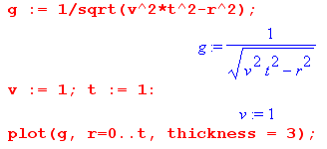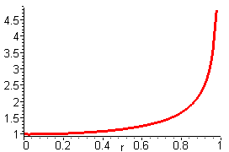

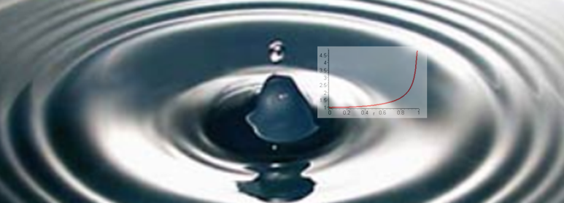
http://physicsilluminati.blogspot.com/2012/10/wave-optics.html

2. The time-domain Green's functions quoted in (A.7.4) for n = 3 and (A.7.7) for n = 2 are propagators for the wave equation (A.7.3) in 3D and 2D. When these Green's functions are Fourier transformed to the frequency ω domain, they become the 3D and 2D Helmholtz propagators discussed in Appendix H and I, namely

gF(r,r'; ω) = e-jkR/4πR = the Helmholtz 3D free-space propagator R = | r - r'| (H.1.7)

gF(r,r'; ω) = (j/4) H0(1)(kR) = the Helmholtz 2D free-space propagator k2 = ω2με (I.1.7)

Appendix B: Magnetization Surface Currents on a Conductor

Overview

When a conductor of magnetic permeability μ2 is embedded in a medium of μ1 with μ1 ≠ μ2, a "bound current" (magnetization current) appears on the conductor surface.

Section B.1 shows how this surface current K is related to the H field at the surface.

Section B.2 shows how to compute H from the volume conduction current density Jc.

Section B.3 then outlines a general plan for computing surface current K for an arbitrary conductor.

Section B.4 computes H and the surface current for a round wire using symmetry.

Section B.5 repeats the calculation using the general method outlined in Section B.3.

Section B.6 presents what we call "the Jm Theorem" which shows that adding the surface current of Section B.3 to the conduction current of a transmission line conductor adjusts the Helmholtz integral for Az so it gives the correct Az when the conductor and dielectric have different permeabilities, μ1 ≠ μ2.

Section B.7 shows how this "Jm Theorem" works for a round conductor. Plots are displayed for the three quantities Az, Bθ and Hθ.

The conductors considered here are those of a transmission line in the "transmission line limit" in which it is assumed that the wavelength along the line is much longer than the transverse dimensions of the line. In this case, it is reasonable to use 2D wave equations whose solutions then involve use of the 2D Poisson free-space propagator ln(R/2π) as discussed in Appendix I.

B.1 Relationship between surface current K and the field H at a conductor boundary

First, consider this blow up of a piece of the boundary between a conductor (medium 2) and a dielectric (medium 1). Both media extend uniformly in the z direction, so we are looking at a piece of the cross section of a transmission line at a particular point on the surface of one of the conductors.

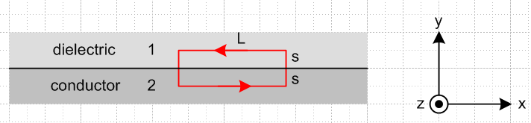 Fig B.1

We shall assume that the conduction current is positive in the z direction, so J = Jz with Jz > 0. Since the lower medium is the conductor in the drawing, the B and H field at the boundary are in the - direction, that is to say, they point to the left due to the right hand rule relating J and B or H .
According to (1.1.44), the tangential component of the H field is continuous at a boundary provided the boundary does not carry a free surface current, which is our situation here. Therefore,

Hx2 = Hx1 (1/μ1)Bx1 = (1/μ2)Bx2 . (B.1.1)

Assuming μ2 ≥ μ1 (which would be the case if μ1 = μ0), the right equation implies |Bx2| ≥ |Bx1| so the B field is larger inside the conductor. But in our picture, both Bx2 and Bx1 are negative, so -Bx2 ≥ - Bx1 which then says Bx2 ≤ Bx1 and finally (Bx2 - Bx1) ≤ 0. Also, Hx2 = Hx1 ≤ 0. For the red loop shown in the figure one then has, as s→ 0,

B • ds = Bx2L - Bx1L = (Bx2 - Bx1)L ≤ 0 . (B.1.2)

Now consider (1.1.31) and (1.1.24) which say ( in the ω domain),

B • ds = ∫S curl B • dS = μ0 ∫S [ jωεE + Jc + Jm] • dS (B.1.3)

where dS = dS . Since E • dS involves only Ez (parallel to surface), and since by (1.1.41) such Ez is continuous at the boundary, and since Ez ≈ 0 inside the conductor, the εjωE term makes no contribution, giving then

B • ds = μ0 ∫S [Jc + Jm] • dS . (B.1.4)

As the distance s is taken to 0 in the red math loop above, ∫S Jc • dS → 0 because the conduction current is non-singular at the boundary. That is to say, ∫S Jc• dS → Jc • ∫S dS → 0. Since we shall take this limit in the end, we can then ignore the Jc term in (B.1.4) and write

B • ds = μ0 ∫S Jm • dS. intending to take s→ 0 . (B.1.5)

Since Jc flows in the + direction, the surface current Jm flows in the - direction (as shown below), so write

Jm = Kz δ(y) (B.1.6)

where Kz ≤ 0 is the magnitude of the surface current. Then

∫S Jm • dS = Kz $^{\int_{0}^{L}{}}$dx $^{\int_{-s}^{s}{}}$dy δ(y) • = Kz $^{\int_{0}^{L}{}}$dx = KzL . (B.1.7)

Thus from (B.1.2), (B.1.5) and (B.1.7) we find that

μ0 Kz = Bx2 - Bx1 . (B.1.8)

Compare this with (1.1.44) which says (as noted earlier, Kzfree = 0 on our boundary)

Kzfree = Hx2 - Hx1 . (1.1.44)

The H field does not "see" our magnetization surface current Kz, but the B field does see it.

The signs are consistent with Kz ≤ 0 and (Bx2 - Bx1) ≤ 0 as noted above. Then from (B.1.1) we find

μ0Kz = Bx2 - Bx1 = (μ2Hx2 - μ1Hx1) = (μ2-μ1) Hx2
and finally

Kz = ( $\frac{μ2}{μ0}$ - $\frac{μ1}{μ0}$ ) Hx2 . (B.1.9)

As noted earlier, Hx2 < 0 so Kz ≤ 0 is consistent with μ2 ≥ μ1.

We now rewrite this result in terms of a different picture:

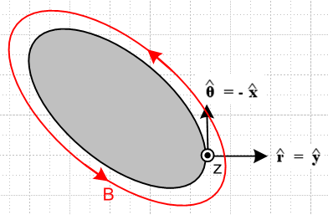 Fig B.2

This shows the cross section of the entire conductor in gray, and Jc is still directed toward the viewer. In this picture a point on the surface is associated with a local coordinate system for which = is normal to the surface and = - is tangent to the surface (so Hθ = -Hx). We are thinking of (r,θ,z) as local cylindrical coordinates at the point shown on the conductor surface, where x = , and the x,y,z directions of the figure match those of the previous figure where as usual x = . Then (B.1.9) says

Kz = - ( $\frac{μ2}{μ0}$ - $\frac{μ1}{μ0}$ ) Hθ amps/m (B.1.10)

where Hθ > 0 and Kz ≤ 0.
In general, Kz is a function of position on the perimeter of the conductor cross section.
We can compute the total magnetization current Im (amps) by integrating Kz around the perimeter of the conductor:

∫C Kz ds = - ( $\frac{μ2}{μ0}$ - $\frac{μ1}{μ0}$ ) ∫C Hθ ds = - ( $\frac{μ2}{μ0}$ - $\frac{μ1}{μ0}$ ) C H • ds

But by (1.1.37),

C H • ds = ∫S [jωεE+J] • dS = ∫S [jωεEz+Jz] dS ≈ ∫S Jz dS = I

and therefore

Im ≡ ∫C Kz ds = - ( $\frac{μ2}{μ0}$ - $\frac{μ1}{μ0}$ ) I (B.1.11)

The ratio of the magnetization current to the conduction current is given by constant fm ,

fm ≡ Im/ I = - ( $\frac{μ2}{μ0}$ - $\frac{μ1}{μ0}$ ) . (B.1.12)

and this result is independent of the shape of the conductor. Of course if μ1 = μ2, there is no magnetization current and Kz and Im are both zero.

Example: For a round wire of radius a carrying an axially symmetric current distribution, we know that 2πaHθ = I so Hθ = I/(2πa) at the surface. Then

Kz = - ( $\frac{μ2}{μ0}$ - $\frac{μ1}{μ0}$ ) [ I/(2πa)] . // round wire of radius a and μ2, dielectric μ1 (B.1.13)

The total surface magnetization current integrated around the round wire surface is then

Im = 2πaKz = - ( $\frac{μ2}{μ0}$ - $\frac{μ1}{μ0}$ ) I (B.1.14)

in agreement with (B.1.11).
For example, if the dielectric has μ1 = μ0 and the conductor has μ2 = 2μ0, then Imag = - I.
We return to this example in Section B.4 below.

Physical mechanism of the magnetization surface current. As a reminder, a surface magnetization current arises at a boundary between media with different μ values just the way surface polarization charge arises at a boundary between media with different ε. In the μ case, here is a suggestive picture :
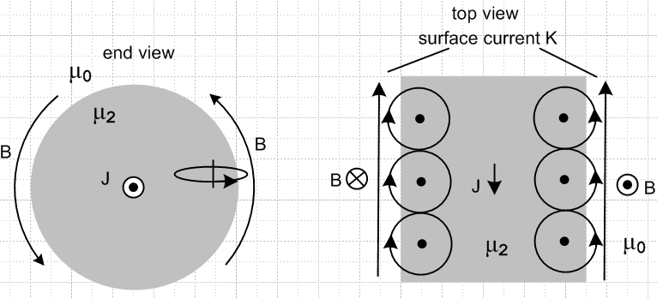 Fig B.3

On the left we look at a round wire end on, while the right shows a top view where the front end of the wire on the left has been tilted down. Here μ1= μ0 so there is only vacuum outside the wire. The B field lines up the little magnetic dipoles (or creates them) according to the right hand rule which we represent schematically as little atoms with orbiting electrons. On the right, B comes out of paper and lines up the magnetic moments CCW as shown there. On the left, B goes into paper so the moments are lined up clockwise instead. In both cases, the resulting magnetization surface current is in the same direction, as indicated by the arrows of the loops hanging outside the wire. The picture shows why it is that the surface current is directed opposite to the current J which creates it, a sort of magnetic Lenz's Law. Note that this surface current is "not seen" by H, but it is seen by B, as mentioned in (1.1.24).
In the case that the outer medium has some μ1 > μ0, both media have surface currents at the boundary, and then when μ1 ≠ μ2 there is a surface current imbalance resulting in a net surface current. If it happens that μ1 < μ2, then the directions shown above are correct, but if μ1 > μ2, the surface current runs in the opposite direction to that shown.
There is also a bulk volume magnetization current away from the surface, not shown above. Details of the magnetization current Jm for a round wire are computed (DC) in Appendix G (G.3.4) where the surface current term involves a surface delta function.

B.2 Calculation of H from the current J in a conductor

(a) An expression for H in terms of J

Start with Maxwell's equation (1.1.1), and we are now working inside a conductor so E = 0 and then

curl H = jωεE + J = J (B.2.1)

where J is the conduction current. Apply curl to both sides and use curl curl = grad div -∇2 to get

grad div H - ∇2H = curl J . (B.2.2)

But in a uniform medium div H = 0 since div B = 0 so

∇2H = - curl J . (B.2.3)

Now let's assume that we have J = Jz(x,y) and assume that the solution H does not depend on z. In that case we have

∇22D H(x,y) = - curl J J = Jz(x,y) . (B.2.4)

The particular solution to this PDE is shown in (I.1.8) to be

H(x,y) = ∫d2x' [ $\frac{1}{2π}$ln(1/R) ] curl' J(x') R = |x-x'| (B.2.5)
or
H(x,y) = - $\frac{1}{4π}$∫d2x' ln(R2) curl' J(x') R = |x-x'| (B.2.6)

where $\frac{1}{2π}$ln(1/R) is the Poisson 2D free-space propagator. This gives H in terms of J.

(b) An alternative derivation using the vector potential Az

An alternate derivation of (B.2.5) makes use of the vector potential Az. Start with (1.5.4),

(∇2 + β2)A(x) = - Σi μiJi (x) . all of region R (1.5.4)

Apply this to a single conductor and assume A(x) = Az(x,y), so the above equation becomes

-∇22D Az(x) = μJz(x) . (B.2.7)

The particular integral from (I.1.8) is then

Az(x) = ∫d2x' [ln(1/R)/2π] [μJz(x') = - (μ/2π) ∫d2x' ln(R) Jz(x') . (B.2.8)

Then use

B = curl A = (∂yAz - ∂zAy) + (∂zAx - ∂xAz) + (∂xAy - ∂yAx)

= (∂yAz) + (- ∂xAz) (B.2.9)

so that

μH = (∂yAz) + (- ∂xAz) . (B.2.10)

Now compute,

∂yAz(x) = ∂y [- (μ/2π) ∫d2x' ln(R) Jz(x') ] = - (μ/2π) ∫d2x' Jz(x') ∂y ln(R) .

But ∂y ln(R) = - ∂y' ln(R) since R = |x-x'|. But then do parts integration to move ∂y'to Jz(x') picking up an offsetting minus sign, and the parts vanish on a great circle surrounding the conductor. Thus,

∂yAz(x) = - (μ/2π) ∫d2x' ln(R) ∂y'Jz(x')
∂xAz(x) = - (μ/2π) ∫d2x' ln(R) ∂x'Jz(x') . (B.2.11)

Then from (B.2.10) one gets,

H = - (1/2π)∫d2x' ln(R) [ ∂y'Jz(x') - ∂x'Jz(x')] .

But the coordinates x = (x,y) and x' = (x',y') have the same unit vectors = ' and = ' . Since
J = Jz we then end up with

H(x) = - (1/2π)∫d2x' ln(R) curl' Jz(x') = + (1/2π)∫d2x' ln(1/R) curl' J(x')

which agrees with (B.2.5).

(c) Boundary conditions

Recall from (B.1.1) that the tangential component of H is continuous through the boundary between conductor and dielectric, even if μ1 ≠ μ2. Consider then the transverse component of (B.2.5) at some point on the conductor surface such as the point shown in Fig 3.3. We have (t = transverse)

Ht(x) = ∫d2x' [ $\frac{1}{2π}$ln(1/R) ] [curl' J(x')]t R = |x-x'| , (B.2.12)

This particular integral is naturally continuous at the boundary between the media, and this agrees with the fact that Ht(x) must have this property. Therefore, no homogeneous solutions of (B.2.4) ∇22DHt = 0 need be added in, so (B.2.12) is the complete solution for Ht(x). This solution can then be used in (B.1.10) to find the magnetization surface current.

(d) The Biot-Savart Law in 3D and 2D

Recall the above 3D vector Helmholtz equation,

∇2H = - curl J . (B.2.3)

In Cartesian coordinates it is three scalar Helmholtz equations which can be solved as in (H.1.8) to give

H(x) = ∫d3x' [ $\frac{1}{4πR}$] curl' J(x') R ≡ |x-x'| (B.2.13)

where 1/4πR is the 3D free-space Poisson propagator. Write this in components and define R as shown,

Hi(x) = ∫d3x' [ $\frac{1}{4πR}$]εijk ∂'jJk(x') , R ≡ x - x' = points to observation point x . (B.2.14)

Then move ∂j' from Jk to (1/R) by parts integration (pick up minus sign) and throw out the parts for the usual reasons (see end of Appendix A.1),

Hi(x) = - ∫d3x' $\frac{1}{4π}$∂'j ($\frac{1}{R}$) εijk Jk(x') . (B.2.15)

Then note that ∂'jR-1 = -R-2 ∂'jR and

∂'jR = ∂'j $\sqrt{Σk(x'k-xk)2}$ = (1/2)(1/R) 2(x'j-xj) = R-1 (x'j-xj) = - R-1 Rj (B.2.16)

so that ∂'jR-1 = +R-3Rj. Only the parts minus sign remains, so

Hi(x) = - ∫d3x' [ $\frac{1}{4πR3}$]εijk Rj Jk(x') (B.2.17)

or reversing the cross product order,

H(x) = ∫d3x' $\frac{1}{4πR3}$ J(x') x R . R ≡ x - x' (B.2.18)

This equation is basically the 3D Biot-Savart Law, see for example Panofsky and Philips p 125 (7.31). For a short piece ds' of thin wire carrying current I, one writes J(x') d3x' = I ds' so the above becomes,

H(x) = $\frac{1}{4πR3}$I ds' x R or dH(x) = $\frac{1}{4πR3}$I ds' x R . (B.2.19)

We can apply the same process to obtain a 2D Biot-Savart Law as follows. Start with

∇22D H(x,y) = - curl J J = Jz(x,y) (B.2.4)

and its solution (B.2.5)

H(x,y) = ∫d2x' [ $\frac{1}{2π}$ln(1/R) ] curl' J(x') R = |x-x'| (B.2.5)

where $\frac{1}{2π}$ln(1/R) is the Poisson 2D free-space propagator. Then, inverting 1/R,

Hi(x,y) = - ∫d2x' [ $\frac{1}{2π}$ln(R) ] εijk ∂'jJk(x') . (B.2.20)

Doing the same parts integration gives

Hi(x,y) = + ∫d2x' [ $\frac{1}{2π}$ ∂'j ln(R) ] εijk Jk(x') (B.2.21)

and now using result (B.2.16) from above,

∂'j ln(R) = R-1∂'jR = R-1 [- R-1 Rj] = -R-2Rj (B.2.22)

we get

Hi(x,y) = - ∫d2x' [ $\frac{1}{2π}$ R-2Rj ] εijk Jk(x') = - ∫d2x' $\frac{1}{2πR2}$ εijk Rj Jk(x') (B.2.23)
or
H(x,y) = ∫d2x' $\frac{1}{2πR2}$ J(x') x R R ≡ x - x' (B.2.24)

which is the 2D Biot-Savart Law. It provides an alternate way to obtain H from J in a 2D problem.

B.3 General Method for computing the surface current Jm on a wire

Here are the steps for a wire of arbitrary cross sectional shape:

1. Compute the H field at all points in the wire cross-sectional plane section using (B.2.6) or (B.2.24)

H(x,y) = - $\frac{1}{4π}$∫d2x' ln(R2) curl' J(x') R = |x-x'| . (B.2.6)
H(x,y) = ∫d2x' $\frac{1}{2πR2}$ J(x') x R R ≡ x - x' (B.2.24)

or use the third method of first computing Az,

Az(x) = - (μ/2π) ∫d2x' ln(R) Jz(x') (B.2.8)

B = curl A = (∂yAz) + (- ∂xAz) H = B/μ (B.2.9)

2. Evaluate this H field at xb = (xb,yb) for all points xb on the cross section boundary.

3. Compute the component of H which is tangential to the boundary in the cross sectional plane. Call this component Hθ.

4. The surface current density is then given by (B.1.10),

Kz = - ( $\frac{μ2}{μ0}$ - $\frac{μ1}{μ0}$ ) Hθ amps/m (B.1.10)

B.4 Surface current on a round wire with uniform J

For a round wire of radius a with uniform Jz (as would be the DC case ω = 0), geometric symmetry makes the calculation of H very easy. One need only apply Ampere's Law separately for a point r outside the wire, and for another point r inside the wire. For the outside case one finds

2πr Hθ(r) = I => Hθ(r) = I/(2πr) r ≥ a . (B.4.1)

And then for the inside case the "current enclosed" is determined by a simple area fraction.

2πr Hθ(r) = I (πr2/πa2) => Hθ(r) = I r/(2πa2) r ≤ a . (B.4.2)

At the boundary the two expressions agree and we have

Hθ = I/(2πa) . (B.4.3)

If this wire has magnetic permeability μ2 and is embedded in an infinite medium of μ1, then the surface magnetization current induced on the wire is

Kz = - ( $\frac{μ2}{μ0}$ - $\frac{μ1}{μ0}$ ) Hθ = - ( $\frac{μ2}{μ0}$ - $\frac{μ1}{μ0}$ ) I/(2πa) amp/m (B.4.4)

Kz = Kz (B.4.5)

and this surface current is in the direction opposite J if μ2 > μ1. If μ1 = μ2, the surface current vanishes. This surface current could be expressed in volume density form as

Jm = Kzδ(r-a) amp/m2 . (B.4.6)

B.5 Computing Hθ for a round wire using the General Method of B.3

For a wire of some general cross section, symmetry is not available to allow the simple solution for Hθ outlined in the previous section. We then have to use the more general method outlined in Section B.3 above. As a check on the viability of this general method, we shall carry out "step 1" of the method and show how Hθ may be computed from J using the formula (B.2.6).

The conduction current density in a round wire with uniform Jz is given by

Jz(r) = J0θ(a-r) (B.5.1)

where θ is the Heaviside step function. Our first step is to compute curl J, and we do this in cylindrical coordinates by just staring at the cylindrical-coordinates curl formula,

curl J = [ r-1∂θJz - ∂zJθ] + [∂zJr - ∂rJz] + [ r-1∂r(rJθ) - r-1∂θJr ] (B.5.2)

and finding the only non-zero piece which is this (uniform Jz)

curl J = [-∂rJz(r)] . (B.5.3)

Inserting Jz(r) from above we find

∂r Jz(r) = J0 ∂rθ(a-r) = - J0 δ(r-a) (B.5.4)

=> curl J(r) = J0 δ(r-a) . (B.5.5)

so we have a "ring source of curl J". For use in our integral for H we then have

curl' J(r') = ' J0 δ(r'-a) . (B.5.6)

For a current distribution which tapers off smoothly to 0 at the wire edge one would not have this singular contribution, but for a wire with prescribed uniform current, it is present, and curl J vanishes everywhere but on the boundary. The relevant picture is this:

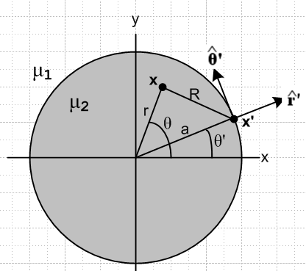 Fig B.4

From (B.2.5) the H field at any point x = (x,y) is then given by

H(x,y) = - $\frac{1}{4π}$∫d2x' ln(R2) curl' J(x') = - $\frac{1}{4π}$∫d2x' ln(R2) ' J0 δ(r'-a)
= - $\frac{J0a}{4π}$ $^{\int_{-π}^{π}{}}$dθ' ln(R2)|r'=a '
or
H(r,θ) = - $\frac{J0a}{4π}$ $^{\int_{-π}^{π}{}}$dθ' ln [ r2 + a2 - 2ar cos(θ'-θ) ] ' . (B.5.7)

The figure shows that

' = cosθ' - sinθ' (B.5.8)

so then
H(r,θ) = - $\frac{J0a}{4π}$ $^{\int_{-π}^{π}{}}$dθ' ln [ r2 + a2 - 2ar cos(θ'-θ) ] [cosθ' - sinθ' ] . (B.5.9)

Next, let x ≡ θ'-θ. Since the ∫dθ' has full range 2π, one can replace $^{\int_{-π}^{π}{}}$dθ' = $^{\int_{-π}^{π}{}}$dx . Then

H(r,θ) = - $\frac{J0a}{4π}$ $^{\int_{-π}^{π}{}}$dx ln [ r2 + a2 - 2ar cos(x) ] [cos(x+θ) - sin(x+θ) ] . (B.5.10)

Now writing H = Hx + Hy , decompose the above into two equations

Hx(r,θ) = + $\frac{J0a}{4π}$ $^{\int_{-π}^{π}{}}$dx ln [ r2 + a2 - 2ar cos(x) ] sin(x+θ)
Hy(r,θ) = - $\frac{J0a}{4π}$ $^{\int_{-π}^{π}{}}$dx ln [ r2 + a2 - 2ar cos(x) ] cos(x+θ) (B.5.11)
or
Hx(r,θ) = + $\frac{J0a}{4π}$ $^{\int_{-π}^{π}{}}$dx ln [ r2 + a2 - 2ar cos(x) ] [ sinxcosθ+cosxsinθ ]
Hy(r,θ) = - $\frac{J0a}{4π}$ $^{\int_{-π}^{π}{}}$dx ln [ r2 + a2 - 2ar cos(x) ] [cosxcosθ - sinxsinθ ] . (B.5.12)

Since $^{\int_{-π}^{π}{}}$dx is over an even range, throw out odd integrand terms, and then fold the negative range into the positive adding a factor of 2 to get

Hx(r,θ) = + sinθ $\frac{J0a}{2π}$ $^{\int_{0}^{π}{}}$dx ln [ r2 + a2 - 2ar cos(x) ] cosx ≡ sinθ $\frac{J0a}{2π}$Q
Hy(r,θ) = - cosθ $\frac{J0a}{2π}$ $^{\int_{0}^{π}{}}$dx ln [ r2 + a2 - 2ar cos(x) ] cosx = -cosθ $\frac{J0a}{2π}$Q (B.5.13)

where

Q ≡ $^{\int_{0}^{π}{}}$dx ln [ r2 + a2 - 2ar cos(x) ] cosx . (B.5.14)

Before evaluating this integral, we see that

H = Hx + Hy = - $\frac{J0a}{2π}$Q [ cosθ -sinθ ] = - $\frac{J0a}{2π}$Q = Hθ . (B.5.15)

Thus we find that the resulting H is entirely in the direction and

Hθ = - $\frac{J0a}{2π}$Q . (B.5.16)

We seek now to evaluate this integral Q,

Q ≡ $^{\int_{0}^{π}{}}$dx ln [ r2 + a2 - 2ar cos(x) ] cosx

= $^{\int_{0}^{π}{}}$dx ln [ {a2}{ (r/a)2 + 1 - 2(r/a) cos(x)} ] cosx

= $^{\int_{0}^{π}{}}$dx { ln (a2) + ln[(r/a)2 + 1 - 2(r/a) cos(x)] } cosx

= ln (a2)[$^{\int_{0}^{π}{}}$dx cosx ] + $^{\int_{0}^{π}{}}$dx ln[(r/a)2 + 1 - 2(r/a) cos(x)] cosx

= ln (a2)[0] + $^{\int_{0}^{π}{}}$dx ln[α2 + 1 - 2α cos(x)] cosx where α ≡ r/a

= $^{\int_{0}^{π}{}}$dx ln[α2 + 1 - 2α cos(x)] cosx . (B.5.17)

This integral is the n=1 special case of the following integral from GR7 page 589 4.379.6,

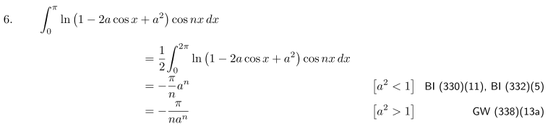
Therefore we find

Q = (B.5.18)
so
Hθ = - $\frac{J0a}{2π}$Q = . (B.5.19)

Now the total current in the wire is I = J0πa2 so (aJ0/2) = (I/2πa) and then

Hθ = = . (B.5.20)

Thus, we finally arrive at the same results for Hθ as obtained in (B.4.2) and (B.4.1).

B.6 Modification of King's Helmholtz integral solution when μ1 ≠ μ2

(a) General Discussion

In Section 4.7 we wrote the vector potential for transmission line conductor C in this manner,

Az(x,ω) = $\frac{1}{4π}$∫$_{}^{}$ μ2 Jzc(x',y',z',ω)$\frac{e-jβR}{R}$dx'dy'dz' . R = |x - x'| (4.7.2)

where we have made a notational change to be consistent with previous sections of Appendix B. Here we shall use μ2 to refer to the permeability of the conductor, and μ1 to be that of the dielectric (these are called μ1 and μ in Section 4). The above "Helmholtz integral" is only the "particular solution" of the Helmholtz equation (∇2 + β12)Az= -μ2Jcz. When μ1 ≠ μ2, it turns out that one must add a homogeneous solution Az(homo) [ that is, (∇2 + β12) Az(homo) = 0] to the Helmholtz solution shown above in order to meet boundary conditions. Appendix G.4 provides a very detailed study of just how this works for a round conductor with a uniform current distribution.
To avoid this major complication, we limited the analysis of Chapter 4 to the case that μ1 = μ2. This means, for example, that Chapters 4,5,6 are applicable for non-magnetic conductors in a non-magnetic dielectric, in which case μ1 = μ2 = μ0.
With the reader's permission, we replicate the following comments from below (4.7.6), making a few small changes:

Comments regarding μ

This is a subtle subject and is not discussed in King's transmission line theory book.
If the dielectric and conductor have the same permeability so that μ1 = μ2, then there exists no "magnetic boundary" between the conductor and dielectric. The solution (4.7.2) is then smooth at this boundary, and so Az(x,y,z) "naturally" satisfies these two boundary conditions,

Az(x+) = Az(x-)
(1/μ1) ∂nAz(x+) = (1/μ2) ∂nAz(x-) (4.7.7) (B.6.0)
where x+ is just outside the conductor surface and x- is just inside. The second equation here is just (1.1.46) in the case that there is no free surface current Kfree flowing on the boundary, and indeed in our example at hand there is no such free surface current. Since we have assumed that μ1 = μ2, this second boundary condition just says ∂nAz(x+) = ∂nAz(x-). Since there is no magnetic boundary at the conductor/dielectric interface, the solution (4.7.2) is continuous and all its derivatives are also continuous at the boundary, since nothing special happens at that boundary. Thus, the Helmholtz integral solution provides the whole solution for Az since it automatically meets both "boundary conditions" at this pseudo boundary.
If on the other hand we have μ1 ≠ μ2, then there is a magnetic boundary between conductor and dielectric which we have to worry about. In this case, (4.7.2) cannot possibly satisfy the second boundary condition of (B.6.0) since, as already noted, the Az of (4.7.2) satisfies ∂nAz(x+) = ∂nAz(x+). Thus, in this case (4.7.2) is not the full solution for Az. One must add a homogeneous Helmholtz equation solution to (4.7.2) in order to have a proper solution for Az that satisfies both equations in (B.6.0).
It turns out that the correct total Az solution can be generated by adding a certain fictitious surface current to μ2Jz in (4.7.2). Since such a surface current vanishes on both sides of the boundary between μ1 and μ2, the Helmholtz solution due just to this surface current is in fact a homogeneous solution to the Helmholtz equation in both the conductor and dielectric regions, away from that boundary. It turns out moreover that the correct fictitious surface current to add is in fact the magnetization surface current Jm which is created at the boundary between μ1 ≠ μ2. Adding this surface current is just a "trick" in order to generate the correct homogeneous adder solution so that the resulting total Az satisfies both boundary conditions in (B.6.0). Formally speaking, the J appearing in (1.5.3) and then Jz in (4.7.2) should not include such magnetization currents since this J is really the J in Maxwell's equation curl H = ∂tD + J, and this J does not include magnetization currents -- it includes only normal conduction currents.

Here we wish to prove the claim that adding the surface magnetization current to the conduction current does in fact make the boundary conditions work. After doing this proof, we will show in Section B.7 just how this works out in the case of a round conductor.

We stress that only the surface part of Jm gets added in. In general Jm will also have a "bulk" component in the dielectric and conductor. If we were to include this bulk component, we would not be adding a homogeneous solution to the particular solution, and we would in fact be creating a non-solution! In (G.3.4) we show the complete Jm for a round wire carrying a uniform current, and it does have both bulk and surface components.

(b) Statement and Proof of the Jm Lemma

The Jm Lemma. If Jmz represents the surface component of magnetization current density for a transmission line conductor C of μ2 with conduction current density Jcz, embedded in a dielectric medium of μ1, then if we write

Az(x) = $\frac{1}{4π}$∫$_{}^{}$ [μ2 Jcz(x') + μ0 Jmz(x')] $\frac{e-jβR}{R}$dV' . R = |x - x'| (B.6.1)

this Az(x) will satisfy the boundary conditions (B.6.0) shown above.

Comments.

1. In this Lemma, we are showing that the contribution to Az(x) just from conductor C satisfies the boundary condition (B.6.0) at the surface of conductor C if we add in the surface current term μ0 Jmz(x') as shown. What we really want to show is that the total Az(x) due to all the transmission line conductors satisfies (B.6.0) at the surface of conductor C. This will be the content of the Jm Theorem presented in Section (c) below. Once this Theorem is proved, we know that "the other conductors" don't interfere with the Jm Lemma and we can regard the boundary conditions on Az(x) given in (B.6.1) as applying also to the full Az(x) which includes the contributions of all conductors.

2. Our proof below applies in the "transmission line limit" of Sections 4.3 and 4.9 which is essentially a long wavelength and small β limit. In this limit, we can replace our various Helmholtz propagators below with Poisson (Laplace) propagators. Nevertheless, we maintain the Helmholtz forms in the hope that the above theorem is valid for reasonably moderate (but not huge) β values. At very large β values the whole transmission line framework collapses anyway, transverse Ax and Ay components are no longer small, and the line picks up transverse waveguide activity.

(1) Preliminaries

We first quote a key result from Stakgold concerning boundary layer a(ξ):

u(x) = ∫σ dSξ a(ξ) E(x|ξ)
u(s) = ∫σ dSξ a(ξ) E(s|ξ) (B.6.2)

∂νu(x) = ∫σ dSξ a(ξ) ∂νE(x|ξ)
∂νu(s) = [∂nu(x)]x→s± = ∫σ dSξ a(ξ) ∂νE(s|ξ) ∓ a(s)/2 // extra term ! (B.6.3)

This is a tricky subject and some words are certainly in order. In the Stakgold world, σ is a surface of n-1 dimensions existing in an n dimensional space. E(x|ξ) is the free-space propagator in that n dimensional space (the "fundamental solution"). The integrals shown above are over the surface σ, and ξ represents the n-1 dimensional coordinate of a point on the surface σ, while dSξ is a piece of "area" on the surface. (Stakgold does not write vectors in bold font as we do in this document.) Function a(ξ) is defined on the surface and is called a simple (monopole) boundary layer. Stakgold also deals with dipole layers (as in a cell membrane), but we don't care about them right now.
The question at hand is this: What happens as a point x away from the surface approaches the surface where it becomes point s? We are interested in the limit x → s. As shown in the first pair of equations, nothing unusual happens for the function u(x) defined as shown by the integral. One then says that u(x) is "continuous" at x = s. But something very unusual happens for the function ∂νu(x) where ∂ν denotes a derivative locally normal to the surface at s. As x → s an "extra term" appears as shown above having value ∓a(s)/2. If normal ν points "out" from the surface then as one approaches from the outside (call it the + side), the extra term is -a(s)/2, but if the approach is from the inside (- side), the extra term changes sign. Here is a picture illustrating the geometry of the above equations: ( n is normal at ξ , ν is normal at s)

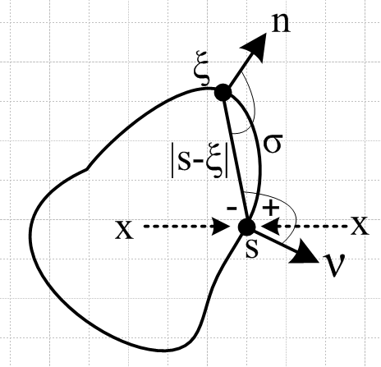 Fig B.5

The reason the extra term appears has to do with the nature of the dξ integration when ξ is very close to s which is somewhat of a singular situation since R ≡ |s-ξ| → 0. Stakgold treats surface layers in Section 6.4 of his Volume II, pages 110-120, and his treatment involves a lot of detail. The claims shown above appear on pages 118 and 119, though the conclusions are a bit obscured in the detail. Stakgold works in 3D with E(x|ξ) = (1/4π|x-ξ|) = 1/4πR and often uses these quantities,

k(s,ξ) = cos(s ξ, )/ [4π|s-ξ|2] // cos(upper marked angle)
k(ξ,s) = cos(ξ s, )/[4π|s-ξ|2] = ∂νE(s|ξ) . // cos(lower marked angle)

Later in his Problem 6.18 through 6.20 Stakgold has the reader verify that the results are also valid in 2D where surface σ is then just a curve. These are the results we shall use. Although he does not state it outright, we think his results are probably valid for σ being a surface of any number of dimensions, but our only interest will be the 2D case.

(2) Outline of Proof of the Jm Lemma

We break up (B.6.1) into these two terms, a "conduction term" and a "magnetization" term,

Az(c)(x) = $\frac{1}{4π}$∫$_{}^{}$ [μ2 Jcz(x')] $\frac{e-jβR}{R}$dV' . R = |x - x'| (B.6.4)
Az(m)(x) = $\frac{1}{4π}$∫$_{}^{}$ [μ0 Jmz(x')] $\frac{e-jβR}{R}$dV' . R = |x - x'| (B.6.5)

Az(x) = Az(c)(x) + Az(m)(x) . two terms (B.6.6)

As noted earlier, the first term is smooth at a point s on a conductor surface and satisfies the two boundary conditions,

Az(c)(s+) = Az(c)(s-)
∂nAz(c)(s+) = ∂nAz(c)(s-) . (B.6.7)

so one can write Az(c)(s) or ∂nAz(c)(s) without concern for whether s is s+ or s-. For this term, which is the Helmholtz "particular" integral, we may then trivially write,

$\frac{1}{μ1}$∂nAz(c)(s+) – $\frac{1}{μ2}$∂nAz(c)(s-) = + [ $\frac{1}{μ1}$- $\frac{1}{μ2}$] ∂nAz(c)(s) . (B.6.8)

Since this is non-zero, the term Az(c) on its own does not meet the required slope boundary condition (B.6.0) at an interface between μ1 and μ2, and that is precisely why we need the Az(m) term. Our goal is to show that

$\frac{1}{μ1}$∂nAz(m)(s+) – $\frac{1}{μ2}$∂nAz(m)(s-) = – [ $\frac{1}{μ1}$- $\frac{1}{μ2}$] ∂nAz(c)(s) (B.6.9)

so that when we add the two terms we will get

$\frac{1}{μ1}$∂nAz(s+) – $\frac{1}{μ2}$∂nAz(s-) = 0 (B.6.10)

as required by (1.1.46). The concludes our proof outline, and it remains then to demonstrate (B.6.9).

(3) Verification of (B.6.9)

We start with (B.6.5) where ∫dV' is over the entire transmission line conductor C,

Az(m)(x) = $\frac{1}{4π}$∫$_{}^{}$ dV' [μ0 Jmz(x')] $\frac{e-jβR}{R}$
= ∫$_{}^{}$ dV' [μ0 Jmz(x') E3(x|x') (B.6.11)
where
E3(x|x') = $\frac{e-jβR}{4πR}$ → $\frac{1}{4πR}$ as β→0 . (B.6.12)

We know from Chapter 4 that in the transmission line limit we can do the dz' integration in dV' and arrive at a 2D-propagator expression for the above potential, where the integral is now over the cross section area of the conductor C,

Az(m)(x) =∫$_{}^{}$ dS' [μ0 Jmz(x')] E2(x|x') (B.6.13)
where
E2(x|x') = (j/4) H0(1)(kR) → - $\frac{1}{2π}$ln(R2) as β→0 . (B.6.14)

This whole subject of transitioning from the 3D to 2D analysis is reviewed in Appendix J, and it occurs in many places in this document.

We are only using that portion of Jmz which is a surface current on the perimeter of C, so we rewrite the above as

Az(m)(x) = C ds' [μ0 Kz(x')] E2(x|x') (B.6.15)

where Kz(x') is the magnetization surface current (amps/m) discussed in Section B.1. Stakgold's surface integral over σ is now just a line integral around the perimeter of the conductor C cross section. Recall from (B.1.10) that the magnetization surface current is given by,

Kz = - ( $\frac{μ2}{μ0}$ - $\frac{μ1}{μ0}$ ) Hθ (B.1.10)

where Hθ is the H field tangent to the cross section surface. Inserting this Kz into (B.6.15) gives

Az(m)(x) = C ds' [(μ1-μ2) Hθ(x')] E2(x|x') . (B.6.16)

We now identify this with the first of Stakgold's equations (B.6.2) and we know we can take x→s with no surprises. If we now replace Stakgold's normal direction ν with our usual normal symbol n, we can write (B.6.3) as

∂nAz(m)(x) = C ds' [(μ1-μ2) Hθ(x')] ∂nE2(x|x') (B.6.17)
∂nAz(m)(s±) = C ds' [(μ1-μ2) Hθ(x')] ∂nE2(s|x') ∓ [(μ1-μ2) Hθ(s)]/2 . (B.6.18)

Now since we want to prove (B.6.9), we first evaluate its left hand side using (B.6.18) twice,

$\frac{1}{μ1}$∂nAz(m)(s+) – $\frac{1}{μ2}$∂nAz(m)(s-)

= $\frac{1}{μ1}${ C ds' [(μ1-μ2) Hθ(x')] ∂nE2(s|x') - [(μ1-μ2) Hθ(s)]/2 }
– $\frac{1}{μ2}${ C ds' [(μ1-μ2) Hθ(x')] ∂nE2(s|x') + [(μ1-μ2) Hθ(s)]/2 } (B.6.19)

= (μ1-μ2) [ $\frac{1}{μ1}$- $\frac{1}{μ2}$] C ds' Hθ(x') ∂nE2(s|x') – [ $\frac{1}{μ1}$+ $\frac{1}{μ2}$] (μ1-μ2) Hθ(s)/2 .

Our task of showing that (B.6.9) is true then boils down to showing that the last expression above is equal to – [$\frac{1}{μ1}$- $\frac{1}{μ2}$] ∂nAz(c)(s) . That is to say, we have to show

(μ1-μ2) [$\frac{1}{μ1}$- $\frac{1}{μ2}$] C ds' Hθ(x') ∂nE2(s|x') – [$\frac{1}{μ1}$+ $\frac{1}{μ2}$] (μ1-μ2) Hθ(s)/2 = – [$\frac{1}{μ1}$- $\frac{1}{μ2}$] ∂nAz(c)(s) ?
(B.6.20)
A question mark indicates an equation that we want to show is true, but have not yet done so.

Canceling (μ1-μ2) factors, (B.6.20) becomes

[$\frac{1}{μ1}$- $\frac{1}{μ2}$] C ds' Hθ(x') ∂nE2(s|x') – [$\frac{1}{μ1}$+ $\frac{1}{μ2}$] Hθ(s)/2 = + $\frac{1}{μ1μ2}$∂nAz(c)(s) ? (B.6.21)
or
(μ2-μ1) C ds' Hθ(x') ∂nE2(s|x') – (1/2)(μ2+μ1) Hθ(s) = ∂nAz(c)(s ) . ? (B.6.22)

The integral in (B.6.22) can be replaced using (B.6.18) with the s+ choice,

∂nAz(m)(s+) = C ds' [(μ1-μ2) Hθ(x')] ∂nE2(s|x') - (1/2)[(μ1-μ2) Hθ(s) (B.6.18)+
so
(μ2-μ1) C ds' Hθ(x') ∂nE2(s|x') = – ∂nAz(m)(s+) – (1/2) (μ1-μ2) Hθ(s) . (B.6.23)

Equation (B.6.22) then becomes,

– ∂nAz(m)(s+) – (1/2)(μ1-μ2) Hθ(s) – (1/2)(μ2+μ1) Hθ(s) = ∂nAz(c)(s) ?
or
– ∂nAz(m)(s+) – μ1 Hθ(s) = ∂nAz(c)(s) ?
or
– μ1 Hθ(s) = ∂n [Az(c)(s) + Az(m)(s+) ] ?
or
– μ1 Hθ(s) = ∂nAz(s+) . ? // using (B.6.6) (B.6.24)

We now introduce a local cylindrical coordinate system in this manner relative to point s

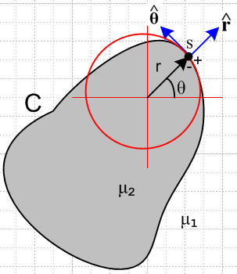 Fig B.6

Notice that is the normal vector at point s, so ∂r = ∂n. Then first we determine Bθ,

B = curl A = [ r-1∂θAz - ∂zAθ] + [∂zAr - ∂rAz] + [ r-1∂r(rAθ) - r-1∂θAr ]
= [ r-1∂θAz] + [- ∂rAz]
= [- ∂rAz] .

Here we have set ∂θAz = 0 according to Fact 7 of (3.8.11) which says Az is constant on the cross section surface. The result is then,

Bθ(s+) = - ∂nAz(s+) . (B.6.25)

Since s+ is in the dielectric with μ1 we then have

Hθ(s+) = (1/μ1) Bθ(s+) = - (1/μ1) ∂rAz(s+) // Hθ(s+) = Hθ(s-) = Hθ(s) says (1.1.42)
so
-μ1 Hθ(s) = ∂rAz(s+) = ∂nAz(s+) . (B.6.26)

But this last equation matches our equation in question (B.6.24), so we can then go back and erase all the question marks and we have then verified equation (B.6.9) and our proof is complete.

Comment: We noted that Stakgold's analysis is quite complicated. He uses the Laplace free-space propagators such as E2(x|x') = -(1/2π) ln(R2), but we think his analysis also applies for the Helmholtz propagators. The reason is that the Helmholtz complication does not really change the singular nature of things near R = 0. This is most obvious when comparing e-jβR/4πR to 1/4πR. If we are wrong about this conjecture, we can regard the above theorem as proven only for small β which in fact defines the transmission line limit.

(c) Statement and Proof of the Jm Theorem

The Jm Theorem. A transmission line consists of two conductors called C2 and C3, since index 1 is reserved for the dielectric. For example, the dielectric has permeability μ1 (but we write β in place of β1). The total "particular" vector potential Az(x) due to the conduction currents in these two conductors is, according to (1.5.9),

A(x)part = $\frac{1}{4π}$ Σi=23∫$_{}^{}$ μiJci(x') $\frac{e-jβR}{R}$dV' . R = |x-x'| (1.5.9)

The theorem claims that (1) the correct total potential is given by

A(x) = $\frac{1}{4π}$ Σi=23∫$_{}^{}$ [ μiJci(x') + μ0Jmi(x')] $\frac{e-jβR}{R}$dV' . (B.6.27)

where Jmi(x') represents the surface current at the surface of conductor Ci, and (2) this correct total potential satisfies the boundary conditions (B.6.0) at the surface of both conductors.

We claim the theorem is also true for a transmission line consisting of any number of conductors, but we restrict our interest to two conductors. We shall show for (B.6.27) that (B.6.0) is valid at the surface of conductor C2 and a similar argument then shows it is also valid at the surface of C3.

Since we are operating in the transmission line limit, the actual claim being made is this:

Az(x) = $\frac{1}{4π}$ Σi=23∫$_{}^{}$ [ μiJczi(x') + μ0Jmzi(x')] $\frac{e-jβR}{R}$dV' . (B.6.28)

To enhance clarity, we shall give each conductor its own custom integration variable. The expression above contains four terms which we now write out:

Az(c2)(x) = $\frac{1}{4π}$∫$_{}^{}$ [μ2 Jcz2(x2')] $_{2}$dV2' R2 = |x - x2'|
Az(c3)(x) = $\frac{1}{4π}$∫$_{}^{}$ [μ3 Jcz3(x3')] $_{3}$dV3' R3 = |x - x3'| (B.6.4)'

Az(m2)(x) = $\frac{1}{4π}$∫$_{}^{}$ [μ0 Jmz2(x2')] $_{2}$dV2' R2 = |x - x2'|
Az(m3)(x) = $\frac{1}{4π}$∫$_{}^{}$ [μ0 Jmz3(x3')] $_{3}$dV3' R3 = |x - x3'| (B.6.5')

Az(x) = Az(c2)(x) + Az(c3)(x) + Az(m2)(x) + Az(m3)(x) . (B.6.6)'
Without loss of generality, we shall consider x → s where s is a point on the surface of conductor C2.

The "conduction solutions" Az(ci) (that is to say, the particular solutions) are naturally smooth at point s, as described in the text surrounding (B.6.0). Thus, we know that

Az(ci)(s+) = Az(ci)(s-)
∂nAz(ci)(s+) = ∂nAz(ci)(s-) . i = 2, 3 (B.6.7)'

Since s = s+ = s- for these functions, we may trivially write

$\frac{1}{μ1}$∂n[Az(c2)(s+) + Az(c3)(s+)] – $\frac{1}{μ2}$∂n[Az(c2)(s-) + Az(c3)(s-)]
= + [ $\frac{1}{μ1}$- $\frac{1}{μ2}$] ∂n[Az(c2)(s) + Az(c3)(s)]. (B.6.8)'

Since this is non-zero, the term [Az(c2)(s+) + Az(c3)(s+)] on its own does not meet the required slope boundary condition (B.6.0) at an interface between μ1 and μ2, and that is precisely why we need the Az(m) terms. Our goal is to show that

$\frac{1}{μ1}$∂n[Az(m2)(s+) + Az(m3)(s+)] – $\frac{1}{μ2}$∂n[Az(m2)(s-) + Az(m3)(s-)]

= - [ $\frac{1}{μ1}$- $\frac{1}{μ2}$] ∂n[Az(c2)(s) + Az(c3)(s)] . (B.6.9)'

so that when we add the four terms of (B.6.6)' we will get

$\frac{1}{μ1}$∂nAz(s+) – $\frac{1}{μ2}$∂nAz(s-) = 0 (B.6.10)

as required by (1.1.46). The concludes our proof outline, and it remains then to demonstrate (B.6.9)'.

At this point, we skip over several equations of the Lemma proof since they are all generalized simply by adding 2 or 3 subscripts in the right places. For example, the surface currents are given by,

Kz2 = - ( $\frac{μ2}{μ0}$ - $\frac{μ1}{μ0}$ ) Hθ2 on C2
Kz3 = - ( $\frac{μ3}{μ0}$ - $\frac{μ1}{μ0}$ ) Hθ3 on C3 . (B.1.10)

We arrive then at (B.6.16)' as follows ( recall that E2 is the 2D Helmholtz propagator ),

Az(m2)(x) = C2 ds2' [(μ1-μ2) Hθ2(x2')] E2(x|x2')
Az(m3)(x) = C3 ds3' [(μ1-μ3) Hθ3(x3')] E2(x|x3') . (B.6.16)'

We regard these as two representations of Stakgold's first equation (B.6.2). Nothing special happens in these equations as x → s. Thus, we can say that in either case, Az(mi)(s+) = Az(mi)(s-). When this is combined with the first line of (B.6.7)', we find by adding all four terms in (B.6.6)' that Az(s+) = Az(x-) and we have thus shown that the first boundary condition of the pair (B.6.0) is satisfied.

A major difference appears at the next step (B.6.18)' ,

∂nAz(m2)(s±) = C2 ds2' [(μ1-μ2) Hθ2(x')] ∂nE2(s|x2') ∓ [(μ1-μ2) Hθ2(s)]/2 .

∂nAz(m3)(s±) = C3 ds3' [(μ1-μ3) Hθ3(x')] ∂nE2(s|x3') . (B.6.18)'

The "extra Stakgold term" only appears when a point s lies on the surface being integrated over since it is this integration which gives rise to the singular situation. Since our s lies on C2 and not on C3, there is no "extra term" in the last equation above.

Now since we want to prove (B.6.9)', we first evaluate its left hand side using each equation of (B.6.18)' twice,

$\frac{1}{μ1}$∂n[Az(m2)(s+) + Az(m3)(s+)] – $\frac{1}{μ2}$∂n[Az(m2)(s-) + Az(m3)(s-)]

= $\frac{1}{μ1}${ C2 ds2' [(μ1-μ2) Hθ2(x2')] ∂nE2(s|x2') - [(μ1-μ2) Hθ2(s)]/2 } // $\frac{1}{μ1}$∂n Az(m2)(s+)
– $\frac{1}{μ2}${ C2 ds2' [(μ1-μ2) Hθ2(x2')] ∂nE2(s|x2') + [(μ1-μ2) Hθ2(s)]/2 } // - $\frac{1}{μ2}$∂n Az(m2)(s-)

+ $\frac{1}{μ1}${ C3 ds3' [(μ1-μ3) Hθ3(x3')] ∂nE2(s|x3') } // $\frac{1}{μ1}$∂n Az(m3)(s+)
– $\frac{1}{μ2}${ C3 ds3' [(μ1-μ3) Hθ3(x3')] ∂nE2(s|x3') } // - $\frac{1}{μ2}$∂n Az(m3)(s-)
= (μ1-μ2) [ $\frac{1}{μ1}$- $\frac{1}{μ2}$] C2 ds2' Hθ2(x2') ∂nE2(s|x2') – [ $\frac{1}{μ1}$+ $\frac{1}{μ2}$] (μ1-μ2) Hθ2(s)/2
+ (μ1-μ3) [ $\frac{1}{μ1}$- $\frac{1}{μ2}$] C3 ds3' Hθ3(x3')] ∂nE2(s|x3') (B.6.19)'

where the last line was not present in (B.6.19). Our task of showing that (B.6.9)' is true then boils down to showing that the last expression above is equal to - [ $\frac{1}{μ1}$- $\frac{1}{μ2}$] ∂n[Az(c2)(s) + Az(c3)(s)] . That is to say, we have to show

(μ1-μ2) [ $\frac{1}{μ1}$- $\frac{1}{μ2}$] C2 ds2' Hθ2(x2') ∂nE2(s|x2') – [ $\frac{1}{μ1}$+ $\frac{1}{μ2}$] (μ1-μ2) Hθ2(s)/2
+ (μ1-μ3) [ $\frac{1}{μ1}$- $\frac{1}{μ2}$] C3 ds3' Hθ3(x3')] ∂nE2(s|x3') = - [ $\frac{1}{μ1}$- $\frac{1}{μ2}$] ∂n[Az(c2)(s) + Az(c3)(s)] . ?
(B.6.20)'
As before, a question mark indicates an equation that we want to show is true, but have not yet done so. Cancelling (μ1-μ2) factors gives

[ $\frac{1}{μ1}$- $\frac{1}{μ2}$] C2 ds2' Hθ2(x2') ∂nE2(s|x2') – [ $\frac{1}{μ1}$+ $\frac{1}{μ2}$] Hθ2(s)/2
- (μ1-μ3) $\frac{1}{μ1μ2}$ C3 ds3' Hθ3(x3')] ∂nE2(s|x3') = + $\frac{1}{μ1μ2}$ ∂n[Az(c2)(s) + Az(c3)(s)] ?
or (B.6.21)'
(μ2-μ1) C2 ds2' Hθ2(x2') ∂nE2(s|x2') – (μ2+μ1) Hθ2(s)/2
+ (μ3-μ1) C3 ds3' Hθ3(x3')] ∂nE2(s|x3') = ∂n[Az(c2)(s) + Az(c3)(s)] . ? (B.6.22)'

The integrals in (B.6.22)' can be replaced using (B.6.18)' with the s+ choice,

∂nAz(m2)(s+) = C2 ds2' [(μ1-μ2) Hθ2(x2')] ∂nE2(s|x2') - (1/2)[(μ1-μ2) Hθ2(s)
∂nAz(m3)(s) = C3 ds3' [(μ1-μ3) Hθ3(x2')] ∂nE2(s|x3') (B.6.18)+
so
(μ2-μ1) C2 ds2' Hθ2(x2') ∂nE2(s|x2') = – ∂nAz(m2)(s+) - (1/2)[(μ1-μ2) Hθ2(s)
(μ3-μ1) C3 ds3' Hθ3(x3')] ∂nE2(s|x3') = – ∂nAz(m3)(s) . (B.6.23)'

Equation (B.6.22)' then becomes

– ∂nAz(m2)(s+) - (1/2)[(μ1-μ2) Hθ2(s) – (μ2+μ1) Hθ2(s)/2
– ∂nAz(m3)(s) = ∂n[Az(c2)(s) + Az(c3)(s)] ?
or
– ∂nAz(m2)(s+) – μ1 Hθ2(s)
– ∂nAz(m3)(s) = ∂n[Az(c2)(s) + Az(c3)(s)] ?
or
- μ1Hθ2(s) = ∂n[Az(c2)(s) + Az(c3)(s) + Az(m2)(s+) + ∂nAz(m3)(s) ] ?
or
- μ1Hθ2(s) = ∂nAz(s+) ? // using (B.6.6)'. (B.6.24)'

But this last equation is true as shown in Fig B.6 (with C = C2) and (B.6.26), so we can then go back and erase all the question marks and we have then verified equation (B.6.9)' and our proof is complete.

By then taking s to be a point on the surface of C3, we would find - μ1Hθ3(s) = ∂nAz(s+) for (B.6.24)' and then Fig B.6 with C = C3 would verify this result as well.

B.7 Application of the Jm Lemma to a round wire with uniform Jz

We shall here verify the Jm Lemma for a round wire which we can regard as the central conductor of a coaxial transmission line with distant shield return. We know from Comment 1 below (B.6.1) that the potential of the shield is not going to interfere with the Jm Lemma and that a verification of the boundary conditions (B.6.0) for the potential of this Lemma applies as well to the combined potential of both conductors.

Assuming the transmission line limit of small β so e-jβR ≈ 1, we start then with (B.6.1),

Az(x) = ∫$_{}^{}$ dV' [μ2 Jcz(x') + μ0 Jmz(x')] $\frac{1}{4πR}$ . R = |x - x'| (B.6.1)

but we go at once to the 2D solution [∇22DA(x) = - μ2Jc(x)] limit to get

-Az(x) = ∫$_{}^{}$ dA' [μ2 Jcz(x') + μ0 Jmz(x')] $\frac{ln(R2)}{4π}$ . // $\frac{1}{2π}$ln(1/R) = - $\frac{ln(R2)}{4π}$ (B.7.1)

The two currents are given by

Jcz(x') = Jcz = I/(πa2) // uniform
Jmz(x') = Kz δ(r'-a) with Kz = - ( $\frac{μ2}{μ0}$ - $\frac{μ1}{μ0}$ ) Hθ . (B.1.10) (B.7.2)

(a) The Az(c) term

The first term in (B.7.1) is then

-Az(c)(r,θ) = $\frac{μ2I}{πa2}$∫$_{}^{}$ dA' $\frac{ln(R2)}{4π}$ = $\frac{μ2I}{πa2}$$^{\int_{0}^{a}{}}$r' dr'$^{\int_{-π}^{π}{}}$dθ' $\frac{ln(R2)}{4π}$
= $\frac{μ2I}{4π2a2}$$^{\int_{0}^{a}{}}$r' dr'$^{\int_{-π}^{π}{}}$dθ' ln(r'2 +r2-2rr' cos(θ-θ') )
= $\frac{μ2I}{2π2a2}$$^{\int_{0}^{a}{}}$r' dr'$^{\int_{0}^{π}{}}$dx ln(r'2 +r2 - 2rr' cosx )
= $\frac{μ2I}{2π2a2}$$^{\int_{0}^{a}{}}$r' dr' Q(r',r) (B.7.3)

where we have defined the integral

Q(r',r) ≡ $^{\int_{0}^{π}{}}$dx ln [r'2 +r2-2rr' cosx] . (B.7.4)

The round wire geometry is shown in this drawing, where R2 shown above comes from the law of cosines,

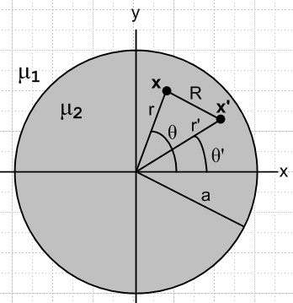 Fig B.7

The integral Q(r',r) may be evaluated using GR7 p 531 4.224,

with a = r'2 +r2 and b = -2rr' and a2-b2 = (r'2-r2)2 so that $\sqrt{a2-b2}$ = | r'2-r2 | . The condition a > |b| > 0 is met since (r±r')2 > 0 => r2+r'2 > ±2rr' which says a > ±b so a > |b|. Thus,

Q(r',r) = $^{\int_{0}^{π}{}}$dx ln [r'2 +r2-2rr' cosx)] = π ln [ $\frac{(r'2 + r2)+ | r'2- r2 |}{2}$] =
= 2π . (B.7.5)

We then have

-Az(c)(r,θ) = $\frac{μ2I}{2π2a2}$$^{\int_{0}^{a}{}}$ dr' r' Q(r',r) = $\frac{μ2I}{πa2}$$^{\int_{0}^{a}{}}$ dr'r'
= $\frac{μ2I}{πa2}$$^{\int_{0}^{a}{}}$ dr' r' { lnr' θ(r'>r) + lnr θ(r'<r) }
= $\frac{μ2I}{πa2}$[ θ(r<a) $^{\int_{r}^{a}{}}$ dr' r' lnr' + lnr $^{\int_{0}^{min(a,r)}{}}$ dr' r' ]
= $\frac{μ2I}{πa2}${ θ(r<a) (1/2){a2lna - r2lnr - (a2-r2)/2} + (1/2)lnr [min(a,r)]2 } (B.7.6)

where Maple says

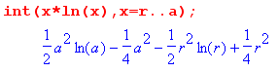 .
We then write out Az(c)(r) in its two regions

Az(c)(r>a) = - $\frac{μ2I}{πa2}$ { (1/2) a2lnr } = - $\frac{μ2I}{2π}$lnr (B.7.7)
Az(c)(r<a) = - $\frac{μ2I}{πa2}$ { (1/2){a2lna - r2lnr - (a2-r2)/2} + (1/2) r2 lnr} = $\frac{μ2I}{2πa2}$ { (a2-r2)/2 - a2lna }

(b) The Az(m) term

From (B.7.1) and (B.7.2),

-Az(m)(x) = μ0∫$_{}^{}$ dA' Jmz(x')] $\frac{ln(R2)}{4π}$
= $\frac{μ0}{4π}$ $^{\int_{0}^{a}{}}$r' dr'$^{\int_{-π}^{π}{}}$dθ' [- ( $\frac{μ2}{μ0}$ - $\frac{μ1}{μ0}$ ) Hθ(r') ] δ(r'-a) ln(R2)
= - $\frac{a}{4π}$ Hθ(a) (μ2- μ1)$^{\int_{-π}^{π}{}}$dθ' ln(a2 +r2-2ra cos(θ-θ'))
= - $\frac{a}{2π}$ Hθ(a) (μ2- μ1) $^{\int_{0}^{π}{}}$dx ln(a2 +r2-2ra cos(x))
= - $\frac{a}{2π}$ Hθ(a) (μ2- μ1) Q(a,r)
= - $\frac{a}{2π}$ Hθ(a) (μ2- μ1) 2π // using (B.7.5)
= a Hθ(a) (μ1- μ2) . (B.7.8)

From Ampere's law (1.1.37) we have (ignoring displacement current inside the conductor)

H • ds = 2πaHθ(a) = ∫S J • dS = I => Hθ(a) = $\frac{I}{2πa}$

and so

-Az(m)(x) = $\frac{I}{2π}$ (μ1-μ2) . (B.7.9)

Then
Az(m)(r>a) = $\frac{I}{2π}$(μ2-μ1) lnr
Az(m)(r<a) = $\frac{I}{2π}$ (μ2-μ1) lna . (B.7.10)

(c) Adding the two terms and checking boundary conditions

Adding the results of (B.7.7) and (B.7.10) we obtain the total Az vector potential,

Az(r>a) = - $\frac{μ2I}{2π}$lnr + $\frac{I}{2π}$(μ2- μ1) lnr = - $\frac{μ1I}{2π}$lnr

Az(r<a) = $\frac{μ2I}{2πa2}$ { (a2-r2)/2 - a2lna } + $\frac{I}{2π}$ (μ2-μ1) lna
= $\frac{μ2I}{2π}$ { (a2-r2)/(2a2) - lna } + $\frac{I}{2π}$ (μ2-μ1) lna
= - $\frac{I}{2π}$ { μ2 (r2-a2)/(2a2) + μ1 lna }

Here then are the finally results for the potential Az = Az(c) + Az(m),

Az(r>a) = - $\frac{I}{2π}$ μ1lnr
Az(r<a) = - $\frac{I}{2π}$ { μ1 lna + μ2$\frac{r2-a2}{2a2}$ } . (B.7.11)

As a check, we calculate the B and H fields implied by these potentials

B = curl A = [ r-1∂θAz - ∂zAθ] + [∂zAr - ∂rAz] + [ r-1∂r(rAθ) - r-1∂θAr ]

= [- ∂rAz] => Bθ = -∂rAz(r)
Then
Bθ(r>a) = $\frac{I}{2π}$μ1 (1/r)
Bθ(r<a) = $\frac{I}{2π}$μ2 $\frac{2r}{2a2}$ = $\frac{I}{2π}$ μ2 (r/a2) (B.7.12)

so the H fields are then

Hθ(r>a) = $\frac{I}{2π}$ (1/r)
Hθ(r<a) = $\frac{I}{2π}$ (r/a2) . (B.7.13)

This agrees with Ampere's Law applied in these two regions:

2πr Hθ(r>a) = I => Hθ(r>a) = $\frac{I}{2π}$(1/r)
2πr Hθ(r<a) = I(πr2/πa2) => Hθ(r>a) = $\frac{I}{2π}$(r/a2) . (B.7.14)

Next, we check the two boundary conditions required by (B.6.0) :

value at r = a:

Az(r>a)|r=a – Az(r<a) |r=a = - $\frac{I}{2π}$ μ1lna - ($\frac{I}{2π}$[ μ2 $\frac{a2-a2}{2a2}$- μ1 lna ]) = 0 OK

slope at r = a: [∂rAz = -Bθ so use (B.7.12) ]

∂rAz(r>a) |r=a = - $\frac{I}{2π}$μ1 (1/a)
∂rAz(r<a) |r=a = - $\frac{I}{2π}$μ2(a/a2) = - $\frac{I}{2π}$μ2(1/a)

$\frac{1}{μ1}$∂rAz(r>a) |r=a – $\frac{1}{μ2}$∂rAz(r<a) |r=a = - $\frac{I}{2π}$(1/a) - [- $\frac{I}{2π}$(1/a)] = 0 OK

Thus we have shown for the round conductor with uniform Jz that "the Jm Lemma" works. By adding the bogus surface current term, we generate the correct homogeneous solution which when added to the Helmholtz integral provides the correct total solution which meets both boundary conditions.

(d) Plots of Az and Bθ and Hθ

Maple provides plots of Az from (B.7.11), Bθ from (B.7.12) and Hθ from (B.7.13) for this round wire situation. Parameters are set to I = 1, a = 2, μ1 = 2 (dielectric), μ2 = 3 (wire).

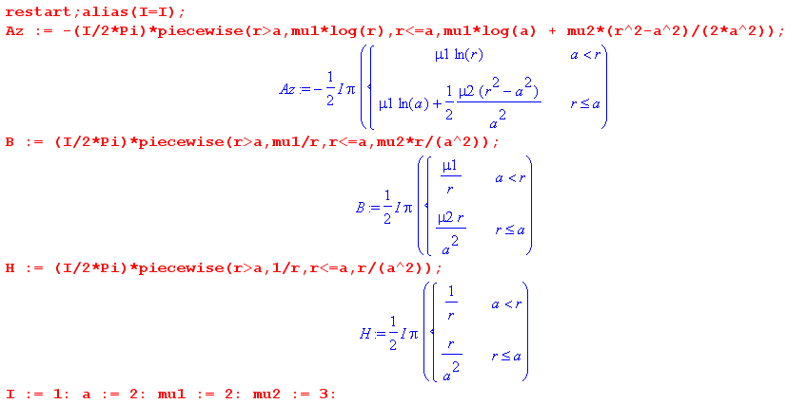

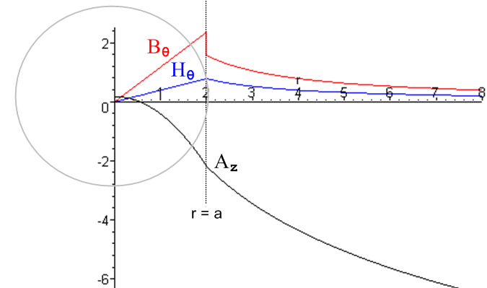 Fig B.8

Az wanders down as ~ -ln(r) for large r; Bθ jumps down at r = a while Hθ is continuous there.

Appendix C: DC Properties of a Wire

C.1 The DC resistance of a wire

The resistance per unit length R of a differential piece of wire of length dz and area dA is derived as follows:

V = E dz, J = σ E, I = J dA ⇒

Rdz = V/I = Edz/JdA = (1/σ) dz/dA ⇒ R = (1/σ) /dA .

If the conductivity σ is constant across the wire, then R = 1/(σA), where A is the cross sectional area. Using resistivity ρ = 1/σ we have

R = ρ/A (C.1.1)

For round wire of radius a, A = πa2, so R = ρ/(πa2).

C.2 The DC surface impedance of a wire

Imagine a wire carrying current I. If, at the surface of the wire, one puts voltmeter probes at longitudinal spacing dz, one measures some potential difference which is dV = Ezdz. When probed at the surface, the wire appears to have this impedance,

(Zsdz) = dV/I .

The quantity Zs is the surface impedance per unit length and is thus given by

Zs = Ez / I (C.2.1)

where Ez is the component of electric field at the surface in the direction of the wire. For a wire operating at DC, the current density is uniform across the wire so Jz = I/A and Ez = Jz/σ = I/(Aσ). Thus,

Zs = 1/(Aσ) = ρ/A // = R of (C.1.1) (C.2.2)

where A is the cross sectional area. For a round wire of radius a, A = πa2, so

Zs = ρ/(πa2) . (C.2.3)

If the wire is a perfect conductor, ρ = 0 and Zs = 0. Of course at DC (ω = 0), Zs = R of (C.1.1). So for DC, we have Zs = R, but for AC this is no longer true.

C.3 The DC internal and external inductance of a round wire

We assume here that μi is the internal permeability of the wire, and μe of the region external to the wire.

The energy density (joules/m3) stored in an electromagnetic field within a medium of negligible loss is given by uem = (E•D + B•H)/2 [ Jackson p 259 Eq. (6.106) ] . We are interested only in the portion of this energy density stored in the magnetic field, so u = (1/2) B•H. Since μ and ε are assumed to be scalars,

u = (1/2) μ H2. (C.3.1)

For any inductor of inductance L carrying current I and having potential difference V, we know that

V = L dI/dt (C.3.2)

P = IV = I (L dI/dt) = d/dt [ (1/2)L I2 ]. (C.3.3)

Since the power fed into an ideal inductor goes into the magnetic field energy, P = dU/dt and so

U = (1/2)L I2 . (C.3.4)

For a straight wire, we now redefine symbol L to mean inductance per unit length, so then

U = (1/2)[Ldz] I2 . (C.3.5)
For either the internal or external region we have U = ∫dV u = dz ∫dS u where dV is a volume element and dS is a cross sectional area element. Thus from (C.3.1) and (C.3.5),

U = dz∫dS (1/2) μ H2 = (1/2)[Ldz] I2 => L = μ ∫dS (H/I)2 . (C.3.6)

In particular,
Li = μi ∫in dS (Hi/I)2 (C.3.7)
Le = μe ∫outdS (He/I)2 . (C.3.8)

For the round wire it is a simple matter to compute Hi and He using Ampere's Law (1.1.37),

H • ds = ∫S J • dS

2πr Hi = I(πr2/πa2) => Hi/I = $\frac{1}{2π}$(r/a2)
2πr He = I => He/I = $\frac{1}{2π}$(1/r) . (C.3.9)

We then compute the two inductances as follows:

Li = μi ∫dS (Hi/I)2 = μi $^{\int_{0}^{a}{}}$rdr$^{\int_{-π}^{π}{}}$dθ [$\frac{1}{2π}$(r/a2)]2 = $\frac{μi}{2πa4}$ $^{\int_{0}^{a}{}}$r3dr = $\frac{μi}{8π}$
Le = μi ∫dS (He/I)2 = μe $^{\int_{a}^{∞}{}}$rdr$^{\int_{-π}^{π}{}}$dθ [$\frac{1}{2π}$(1/r)]2 = $\frac{μe}{2π}$ $^{\int_{a}^{∞}{}}$(1/r) dr = ∞ .

Both results are interesting. Li is interesting because it is independent of the wire radius a. For the same current, a smaller a results in a larger H and B field, which is then offset by the smaller volume (area).

Le is interesting because it is infinite ! Even a tiny 1 cm piece of our infinitely long round wire stores an infinite amount of energy in its magnetic field. We therefore limit the external region by some large radius R and then we have
Li = $\frac{μi}{8π}$ = $\frac{μi}{μ0}$ $\frac{μ0}{8π}$ = $\frac{μi}{μ0}$ $\frac{4π x 10-7}{8π}$ = $\frac{μi}{μ0}$ * 50 nH/m (C.3.10)
Le = $\frac{μe}{2π}$ln(R/a) . (C.3.11)

Thus for a round wire in air the internal inductance is exactly 50 nH/m.

A "practical wire" is more like a loop of wire than an infinitely long wire. It is difficult to conjure up an experiment to test (C.3.11) even for a very long straight piece of wire without having some return path for the current to return to the driving "battery". For wire and dielectric both having μ0, Jackson shows (p 216-218) that the inductance per unit length of a loop of projected area A of radius-a wire is given by
Le + Li = (μ0/4π) [ ln(ξA/a2) + 1/2], where ξ is a near-unity factor which accounts for messy details of the calculation. The 1/2 term accounts for the internal inductance Li = μ0/8π as in (C.3.10).

For a circular loop of radius R, one has A = πR2 and, if R >> a, ξ = 64/(πe4) ≈ .373. So,

ln(ξA/a2) = ln(64 πR2/πe4a2) = 2 ln(8R/ae2) = 2 ln(8R/a) + 2 ln(e-2) = 2 ln(8R/a) - 4

and then the total inductance per unit length is

Le + Li = (μ0/4π) [2 ln(8R/a) - 4 + 1/2] = (μ0/2π) [ ln(8R/a) - 2 + 1/4] = (μ0/2π) [ ln(8R/a) -7/4] .

The total inductance of such a loop is then

L = 2πR(μ0/2π) [ ln(8R/a) -7/4] = μ0R [ ln(8R/a) -7/4] (C.3.12)

in agreement with Jackson Problem 5.32 p 234. If one omits the internal inductance, the last factor is -2 instead of -7/4, and this result is seen in some sources. The point is that this is a finite result, even though the (dipole) magnetic field of such a loop does extend to infinity. A loop of N turns gets an extra factor N2 because in effect current I → NI in (C.3.5), so the total field energy increases by factor N2.

Suppose there were two parallel wires with currents flowing in opposite directions. In this case, we could compute the magnetic field H at any point in space as the vector sum of the fields of the two wires, then we could integrate H2 over all space to get the total energy U and from that the external inductance Le. In this case, the ln(R) divergence does not appear. In effect, the divergence cancels between the two wires, similar to the way opposite short segments of the circular wire cancel to give the finite result quoted above.

We really only care about the internal inductance Li of a wire in our transmission line analysis because the external inductance Le is already accounted for by the techniques of Chapter 4. That is, Le is computed by considering the magnetic potential Az ( or W ) between the wires.

C.4 The DC internal inductance of a wire of rectangular cross section

The internal inductance expressions above apply to any cross sectional shape,

Li = μi ∫in dS (Hi/I)2 (C.3.7)
Le = μe ∫outdS (He/I)2 (C.3.8)

so the only problem is how to compute H for a non-round wire. That problem is solved in Appendix B where it is shown that

H(x,y) = - $\frac{1}{4π}$∫d2x' ln(R2) curl' J(x') R = |x-x'| . (B.2.6) (C.4.1)

Consdider a wire of rectangular cross section 2a x 2b (uniform Jz) as an example.

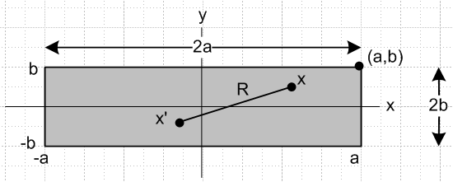 Fig C.1

The current density is given by

Jz(x) = (I/4ab)θ(-a ≤ x ≤ a) θ(-b ≤ y ≤ b)

= (I/4ab) θ(x ≤ a)θ(x≥-a) θ(y ≤b)θ(y≥-b) // θ(s≥r) means θ(s-r) Heaviside

= (I/4ab) θ(a- x)θ(x + a) θ(b- y)θ(y +b) . (C.4.2)

Calculate curl J :

curl J = (∂yJz - ∂zJy) + (∂zJx - ∂xJz) + (∂xJy - ∂yJx)

= (∂yJz) + (- ∂xJz) (C.4.3)

∂xJz = (I/4ab) ∂x[θ(a- x)θ(x + a)] θ(b- y)θ(y +b)
= (I/4ab) [θ(a-x)δ(x+a) - δ(x-a) θ(x+a)] θ(b- y)θ(y +b) // ∂xθ(a-x) = - δ(x-a)

∂yJz = (I/4ab) θ(a- x)θ(x + a) ∂y[θ(b- y)θ(y +b)]
= (I/4ab) θ(a- x)θ(x + a) [θ(b- y)δ(y+b) - δ(y-b) θ(y +b)]

so then

[curl J]x = (I/4ab) θ(a- x)θ(x + a) [θ(b- y)δ(y+b) - δ(y-b) θ(y +b)]
[cur lJ]y = - (I/4ab) [θ(a-x)δ(x+a) - δ(x-a) θ(x+a)] θ(b- y)θ(y +b) . (C.4.4)

Notice that we can obtain [cur lJ]y from [curl J]x by doing a↔b, x↔y and adding a minus sign.

Finally calculate Hx from (C.4.1).

Hx(x,y) = - $\frac{1}{4π}$∫d2x' ln(R2) [curl' J(x')]x R = |x-x'|
= - $\frac{I}{16πab}$$^{\int_{-a}^{a}{}}$dx'$^{\int_{-∞}^{∞}{}}$dy' ln [ (x-x')2 + (y-y')2] [θ(b- y')δ(y'+b) - θ(y'+b)δ(y'-b) ] }

= - $\frac{I}{16πab}$$^{\int_{-a}^{a}{}}$dx'$^{\int_{-∞}^{b}{}}$dy' ln [ (x-x')2 + (y-y')2] δ(y' +b)
+ $\frac{I}{16πab}$$^{\int_{-a}^{a}{}}$dx'$^{\int_{-b}^{∞}{}}$dy' ln [ (x-x')2 + (y-y')2] δ(y'-b)

= - $\frac{I}{16πab}$$^{\int_{-a}^{a}{}}$dx' ln [ (x'-x)2 + (y+b)2] + $\frac{1}{16πab}$$^{\int_{-a}^{a}{}}$dx' ln [ (x'-x)2 + (y-b)2] }

≡ $\frac{I}{16πab}$ ( -I1+I2) I1(b) = $^{\int_{-a}^{a}{}}$dx' ln [ (x'-x)2 + (y+b)2]
I2(b) ≡ $^{\int_{-a}^{a}{}}$dx' ln [ (x'-x)2 + (y-b)2] = I1(-b) . (C.4.5)
≡ $\frac{I}{16πab}$ F(x,y,a,b) F = -I1+ I2 .

As an aid to Maple's grouping of elements, let x" = x'-x, then take x"→ x' to get

I1(b) = $^{\int_{-a-x}^{a-x}{}}$dx' ln [ x'2 + c2] where c = y+b .

Maple then evaluates I1 and I2 as follows.

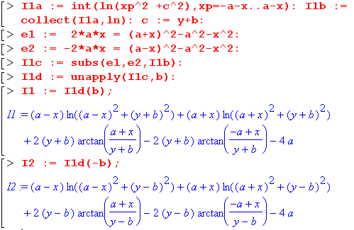

In Maple, unapply(f,x) causes expression f to be a function of x which can then be called as f(x). Collect just orders terms in a certain way, while subs forces Maple to be a little smarter about expressions. The next step is to create function F(x,y,a,b) which is just -I1+ I2 as shown above

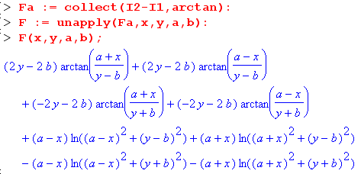

Reading from the above and putting x,y last in each parentheses, the four arctangents can be written

(1/2) F(x,y,a,b)atan = -(b-y) [- tan-1 $\frac{a+x}{b-y}$] +(b-y)tan-1$\frac{a-x}{b-y}$ - (b+y)tan-1($\frac{a+x}{b+y}$) +(y+b)[-tan-1($\frac{a-x}{b+y}$)]
= (b-y) [ tan-1 $\frac{a+x}{b-y}$ + tan-1$\frac{a-x}{b-y}$ ] - (b+y) [ tan-1($\frac{a+x}{b+y}$) + tan-1($\frac{a-x}{b+y}$) ] .

Next, the four log terms can be combined to give

(1/2) F(x,y,a,b)ln = (1/2) (a-x) ln [ $\frac{(a-x)2 +(b-y)2}{(a-x)2 +(b+y)2}$] + (1/2) (a+x) ln [ $\frac{(a+x)2 +(b-y)2}{(a+x)2 +(b+y)2}$] .

Combining and reordering these terms, we get

(1/2) F(x,y,a,b) = (1/2) (a+x) ln [ $\frac{(a+x)2 +(b-y)2}{(a+x)2 +(b+y)2}$] + (1/2) (a-x) ln [ $\frac{(a-x)2 +(b-y)2}{(a-x)2 +(b+y)2}$]
+ (b-y) [ tan-1$\frac{a-x}{b-y}$ + tan-1 $\frac{a+x}{b-y}$ ] - (b+y) [ tan-1($\frac{a-x}{b+y}$) + tan-1($\frac{a+x}{b+y}$) ] .

This expression agrees with Holloway and Kuester's W1 if one replaces a = w/2 and b = t/2. With such replacements, we would have

Hx(x,y) = $\frac{I}{16πab}$ F(x,y,a,b) = $\frac{I}{4πwt}$ F(x,y, w/2, t/2) = $\frac{I}{2πwt}$ [ (1/2) F(x,y, w/2, t/2) ] ≡ $\frac{I}{2πwt}$ W1

so our Hx then agrees with their equations (9) and (11).

Now based on the comment below (C.4.4) above, we may conclude for Hy that

Hy(x,y) = - $\frac{1}{4π}$∫d2x' ln(R2) [curl' J(x')]y = Hx(x,y) if we swap a↔b, x↔y and add a minus
= - $\frac{1}{16πab}$F(y,x,b,a) . (C.4.6)
Just for the record,

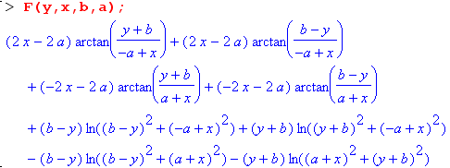

We can now make a "field plot" showing the H field (direction and magnitude) in the cross section plane of our rectangular conductor, where we stick with the 4:1 ratio of edges as in Fig C.1 above,

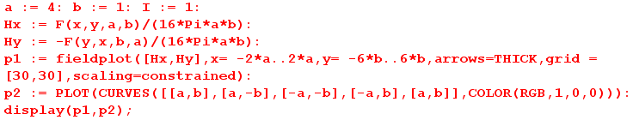

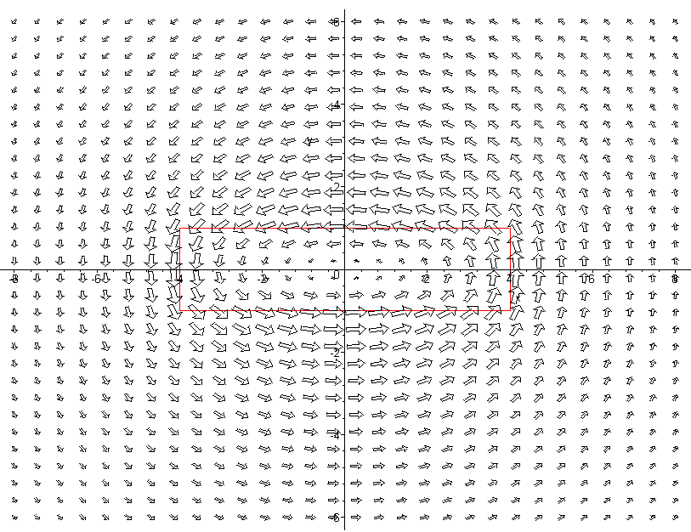

Fig C.2

In this plot the H field appears to be maximal at the conductor boundary (shown in red) and as one moves away it becomes the field of a thin round wire. Current Jz is flowing in the z direction toward the viewer.
The second plot is of |H|2 as a surface over the x,y plane. Recall that |H|2 is proportional to the energy density in the magnetic field which in turn contributes to inductance.

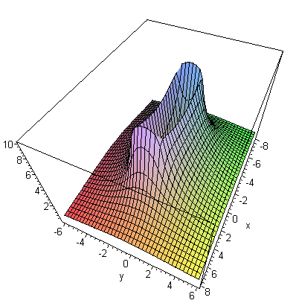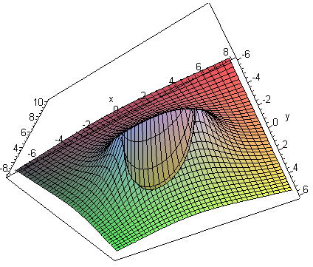
view from above view from below
Fig C.3

The |H|2 surface is very steep at the conductor boundaries, somewhat resembling a rectangular volcano which dips all the way down to 0 in the center, as shown on the right. The Li integration discussed below is over this central "cone" of the volcano.
The red plot below is a slice through the volcano at x = 0 :

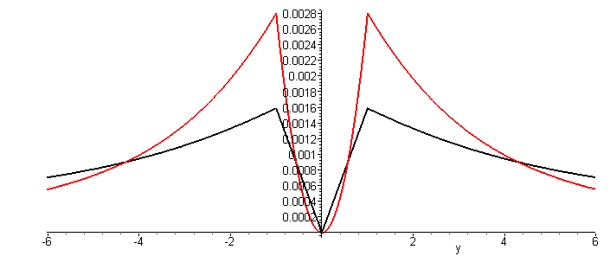 Fig C.4

The black plot is of | H | (but scaled down) and resembles the Hθ plot for the round wire shown in Fig B.8.

We return now to a computation of the internal inductance Li of the rectangular wire. From (C.3.7),

Li = μi ∫idS (H/I)2 = μi ($\frac{1}{16πab}$)2$^{\int_{-a}^{a}{}}$dx$^{\int_{-b}^{b}{}}$dy [F(x,y,a,b)2 + F(y,x,b,a)2] . (C.4.7)

Since F(x,y,αa,αb) = αF(x/α,y/α,a,b) one can show that Li must have this functional form

Li = (μi/8π) f(b/a) (C.4.8)

though this conclusion is obvious based on dimensions alone. The factor (μi/8π) is Li for a round wire of any radius, as shown in (C.3.10). The problem is to find function f . We set a = 1 with no loss of generality, and use the obvious four-fold symmetry of the energy density so that

Li = 4 μi ($\frac{1}{16πb}$)2 $^{\int_{0}^{1}{}}$ dx$^{\int_{0}^{b}{}}$dy [F(x,y,1,b)2 + F(y,x,b,1)2]
= ( $\frac{μi}{8π}$) { $\frac{1}{8π2b2}$$^{\int_{0}^{1}{}}$ dx$^{\int_{0}^{b}{}}$dy [F(x,y,1,b)2 + F(y,x,b,1)2] } . (C.4.9)

Thus our function of interest is

f(b) = $\frac{1}{8π2b2}$$^{\int_{0}^{1}{}}$ dx$^{\int_{0}^{b}{}}$dy [F(x,y,1,b)2 + F(y,x,b,1)2] (C.4.10)

where

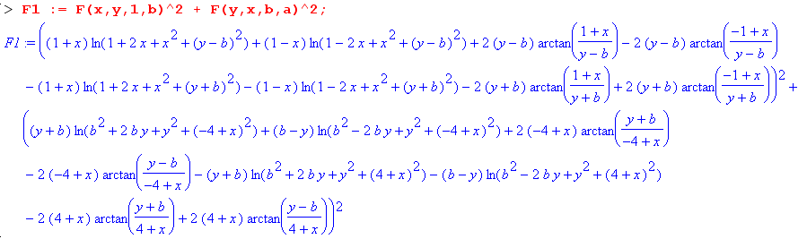

If one were to expand this expression, there would be 162 + 162 = 256 + 256 = 512 terms if no terms combined. In fact there are 232 terms:

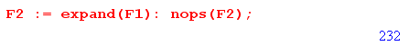

Here are four sample terms in the integrand of (C.4.10),

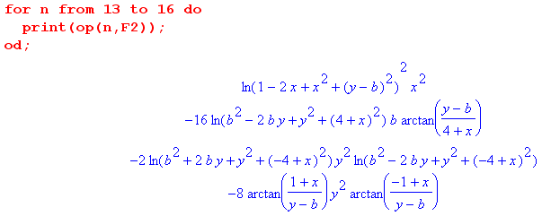

It seems rather unlikely that all 232 terms can be double-integrated analytically! For example, if we ask Maple to analytically integrate the last term shown above just over the x range, it gives up,

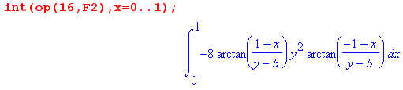

Thus, in order to compute f(b) we must turn to numerical integration which, for each value of b, requires doing 232 numerical double integrals and adding up the results. As is visible in Fig C.3 and Fig C.4, the overall integrand is singular at the conductor edge, so we might expect some difficulties with the numeric integrations near the upper endpoints.

We were not successful trying for a hour to get Maple to compute the integral (C.4.10) analytically or numerically, but certainly the numerical integration can be done. Holloway and Kuester quote the following numerical approximate formulas for two special cases,

Li = (μi/8π) [0.96639] a = b (square wire) // very close to the round conductor

Li = (μi/8π) [(4π/3) b/a ] b/a << 1 (flat wire) // Li = (1/6) μi (b/a) (C.4.11)

We discuss the second case in Section C.5

Reader Exercise: Do the numerical integration outlined above to determine function f(b) for several b values and plot for b = 1 to 10. Is f(1) = 0.96639 ? Holloway and Kuester have a plot in their Fig 2 which looks like this for Li [Li for a circular wire is 50 nH as shown in (C.3.10)],
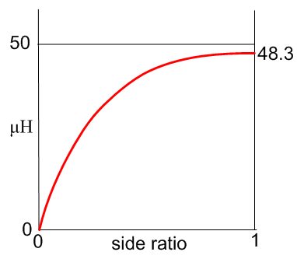 Fig C.5

Comment: Appendix B.2 provides three methods of computing H from J. We chose to use the formula (B.2.6). Holloway and Kuester use the second method of first computing A then B = curl A. A third method is to use the 2D Biot Savart Law (B.2.24). That third method begins this way :

H(x,y) = ∫d2x' $\frac{1}{2πR2}$ J(x') x R R ≡ x - x' (B.2.24)
and
Jz(x) = (I/4ab)θ(-a ≤ x ≤ a) θ(-b ≤ y ≤ b)
so
H(x,y) = $^{\int_{-a}^{a}{}}$dx'$^{\int_{-b}^{b}{}}$dy' $\frac{1}{2πR2}$ (I/4ab) x R .
But
R = (x-x') + (y-y') => x R = (x-x') - (y-y') .

Thus,
Hx(x,y) = $^{\int_{-a}^{a}{}}$dx'$^{\int_{-b}^{b}{}}$dy' $\frac{1}{2πR2}$ (I/4ab) [- (y-y')]
Hy(x,y) = $^{\int_{-a}^{a}{}}$dx'$^{\int_{-b}^{b}{}}$dy' $\frac{1}{2πR2}$ (I/4ab) [+ (x-x')]
or
Hx(x,y) = (I/8πab) $^{\int_{-a}^{a}{}}$dx'$^{\int_{-b}^{b}{}}$dy' (y'-y)/R2
Hy(x,y) = - (I/8πab) $^{\int_{-a}^{a}{}}$dx'$^{\int_{-b}^{b}{}}$dy' (x'-x)/R2 . (C.4.12)

These last integrals are the same as (7) and (8) of Holloway and Kuester with 2a = w and 2b = t.

C.5 The DC internal inductance of a thin flat wire

This is a fascinating problem with a result that is non-obvious.

Consider an infinitely long conductor whose cross section has the shape of a thin strip of width w and height t with t << w,

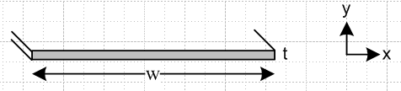 Fig C.6

The correct result for Li was given earlier in (C.4.11) and we repeat it here, setting w = 2a and t = 2b,

Li = (μi/8π) [(4π/3) t/w ] = (1/6) μi (t/w) t << w . (C.4.11)

We shall now attempt to obtain this result in a simple manner, intentionally misleading the reader a bit.

The uniform current density is Jz = I/(wt), flowing toward the viewer. Here is a blowup of a piece of the strip near its center,

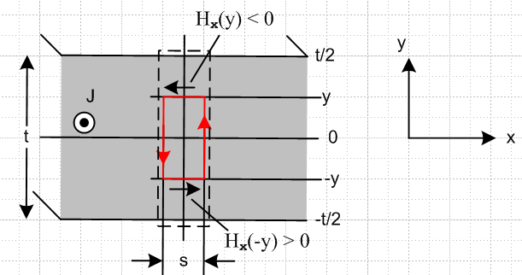 Fig C.7

The red math loop is positioned as shown for an application of Ampere's Law,

∫S J • dS = C H • ds . (1.1.37)

Starting at the lower left corner of the red loop for C, this says

Jz 2y s = s Hx(-y) + 0 2y - Hx(y)s - 0 2y . (C.5.1)

We assume that "near the center of the strip" there is no significant transverse field component Hy, though we accept that such transverse fields do exist far away "near the edges" of the strip as in Fig C.2,

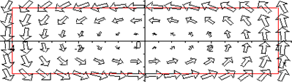 Fig C.8

Thus, the two vertical sections of the red loop make negligible contribution to the line integral in the main central region. Symmetry indicates that Hx on the upper red loop segment is equal and opposite to that on the lower segment, so the line integral is then -2Hx(y) s and we continue :

Jz 2y s = - 2 Hx(y)s

Jz y = - Hx(y)s

I/(wt)*y = - Hx(y)s

Hx(y)/I = - y/(wt) . (C.5.2)

The result is that Hx(y) = -(I/wt)y which is a very reasonable linear function of y, with Hx(y=0) = 0. The fact that Hx(y) does not depend on x is also reasonable since, when w >> t, the central region of the strip is basically all of the strip excluding the tiny end regions which we ignore. A similar argument is made for the analysis of a parallel plate capacitor, where the end effects are ignored if w >> t.
To get the internal inductance due to this Hx energy storage, we compute its contribution from the dotted rectangle in Fig C.6, then multiply by (w/s) to get Li for the entire strip. So, using (C.3.7),

Li = (w/s) μ ∫dotted dS (H/I)2 = (w/s) μ∫dotted (sdy) [-y/(wt)]2

= (w/s) μ s (wt)-2 $^{\int_{-t/2}^{t/2}{}}$dy y2 = (w/s) μ s (wt)-2 2 $^{\int_{0}^{t/2}{}}$dy y2

= (w/s) μ s (wd)-2 2 (1/3) (t/2)3 = w-1 μ t-2 (2/3) t3/8

= (1/12) μ (t/w) = (μi/8π) [ 2π/3 (t/w) ] // strip w>>t , due to Hx (C.5.3)

But this is only half the correct result for Li which was just quoted above. By luck, (C.5.3) happens to be the correct result for the Hx contribution to Li; by luck because it is derived from Fig C.7 with the assumption that Hy ≡ 0 which is not true. The other half of Li in fact comes from the Hy field in the strip. One can write

Li = μ $^{\int_{-t/2}^{t/2}{}}$ dy $^{\int_{-w/2}^{w/2}{}}$ dx [ (Hx/I)2 + (Hy/I)2 ] = Lix + Liy (C.5.4)

so the Hx and Hy contributions are simply additive with no interference.

So where did the argument above go wrong? It all seemed so reasonable. One is of course biased by the appearance of the fields in Fig C.8 shown just above. One's impression is that as the aspect ratio is increased from 4:1 to perhaps 100:1, the nature of the above plot should become even more convincing: large horizontal arrows to the left along the top of the strip, large horizontal arrows to the right along the bottom of the strip, and some minor edge effects at the distant ends.

But this is in fact not a correct impression! For a 10:1 aspect ratio strip, here is the field map (Hx,Hy) for the upper right quadrant of the strip

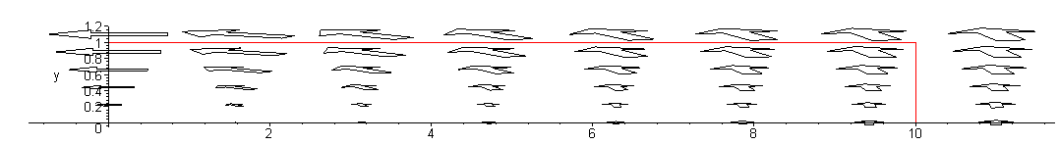 Fig C.9

If we plot only the Hx component by setting Hy = 0 in our field plot, we get

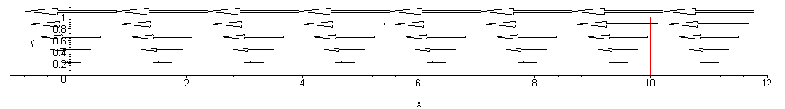 Fig C.10

and this displays our conjectured functional shape Hx(y) = -(I/wt)y applying not just at the center of the strip, but all along the strip. This then explains graphically why our calculation above came up with the correct result for the Hx contribution to Li. The other half of Li comes from the transverse field component Hy which has this appearance (we now set Hx = 0 in the field plot)

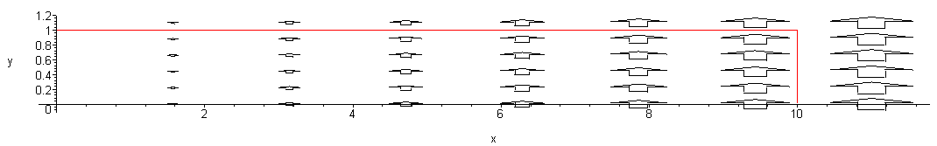 Fig C.11

The fact that the Hy contribution to Li is exactly equal to the Hx contribution is just not obvious. One would think some simple argument could be concocted to explain this fact. For example, one might conjecture looking at the above plot that Hy ≈ Hy(x) so that Ampere's law for the Fig C.7 red loop says, using s = dx,

Jz 2y dx = dx Hx(-y) + Hy(x+dx) 2y - Hx(y)dx - Hy(x)2y .

Jz 2y = -2 Hx(y) + [Hy(x+dx) - Hy(x)]/dx * 2y .

Jz y = - Hx(y) + y ∂xHy(x) . (C.5.5)

We might then try Hx(y) = -A(I/wt)y based on Fig C.10 with A some constant. Then (C.5.5) says

(I/wt) (1-A) = ∂xHy(x) => Hy(x) = [(I/ωt) (1-A)] x ≡ Bx (C.5.6)

which seems reasonable in terms Figure C.11. But Hy(x) = Bx is problematical in two respects: (1) there is no obvious way to determine B without taking a limit of the complicated full Hy formula ; (2) Even when that is done, Hy(x) is in fact not linear in x as a simple plot shows, so the model is inaccurate and does not give the result that Li due to Hy is (1/12) μ (t/w).

The field plots shown above and the energy plots of Fig C.3 are easy to produce from Maple. These latter plots are like topographical maps and they can be displayed in that manner as shown on the right below

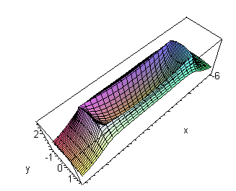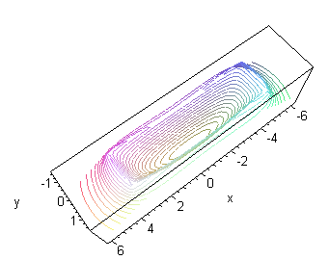 Fig C.12

where we have reverted to the 4:1 aspect ratio strip.

One should not confuse the topo contour lines shown here with a plot of the H field lines. Making a field line plot is not a built-in function for our old Maple V and requires some minor coding to implement. Here is such a field line plot for a 20:1 aspect ratio thin strip,

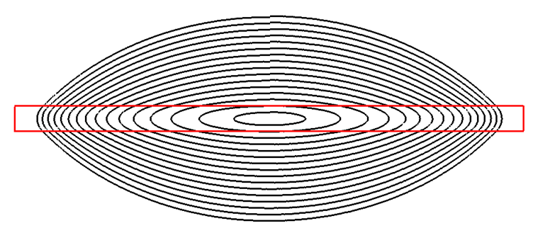
Fig C.13

Each contour starts at x = 0 and y = some value and is iterated CCW (chasing the direction of the H vector) until it arrives back where it started. The little jogs at the top represent the small error of this numerical process. Looking at this field line plot, it is totally obvious that there does not exist some "broad central region" in the strip where the field lines are mostly horizontal. The transverse field components (vertical) appear as soon as one leaves the exact center of the strip and it is totally wrong to ignore such transverse Hy components in the computation of Li.
The correct calculation of Li is done in the 2009 paper of Holloway and Kuester. They point out errors made by earlier authors and make the point that half the internal inductance comes from each field component. They do not claim that the transverse contribution is exactly half the result, but that it is half to a high degree of precision. In an email communication, Prof. Kuester made the appropriate point that, since div H = 0 (there is no magnetic charge), the H field lines must close on themselves and that is what forces the above figure to have the shape it has, where there is no "broad central region" having essentially horizontal field lines. In the corresponding parallel plate capacitor picture for electrostatics, since electric charge does exist, the E fields lines do not need to close on themselves, and have sources and sinks all along the capacitor cross section, allowing for a uniform broad central region.
Here is one more field line plot showing a larger range of field lines,

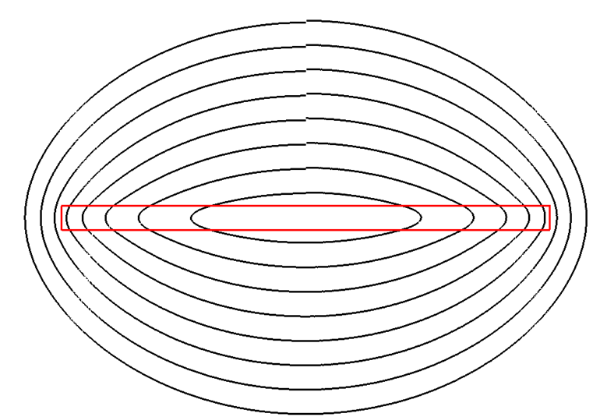
Fig C.14

As the field lines are continued outward, they eventually become circles as the strip eventually becomes a line source ( a point source in cross section) when viewed from far away.

Reader Exercise: Come up with a simple explanation for why the Hx and Hy fields each contribute half the total Li value for the strip. Is this perhaps true for any edge ratio of the rectangular cross section? That certainly seems unlikely.

C.6 The DC internal inductance of a hollow round wire

The pipe geometry is as follows, where we assume Jz is uniform and total current is I :

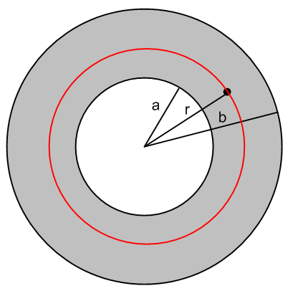 Fig C.15

As with the round wire case, we can avoid using (C.4.1) (or alternates) to compute H due to symmetry. The total current enclosed within the red circle is this,

Ienc(r) = $\frac{area inner annulus a to r}{area full annulus a to b}$ = $\frac{r2- a2}{b2-a2}$ I valid for a ≤ r ≤ b . (C.6.1)

For r < a, Ienc(r) = 0, and for r > b, Ienc(r) = I. Ampere's Law says

2πr Hθ(r) = Ienc(r) . (C.6.2)

Note that Hθ(r) = 0 inside the tube, so this region makes no contribution to Le or Li. Inside the annulus,

Hθ(r) = Ienc(r)/ (2πr) = $\frac{1}{2π}$ $\frac{1}{r}$ $\frac{r2- a2}{b2-a2}$ I . a ≤ r ≤b (C.6.3)

Recalling that

Li = μi ∫in dS (H/I)2 (C.3.7)

we conclude that

Li = μi $\frac{1}{(2π)2}$ $\frac{1}{(b2-a2)2}$ ∫in dS $\frac{1}{r2}$ (r2 - a2)2

and then using dS = 2πrdr we find

Li = μi $\frac{1}{2π}$ $\frac{1}{(b2-a2)2}$ $^{\int_{a}^{b}{}}$dr $\frac{1}{r}$ (r2 - a2)2
= μi $\frac{1}{2π}$ $\frac{1}{(b2-a2)2}$ J . (C.6.4)

Maple computes the integral J as follows

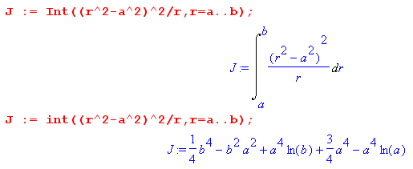

which we restate as

J = (1/4)b4 + (3/4)a4 - a2b2 + a4 ln(b/a) (C.6.5)

and then the final result for the internal inductance of a hollow pipe with b > a is

Li = μi $\frac{1}{2π}$ $\frac{1}{(b2-a2)2}$ [(1/4)b4 + (3/4)a4 - a2b2 + a4 ln(b/a)] . (C.6.6)

(a) limit as a→ 0: should be round wire of radius b

Reading off this limit from (C.6.6),

Li = μi $\frac{1}{2π}$ $\frac{1}{(b2-a2)2}$ [(1/4)b4 + (3/4)a4 - a2b2 + a4 ln(b/a)]

= μi $\frac{1}{2π}$ $\frac{1}{b4}$ [(1/4)b4 + 0 - 0 + 0 ln(b/a)]

= μi $\frac{1}{8π}$ (C.6.7)

and we recover the Li of a round wire as found in (C.3.10).

(b) External Verification of (C.6.6)

The result appears in a very fat (2,263 pages) 1922 handbook edited by Pender and Del Mar, from which we quote via Google books, page 827,

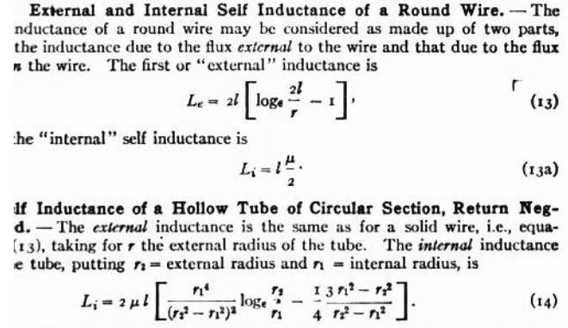

In their version of cgs units, the round wire has Li = (μ/2) per unit length according to (13a), so one must add (1/4π) to their (14) result to compare with (C.6.6). Using r2 = b and r1 = a the results then agree after some algebra.

(c) limit as b-a → 0: thin shell radius a and thickness d

In this limit, the hollow pipe is a thin cylindrical shell of inner radius a and thickness d. Continuing the Maple code, we first replace parameter b by a+d,

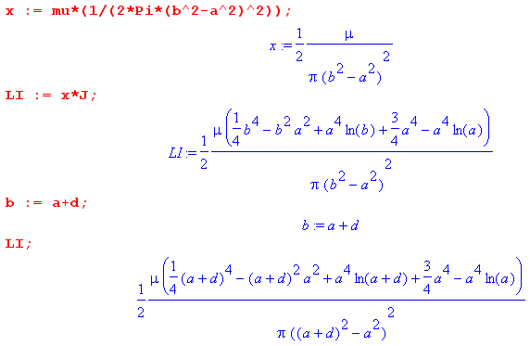

Maple then expands this Li function about d = 0,

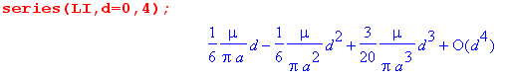

Of course our only interest is in the first term, so in this limit we have found that

Li = μi $\frac{1}{6π}$ (d/a) = $\frac{μi}{8π}$ [ (4/3)(d/a) ] thin shell, valid for d << a (C.6.8)

where again (μi/8π) is Li for a round conductor of any radius.

(d) Maple Plot

Write (C.6.6) as

Li = $\frac{μi}{8π}${ $\frac{1}{(b2-a2)2}$ [b4 + 3a4 - 4a2b2 + 4a4 ln(b/a)] } (C.6.6)
= $\frac{μi}{8π}$ { $\frac{1}{(1-x2)2}$ [ 1 + 3x4 - 4x2 - 4x4 ln(x) ] x ≡ a/b
= $\frac{μi}{8π}$ f(x) .

Maple then plots f(x) :

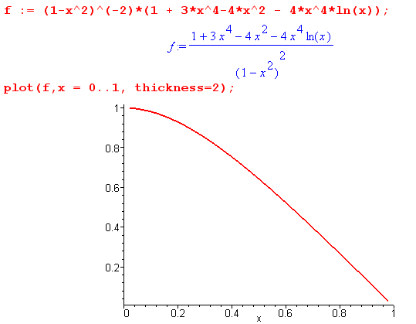 Fig C.16

As the pipe is hollowed out from a round wire to a foil shell, f(x) drops from 1 to 0 as shown.

Appendix D : The General E and B Fields Inside an Infinite Straight Round Wire

This Appendix presents a rather lengthy calculation of the fields and currents inside a round wire without the Chapter 2 assumption that such fields and currents are symmetrical about the axis. This wire may be regarded as one conductor of a transmission line down which a wave is propagating.

Since this Appendix is quite long, a brief summary is in order (see also Table of Contents) :

Section D.1
(a) A longitudinal traveling wave form E(r,φ,z,t) = ej(ωt-β$_{d}$z) E(r,φ) is assumed inside the round wire and E(r,φ,z,t) is then shown to satisfy a certain vector Helmholtz equation.
(b) The field E(r,φ) and the surface charge n(φ) are both expanded onto "azimuthal partial waves" ejmφ with coefficients E(r,m) and Nm.
(c) The Helmholtz equation's vector Laplacian ≡ ∇2 is stated in cylindrical coordinates.
(d) The three Helmholtz component equations and div E = 0 are written out in these coordinates.

Section D.2
(a),(b),(c): The z and r Helmholtz equations and the div E = 0 equation are solved for Ez then Er and then Eφ.These solutions are expressed in terms of Bessel J functions of a complex argument and two unknown constants am and Km for each partial wave.
(d) a boundary condition relating Er to surface charge density n(φ) is derived.
(e) this and another boundary condition Eφ(a,m) = 0 (see D.8 below) are used to evaluate am and Km and then the solution E field components are stated in box (D.2.33).

Section D.3
It is noted that the boxed E field solutions also satisfy the ignored third φ Helmholtz equation.

Section D.4
The B fields are computed from the E fields using Maxwell -jωB = curl E, and then box (D.4.9) summarizes both the E and B partial wave fields inside a round wire.

Section D.5 These E and B fields are shown to exactly solve the other three Maxwell equations.

Section D.6 The m = 0 partial wave results are stated and compared to the results of Chapter 2.

Section D.7 The problem of finding an exterior field solution for the round wire is discussed.

Section D.8 Arguments supporting the second boundary condition Eφ(a,m) = 0 are presented.

D.1 Partial Wave Expansion

Warning: In this appendix, we use the same function name E to represent three different functions,

E(r,φ,z,t) E(r,φ) E(r,m)

The functions are distinguished by the arguments shown, and if they are not shown, the general context of the discussion will indicate which function is implied. The symbol E is thus "overloaded".

(a) The General Method

The starting point for the calculation is the damped wave equation (1.3.36, region 2) for the E field inside the wire. Unsubscripted parameters refer to properties of the wire.

(∇2 - με ∂t2 - μσ∂t)E(r,φ,z,t) = 0 . (1.3.36)

Cylindrical coordinates (r,φ,z) are used, as appropriate for an infinite straight round wire. Recall that the damping term arises when the driving current J on the right of (1.2.1) is replaced by Ohm's Law J = σE.
We now make the ansatz that a solution to the above wave equation may be expressed in the following form where the t and z dependence is exposed and where E(r,φ) is a complex function to be determined:

E(r,φ,z,t) = ej(ωt-β$_{d}$z) E(r,φ) . (D.1.1)

This E(r,φ) is also a function of ω and βd but we don't display these arguments. The symbol βd stands for the value that parameter β = ω $\sqrt{μx}$ of (1.5.1) takes in the dielectric outside the round wire. The form shown in (D.1.1) describes a simple "traveling wave" moving down a transmission line in the +z direction. We assume that one of the conductors of this transmission line is our round wire, while the other conductors (perhaps more than one) are unspecified, but have uniform cross section.
When (D.1.1) is put into the above wave equation (1.3.36), time derivatives can be replaced ∂t→ jω with the result

(∇2 + β2) E(r,φ,z,t) = 0 (D.1.2a)
or
[∇2D2 + (β2-βd2) ] E(r,φ) = 0 ∇2 = ∇2D2 + ∂z2 (D.1.2b)

where

β2 = μεω2 - jωμσ = ω2μ (ε - jσ/ω) = ω2μ ξ ξ ≡ ε - jσ/ω . (1.5.1)

We could have defined the temporal Fourier Transform of E(r,φ,z,t),

E^(r,φ,z,ω') ≡ FT{ E(r,φ,z,t), ω'} = e-jβ$_{d}$z E(r,φ) 2πδ(ω-ω') = e-jωt E(r,φ,z,t) 2πδ(ω-ω')

as in (1.6.11) and then (D.1.2a) would be valid as well for E^(r,φ,z,ω) which would be a more conventional Helmholtz equation, but since E(r,φ,z,t) is monochromatic, we leave (D.1.2a) as is.
One can regard (D.1.1) as an assumed variable-separated form for a solution, an "ansatz". If a consistent solution to the Maxwell equations can be found with this assumption, it is justified de facto.

Sign Convention Comment: Section 1.6 discusses the Fourier Transform (1.6.8) where e+jωt appears in the expansion formula. For E^(x,ω) = 2πδ(ω-ω1) one gets E(x,t) = e+jω$_{1}$t and then the form of a wave solution is e+j(ωt-kz) with the + sign associated with ωt. In general, EE people like to assume time dependence of the form e+jωt (and they prefer j in place of i for $\sqrt{-1}$). The Fourier Transform is of course valid with the other sign choice for the two exponentials, and for that other sign choice one would have E^(x,ω) = 2πδ(ω-ω1) => E(x,t) = e-jω$_{1}$t and one would think of a wave as e-j(ωt-kz) = e+j(kz-ωt). This sign convention is common in many physics texts [e.g. Jackson (7.8)], but in this document we use the e+j(ωt-kz) convention usually used in EE texts [e.g. Haus-Melcher 13.1 (7)]. Jackson suggests a physics/EE conversion algorithm of i ↔ -j. It is all just a convention choice and, as in (1.6.6), only the sign of the imaginary physical field under consideration is affected. If one thinks of the physical field under consideration as Re{ E(x,t)}, the sign convention choice makes no difference at all.

(b) Partial Wave Expansions

The next step is to do a "partial wave expansion" (that is, a complex Fourier series expansion) of E(r,φ) in terms of "azimuthal harmonics" eimφ, so that the variable φ is replaced with the partial wave index m:
E(r,φ) =$\sum_{m = -∞}^{∞}{}$ E(r,m) ejmφ // expansion (D.1.3a)
E(r,m) = (1/2π) $^{\int_{-π}^{π}{}}$dφ E(r,φ) e-jmφ . // projection (D.1.3b)

In analogy with (D.1.1) we define a surface charge density n(φ,z,t) which has the following ansatz variable-separated form,

n(φ,z,t) = ej(ωt-β$_{d}$z) n(φ) . (D.1.4)

We then expand n(φ) as in (D.1.3),
n(φ) = $\sum_{m = -∞}^{∞}{}$ Nm ejmφ (D.1.5a)
Nm = (1/2π) $^{\int_{-π}^{π}{}}$dφ n(φ) e-jmφ . (D.1.5b)

Nm is the "moment" of the surface charge distribution in the mth partial wave. As with E(r,φ), the function n(φ) is also a function of implicit arguments ω and βd.
We now temporarily make a stricter ansatz than that stated in (D.1.4) by adding to our ansatz the assumption that the function n(φ) is real and so the physical surface charge is then given by the real part of (D.1.4),

nphysical(φ) = cos(ωt-β$_{d}$z) n(φ) // n(φ) is real .

For real n(φ), equation in (D.1.5b) tells us that N-m = Nm* and then

n(φ) = $\sum_{m = -∞}^{∞}{}$ Nm ejmφ = N0 + $\sum_{m = 1}^{∞}{}$[ Nm ejmφ + Nm* e-jmφ ] = N0 + 2 $\sum_{m = 1}^{∞}{}$Re{ Nm ejmφ}
= N0 + 2 $\sum_{m = 1}^{∞}{}${ Re(Nm) cos(mφ) - Im(Nm) sin(mφ) } . (D.1.6)

If furthermore n(φ) is an even function of φ, as symmetry implies for our particular figure below, (D.1.5b) says the Nm are real and then we have

n(φ) = N0 + 2$\sum_{m = 1}^{∞}{}$Nm cos(mφ) // n(φ) even in φ (D.1.7)

For a moderately closely spaced twin lead transmission line (we allow for different radii), one might expect the m=0 and m=1 partial waves to be dominant :

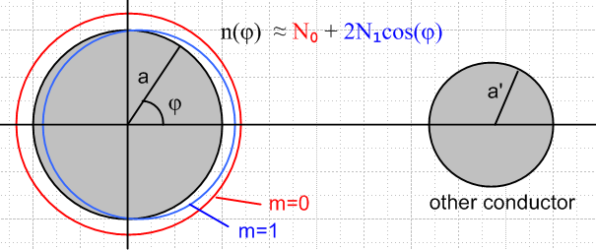 Fig D.1

(c) The Vector Laplacian in Cylindrical Coordinates

Given the following cylindrical-coordinates field components,

E(r,φ,z,t) = Er(r,φ,z,t) + Eφ(r,φ,z,t) + Ez(r,φ,z,t) (D.1.8)

we may write out our ansatz wave form (D.1.1) and the Helmholtz equation (D.1.2a) in more detail,

Er(r,φ,z,t) = ej(ωt-β$_{d}$z) Er(r,φ) . [∇2E(r,φ,z,t)]r + β2 Er(r,φ,z,t) = 0
Eφ(r,φ,z,t) = ej(ωt-β$_{d}$z) Eφ(r,φ) . [∇2E(r,φ,z,t)]φ + β2 Eφ(r,φ,z,t) = 0
Ez(r,φ,z,t) = ej(ωt-β$_{d}$z) Ez(r,φ) . [∇2E(r,φ,z,t)]z + β2 Ez(r,φ,z,t) = 0 . (D.1.9)

In Cartesian coordinates, it happens that [∇2E]i = ∇2(Ei), but this is not generally true for curvilinear coordinates. In cylindrical coordinates, it is true for the z coordinate only. The operator ∇2 when applied to a vector field is called "the vector Laplacian" and it is very different from the scalar Laplacian, so much so that some authors (Moon and Spencer) replace [∇2E] by [E] which is defined in this manner

[E] ≡ [∇2E] ≡ grad(div E) – curl (curl E) (D.1.10)

whereas

∇2φ ≡ div(grad φ) = ∇•(∇φ) . (D.1.11)

It is the vector Laplacian that appears in our Helmholtz equation (D.1.2). For cylindrical coordinates it turns out that,

(∇2E)r = ∇2Er - (2/r2) ∂φEφ - (1/r2) Er
(∇2E)φ = ∇2Eφ + (2/r2) ∂φEr - (1/r2) Eφ
(∇2E)z = ∇2Ez (D.1.12)

where ∇2 is the scalar Laplacian, given in cylindrical coordinates by

∇2 = (1/r)∂r(r∂r) + (1/r2)∂φ2 + ∂z2 = ∂r2 + (1/r)∂r + (1/r2)∂φ2 + ∂z2 . (D.1.13)

See for example Morse and Feshbach Vol I p 116, Moon and Spencer p 139, or do a web search on "vector Laplacian"; the author's Tensor Analysis document, Sections 13, 14 and 15, derives these results for arbitrary coordinate systems. Here is a summary of vector differential operators in cylindrical coordinates taken from Morse and Feshbach, where the last line corresponds to the above discussion:

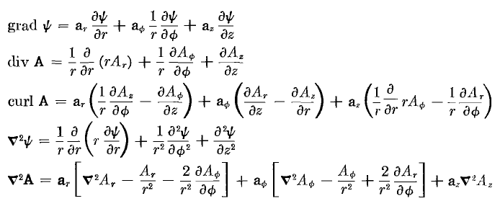 (D.1.14)

Using the ansatz form (D.1.1) and partial wave expansions of the form (D.1.3) or (D.1.5), it is a simple matter to convert an equation involving components like Ei(r,φ,z,t) or n(r,φ,z,t) to a simpler equation involving components like Ei(r,m) and n(r,m).

(d) The three Helmholtz equations and div E = 0 (in partial waves)

1. The z equation: The Ez Helmholtz Equation from (D.1.9) is [∇2E]z + β2 Ez = 0.

Using (D.1.12) and (D.1.13), the Ez equation may be written,

[∂r2 + (1/r) ∂r + (1/r2) ∂φ2 + ∂z2 + β2 ] ej(ωt-β$_{d}$z)Ez(r,φ) = 0 . (1)

Inserting the expansion (D.1.3) for Ez(r,φ) and moving the m sum to the left gives

$\sum_{m = -∞}^{∞}{}$ [∂r2 + (1/r) ∂r + (1/r2) ∂φ2 + ∂z2 + β2 ] ej(ωt-β$_{d}$z)Ez(r,m) ejmφ = 0 . (2)

We can then make the obvious replacements ∂z = -jβd and ∂φ = +jm to get,

$\sum_{m = -∞}^{∞}{}$ { [∂r2 + (1/r) ∂r -m2 (1/r2) – βd2 + β2 ] ej(ωt-β$_{d}$z)Ez(r,m) } ejmφ = 0 . (3)

Due to the completeness of functions ejmφ on the interval (-π.π), we conclude that { } = 0, or

[∂r2 + (1/r) ∂r -m2 (1/r2) – βd2 + β2 ] ej(ωt-β$_{d}$z)Ez(r,m) = 0 . (4)

Alternatively one can apply $^{\int_{-π}^{π}{}}$dφ e-jm'φ to both sides of (3), use the orthogonality property

$^{\int_{-π}^{π}{}}$dφ ej(m-m')φ = 2π δm,m' , (5)

and then change m' to m to get (4).

Next, multiply both sides of (4) by r2 e-j(ωt-β$_{d}$z) to get,

[r2∂r2 + r ∂r - m2 +r2( β2- βd2)] Ez(r,m) = 0 . (D.1.15)

We may then write these rules for converting equation (1) to equation (D.1.15)

Conversion Rules: ∂z → -jβd (D.1.16)
∂φ → +jm
∂t→ +jω
f(r,φ,z,t ) → f(r,m)

We can now practice with these rules to convert various other equations of interest. A field with unstated arguments has the full arguments (r,φ,z,t).

2. The r equation: The Er Helmholtz Equation from (D.1.9) is [∇2E]r + β2 Er = 0 .

Using (D.1.12) we find,

∇2(Er) - (2/r2) ∂φEφ - (1/r2) Er + β2Er = 0

[∂r2 + (1/r)∂r + (1/r2)∂φ2 + ∂z2] Er - (2/r2) ∂φEφ - (1/r2) Er + β2Er = 0

[∂r2 + (1/r)∂r + (1/r2)∂φ2 + ∂z2 - (1/r2) + β2] Er - (2/r2) ∂φEφ = 0 .

Now apply the conversion rules to get

[∂r2 + (1/r)∂r + (1/r2) (-m2) - βd2 - (1/r2) + β2] Er(r,m) - (2/r2) jm Eφ(r,m) = 0 .

Group like terms and multiply by r2 to get

[r2∂r2 + r∂r - (m2+1) + r2(β2-βd2)] Er(r,m) - 2jm Eφ(r,m) = 0 . (D.1.17)

3. The φ equation: The Eφ Helmholtz Equation from (D.1.9) is [∇2E]φ + β2 Eφ = 0 .

Using (D.1.12) we find,

∇2(Eφ) + (2/r2) ∂φEr - (1/r2) Eφ + β2Eφ = 0

[∂r2 + (1/r)∂r + (1/r2)∂φ2 + ∂z2] Eφ + (2/r2) ∂φEr - (1/r2) Eφ + β2Eφ = 0

[∂r2 + (1/r)∂r + (1/r2)∂φ2 + ∂z2 - (1/r2) + β2] Eφ + (2/r2) ∂φEr = 0 .

Now apply the conversion rules to get

[∂r2 + (1/r)∂r + (1/r2)(-m2) + (-βd2) - (1/r2) + β2] Eφ(r,m) + (2/r2) jm Er(r,m) = 0 .

Group like terms and multiply by r2 to get

[r2∂r2 + r∂r - (m2+1) + r2(β2-βd2)] Eφ(r,m) + 2jmEr(r,m) = 0 . (D.1.18)

4. The divE = 0 equation: Using (D.1.14) for div E ( times r) we write div E = 0 as

∂r (r Er) + ∂φEφ + r ∂zEz = 0 .

Applying the conversion rules gives

∂r [r Er(r,m)] + jmEφ(r,m) + r (-jβd)Ez(r,m) = 0

[1 + r∂r ] Er(r,m) + jmEφ(r,m) + r (-jβd)Ez(r,m) = 0 . (D.1.19)

Here then is a summary of the above four results:

The Three Helmholtz Equations and the div E = 0 equation (in partial waves) (D.1.20)

[∇2E]z + β2 Ez = 0 :
[r2∂r2 + r ∂r - m2 + r2 ( β2- βd2)] Ez(r,m) = 0 (D.1.15)

[∇2E]r + β2 Er = 0 :
[r2∂r2 + r∂r - (m2+1) + r2(β2-βd2)] Er(r,m) - 2jm Eφ(r,m) = 0 (D.1.17)

[∇2E]φ + β2 Eφ = 0 :
[r2∂r2 + r∂r - (m2+1) + r2(β2-βd2)] Eφ(r,m) + 2jmEr(r,m) = 0 (D.1.18)

div E = 0 :
∂r [r Er(r,m)] + jmEφ(r,m) -jβd r Ez(r,m) = 0 (D.1.19)

Helmholtz Comments: The scalar Helmholtz equation (∇2+β2)u(r,φ,z) = 0 is fully separable in cylindrical coordinates and the "harmonics" (we call them atomic forms) are as follows

[ Jm(β'r), Ym(β'r)] * [ejmφ, e-jmφ] * [e jβ$_{d}$z , e- jβ$_{d}$z] (D.1.21)

where βd is a free real parameter and where β'2 = β2 - βd2. Here we use parameter names relevant for our particular problem where u = Ez. These atomic forms appear for example in Moon and Spencer p15 with β = κ, m = p, β' = iq, α2 = m2, and -α3 = β'2. Whether a parameter like m or β' is real, imaginary or complex depends on the nature of the problem, and the above is a standard atoms choice for problems of our type. The φ "quantum number" m is quantized to be an integer by the fact that our problem region is the entire range (-π,π) for φ and the solution must be single valued in φ. Our βd is a fixed parameter determined by βd = ω$\sqrt{μdεd}$ and is thus correlated with the selected frequency ω, whereas our parameter β is always complex as in (1.5.1). In general, in any list of atomic forms like that shown above, two of the three atoms will be oscillatory and the third will be exponential, and in our case Jm(β'r) is the exponential one, hence the skin effect with its exponential damping as shown in (2.3.7). Away from a singular point, any solution to (∇2 + β2)u(r,φ,z) = 0 must be writable as a linear combination of the atoms, so

u = ∫dβd Σm [Aβ$_{d}$,m Jm(β'r) + Bβ$_{d}$,m Ym(β'r) [Cβ$_{d}$,m ejmφ + Dβ$_{d}$,m e-jmφ ] [Eβ$_{d}$,m e jβ$_{d}$z + Fβ$_{d}$,m e- jβ$_{d}$z ].

A general solution method is to find a subset of the above most-general form that is appropriate in each "region" of the problem, and then to match boundary conditions between regions. If the problem is well-posed, this will determine all the constants A,B,C,D,E,F. We refer to this solution method as "the method of Smythian forms" (Smythe used this method a lot). Often many of these constants are 0.
In contrast, the vector Helmholtz equation is NOT separable in cylindrical coordinates (see Moon and Spencer p 139), it is not even "R-separable", so there are no associated "harmonics" as there are with the scalar Helmholtz equation.. Nevertheless, the functions ejmφ form a complete set for φ in (-π,π) and our expansion of each Ei onto these ejmφ is certainly allowed, even though these ejmφ are not part of any associated harmonics for the vector Helmholtz equation.
However, in Cartesian coordinates each Helmholtz component equation is a scalar Helmholtz equation. In cylindrical coordinates z is a Cartesian coordinate, so we should not be surprised when we find below that Ez ~ Jm(β'r) eimφ e- jβ$_{d}$z and this fits into the general form noted above. Neither Er nor Eφ will have such a form.

D.2 Solutions for Ez,Er and Eφ

(a) The Ez Solution

As shown in (D.1.15), the Helmholtz equation for Ez(r,m) is

[r2∂r2 + r ∂r + (r2 β'2 - m2)] Ez(r,m) = 0 (D.2.1)

where

β'2 = β2 - βd2 . (D.2.2)

In a conductor like copper, |β| is very large compared to the dielectric βd, so we could ignore the distinction between β and β', but we won't in order to keep our results exact. Recall from (1.5.1) and (2.2.3) that

βd2 = ω2μdξd β2 ≈ - jωμσ => | $\frac{β2}{βd2}$| ≈ $\frac{μ}{μd}$ $\frac{σ}{ωεd}$.

In scale, μ and μd are about the same, so the condition for | $\frac{β2}{βd2}$| >> 1 is that ω << σ/εd. This is the same condition considered with respect to (2.2.3) where for copper and εd ≈ ε0 we found the condition to be met for f << 1018Hz. For example if f = ω/2π = 100 GHz we have $\frac{σ}{ωεd}$≈ 107 so | β/βd|2 ≈ 107 and then we end up with |β/βd| ≈ 3200. Nevertheless, we maintain the distinction between β and β' .

Setting x = β'r one finds ∂r = β'∂x and then r∂r = x∂x and so on so that (D.2.1) reads

[x2∂x2 + x ∂x + (x2- m2)] Ez(x/β',m) = 0 . x = β'r (D.2.3)
This is Bessel's equation [ Spiegel 24.1] and the solution subject to the condition that Ez be finite at r = 0 is Ez(x/β',m) = Czm Jm(x) or

Ez(r,m) = Czm Jm(β'r) (D.2.4)

where Czm is an arbitrary constant for each partial wave m.
For m = 0, equation (D.2.4) is consistent with (2.2.22) found by other means. In Section 2.1 we dealt only with the m=0 partial wave, which embodies the symmetrical part of the problem.

(b) The Er Solution

As shown in (D.1.17), the Helmholtz equation for Er(r,m) is, using (D.2.2),

[r2∂r2 + r∂r - (m2+1) + r2β'2] Er(r,m) - 2jm Eφ(r,m) = 0 (D.2.5)

while the div E = 0 condition was stated in (D.1.19) as

[1 + r∂r ] Er(r,m) + jmEφ(r,m) + r (-jβd)Ez(r,m) = 0
or
-jmEφ(r,m) = [1 + r∂r ] Er(r,m) - r (jβd)Ez(r,m) . (D.2.6)

Inserting this into (D.2.5) gives

[r2∂r2 + r∂r - (m2+1) + r2 β'2] Er(r,m) + [2 + 2r∂r ] Er(r,m) - 2r (jβd)Ez(r,m) = 0
or
[r2∂r2 + 3r∂r + (1-m2) + r2 β'2] Er(r,m) = 2r (jβd)Ez(r,m) . (D.2.7)

Inserting solution (D.2.4) for Ez(r,m) this becomes

[r2∂r2 + 3r∂r + (1-m2) + r2 β'2] Er(r,m) = 2r (jβd) Czm Jm(β'r)
or
[r2∂r2 + 3r∂r + (1-m2) + r2 β'2] Er(r,m) = 2j (βd/β') Czm β' r Jm(β'r)
or
[r2∂r2 + 3r∂r + (1-m2) + r2 β'2] Er(r,m) = Km β'r Jm(β'r) (D.2.8)

where

Km ≡ 2j (βd/β') Czm . (D.2.9)

In order to get the left side of (D.2.8) into something recognizable, we define

Er(r,m) = x-1 fm(x) (D.2.10)

where x is a dimensionless radial variable which will play a major role in the following,

x ≡ β'r and xa ≡ β' a . (D.2.11)

Then (D.2.8) becomes

[x2∂x2 + 3x∂x + (1-m2) + x2] { x-1 fm(x)} = 2j (βd/β') Czm x Jm(x)
or
x [x2∂x2 + 3x∂x + (1-m2) + x2] { x-1 fm(x)} = Km x2 Jm(x) . (D.2.12)

Ever eager, Maple expands the left side of (D.2.12),

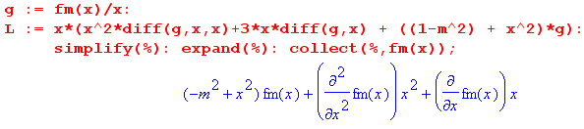
so that (D.2.12) becomes

[ x2 ∂x2 + x ∂x + (x2-m2)] fm(x) = Km x2 Jm(x) . (D.2.13)

The left side of (D.2.13) is the normal Bessel operator [ Spiegel 24.1] , but the equation is also driven by a power times a Bessel function. The solution to the equation is the homogeneous solution of the Bessel equation plus the particular solution which is the response to the driving function on the right hand side.

The homogeneous solution is the usual linear combination of Jm(x) and Ym(x), but we must reject Ym(x) since it blows up at x=0 and thereby causes the field Er to be singular, which it cannot be, smack in the middle of a wire.

The particular solution is not very obvious and required some hunting to find. It is this

fm(x)particular = (1/2) Km [ x Jm+1(x) ] . (D.2.14)

as Maple confirms, continuing the above code,

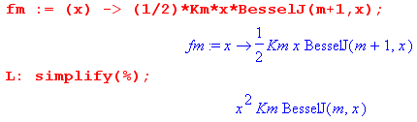

Therefore, we now have this full solution for fm(x)

fm(x) = fm(x)particular + fm(x)homogeneous = (1/2) Km [ x Jm+1(x) ] + am Jm(x)

and then from (D.2.10) the full solution for Er ,

Er(r,m) = am x-1 Jm(x) + $\frac{Km}{2}$ Jm+1(x) . (D.2.15)

For each value of m, there are two as-yet undetermined constants, am and (Km/2). However, looking at (D.2.15), we see that, since J0(x) ≈ 1 for small x, we must have

a0 = 0 (D.2.16)

to keep Er finite at r = 0. Later we shall obtain expressions for am and (Km/2).

(c) The Eφ Solution

Recall (D.2.6) in slightly altered form,

jmEφ(r,m) = -∂r[rEr(r,m)] + r (jβd)Ez(r,m) . (D.2.6)

We can then insert our known Ez and Er to get Eφ :

Ez(r,m) = Czm Jm(x) (D.2.4)
Er(r,m) = am x-1 Jm(x) + $\frac{Km}{2}$ Jm+1(x) . (D.2.15)

so (D.2.6) just above becomes the following

jmEφ(r,m) = -∂r[r{ am x-1 Jm(x) + $\frac{Km}{2}$ Jm+1(x)}] + r (jβd) Czm Jm(x)
jmEφ(r,m) = -∂x[x{ am x-1 Jm(x) + $\frac{Km}{2}$ Jm+1(x)}] + $\frac{Km}{2}$ x Jm(x) // Km ≡ 2j (βd/β') Czm
jmEφ(r,m) = -∂x[am Jm(x) + $\frac{Km}{2}$ x Jm+1(x)] + $\frac{Km}{2}$ x Jm(x)
jmEφ(r,m) = -am Jm'(x) - $\frac{Km}{2}$ Jm+1(x) -$\frac{Km}{2}$ x Jm+1'(x) + $\frac{Km}{2}$ x Jm(x)
jmEφ(r,m) = - am Jm'(x) + $\frac{Km}{2}$ [ - Jm+1(x) - x Jm+1'(x) + x Jm(x) ] . (D.2.17)

At this point we invoke the recurrence relations [ NIST 10.6.2 ], where C is any Bessel function,

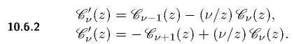
to write

Jm+1' = Jm - (m+1)x-1Jm+1 first relation with ν = m+1
Jm' = -Jm+1 + (m/x)Jm second relation with ν = m . (D.2.18)

Insert these into (D.2.17) to get

jmEφ(r,m) = - am Jm' + $\frac{Km}{2}$ [ - x Jm+1' - Jm+1 + xJm]
= - am {-Jm+1 + (m/x)Jm } + $\frac{Km}{2}$ [ - x { Jm - (m+1)x-1Jm+1} - Jm+1 + xJm]
= am Jm+1 - am (m/x)Jm + $\frac{Km}{2}$ [ - x Jm + (m+1) Jm+1 - Jm+1 + xJm]
= am Jm+1 - am (m/x)Jm + $\frac{Km}{2}$ [ m Jm+1]
= - am (m/x)Jm + ( $\frac{Km}{2}$ m + am ) Jm+1 .

Dividing by m then gives the final solution,

jEφ(r,m) = - am x-1 Jm(x) + ( $\frac{Km}{2}$+ $\frac{am}{m}$ ) Jm+1(x) x = β'r . (D.2.19)

We now gather up the solutions developed above, but first, recall that

Km ≡ 2j (βd/β') Czm (D.2.5)

which we can solve to get

Czm = (1/2j)(β'/βd) Km . (D.2.20)

Installing this into (D.2.4), our three E field components are then

First summary of the E field solutions (D.2.21)

Ez(r,m) = - j (β'/βd) $\frac{Km}{2}$ Jm(x) x = β'r (D.1.27)

Er(r,m) = am x-1 Jm(x) + $\frac{Km}{2}$ Jm+1(x) β'2 = β2 - βd2 (D.2.11)

jEφ(r,m) = - am x-1 Jm(x) + ( $\frac{Km}{2}$+ $\frac{am}{m}$ ) Jm+1(x) (D.2.15)

These solutions were obtained from the z and r Helmholtz equations and from the div E = 0 equation. It is an easy matter to have Maple verify that this solution set solves the div E equation and all three of the Helmholtz equations z, r and φ :

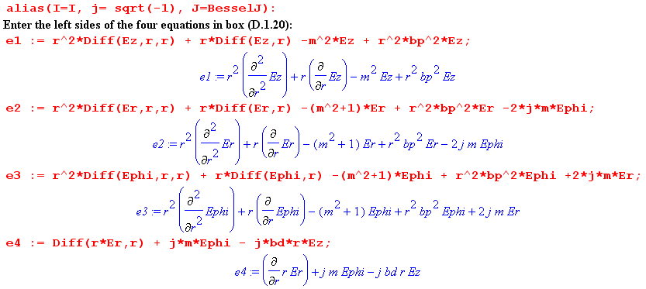

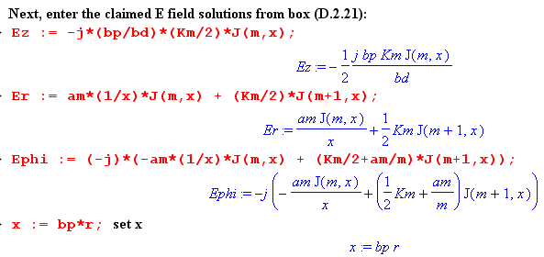

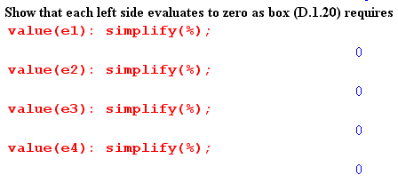
In Maple one must be careful with this kind of verification to make sure Maple has not misunderstood something. For example, perhaps it thinks ∂rEz = 0 because it thinks Ez is a constant. This is the purpose of using the "inert" Diff operators (versus diff) and then forcing them to evaluate later with the value() operator. One should always view expressions before simplification to make sure things are kosher. For example, changing the colon to semicolon after value(e1) to force display, one gets

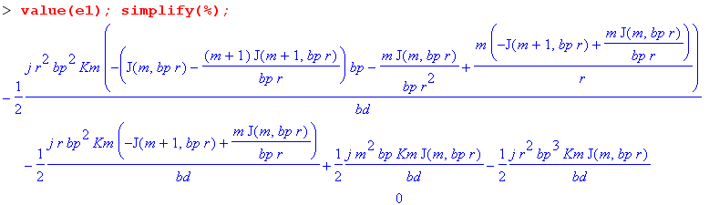
Here Maple has duly computed the Bessel function derivatives in expression e1 but does not yet realize that the expression is 0. This is brought out by the simplify(%) command (simplify that last computed expression) and the output of the simplify command is the 0 on the last line.

(d) The Charge Pumping Boundary Condition

The reason we are interested in the surface charge n(φ) of (D.1.5) is that it acts as a driving source of the radial electric field in the wire. Recall the equation of continuity (1.1.35) converted to the ω domain

div J = - jωρ ⇔ -jω[∫V ρ dV] = ∫S J • dS . (D.2.22)

This is meant to be (1.1.25) where J is conduction current and ρ is free charge. When applied to a thin box of radial area dS straddling the wire surface,

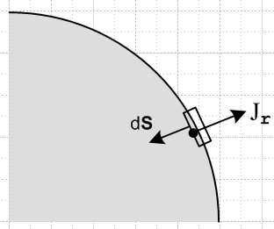 Fig D.2

one finds that ∫S J • dS = -Jr(r=a-ε,φ)dS and ∫V ρ dV = n(φ) dS so that (ε implies just below surface)

Jr(r=a-ε,φ) = jω n(φ) . (D.2.23)

We assume that there is no conduction current outside the wire to get this result (non-conducting dielectric). Since J = σE, this is really a boundary condition on the radial electric field just below the surface,

Er(r=a-ε,φ) = (jω/σ) n(φ) . (D.2.24)

We convert this to m-space using the conversion rules (D.1.16) to obtain (dropping the ε)

Er(r=a,m) = (jω/σ) Nm . (D.2.25)

Thus, the interior radial electric field must have a certain value at the r=a boundary in each partial wave, and this value is determined by the moment of the surface charge distribution.

By way of interpretation, the surface charge of a transmission line is "pumped" by the radial current in the wire (in quadrature). This radial current is accompanied by the usual longitudinal current one expects to find inside the conductors of a transmission line.

(e) Application of the Boundary Conditions

Our task here is to derive expressions for the constants am and Km appearing in the above E field component equations.

We have two boundary conditions to impose:

Er(r=a,m) = (jω/σ) Nm (D.2.26)

Eφ(r=a,m) = 0 (D.2.27)

The first is the radial charge pumping condition shown in (D.2.25) above. The second boundary condition is an assumption that requires its own discussion in Section D.8 below. It implies that the cross sectional wire surface is an equipotential surface and that therefore Eφ(r=a,φ) = 0. This in turn requires that in each partial wave Eφ(r,m) = 0 since

Eφ(r,m) = (1/2π) $^{\int_{-π}^{π}{}}$dφ Eφ(r,φ) e-jmφ (D.1.3b)
Eφ(a,m) = (1/2π) $^{\int_{-π}^{π}{}}$dφ Eφ(a,φ) e-jmφ = (1/2π) $^{\int_{-π}^{π}{}}$dφ 0 e-jmφ = 0 .

These two boundary conditions serve to determine the two constants am and Km, though a bit of algebra is required. The first step is to use the Er and Eφ expressions shown in summary box (D.2.21) to write out the two boundary conditions as

am xa-1 Jm(xa) + $\frac{Km}{2}$ Jm+1(xa) = (jω/σ) Nm (1)
- am xa-1 Jm(xa) + ( $\frac{Km}{2}$+ $\frac{am}{m}$ ) Jm+1(xa) = 0 . (2)

Addition and subtraction of these equations gives two new equations,

$\frac{Km}{2}$ Jm+1(xa) + ( $\frac{Km}{2}$+ $\frac{am}{m}$ ) Jm+1(xa) = (jω/σ) Nm (3)
2 am xa-1 Jm(xa) - $\frac{am}{m}$ Jm+1(xa) = (jω/σ) Nm . (4)

Using the recursion relation 2m x-1 Jm = [Jm+1 + Jm-1] , the second may be immediately solved for am,

$\frac{am}{m}$ = (jω/2σ) 2 Nm $\frac{1}{Jm-1(xa)}$ . (5)

Using this same recursion relation and (5) for am , equation (2) may be solved to get

( $\frac{Km}{2}$+ $\frac{am}{m}$ ) = (jω/2σ) Nm [$\frac{1}{Jm+1(xa)}$ + $\frac{1}{Jm-1(xa)}$ ] . (6)

Finally, subtracting (5) from (6) we find

$\frac{Km}{2}$ = (jω/2σ) Nm [$\frac{1}{Jm+1(xa)}$ – $\frac{1}{Jm-1(xa)}$ ] . (7)

We summarize the coefficients as follows:

am = (jω/2σ) 2m Nm $\frac{1}{Jm-1(xa)}$ . => a0 = 0 (D.2.28)

$\frac{Km}{2}$ = (jω/2σ) Nm [$\frac{1}{Jm+1(xa)}$ – $\frac{1}{Jm-1(xa)}$ ] => $\frac{K0}{2}$= (jω/σ) N0 $\frac{1}{J1(xa)}$ // J-1(z) = - J1(z)

($\frac{Km}{2}$+ $\frac{am}{m}$ ) = (jω/2σ) Nm [$\frac{1}{Jm+1(xa)}$ + $\frac{1}{Jm-1(xa)}$ ]

The third equation is obvious from adding the first two, and Maple verifies that the first two satisfy (1) and (2). At this point it is convenient to introduce the DC resistance per unit length of the wire

Rdc = $\frac{1}{σπa2}$ (D.2.29)

along with a new symbol to indicate the relative surface charge moment,

ηm ≡ $\frac{Nm}{N0}$ . (D.2.30)

The DC moment N0 can be related to the total current I in the wire as follows:
I = $^{\int_{0}^{2π}{}}$dφ $^{\int_{0}^{a}{}}$r dr Jz(r,φ) = $^{\int_{0}^{2π}{}}$dφ $^{\int_{0}^{a}{}}$r dr { σ $\sum_{m = -∞}^{∞}{}$ Ez(r,m) ejmφ } // (D.1.3a)
= σ $\sum_{m = -∞}^{∞}{}$ $^{\int_{0}^{a}{}}$r dr Ez(r,m) $^{\int_{0}^{2π}{}}$dφ ejmφ = 2π σ$^{\int_{0}^{a}{}}$r dr Ez(r,0)
= 2π σ$^{\int_{0}^{a}{}}$r dr {-j(β'/βd) $\frac{K0}{2}$J0(x) } // (D.2.21) for Ez(r,0)
= -j(β'/βd) 2π σ $\frac{K0}{2}$$^{\int_{0}^{a}{}}$r dr J0(x) // x = β'r so xdx = β'2 rdr
= -j(β'βd)-1 2πσ $\frac{K0}{2}$ [$^{\int_{0}^{xa}{}}$dx x J0(x)] = -j(β'βd)-1 2πσ $\frac{K0}{2}$ [ xa J1(xa) ] // GR7 5.52.1
= -j(β'βd)-1 2πσ {(jω/σ) N0 / J1(xa)} [ xa J1(xa) ] // (D.2.28) for $\frac{K0}{2}$

= (β'βd)-1 2πω N0 xa = (β'βd)-1 2πω N0 β'a

= 2πω (a/βd) N0
so that

N0 = (βd/2πωa) I . (D.2.31)

It follows from (D.2.31) that the normalization factor appearing in (D.2.28) may be written as

(jω/2σ) Nm = (jω/2σ) $\frac{Nm}{N0}$N0 = (jω/2σ) ηm [(βd/2πωa) I ] = (j/4) ηm (aβd/σπa2) I

= (j/4) (aβd) ηm I Rdc . (D.2.32)

We may now construct the final form for our E field solutions in (D.2.21) using the coefficients in (D.2.28) and the replacement (D.2.32) :

Ez(r,m) = -j(β'/βd) $\frac{Km}{2}$ Jm(x) = -j(β'/βd) (jω/2σ) Nm [$\frac{1}{Jm+1(xa)}$ – $\frac{1}{Jm-1(xa)}$ ] Jm(x)

= -j(β'/βd) [(j/4) (aβd) ηm I Rdc] [$\frac{1}{Jm+1(xa)}$ – $\frac{1}{Jm-1(xa)}$ ] Jm(x)

= (1/4) ηm I Rdc (aβ') [$\frac{Jm(x)}{Jm+1(xa)}$ - $\frac{Jm(x)}{Jm-1(xa)}$ ]

Er(r,m) = am x-1 Jm(x) + $\frac{Km}{2}$ Jm+1(x)

= [(jω/2σ) Nm] { 2m $\frac{1}{Jm-1(xa)}$ x-1 Jm(x) + [$\frac{1}{Jm+1(xa)}$ – $\frac{1}{Jm-1(xa)}$ ] Jm+1(x) }

= (j/4) (aβd) ηm I Rdc { $\frac{2mx-1Jm(x)}{Jm-1(xa)}$+ $\frac{Jm+1(x)}{Jm+1(xa)}$- $\frac{Jm+1(x)}{Jm-1(xa)}$ }

jEφ(r,m) = - am x-1 Jm(x) + ($\frac{Km}{2}$+ $\frac{am}{m}$) Jm+1(x)

= [(jω/2σ) Nm] { - 2m x-1 $\frac{1}{Jm-1(xa)}$ + [ $\frac{1}{Jm+1(xa)}$+ $\frac{1}{Jm-1(xa)}$] Jm+1(x)

= (j/4) (aβd) ηm I Rdc { - $\frac{2mx-1Jm(x)}{Jm-1(xa)}$ + [ $\frac{Jm+1(x)}{Jm+1(xa)}$+ $\frac{Jm+1(x)}{Jm-1(xa)}$] }

Gathering up one more time:

Second summary of the E field solutions : Rdc = $\frac{1}{σπa2}$ β'2 = β2 - βd2 (D.2.33)
Ez(r,m) = (1/4) ηm I Rdc (aβ') [$\frac{Jm(x)}{Jm+1(xa)}$ - $\frac{Jm(x)}{Jm-1(xa)}$ ] a = radius ηm ≡ $\frac{Nm}{N0}$
Er(r,m) = (j/4) ηm I Rdc (aβd) [ $\frac{2mx-1Jm(x)}{Jm-1(xa)}$+ $\frac{Jm+1(x)}{Jm+1(xa)}$ - $\frac{Jm+1(x)}{Jm-1(xa)}$ ] x = β'r
Eφ(r,m) = (1/4) ηm I Rdc (aβd) [ - $\frac{2mx-1Jm(x)}{Jm-1(xa)}$+ $\frac{Jm+1(x)}{Jm+1(xa)}$ + $\frac{Jm+1(x)}{Jm-1(xa)}$ ] xa = β'a

Maple verification of these solutions is shown below.

Observations about the solution:

(1) We looked for a wave solution inside a round wire in which phase fronts propagate down the wire (z direction) with angular frequency ω and wavelength λd = 2π/βd. We found the solution shown in the above box. This solution satisfies all three components of the vector Helmholtz equation (D.1.2) as well as the div E = 0 equation.

(2) For a good conductor and a good dielectric, one has ξ ≈ σ/(jω) and ξd ≈ εd. These are the complex dielectric "constants". The corresponding wavenumbers are then

β' ≈ β = ω $\sqrt{μx}$ ≈ ω $\sqrt{μ σ/(jω)}$ = ej3π/4 $\sqrt{ωμσ}$ = ej3π/4 ($\sqrt{2}$/δ) (1.5.1) ,(2.2.19), (2.2.21)

βd = ω $\sqrt{μdxd}$ ≈ ω $\sqrt{μdεd}$ = ω / vd vd = speed of light in the dielectric (D.2.34)

Thus, in our wave solution (D.1.1), the phase fronts propagate down the inside of the wire at vd, the speed of light in the dielectric outside the wire. Although we have been silent about the fields outside the wire, it seems reasonable to presume there is a wave outside also moving down the wire at vd . See Section D.8.

(3) For r near a, where most of the action occurs due do the skin effect, the Bessel function ratios appearing in (D.2.33) are on the general order of unity so we expect the three brackets [...] to be of the same general size. It then follows that the Er and Eφ fields are smaller than Ez by the ratio |βd/β'| which we have shown in the discussion below (D.2.2) is very small at frequencies below 100 GHz. Since Ez is an electric field inside copper, it is already itself quite small, so the Er and Eφ fields are extremely small. This then justifies their omission from the development of Chapter 2.

(4) If there exist moments Nm of the surface charge distribution on the wire with m > 1, then the corresponding ηm ≠ 0 and it is clear that Ez(r,φ) and hence Jz(r,φ) are non-uniform inside the wire. That is, these fields vary with φ as cos(mφ) as well as with r. The non-uniformity is not "small" but has the full strength of ηm. Of course we only expect to get significant moments of charge density n(φ) when conductors are "fat and close". It seems likely in this case that a large contribution will come from m=1.

(5) The surface impedance from (C.2.1) is just Zs(φ) = Ez(r=a,φ)/I. Thus, from (D.1.3a),

Zs(φ) = (1/I) $\sum_{m = -∞}^{∞}{}$ Ez(a,m) ejmφ // (D.1.3a)
= (1/4) Rdc $\sum_{m = -∞}^{∞}{}$ ηm [$\frac{xaJm(xa)}{Jm+1(xa)}$ - $\frac{xaJm(xa)}{Jm-1(xa)}$ ] ejmφ // (D.2.33)
where, (D.2.35)
ηm = Nm/N0 = $\frac{ωa}{βdI}$ $^{\int_{-π}^{π}{}}$dφ n(φ) e-jmφ // (D.1.5b) and (D.2.31)

Thus we see the expected non-uniformity of Zz(φ) around the perimeter of the wire cross section for the m ≠ 0 components.

Maple verification of box (D.2.33)

We use the same method illustrated below box (D.2.21). The same expressions e1,e2,e3,e4 are entered as the left sides of the four equations whose right sides we expect to be 0. Then:

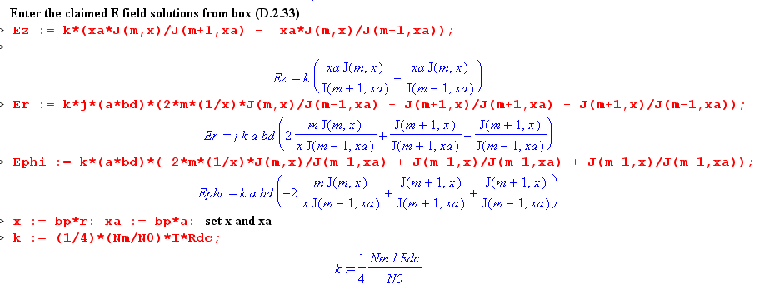
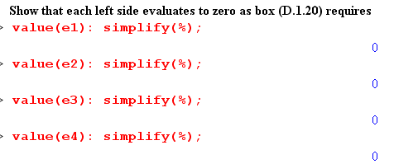
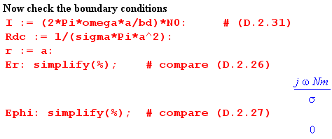

D.3 What about the Eφ Helmholtz Equation ?

A review of the above derivation of the three fields Ez, Er and Eφ shows that the Eφ Helmholtz equation has been completely ignored. The Eφ expression was obtained from the div E = 0 equation after the Ez and Er fields were computed.

It is reasonable to wonder whether the solution fields we have found above in fact solve this φ Helmholtz equation which mixes the Er and Eφ fields together in a manner similar to the r Helmholtz equation.

A related question is whether the three Helmholtz equations and div E = 0 are four independent equations, or is one of the three Helmholtz equations dependent? In Cartesian coordinates suppose we know that (implied sums on repeated indices)

(∂j∂j + β2) E1 = 0
(∂j∂j + β2) E2 = 0
∂iEi = 0 . // div E = 0 (D.3.1)

Can we show that (∂j∂j + β2) E3 = 0 so this third Helmholtz equation is dependent? If we apply the operator (∂j∂j + β2) to the last equation above we get

(∂j∂j + β2) ∂iEi = 0
or
∂i (∂j∂j + β2) Ei = 0
or
∂1 (∂j∂j + β2) E1 + ∂2 (∂j∂j + β2) E2 + ∂3 (∂j∂j + β2) E3 = 0
or
∂3 [(∂j∂j + β2) E3] = 0 (D.3.2)

This does not prove that (∂j∂j + β2) E3 = 0 since (∂j∂j + β2)E3 = f(x1,x2) ≠ 0 also satisfies (D.3.2).

Rather than pursue this question further, we simply note that the Maple code below box (D.2.21) verifies that the E field solutions given in that box do indeed satisfy the φ Helmholtz equation (as well as the other two Helmholtz equations and the div E = 0 equation).

Reader Exercise: Come up with some reason this had to be the case.

D.4 Computation of the B fields in the round wire

The B field components may be computed from the Maxwell curl E equation (1.1.2)

- ∂tB = curl E . Maxwell curl E equation (1.1.2) (D.4.1)

In cylindrical coordinates one has from (D.1.14),

curl E = [ r-1∂φEz - ∂zEφ] + [∂zEr - ∂rEz] + [ r-1∂r(rEφ) - r-1∂φEr ] (D.4.2)

where the fields are of the form shown in (D.1.1) which we assume also for the B field. Thus, combining (D.1.1) with (D.1.3a), one has
E(r,φ,z,t) = ej(ωt-β$_{d}$z) E(r,φ) = ej(ωt-β$_{d}$z) $\sum_{m = -∞}^{∞}{}$ E(r,m) ejmφ (D.4.3)
B(r,φ,z,t) = ej(ωt-β$_{d}$z) B(r,φ) = ej(ωt-β$_{d}$z) $\sum_{m = -∞}^{∞}{}$ B(r,m) ejmφ . (D.4.4)

Inserting the three cylindrical components of the E expansion (D.4.3) into (D.4.2), one finds that these replacements may be made,

∂t → +jω ∂z → -jβd ∂φ → +jm . (D.4.5)

Similarly, inserting the B expansion (D.4.4) into -∂tB one may replace ∂t→ +jω. After doing this, both sides of (D.4.1) are expansions of the general form of (D.4.3) and one may then equate terms in the m sum [completeness of the ejmφ on (-π.π)] to find that

-jωB(r,m) = [ r-1jmEz +jβdEφ] + [-jβdEr - ∂rEz] + [ r-1∂r(rEφ) - r-1jmEr ] (D.4.6)

and this then gives the three components of the B field

Br(r,m) = (j/ω) [curl E]r = (j/ω) [r-1jmEz +jβdEφ]
Bφ(r,m) = (j/ω) [curl E]φ = (j/ω)[-jβdEr - ∂rEz]

Bz(r,m) = (j/ω) [curl E]= (j/ω) [r-1∂r(rEφ) - r-1jmEr] . (D.4.7)

It is now a mechanical task to insert our E field components, and such tasks are grist for Maple's mill. We use the E component forms summary box (D.2.21) which have the am and Km constants not yet specified.

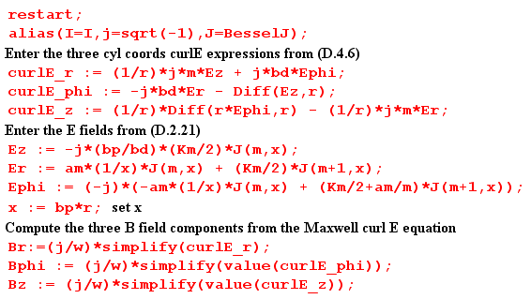

The alias line "unaliases" I, sets j = $\sqrt{-1}$in place of the default I, and allows simple reference to the Bessel functions of interest. Diff(Ez,r) represents ∂rEz, but in an "inert" form which is not executed until later after Ez has been specified. The resulting B field expressions are somewhat ugly but can be cleaned up using a few more Maple manipulations. Having seen the results, we extract certain factors as shown in the following commands,

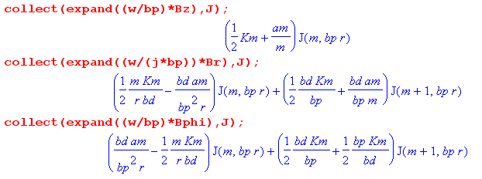
which we then translate back into our normal notation,

(ω/β')Bz(r,m) = ($\frac{Km}{2}$ + $\frac{am}{m}$ )Jm(x)
(ω/jβ')Br(r,m) = + ( m$\frac{Km}{2}$ $\frac{1}{rβd}$ - $\frac{βd}{rβ'2}$ am) Jm(x) + $\frac{βd}{β'}$ ($\frac{Km}{2}$ + $\frac{am}{m}$ ) Jm+1(x)
(ω/β')Bφ(r,m) = - ( m$\frac{Km}{2}$ $\frac{1}{rβd}$ - $\frac{βd}{rβ'2}$ am) Jm(x) + $\frac{Km}{2}$ ($\frac{βd}{β'}$ + $\frac{β'}{βd}$ ) Jm+1(x) . (D.4.8)

The last two equations contain the same term which can be written as (recall x = rβ')

( m$\frac{Km}{2}$ $\frac{1}{rβd}$ - $\frac{βd}{rβ'2}$ am) = ( m$\frac{Km}{2}$ $\frac{β'}{rβ'βd}$ - $\frac{βd}{rβ'2}$ am) = ( m$\frac{Km}{2}$ $\frac{β'}{βd}$ - $\frac{βd}{β'}$ am)(1/x)

The three equations for the exact B field components in the round wire are then shown in the summary box below which includes the earlier E field results as well:

Summary of E and B fields inside a round wire (D.4.9)

Ez(r,m) = - j (β'/βd) $\frac{Km}{2}$ Jm(x) x = β'r β'2 = β2 - βd2
Er(r,m) = am x-1 Jm(x) + $\frac{Km}{2}$ Jm+1(x) .
jEφ(r,m) = - am x-1 Jm(x) + ( $\frac{Km}{2}$+ $\frac{am}{m}$ ) Jm+1(x) (D.2.21)

Bz(r,m) = (β'/ω) ($\frac{Km}{2}$ + $\frac{am}{m}$ )Jm(x)
Br(r,m) = j(β'/ω){ + ( m$\frac{Km}{2}$ $\frac{β'}{βd}$ - $\frac{βd}{β'}$ am) x-1Jm(x) + $\frac{βd}{β'}$ ($\frac{Km}{2}$ + $\frac{am}{m}$ ) Jm+1(x) }
Bφ(r,m) = (β'/ω){ - ( m$\frac{Km}{2}$ $\frac{β'}{βd}$ - $\frac{βd}{β'}$ am) x-1Jm(x) + $\frac{Km}{2}$ ( $\frac{βd}{β'}$ + $\frac{β'}{βd}$ ) Jm+1(x) } , (D.4.8)

where the constants are given in (D.2.28), which we rewrite using (D.2.32),

am = (j/4) (aβd) ηm I Rdc * 2m $\frac{1}{Jm-1(xa)}$
$\frac{Km}{2}$ = (j/4) (aβd) ηm I Rdc * [$\frac{1}{Jm+1(xa)}$ – $\frac{1}{Jm-1(xa)}$ ]
($\frac{Km}{2}$+ $\frac{am}{m}$ ) = (j/4) (aβd) ηm I Rdc * [$\frac{1}{Jm+1(xa)}$ + $\frac{1}{Jm-1(xa)}$ ] .

The three constant quantities at the end of the above summary box are roughly the same size in terms of scale. Using this fact, and the fact that |β'| >> βd (so β = $\sqrt{β'2+βd2}$≈ β') we can simplify (D.4.9) to read,

Bz(r,m) = (β/ω) ($\frac{Km}{2}$ + $\frac{am}{m}$ )Jm(x) β' ≈ β, x = βr
Br(r,m) = j(β/ω){ + ( m$\frac{Km}{2}$ $\frac{β}{βd}$) x-1Jm(x) } // m ≠ 0
Bφ(r,m) = (β/ω){ - ( m$\frac{Km}{2}$ $\frac{β}{βd}$ ) x-1Jm(x) + $\frac{Km}{2}$ ($\frac{β}{βd}$ ) Jm+1(x) } . (D.4.10)

The last line of (D.4.10) can be further simplified,

Bφ(r,m) = (β/ω){ - ( m$\frac{Km}{2}$ $\frac{β}{βd}$) x-1Jm(x) + $\frac{Km}{2}$ ($\frac{β}{βd}$ ) Jm+1(x) }
= (β/ω) $\frac{Km}{2}$ $\frac{β}{βd}$ $\frac{1}{2}$ { - 2mx-1Jm(x) + 2Jm+1(x) }
= (β/ω) $\frac{Km}{2}$ $\frac{β}{βd}$ $\frac{1}{2}$ { - Jm+1(x) - Jm-1(x) + 2Jm+1(x) } // Spiegel 24.17 identity
= (β/ω) $\frac{Km}{2}$ $\frac{β}{βd}$ $\frac{1}{2}$ { Jm+1(x) - Jm-1(x) } . (D.4.11)

Therefore, in the limit |β'| >> βd equations (D.4.10) become

Bz(r,m) = (β/ω) ($\frac{Km}{2}$ + $\frac{am}{m}$ )Jm(x) β' ≈ β
Br(r,m) = j(β/ω) $\frac{β}{βd}${ m$\frac{Km}{2}$ x-1Jm(x) } // m ≠ 0
Bφ(r,m) = (β/ω) $\frac{β}{βd}$ $\frac{Km}{2}$ $\frac{1}{2}$ [ Jm+1(x) - Jm-1(x)] . (D.4.12)

For m>0, |Br| and |Bφ| are larger than |Bz| by the large factor| β/βd|.
For m = 0, βr ≈ 0 so |βφ| >> |Bz|. It is this large Bφ field which appears in Chapter 2 as Bθ.

D.5 Verification that the E and B fields satisfy the Maxwell equations

The Maple program discussed above goes on to verify that the exact E and B fields obtained above for the round wire in fact satisfy Maxwell's equations. Since the B equations were obtained from the curl E Maxwell equation, this one is not verified. The other three Maxwell equations are projected into their partial wave versions analogous to (D.4.6) above :

div B(r,m) = r-1∂r(rBr) + r-1∂φBφ + ∂zBz
= r-1∂r(rBr) +r-1jmBφ -jβd Bz (D.5.1)

div E(r,m) = r-1∂r(rEr) + r-1∂φEφ + ∂zEz
= r-1∂r(rEr) + r-1jmEφ - jβdEz (D.5.2)

curl B(r,m) = [ r-1∂φBz - ∂zBφ] + [∂zBr - ∂rBz] + [ r-1∂r(rBφ) - r-1∂φBr ]
= [ r-1jmBz + jβdBφ] + [-jβdBr - ∂rBz] + [ r-1∂r(rBφ) - r-1jmBr ] . (D.5.3)

Inside the round wire we expect to find

div B = 0

div E = 0 // no free charge

curl B = μ J + μ jωεE = μ(σ + jωε) E = μ(jω)( ε - jσ/ω) E = jω μξ E

= j (β2/ω) E . // see (1.5.1)

Thus, for the divergence equations we just compute the divergence as shown and see if it comes out zero, while for the curl B equation we verify that

curl B - j(β2/ω) E = 0 (D.5.4)

for each component. The fact (D.2.2) that β'2 = β2 - βd2 is also used.

Here then is the Maple code which does the verification of the three Maxwell equations:

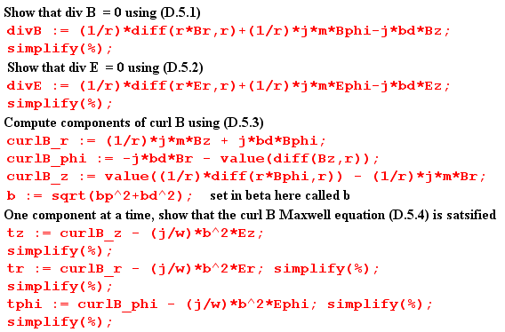

In Maple % refers to the last quantity computed. Prior to each simplify(%) statement we find a huge mess for the expression at hand, but simplify then shows it is really zero. As an example, here is the execution of the verification that [curl B]z - j(β2/ω) Ez = 0 :

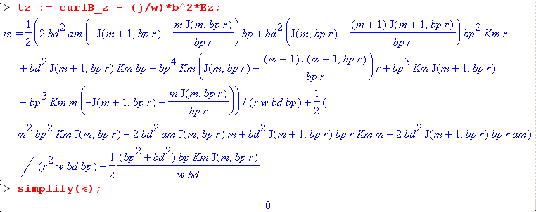

No approximations were made in the E fields, the B fields, or in these Maxwell verifications.

D.6 The exact E and B fields for the m=0 partial wave

The m=0 partial wave is all there is for an axially symmetric problem like that considered in Chapter 2, where the round wire is imagined in isolation, but is operationally the central conductor of a coaxial cable with a very distant return cylinder (outer shield). Here is the reduction of (D.4.9) for m = 0

Summary of E and B fields inside a round wire ( m = 0 only ) (D.6.1)

Ez(r,0) = - j (β'/βd) $\frac{K0}{2}$ J0(x) // large a0 = 0 x = β'r β'2 = β2 - βd2
Er(r,0) = $\frac{K0}{2}$ J1(x) . // small $\frac{K0}{2}$ = (j/2) (aβd) I Rdc $\frac{1}{J1(xa)}$
jEφ(r,0) = $\frac{K0}{2}$ J1(x) // small Rdc = $\frac{1}{σπa2}$

Bz(r,0) = (β'/ω) $\frac{K0}{2}$ J0(x) // small ~ β'
Br(r,0) = j(β'/ω) $\frac{βd}{β'}$ $\frac{K0}{2}$ J1(x) // very small ~ βd
Bφ(r,0) = (β'/ω) ( $\frac{βd}{β'}$ + $\frac{β'}{βd}$ ) $\frac{K0}{2}$J1(x) // large ~ β' (β'/βd)

No approximations have been made in these results, but a very good approximation is that |β| >> βd which means β' ≈ β, as discussed below equation (D.2.2). With this approximation, we have commented in the above box on the size of the various field components. The dominant components are

Ez(r,0) = - j (β/βd) $\frac{K0}{2}$ J0(x) = - j (β/βd) (j/2) (aβd) I Rdc $\frac{J0(x)}{J1(xa)}$
= (1/2) β a I Rdc $\frac{J0(x)}{J1(xa)}$ = (ω/β) (1/2) (aβ2/ω) I Rdc $\frac{J0(x)}{J1(xa)}$

Bφ(r,0) = (β/ω) ($\frac{β}{βd}$ ) (j/2) (aβd) I Rdc $\frac{J1(x)}{J1(xa)}$
= (j/2) (aβ2/ω) I Rdc $\frac{J1(x)}{J1(xa)}$.

As shown in (2.2.3) we can write β2/ω ≈ - jμσ so that

(1/2) (aβ2/ω) I Rdc = (1/2) a (- jμσ) I $\frac{1}{σπa2}$ = - j $\frac{μI}{2πa}$

and then the dominant components above become

Ez(r,0) = (ω/β) [ - j $\frac{μI}{2πa}$] $\frac{J0(x)}{J1(xa)}$ = -j (ω/β) $\frac{μI}{2πa}$ $\frac{J0(x)}{J1(xa)}$

Bφ(r,0) = j [- j$\frac{μI}{2πa}$ ] $\frac{J1(x)}{J1(xa)}$ = $\frac{μI}{2πa}$ $\frac{J1(x)}{J1(xa)}$. (D.6.2)

These results are in agreement with E(r) and B(r) shown in summary box (2.2.30) from the Chapter 2 calculation where we assumed E = E(r) and B = B(r) (Chapter 2's θ is Appendix D's φ).

D.7 What about the E fields outside the round wire?

The Helmholtz equation (D.1.2) outside the wire contains βd instead of β. The assumed wave solution form is still (D.1.1). In the three component Helmholtz equations this means that

β'2 ≡ β2- βd2 = βd2 - βd2 = 0

We can then translate box (D.1.20) by replacing β2- βd2 → 0 and β2 → βd2 to get the following "exterior" versions: (Note that ∇2 = ∇22D + ∂z2)

[∇2E]z + βd2 Ez = 0 : // [∇22DE]z = 0
[r2∂r2 + r ∂r - m2] Ez(r,m) = 0 (D.1.15)ext

[∇2E]r + βd2 Er = 0 : // [∇22DE]r = 0
[r2∂r2 + r∂r - (m2+1)] Er(r,m) - 2jm Eφ(r,m) = 0 (D.1.17)ext

[∇2E]φ + βd2 Eφ = 0 : // [∇22DE]φ = 0
[r2∂r2 + r∂r - (m2+1)] Eφ(r,m) + 2jmEr(r,m) = 0 (D.1.18)ext

div E = 0 :
∂r [r Er(r,m)] + jmEφ(r,m) -jβd r Ez(r,m) = 0 (D.1.19)ext

The differential operators appearing in the above equations are no longer Bessel-style operators, they are Euler-style operators. Euler ODEs have the general form [ r2∂r2 + a r ∂r + b] f(r) = 0, and the solutions have this form ( from p 45 of Polyanin's excellent ODE compendium, or just use Maple),

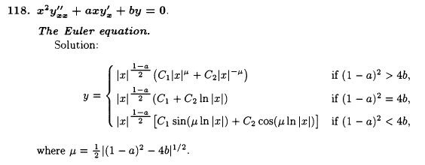

For Ez(r,m) the equation (D.1.15)ext shown just above is in fact an Euler equation which has a = 1 and
b = -m2 so μ = m and the solution forms are these (r ≥a outside the wire),

Ez(r,m) = Amrm + Bmr-m m > 0
Ez(r,0) = Czln(r) + Dz m = 0 . (D.7.1)

Since z is a Cartesian coordinate, [∇22DE]z = 0 is the same as ∇22DEz = 0 which is just the 2D Laplace equation. When this equation is solved in polar coordinates (r,φ), one finds Ez = Ez(r,m) ejmφ and the expressions shown above are the standard atomic forms for the radial function. See for example Stakgold Vol II p 92 (6.7) and following discussion.

We can mimic our interior solution method presented in Section D.2 above, using the div E = 0 equation to eliminate Eφ, and eventually end up with expressions for the three field components outside the wire. For m > 1 the general form for the exterior solution is found to be,

Ez(r,m) = Am rm + Bm r-m
Er(r,m) = -(jβd/2) $\frac{1}{m-1}$ Bm r1-m - 2j βd $\frac{1}{m2-1}$Am r1+m + Cm rm-1 + Dm r-m-1
jEφ(r,m) = (jβd/2) $\frac{1}{m-1}$ Bm r1-m + j βd $\frac{m2+ 2m+3}{m(m2-1)}$Am r1+m - Cm rm-1 + Dm r-m-1 (D.7.2)

where there are now four constants Am, Bm, Cm and Dm to be determined in each partial wave. One could match the three E-field boundary conditions at r = a as per (1.1.50) (subscript d means dielectric)

Ez(a,m) = Ezd(a,m)
ξ Er(a,m) = ξd Erd(a,m)
jEφ(a,m) = jEφd(a,m) (D.7.3)

using the interior solutions shown in (D.2.33) where Eφ(a,m) = 0. This gives 3 conditions on the 4 unknown constants so these boundary conditions can be met.
The problem with this exterior solution method is that more information is needed to solve the problem. The "Smythian Form" solution (D.7.2) is fine, but it only applies inside a thick cylindrical shell (blue) whose inner diameter is r = a and whose outer diameter is r = b, where b causes this shell to touch the nearest other conductor, as illustrated here,

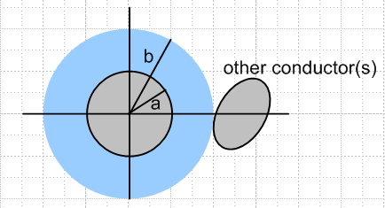 Fig D.3

The reason is that the dielectric E-field wave (Helmholtz) equation is not valid inside the "other conductor", so the form (D.7.2) cannot apply in a region which includes any of this other conductor. Since the blue shell region does not include r = ∞, one cannot rule out coefficients like Am and Cm. One is now stuck worrying about boundary conditions at r = b and the whole problem becomes intractable. But if one could find the complete exact exterior solution, one would find that inside the blue cylindrical shell the solution's partial wave fields would have the form shown in (D.7.2).

Reader Exercise:

(a) Verify (D.7.2).

(b) In Chapter 6 a transmission line with two round conductors is solved "exactly". Convert the solution to a coordinate system like that shown above, compute the Ei(r,m) using (D.1.3b), and verify that these Ei field components fit into the form shown in (D.7.2).

D.8 About the boundary condition Eφ(r=a,m) = 0

In earlier sections of this Appendix we examined the electric field inside a round wire (radius a) which was regarded as a conductor in a straight transmission line. The electric field was assumed to have the form of a longitudinal wave travelling down the conductor,

E(r,φ,z,t) = ej(ωt-β$_{d}$z) E(r,φ) , (D.1.1)

where βd is the wavenumber parameter of the surrounding dielectric medium. We expanded the function E(r,φ) onto azimuthal partial waves ejmφ and solved the Helmholtz wave equation inside the wire with solutions as shown in box (D.2.21),

Ez(r,m) = - j (β'/βd) $\frac{Km}{2}$ Jm(x) x = β'r (D.1.27)
Er(r,m) = am x-1 Jm(x) + $\frac{Km}{2}$ Jm+1(x) . (D.2.11)
jEφ(r,m) = - am x-1 Jm(x) + ( $\frac{Km}{2}$+ $\frac{am}{m}$ ) Jm+1(x) . (D.2.15)

where β'2 = β2-βd2 with β being the (complex) wavenumber parameter of the conductor, and where am and Km are undetermined constants.
At this point we applied the two boundary conditions,

Er(r=a,m) = (jω/σ) Nm (D.2.26)
Eφ(r=a,m) = 0 . (D.2.27)

where Nm is the mth partial wave moment of the surface charge n(φ) distribution, where

n(φ,z,t) = ej(ωt-β$_{d}$z) n(φ) . (D.1.4)

These conditions determined the constants am and Km giving the resulting E field inside the wire,

Ez(r,m) = (1/4) ηm I Rdc (aβ') [$\frac{Jm(x)}{Jm+1(xa)}$ - $\frac{Jm(x)}{Jm-1(xa)}$ ] a = radius ηm ≡ $\frac{Nm}{N0}$ (D.2.33)
Er(r,m) = (j/4) ηm I Rdc (aβd) [ $\frac{2mx-1Jm(x)}{Jm-1(xa)}$+ $\frac{Jm+1(x)}{Jm+1(xa)}$ - $\frac{Jm+1(x)}{Jm-1(xa)}$ ] x = β'r
Eφ(r,m) = (1/4) ηm I Rdc (aβd) [ - $\frac{2mx-1Jm(x)}{Jm-1(xa)}$+ $\frac{Jm+1(x)}{Jm+1(xa)}$ + $\frac{Jm+1(x)}{Jm-1(xa)}$ ] xa = β'a

where Rdc = 1/(πa2σ) is the DC resistance of the wire per unit length, and I is the amplitude of the current in the wire. Everything is an implicit function of frequency ω. It was noted that, for |βd/β'| << 1, the fields Er and Eφ are much smaller than Ez, and this is the case for f ~ 100 GHz or below.
An implication of the solution is that the E fields inside the wire for each partial wave are described by a single parameter Nm which is the surface charge moment noted above. If the other transmission line conductor(s) were to change their position relative to the round wire and/or to vary their cross sectional shape, the only effect this would have would be to adjust the set of parameters Nm, and the solutions would still be given by (D.2.33) quoted above. Although the set {Nm} is infinite, it seems likely that for reasonable shapes of the other conductor(s), the lowest few Nm partial waves would provide a good approximation to the E fields inside the wire. Since Ohm's Law is assumed to apply inside the wire, one then knows in detail the current densities Jz, Jr and Jz. The magnetic field B inside the wire is then also known and was calculated above. The lowest moment is always N0 = (βd/2πωa) I from (D.2.31).
As an example, the following five-conductor transmission line might be expected to have a strong m = 2 quadrupole surface charge moment N2,

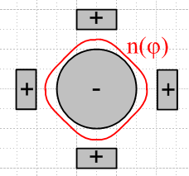 Fig D.4

A critical ingredient of our solution is the assumption that Eφ(r=a,m) = 0 and that is the subject now addressed. We present two somewhat different arguments as to why Eφ(r=a,m) = 0. It should be noted that King in his Transmission-Line Theory book always assumes that any straight transmission line conductor cross section has an equipotential surface (a ring, see for example middle p 14, top 15, 25 bottom).

(a) The Quasi-Static Argument

In electrostatics, we are used to metal surfaces being equipotentials. For example, if we put a point charge q near a metal sphere, it induces a surface charge on that sphere. The electric field lines land on the sphere exactly perpendicular to the surface. One argues that if there were even some tiny E field component tangential to the surface, the surface charges would adjust their position to cancel out that tangential field. Since the situation is static, any adjustment has already been made. Since Etan = 0, the sphere's surface is an equipotential surface.
If we were to then slowly move the charge q around (perhaps it rotates in a circle around the sphere), the surface charge instantly adjusts at each new position of q, and those E field lines remain perpendicular to the surface, and Etan = 0. While the charges are adjusting position, there is admittedly some very tiny surface current driven by some tiny Etan , but if we move the charge slowly, we are "quasi-static" and the approximation Etan ≈ 0 is very good. One might compare the time constant of the moving sphere (T, the period of q's revolution around the sphere) to the time constant of the surface charge adjustment. For copper the time constant is roughly the mean electron collision time which is on the order of 10-14 sec. The conclusion here is that for frequencies << 1014 Hz, the quasi-static situation prevails and then Etan ≈ 0 is a very good approximation.
This then is our first argument for why we claim the boundary condition Eφ = 0 on the surface of the round wire in a transmission line operating at a typical frequency.
We note from our solution Eφ(r,m) that if we assume Eφ(a,m) = 0 on the round wire surface, we will still have Eφ(r,m) ≠ 0 inside the wire. This fact is consistent with our argument above since there are no free charges available to adjust themselves inside the wire.

However: if Eφ = 0 by this quasi-static argument, then we should expect that Ez = 0 by the same argument, since Ez is also a tangential field at the round wire surface, and since Ez operates at the same frequency ω as Eφ. But we know that Ez ≠ 0 because Jz ≠ 0 just below the wire surface -- there is current flowing there -- and Ez is continuous through the surface by (1.1.50). So the E field lines are not quite perpendicular to the round wire surface in the z direction. This is not too surprising since we expect everything to vary in the z direction as ej(ωt-β$_{d}$z) so we would expect the surface not to be an equipotential in this direction.
But what happened to that quasi-static argument we just applied to Eφ ? What happened is that there is external field activity associated with the wave going down the line which forces Ez ≠ 0. One might say the EM wave travelling down the line induces a Jz in the round wire, with its associated Ez ≠ 0. But then perhaps this same thing could somehow happen with Eφ and then our quasi-static argument that Eφ = 0 collapses. We think this could happen in fact, but only if the transmission line is driven by an apparatus which creates a "torsion wave" in the line. For example, the apparatus could drive counter-rotating azimuthal currents onto the round wire surfaces of a twin-lead transmission line as suggested by this picture (which is not meant to imply that other field components vanish),

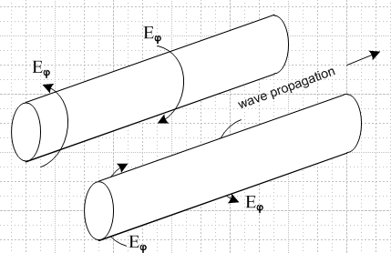 Fig D.5

It seems from our work above that such a wave would satisfy Maxwell's equations and be a viable mode of the transmission line. In this case, Eφ≠ 0 because the EM wave going down the line forces Eφ ≠ 0, just as the normal wave forces Ez ≠ 0.
We have not investigated whether this type of torsion wave is really viable. Whether or not it is, we assume in our transmission line discussion that this mode is not activated and that therefore the quasi-static argument for Eφ = 0 is valid at the round wire surface.

(b) An Ansatz Argument

We make an ansatz that Er,Eφ << Ez in our round wire E field solution, perhaps based on an expectation that most current in the wire will be longitudinal. We assume this is true, and see if this assumption is born out in a final solution of Maxwell's equations. Given that Eφ is then very small, we can make an approximation (another ansatz) that this field Eφ is exactly zero on the surface of the round wire. This may not be exactly true, but again we assume it for our purposes and see where it leads. This is the nature of an "ansatz".
When we make this assumption, the cross section of the transmission line may be regarded (Chapter 5) as a two dimensional potential theory problem -- basically a capacitor problem where one conductor has potential V/2 and the other -V/2, say (at some fixed value of z). In such a potential problem, one always assumes that the electrostatic potential Φ is a constant on the surface of each conductor, and that is precisely what our ansatz says: Eφ = -(∇Φ)φ = 0, Φ = constant in the φ direction. Now when we solve the capacitor problem for potential Φ, that gives E = - ∇Φ in the dielectric between the conductors, and from that we may deduce E • at the surface of one of the conductors. For the round wire with a cylindrical coordinate system whose axis is aligned with the wire center, that field is Er. Next, from this surface value of Er (which will be proportional to V) we may compute the surface charge density n(φ) on the round wire using (D.2.24) which says Er(r=a,φ) = (jω/σ) n(φ). For a "fat" twin lead transmission line for example we expect this to have a bulge in n(φ) on the side of the wire facing the other wire (m = 1, dipole), since that is what happens in such a capacitor. In any event, given n(φ) we may compute the moments Nm of the surface charge using (D.1.5b) and this then provides one "boundary condition" on our coefficients am and Km which appear in all the field expressions we found above,

Er(r=a,m) = (jω/σ) Nm . (D.2.26)

But recall that, in order to carry out this entire process just described, we had to start with the assumption that Eφ = 0 on the conductor cross section surface, so that we could have a capacitor problem in the first place. According to (D.1.3b), if Eφ(r=a,φ) = 0, then Eφ(r=a,m) = 0, so that in fact we must have Er(a,m) being zero in all partial waves m. Thus our assumed ansatz condition is

Eφ(r=a,m) = 0 (D.2.27)

which is then a second boundary condition on am and Km. Although (D.2.27) might not be exactly true, we know it is very close to being true. More importantly, we know that the above two conditions on am and Km are consistent with each other, even though both boundary conditions might be slightly wrong. We then expect them to give good values for constants am and Km.
Using these "perhaps slightly wrong" boundary conditions, we obtain the solutions shown in (D.2.33). It has already been noted above that for copper conductors and normal dielectrics, |βd/β'| << 1 up to at least 100 GHz. The condition |βd/β'| << 1 when applied to the (D.2.33) results shows that in fact our ansatz that Er,Eφ << Ez is born out.
There are three footnotes to the above discussion.
First, we note that the second boundary condition does not force Eφ(r,m) = 0 for r < a inside the wire. In fact, there will be some small azimuthal "swirling" current inside the wire even if Eφ(r=a,m) = 0, and this is just a result of Maxwell's equations and their solutions above.
Second, one might make the argument that the round wire surface is an equipotential since that is the way a line is driven at the source. For example, the center conductor of a coaxial cable plugs into a tiny driving cylinder (jack) in a BNC connector and this drives only the wire surface, and it does so in an azimuthally symmetric way so that one expects to have the wire surface be an equipotential at the driving point; this equipotential surface then moves down the line as the wave progresses.
Third, we have the complication that we don't really have a purely electrostatic situation, and the potential is in fact related to E by equation (1.3.1) which says E = - ∇ Φ - ∂tA . The rescue here comes by claiming that roughly A ≈ A so that the transverse components Ar and Aφ are very small. In this case, we then do get E ≈ -∇Φ so that Eφ = 0 is associated with constant Φ on the wire surface. The argument for A ≈ A is that A is driven by J, and J is mostly in the direction, which in turn is related to our starting ansatz.

Exercise for the Reader

(1) Show using F = ma and F = qE that a classical electron inside a transmission line conductor traverses a tiny elliptical path and thus never really goes anywhere. That path is traversed once per period T= 2π/ω. Mathematically, show that this amounts to proving that the three equations

x = Acos(ωt-a)
y = Bcos(ωt-b)
z = Ccos(ωt-c) (D.8.1)

are parametric equations for an ellipse with some orientation in 3D space. This goes-nowhere aspect of the electron is similar to what happens with a droplet of water in an ocean wave. (Hint: first show that the first two equations describe an ellipse in the xy plane and that the semi-major axes in general are not A and B .)

(2) When a TEM wave travels down a transmission line with a round conductor, the electric field "raises" a surface charge density on that conductor as it passes by. Exactly where does this surface charge come from? Is the charge density (though not individual charges) just sliding down the line in the z direction at the dielectric light velocity, and that is where it comes from -- the surface charge moves in the z direction, and there is then a z-directed surface current? Or does this charge get pumped off the other side of the conductor through the interior by the radial field Er ? Or does the charge get driven around the cross section surface of the conductor by an Eφ field which we have proposed vanishes? Here is a simplified drawing showing how the phased elliptical motions of individual electrons might answer these questions:

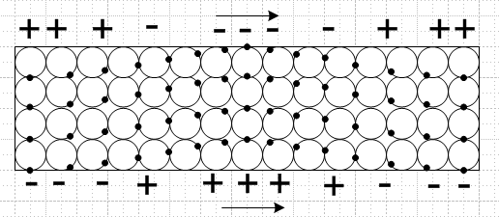 Fig D.6

(3) Use Maple or other software to make a cross-sectional 2D "field plot" like Fig C.2 of current flow in a round wire for a given partial wave m. A starting point (for z = 0) might be

Etrans (r,φ,t) = cos(-ωt + mφ + arg[Eφ(r)] ) |Eφ| + cos(-ωt + mφ + arg[Er(r)] ) |Er| (D.8.2)

where = -sinφ + cosφ and = cosφ + sinφ . Make a series of plots at sequential t values to obtain a weather pattern for the E field components (and thus the currents), and see if this helps answer question (2) above. Try making a 3D field plot adding in the field component.

Appendix E: How Thick is Surface Charge on a Metal Conductor?

It is often said that surface charges exist only very close to the surface of a conductor. In this section, we will show how extremely true this statement is. Here is a crude sketch of what we expect surface charge distributions might look like at the plates of a capacitor.

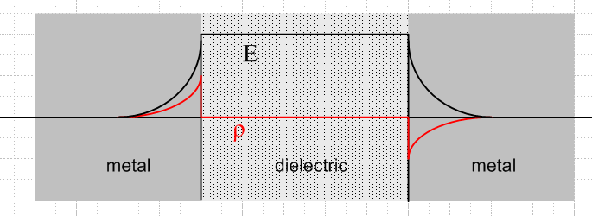 Fig E.1

The red plot is charge density ρ, and the black plot is the electric field magnitude. The charge density is exactly ρ = 0 in the dielectric region between the two plates simply because there are no available charge carriers as there are in a metal (the electron cloud), see Section 3.1. Barring a huge E field or very high temperatures, electrons cannot just "jump off" the metal surface into the dielectric region because of an energy cost to do so called the work function.
The figure suggests that the charge distribution might have an exponential decay going into each metal surface, with some characteristic distance which we seek to find. The reader might wonder: is it the skin depth δ? The answer to that question is: most definitely not!
We are used to using Ohm's law J = σE in various forms. Application of this law in the regions of charge density in the above figure leads to a contradiction. In the DC static case, nothing moves, so there can be no J, but there is clearly some E, so how can J = σE ? The reason is that Ohm's law only applies in a neutral medium. When there is a net charge density, the corrected Ohm's law is this:

J = σE - D grad ρ . (E.1)

The grad term, associated with Fick's Law, represents a flux of charged particles (a current) created by a gradient of the charge density. The charge flows (diffuses) from a region of high density to one of lower density, hence the minus sign, just as heat flows from a region of higher temperature to one of lower temperature. In a static situation with no current, the second term balances the first term in a surface charge region,

σE = D grad ρ . (E.2)

As electrons pile up on the boundary, they resist further pileup by their higher density. Basically this is a diffusion effect, and D is a diffusion coefficient.
There is another more familiar equation which relates E and ρ, namely (1.1.3) + (1.1.6),

div E = ρ/ε . (E.3)

Inside a metal conductor the dielectric constant ε requires some careful study, but here we shall just set it to ε0 as if there were nothing in the electron cloud of the metal that could be polarized. Taking the divergence of (E.2) and using (E.3) we get this result

∇2ρ = (σ/Dε0) ρ . (E.4)

The inverse combination of symbols in (E.4) is the square of something called the Debye length,

λD2 = (Dε0/ σ) (E.5)

which is associated with charge screening in plasmas (such as the electrons in a metal). Thus, (E.4) may be written,

∇2ρ = (1/λD2) ρ . (E.6)

In our one-dimensional problem of the above figure, the solution of this equation is

ρ(x) = ρ(0) e-x/λ$_{D}$ (E.7)

where x is a coordinate going into the surface. This says that the thickness of the charge surface layer inside the metal is basically λD.
If the electron cloud inside the metal is treated as a classical gas of particles of mass m, charge q, temperature T, and density n, one gets formulas for the various coefficients. Here are some expressions:

J = nqv v = average drift velocity

τ = mean lifetime between collisions

μ = (v/E) = (q/m)τ = mobility

D = (kTτ/m) = diffusion coefficient (k = Boltzmann constant)

σ = (nq2τ/m) = conductivity

λD = $\sqrt{ε0 kT/nq2}$= Debye length (E.8)

This set of equations represents a classical model for the free charge in a metal.
One major and one minor adjustment is needed when quantum theory is applied because electrons are fermions. This means that they cannot all park in the same state, so they "pile up" in higher and higher states in something known as the Fermi sphere. Only electrons at the surface of this sphere can do anything useful. Due to the pileup, the temperature of the active electrons is very much higher than one might think using classical physics. One finds this temperature by setting kT = EF where this latter is the Fermi energy,

EF = (h2/ 8π2m) (3π2n)2/3 = kTF . (E.9)

The appearance of the Plank constant h is the clue that this is a quantum result. This was the major quantum adjustment. The minor one is that T in the Debye formula gets replaced by (2/3)T. Thus,

λD = $\sqrt{ε0 k(2TF/3)/nq2}$= Debye length (quantum correct) . (E.10)

We shall now do some numbers. Here are the basics,

n = 8.45 x 1028 electrons/ m3 for Copper

k = 1.38 x 10-23 = Boltzmann constant

m = 9.1 x 10-31 kg = electron mass

h = 6.63 x 10-34 J sec = Planck constant

Plugging these into (E.9) gives the following effective electron temperature

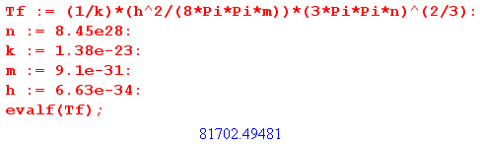
so
TF = 81,702 ° K = pretty hot . (E.11)

We can now compute the Debye length, using (E.10) :

ε0 = 8.85 x 10-12 F/m

q = 1.60 x 10-19 C

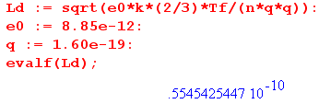
so
λD = 5.55 x 10-11 m = 0.55 A (Angstroms) // = 55 pm (E.12)

The atomic spacing in crystal copper is 3.6A, while the copper atomic radius is about 1.3A.
The basic discussion above through (E.7) appears in Portis pp 162-164 (Chap 5, Sec 11). Portis then gives a small table of metal parameters and λD for copper is quoted as 0.59A, close to our result above.

Thus, we come to the dramatic conclusion of this section:

Fact: In our simple model, the thickness of the surface charge density below the surface of a conductor is incredibly small. For copper, it is less than the radius of one copper atom, and the general result applies to any metal. Thus, the surface charge decays away right in the very first atomic layer of a metal.

Fact: The thin layer of negative surface charge on the right plate in Fig E.1 above serves to neutralize the E field which would otherwise be present inside the right conductor due to the positive charge on the surface of the left plate. One says that the E field inside (and to the right of) the right plate is "screened" (killed off) by the negative surface charge layer on the right plate.
This is of course the principle behind the ever-popular Faraday Cage (note kids inside):

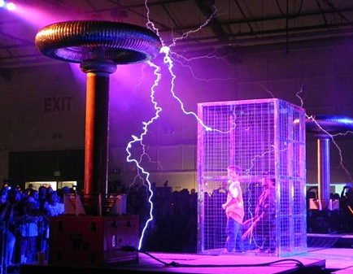 Fig E.2

From Section 2.2, we found that the skin depth δ for copper at 100 GHz is about 0.2 microns which is 2x10-7m = 2000A. Even at this large frequency, the skin depth is still about 4000 times larger than the thickness of the surface charge layer. At 1 GHz this ratio is 40,000.

Fact: Whereas surface current can exist "deep" into the surface of a conductor, even when the skin effect is dominant, the surface charge can always be thought of as being exactly on the surface.

Appendix F: Waveguides

F.1 Discussion

A transmission line must have at least two distinct conductors to carry the TEM wave described in Section 3.7 and as illustrated in the figures there. For a two conductor transmission line the surfaces of the conductors have a potential difference of amplitude V ≠ 0.
A single wire cannot carry a TEM wave except in the sense of Section 2.1 where it acts as the center conductor of a coaxial cable with a far-distant return sheath. A TEM wave cannot propagate down the inside of a hollow pipe regardless of cross section shape since the continuous conductor cross section "shorts out" any possible V ≠ 0.
In this document we have associated the TEM wave with the phrase "transmission line". but certainly a waveguide is a form of transmission line. Normally one associates the word "waveguide" with the TE and TM modes such waveguides carry. The usual form of a waveguide is in fact a hollow pipe, often of rectangular or circular cross section. However, it is possible for a 2 conductor transmission line to have TE and TM modes. In this Appendix we shall not present a theory of waveguides since that is well done in Jackson and many other texts, but we would like to show that a transmission line made from two closely spaced parallel plates can carry waveguide modes in addition to the TEM mode. And we want to use this simple example to illustrate the notion that waveguide modes have lower cutoff frequencies whereas the TEM mode can operate all the way down to ω = 0.
The terminology TEM (Transverse Electric and Magnetic) means that both the E and B fields are transverse, as shown in Figures 3.5 through 3.7. In reality, we know there is a very small longitudinal Ez field because Ez is continuous at a conductor surface and we know Jz = σEz just inside the conductor. This Ez field exists and has a cosine-like shape between the conductors, having the opposite direction at the second conductor. This field might be smaller than the transverse E field by a factor 10-4 as shown in (3.6.2).
A TEM wave is very much like a plane wave with its transverse E and B fields, but the fields are distorted by the presence of the conductors. As Fig 3.5 shows, this distortion is such that the Poynting vector E x B always points down the line (z direction), E and B are always perpendicular at any point, but the E field lands perpendicularly on the conductors. The TE and TM modes have much more complicated field patterns.
The waveguide modes are called TE (Transverse Electric) and TM (Transverse Magnetic). The nomenclature is a little confusing since both TE and TM waves generally have transverse E and B fields. The distinction is that the TE modes have no Ez field, while the TM modes have no Bz field. So TE means the E field is "transverse only".

F.2 The TE waveguide modes for a parallel-plate transmission line

We shall assume (an "ansatz") that the entire E field is given by

E(x,y,z) = Ey(x) ej(ωt-kz) (F.2.1)
where we have our usual overloading of the symbol E.

This field in the dielectric must satisfy the ω-domain wave equation (1.5.32) which says

(∇2 + β2) E = 0 . (F.2.2)

Here β is the usual Helmholtz parameter of the dielectric as in (1.5.1),

β2 = μεω2 - jωμσ = ω2μ ( ε - jσ/ω) = ω2μ ξ ξ ≡ ε - jσ/ω (1.5.1)

but in this Appendix we assume the dielectric is non-conducting so β2 = ω2με.

Inserting our ansatz form (F.2.1) for E into (F.2.2) we find that

(∂x2 + ∂y2 + ∂z2+ β2) Ey(x) ej(ωt-kz) = 0
or
(∂x2 + 0 +(-k2)+ β2) Ey(x) = 0 . (F.2.3)

Define

γ2 ≡ β2-k2 (F.2.4)

so that

(∂x2 + γ2) Ey(x)= 0 (F.2.5)
so
Ey(x) = A sin(γx) + Bcos(γx) . (F.2.6)

We now introduce our parallel plate transmission line (the gap is exaggerated in width)

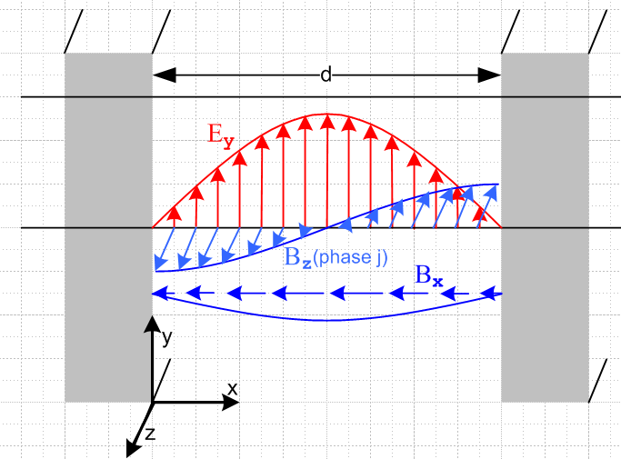 Fig F.1

Since we require Ey = 0 at the two inner plate surfaces, we find that

Ey(x) = A sin(γx) where sin(γd) = 0 => γd = mπ . (F.2.7)

Thus, the parameter γ is quantized by the boundary conditions and we have

Ey(m)(x) = A sin(γmx) γm = m(π/d) m = 1,2,3.... (F.2.8)

Suddenly we have "modes" labeled by m. The lowest non-vanishing mode has m = 1, and this is the mode shown in the figure.

We find that the wave's wavenumber k is also quantized. From (F.2.4) we get

km = $\sqrt{β2 - γm2}$ . (F.2.9)

In order for there to be a traveling wave ej(ωt-kz), we need k in (F.2.1) to be real, which requires that

β ≥ γm . (F.2.10)

For a non-conducting dielectric one has β = ω$\sqrt{με}$ = ω/v where v is the light speeed in the dielectric. Recall from (1.1.29) that $\sqrt{μ0ε0}$ = 1/c. So the above condition is

ω/v ≥ m(π/d) => ω ≥ m(π/d)v

so
ω ≥ ωm ωm ≡ m(π/d)v = γm v . (F.2.11)

Thus the mth TE mode can only operate for ω above ωm, and as m increases the low end mode cutoff increases. For ω < ω1 there can be no TE action on this waveguide.

The B fields for our TE mode can be obtained from the Maxwell curl E (1.6.19),

B = (j/ω) curl E = (j/ω) [ (∂yEz - ∂zEy) + (∂zEx - ∂xEz) + (∂xEy - ∂yEx)]

= (j/ω) [ (- ∂zEy) + (∂xEy) ]

so then

Bx(m)(x) = (j/ω)(jk)Ey(x) = -(km/ω) A sin(γmx) (F.2.12)

Bz(m)(x) = (j/ω)∂xEy(x) = (j/ω) γm A cos(γmx) . (F.2.13)

Ey(m)(x) = A sin(γmx) . (F.2.8)

If A is real, then Ey and Bx are real and in time phase, while Bz is 900 out of phase. An attempt has been made to display all three field components in Fig F.1.

To show that the waveguide mode outlined above is viable, we verify Maxwell's equations. Since the Maxwell curl E equation was used to obtain B, we need verify only the remaining three equations:

div E = ∂xEx + ∂yEy + ∂zEz = ∂yEy(x) = 0 (F.2.14)

div B = ∂xBx + ∂yBy + ∂zBz = ∂xBx + ∂zBz

= -(km/ω) γm Acos(γmx) - jkm (j/ω) γm A cos(γmx)

= -(km/ω) γm Acos(γmx) + km (1/ω) γm A cos(γmx) = 0 (F.2.15)

Finally,

curl B = (∂yBz - ∂zBy) + (∂zBx - ∂xBz) + (∂xBy - ∂yBx)

= + (∂zBx - ∂xBz) = [ (-jkm )-(km/ω) A sin(γmx) + (j/ω) γm2 A sin(γmx) ]

= [ (jkm2 /ω) A sin(γmx) + (j/ω) γm2 A sin(γmx) ]

= [ km2 + γm2 ] j (A/ω)sin(γmx) = β2 j (A/ω)sin(γmx) . (F.2.16)

According to (1.6.18)

curl H(x,ω) = jωD(x,ω) + J(x,ω) (1.6.18)

with J = 0 , D = εE and H = B/μ we should have

curl B = jωεμ E (F.2.17)

or
β2 j (A/ω)sin(γmx) = jωεμ A sin(γmx)
or
β2 (1/ω) = ωεμ
or
β2 = ω2εμ

which is (1.5.1) quoted above. Thus we have shown that our TE waveguide modes satisfy all four of Maxwell's equations.
Although the TE and TEM modes are both "transverse electric", there is a significant difference in the E field pattern. In TEM the E field lines run from one conductor to the other so that the line integral of E generates the potential difference V, as shown in Fig 3.5. The E field lines are "sourced by" (or "create") the surface charge on the conductors. In the TE mode of Fig F.1, the E field is still transverse but is parallel to the conductors so the line integral of E between the conductors gives V = 0. These E lines are not sourced by charges on the conductors but are more like the E field lines in a free-space light wave.

Comments:

1. The parallel plate transmission line also has TM waveguide modes, and the cutoff frequencies are the same as for the TE mode.

2. A rectangular waveguide mode has two quantized integers and the cutoff frequency is then a function of both these integers. For TM the Ez field will have sine behavior in both x and y directions.

3. The obvious boundary condition is that Et = 0 at the walls, while a less obvious condition is that
Bn = 0 at the walls. Notice in our example that Bx(m)(x) = 0 at the walls and this is a normal B field.

4. Waveguide problems are normally dealt with using the Helmholtz equation for the E and B fields, whereas the TEM transmission line problem is more easily dealt with using potentials φ and Az.

5. We have dealt above with an ideal waveguide. In real waveguides the fields E and B penetrate distance δ (skin depth) into the walls and generate ohmic losses causing the wave to be damped. The same thing of course also happens for the transmission line TEM mode.

Reader Exercise: Make a 3D vector plot of the E and B fields for Fig F.1, and also plot the Poynting vector S = E x B and compare with the TEM wave pattern. Except at the center, in addition to Sz there seems to be an Sx component suggesting a transverse power flow distribution in addition to the expected longitudinal power flow.

Appendix G: The DC vector potential of a round wire carrying a uniform current

In this problem, an isolated, infinitely-long and z-aligned round wire ( μ2,ε2,σ2, radius a ) carries a current I. The wire is immersed in an infinite dielectric medium (μ1,ε1,σ1). We begin for general ω, but quickly go to the DC limit ω = 0. We wish to calculate the vector potential A of this wire both inside and outside.
Section G.1 sets up the problem, makes some ansatz assumptions, and then ends up with a 2D Poisson equation for the potential which is ∇22D Az(r) = - [Iμ2/(πa2)] θ(r≤a).
Section G.2 directly solves this Poisson equation for the potential Az(r). The solution is required to meet two boundary conditions at r = a.
Section G.3 very quickly computes this same Az(r) using Ampere's Law with the same boundary conditions and obtains the same result found in Section G.2.
Section G.4 laboriously obtains the same Az(r) result using the 2D Helmholtz integral (which in this case is really just a Poisson integral). This serves as a prototype case for dealing with such integrals, so much detail is provided. It is found that for μ1 ≠ μ2 homogenous terms must be added to the Helmholtz integral in order to meet the boundary conditions.
Section G.5 comments on the solution for Az at low frequencies.

G.1 Setup and Assumptions

The ω-domain Helmholtz wave equation for A using the King gauge is given by (1.5.4),

(∇2 + β12)A = - μ2J2 β12 = ω2μ1 ξ1 ξ1 ≡ ε1 - jσ1/ω (G.1.1)

div A = jωμ1ξ1φ . // King gauge [ 1 = dielectric, 2 = wire ] (G.1.2)

We take a uniform prescribed current inside the wire ( assume low frequency),

J2 = [I/(πa2)] (G.1.3)

so the Helmholtz wave equation reads

(∇2 + β12)A(x) = - [Iμ2/(πa2)] θ($\sqrt{x2+y2}$< a)

where ∇2 is the vector Laplacian and where θ(B) = 1 if B is true, else 0.

Using Cartesian components, this says

(∇2 + β12)Ax(x) = 0
(∇2 + β12)Ay(x) = 0
(∇2 + β12)Az(x) = - [Iμ2/(πa2)] θ($\sqrt{x2+y2}$< a)

where in these three equations ∇2 is the scalar Laplacian. We shall seek a solution in which both Ax and Ay vanish. In this case we have

A(x) = Az(x) .

We assume a very low frequency ω for which we know any longitudinal wave that might be going down the wire has a very long wavelength. We then ignore z variations in Az to write
A(x) = Az(x,y) . (G.1.4)

In this case, one finds that ∇2Az = ∇22D Az and then our only equation of interest is this:

(∇22D + β12) Az(x,y) = - [Iμ2/(πa2)] θ($\sqrt{x2+y2}$< a) . (G.1.5)

We now take ω→0 to get

∇22D Az(x,y) = - [Iμ2/(πa2)] θ(x2+y2 < a2)

which is just a 2D Poisson equation with a constant source limited to a region of space. At this point we are free to replace x,y with polar coordinates r,θ, so we have for r in the range (0,∞),

∇22D Az(r,θ) = - [Iμ2/(πa2)] θ(r<a) . // θ(r<a) = Heaviside θ(a-r). (G.1.6)

From B = curl A in cylindrical coordinates we find that, since only Az is non-vanishing,

B = curl A = [ r-1∂θAz - ∂zAθ] + [∂zAr - ∂rAz] + [ r-1∂r(rAθ) - r-1∂θAr ]

= [ r-1∂θAz] + [- ∂rAz] .

Since we expect the magnetic field lines to be entirely in the direction, we are led to make the assumption that ∂θAz = 0 and then the problem is this

∇22D Az(r) = - [Iμ2/(πa2)] θ(r<a) B = Bθ with Bθ = - ∂rAz . (G.1.7)

If we can find a solution, then our ansatz assumptions that Ax = Ay = 0 and B = Bθ are justified.

G.2 Direct solution for Az(r) from the differential equation

Using ∇22D in polar coordinates our ODE (G.1.7) reads

(1/r)∂r(r∂rAz(r)) = - [Iμ2/(πa2)] θ(r≤a)
or
∂r(r∂rAz(r)) = - [Iμ2/(πa2)] r θ(r≤a)
or
r Az"(r) + Az'(r) = - [Iμ2/(πa2)] r θ(r≤a) . (G.2.1)

The two regional differential equations are then

r Az"(r) + Az'(r) = 0 r>a region 1
r Az"(r) + Az'(r) = - [Iμ2/(πa2)] r r<a region 2 . (G.2.2)

The general-form solutions to these ODE's are,

Az(r) = C ln(r) + D r>a region 1
Az(r) = - [Iμ2/(4πa2)] r2 + E ln(r) + F r<a region 2 (G.2.3)

where there are 4 constants to be determined. For r>a the functions 1 and lnr are the well-known atomic forms (harmonic elements) for the 2D Laplace equation for situations of azimuthal symmetry. The first term in region 2 (G.2.3) is the particular solution of region 2 (G.2.2) to which we have added a possible homogeneous solution E ln(r) + F.
In order that Az(r) be finite at r = 0, we must set E = 0.
For very large r the round wire looks like a line source and we know the solution of that problem. Using Ampere's Law that 2πrHθ = I we find ( recall that Bθ = - ∂rAz)

Hθ = [I/2π](1/r) => Bθ = μ1 [I/2π](1/r) => Az = - [I μ1/2π] ln(r) + D' . r >> a

Comparing this solution to our r>a round wire solution we conclude that D' = D and C = -[μ1I/2π] . There are still two unknown constants D and F :

Az(r) = -[Iμ1/2π] ln(r) + D r > a region 1
Az(r) = - [Iμ2/(4πa2)] r2 + F r < a region 2 . (G.2.4)

The potential Az(r) always has an additive constant which we are free to specify and which affects nothing. We shall choose the zero point of Az(r) by setting D = 0 arbitrarily. This means that Az(r) has the simple form K ln(r) for r>a, and that choice implies that Az(a) = - [Iμ1/2π] ln(a), so we have in effect specified Az(r) on the wire surface to be this value. Notice for future reference that

∂rAz(r) = - [Iμ1/2π] (1/r) r > a region 1
∂rAz(r) = - [Iμ2/(2πa2)] r r < a region 2 . (G.2.5)

Now, since our prescribed current J2 does not specify a free surface current Kz on the round wire surface, which would have the form

Js,surface = Kzfree δ(a-r),

we conclude that there is no free surface current on the round wire surface; there is only the bulk volume current Jz = I/(πa2)θ(r<a). Therefore the boundary condition (1.1.46) applies (though now in polar coordinates) and we conclude that

(1/μ1) [(∂rAz)(a)]1 = (1/μ2) [(∂rAz)(a)]2 .

In addition, we shall require that Az itself be continuous at the boundary, so here are our two boundary conditions of interest (superscript 1 means region 1 which is r>a),

[Az(a)]1 = [Az(a)]2 .
(1/μ1) [(∂rAz)(a)]1 = (1/μ2) [(∂rAz)(a)]2 . (G.2.6)

We now require that both these boundary conditions be met by the Az expressions of (G.2.4),

[Az(a)]1 = [Az(a)]2 // (G.2.6) repeated
(1/μ1) [(∂rAz)(a)]1 = (1/μ2) [(∂rAz)(a)]2
or
-[Iμ1/2π] ln(a) = - [Iμ2/(4πa2)] a2 + F // insert expressions, set r = a
(1/μ1){- [Iμ1/2π] (1/a)} = (1/μ2){ - [Iμ2/(2πa2)]a }
or
-[Iμ1/2π] ln(a) = - [Iμ2/(4π)] + F // simplify
1 = 1

The second boundary condition is thus met automatically by our solution. The first says

F = [Iμ2/(4π)] - [Iμ1/2π] ln(a)

and so the solution is then

Az(r) = - [Iμ1/2π] ln(r) r > a region 1
Az(r) = - [Iμ2/(4πa2)] r2 + [Iμ2/(4π)] - [Iμ1/2π] ln(a) r < a region 2
or
Az(r) = - [Iμ1/2π] ln(r) r > a region 1
Az(r) = - [Iμ2/(4πa2)] (r2-a2) - [Iμ1/2π] ln(a) r < a region 2 . (G.2.7)

This then is the complete solution to the problem for the round wire,

∇22D Az(r) = - [Iμ2/(πa2)] θ(r≤a) B = Bθ with Bθ = - ∂rAz . (G.1.7)

where the potential is "pinned" by the requirement that Az = K ln(r) for r > a.

We may now compute the B field from our potential solution (G.2.7),

Bθ = - ∂rAz = [Iμ1/2π]∂rln(r) = [Iμ1/2π](1/r) r > a region 1
Bθ = - ∂rAz = [Iμ2/(2πa2)] r = [Iμ2/2π](r/a2) r < a region 2 . (G.2.8)

Comment: Although only μ2 appears in the differential equation (G.1.7), once the equation is properly solved with attention to boundary conditions, we find that μ1 appears in Bθ in region 1, while μ2 appears in Bθ in region 2! This is the main point of this Section G.2.

G.3 Instant solution for A using Ampere's Law and computation of Jm

For r > a Ampere's law (1.1.37) (converted to ω space with ω = 0) says 2πrHθ = I so

Hθ = I/(2πr) => Bθ = μ1I/(2πr) [ 1 = dielectric ]
r>a region 1 (G.3.1)
=> - ∂rAz = μ1I/(2πr) => Az = - [μ1I/(2π)] ln(r) + D .

For r < a Ampere's law says 2πrHθ = I(πr2/πa2) [ the "current enclosed" ]

Hθ = I(r2/a2)1/(2πr) = I r/(2πa2) => Bθ = [Iμ2/2π](r/a2) [ 2 = wire ]
r<a region 2 (G.3.2)
=> - ∂rAz = [Iμ2/2π](r/a2) => Az = - [Iμ2/4π](r2/a2) + E .

We then set D = 0 to get Az = K ln(r) for r > 0, as done previously, and then we must match at r = a :

- [μ1I/(2π)] ln(a) = - [Iμ2/4π] + E => E = [Iμ2/4π] - [μ1I/(2π)] ln(a)

so our potential solution is then

Az(r) = - [μ1I/(2π)] ln(r) r>a
Az(r) = - [Iμ2/4π](r2/a2) + { [Iμ2/4π] - [μ1I/(2π)] ln(a) } r<a
or
Az(r) = - [μ1I/(2π)] ln(r) r>a
Az(r) = - [Iμ2/4πa2]r2 + [Iμ2/4π] - [μ1I/(2π)] ln(a) r<a
or
Az(r) = - [μ1I/(2π)] ln(r) r>a
Az(r) = - [Iμ2/4πa2](r2-a2) - [μ1I/(2π)] ln(a) r<a (G.3.3)

This result agrees with result (G.2.7) of the previous section.

The Magnetization Current

It was mentioned in Section G.2 that there is no free surface current Kzfree at the wire surface. There is in fact a bound magnetization current on this surface and inside the wire as well. Luckily, our Helmholtz equation only "sees" conduction currents so we don't have to worry about the magnetization currents. The magnetization current density is given by Jm = curl M where M = [μ/μ0- 1] H as shown in (1.1.20-23). Here then is the calculation of Jm:

Mθ1 = [ μ1/μ0 - 1] Hθ1 = [ μ1/μ0 - 1] (I/2πr) r > a
Mθ2 = [ μ2/μ0 - 1] Hθ2 = [ μ2/μ0 - 1] (Ir/2πa2) r < a
or
Mθ(r) = [ μ1/μ0 - 1] (I/2πr) θ(r>a) + [ μ2/μ0 - 1] (Ir/2πa2)θ(r<a) // θ(r>a) = θ(r-a)

∂rMθ = - [ μ1/μ0 - 1] (I/2πr2) θ(r>a) + [ μ1/μ0 - 1] (I/2πr) δ(r-a)
+ [ μ2/μ0 - 1] (I/2πa2) θ(r<a) + [ μ2/μ0 - 1] (Ir/2πa2) )[ -δ(r-a)]

= - [ μ1/μ0 - 1] (I/2πr2) θ(r>a) + [ μ2/μ0 - 1] (I/2πa2)θ(r<a) + [ μ1/μ0 - μ2/μ0] (I/2πa) δ(r-a)

Jmz = r-1∂r{rMθ} = r-1[ Mθ + r∂rMθ] = r-1Mθ + ∂rMθ

= [ μ1/μ0 - 1] (I/2πr2) θ(r>a) + [ μ2/μ0 - 1] (I/2πa2)θ(r<a)
- [ μ1/μ0 - 1] (I/2πr2) θ(r>a) + [ μ2/μ0 - 1] (I/2πa2)θ(r<a) + [ μ1/μ0 - μ2/μ0] (I/2πa) δ(r-a)

= [ μ2/μ0 - 1] (I/πa2)θ(r<a) + [ μ1/μ0 - μ2/μ0] (I/2πar) δ(r-a) . (G.3.4)
constant inside wire surface current

It is the discontinuity of Mθ(r) at the wire surface r = a which creates the surface current term in Jmz.
The simplest possible case to consider is the boundary at x = 0 between two half spaces of μ1 and μ2 assuming there exists a uniform constant Hy field everywhere. In this case, one would have

My1(x) = [ μ1/μ0 - 1] Hy θ(x) // Hy is continuous at the boundary by (1.1.42)
My2(x) = [ μ2/μ0 - 1] Hy θ(-x) (G.3.5)

∂xMy(x) = [ μ1/μ0 - μ2/μ0] Hyδ(x)

Jmz = [curl M]z = ∂xMy = [ μ1/μ0 - μ2/μ0] Hyδ(x) . (G.3.6)

so here there is only a surface magnetization current and no bulk magnetization current on either side.

G.4 Solution for Az using the 2D Helmholtz Integral

This method of finding Az is technically more difficult than the first two methods shown in Section G.2 (solving the ODE and adding a homogeneous solution to meet the boundary conditions) and Section G.3 (instant Ampere's Law solution). The method is important because our entire Chapter 4 is based on using Helmholtz integrals to develop the theory of transmission lines, and this is one Helmholtz integral that we can actually compute without too much effort. An important result we find is that, when μ1≠μ2, the Helmholtz integral by itself does not supply the complete solution, and one must add in some amount of homogeneous solution of ∇22D Az(r) = 0 to meet the required boundary conditions at r=a.
We really have a Poisson integral since β12 = 0, but the full Helmholtz integral works the same way so we keep referring to it as a Helmholtz integral.

Recall from above:

∇22D Az(r) = - [Iμ2/(πa2)] θ(r≤a) B = Bθ with Bθ = - ∂rAz . (G.1.7)

Using the 2D free-space Green's function (propagator) as reviewed in Appendix I equation (I.1.6),

g(x|x') = (1/2π) ln(1/R) = - (1/4π) ln(R2) R = R = |x-x'| , (G.4.1)

we may write the particular solution to (G.1.7) as the following "Helmholtz" integral [see (I.1.8)]

-AzH(r) = ∫dA' [(1/4π) ln(R2) ] [Iμ2/(πa2)] θ(r≤a)

= $^{\int_{0}^{a}{}}$r' dr'$^{\int_{-π}^{π}{}}$dθ' [(1/4π) ln(r2+ r'2- 2rr'cos(θ-θ'))] [Iμ2/(πa2)]

= (1/4π) [Iμ2/(πa2)] $^{\int_{0}^{a}{}}$r' dr' [ $^{\int_{-π}^{π}{}}$dθ' ln(r2+ r'2- 2rr'cos(θ-θ')) ]

= $\frac{μ2I}{4π2a2}$ $^{\int_{0}^{a}{}}$r' dr' [ 2 Q(r',r) ] (G.4.2)
where
Q(r',r) ≡ (1/2) $^{\int_{-π}^{π}{}}$dθ' ln(r2+ r'2- 2rr'cos(θ-θ')) = (1/2) $^{\int_{-π}^{π}{}}$dθ" ln(r2+ r'2- 2rr'cos(θ"))

= $^{\int_{0}^{π}{}}$dx ln(r2+ r'2- 2rr'cosx) . (G.4.3)

But we have already computed this AzH(r) in Appendix B where it was called Az(c)(r,θ), see (B.7.3) and (B.7.4). We may therefore borrow the solution (B.7.7) to obtain the results,

AzH(r>a) = - $\frac{μ2I}{πa2}$ { (1/2) a2lnr } = - $\frac{μ2I}{2π}$lnr
AzH(r<a) = $\frac{μ2I}{2πa2}$ { (a2-r2)/2 - a2lna } . (G.4.4)

The derivatives are

∂rAzH(r>a) = - $\frac{μ2I}{2πr}$
∂rAzH(r<a) = - $\frac{μ2I}{2πa2}$ r . (G.4.5)

Recall the two boundary conditions,

[Az(a)]1 = [Az(a)]2 .
(1/μ1) [(∂rAz)(a)]1 = (1/μ2) [(∂rAz)(a)]2 . (G.2.6)

For our particular Helmholtz integral AzH(r) we evaluate these boundary conditions to find

- $\frac{μ2I}{2π}$lna = $\frac{μ2I}{2πa2}$ { (a2-a)/2 - a2lna }
(1/μ1) [- $\frac{μ2I}{2πa}$ ] = (1/μ2)[- $\frac{μ2I}{2πa2}$ a]
or
1 = 1
(μ2/μ1) = 1 . (G.4.6)

Thus, only in the case μ1 = μ2 does the Helmholtz particular solution meet both boundary conditions. If μ1≠ μ2, we must add to the particular solution some amount of homogeneous solution of ∇22D Az(r,θ) = 0. So we then write generally,

Az(r) = AzH(r) + Azhomo(r) (G.4.7)

where we know that Azhomo(r) can only have terms α + β ln r. We then write for the two regions

Az(r) = -$\frac{μ2I}{2π}$ ln(r) + α + β lnr r>a
Az(r) = $\frac{μ2I}{2πa2}$ { (a2-r2)/2 - a2lna } + α ' + β' lnr r<a . (G.4.8)

As earlier, we choose the zero point for Az(r) by requiring that the large r behavior be K ln(r) without a constant added, which then means α = 0. And for r<a we must have β' = 0 to be finite at r = 0. So

Az(r) = -$\frac{μ2I}{2π}$ ln(r) + β lnr r>a
Az(r) = $\frac{μ2I}{2πa2}$ { (a2-r2)/2 - a2lna } + α ' r<a (G.4.9)

-∂rAz(r) = [$\frac{μ2I}{2π}$ - β](1/r) r>a
-∂rAz(r) = $\frac{μ2I}{πa2}$ (2r) r<a . (G.4.10)

The boundary conditions are then

[Az(a)]1 = [Az(a)]2
(1/μ1) [(-∂rAz)(a)]1 = (1/μ2) [(-∂rAz)(a)]2 (G.2.6)
or
-$\frac{μ2I}{2π}$ ln(a) + β lna = $\frac{μ2I}{2πa2}$ { (a2-a2)/2 - a2lna } + α '
(1/μ1) [$\frac{μ2I}{2π}$ - β](1/a) = (1/μ2) $\frac{μ2I}{πa2}$ (2a)
or
[- Iμ2/(2π) + β] lna = - Iμ2/(2π) lna + α '
(1/μ1)[ Iμ2/(2π) - β](1/a) = I/(2πa) // simplify
or
β lna = α '
Iμ2/(2π) - β = μ1I/(2π) // simplify some more

so we find that

β = I/(2π) (μ2-μ1)
α' = I/(2π) (μ2-μ1) lna . (G.4.11)

The full solution is then

Az(r) = [- Iμ2/(2π) + β] lnr r>a
Az(r) = - Iμ2/(πa2) { (1/4) (r2-a2) + (1/2) a2lna } + α ' r<a
or
Az(r) = [- Iμ2/(2π) + {I/(2π) ( μ2-μ1)}] lnr r>a
Az(r) = - Iμ2/(πa2) { (1/4) (r2-a2) + (1/2) a2lna } + { I/(2π) ( μ2-μ1) lna } r<a
or
Az(r) = I/(2π) [- μ2 + ( μ2-μ1)] lnr r>a
Az(r) = - Iμ2/(πa2) (1/4) (r2-a2) - Iμ2/(πa2) (1/2) a2lna + I/(2π) ( μ2-μ1) lna r<a
or
Az(r) = - (I/(2π) [μ1] lnr r>a
Az(r) = - Iμ2/(πa2) (1/4) (r2-a2) - Iμ1/(π) (1/2) lna r<a
or
Az(r) = - [Iμ1/2π] lnr r>a
Az(r) = - [Iμ2/(4πa2)] (r2-a2) - [Iμ1/2π] lna r<a . (G.4.12)

This result matches the results (G.2.7) and (G.3.3) of the previous two methods and then results in the B field solution,

Bθ = - ∂rAz = [Iμ1/2π]∂rln(r) = [Iμ1/2π](1/r) r > a region 1
Bθ = - ∂rAz = [Iμ2/(2πa2)] r = [Iμ2/2π](r/a2) r < a region 2 . (G.2.8)

G.5 Comments on the low frequency solution for Az

In Chapter 2 we compute the E and B fields inside a round wire operating at frequency ω. The results are rather complicated and involve special Bessel functions called Kelvin functions. The vector potential was not used in that Chapter. Here we consider computing Az using the true Helmholtz integral rather than its Poisson approximation, and see how the derived results might compare with the Chapter 2 results.

Comments:

1. For sufficiently low frequencies (the transmission line limit) we imagine that the ansatz assumptions we made in Section G.1 are still pretty good. The current distribution will be nearly uniform. There will likely be some small Ax and Ay fields which we can ignore, and we still assume roughly that B = Bθ with Bθ = - ∂rAz and that we can ignore the z-dependence of Az, though we know it must vary some small amount in order to have a long-λ wave passing down the wire. Therefore, our problem is basically (G.1.5) for small β12,

(∇22D + β12) Az(r) = - [Iμ2/(πa2)] θ(r<a) B = Bθ with Bθ = - ∂rAz . (G.5.1)

2. Since ∇22D = (1/r)∂r(r∂r), one could write out the above differential equation and repeat the work of section G.2 above. The resulting B field obtained from Bθ = - ∂rAz should then agree with the low frequency limit of (2.2.25) which applies inside the round wire,

Bθ(r) = Bθ(a) $\frac{J1(β1r)}{J1(β1a)}$ . (2.2.25)

That low-frequency limit is

Bθ(r) ≈ Bθ(a) = Bθ(a) $\frac{r - β12r3/8}{a - β12a3/8}$ β12 = ω2μ ξ1 . (G.5.2)

Certainly as ω → 0 so β1→ 0 the result Bθ(r) = Bθ(a)(r/a) agrees with (G.2.8).

3. The 2D free-space Helmholtz propagator is shown in (I.1.7) to be

g(x|x') = (j/4) H0(1)(β1R) R = R = |x-x'|

where H0(1) is a Hankel function. Thus, we may write the particular solution to (G.5.1) as the following Helmholtz integral [ see (I.1.9) ] ,

AzH(r) = ∫dA' [(j/4) H0(1)(kR) ] [Iμ2/(πa2)] θ(r≤a) R = R = |x-x'|

= [Iμ2/(πa2)] (j/4)$^{\int_{0}^{a}{}}$r' dr' $^{\int_{-π}^{π}{}}$dθ' H0(1)(β1$\sqrt{r2+ r'2- 2rr'cos(θ-θ')}$) . (G.5.3)

The dθ' integral is actually doable with this result (making use of GR7 p 726 6.684 1 and 2)

$^{\int_{-π}^{π}{}}$dθ' H0(1)(β1$\sqrt{r2+ r'2- 2rr'cos(θ-θ')}$)

= (1/2) { π J0(β1r) H0(1)(β1r')θ(r'>r) + π J0(β1r') H0(1)(β1r)θ(r'<r) } . (G.5.4)

The two dr' integrals can then be done (using GR7 p 629-630 Section 5.5) with the final result

AzH(r) = [Iμ2/(πa2)](j/4)2π (1/β1) *
{ J0(β1r) θ(a>r) [a H1(1)(β1a) - r H1(1)(β1r) ] + H0(1)(β1r) } . (G.5.5)

We leave it to the reader to determine the small β1 limit of this result and see if the resulting Bθ = - ∂rAz agrees with (G.5.2) after homogeneous solutions are added to match boundary conditions. Remember that we only expect this result to be meaningful for low ω since we have assumed the uniform current distribution of (G.1.3).

If one makes the small-argument approximation H0(1)(x) ≈ (2j/π)ln(x) directly in (G.5.3), the integral replicates the Poisson result (G.4.2), so more expansion terms would be needed for this approach.

Appendix H : Poisson and Helmholtz Propagators in 3D

Note: Appendix I deals with these propagators in 2D rather than 3D.
__________________________________________________________________________________

H.1 Overview and Meaning of Free-Space Propagators

This appendix proves the following Facts:

Fact 1 : -∇2[1/4πr] = δ(r) (H.2.1) (H.1.1)

Fact 2 : -∇2[h(r)/r] = 4π h(0) δ(r) - h"(r)/ r (H.3.1) (H.1.2)

Fact 3 : - (∇2+k2) (e-jkr/4πr) = δ(r) (H.3.5) (H.1.3)

Throughout, ∇2 is the usual 3D Laplacian operator ∇2 = ∂x2 + ∂y2 + ∂z2. In the first and last results above, if one replaces r → r-r' (a simple translational shift of origin) ones finds

-∇2[1/4πR] = δ(r-r') R = | r - r' | (H.1.4)

- (∇2+k2) [e-jkR/4πR] = δ(r-r') δ(r-r') = δ(x-x') δ(y-y') δ(z-z') (H.1.5)

The quantities in brackets are known as free-space Green's Functions (Green Functions) or propagators, or as "fundamental solutions":

1/4πR = the Poisson 3D free-space propagator (H.1.6)

e-jkR/4πR = the Helmholtz 3D free-space propagator (H.1.7)

The last item above is the ω-domain 3D Helmholtz propagator, where k2 = ω2με. See (A.7.4) for a discussion of the time domain version of this propagator which is the 3D wave equation propagator.

The significance of these propagators is the following:

-∇2 f(x) = s(x) => f(x) = ∫d3x' [1/4πR] s(x') + homogeneous solutions
The Poisson Equation (H.1.8)

- (∇2+k2) f(x) = s(x) => f(x) = ∫d3x' [e-jkR/4πR] s(x') + homogeneous solutions
The Helmholtz Equation (H.1.9)

The equations on the left are inhomogeneous partial differential equations driven by source function s(x). If one is careful to include in s(x) all source contributions (such as those on boundary surfaces), one generally does not have to add any homogeneous solutions on the right. A homogeneous solution refers to
-∇2 fh(x) = 0, for example. The solutions shown on the right above can be instantly verified as follows:

f(x) = ∫d3x' [1/4πR] s(x') + fh(x)
-∇2 f(x) = ∫d3x' (-∇2 [1/4πR] ) s(x') -∇2 fh(x) = ∫d3x' δ(r-r') s(x') - 0 = s(x) (H.1.10)

and similarly for - (∇2+k2) f = g.
A "free space" Green's Function gF in general is a solution of

D gF(r, r') = δ(r-r'), gF(r, r') → 0 as r → ∞ (H.1.11)

where D is some differential operator. The condition on the right says gF must vanish on the Great Sphere. More generally one can define a full Green's function by,

D g(r, r') = δ(r-r'), g(r, r') = 0 for r on some closed surface
enclosing a region of interest (H.1.12)

This non-free-space Green's function is briefly discussed in the text surrounding (1.5.11). George Green (1793-1841), by the way, was an English grain miller.

Looking at f(x) = ∫d3x' [1/4πR] s(x') = ∫ gF(x,x') [s(x') d3x'], one can say that the kernel Green's Function gF(x,x') "propagates" a tiny piece of "source" [s(x')d3x'] from location x' to location x so that the solution f(x) is then a sum of all such propagated contributions as the source ranges over the entire volume of interest, which for us is all 3D space where the source is non-vanishing. See Fig 1.6.
__________________________________________________________________________________

H.2 Derivation of Fact 1: -∇2[1/r] = 4πδ(r) (H.2.1)

Proof: Let volume V be all of 3D space. Carve out from V a small spherical cavity of radius a centered at r = 0. If we call this spherical volume Va and then V' = V - Va is the original volume with the spherical cavity carved out:
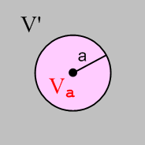 Fig H.1

In order to show that some function g(r) = δ(r), one has to show that

lima→0 ∫V' dV g(r) = 0 (H.2.2a)
lima→0 ∫Va dV g(r) = 1 . (H.2.2b)

This is basically the definition of δ(r). Since δ(r) has units L-3, g(r) has units L-3.

Our candidate function of interest is

g(r) = - (1/4π) ∇2[1/r] . (H.2.3)

Using ∇2 in spherical coordinates acting on a function of r, one finds that, since ∂r(1) = 0,

∇2[1/r] = (1/r2)∂r(r2∂r) [1/r] = 0 r > 0 (H.2.4)

so that

g(r) = - (1/4π) ∇2[1/r] = 0 r > 0 . (H.2.5)

Thus, condition (H.2.2a) is trivially satisfied since r > 0 everywhere in volume V'.

It remains to verify condition (H.2.2b). Consider the integral appearing on the left side of (H.2.2b)

∫Va dV g(r) = - (1/4π) ∫Va dV ∇2[1/r] = - (1/4π) ∫Va dV ∇ • ∇[1/r] . (H.2.6)

The divergence theorem (1.1.30) says,

∫V dV div F = ∫S dS • F (H.2.7)

where V is any closed volume whose surface is S, and dS points out. Using

V = Va and F = ∇[1/r] = ∂r(1/r) = -r-2

we find that

LHS (H.2.7) = ∫Va dV div ∇[1/r] = ∫Va dV ∇2[1/r] = ∫Va dV [-4πg(r)] = -4π ∫Va dV g(r)

RHS (H.2.7) = ∫S dS • ∇[1/r] = ∫dΩ [a2 ] • ∇[1/r]|r=a = ∫dΩ[a2 ]• [-a-2] = -4π

which tells us that ∫Va dV g(r) = 1 for any a. Thus,

lima→0 ∫Va dV g(r) = 1

and we have then verified (H.2.2b). Therefore we conclude that the candidate g(r) of (H.2.3) is in fact the same as δ(r) so

- (1/4π)∇2[1/r] = δ(r) (H.2.8)
or
∇2[1/r] = - 4πδ(r) (H.2.9)

which is (H.2.1). QED
__________________________________________________________________________________

H.3 Derivation of Fact 2: ∇2[h(r)/r] = - 4π h(0) δ(r) + h"(r)/ r (H.3.1)

Proof: Start with this vector identity,

∇2(φψ) = φ∇2ψ + ψ∇2φ + 2 ∇φ • ∇ψ . (H.3.2)

This identity is valid in any number of dimensions (implied sum on i from 1 to N) ,

∂i2(φψ)= ∂i[ (∂iφ)ψ + ψ(∂iφ)] = (∂i2φ)ψ + (∂iφ) (∂iψ) + φ(∂i2ψ) + (∂iφ) (∂iψ) .

So apply (H.3.2) to the case φ = h and ψ = r-1,

∇2(h r-1) = h∇2(r-1) + r-1∇2h + 2 ∇h • ∇(r-1)

= - h 4π δ(r) + r-1∇2h + 2 [ h' • (-r-2) ] // using (H.2.9)

= - 4π h(0) δ(r) + r-1∇2h - 2 r-2 h'(r) . (H.3.3)

Algebra shows that, using spherical coordinates,

∇2h = (1/r2)∂r(r2∂r)h(r) = h"(r) + (2/r)h'(r) (H.3.4)

so then

∇2(h r-1) = - 4π h(0) δ(r) + r-1 [h"(r) + (2/r)h'(r) ] - 2 r-2 h'(r)

= - 4π h(0) δ(r) + h"(r)/ r

which is the claim of (H.3.1). QED

Fact 3: - (∇2+k2) (e-jkr/4πr) = δ(r) (H.3.5)

This Fact is just an application of Fact 2 to the case h(r) = e-jkr :

h = e-jkr h(0) = 1 h' = -jk e-jkr h" = -k2 e-jkr

∇2[h(r)/r] = - 4π h(0) δ(r) + h"(r)/ r (H.3.1)
so
∇2(e-jkr/r) = - 4π 1 δ(r) + [-k2 e-jkr ] / r

= -4πδ(r) - k2(e-jkr/r)
Thus,

( ∇2+k2) (e-jkr/r) = - 4πδ(r)
or
- (∇2+k2) (e-jkr/4πr) = δ(r)

as claimed.

Appendix I : Poisson and Helmholtz Propagators in 2D

Note: Appendix H deals with these propagators in 3D rather than 2D. Sections I.1 and I.2 below are basically "cut, paste and edit" versions of Sections H.1 and H.2, and we have made equation numbers match. However, Section I.3 is something new since it involves a "special function".
__________________________________________________________________________________

I.1 Overview and Meaning of Free-Space Propagators

This appendix proves two Facts: (H0(1) is a Hankel function )

Fact 1 : -∇2[ln(1/r)/2π] = δ(r) (I.2.1) (I.1.1)

Fact 2 : - (∇2+k2) [(j/4) H0(1)(kr)] = δ(r) . (I.3.1) (I.1.2)

Throughout this Appendix, ∇2 is the usual 2D Laplacian operator,

∇2 = ∂x2 + ∂y2. and δ(r) = δ(x) δ(y) . (I.1.3)

In the two Facts above, if one replaces r → r-r' (a simple translational shift of origin) ones finds

-∇2[ln(1/R)/2π] = δ(r-r') R = | r - r' | (I.1.4)

- (∇2+k2) [(j/4) H0(1)(kR)] = δ(r-r') δ(r-r') = δ(x-x') δ(y-y') . (I.1.5)

The quantities in brackets are known as free-space Green's Functions (Green Functions) or propagators, or as "fundamental solutions" :

$\frac{1}{2π}$ln(1/R) = the Poisson 2D free-space propagator (I.1.6)

(j/4) H0(1)(kR) = the Helmholtz 2D free-space propagator . (I.1.7)

The last item above is the ω-domain 2D Helmholtz propagator, where k2 = ω2με. See (A.7.7) for a discussion of the time domain version of this propagator which is the 2D wave equation propagator.

The significance of these propagators is the following:

-∇2 f(x) = s(x) => f(x) = ∫d2x' [ln(1/R)/2π] s(x') + homogeneous solutions
The Poisson Equation (I.1.8)

- (∇2+k2) f(x) = s(x) => f(x) = ∫d2x' [(j/4) H0(1)(kR)] s(x') + homogeneous solutions
The Helmholtz Equation (I.1.9)

The equations on the left are inhomogeneous partial differential equations driven by source function s(x). If one is careful to include in s(x) all source contributions (such as those on boundary curves), one generally does not have to add any homogeneous solutions on the right. A homogeneous solution refers to
-∇2 fh(x) = 0, for example. The solutions shown on the right above can be instantly verified as follows:

f(x) = ∫d2x' [ln(1/R)/2π] s(x') + fh(x)
-∇2 f(x) = ∫d2x' (-∇2 [ln(1/R)/2π] ) s(x') -∇2 fh(x) = ∫d3x' δ(r-r') s(x') - 0 = s(x) (I.1.10)

and similarly for - (∇2+k2) f = g.
A "free space" Green's Function gF in general is a solution of

D gF(r, r') = δ(r-r'), gF(r, r') → 0 as r → ∞ (I.1.11)

where D is some differential operator. The condition on the right says gF must vanish on the Great Circle. More generally one can define a full Green's function by,

D g(r, r') = δ(r-r'), g(r, r') = 0 for r on some closed curve
enclosing a region of interest (I.1.12)

This non-free-space Green's function is briefly discussed in the text surrounding (1.5.11).

Looking at f(x) = ∫d2x' [ln(1/R)/2π] s(x') = ∫ gF(x,x') [s(x') d2x'], one can say that the kernel Green's Function gF(x,x') "propagates" a tiny piece of "source" [s(x')d2x'] from location x' to location x so that the solution f(x) is then a sum of all such propagated contributions as the source ranges over the entire area of interest, which for us is all 2D space where the source is non-vanishing.
__________________________________________________________________________________

I.2 Dervivation of Fact 1: ∇2[ln(1/r)] = - 2πδ(r) (I.2.1)

Proof: Let area A be all of 2D space. Cut out from A a small circular hole of radius a centered at r = 0. If we call this circular area Aa and then A' = A - Aa is the original area with the circular hole cut out:

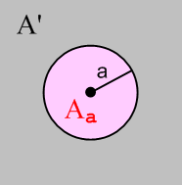 Fig I.1

In order to show that some function g(r) = δ(r), one has to show that

lima→0 ∫A'dA g(r) = 0 (I.2.2a)
lima→0 ∫A$_{a}$dA g(r) = 1 . (I.2.2b)

This is basically the definition of δ(r). Since δ(r) has units L-2, g(r) has units L-2.

Comment: When any differential operator like ∇ or ∇2 is applied to ln(r0/r), the result is independent of r0 so we can always take r0 = 1. For example, ∂x [ln(r0/r)] = ∂x [ lnr0 + ln(1/r)] = ∂x ln(1/r). In what follows, ln(r) and ln(1/r) are always acted upon by differential operators, so we can interpret these objects as dimensionless quantities ln(r/r0) and ln(r0/r) for any r0. Then it is clear below that dim [g(r)] = L-2.

Our candidate function of interest is

g(r) = - (1/2π) ∇2[ln(1/r)] = +(1/2π) ∇2 [ ln(r) ] . (I.2.3)

Using ∇2 in polar (cylindrical without the z) coordinates acting on a function of r, one finds that, since ∂r(1) = 0,

∇2[ln(r)] = (1/r)∂r(r∂r) [ln(r)] = 0 r > 0 (I.2.4)

so that

g(r) = - (1/2π) ∇2[ln(1/r)] = 0 r > 0 . (I.2.5)

Thus, condition (I.2.2a) is trivially satisfied since r > 0 everywhere in area A' for any a > 0.

It remains to verify condition (I.2.2b). Consider the integral appearing in the left side of (I.2.2b)

∫A$_{a}$dA g(r) = - (1/4π) ∫A$_{a}$dA ∇2[1/r] = - (1/4π) ∫A$_{a}$dA ∇ • ∇[1/r] . (I.2.6)

The divergence theorem (1.1.30) says, in 2D,

∫A dA div F = C ds • F (I.2.7)

where A is any closed area whose bounding curve is C, and where ds = ds where is normal to C at any given point on C. Notice that this closed area is necessarily planar since everything is 2D here. Using

A = Aa = disk of radius a and F = ∇[ln(1/r)] = ∂r(ln(1/r)) = - ∂r(lnr) = [ -r-1]

we find that

LHS (I.2.7) = ∫A$_{a}$dA div ∇[ln(1/r)] = ∫A$_{a}$dA ∇2[ln(1/r)] = ∫A$_{a}$dA [-2πg(r)] = -2π ∫A$_{a}$dA dA g(r)

RHS (I.2.7) = ∫C ds • ∇[ ln(1/r)] = ∫ [adθ ] • ∇[ ln(1/r)]|r=a = ∫dθ [a ]• [-a-1] = -2π

which tells us that ∫Aa dA g(r) = 1 for any a. Thus,

lima→0 ∫Aa dA g(r) = 1

and we have then verified (I.2.2b). Therefore we conclude that the candidate g(r) of (I.2.3) is in fact the same as δ(r) so

- (1/2π)∇2[ln(1/r)] = δ(r) (I.2.8)
or
∇2[ln(1/r)] = - 2πδ(r) (I.2.9)

which is (I.2.1). QED
__________________________________________________________________________________

I.3 Derivation of Fact 2: - (∇2+k2) [(j/4) H0(1)(kr)] = δ(r) (I.3.1)

We seek the solution E(r) of this equation

- (∇2+k2 ) E(r) = δ(r) where E(r→∞) = 0 (I.3.2)

which we write as

∇2E+ k2E = - δ(r).

In polar coordinates this says

r-1∂r(r∂rE) + k2E = - δ(r)
or
E" + r-1E' + k2E = - δ(r)
or
r2E"(r) + rE'(r) + r2k2E(r) = - δ(r) . (I.3.3)

Writing E(r) = F(kr) we get

r2k2F"(kr) + rk F'(kr) + r2k2F(kr) = - δ(r)
or
(rk)2F"(kr) + (rk) F'(kr) +(rk)2F(kr) = - δ(r)
or
z2F"(z) + z F'(z) + z2F(z) = - δ(r) where z ≡ kr . (I.3.4)

Away from r = z = 0, this is Bessel's equation of index 0 (NIST 10.2.1) so solutions are Bessel functions like these,

F(z) = J0(z), Y0(z), H0(1)(z), H0(2)(z). z = kr (I.3.5)

which are Bessel functions of the first, second and third kind. The third kind functions (the H's) are called Hankel Functions. If we assume that k has a tiny positive imaginary part (see Comments later), then of all the functions just listed, only H0(1)(kr) has decaying behavior for large r (NIST 10.2.5). We therefore put forward the following candidate for a delta function

g(r) = - (∇2+k2 ) C H0(1)(kr) . (I.3.6)

Recall from Section I.2 that a successful δ(r) candidate must satisfy these two conditions (same as in the previous section, and same figure),

lima→0 ∫A'dA g(r) = 0 (I.2.2a)
lima→0 ∫A$_{a}$dA g(r) = 1 (I.2.2b)

Fig I.1

Our candidate g(r) vanishes within any region A' no matter how small the hole because g(r) = 0 for any
r> 0, so the first condition is already met. It remains only to show that the second condition is also met. We must then show that

lima→0 ∫A$_{a}$ dA {- (∇2+k2 ) C H0(1)(kr)} = 1 . (I.3.7)

Since Aa is a very small disk as we approach the limit, we may use the small argument behavior of our candidate g(r) in studying the situation. We know that

H0(1)(kr) ≈ (2j/π) ln(kr) // NIST 10.7.2 (I.3.8)

so what we need to show is that

lima→0 ∫A$_{a}$dA {- (∇2+k2) C (2j/π) ln(kr)} = 1
or
- C (2j/π) lima→0 ∫A$_{a}$dA { (∇2+k2) ln(kr)} = 1
or
- C (2j/π)2π lima→0 $^{\int_{0}^{a}{}}$rdr{ (∇2+k2) ln(kr)} = 1 // ∫dθ = 2π
or
C (4/j) lima→0 $^{\int_{0}^{a}{}}$rdr{ (∇2+k2) ln(kr)} = 1 . (I.3.9)

Now consider :

lima→0 [$^{\int_{0}^{a}{}}$rdr ln(kr)] = lima→0 [(1/4)a2{2ln(ka)-1}] = 0 . (I.3.10)

Thus, the k2 ln(kr) term in (I.3.9) makes no contribution in the limit, so we then have to show that

C (4/j) lima→0 $^{\int_{0}^{a}{}}$rdr ∇2 [ ln(kr)] = 1 . (I.3.11)

But (I.2.9) says that

∇2[ln(r)] = 2πδ(r) . (I.2.9)

Now

δ(r) = δ(x)δ(y) = δ(r)/2πr (I.3.12)

since
1 = ∫∫dxdy δ(x)δ(y) = ∫rdr∫dθ δ(r)/2πr = 2π∫rdr δ(r)/2πr = ∫dr δ(r) = 1 .

Therefore

∇2[ln(r)] = δ(r)/r (I.3.13)

and then

∇2[ln(kr)] = ∇2[ln(k) + ln(r)] = ∇2[ln(r)] = δ(r)/r . (I.3.14)

Inserting this last result into (I.3.11) then gives

C (4/j) lima→0 $^{\int_{0}^{a}{}}$rdr ∇2 [ ln(kr)] = 1
C (4/j) lima→0 $^{\int_{0}^{a}{}}$rdr δ(r)/r = 1
C (4/j) lima→0 $^{\int_{0}^{a}{}}$dr δ(r) = 1
C (4/j) lima→0 1 = 1
C (4/j) = 1 .

Thus, we have a solution if we select constant C = (j/4). Therefore, the solution to (I.3.2) is

E(r) = C H0(1)(kr) = (j/4) H0(1)(kr) . (I.3.15)

Stakgold Vol II page 55 (5.120) confirms this result where $\sqrt{λ}$ = k.
Therefore we have shown that

- (∇2+k2) [(j/4) H0(1)(kr)] = δ(r) (I.3.16)

which is the Fact stated as (I.3.1). QED

On page 54 Stakgold gives the solution to - (∇2+k2 ) E(r) = δ(r) for n ≥ 2 dimensions as (5.118):

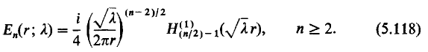

Comments:

1. Complex Helmholtz Parameter and Hν(1)(z). Stakgold considers the Helmholtz parameter to be λ which is our k2. He regards λ as a complex variable which can lie anywhere in the complex λ plane. If we consider the function k(λ) = λ1/2, we find that it has a branch point at λ = 0. If we take the branch cut to the right, then one of the two Riemann sheets in λ-space for this function maps to the upper half k-plane as shown. This is the branch of λ1/2 that Stakgold selects and that is why we think of k and therefore k2 as having a tiny positive imaginary part when k is "real". The point is that we approach the positive real axis from above, not from below. It is this assumption that causes the large-r-decaying solution to our problem to be H0(1)(kr) instead of H0(2)(kr) .

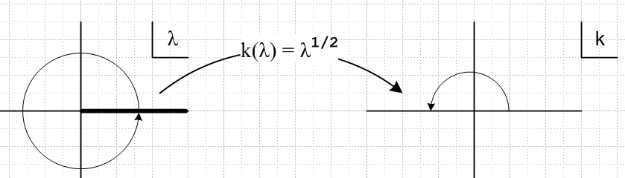 Fig I.2

As shown on NIST p 229 10.17.5,6, expansions of the Hankel functions for large argument are,

Hν(1)(z) ≈ $\sqrt{2/π}$ z-1/2 e+j(z-νπ/2-π/4) Σk=0∞ (+j)k ak(ν) z-k
Hν(2)(z) ≈ $\sqrt{2/π}$ z-1/2 e-j(z-νπ/2-π/4) Σk=0∞ (-j)k ak(ν) z-k

where ak(ν) are some real coefficients shown in 10.17.1 which we don't care about right now. The differences are highlighted in red. Here one sees that Hν(1)(z) ~ e+jz = e-Imz ejRez. Thus Hν(1)(kr) ~ e-rImk ejrRek and as long as k is in the upper half plane as shown in the right, Hν(1)(kr) decays exponentially (whereas Hν(2)(kr) blows up).

2. Helmholtz morphs into Poisson. We have shown that

- (∇2+k2) [(j/4) H0(1)(kr)] = δ(r) . (I.3.16)

In the limit that k << 1, we showed above that

H0(1)(kr) ≈ (2j/π) ln(kr) // A&S 10.7.2 (I.3.8)

In this limit we then have

- (∇2+k2) [(j/4)) (2j/π) ln(kr) ] = δ(r)
or
- (∇2) [(1/2π) ln(kr) ] = δ(r)

and this is in agreement with the Poisson result (I.1.1). So as the Helmholtz equation morphs into the Poisson equation as k → 0, the Helmholtz propagator morphs into the Poisson propagator.

Appendix J : The 3D→2D Propagator Transition

Infinitely long transmission lines are -- in the transmission line limit of long wavelength -- basically 2D objects rather than 3D objects. We see that fact appearing in various Chapters and Appendices of this document. Here we wish to focus on this single fact.

Case 1

In Chapter 1 we presented the natural 3D view of transmission lines with equations like the following taken from (1.5.3), (1.5.4) and (1.5.23), where we used the King gauge,

(∇2 + β2)φ = - (1/ε) Σiρi ⇔ φ(x,ω) = $\frac{1}{4πξ}$ Σi∫ρci(x',ω)$\frac{e-jβR}{R}$dV'
(∇2 + β2)A = - ΣiμiJi ⇔ A(x,ω) = $\frac{1}{4π}$ Σi∫μiJi(x',ω) $\frac{e-jβR}{R}$dV' ., (J.1)

The Helmholtz integrals on the right are particular solutions of the PDEs on the left. The equations on the right are derived from those on the left as shown in Appendix H where we had the more generic statement that

- (∇2+k2) f(x) = s(x) => f(x) = ∫d3x' [e-jkR/4πR] s(x') + homogeneous solutions
The 3D Helmholtz Equation particular solution (H.1.9)

The object [e-jkR/4πR] is the 3D free-space Helmholtz propagator as discussed in Appendix H.

If it happens that f(x) = f(x,y) in this last equation, then ∂z2f = 0 and we find ourselves looking at a 2D Helmholtz equation which has a completely different-looking particular solution, where ∇2 = ∇2D2 + ∂z2,

- (∇2D2+k2) f(x) = s(x) => f(x) = ∫d2x' [(j/4) H0(1)(kR)] s(x') + homogeneous solutions
The 2D Helmholtz Equation particular solution (I.1.9)

This is the most abrupt and simple way the transition from 3D to 2D can occur.

If k is small, meaning the corresponding wavelength λ = 2π/k is large, we can take the small k limit of the above two particular integrals. The limit of [e-jkR/4πR] is completely obvious,

[e-jkR/4πR] → [1/4πR] (J.2)

whereas the limit of the 2D propagator [(j/4) H0(1)(kR)] is less obvious:

H0(1)(kr) ≈ (2j/π) ln(kr) // NIST 10.7.2 (I.3.8)

so that

[(j/4) H0(1)(kR)] ≈ - (1/2π) ln(kR) = [- (1/2π) ln(R)] - (1/2π) ln(k) . (J.3)

If we momentarily ignore the inconvenient constant - (1/2π) ln(k), we can say that

2D Helmholtz propagator = [$\frac{j}{4}$ H0(1)(kR)] → [- $\frac{1}{2π}$ ln(R)] = [-$\frac{1}{4π}$ln(R2)] = [$\frac{1}{2π}$ ln(1/R) ] . (J.4)

The objects on the right of (J.2) and (J.4) and are in fact the 2D Poisson propagators which belong to this pair of PDE's and their particular solutions,

-∇2 f(x) = s(x) => f(x) = ∫d3x' [1/4πR] s(x') + homogeneous solutions
The 3D Poisson Equation particular solution (H.1.8)

-∇2D2 f(x) = s(x) => f(x) = ∫d2x' [ln(1/R)/2π] s(x') + homogeneous solutions
The 2D Poisson Equation particular solution (I.1.8)

Since in our applications f(x) is always a potential like φ or A , and since

B = curl A E = - grad φ - ∂tA (1.3.1)

we see that a constant like - (1/2π) ln(k) added to a potential has no effect on the physical fields E and B, so we can just ignore such constants. Another way to say this is that the zero level of a potential is always arbitrary so additive constants are meaningless. In Chapter 4 we are only really concerned with the potential difference V(z) or W(z) between conductors.

We can now look at some of the 3D/2D "transitions" that occurred in other parts of the document.

Case 2

In Section 4.4 we had

V(z) ≡ φ12(x1) - φ12(x2)

= $\frac{1}{4πξ}$ q(z) $^{\int_{-∞}^{∞}{}}$dz'{ $^{\int_{C1}^{}{}}$dx1' dy1' α1(x1',y1') $\frac{1}{R11}$– $^{\int_{C2}^{}{}}$dx2' dy2' α2(x2',y2') $\frac{1}{R12}$ }
– $\frac{1}{4πξ}$ q(z) $^{\int_{-∞}^{∞}{}}$dz'{ $^{\int_{C1}^{}{}}$dx1' dy1' α1(x1',y1') $\frac{1}{R21}$– $^{\int_{C2}^{}{}}$dx2' dy2' α2(x2',y2') $\frac{1}{R22}$ } (4.4.1)

which we obtained by assuming a separated form (4.1.2) for the charge density and by assuming a small Helmholtz parameter β. The 1/4πR factors here are in fact the 3D Poisson free-space propagators. This propagator has the less glamorous name of being the electrostatic potential of a (1/ε)-size point charge (in "free space" of course), so by assuming the transmission line limit of small Helmholtz parameter β, we arrive at this electrostatics Poisson propagator appearing in the integrals. These propagators are "propagating" the effect of charges on the conductor surfaces to their destinations x1 and x2 in Fig 4.2 .

We then did the dz' integral over (-∞,∞) making use of integral (4.4.5),

$^{\int_{-∞}^{∞}{}}$dz' ( $\frac{1}{R12}$- $\frac{1}{R22}$) = ln(s222/s122) (4.4.5)

and arrived at

V(z) = q(z) $\frac{1}{4πξ}$ {$^{\int_{C1}^{}{}}$dx1' dy1' α1(x1',y1') ln(s212/s112) -$^{\int_{C2}^{}{}}$dx2' dy2' α2(x2',y2') ln(s222/s122) } .
(4.4.6)
This is really four terms and one recognizes -$\frac{1}{4π}$ln(R2) in the form -$\frac{1}{4π}$ln(sij2) as the 2D Poisson propagator just discussed above, and the sij are the 2D transverse distances shown in Fig 4.3. So here we see a very clear example of doing the 3D → 2D transition.

Case 3

Another transition example is the "scaling boundary condition" of Section 5.3 (b). We started there with

φt(x) = $^{\int_{-∞}^{∞}{}}$dz'{ $^{\int_{C1}^{}{}}$dx1' dy1' α1(x1',y1') $\frac{1}{R1}$– $^{\int_{C2}^{}{}}$dx2' dy2' α2(x2',y2') $\frac{1}{R2}$ } (5.1.2)

and we moved the observation point x far away from the transmission line. The result in this limit was found to be

φt(x) ≈ ln(s22/s12) // limiting form as point x = (x,y) moves far from the conductors
(5.3.11)
In this case, we had earlier done the following separation of the full potential

φ(x,y,z) = $\frac{1}{4πε}$ q(z) φt(x,y) (5.1.1)

so the limit shown for φt says

φ(x,y,z) ≈ (q/ε) $\frac{1}{4π}$ ln(s22/s12) = (q/ε) $\frac{1}{4π}$ ln(s22) – (q/ε) $\frac{1}{4π}$ ln(s12) (J.5)

and we interpret this as being the sum of the 2D free-space propagations of charges ±q(z)dz to our distant point. We are so far from the transmission line that these charges appear as 2D point charges which form a little electric dipole as shown in Section 5.4 (b).

Case 4

As a third example, we consider a simple generic situation alluded to above as our "abrupt" transition. Start again with

- (∇2+k2) f(x) = h(x) => f(x) = ∫d3x' [e-jkR/4πR] h(x') + homogeneous solutions
The Helmholtz Equation particular solution (H.1.9)

We changed the source name from s(x) to h(x) to avoid confusion with distance s below. We now assume that f(x) = f(x,y). What happens to the Helmholtz integral on the right?

f(x) = ∫d3x' [e-jkR/4πR] h(x') = ∫dx' ∫dy' $^{\int_{-∞}^{∞}{}}$dz' h(x',y') [e-jkR/4πR]

where
s = $\sqrt{(x-x')2 + (y-y')2}$ and R = $\sqrt{s2 + z'2}$ .

Then

f(x) = ∫dx' ∫dy' h(x',y') $\frac{1}{4π}$$^{\int_{-∞}^{∞}{}}$dz' $\frac{e-jkR}{R}$ R = $\sqrt{s2 + z'2}$ .

We can do the dz' integral as follows:

R2 = s2+ z'2 => RdR = z'dz'
so
$^{\int_{-∞}^{∞}{}}$dz' $\frac{e-jkR}{R}$ = $^{\int_{-∞}^{∞}{}}$$\frac{RdR}{z'}$ $\frac{e-jkR}{R}$ = $^{\int_{-∞}^{∞}{}}$dR $\sqrt{R2-s2}$ = $^{\int_{-∞}^{∞}{}}$dR $\sqrt{R2-s2}$
= 2 $^{\int_{0}^{∞}{}}$dR $\sqrt{R2-s2}$. (J.6)

We then take note of the following integral in GR7 3.754.2 page 435,

which then says

$^{\int_{-∞}^{∞}{}}$dR $\sqrt{R2-s2}$ = K0(k$\sqrt{-s2}$) = K0(-jks) z = -jks phase (z) = -π/2 (J.7)
(zeπj/2) = zj = ks
But NIST p 250 says

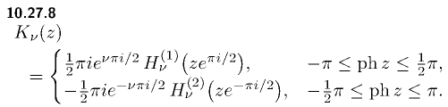

so that

K0(-jks) = π(j/2)H0(1)(ks) (J.8)

and then

$^{\int_{-∞}^{∞}{}}$dz' $\frac{e-jkR}{R}$ = 2 $^{\int_{-∞}^{∞}{}}$dR $\sqrt{R2-s2}$ = jπH0(1)(ks) . (J.9)

Finally

f(x) = ∫dx' ∫dy' h(x',y') $\frac{1}{4π}$ $^{\int_{-∞}^{∞}{}}$dz' $\frac{e-jkR}{R}$ R = $\sqrt{s2 + z'2}$

= ∫dx' ∫dy' h(x',y') $\frac{1}{4π}$ jπH0(1)(ks)

= ∫dx' ∫dy' h(x',y')[ (j/4) H0(1)(ks)] s2 (x-x')2 + (y-y')2

and once again we have transitioned from the 3D propagator $\frac{e-jkR}{R}$to the 2D one (j/4) H0(1)(ks).

Case 5

In the k = 0 limit the above Case becomes a transition from 3D propagator $\frac{1}{R}$ to 2D propagator -$\frac{1}{2π}$ln(s) as follows :

f(x) = ∫d3x' [1/4πR] h(x') = (1/4π) ∫dx' ∫dy' h(x',y') $^{\int_{-∞}^{∞}{}}$$\sqrt{s2 + z'2}$ .

But now the dz' integral is logarithmically divergent so we install a very large cutoff Λ and write

$^{\int_{-∞}^{∞}{}}$ $\sqrt{s2 + z'2}$ → $^{\int_{-Λ/2}^{Λ/2}{}}$$\sqrt{s2 + z'2}$ = 2 $^{\int_{0}^{Λ/2}{}}$$\sqrt{s2 + z'2}$ = 2 ln[ z' + $\sqrt{z'2 + s2}$] | Λ/20

= 2ln[Λ/2 + $\sqrt{(Λ/2)2 + s2} ] - 2 ln s$

≈ 2ln(Λ) - 2lns = -2ln(s/Λ) . (J.10)

Now we apply the argument above about ignoring constants to get,

$^{\int_{-∞}^{∞}{}}$ $\sqrt{s2 + z'2}$ = - 2lns // ignoring constants

f(x) = ∫dx' ∫dy' h(x',y') (1/4π) (-2lns) = ∫dx' ∫dy' h(x',y') [-$\frac{1}{2π}$ln(s)]

and so we have transitioned in this case from the 3D Poisson propagator to the 2D one.

Appendix K : Line Parameters: Comparison of Network and Maxwell Views

(a) The Network Model

The usual model of a transmission line is an infinite repetition of differentially small R,L,C,G segments as shown here between the vertical red lines,

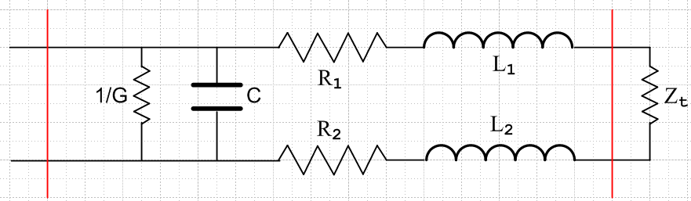 Fig K.1
This is of course electrically identical to the following

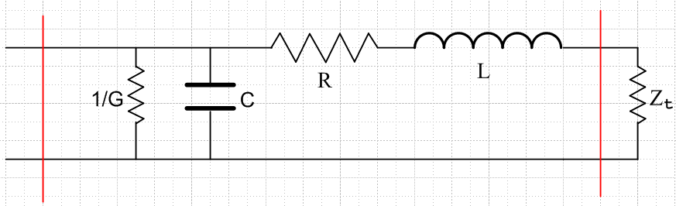 Fig K.2

where R = R1 + R2 and L = L1 + L2. In the circuit diagrams, it is implied that R,L,C,G are all quantities per unit length of the transmission line. Thus, if the distance between the two red lines is δ, the values of the lumped parameters in Fig K.2 are Rδ,Lδ,Cδ,Gδ. For example, if δ doubles, the total conductance of the segment doubles since it is a measure of current flowing between the conductors. The model implied by the picture is then the limit as δ→0.
We wish to compare these parameters R,L,C,G with our parameters calculated from Maxwell's equations.

(b) Characteristic Impedance in the Network Model

The first step to this end is to compute the impedance Zin one would see looking into the left end of the above "two-port network" consisting of a single segment terminated by some impedance Zt. If we set this computed impedance Zin equal to Zt, the resulting Zt must then be the "characteristic impedance" of the infinite transmission line looking in from the left end.
The impedance of a capacitor C and inductor L operating at frequency ω is determined by

Q = CV => I = ∂tQ = C∂tV => I = jωCV => ZC = V/I = 1/(jωC)

V = L∂tI => V = jωLI => ZL = V/I = jωL . (K.1)

If we momentarily set δ = 1, then using the usual circuit rules for computing impedance we see that

Zin = (1/G) || ZC || (R + ZL+ Zt) ZC = 1/(jωC) ZL = jωL .

since these three elements are in parallel. For parallel elements, since all have the same voltage Vin, it is easier to add up the inverse impedances ("admittances"), which basically adds up the three currents to get the total current (a fact easily shown) so then

Zin-1 = G + ZC-1 + (R + ZL + Zt)-1
or
Zin-1 = G + jωC + (R + jωL + Zt)-1 . (K.2)

To find the characteristic impedance we set Zin = Zt = Z0 to get

Z0-1 = G + jωC + (R + jωL + Z0)-1 . (K.3)

Now we reinstall our δ factors to get

Z0-1 = (G+jωC)δ + $\frac{1}{(R+jωL)δ + Z0}$ (K.4)
or
[(R+jωL)δ + Z0] Z0-1 = (G+jωC)δ [(R+jωL)δ + Z0]
or
[(R+jωL)δ + Z0] = (G+jωC)δ [(R+jωL)δZ0 + Z02] . (K.5)

We enter into Maple the equation in the form (K.4). The two quadratic solutions go into array elements s[1] and s[2], and s[1] gives the physical solution. This result includes terms of order δ0, δ and δ2 and we then take the limit δ→0 simply by setting δ = 0. The extra Maple commands are just guides to help Maple obtain the result in a simple form.

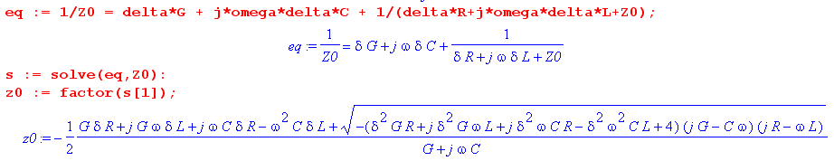

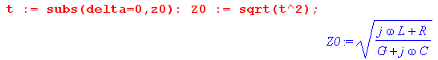

Thus we arrive at the famous result for the characteristic impedance of a transmission line in the network model described above,

Z0 = $\frac{R+jωL}{G+jωC}$ . (K.6)

(c) Characteristic impedance computed from Maxwell's Equations

The main results of Chapter 4 appear in summary box (4.11.30) from which we quote in part,

$\frac{∂V(z)}{∂z}$ = - z i(z) where z = R + jωL transmission line equations
$\frac{∂i(z)}{∂z}$ = - yV(z) (4.11.11) y = G +jωC (4.11.12)

z = Zs1 + Zs2 + jωLe (4.11.13) XL ≡ ωLe , XC ≡ 1/(ωC)
y = jωC' = jωC + (σ/ε)C (4.11.20) G = (σ/ε)C (4.11.21)

R = Re(Zs1+ Zs2)
L = Le + (1/ω) Im(Zs1+ Zs2)

Le = (μ/4π)K (4.11.25) and (4.11.26)
C = 4πε/K (4.11.22)
G = 4πσ/K (4.11.22) + (4.11.21) (K.7)

Assuming the transmission line carries a wave of the usual form ej(kz-ωt), we know that

V(z) = V(0)e-jkz => ∂zV(z) = jkV(z)
i(z) = i(0)e-jkz => ∂zi(z) = jki(z) . (K.8)

Thus the transmission line equations above may be written

jkV = - z i
jk i = - yV . (K.9)

Multiply the first by i and the second by V and subtract the resulting equations to get

0 = - z i2 + yV2 => z i2 = yV2 => (V/i)2 = z/y . (K.10)

Therefore we find that the characteristic impedance of the infinite transmission line is

Z0 = V/i = $\sqrt{z/y}$ = $\frac{R+jωL}{G+jωC}$ (K.11)
where R,L,G,C are the parameters computed from Maxwell's equations. Since this result agrees exactly with our network computation, we conclude that these R,L,G,C parameters are the same in both the Maxwell and network models. Thus, we make the connection between the network parameters and the Maxwell calculation parameters as follows:

R = Re(Zs1+ Zs2)
L = Le + (1/ω) Im(Zs1+ Zs2)
Le = (μ/4π)K
G = 4πσ/K
C = 4πε/K (K.12)

where K is the dimensionless real integral in Chapter 4, see (4.4.8). Recall that this integral requires knowledge of both the conductor geometry as well as the normalized Jz current distributions inside the conductors. Here ε, μ and σ are for the dielectric between the conductors.

(d) Low frequency case (no skin effect)

At low frequencies where there is no skin effect, the conductor current densities are uniform, so that Jz = I/area for each conductor. In Chapter 2 for a round conductor C1 at low frequency we found that

Zs(ω) = $\frac{1}{σ1πa2}$ + jω $\frac{μ1}{8π}$ // low frequency limit (2.4.12)
=> Re(Zs) = $\frac{1}{σ1πa2}$ and Im(Zs) = ω $\frac{μ1}{8π}$ . (K.13)

From (K.12) we then find that for low frequencies and round conductors,

R = $\frac{1}{σ1πa12}$ + $\frac{1}{σ2πa22}$ = Rdc1 + Rdc2 (K.14)
L = Le + ( $\frac{μ1}{8π}$+ $\frac{μ2}{8π}$) = Le + (Li1 + Li2) . (K.15)

In this case parameter R is just the sum of the DC resistances of the conductors (per unit length), and parameter L is the sum of the external inductance Le and the internal inductances of the two wires. Here σi and μi are for the material from which conductor Ci is constructed. The external inductance Le can be interpreted as the inductance of the red wire loop below,

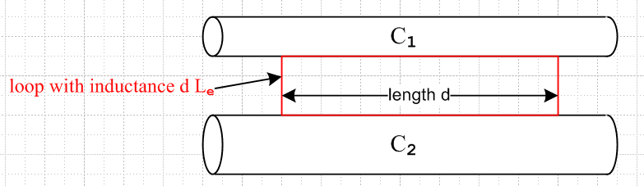 Fig K.3

The sides of the red loop make contact on any line on the conductor surfaces, though here we show it having its minimal size. The red loop may in fact be replaced by any loop, possibly non-planar, which captures all the external magnetic flux passing between the conductors. See Fig 4.11 and discussion there.

Note that Le is not the inductance of a rectangular thin wire loop in isolation, but rather Le = (μ/4π)K as in (K.12) above, where K is related to the capacitance between the conductors. If both conductors are round and very thin and separated by distance b, we know from (4.5.7) that K = 4 ln(b/$\sqrt{a1a2}$) and then Le = (μ/π) ln(b/$\sqrt{a1a2}$).

Although we have not formally proven it, it seems clear that for arbitrary conductor cross sections the following equations will apply at low frequency :

R = $\frac{1}{σ1A1}$ + $\frac{1}{σ2πA2}$ Ai = cross section area of Ci (K.16)

L = Le + (Li1 + Li2) . (K.17)

Appendix C computes the DC Li for various conductor cross section shapes. One result quoted there from the literature is that for a square conductor,

Li = (μi/8π) [0.96639] . (C.4.11)

Thus the Li for a square cross-section conductor is barely different from that of a round conductor.

(e) High frequency case for round conductor (strong skin effect)

At high frequencies there is a pronounced skin effect. In Chapter 2 for a round conductor C1 at high frequency (and with a symmetric current distribution) we found that

Zs(ω) ≈ $\frac{1}{σ1(2πa1)δ1}$ (1+j) δ1 << 16a1 (2.4.16)

Re(Zs) = Im(Zs ) = $\frac{1}{σ1(2πa1)δ1}$

where here δ1 is the skin depth δ1 = $\sqrt{2/(ωμ1σ1)}$ and a1 is the wire radius.

From (K.12) we find that for high frequencies and round conductors,

R = $\frac{1}{σ1(2πa1)δ1}$ + $\frac{1}{σ2(2πa2)δ2}$

L = Le + (1/ω) Im(Zs1+ Zs2) = Le + (1/ω) R . (K.18)

In this case, we recognize 2πa1δ1 as the effective current carrying cross-sectional area of round conductor C1, so the expression for R is quite intuitive. Since,

δ ≡ $\sqrt{2/ωμσ}$ => 1/δ1 = $\sqrt{(ωμ1σ1)/2}$ and 1/ω = μ1σ1δ12/2 (K.19)

we may write
Li(ω) = (1/ω) Im(Zs) = (1/ω) $\frac{1}{σ1(2πa1)δ1}$ = (1/ω) $\frac{1}{σ1(2πa1)}$$\sqrt{(ωμ1σ1)/2}$ = $\frac{1}{2πa1} \sqrt{\frac{μ1}{2σ1ω}}$
(K.20)
so Li(ω) ~ 1/$\sqrt{ω}$. Expressing Li instead in terms of δ1 we find

Li(δ1) = (1/ω) Im(Zs) = (1/ω) $\frac{1}{σ1(2πa1)δ1}$ = μ1σ1(δ12/2) $\frac{1}{σ1(2πa1)δ1}$ = μ1 (1/4π) (δ1/a1)
= $\frac{μi}{8π}$ [ 2 (δ1/a1) ] . (K.21)

The DC internal inductance of a thin shell of radius a and thickness d is shown in Appendix C.6 to be

Li = μi $\frac{1}{6π}$ (d/a) = $\frac{μi}{8π}$ [ (4/3)(d/a) ] thin shell, valid for d << a (C.6.8)

so the high frequency internal inductance of a round wire is the same as the DC internal inductance a shell of thickness d = (3/2)δ. This is perhaps reasonable since for the DC shell Jz is uniform over distance d, but for the skin effect case Jz decays down to 1/e in distance δ.
On the other hand, for the DC current interpretation above, this 1/e drop-off is offset by the fact that some current still exists inside the skin depth δ.
In any event, the above expression (C.6.8) shows that the inductance of a thin cylindrical shell is linear in the shell thickness d, so we expect that the high frequency Li of a round wire should be linear in δ, and thus proportional to 1/$\sqrt{ω}$.
Section 2.5 shows how to handle non-round conductors and non-symmetric current distributions by replacing 2πa by an effective active perimeter D. For the special case of Chapter 6, everything can be computed exactly.

Appendix L: Point and Line Charges in Dielectrics

Chapter 1 states in (1.1.19) through (1.1.24) various equations concerning the magnetization of a magnetic medium. These equation are "exercised" somewhat in Section G.3 and also in Appendix B concerning how the transmission line theory is altered when the dielectric and conductors have different μ values.

Chapter 1 also states in (1.1.9) through (1.1.15) corresponding equations concerning the polarization of a dielectric medium. Although the transmission line theory assumes a dielectric between the conductors, and in fact allows for a complex dielectric constant ξ, there has been no "exercise" of the polarization equations, so in this Appendix some simple examples are provided.

The examples presented here are rarely presented in E&M texts perhaps because they are too simple. The spherical problem appears in the 2nd edition of Corson and Lorrain (p 111-113) but it got replaced by a short comment in the 3rd edition (Corson and two Lorrains) p 186.

The examples are useful to the author in that they provide a physical picture of how the potential and field of a point or line charge are affected by the presence of a dielectric medium. In Sections L.1 and L.2 the 3D problem is solved and limits are taken of the solution. Two of these limits involve a full embedding of the charge in the dielectric where dielectric charge shielding is exhibited. Sections L.3 and L.4 briefly repeat the solution in two dimensions, so the results then apply to an extruded cross section.

L.1 The potential of a point charge inside a thick dielectric spherical shell.

A positive point charge q lies at the center of a spherical shell of radii b>a as follows,

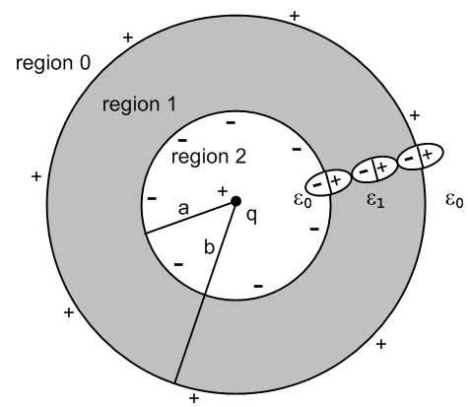 Fig L.1

Inside and outside the shell of dielectric constant ε1 is empty space with ε0.
Whatever the potential φ is for the above picture, it is obviously symmetric and is then φ(r). This in turn means that the E field is just E = Er where Er = -∂rφ (in each region), so the E field is radial. This radial E field polarizes the dielectric in the shell as suggested by the three symbolic polarized molecules shown in the figure. If the total bound charge on the r = a surface is -Q, then the total charge on the r = b surface must be +Q, as one would conclude imagining the entire dielectric having the form of the three molecules shown.
One implication of this fact is that for a sphere of r > b, the total charge enclosed is just q. Applying Gauss's law to a spherical Gaussian box of radius r > b

q = ∫V ρ dV = ∫S ε E • dS = ε0[∫dΩ] r2 E • dr = ε04π r2Er (1.1.33)

=> Er0 = ( 1/4πε0) q/r2 .

The corresponding potential is

φ0(r) = (1/4πε0) q/r r > b region 0

since then Er0 = -∂rφ0(r) = (1/4πε0)q/r2. This is a special case of the fact that any spherical distribution of charge appears outside that distribution as a point charge at the center, so φ0(r) is just the potential of a point charge q at the origin. We then at least know φ in one of the three regions.
In regions 1 and 2 as an ansatz we assume these forms with constants α,C and D to be determined,

φ1(r) = (1/4πα ) q/r + C
φ2(r) = (1/4πε0) q/r + D .

In a spherically symmetric geometry the Laplace equation only allows harmonics that are powers rn and each term above is one such power times a constant. A motivation for the φ2 form is that for r very close to r = 0, the potential must be that of the point charge since everything else is then relatrively far away.

We now determine constants B,C and D from boundary conditions. The three potentials and fields are

φ0(r) = (1/4πε0) q/r Er0(r) = (1/4πε0) q/r2 region 0
φ1(r) = (1/4πα ) q/r + C Er1(r) = (1/4πα ) q/r2 region 1
φ2(r) = (1/4πε0) q/r + D Er2(r) = (1/4πε0) q/r2 region 2 . (L.1.1)

The electrostatic potential must be continuous at all values of r. Why? Consider:

Er = -∂rφ $^{\int_{a}^{b}{}}$Erdr = - $^{\int_{a}^{b}{}}$∂rφ dr = - [ φ(b) - φ(a) ] .

The physical electric field at any point must have a well-defined finite single value. Then for small ε

$^{\int_{a}^{a+ε}{}}$Erdr = Er(a) ε = - [ φ(a+ε) - φ(a) ] => φ continuous at a . (L.1.2)
As ε → 0, we must have φ(a+ε) → φ(a) so φ(r) must be continuous at r = a.
Apply this rule at our two boundaries to find that,

(1/4πε0) q/b = (1/4πα ) q/b + C region 0/1 boundary, r = b
(1/4πε0) q/a + D = (1/4πα ) q/a + C region 2/1 boundary, r = a (L.1.3)
which is two conditions on the unknown constants α,C,D.
Meanwhile, the normal electric field boundary condition from Chapter 1 is

[ε1En1 - ε2En2] = nfree . (1.1.47)

Although there exists bound charge at each of our two boundaries, there is no free charge, so

ε0Er0(b) = ε1Er1(b) region 0/1 boundary, r = b
ε0Er2(a) = ε1Er1(a) region 2/1 boundary, r = a
or
ε0 q/ [4πε0b2] = ε1 (1/4πα ) q/b2 => 1 = ε1/α
ε0 q/ [4πε0a2] = ε1 (1/4πα ) q/a2 => 1 = ε1/α . (L.1.4)

These equations are the same and tell us that α = ε0. The boundary conditions (L.1.3) then say,

(1/4πε0) q/b = (1/4πε1) q/b + C region 0/1 boundary, r = b
(1/4πε0) q/a + D = (1/4πε1) q/a + C region 2/1 boundary, r = a . (L.1.5)

Subtract the first from the second to cancel the C,

D + (1/4πε0) q(1/a-1/b) = (1/4πε1)q (1/a-1/b)
so
D = (1/a-1/b)(q/4π)(1/ε1-1/ε0) = - (b/a-1)(q/4πb)(1/ε0-1/ε1) .

From the first of (L.1.5) we find

C = (q/4πb) (1/ε0-1/ε1) .

Thus the boundary conditions have determined our three constants

α = ε0
C = (q/4πb) (1/ε0-1/ε1)
D = (q/4πb)(1/ε0-1/ε1) (1-b/a) . (L.1.6)

The potentials in the three regions are then

φ0(r) = (1/4πε0) q/r
φ1(r) = (1/4πε1) q/r + (q/4πb)(1/ε0-1/ε1)
φ2(r) = (1/4πε0) q/r + (q/4πb)(1/ε0-1/ε1) (1-b/a) (L.1.7)

while the fields are

Er0 = (1/4πε0) q/r2
Er1 = (1/4πε1) q/r2
Er2 = (1/4πε0) q/r2 . (L.1.8)

The following Maple plots show the continuity of φ and the jumps in Er at the boundaries

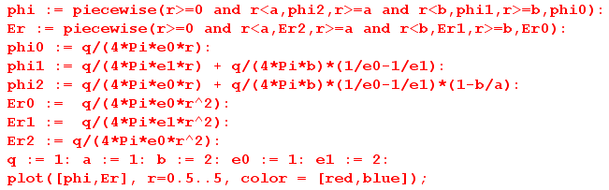

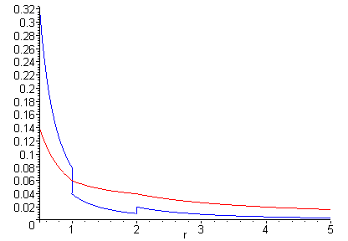 Fig L.2
φ(r) [red] and Er(r) [blue] for r in (0.5, 5)

What about the bound charge densities at r = a and r = b?

One must first compute polarization P, and for a region with ε, P is given by

P = ε0χeE // polarization assumed proportional to the polarizing E field (1.1.12)

so
P = ε0χeEr χe = (ε/ε0 - 1) => P = ε0(ε/ε0 - 1)Er = (ε-ε0)Er .

Obviously P = 0 in regions 0 and 2, while in region 1 we have

Pr1(r) = (ε1-ε0)Er1(r) θ(r>a)θ(r<b) // points radially outward since ε1 > ε0 (L.1.9)

From (1.1.11) the polarization charge density is then

ρpol = - div P (1.1.11)

so in spherical coordinates,

ρpol(r) = - [r-2∂r(r2Pr) + [rsinθ]-1∂θ[sinθPθ] + [rsinθ]-1∂φPφ]

= - r-2∂r(r2Pr1)

= - r-2∂r(r2[(ε1-ε0)Er1(r) θ(r>a)θ(r<b)]) // from (L.1.9)

= - r-2∂r( [(ε1-ε0)(1/4πε1) q θ(r>a)θ(r<b)] ) // from (L.1.8)

= - q(ε1-ε0)(1/4πε1) r-2∂r( [θ(r>a)θ(r<b)] )
But

∂r[θ(r>a)θ(r<b)] = ∂r[θ(r-a)θ(b-r)] = δ(r-a) θ(b-r) + θ(r-a) [-δ(r-b)]

= δ(r-a) θ(b-a) - θ(b-a) δ(r-b) = [δ(r-a) - δ(r-b)] ,
so
ρpol(r) = - q(ε1-ε0)(1/4πε1) r-2 [δ(r-a) - δ(r-b)]

= - q(ε1-ε0) (1/4πε1) { δ(r-a)/a2 - δ(r-b)/b2} . (L.1.10)

We may then read off the bound surface charge densities at r = a and b,

σinner = - (ε1-ε0) (1/4πε1)(q/a2)
σouter = (ε1-ε0) (1/4πε1)(q/b2) (L.1.11)
so
Qinner = ∫dS σinner = - (ε1-ε0) (1/4πε1)(q/a2) * 4πa2 = - (1-ε0/ε1) q
Qouter = ∫dS σouter = (ε1-ε0) (1/4πε1)(q/b2) * 4πb2 = (1-ε0/ε1) q . (L.1.12)

Thus the outer boundary has total charge

Q = (1-ε0/ε1) q // ranges from 0 to q (L.1.13)

and the inner boundary has -Q. If the dielectric were a conductor, we would replace ε1 = ξ1 as in (1.5.1) and then a perfect conductor has ξ1 = ∞ and so Q = q, as one would expect looking at Fig L.1.

L.2 Limits of the Previous Problem

(a) Point charge in a cavity in a dielectric

Taking b→∞ in the previous problem removes outer region 0 and leaves us with this picture of a point charge at the center of a spherical hole in an infinite medium of ε1 :

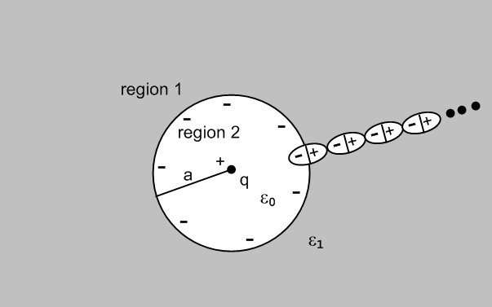 Fig L.3

The potentials and fields shown in (L.1.7) and (L.1.8) are then, taking b→∞,

φ1(r) = (1/4πε1) q/r
φ2(r) = (1/4πε0) q/r - (q/4πa)(1/ε0-1/ε1) (L.2.1)

while the fields are

Er1 = (1/4πε1) q/r2
Er2 = (1/4πε0) q/r2 . (L.2.2)

The induced bound charge density σ at r = a, and the total charge there, are still given by

σ = - (ε1-ε0) (1/4πε1)(q/a2)
-Q = (1-ε0/ε1) q . (L.2.3)

(b) Point charge embedded in a dielectric sphere

Here we take the limit a→0 so that region 2 of Fig L.1 goes away. Looking at (L.1.12), the total inner surface bound charge continues to be - (1-ε0/ε1) q = -Q in this limit. It just crowds around the point charge and of course the surface density σinner → ∞. Here is a suggestive drawing of a piece of region 1 in this limit:

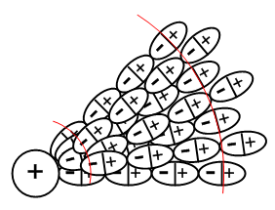 Fig L.4

The limiting picture of Fig L.1 is then the following,

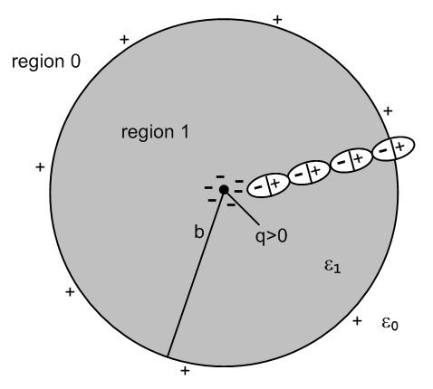 Fig L.5

The potentials and fields shown in (L.1.7) and (L.1.8) are then, taking a→ 0,

φ0(r) = (1/4πε0) q/r
φ1(r) = (1/4πε1) q/r + (q/4πb)(1/ε0-1/ε1) (L.2.4)

while the fields are

Er0 = (1/4πε0) q/r2
Er1 = (1/4πε1) q/r2 . (L.2.5)

Inside the dielectric the E field is Er1 = (1/4πε1) q/r2 where ε1 takes into account both the point charge q and the bound charge crowding around it which is - (1-ε0/ε1) q. One could interpret this as saying that the total charge at the origin is q - (1-ε0/ε1) q = q(ε0/ε1) and then E = (1/4πε0) [q(ε0/ε1)]/r2. Remember from (1.1.15) that E sees both free and bound charge. In this last interpretation, the dielectric is shielding the point charge, reducing it from q to q(ε0/ε1).

Outside the sphere, the E field is Er1 = (1/4πε0) q/r2, just as if the sphere were not there. The reason of course is that the surface charge at r = b still cancels the crowded surface charge at r =0, so outside one sees in effect just the point charge q.

(c) Point charge embedded in an infinite dielectric

We now take b→∞ in Fig L.5 to remove outer region 0, with this result:

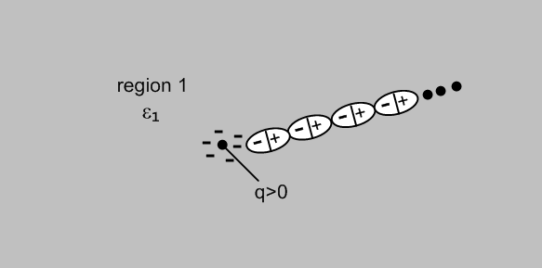 Fig L.6

There is only one region left and from (L.2.4) and (L.2.5) we get

φ1(r) = (1/4πε1) q/r (L.2.6)

while the field is

Er1 = (1/4πε1) q/r2 . (L.2.7)

The presence of the dielectric ε1 is then completely accounted for by the (1/4πε1) factor. As before, one could interpret this as a shielded charge [q(ε0/ε1)] and E = (1/4πε0) [q(ε0/ε1)]/r2. The crowded-around polarization charge is still -Q = - (1-ε0/ε1) q, and the positive Q that was on the r = b surface is still present, but at r = ∞.

L.3 The potential of a line charge inside a thick dielectric cylindrical shell

In this section, we repeat everything done in Section L.1 in the 2D world instead of the 3D world. The 3D Poisson propagator (1/4πε0)(1/r) becomes (1/2πε0) ln(1/r) as discussed in Appendix J. We reuse the same drawings, the first of which is

Fig L.1'

This is now a cross section of an infinite uniform cylindrical dielectric pipe. Quantity q is now a linear charge density with dimensions Coulombs/m. Rather that copy, paste and edit Section L.1, here we just show the altered equations and skip most of the words. The equation numbers are those of Section L.1 with a prime added. One difference encountered is that we must take b→R (a large value) rather than b→∞. As noted in Appendix J, a constant in a potential can be ignored even if it is infinite, and such constants do not appear in the field E = -∇φ.

Ansatz potential forms: (to-be-determined constants are α, C, D)

φ0(r) = (1/2πε0) q ln(1/r) Er0(r) = (1/2πε0) q/r region 0
φ1(r) = (1/2πα ) q ln(1/r) + C Er1(r) = (1/2πα ) q/r region 1
φ2(r) = (1/2πε0) q ln(1/r) + D Er2(r) = (1/2πε0) q/r region 2 . (L.1.1)'

Continuity of φ at r=a and b:

(1/2πε0) q ln(1/b) = (1/2πα ) q ln(1/b) + C region 0/1 boundary, r = b
(1/2πε0) q ln(1/a) + D = (1/2πα ) q ln(1/a) + C region 2/1 boundary, r = a . (L.1.3)'

Rule for E field normal components at a boundary:

ε0Er0(b) = ε1Er1(b) region 0/1 boundary, r = b
ε0Er2(a) = ε1Er1(a) region 2/1 boundary, r = a
or
ε0 q/ [2πε0b] = ε1 (1/2πα ) q/b => 1 = ε1/α
ε0 q/ [2πε0a] = ε1 (1/2πα ) q/a => 1 = ε1/α . (L.1.4)'

Restated continuity of φ with α = ε1:

(1/2πε0) q ln(1/b) = (1/2πε1 ) q ln(1/b) + C region 0/1 boundary, r = b
(1/2πε0) q ln(1/a) + D = (1/2πε1 ) q ln(1/a) + C region 2/1 boundary, r = a . (L.1.5)'

Second equation minus first above:

D + (1/2πε0) q(ln(1/a)- ln(1/b)) = (1/2πε1)q (ln(1/a)- ln(1/b))
=> D + (1/2πε0) q ln(b/a) = (1/2πε1) q ln(b/a) .

Solution for the three constants:

α = ε
C = q ln(1/b)(1/2π) (1/ε0-1/ε1)
D = q ln(a/b)(1/2π) (1/ε0-1/ε1) . (L.1.6)'

The potentials in the three regions are then

φ0(r) = (1/2πε0) q ln(1/r)
φ1(r) = (1/2πε1) q ln(1/r) + (q/2π) ln(1/b) (1/ε0-1/ε1)
φ2(r) = (1/2πε0) q ln(1/r) + (q/2π) ln(a/b) (1/ε0-1/ε1) (L.1.7)'

while the fields are

Er0 = (1/2πε0) q/r
Er1 = (1/2πε1) q/r
Er2 = (1/2πε0) q/r . (L.1.8)'

The following Maple plots show the continuity of φ and the jumps in Er at the boundaries

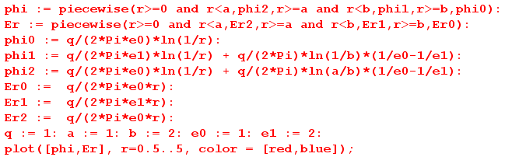

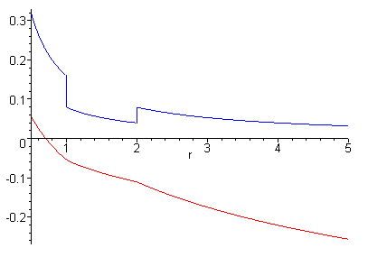 Fig L.2'
φ(r) [red] and Er(r) [blue] for r in (0.5, 5)

What about the (now linear) bound charge densities at r = a and r = b?

P = (ε-ε0)Er

Pr1(r) = (ε1-ε0)Er1(r) θ(r>a)θ(r<b) // points radially outward since ε1 > ε0 (L.1.9)'

From (1.1.11) the polarization charge density is then

ρpol = - div P (1.1.11)

so in cylindrical coordinates,

ρpol(r) = - [r-1∂r(rPr) + r-1∂θPθ + ∂zPz]

= - r-1∂r(rPr)

= - r-1∂r(r[(ε1-ε0)Er1(r) θ(r>a)θ(r<b)])

= - r-1∂r(r[(ε1-ε0) (1/2πε1) q/r θ(r>a)θ(r<b)]) // from (L.1.8)'

= - q(ε1-ε0) (1/2πε1) r-1∂r[θ(r-a)θ(b-r)]

= - q(ε1-ε0) (1/2πε1)r-1 [ δ(r-a) -δ(r-b) ] // from above (L.1.10)

= - q(ε1-ε0) (1/2πε1) [ δ(r-a)/a - δ(r-b)/b ] . (L.1.10)'

We may then read off the bound linear charge densities at r = a and b

σinner = - (ε1-ε0) (1/2πε1)(q/a) // Coulombs/m
σouter = (ε1-ε0) (1/2πε1)(q/b) (L.1.11)'
so
Qinner = ds σinner = - (ε1-ε0) (1/2πε1)(q/a) * 2πa = - (1-ε0/ε1) q
Qouter = ds σouter = (ε1-ε0) (1/2πε1)(q/bb) * 2πb = (1-ε0/ε1) q (L.1.12)'

Q = (1-ε0/ε1) q // exactly the same equation as in the 3D case (L.1.13)'

Here Q is the total charge/m on the outer surface of the cylindrical shell at r = b, and -Q is the same thing at r = a. Recall that q is the charge/m of the central linear line charge.

L.4 Limits of the Previous Problem

(a) Line charge in an infinite cylindrical hole in a dielectric

Fig L.3'

The potentials and fields shown in (L.1.7)' and (L.1.8)' are then, taking b→R (some large value)

φ1(r) = (1/2πε1) q ln(1/r) + (q/2π) ln(1/R) (1/ε0-1/ε1)
φ2(r) = (1/4πε0) q/r - (q/4πa)(1/ε0-1/ε1) (L.2.1)'

while the fields are

Er1 = (1/2πε1) q/r
Er2 = (1/2πε0) q/r . (L.2.2)'

The induced bound charge density σ at r = a, and the total charge there, are still given by

σ = - (ε1-ε0) (1/2πε1)(q/a)
-Q = (1-ε0/ε1) q . (L.2.3)'

(b) Line charge embedded in an infinite dielectric cylinder

Fig L.5'

The potentials and fields shown in (L.1.7)' and (L.1.8)' are then, taking a→ 0

φ0(r) = (1/2πε0) q ln(1/r)
φ1(r) = (1/2πε1) q ln(1/r) + (q/2π) ln(1/b) (1/ε0-1/ε1) (L.2.4)'

while the fields are

Er0 = (1/2πε0) q/r
Er1 = (1/2πε1) q/r = (1/2πε0) [q(ε0/ε1)] / r (L.2.5)'

where the last expression shows the "shielded charge interpretation".
Outside the cylinder, the E field is Er1 = (1/2πε0) q/r, just as if the cylinder were not there.

(c) Line charge embedded in an infinite dielectric

We now take b→R (a large value) in Fig L.5' to remove outer region 0, with this result:

Fig L.6'

There is only one region left and from (L.2.4)' and (L.2.5') we get

φ1(r) = (1/2πε1) q ln(1/r) + (q/2π) ln(1/R) (1/ε0-1/ε1) (L.2.6)'

while the field is

Er1 = (1/2πε1) q/r = (1/2πε0) [q(ε0/ε1)] / r (L.2.7)'

where the last expression shows the "shielded charge interpretation". As usual, we can ignore the infinite constant in the potential φ1(r).

References

References are in alphabetical order by the last name of the (first) author. For broken links, the referenced item can usually be found by a quick web search on the item title.

B.I. Bleaney and B. Bleaney, Electricity and Magnetism, 3rd Ed. (Oxford University Press, London, 1976). That would be Brevis Bleaney and wife Betty Isabelle. Brevis pioneered electron spin resonance independently with Russian Yevgeny Zavoisky in 1944. This book was reissued in 2013 as a two-volume paperback set. Chapter 10 on dielectrics is the first chapter of the second volume.

R.F. Eaton and C.J. Kmiec, "Electrical Losses in Coaxial Cable" (Proceedings of the 57th International Wire and Cable Symposium, Nov. 2008), www.ecadigitallibrary.com/pdf/IWCS08/14_2.pdf .

[GR7] I.S. Gradshteyn and I.M. Ryzhik, Table of Integrals, Series, and Products, 7th Ed. ( Academic Press, New York, 2007). Editor Dan Zwillinger has been collecting errata. A PDF version exists.

H.A. Haus and J.R. Melcher, Electromagnetic Fields and Energy (Prentice-Hall, New Jersey, 1989). Though out of print and hard to get, this very detailed and practical book is alive and well on the MIT OpenCourseWare website where all chapters can be read and downloaded. Two of the instructors are the authors. http://ocw.mit.edu/resources/res-6-001-electromagnetic-fields-and-energy-spring-2008/

C.L. Holloway and E.F. Kuester, "DC Internal Inductance for a Conductor of Rectangular Cross Section", IEEE Transactions on Electromagnetic Compatibility, Vol. 51, No. 2, pp. 338-344, May 2009.

J.D. Jackson, Classical Electrodynamics, 3rd Ed. (Wiley & Sons, New York, 1998). The author was fortunate to have learned his E&M from Dave Jackson circa 1971 (green 1st edition).

R.W.P. King, Electromagnetic Engineering (McGraw-Hill, New York, 1945). This is the first of twelve books that Ronold King wrote or co-authored. His last was an antenna book (his specialty) published in 2002; he died in 2006 at age 100. It happens that the author did an "independent study" with Prof. King circa 1969, but regrettably knew so little that Prof. King could only smile and be encouraging.

[TLT] R.W.P. King, Transmission Line Theory (Dover, 1965). Another of the twelve books.

P. Lorrain, D.R Corson, F. Lorrain, Electromagnetic Fields and Waves, 3rd Ed. (W.H. Freeman & Co., New York, 1988). The first and second editions (without the third author) were published in 1962 and 1970. These authors have written various other books on related topics at least through 2006.

P. Lucht. The most recent version of the document you are reading and related documents are downloadable at http://user.xmission.com/~rimrock. If not there, search on or the document title.

P. Moon and D.E. Spencer, Field Theory Handbook, Including Coordinate Systems, Differential Equations and their Solutions (Springer-Verlag, Berlin, 1961). This book is not about quantum field theory or anything like that, it is about curvilinear coordinate systems, how the Laplace and Helmholtz equations appear in each system, and what the solutions of these equations look like. This husband and wife team wrote several excellent books. Long ago they were strangely involved in an accident involving a test of general relativity.

P.M. Morse and H. Feshbach, Methods of Theoretical Physics ( McGraw-Hill, New York, 1953). This 2000 page 2-volume classic behemoth is simply amazing.

R. Nevels and C-S Shin, "Lorenz, Lorentz, and the Gauge", IEEE Antennas and Propagation Magazine, Vol 43, No 3, June 2001, pp 70-71.
See www.engr.mun.ca/~egill/index_files/7811_w10/lorenz_gauge.pdf and elsewhere.

[NIST] F.W.J. Olver, D.W. Lozier, R.F. Boisvert and C.W. Clark, NIST Handbook of Mathematical Functions (Cambridge University Press, 2010). NIST is the U.S. National Institute of Standards and Technology which published the world-famous earlier edition in 1964 with editors Abramowitz and Stegun, known affectionately as "A&S". The greatly expanded 2010 edition (968 p) can be accessed online at dlmf.nist.gov which also has errata. The book (≥ $17) comes with a CD containing a bookmarked PDF file which of course has been bootlegged onto the web. Olver died in 2013.

K.E. Oughstun, "EE 141 Lecture Notes Topic 15" (School of Engineering, University of Vermont, 2012).
See http://www.emba.uvm.edu/~keoughst/LectureNotes141/Topic_15_(Capacitance).pdf

W.K.H. Panofsky and M. Phillips, Classical Electricity and Magnetism, 2nd Ed. (Addison-Wesley, Reading MA, 1962), reissued as a Dover paperback in 2005. Some of the fascinating history of Prof. Wolfgang "Pief" Panofsky appears in Jackson's Jan 2009 Physics Today article "Panofsky agonistes.." which can be found at http://www-theory.lbl.gov/jdj/PT_article.pdf.

H. Pender and W.A. Del Mar Editors, Handbook for Electrical Engineers, 2nd Ed (John Wiley & Sons, New York, 1922).

A.D. Polyanin, Handbook of Linear Partial Differential Equations for Engineers and Scientists (Taylor & Francis, CRC Press, 2001). Polyanin and his Russian friends have recently published a whole bookshelf of fat and excellent handbooks. One deals with non-linear PDEs, another with integral equations. Search for him at http://www.taylorandfrancis.com/search/ and on the web.

A.M. Portis, Electromagnetic Fields: Sources and Media (Wiley, New York, 1978).

C. Quigley, "On the Origins of Gauge Theory" (2003),
www.math.toronto.edu/~colliand/426_03/Papers03/C_Quigley.pdf.

R.K. Rajput, Power System Engineering (Laxmi Publications, 2006), see Google books.

W.R. Smythe, Static and Dynamic Electricity, 2nd Ed. ( McGraw-Hill, New York, 1950).

Spiegel, S. Lipschutz, M. and J. Liu, Schaum's Outlines: Mathematical Handbook of Formulas and Tables (4th Ed.), (McGraw-Hill, 2012). The excellent original 1968 edition by Murray Spiegel has been a dog-eared reliable friend for many years. John Liu was added for the 1999 2nd Ed, and Seymour Lipschutz joined for the 2008 3rd Ed. Not to be confused with a watered-down "Easy Outline" version. This low-cost paperback is an excellent fast reference for well-known mathematical facts.

I. Stakgold, Boundary Value Problems of Mathematical Physics, Volumes 1 and 2 (MacMillan, London, 1967). These are astoundingly good books, but the high level of detail (the subject is intrinsically complex) makes them hard to use in a normal "course", which is why the author later put out a condensed single-volume version Green's Functions and Boundary Value Problems, now in a third edition. The original two volumes were reprinted with some corrections in 2000 ( SIAM, Philadelphia). P. Lucht has a short list of errata.

Thomson, W.T. (Lord Kelvin), "Ether, Electricity and Ponderable Matter", The Proceedings of the Institution of Electrical Engineers (founded 1871), Volume 18 (1889), No 77, pp 4-37. The Appendix with ber and bei begins on page 35. Google Books has an unrestricted scan of a Harvard library copy of Vol. 18 which can be downloaded in PDF format: http://books.google.com/books?id=Wy89AAAAYAAJ

[RDE] M.E.V. Valkenburg and W.M. Middleton (editors), Reference Data for Engineers: Radio, Electronics, Computers and Communications, 9th Ed. (Newnes/Elsevier, Boston, 2001). Some of this document exists in Google book preview form:

