King Notes from Electromagnetic Engineering PhL 10.19.13

Here are the things King has to say about ξ in his 1945 book Electromagnetic Engineering which I got from the ARC. Will archive this as "reviewed", 11.15.13.

The page below shows the usual ν0 version of A where he breaks current integral into a volume integral term and then a surface integral term dσ' . He also shows the boundary condition terms which arise from the Green's Theorem thing. It has the normal gradient of various things as you expect. The boundary is called Σ0. He then arm-waves in the middle paragraph, defines ξ as usual as ε + σ/jω and then suddenly you see ξ appearing in the final integral! This is his unexplained magic trick. He references III.14 as if that section were going to explain things in more detail. We shall see.

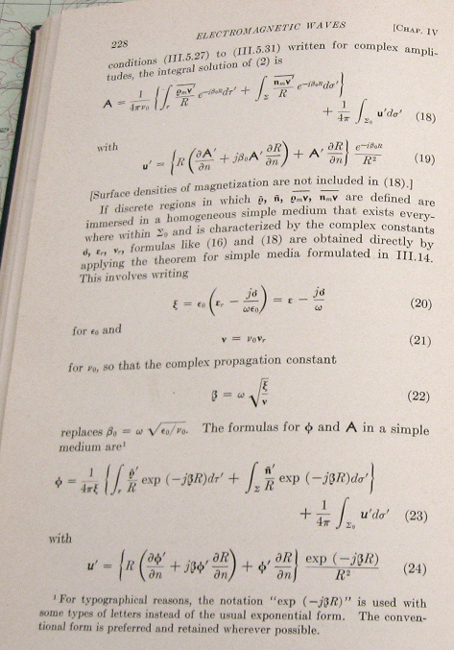

Here is the corresponding A integral on the next facing page. More fiddly words that don't mean much to me. He then discusses those boundary terms and how we like them to go away.

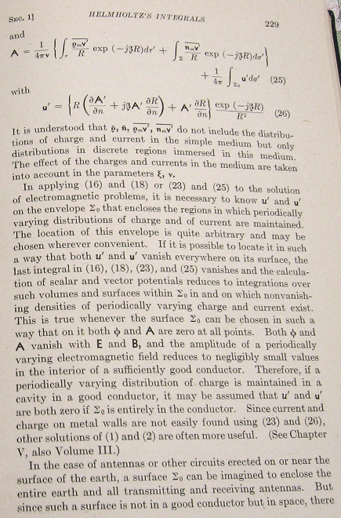

Here is a later page in the book where I think he is doing transmission lines. Again we have the fancy version of the Az integral as you see with βc in the exponent and the fancy ν presumably. This page is not too important for this discussion since we have already seen the fancy integrals.

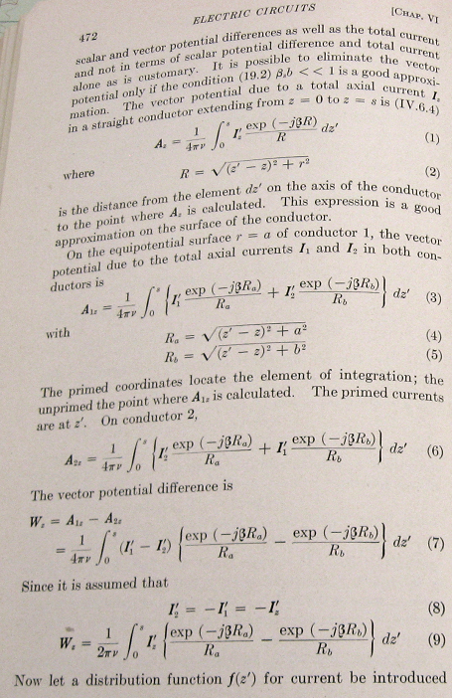

This is just the page facing the above, nothing of direct interest.

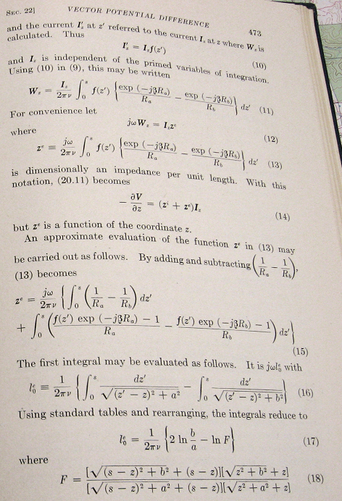

Here is where he claims that you can just magically replace ε0 → ξ and so on, bottom of page.

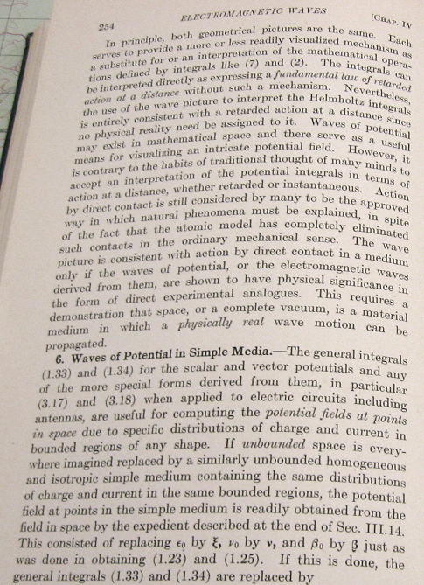

And here you see the fancy integrals. He says the integral is only over boundary ρ and J and does not include things like J in the medium. The medium takes care of itself. That is an interesting point and I will ponder it more later. I don't think I got that idea right before.

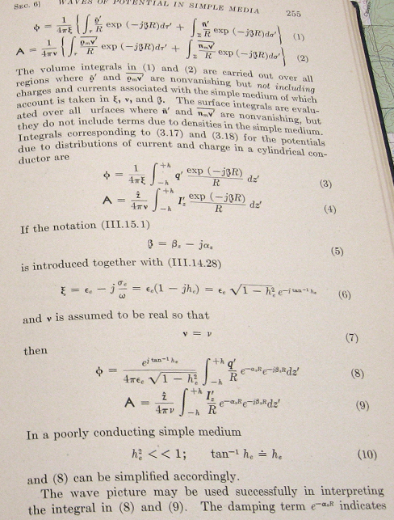

Here he interprets the Green's propagator in terms of the decay component, fine.

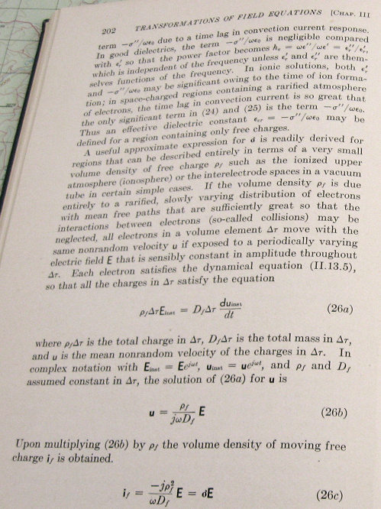

Here is the Chapter III section 14 stuff he quoted above. But let's see where it goes. In (28) there is our friend ξ, and his friend β2 as usual.

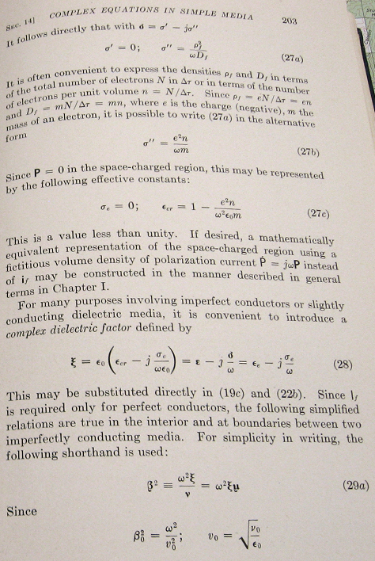

But now where do we go after this ξ definition? Yes, β2 appears in the curl B equation because of the displacement current contribution, but I already had that much. The interface boundary conditions are new to me, however. It is hard to see, but (31a) starts off as ξ1(1,E1) which means ξ1E1n where E1n is the normal component of E in medium 1. This conflicts ? with my claim that

[ε1E⊥(1) - ε2E⊥(2)] = n = surface charge density (1.1.22)

I need to ponder all these BC's and see if I have something wrong for a conducting medium.

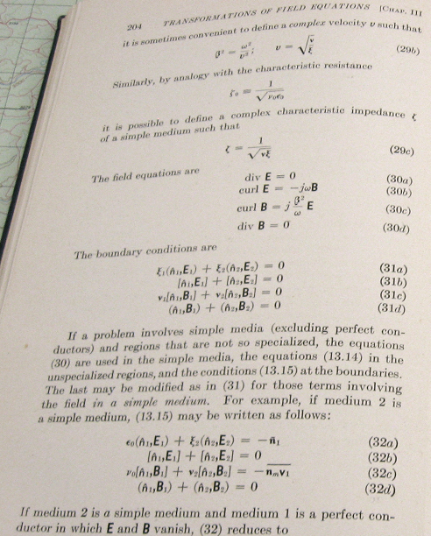

More on those BC's and then we have the complex wave equations with 0 driving terms. And then we have the King gauge sitting there. They we are off to other stuff, but he does end up with the E and B field wave equations again with complex parameter.

