Third Whiteboard Picture PhL 10.19.14

All three of my complicated whiteboard pictures relate to the ω = 0 Jz asym problem in lines doc. Here is the third image of interest, go to 200% in Word to view the picture. It's point is quite simple. If you assume e-jkz as on the left, you get the App D E field solutions (D.2.33), and from them the (D.4.7) solutions for B which is now all in (D.4.13). These solutions as ω→0 have two "bugs". The top right one is that Jz is asymmetric at DC regardless of other assumptions. Going down if we use the k =-j $\sqrt{zy}$connection from the TL equations, then we get the B = infinity bug. The first bug is just emphasized in the Section D.11 low ω / low k limits of things. This led me to write Chapter 7 for a resolution which is that the original e-jkz ansatz is invalid at low ω because the TL equations are invalid.

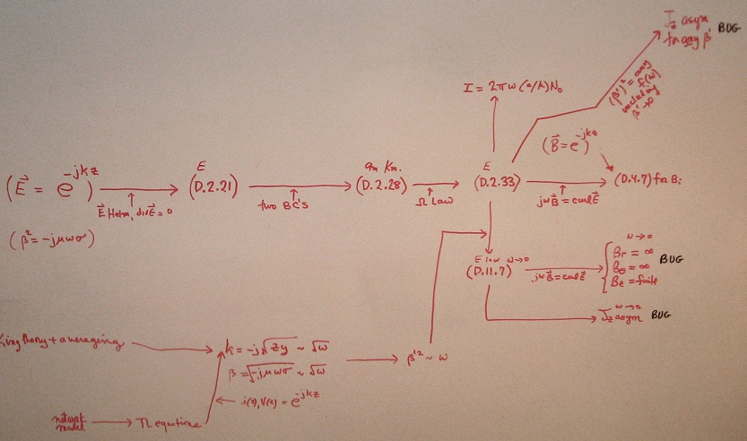

Here is the most recent version today 10/19/14

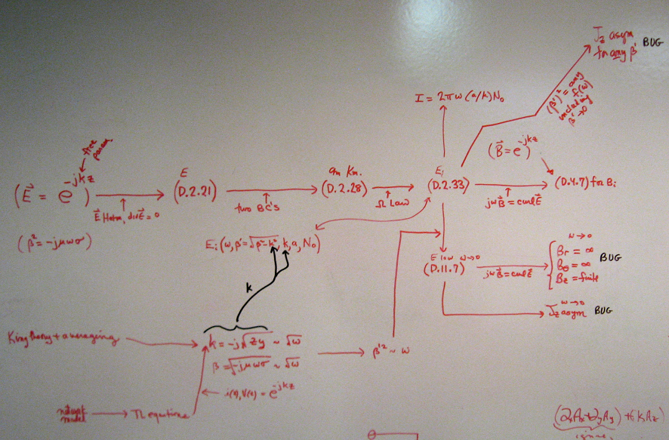

Here I just make the point with black arrows that that I am setting k = k(ω) in the App D solutions and then when I take the limit ω→ 0, I get the two bugs.

