Conclusions on the Low Frequency Transmission Line Limit PhL 3.20.14

Summary made 5.14.14 [ review is all OK ]

Section 1 says Appendix D is still correct if you allow βd to be complex to account for losses.

Section 2 says β' = β = =-jωμσ inside copper at any ω.

Section 3 studies all the β's at low ω.

Section 4 plots waves on transmission lines showing the kinds of decay you can get.

Section 5 discovers the ω→0 Escape Hatch regarding symmetry, which I don't think is true now.

Section 6 reminds me that the cppb assumes σd = 0 but I don't want to mess with that.

Section 7 suggests that King implicitly assumes the extreme skin effect regime all the time! In his language, he deals with a "good conductor".

1. Appendix D is Correct with complex parameter β_{d} 1
2. For all ω of possible interest, β'2 = β2 = -jωμσ . 2
3. We can then analyze the parameter β'2 ≡ β2- βd2 : 2
4. The nature of the transmission line wave 3
5. Characteristic impedance at low ω and the Limit of Things as ω → 0 3
6. What about G ? 6
7. Interpretation of King 6

This is not meant to be a publishable final write-up. [ I'll say! ]

I have been confused by this limit for many days now, and I think things have finally cleared up, the fog has lifted, but it is a fairly long story. There are various doc, vsd and msw files in this folder called "Low Frequency Limit.

1. Appendix D is Correct with complex parameter βd

[ This basically just says "Appendix D is OK" and can account for losses with βd if need be. ]

All the field results of Appendix D are completely correct, as long as one treats βd as a possibly complex parameter. When losses are considered, I show in one of my docs that

βd = (ω/vd) - jα α = [ (R1+ R2)C ] (vd/2) = RC (vd/2)

where R and C are of course per unit length and vd is for the dielectric. At low frequencies Ri are the DC resistances, but at high frequencies you would have to calculate "effective values" for R1 and R2 based on your model for the Jz current distribution in the wires, and you would then include both the skin effect and proximity effect somehow in this calculation. The result would be that, at higher ω, the Ri are larger, and the loss α is larger. But at any ω, there are some effective Ri values that are right. Notice that this argument says losses increase with ω. Sometimes you read that skin effect reduces losses because then fields don't penetrate so far into the conductor, but I think that argument is wrong.

In Appendix D I assume at the start the form E(r,θ,z,t) = ej(ωt-β$_{d}$z) E(r,θ) and that is how βd "gets into" the analysis, and of course the imaginary part shown above results in a decay e-αz in the z direction, so α is the 1/e decay distance. Later when I solve the component Helmholtz equations (which have parameter β2 = -jωμσ which is totally different from βd), the rule ∂z → -jβd causes βd to appear in various places. In particular, in the three Helmholtz equations the only parameter which appears is β'2 ≡ β2- βd2 , whereas in the div E = 0 equation, the parameter βd appears (not squared) and worms its way into the field results. My final field summary appears in (D.4.9) for E and B fields, and there you see the many places where βd appears. I was careful in Appendix D never to replace βd by its high-frequency value ω/vd, Of course β' also appears in many places, and β never appears by itself.

2. For all ω of possible interest, β'2 = β2 = -jωμσ . [ fine ]

The parameter β2 is studied in lines below (2.2.2) and we conclude that for ω < 1018 Hz or so, we can ignore jωε relative to σ, which means we can ignore ε relative to σ/jω, and this in turn says β2 = - jωμσ. This simple form can always be used for β inside a copper or similar conductor.

3. We can then analyze the parameter β'2 ≡ β2- βd2 : [ I ponder the β's at very low ω ]

β'2 ≡ β2- βd2 = -jωμσ - [(ω/vd) - jα]2 = -jωμσ - (ω/vd)2 + α2 + 2jα (ω/vd)

= ω [-jμσ - ω/vd2 + 2jα (1/vd)] + α2

In general the quantity -jμσ is "large". We would neglect the term ω/vd2 when

μσ >> ω/vd2
or
εμσ/ε >> ω/vd2
or
σ/ε >> ω

But this says basically that we need ω << 1018, so we chuck that term right away and then

β'2 = ω [-jμσ + 2jα (1/vd)] + α2

We would like now to drop the second term in the square brackets as well. We want to show that

μσ >> 2α/vd = RC (vd/2)/vd = 2RC

For Belden 8281 coaxial cable we find 73 >> 10-11 so probably in any reasonable transmission line we can go ahead and drop this term as well. So then

β'2 = -jμσω + α2

Once again, we would like to drop the α2 term. This requires that

ω >> α2/μσ

For the same Belden cable, this requires that ω >> 10-9 Hz. This is not much of a problem, unless we truly insist on going to the ω→0 limit all the way, in which case we find β'2 = α2 = a constant. We shall be happy to keep ω >> 10-5 Hz, shall we say, so we never need this α2 term and then we have our final result

β'2 = -jμσω

which is valid for 10-9 Hz < ω < 1018 Hz. Our conclusion this is

β'2 = β2 = -jμσω for all ω of possible interest

4. The nature of the transmission line wave [ graphs of signals in lossy lines ]

Recall ej(ωt-β$_{d}$z) form above where βd = (ω/vd) - jα . We usually like to think of this having a "small imaginary part". This is true as long as

ω >> αvd = RC (vd2/2)

For the Belden 8281 this says ω >> 48,827 which means f >> 7 KHz. As long as we are well above this frequency, we have a reasonable slightly damped waveform going down the transmission line, you can imagine the standard picture

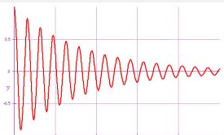

where the damping in z is highly exaggerated. Near this frequency fc = 7 KHz, you only get about 1 wave per 1/e decay distance, so more like this

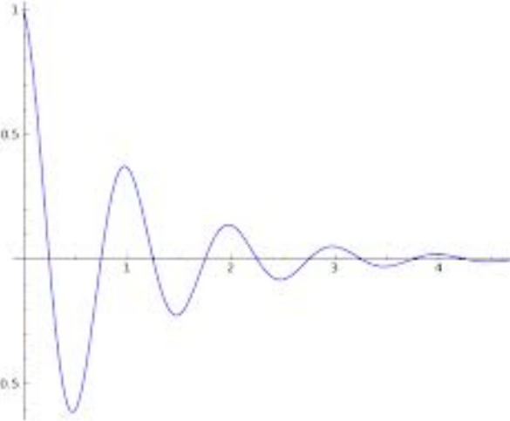

Nevertheless, regardless of how low we take f (including far below fc), if we look out at some distance z from the source, we do see our wave oscillating in time, albeit with the e-αz amplitude decay. Thus, a cable is certainly functional and useable anywhere below fc. For example, the Belden cable as noted has this fc = 7 KHz, but it also has 1/α = 4000 meters, so you can certainly send audio through such a cable for a long distance.

5. Characteristic impedance at low ω and the Limit of Things as ω → 0 [ The Escape Hatch ]

[ As ω → 0, Z0 → ∞ and I → 0 so "don't care about Jz asymmetry", my escape hatch idea. But I think in reality the whole transmission line theory is highly inaccurate at low ω and I don't trust it, so the fact that it seems to give an asymmetric Jz does not bother me on 5.14.14 . For example, I never resolved the issue of how reflections to simulate a shorted end would "get rid of the asymmetry". ]

Now for the first time in this document we consider low frequencies. We assume low enough that we can neglect jωL versus R, so we are cranking down quite low here. In the Belden cable we know L and we know Rdc so we can ask when ωL = R and we find the balance point is ω = 84,000. So we now assume we are well below that value, and we also assume that G = 0 (conductance). Then our network model tells us that

Z0 = $\frac{R+jωL}{G+jωC}$ = $\frac{R}{jωC}$ = $\frac{R}{jC}$ ω-1/2.

So this is now Z0 behaves in the low frequency regime. As ω→0, we get Z0 → ∞ as 1/$\sqrt{ω}$ .
One implication is that the current in our transmission line is then given by

I = V/Z0 = V $\sqrt{jC/R}$ $\sqrt{ω}$

and as we hold our driving voltage fixed, we find that as ω → 0, we have I → 0 as $\sqrt{ω}$.
In the final limit where ω = 0, we have I = 0 and our transmission line is totally quiet. All E and B fields inside the wires are 0. The entire transmission line is has potential difference V volts at any point -- since I = 0 there is no voltage drop along the line! The two cylinders basically act as one very long capacitor, and the charge q per unit length exists on the surfaces and is given by q = CV. Of course the battery had to supply an infinite amount of charge to charge this capacitor, we don't worry about such technical details. So this is the final low-ω limit of our transmission line theory! Since I = 0, we don't ask about the Jz current distribution in the wire, or radial charge pumping. All internal fields and currents are zero. In the dielectric there is an E field for the capacitor. One could model this transmission line as a finite line terminated in Z0 which exactly matches the line, and at ω = 0 we have Z0 = ∞ and this is why no current flows and I = 0.
Notice that this limit describes a situation that is totally different from a situation of two cylinder carrying equal and opposite currents I. In this situation, there is a shorting bar at the end of a long section of the line, not a proper Z0 termination. In THIS DC situation, things are very different. The potential difference varies linearly from V to 0 as you go down the length of the line (say length is L, long but finite). The charge on the surface q of course then has this same linear decrease going down the line. Yes, there is charge on the surface, and the E field in the dielectric at least resembles a decaying 2D bipolar type pattern, probably it is exactly this. We think that the Jz distribution in each wire is uniform at DC, no matter how closely spaced the two cylinders are placed (as long as they don't touch). This is true despite the fact that there is n(θ) on the surface of each conductor which is perhaps highly peaked toward the common central region. This n(θ) asymmetry does not "get into" the wires because there is no radial charge pumping going on so there is no Jr . Basically there is no reason for the current to be non-uniform, barring some kind of DC proximity effect which I don't think exists. This involves solving the Hall effect in each conductor and showing that an appropriate Hall charge can build up which neutralizes the Lorentz force everywhere on the electron current carriers. I have never carried this out, but I have lots of sources which say Jz is uniform at DC, and lots of sources that say for closely spaced wires it is not uniform at AC. Now, since Jz is uniform in each wire, it is easy to compute the B field and I have done that elsewhere. The conductor cross section circles do NOT line up with any B field lines, and so the conductor surfaces are NOT equipotential Az surfaces.
Now let's back off on the limit for our transmission line. At some finite ω, no matter how small, there is some current I, and I now believe that the Jz distribution in the wire is asymmetric in exactly the way my equations predict, and I want to get this into lines doc! I have shown elsewhere and should probably show in a wrap-up of all this stuff that the B fields are all finite at any such small ω. This Jz asymmetry is no longer a paradox because this low ω situation does not correspond non-transmission line situation described in the last paragraph where the Jz is uniform.
The question then arises: Suppose you take the Z0 = 0 shorted transmission line (the two wires) and drive it with low-ω AC signal. I think one could analyze this in terms of a true transmission line doing a perfect reflection at the shorted end. We then have two waves at once, going in opposite directions. What would Jz look like in this case? This problem maybe looks like this where waves have A and B amplitudes,

A+B = V

Ae-jβdL + Be+jβdL = 0 at the shorting bar point

Maple says

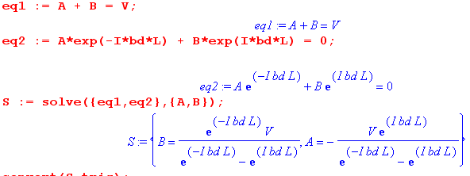

So
A = V e+jβdL/ [2jsin(βdL)]
B = -V e-jβdL/ [2jsin(βdL)]

and we then have (ignoring secondary reflections at the source somehow!)

V(z) = A ej(ωt-β$_{d}$z) + B ej(ωt+β$_{d}$z)

Continuing this development 5.14.14:

So,
V(z) = $\frac{V}{2jsin(βdL)}$ [ ej(ωt-β$_{d}$z+β$_{d}$L) - ej(ωt+β$_{d}$z-β$_{d}$L) ]

= $\frac{V}{2jsin(βdL)}$ ejωt 2j sin(-βdz + βdL) = $\frac{V}{sin(βdL)}$ ejωt sin(βd(L-z))

Redefine V(z) without the time phasor and we then have

V(z) = V $\frac{sin(βd(L-z))}{sin(βdL)}$ = standing wave pattern βd = ω/v

As ω→ 0 we get

V(z) = V $\frac{L-z}{L}$

This does meet the conditions that V(0) = V and V(L) = 0 where the short is. This is just what you would expect from the resistance of the line, whatever it might be per unit length. What happened to n(θ) ???

Well, it is a bit of a mess, but that is the basic idea. Since we are back to being an operating transmission line at ω> 0, we are also then in a situation of non-uniform Jz. One could interpret this in terms of eddy currents which distort the Jz fields, or just in terms of my theory, but now I have to somehow add the Jz in the two directions. If no loss, then maybe just Jz = AJz1 + BJz2. Since A≠B, these don't cancel and there is some Jz distribution in the wires. I do not wish to pursue this further. But in any AC situation, with close wires you will get this proximity effect.
I admit that it does seem odd that the asymmetric Jz starts up so suddenly in the reflection scenario as you move from ω = 0 to ω > 0. You would think there might be a gradual buildup of asymmetry instead. That could still happen given that the in Jz the two terms have totally difference phases and maybe the asym somehow cancels?? That seems unlikely. But here is a possible way out: at low ω, the wavelength is very long compared to L, so each wave is a constant more or less, so how do you meet the two reflection conditions? Well, that just means A and B are both very large numbers.
I don't think this "reflection idea" is correct, something is not right with it. I guess with L very large you would get standing waves due to finite vd
My "transmission line theory" always predicts asym Jz at any ω, there is no escaping it at low ω.

6. What about G ? [ this is the ε versus ξ issue, let it be ]

If G is present in the dielectric, then the charge pump boundary condition has to be modified [ yes] , and this will modify the nature of the low ω limit since in that case Z0 won't go to ∞ and I won't go to 0. I have never done this modification of things, maybe I should generalize Appendix D slightly to account for G ≠ 0 if it is not too much of a mess.

7. Interpretation of King

I think King implicitly assumes the strong skin depth limit all the time, as one would have with a "very good conductor" at one's frequency of interest. Only in this situation can you treat the conductors as equipotential surfaces, and only then can you even talk about W(z) which is used in his theory. So only in that limit will certain things in Chapter 4 be true! I still have to go through all that stuff! [ As of 5.4.14 I have in fact gone through all that stuff and lines doc is fully updated. ]

