The DC Limit of the Appendix D electric fields PhL 3.19.14

Review 5.15.14.

In Section 1 I consider the loss effect on βd and find that βd → -j (ωc/vd) instead of 0. This seems important since βd is embedded in Appendix D analysis.
In Section 2 however I show that despite this effect, you still have β'2 = -jωμσ as ω → 0 unless you want to talk about things way down at ω = 10-9 Hz, which I don't.
Section 3 is then a very brief review of the basic asymmetry paradox as ω→0.
Section 4 is a nothing as far as I can tell.
Section 5 is the realization that Z0 = ∞ as ω = 0, with nice ladder picture, and this is perhaps the first time I realize this "escape hatch" to my paradox. Date is 3/20/14 on this section.

1. Power Loss and the limit of β_{d} as ω → 0. 1
2. The limit of β' as ω → 0 3
3. What happens if we try ω→0 on the Appendix D E_{z}(r,m) expression in (D.2.33)? 5
4. New application of the boundary conditions 5
5. Pick up the ball and run a little more on March 20, 2014 6

1. Power Loss and the limit of βd as ω → 0.

[ When the loss term is included, one finds that βd → constant at low ω, not βd → 0. This constant becomes significant at some frequency fc which is 7 KHz for Belden 8281. βd = A + Bω ]

In Appendix D we assume e-jβ$_{d}$z as the z-dependence of all quantities. If we want to include "loss", we have to reinterpret βd in the following manner

βd → (ω/vd) - j [(Rdc1+ Rdc2)C ] (vd/2) βd0 = (ω/vd)
1/m sec/m2 m/sec

Here R and C are the effective network values and it might take some effor oops

The details of the imaginary part are not so important compared to the fact that it is "some constant" which does not depend on ω. I may find that this imaginary part has an error in it, but for now just note that it is a constant independent of ω. After reinterpretation we have

βd = (1/vd) [ ω - j (vd2/2) (Rdc C) ] = (ω/vd) - jα α = Rdc C (vd/2)

= (1/vd) [ 2πf - j (vd2/2) (Rdc C) ]

= (2π/vd) [f - j (vd2/4π) (Rdc C) ] fc = (vd2/4π) (RdcC)

≡ (2π/vd) [f - j fc ] ωc = (vd2/2) (RdcC) = vdα

= (1/vd)(ω-jωc) . = βd0 - jα βd0 = ω/vd α = Rdc C (vd/2 )

Note that we get the expected decay with parameter α,

e-jβ$_{d}$z = e-jβ$_{d0}$z e-j(-jα)z = e-jβ$_{d0}$z e-αz

We see that there is a certain "time constant" τc associated with the transmission line which is

fc = τc-1 = Rdc C vd2 /4π sec/m2 * m2/sec2 = 1/sec

Here is some data for Belden 8281 from a pdf I just downloaded,

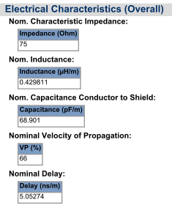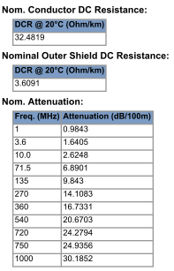

It says that

Rdc = (32.5 + 3.6) Ω/km = 36.1 x 10-3 ohms/m

C = 69 pF/m = 69 x 10-12 farad/m

vd = 0.66c = 0.66 x 3 x 108 m/sec = 2 x 108 m/sec

so therefore

fc = τc-1 = Rdc C vd2/(4π) ωc = Rdc C vd2/2

and Maple to the rescue:

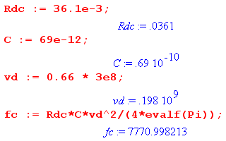

So basically fc ≈ 7.7 KHz. So go back to

βd = (2π/vd) [f - j fc ] fc = τc-1 = Rdc C vd2/(4π) .

If we are operating substantially above this frequency fc, perhaps f > 10 fc, then we can neglect fc and we then have

βd ≈ (2π/vd) [f ] = (ω/vd) = βd0

which is our "traditional" meaning for this symbol βd . But we now have a specific frequency which in a ball park sense tells us when we have to pay attention to the second term!

In particular, if we are talking about ω → 0 we find that

βd → (2π/vd)[ - j fc ] = -j (ωc/vd) = some constant

In earlier work, I assumed that βd = (ω/vd) → 0 as ω→0 and this was the cause of much of my trouble!

2. The limit of β' as ω → 0

[ I conclude that -jωμσ is good for any ω, but find a few peculiar things at ultra low ω like 10-9 Hz. I conclude here that basically β'2 ≈ -jωμσ unless you go way down to 10-9 Hz ! ]

First, the Helmholtz parameter inside the conductor is given by

β2 = μεω2 - jωμσ = ω2μ ( ε - jσ/ω) = ω2μ ξ ξ ≡ ε - jσ/ω parameter β (1.5.1)

Keeping even the ε term (which we normally neglect), we compute

β'2 = β2 - βd2 ≈ μεω2-jωμσ - [(1/vd)(ω-jωc)]2

= μεω2-jωμσ - (1/vd2) (ω-jωc)2

= μεω2-jωμσ - (ω2/vd2) + (ωc2/vd2) + (2jωcω/vd2)

If we go to very low but finite ω, we can drop both ω2 terms and we get

β'2 = -jωμσ+ (2jωcω/vd2) + (ωc2/vd2) = -jωμσ+ (2jαω/vd) + α2

= [-jμσ + 2jωc/vd2] ω + (ωc2/vd2) very low ω > 0
t1 t2 t3

Pause: What are the relative sizes of terms here?

μσ = μεσ/ε = (1/vd2)(σ/ε)

so in abs value,

t1/t2 = (1/vd2)(σ/ε) / 2ωc/vd2 = (σ/2ωcε)

For our Belden cable example this ratio is

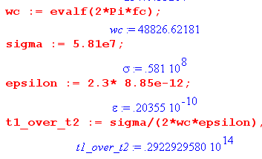

which I think I compute elsewhere in terms of something being 1018 Hz. So obviously we can drop the second term and have this for the low ω form of β'2 (that is, the β2 contribution is just -jμσ ω )

β'2 = -jμσ ω + (ωc2/vd2) = -jμσ ω + α2

Now you might ask at what frequency the two terms become equal in mag,

μσω = ωc2/vd2 = α2

ωμεσ/ε = ωc2/vd2

ω σ/ε = ωc2

ω = ωc2/(σ/ε)

I know from above (2.2.3) that for ε = ε0,

(σ/2πε ) = 1.04 x 1018 Hz

And in our example case we have

(σ/ε) = 0.3 x 1019

so we then get equality of the terms above when

ω = ωc2/(σ/ε) = ωc2 / [0.3 x 1019] = (48,836)2 / [0.3 x 1019] = 0.8 x 10-9

which is a VERY low frequency indeed. Lower in fact that I would have expected. This last fact makes my VERY dubious that I am on the right track here. What this says is that for any reasonable low frequency like 1/10 Hz, we are going to have β'2 = -jμσ ω with no correction to speak of.

[ This says I can forget about that loss correction stuff where βd → constant instead of 0.]

Resume: Finally, we go to ω→0 to get [ not sure what this is about ]

β'2 = + (ωc2/vd2) = + [Rdc C vd2/2]2/vd2 = [Rdc2C2vd2/4] = α2

β'(ω=0) = RdcC vd/2 = α sec/m2 * m/sec = 1/m = correct

The claim is that this is a "small number" because Rdc is supposedly small. Recall that

ωc = Rdc C vd2/2 = [RdcC vd/2] vd = -j β'0 vd
so
β'0 = j (ωc/vd) = j kc = j(2π/λc)

Now λc is the wavelength at 8 KHz for our 8281 cable which is pretty large.

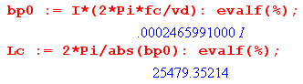

Here you see that λc = 25 km and β'0 = .00025 which does seem "small". Certainly λc is a lot larger than the transverse line dimensions, so we expect Jm(β'0r) to be far in the small argument limit!!

3. What happens if we try ω→0 on the Appendix D Ez(r,m) expression in (D.2.33)?

[ 5.14.14: I see the Paradox here! As ω gets very small, it seems likely that φ = constant is valid for the two cylinders, and then the capacitor problem is valid, the ηm are valid. The limit Ez(r,m) ≠ 0 for m≠0 is correct and you end up at ω= 0 with Jz asymmetry! The only way out is the Z0 = ∞ escape hatch! The problem is that n(θ) has the same shape at all ω including ω = 0. The Paradox still lives! ]

That formula says

Ez(r,m) = (1/4) ηm I Rdc (aβ') fm fm = [$\frac{Jm(x)}{Jm+1(xa)}$ - $\frac{Jm(x)}{Jm-1(xa)}$ ]

Looking at "very low freq... v 2" we get from our Maple program, for ω → 0,

fm = (2/aβ'0) (m+1)(r/a)m m > 0
f0 = (4/aβ'0) m = 0

We then get

Ez(r,m) = (1/4) ηm I Rdc (aβ'0) fm(ω=0)

= (1/4) ηm I Rdc (aβ'0) (2/aβ'0) (m+1)(r/a)m

= (1/2) ηm I Rdc(m+1)(r/a)m

and this is the Problem Child limit that we don't want!! We need to re-derive the field equations, and that is done in the next section.

4. New application of the boundary conditions [ this leads nowhere ]

Here are the two boundary conditions taken from below (D.2.27) :

am xa-1 Jm(xa) + $\frac{Km}{2}$ Jm+1(xa) = (jω/σ) ηmN0 (1)
- am xa-1 Jm(xa) + ( $\frac{Km}{2}$+ $\frac{am}{m}$ ) Jm+1(xa) = 0 . (2)

If we now use the leading small x term Jm(x) = (x/2)m / m!, we can write the small xa limit of the two boundary conditions as:

am/2 (β'a /2)m-1 / m! + $\frac{Km}{2}$ (β'a /2)m+1 / (m+1)! = (jω/σ) Nm (1) low ω
- am/2 (β'a /2)m-1 / m! + ( $\frac{Km}{2}$+ $\frac{am}{m}$ ) (β'a /2)m+1 / (m+1)! = 0 . (2) low ω

Our purpose in writing this out is merely to show that, as ω → 0, the two left sides go to certain constant values, whereas the RHS of the first equation goes to 0. So very close to this limit, we write

am/2 (β'0a /2)m-1 / m! + $\frac{Km}{2}$ (β'0a /2)m+1 / (m+1)! = (jω/σ) ηm N0 (1) low ω
- am/2 (β'0a /2)m-1 / m! + ( $\frac{Km}{2}$+ $\frac{am}{m}$ ) (β'0a /2)m+1 / (m+1)! = 0 . (2) low ω

N0 = (βd/2πωa) I = I/(2πavd) = a constant (D.2.31)

BUT here is a fly in the ointment. The last line should really say

N0 = (βd/2πωa) I = [(1/vd)(ω-ωc)] (I/2πωa) = (1/vd) (I/2πa) (1-ωc/ω)

and then

(jω/σ) ηm N0 = (jω/σ) ηm (1/vd) (I/2πa) (1-ωc/ω) = (j/σ) ηm (1/vd) (I/2πa) (ω-ωc)

→ (j/σ) ηm (1/vd) (I/2πa) (-ωc)

and then it does NOT vanish after all !! Ouch, tower of cards collapses again!

5. Pick up the ball and run a little more on March 20, 2014

[ This is a good use of the network picture, it supports the idea that Z0 = $\sqrt{R/jωC}$ → ∞ ]

Let's keep this picture in mind, where we have no conductance G and we are so low in ω that we ignore L.

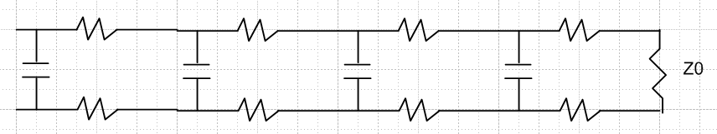

The Z0 is given at low ω by

Z0 = $\sqrt{R/jωC}$

and yes, as ω→0 it goes infinite. But let's keep ω small but non-zero. Then

I = V/Z0 = V$\sqrt{C/R}$$\sqrt{jω}$

so this shows how current I is being shut down as Z0 is increasing in the above picture. Here then are our fields with this current so expressed: (from very low freq v 2)

Ez(r,m) = (1/4) ηm I Rdc (aβ) (2/aβ) (m+1)(r/a)m = (1/2) ηm I Rdc (m+1)(r/a)m
Er(r,m) = (j/4) ηm I Rdc (aβd) gm = (j/4) ηm I Rdc (-ajα) (1/ar) (r2+ a2)(r/a)m
Eθ(r,m) = (1/4) ηm I Rdc (aβd) hm = (1/4) ηm I Rdc(-ajα) (1/ar) (r2- a2)(r/a)m

Then for m = 0 we get instead, as ω → 0,

Ez(r,0) = (1/4) I Rdc(aβ) f0 = (1/4) I Rdc(aβ) (4/aβ) = I Rdc
Er(r,0) = (j/4) I Rdc (aβd) g0 = (j/4) I Rdc (aβd)2(r/a) = (j/4) I Rdc(-ajα)2(r/a)
Eθ(r,0) = (1/4) I Rdc (aβd) h0 = (1/4) I Rdc (aβd) 2(r/a) = (1/4) I Rdc(-ajα)2(r/a)

Which I then write as

Ez(r,m) = (1/2) ηm V$\sqrt{C/R}$$\sqrt{jω}$ Rdc (m+1)(r/a)m
Er(r,m) = (j/4) ηm V$\sqrt{C/R}$$\sqrt{jω}$ Rdc (-ajα) (1/ar) (r2+ a2)(r/a)m
Eθ(r,m) = (1/4) ηm V$\sqrt{C/R}$$\sqrt{jω}$ Rdc(-ajα) (1/ar) (r2- a2)(r/a)m

Ez(r,0) = V$\sqrt{C/R}$$\sqrt{jω}$ Rdc
Er(r,0) = (j/4) V$\sqrt{C/R}$$\sqrt{jω}$ Rdc(-ajα)2(r/a)
Eθ(r,0) = (1/4) V$\sqrt{C/R}$$\sqrt{jω}$ Rdc(-ajα)2(r/a)

Now as we take the limit ω → 0, ALL these fields go to 0 !! This is what our physical experimental setup absolutely required! This limit involves I = 0, so there is nothing happening whatsoever at DC. You don't have a slowly decaying voltage going down the line. In this limit there is no voltage drop on any of these resistors in the picture,

so you basically have "one giant long capacitor" which is charged to V = 6 volts, and nothing happens. This is the ultimate DC limit of my theory!

