Low Freq Status PhL 5.16.14

One of my many painful "reviews" of the low-ω asymmetry problem, this one May 2014. Below I argue that averaging in Ch 4 makes everything OK for small ω, but Appendix S later shows this is not true. Below I also develop the idea from div E = 0 that Jz tracks n(θ) and that is where the aysm is coming from. I now think it all has to do with the e-jkz ansatz. (10.8.14)

Yesterday I finished reviewing all the docs in the low freq folder. I am still unhappy about the fact that asymmetry of Jz seems to persist as ω→0 despite the escape hatch of I→0. Maybe I can come up with "something new" after doing all that reviewing.

Question #1: Which parts of "the theory" are valid, and which are not, at low ω?

At very low ω, one thinks that φ = constant would be pretty solid, though I cannot prove how high ω could go. Certainly in the ω→0 limit φ = constant is good. And we know for sure that Az ≠ constant at low ω. If we look at Chapter 4, I think it is all valid through Sec 4.9. It is not until Sec 4.10 that W(z) appears. I updated lines doc just now to interpret Le = <Le(x1,x2> which rescues W(z) = Le i(z)
So now we start marching down Section 4.11. I will quote equations which are not valid at low ω:

∂zAz(x) = - j (β2/ω) φ(x) . maybe? (4.11.3)

I am just not sure whether we can drop the rest of div A. Now we follow down to

Ez(x1) - Ez(x2) = - ∂zV - jωW (4.11.6a)
∂zW = - j (β2/ω) V . (4.11.6b)

But I rescue these equations using my averaging trick, so that ought be good even at low ω where I know for example that W ≠ constant on the conductors! So maybe my averaging trick rescues everything at low Az !! I get right down to the classic line equations, and again averaging fixes everything!!! You just have to interpret ALL quantities like C, Le, K, KL, Z0 as involving these averages. That is nice because the "network model" does this same thing implicitly! For example, R would be the current averaged resistance. [ maybe compute this somewhere in an example ***** ]

Fact: My entire theory is rescued by the current-averaging process and therefore applies at low ω !

WRONG! Averaging does not remove the need to maintain the transverse terms like ∂xAx . Appendix S shows how this works now with T(z). So there really IS a low-ω assumption that averaging does not make go away! (10.8.14)

Question #2: In the eddy current approach, Jz asymmetry must go away as ω→0. If I have an infinitely long transmission line, as ω → 0 it is true that Z0 → ∞ and this I = V/Z0 → 0. But suppose we look for some very small ω where there is then some very small current I and very large Z0 . How do I explain that for such a small ω, where eddy currents are very small, that I get this huge asymmetry:

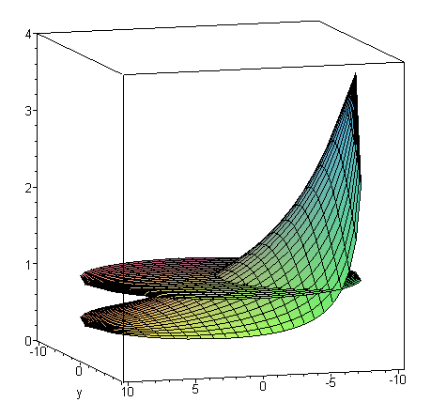

The problem is that my theory causes Jz to track n(θ), and n(θ) does not depend on ω. I address this issue in Section 6.5 (d) using the divE = 0 equation. Here is the logic flow concerning this tracking:

∂r (r Er(r,θ)) + ∂θEθ(r,θ) + r ∂zEz(r,θ) = 0 .

∂r (r Er(r,θ)) + r ∂zEz(r,θ) ≈ 0 // near r = a " near surface"

∂r (r Er(r,θ)) -jβd r Ez(r,θ) ≈ 0 // using ∂z → -jβd, see (D.1.16) "wave"

Ez(r,θ) ≈ (1/jβd) (1/r) ∂r (r Er(r,θ)) . // near r = a (6.5.17)

Ez(r) = Ez(a) $\frac{J0(βr)}{J0(βa)}$ . // From Appendix D (2.2.29)

Up to this point I have assumed nothing about ω. I continue,

Er(r,θ) ≈ Er(a,θ) $\sqrt{\frac{a}{r}}$e(r-a)/δ ej(r-a)/δ // assumption of large ω (6.5.18)

Er(a,θ) = (jω/σ) n(θ) the cpbc

Ez(a,θ) = (1/ja βd) [(1+j)a/δ ] (jω/σ) n(θ) tracking result (6.5.20)

I have no real support for my assumption in red. But suppose instead I use Appendix D,

Er(r,m) = (j/4) ηm I Rdc (aβd) gm

I could now look at this for both large ω and for small ω. I have never computed the large ω limit of gm but I could easily do that and I should do that! DONE. And my red assumption above is vindicated!

Now suppose instead we do the low ω limits. Then from "very low freq v2" I quote

Ez(r,m) = (1/2) ηm I Rdc (m+1)(r/a)m
Ez(r,0) = I Rdc

Er(r,m) = (j/4) ηm I Rdc (aβd) [(r/a)m+1 + (r/a)m-1]
Er(r,0) = (j/2) I Rdc (rβd)

Eθ(r,0) = (1/4) ηm I Rdc (aβd) [(r/a)m+1 - (r/a)m-1]
Eθ(r,0) = (j/2) I Rdc (rβd) (*)

Now I think things will be different! The div E equation stated above is this in m space,

Ez(r,m) ≈ (1/jβd) (1/r) ∂r (r Er(r,m))

where for r ≈ a we see the cancelling minus sign that sort of removes Eθ.

But now I have explicit forms for Ez so why not just use them. In fact, let's back up and quote these results from "very low freq 2"

fm = (2/aβ) (m+1)(r/a)m m > 0
f0 = (4/aβ) m = 0 β = e3πj/4 $\sqrt{σμ}$ ω1/2

gm = (1/ar) (r2+ a2)(r/a)m = (r/a)m+1 + (r/a)m-1 m> 0
g0 = 2(r/a) m = 0

hm = (1/ar) (r2- a2)(r/a)m = (r/a)m+1 - (r/a)m-1 m> 0
h0 = 2(r/a) m = 0

Recall from (6.5.13) that

Ez(r,θ) = I Rdc (βa/4) [ f0(r) + 2 Σm=1∞ (-1)m e-m|ξ$_{1}$| fm(r) cos(mθ) ]

So we can just install our results to get

Ez(r,θ) = I Rdc (βa/4) [ (4/aβ) + 2 Σm=1∞ (-1)m e-m|ξ$_{1}$| (2/aβ) (m+1)(r/a)m cos(mθ) ]

= I Rdc [ 1 + Σm=1∞ (-1)m e-m|ξ$_{1}$| (m+1)(r/a)m cos(mθ) ]

and now we do NOT get a simple image of n(θ), though we do get asymmetry still. Do I have a plot of this already somewhere? Well his is in fact just what I show above from "very low freq 1"

Question #2.5. Look at the equations (*). As ω→0, we get Er = Eθ= 0. So if these fields are zero, how can there be some violently varying Ez field?

Answer: We have from (*) that Er = ω er where er is not small. Then we get

Ez(r,θ) ≈ (1/jβd) (1/r) ∂r (r Er(r,θ)) = (1/ω) * constant * (1/r) ∂r (r ω er(r,θ))

and the two ω factors cancel each other resulting in Ez still being influenced by Er at full strength.

A Fast Path to Asymmetry at low ω

1. I believe that my Appendix D is valid for all ω, as long as you use the correct thing for β and βd which go into β'.

2. What I have done above is this: I have evaluated the Appendix D electric fields at small β', making no assumptions about the nature of β' other than to assume that β'a << 1 for low ω. This then gave

Ez(r,θ) = I Rdc [ 1 + Σm=1∞ (-1)m e-m|ξ$_{1}$| (m+1)(r/a)m cos(mθ) ]

which exhibits strong Jz asymmetry!

Question #3. Is it really true that β'a << 1 for low ω ? In the skin effect regime we have β'a >> 1 .

Note: Assuming β'a << 1, we find the second line saying Ez(r,0) = I Rdc . This says that the non-θ dependent term in Ez(r,θ) is I Rdc which is correct.

Comment: Regardless of the answer to Question #3, we have this result from Appendix D:

Ez(r,m) = (1/4) ηm I Rdc (a β') fm(r β', a β')

Ez(r,0) = (1/4) I Rdc (a β') f0(r β', a β')

The only way to avoid asymmetry as ω → 0 is to have the first line vanish and not the second line. But this just doesn't happen, assuming the ηm don't somehow vanish.

Eddy Current Argument. If we look at our basic picture

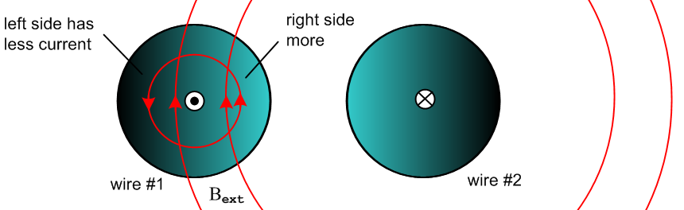

then we see where B is strong and weak and that causes the asymmetry. As ω → 0, we get weaker B on both sides and then it just goes away. But the zeroth order current remains!! The eddy current contribution maintains its asymmetry all the way down to ω = 0, but the amount of eddy current drops off relative to the base current, so you get a gradual diminishing of the asymmetry in this world!!

