Low Frequency Limit of My Theory PhL started notes 3.10.14

Review on 5.15.14.

Section 1 I don't like much, not practical and things are wrong. Just not helpful.

Section 2 is a massive web search on proximity effect and a library trip. At the time, I thought there might be a DC proximity effect, but now I am sure there is no such thing despite ambiguous statements of Paul (an author) and various websites. This is now embodied in my Appendix P on eddy currents.

Section 3 is a short abortive attempt but it got me thinking about eddy currents.

In Section 4 I give my argument for why Jz is uniform in the two cylinders at DC. This does however bring up a topic which later becomes the radial Hall effect of Appendix N. I go on to do some eddy current theory discussion and that is now in Appendix P. Then I wander off on things that just don't seem useful so I ignore them in retrospect.

1. Statement of the Problem and my Initial Response 1
(a) The first Set of Steps 2
(b) The second Set of Steps 5
(c) Physical Experiment Description as ω → 0 6
2. Search the web for evidence of non-uniform J_{z} at DC. 7
(a) the book of Clayton Paul 8
(b) Library Trip looking for the Paul book 12
(c) Continue web search. 12
3. Try again perhaps using uniform J_{z} as zeroth approx: 17
4. The Eddy Current Interpretation 18
(a) argument for uniform J_{z} at DC. 18
(b) eddy current argument for skin effect and proximity effect 19
(c) Mystery with Lorentz force and isolated cylinder wire 19

Mar 10, 2014
last update 3.12.14

1. Statement of the Problem and my Initial Response

I have studied the Appendix D E and B fields as ω → 0 and results for m ≠ 0 are all weird. Here is the problem: at normal RF line frequencies, I expect to have an asymmetric Jz inside conductors. A quick argument in favor of this is that the E and B fields on such a line are, we feel, strong right between the conductors and weak elsewhere. Here we think of shooting a wave down the line and the currents Jz are just induced by the field pattern. As the charge pattern "dances down the surfaces" I expect this creates a radial current Jr to feed the charge pattern. I know the B field pattern and I could use the curl B = J crude rule to show there must be Jz inside. I expect this Jz to be large near the "gap" and small far from the "gap". So I am happy to have an asymmetric Ez in this situation, I want to have asymmetry in fact. This means that Ez varies around the perimeter. ok

Now what happens in the above "description" as we lower ω? The ηm stay the same. The skin depth increases and becomes larger than the conductors. I expect the E outside pattern to stay the same since it is basically caused by the charge density which I claim stays the same. So imagine that the E pattern stays the same and consider

curl E = -jωB
so
B = 1/(-jω) curl E this next section I think is wrong, just skip it

This would SEEM to determine B in the dielectric just from the E pattern. Away from surfaces, we expect E and curl E to be finite. So this DOES seem to imply that B→∞ as ω→0. [ but that is wrong since in fact curl E is proportional to ω even though E is constant in ω.]
So let us reconsider the idea that E does not change with ω. Let's just suppose we have some FIXED driving potential V. [ok] The line has some known capacitance that does not vary with ω we shall say, [ok] so fixed V means fixed q on each conductor [ok]. I suspect somehow that in order to maintain this fixed V, we are going to have I → ∞. [wrong] OK, here is how that might work: you see from above that B gets larger without limit. I think we can ignore Debye surface currents, so I think assuming all μ the same that B passes right through the surface. Once you have the pattern of B just inside the surface, that must somehow determine I. I don't know offhand exactly how that works, but I can see that if B → ∞, then probably I → ∞ and that is then the explanation! [ but B not → ω, see below ] Probably the Z0 goes to 0 ohms or something like that.
There is a vector Helm equation for B inside the wire:

(∇2+β2)E = 0 (∇2+β2)B = 0 // region 3 (1.5.27)

where β is the usual inside conductor quantity. so maybe we have this problem:

(∇2d2+β'2)B(r,θ; ω) = 0 B(a,θ; ω) = prescribed // vector Helm!

We solve this somehow, then the inside current is given by

curl H = ∂tD + J ≈ J inside

[ But Appendix D has already solved the Helm equation for B so I should be able to use its results ]

(a) The first Set of Steps [ this section does not seem useful, and is wrong ]

Program for Computing things for two cylinders transmission line. [WRONG]

1a. Compute the potential which is the solution of this system.

φ(x,y,z) = $\frac{1}{4πεd}$ q(z) φt(x,y) // non-conducting dielectric to make simple

[ ∇t2 + (βd2 - kφ2)] φ(x,y) = 0 φt(C1) = V1(z) φt(C2) = V2(z) (5.1.8)

where for low loss we think (βd2 - kφ2) ≈ 0 so this is just the Laplace capacitor problem. [ok]

1b. Then compute the E field, then the surface charge, then the moments ηm. I have done this completely in bipolar doc. This assumes some potential V(z) = V0exp(-jβdz). Thus, we have a fixed potential scale from the start, and the E field will be proportional to V0. [ok]

2. Compute the B field everywhere in the dielectric from B = 1/(-jω) curl E [ok]. Note that for fixed V0, the E field does not change with ω and so B blows up as ω → 0. [wrong]

3. We know the B field on a conductor surface so we have a Helmholtz Dirichlet Problem:

(∇2d2+β'2) B(r,θ; ω) = 0 B(a,θ; ω) = prescribed

Solve this (in theory at least) for B(r,θ; ω) everywhere inside the conductor. [ok, in theory. In practice, Appendix D already solved this problem I think in terms of those moments]

4. Compute the current distribution inside the conductor using

μJ = curl B [ok]

5. Compute I in the conductor by integrating Jz obtained in item 4. [ok]

6. As ω → 0, we expect from step 2 that B → ∞ in scale, and thus J → ∞ and I → ∞, again all this being for fixed V0. [wrong because B does not go to ∞ ]

Question: But how can I → ∞ if the conductors have resistance? [ good question ]

[ Note: I am only writing I→∞ because my error above says B → ∞ ]

Remember that the line has a load which matches its impedance and probably Z0 → 0 but I am not sure. In any event, as I increases, eventually you get a huge loss and V0 cannot be maintained very far in z, and then you don't really have a useful wave. [ok] Here is what happens: as ω→ 0, the transmission line terminated in a short is just a resistor [ maybe ], and V(z) decreases linearly from V0 at the source end to 0 at the termination end. At each point along the way, it is still a capacitor, and there is still surface charge q that linearly drops off as you go down the line! [ok I think] This DC charge is NOT explained by the Hall effect for each conductor being in the other conductors B field. That creates a tiny charge that is neutral in each conductor and looks like +.....- -......+. [ok] It is the capacitor charge that is still there, but it drops off linearly as you go down the line. [ok] It has to be there because you have Vo being + on one side and - on the other. So this seems to me to be a reasonable limit of the situation as ω → 0. Somehow my six-point plan shown above does not get to this limit. Right at the driving end we ought to have V0 in full and thus E in full and thus B = 1/(-jω) curl E as being very large. But it can't really be large because I is limited! So something is missing in the above model . [ one thing missing is that I need to actually compute curl E and see what it looks like ]
One thing I know is missing is this notion in Chap 5 transverse problem:

[ ∇t2 + (βd2 - kφ2)] φt(x,y) = 0 (5.1.8)

[ ∂z2 + kφ2] q(z) = 0 . q(z,t) = q(0) ej(ωt-k$_{φ}$z) (5.1.9)

Something MUST happen to the transverse equation when kφ gets a part -jκ so q(z,t) decays. Ignoring the dielectric loss we have βd2 = (1/vd)2 ω2 . I don't know how to deal with this right now, but my guess is that the loss stuff will in fact reduce φ and reduce E in the dielectric, so B does not then get so big after all as we move to the limit. [ an interesting "way out" idea from the perceived ∞B problem. This is a little "spin off question" that I started (scratch paper) to pursue in a 1D example and I found that yes φ does seem to change. But I stopped going down that path because I think my confusion still exists even with very low loss lines. ]

Mar 11, 2014 [ here I seem to repair the B→∞ problem ]

As you go to higher ω, where skin effect sets in, same current has to go through sheath, so Jz is larger and you would think that I2R losses would increase, not decrease. [ web sites confirm this fact and it is an engineering concern. ] But in medium ω, we don't have a skin effect and I is already "fully spread out" in the conductor, ignoring partial wave contributions. I have never tried to compute the loss stuff including the complex part of kφ because I know this is not easy to do in terms of potentials. Pozar spends a lot of time on this subject I recall, I should eventually do something more than I have already done. [spinoff question] You would think that as ω decreases below mid range, the I2R loss would stay the same. It is true that λ gets longer, so loss per wave then increases. But kφz involves loss per meter, and you would think that then does not change for such low ω getting lower.

Now, once current is already spread out for lowish ω in the conductor, you would not think loss increases per meter as you go to still lower ω. [ seems reasonable] So my kφ then does not get worse in loss sense, so the φ solution does not change, and the electrostatic problem stays the same, so we carry out steps 1a and 1b and 2 above and we end up with that [wrong] problem of B → ∞ as ω→ 0 and then I→∞, so something is wrong with this set of steps. So something is wrong just with my first two steps!

Let's look at curl E in detail in cylindricals: [ its about time ] This computation is IN THE DIELECTRIC and we will quickly go close to one of the conductors:

curl E = [ r-1∂θEz - ∂zEθ] + [∂zEr - ∂rEz] + [ r-1∂r(rEθ) - r-1∂θEr ]

and install ∂z = -jβd

curl E = [ r-1∂θEz + jβdEθ] + [-jβdEr - ∂rEz] + [ r-1∂r(rEθ) - r-1∂θEr ]

Now use the exact equation B = 1/(-jω) curl E to obtain these three exact equations:

-jωBr = r-1∂θEz + jβdEθ
-jωBθ = -jβdEr - ∂rEz
-jωBz = r-1∂r(rEθ) - r-1∂θEr // in the dielectric just above surface

where we are using cyl coords of left wires say. To simplify things, set Ez= 0 relative to transverse components in the dielectric, [ justification? At boundary, Ez(dielectric) = Ez(conductor) and we expect for a very good conductor to have Ez(conductor) ≈ 0, though of course not exactly so. ]

-jωBr = jβdEθ = j(ω/vd) Eθ
-jωBθ = -jβdEr = -j(ω/vd) Er
-jωBz = r-1∂r(rEθ) - r-1∂θEr // in the dielectric just above surface

curl E = [jβdEθ] + [-jβdEr] + [ r-1∂r(rEθ) - r-1∂θEr ]

Now let's go "close to the left wire" in which region we expect Eθ = small, so get

-jωBr = 0 // note NO NORMAL B COMPONENT at surface
-jωBθ = -j(ω/vd) Er => Bθ = (ω/vd)Er
-jωBz = - r-1∂θEr // in the dielectric just above surface

curl E = [-jβdEr] + [- r-1∂θEr ] B = 1/(-jω) curl E close to wire

I feel that the is the main term here (no reason given other than intuition of picture, maybe expect small radial Er at low ω), so

B = 1/(-jω) curl E = 1/(-jω)[ [-jβdEr] = (βd/ω) Er = (1/vd) Er

So my conclusion that Bθ → ∞ is then completely 100% wrong! [ hurray! ] Basically

curl E = [-jβdEr] = [-j(ω/vd) Er]

and when you set curl E = -jωB the ω factors cancel. [ βd is just the wave number v = ω/k in a low loss situation ]

(b) The second Set of Steps

So let's make a new set of steps! [ focus is on B so can do μJ = curl B, but intractable ]

1a. Compute the potential which is the solution of this system.

φ(x,y,z) = $\frac{1}{4πεd}$ q(z) φt(x,y) // non-conducting dielectric to make simple

[ ∇t2 + (βd2 - kφ2)] φ(x,y) = 0 φt(C1) = V1(z) φt(C2) = V2(z) (5.1.8)

where for low loss we think (βd2 - kφ2) ≈ 0 so this is just the Laplace capacitor problem.

1b. Then compute the E field, then the surface charge, then the moments ηm. I have done this completely in bipolar doc. This assumes some potential V(z) = V0exp(-jβdz). Thus, we have a fixed potential scale from the start, and the E field will be proportional to V0.

1c. Then compute curl E and find that near a conductor (we ignore the z component for now)

curl E = [-j(ω/vd)Er] + [- r-1∂θEr ] [ curl E ]t = (-jω) (1/vd) Er

2. Compute the B field everywhere in the dielectric from B = 1/(-jω) curl E . The result is

Bθ = 1/(-jω) [ curl E ]θ = (1/vd) Er // other B components ≈ 0

Notice that Bθ does not vary with ω as ω→ 0. But it does vary with θ since Er varies with θ.
[This Bθ result at the surface is exact to the extent that we have set ∂rEz = 0 inside the conductor. ]

3. We know the B field on a conductor surface so we have a Helmholtz Dirichlet Problem:

(∇2d2+β'2) B(r,θ; ω) = 0 B(a,θ; ω) = prescribed

Solve this (in theory at least) for B(r,θ; ω) everywhere inside the conductor. [ but remember this is a vector Helmholtz so Bθ and Br get entangled as shown in (D.1.20) . Since I claim to have already solved this Helm equation in Appendix D, there should be no reason to do it again! ]

4. Compute the current distribution inside the conductor using [ ok, the plan at least seems good ]

μJ = curl B

5. Compute I in the conductor by integrating Jz obtained in item 4.

So, with this new set of steps, as ω→0, we go deep into the electrostatic limit, and all fields become constant (independent of ω) values as shown above. So I have repaired the B=∞ catastrophe at low ω.

(c) Physical Experiment Description as ω → 0

So imagine our test transmission line with two round conductors driven by V0 = 6 volts and we just keep lowering ω and look at the piece of line close to the driving end (it is a long line). Step 1a tells us there is a certain Er near the left conductor surface that is proportional to V0. I must believe that the charge does not "run away down the line" and we have our usual q(z) at very low ω. As ω → 0, this charge becomes static and q(z) right next to the driving end is, from Q = CV, equal to q(z) = C V0 and you could in theory measure the charge, positive on left, negative on right. As we move down the line at DC, V(z) drops off linearly due to the IR drop, and Er and Bθ decrease along the line, and everything seems OK (finally!).

[ I am still uncomfortable that maybe that charge will "run away" at DC, but we continue on ]

Question: Is JZ symmetric or asymmetric in this limit inside the left wire? [ the Big Question ]

Assuming closely spaced fat conductors, I know that Er(θ) has strong θ variation. This

Bθ(θ) = (1/vd) Er(θ)

has strong θ variations just above the surface of the left conductor. This is perhaps a new realization for me? Well, here we are not talking about the direction of B, but its magnitude going around the conductor, or at least the magnitude of the Bθ component. From our formula above where we set Eθ ≈ 0 just above the surface, we see that curl E = [-j(ω/vd)Er] + [- r-1∂θEr ] so that B = 1/(-jω) curl E has no component, so we end up with B being exactly tangent to the surface and Bn = 0, which is a long discussion I have elsewhere. [ seems right ]
So, we have the boundary value problem of step 3 above,

(∇2d2+β'2) B(r,θ; ω) = 0 B(a,θ; ω) = prescribed = [(1/vd) Er(θ)]

The solution to this problem would seem to be some B(r,θ) inside the wire which is a strong function of θ, but right now I don't know the exact solution [ see App D ]. Then for step 4 we get

μJ = curl B = [ r-1∂θBz +jβdBθ] + [-jβdBr - ∂rBz] + [ r-1∂r(rBθ) - r-1∂θBr ]

and of special interest to me then is

μJz = r-1∂r(rBθ) - r-1∂θBr

I am guessing the second term is small and then we have

μJz = r-1∂r(rBθ) = ∂rBθ + (1/r) Bθ

I feel strongly that Bθ varies a lot going around the perimeter region, say, but I don't really know what the first term is doing without having a full solution, so I cannot simply claim that Jz is non-uniform. However, I do know this fact: If I assume that Jz is uniform at DC in both wires, I find that the B field is not normal to the conductor surface -- I have plotted this now many times. But the analysis above says there is no component of B , where I did assume Ez= 0 as for a perfect conductor.

[ Note added 3/12/14 as other red notes: At this point, I seem to conclude that Jz is non-uniform at any frequency ω, including DC, since ω does not appear in the solution shown above. This is in direct conflict with what I have always assumed, that Jz is uniform at DC. This seems to agree with my calculation of Ez as shown in Very Low Frequency Limit of the Appendix D fields.doc where the m≠0 components do not vanish at DC. ]

Comment: My answer to the question of whether the DC current is uniform or non-uniform seems to swing back and forth sometimes on an hourly basis. Currently (no pun), since I have a smooth description of the limit ω → 0, I am arguing for non-uniform, but I have never found support from another source on this conjecture. My Appendix D stuff also argues for non-uniform.

2. Search the web for evidence of non-uniform Jz at DC.

Let's try another search effort, perhaps with the search handle "proximity effect". Here is a first offering:

http://www.atlascables.com/cable-construction.html

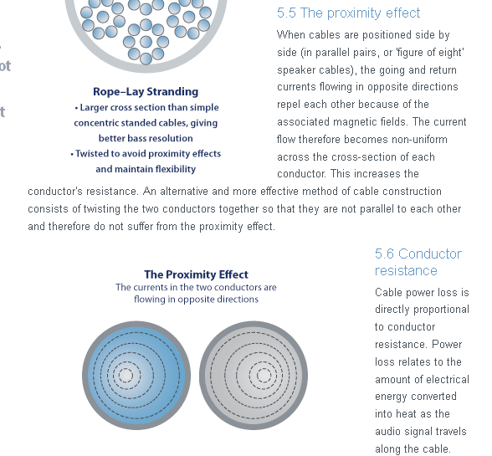

This is one of those "monster audio speaker cable" companies and no support is offered for their claim or their picture, but at least someone is making the claim!!! There are a lot of hits, and most of them claim this is only an AC effect. They claim that you induce eddy currents in the other wire and that does it.

(a) the book of Clayton Paul

But here is a Google book which seems to make claims without regard to frequency:

http://books.google.com/books?id=3a7z8TzxaDMC&pg=PT150&lpg=PT150&dq=current+wire+%22proximity+effect%22+DC+-skin+-rotating&source=bl&ots=OZlFOOnRIj&sig=eqa0X1Kmi-VbcKE3eqmMKFy8nEY&hl=en&sa=X&ei=kiMfU4rIJpXqoATyoILYAg&ved=0CEUQ6AEwBA#v=onepage&q=current%20wire%20%22proximity%20effect%22%20DC%20-skin%20-rotating&f=false

[ I now have this Paul book which has a strange title: Inductance, Loops and Partial. ]
[ this guy died on 6/27/12 so I won't be doing any email.]

Inductance: Loop and Partial By Clayton R. Paul

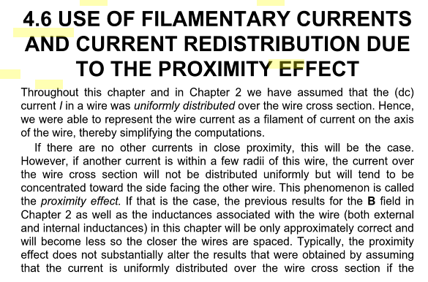

Notice his specific mention of DC in the first sentence. Other authors always claim AC only. But later he says

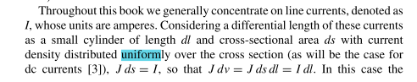

and

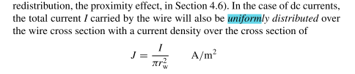
and

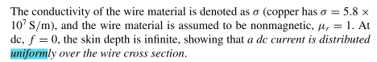
and
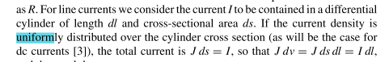
so now he is saying things are uniform for DC currents.

BUT,

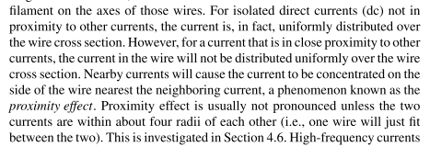

AND

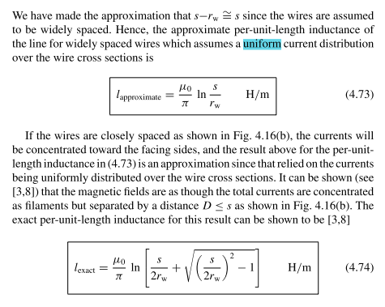

But then later he flops back again to no DC prox effect:

Here he is explicitly making the focal point claim for the currents, not just the charges! You see his statement right there! But the references concern the inductance formula perhaps and not the fact I am looking for. I note that his (4.74) disagrees with my Chapter 6 result! Perhaps that is because I used a uniform current density. So I am still in dire need of his reference 3 or 8 to get more on this!

Here he really is saying there is a DC proximity effect! I swear that is what he is saying in the above paragraph!

This author Clayton Paul talks about inductance rather than the current, and shows that the proximity effect causes the inductance to be what I say it is from K in lines doc, the fancy formula similar for K.

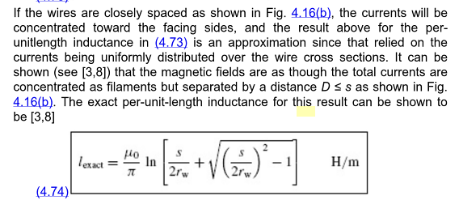

There is his clear statement with no comment on frequency ω. And he says that the currents act as if concentrated at the bipolar focal points. I only showed this was true of the surface charge. He gives two references which are:

[ note that inductance is both a DC and AC effect. Paul's statements seem valid to me in terms of surface charge, but maybe not so valid in terms of conductor current. Later when I look up one of his books, he discusses proximity effect there ONLY in terms of surface charge! ]

[ Comment 5.15.14. I now know that in the extreme skin effect, Jz(a,θ) is proportional to n(θ), and so Paul is correct in this situation when he says the currents act if they were at the focal points in the sense that lines through the focal points would be the "center of Jz current" for what that is worth. Perhaps the B fields from this current are as if they were at the focal points. For small ξ, this would mean a stronger B field in the gap than on a far part of the surface. ]

I was able to get Paul's book from Russia, so I can look up the refs which I think are missing in google. This book is very much "up my alley", maybe the closest thing I have seen yet to what I do. Here are his two references (they are in fact at the end of the book and were in google after all)

Both refer to his own work (again, similar to me).

[3] I get a partial web copy, index says proximity effect is on page 424. By the way, NONE of my E&M books has this word in the index. I cannot find a download of this item. But the amazon cover picture sure seems relevant

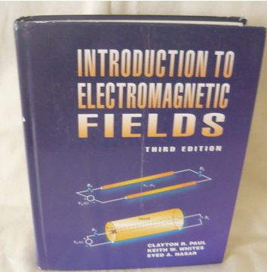

Web scan for this book? It is very well protected probably by the other two authors. I have the TOC but no phrases show anywhere on the web.

What about Ref 8 ? I have some TOC text and that led to a google book. Here are some quotes from this Ref 8

As in the Partial book, he continues to hem and haw on my question, but he never presents any calculation of the asymmetry due to the prox effect.

An older 1982 version of this book is at Marriott and is on the shelf right now! He gives ref 10 for proximity effect, which is this

This thing is nowhere to be found, fine.



[8] This one IS at Marriott. But only as "online access", as if they don't really have the book. Then of course the online access is "not available" with no reason given. Perhaps they just have it up during a course. So in fact Marriot does NOT have this book at all.
so I could go over there and take a look I suppose. // Nothing there.

I continue the general proximity effect web search

This one says it only happens at AC:

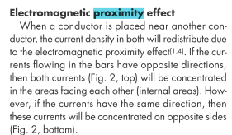

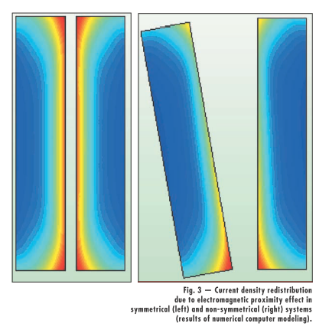

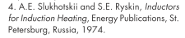

"DC proximity effect" shows only 7 hits! So that Marriott book is very valuable, I will go look at it. We are right now in spring break, limited hours are 7AM to 6 PM. Fine.

(b) Library Trip looking for the Paul book

I found the 1982 book, it had proximity effect in the index p 321, but that pointed only to a discussion of the surface charge being asymmetric, which is not the issue in question. It said nothing about currents. I looked in the index of about 20 nearby "electromagnetism" books and only one had "proximity" in its index, but it was the charge thing again. I bet the newer Paul book has the same thing.

(c) Continue web search.

Maybe this is the wrong search handle. Current crowding seems semiconductor in nature.

"proximity effect" = 450,000 hits

"proximity effect" conductors = 43,000 hits

"proximity effect" conductors "current distribution" = 40,000 hits

"proximity effect" conductors "current distribution" DC = 36,000 hits

I have found some hits and will continue. I want someone who actually calculates the effect. I will note references as I find them

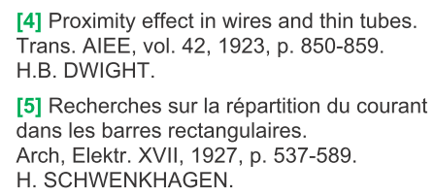

I have located a web readable version of the Dwight paper, first page only.

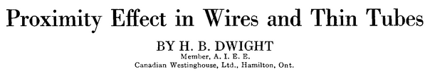

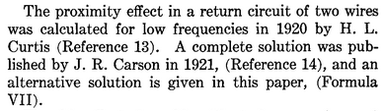

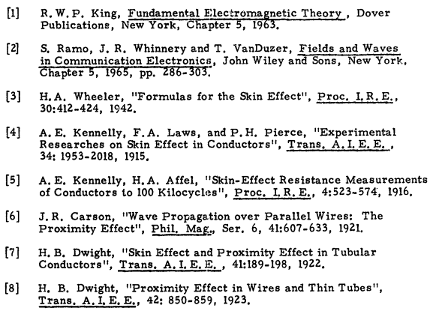

Search for Kennelly: I have a Kennelly google book "skin effect in conductors" full view I think. They not that the resistance increases with proximity, that is their point of view on this issue. It suggests AC only but has no theory.

Someone else:

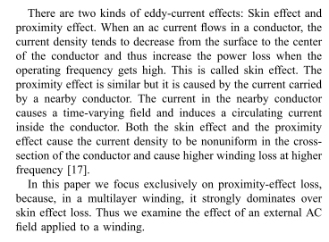

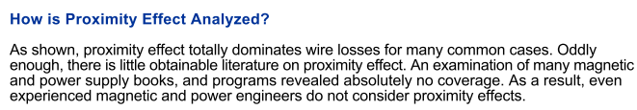

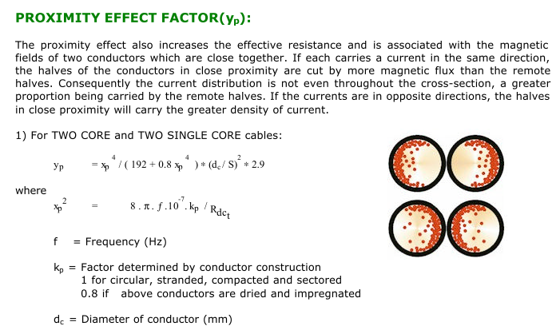

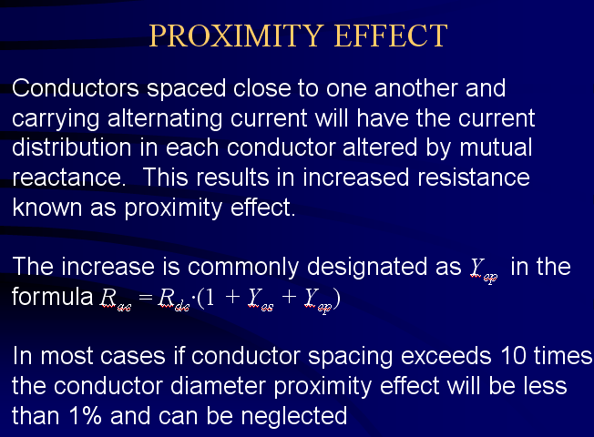

The following 1935 paper seems pretty trustworthy, I downloaded a PDF of it":
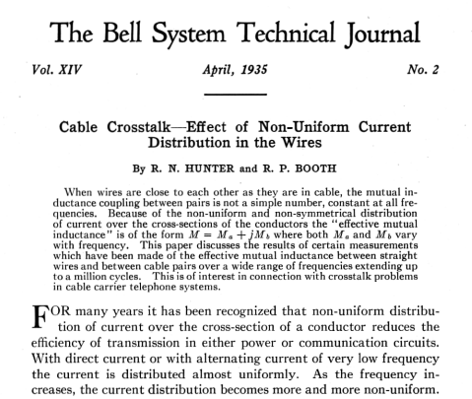

Note the ambiguity of the last sentence. Is the distribution "almost uniform" at DC ? But here we are later on:

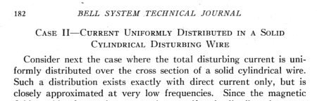

So they are clearly stating what I want to see: current is uniform at DC, case closed! But wait, maybe they are talking about one conductor in isolation. No, I don't think so. They go on to discuss the AC case in great detail with wonderful drawings of the current distribution.

Status 2:30PM. I made no progress today despite lots of web search and library trip. My "new set of rules" found today seems to indicate a DC non-uniform field, but nobody else sees this except author Clayton Paul in one place but I don't have his 1987 book and it has been purged from the web. It has a 1987 and 1998 edition, but I doubt it really deals with the issue at hand. Author just self-promoting.
I have this sinking feeling that Paul is wrong and so am I and there is no DC proximity effect. So something is wrong with my derivation.

3. Try again perhaps using uniform Jz as zeroth approx:

[ this is perhaps my first attempt at "eddy current theory" which now appears in Appendix P. The work below is pretty inscrutable as it is stated and I don't think of any use. ]

Just writing for the record:

curl E = - ∂tB ⇔ C E • ds = -∂t[∫S B • dS] . (1.1.36)
curl E = - jωB ⇔ C E • ds = -jω[∫S B • dS] . (1.1.36)

Go back to this:

curl E = [ r-1∂θEz - ∂zEθ] + [∂zEr - ∂rEz] + [ r-1∂r(rEθ) - r-1∂θEr ]

curl E = -jωB = [ -jωBr ] + [-jωBθ] + [-jωBz ]

This is EXACT! Now there are three different equations:

-jωBr = r-1∂θEz - ∂zEθ
-jωBθ = ∂zEr - ∂rEz
-jωBz = r-1∂r(rEθ) - r-1∂θEr [ all OK ]

Maybe better to do this in Cartesian

curl E = (∂yEz - ∂zEy) + (∂zEx - ∂xEz) + (∂xEy - ∂yEx)
curl E = -jωB [ recognize this as (P.1.5) in my eddy current Appendix P! ]

-jωBx = ∂yEz - ∂zEy
-jωBy = ∂zEx - ∂xEz
-jωBz = ∂xEy - ∂yEx [ all OK ]

Now suppose we use our static Hx, Hy fields found in my plotting program deal (based on uniform Jz in each conductor) AND, suppose we assume without justification that Ez is the dominant field inside, Then

-jωBx(x,y) = ∂yEz(x,y)
-jωBy(x,y) = - ∂xEz(x,y)
0 = ∂xEy(x,y) - ∂yEx(x,y)

So what exactly do I do with these first two equations:

∂yEz(x,y) = -jωBx(x,y)
∂xEz(x,y) = jωBy(x,y)

where the right sides are fully known.

[ At this point I first interpreted the above as a system of two PDE's! Later I realized it was just ∇Ez = -jωB, but not until I went off on this spawned question and looked in Polyanin (downloading his 1st order PDE pdf this time, so he has two PDE pdf's). I then wrote up this "inverse gradient" problem as a doc, and that along with a certain nice pdf is now stored in math/calculus ]

I was intending to use my plot routine's functions Hx and Hy and then use that to compute Ez, but now that seems a fruitless task. The integrals will be difficult, but you should just end up with Ez = uniform inside the wires, since that is what you assumed to compute the B field. So I won't go off on that spawned tangent, I just let it be. At least I learned about the "inverse tangent operator".

4. The Eddy Current Interpretation

This is a way to show that you expect Jz asymmetry only to appear when ω > 0.

You start with your two cylinders at DC, each one carries I, and you assume Jz is uniform. Here is an argument for why it should be uniform.

(a) argument for uniform Jz at DC.

[ Notice how this next paragraph brings up the notion of a radial Hall effect, requiring me later to do a long digression on that subject! ]

Imagine you are an electron flowing in one of these two closely spaced cylinders at DC. Your only awareness of the other cylinder is that your local B field is "wrong" -- it is not what it would be if you were in an isolated cylinder wire. Be that as it may, at each point inside the left cylinder where you are flowing in the z direction, there is a static B field. It is the sum of the B fields of the two wires, and we know its general direction from our famous picture,

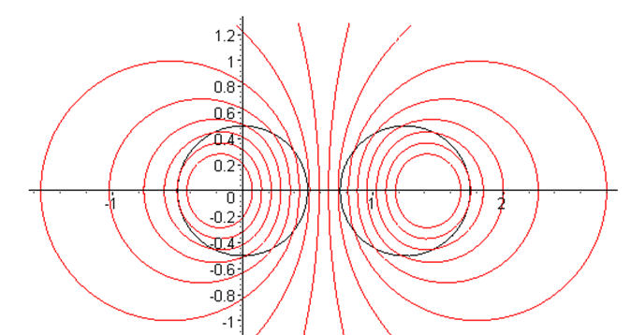

As you flow, you are first feel a v x B Lorentz force perhaps pushing you do the left. But after a very short while, a tiny Hall effect surface charge will appear on the surface of your conductor and will arrange itself in a complicated manner such that it exactly cancels the Lorentz force on every flowing electron inside the fat conductor. This would of course be an interesting spawned problem, to compute that surface charge! If the charge is wrong, electrons continue to deflect and continue to build up charge at the surface (radial pumping!) until that surface is just right, and then there is no more deflection, and every electron goes in the z direction only. Now the claim is that in this final stable static situation, there is no reason for Jz to be more toward the left edge versus the right edge of the conductor. That Hall surface charge has no effect on the Jz other than exactly balancing out the static Hall field. So if you buy this argument, you end up with a uniform Jz and some tiny charges on the surfaces of each conductor, and on each conductor the total such charge (per unit length) is zero. You can see from the red field lines above that the field has a different direction at different location in the cylinder, so the Hall charge generated E field has to have a very strange configuration.

Bug in this argument: When I draw the Hall E field that would be required, it seems to point outward from the approximate center in all directions. This, there is a region inside the conductor that seems to have div E ≠ 0. But there can be no charge inside the conductor, so we have a nice new Paradox!

[ this is resolved in my radial Hall effect appendix N stuff ]

Ignoring this bug for a moment, here is the eddy current argument.

(b) eddy current argument for skin effect and proximity effect

[ this is now all presented in Appendix P ]

You now raise ω → 0 and you imagine some thin math loop in the left conductor. It is long in the z direction, and the thin edges are horizontal in the above picture. If there were only one conductor present, one could analyze the changing flux through this loop and that would give rise to a symmetrical left/right variation in the field Ez and this would (hopefully) lead to the skin effect.
Now you bring in the other conductor and the B field changes. It is now stronger on the right side of the left conductor than on the left side, so flux change is larger on the right, so ∂xEz is larger there and this is supposed to cause the "proximity effect" non-uniform Jz. But since there is only changing flux at AC, there is no such effect when ω = 0. So this then is the "eddy current argument" for the proximity effect which occurs with closely spaced wires at AC. I guess you are supposed to add this eddy current induced Ez field to the uniform one.
I can only assume that this effect would be included in my "general theory" of current inside a round wire. It should just "fall out" from the equations which are exact solutions of all the Helmholtz stuff.

(c) Mystery with Lorentz force and isolated cylinder wire

[ this is the radial Hall effect subject ]

Draw picture on whiteboard of the B field inside a round wire where current flows toward the viewer. Imagine current of plusons instead of electrons. B field is CCW. Consider an arbitrary pluson in motion in the z direction. The Lorentz v x B force is always toward the center of the wire. So every pluson wants to deflect toward the center of the wire. How can a surface Hall charge stop this deflection? You would need a line of physical charge existing along the cylinder axis and a counter charge on the outer surface in order to straighten out the deflections in order to end up with Jz only in the z direction. But I thought I said you could not have free charge inside a conductor? So I have spawned a brand new complete mystery . I now have to go spend 4 hours trying to find this situation discussed on the web under some unknown search handle. Otherwise I have a live mystery which can infect my thinking on other subjects because something is missing! That could then invalidate everything else I do. So off we go to the web!

"Lorentz force inside a round wire" no hits

This is for me a completely mind-blowing question. The simplest questions are often the hardest questions I have found. The question is here is completely trivial. What happens with a typical electron in the current carrying wire. Does it see the B field of all the other electrons? Does it not see this B field for some reason due to the macroscopic average business? Suppose you "shoot" an electron through a region of space with a uniform B field, what does it do? I don't even know! The Lorentz force is perp to both v and B. For a uniform B field going into the plane of paper, a pluson which is launched tangent to just the right circle will go in a circle in the plane of paper, were mv2/r balances the L force. This is the cyclotron story. In Purcell's Hall picture page 218, electrons start off doing a circular path, that is, their deflection is the start of a circular path, but then the E field comes on and the deflection is stopped.
Of course there are collisions and we are talking about the average path of an electron.

I did some web searching 3/12/14. Yes, you really need to do the quantum theory of solids and all that stuff, but I want something simple. My solution is that yes, initially all the electrons deflect toward the center (say), but this builds up a free electron density there which then creates a field relative to the outer surface which then stops the deflection. I doubt anyone could ever measure such a thing because you cannot put a voltage prove at the center of a solid cylinder. That is just going to have to be my personal resolution of this mystery until I run into some better explanation. Surely the drifting electrons see the B field made by all the other electrons. So I am claiming then a "cylindrical Hall effect". Needless to say, there are no web hits on that phrase. Well there are, but they have to do with Hall Thrusters which is not really what I am interested in.

March 13, 2014

I verified today with Maple two things concerning my Appendix D E field solutions with the coefficients evaluated at per my two boundary conditions:
(1) they satisfy div E = 0
(2) they satisfy (∇2 + β2) E = 0 vector Helmholtz.
Given the BC's, my solutions are correct, I just don't think there is any error in them. I used the Maple fancy cyl coordinates diff op operators for the first time to do this.

Question: At DC, do I expect the E fields inside a wire to satisfy these two equations?

(1) All electrostatics situations have div = E where there is no free charge.

(2) At DC, β2 = 0 so the Helmholtz is just the vector Laplace equation ∇2 E = 0. This is not familiar to me. Well, write ∇2 = grad(div E) – curl (curl E) . We know that div E so this says

∇2 E = – curl (curl E) = 0.

Now at ω = 0 we look at curl E = - ∂tB and say curl E = 0 at DC, so there it is, ∇2 E = 0 .

Plan A. How about a pure DC solution to the problem. As a start, suppose I do this;

(1) assume uniform Jz in each of two adjacent cylinders
(2) compute H everywhere (I think I have already done this)
(3) Then use curl H = J to compute J, and see if it agrees with the starting uniform value.

Confusion: Somehow this has to give J = 0 outside the conductors. How is that going to work?

OK, my existing calculation of H is located in "the surface currents issue" doc, Section 6 (b), and this is already loaded into "B field two round wires.mws" . So all I have to do is use the Maple Cartesian curl operator I used earlier today. Interestingly, I have no idea what mws file that was done in, even though it was earlier today! It is not in any of my usual working areas! Where did I enter all those fm values? I can't even find the doc I did it in!

Time out to search for this morning's lost work. First, I seek a doc which has curl(curl in it.

Desktop? no
Trans lines folder: no

Witzend: the mws file is here (but not the doc)
D:\Work\My Interests\Physics\Transmission Lines\Appendix D EB round

I guess my only comment on this is a shown above right in this doc now in red.

Resume: I added code to "B field two round wires". The result is quite conclusive:

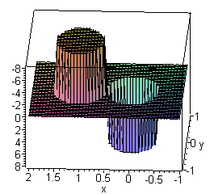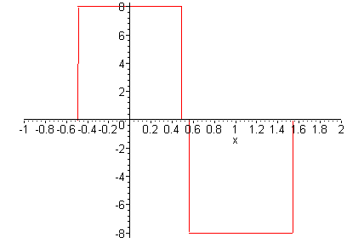

You get back exactly what you started with, for J everywhere!!! There is no "tilt" of Jz, even if I set b = 1.01 which brings them very close. And b = 1.01 and both radii 1/2 I get ξ = 0.144 which is plenty small to show any effect if it existed.

Conclusion: This is a self-consistent magnetostatics problem! Start with constant I = 2π and then

Jz = 2π/πa12 = 2/(a1)2 = 8 [ OK, magnetostatics works I am saying ]

Then compute the exact H field everywhere, then use curl H = J to get J, and you get exactly what you started with! Is this a fact of superposition? I guess it is, but the AC problem for some reason does not allow superposition. If my radial Hall voltage were needed to stabilize the current, that E field would have no effect on this little self-consistent problem! I think solutions are unique, so this MUST BE the only solution to this DC problem.

Friday 3/14/14

Two questions:
(1) If I start with my asymmetric predicted current at ω = 0, what B lines does it produce?
(2) What happened to the King gauge condition in my whiteboard flow chart

Item (1) : My current B line program is based on these fields taken from "surface currents":

H1(r1) = (I/2π)[ θ(r1>a1) (1/r1) + θ(a1>r1) (r1/a12)]
H2(r2) = -(I/2π)[ θ(r2>a2) (2/r2) + θ(a2>r2) (r2/a22)]

Hx = - (y/r1)H1(r1) - (y/r2) H2(r2)
Hy = (x/r1) H1(r1) + ((x-b)/r2) H2(r2)

This is a direct superposition deal : I compute H for each wire assuming uniform Jz, I do the vector addition, and there you are. For my asymmetric current, things are much harder. I would have to use my 2D Biot Savart from lines doc which says

H(x,y) = ∫d2x' $\frac{1}{2πR2}$ J(x') x R R ≡ x - x' (B.2.24)
Jz = σI Rdc [ 1 + $\sum_{m = 1}^{∞}{}$ (-1)m e-m|ξ$_{1}$| (r/a)m [ (m+1)] cos(mθ) ]

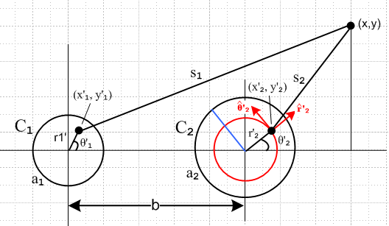

For the left conductor

J(x') x s1 = [Jz ] x [(x-x'1) + (y-y'1) ] = Jz {(x-x'1) - (y-y'1) } θ(r'1 < a1)

Hleft(x,y) = ∫d2x' $\frac{1}{2πs12}$ θ(r'1 < a1) Jz {(x-x'1) - (y-y'1) }

= ∫r'1dr'1dθ'1 $\frac{1}{2π[(x-x'1)2 + (y-y'1)2]}$ θ(r'1 < a1) Jz(r'1, θ'1) {(x-x'1) - (y-y'1) }

= ∫r'1dr'1dθ'1 $\frac{1}{2π[(x-r'1cosθ'1)2 + (y-r'1sinθ'1)2]}$ Jz(r'1, θ'1) {(x- r'1cosθ'1) - (y- r'1sinθ'1) }

So then

[Hleft(x,y)]x = ∫r'1dr'1dθ'1 $\frac{(x- r'1cosθ'1)}{2π[(x-r'1cosθ'1)2 + (y-r'1sinθ'1)2]}$ Jz(r'1, θ'1)

[Hleft(x,y)]y = - ∫r'1dr'1dθ'1 $\frac{(y- r'1sinθ'1)}{2π[(x-r'1cosθ'1)2 + (y-r'1sinθ'1)2]}$ Jz(r'1, θ'1)
where
Jz(r'1, θ'1) = σI Rdc [ 1 + $\sum_{m = 1}^{∞}{}$ (-1)m e-m|ξ$_{1}$| (r'1/a)m [ (m+1)] cos(mθ'1) ]

Not surprisingly, the integration is ugly, but might be doable analytically. Numerically we would have to do a double integral for every point in the x-y plane. I suspect this calculation is much easier in bipolar coordinates. I have two conjectures:

Conjecture 1: The current in each conductor acts as if concentrated at the bipolar focal point.
[ I know this is true now in extreme skin effect ]

Conjecture 2: One would find that the H lines align with the cylinder surface, which would mean that Az was a constant on the cylinder surface.

Digression: Let's now review Appendix M which says At << Az . One of the assumptions I make there can be written this way

fm ≈ gm ≈ hm in "scale"

I think somewhere I showed this was valid for the skin depth regime but I would have to do a 10 minute search to find that info. Right now I wonder what happens for small ω. I found that

fm = (2/aβ) (m+1)(r/a)m m > 0
f0 = (4/aβ) m = 0 β = e3πj/4 $\sqrt{σμ}$ ω1/2

gm = (1/ar) (r2+ a2)(r/a)m m> 0
g0 = 2(r/a) m = 0

hm = (1/ar) (r2- a2)(r/a)m m> 0
h0 = 2(r/a) m = 0

It seems fair to say that gm ≈ hm in "scale", but fm recall blows up as ω → 0. But lets keep going:

Second summary of the E field solutions for m = 0 and ω → 0 (D.2.33)

Jz(r,0) = σ I Rdc

Jr(r,0) = σ(j/2) I Rdc (rβd)

Jθ(r,0) = σ(1/2) I Rdc (rβd)

What we see in this limit is that Jr and Jθ are smaller than Jz by factor (rβd/2) which in fact is very small if we are in the transmission line limit. This the claim of Observation (1) in Appendix M is borne out in the limit ω → 0, but not quite in the manner in which it was described there. I think the cancellation argument continues to be valid, so the conclusion of small At seems to survive!

Item (2) : We now switch gears to see how the King gauge fits into our whiteboard theory architecture which I don't yet have as hard copy. The King gauge says

div A = - μεjωφ - μσφ = -jωμ(ε+σ/jω)φ = -jωμξφ = -j(β2/ω) φ King gauge (1.5.5)

Write this as both inside and outside conductors in this manner

∂xAx + ∂yAy + ∂zAz = -j(β2/ω) φ inside

∂xAx + ∂yAy + ∂zAz = -j(βd2/ω) φ outside

I have never addressed the question of potential φ inside the conductor, only in the dielectric. So let's stick with the dielectric so

∂xAx + ∂yAy + ∂zAz = -j(βd2/ω) φ dielectric

Suppose now according to Appendix M we could ignore the first two terms, just suppose. Then you would have

∂zAz = -j(βd2/ω) φ
or
-jβdAz = -j(βd2/ω) φ
or
-jAz = -j(βd/ω) φ
or
Az = (βd/ω) φ
or
Az = (1/vd) φ

as I have found elsewhere, but don't want to search now. If this condition were true, it would say that the equipotential lines of Az must match the boundary of the cylinder cross section, since that is the case for φ in the dielectric. This then is the basis for my Conjecture 2 above. Somehow my "theory" gives an asymmetric current and Az lines that match the boundary, whereas the known DC solution instead gives a uniform current Jz and Az lines that do NOT match the boundary.

Elsewhere I crudely said let D be a transverse dimension and then

T1 ≡ ∂xAx + ∂yAy ≈ (Ax + Ay)/D

T2 ≡ ∂zAz ≈ βdAz = ( 2π/λ) Az

T1/T2 = (Ax + Ay)/D / ( 2π/λ) Az = (Ax + Ay)/Az * (1/2π) * (λ/D)
= small large

I don't recall this result earlier. It shows that the derivatives might offset the potential ratio and make the above approximation invalid. Now for DC and Jz = uniform, I know of a surety that the Az lines do NOT line up with the conductor boundaries, so Az = (1/vd) φ cannot be exactly true. This is a long subject I have dealt with elsewhere. Maybe in the skin effect limit we get D replaced by δ, and then we have

T1/T2 = (Ax + Ay)/Az * (1/2π) * (λ/δ)

but then this is even worse since the last factor is then even larger than before.

Conclusion: Az = (1/vd) φ is probably not valid for any ω. Earlier in "computation of Az for two cylinders" I claimed this was valid in the skin limit and there justified the King approach to things.

