REF 3:

This is supposed top be the TOC for Paul's 3rd Intro book. If you search for a unique piece of text, you get no web hits whatsoever!
Table of Contents
Preface xvii

Chapter 1 Introduction 1
1.1 A Brief History of the Development of Electromagnetics 2
1.2 Some Applications of Electromagnetic Field Theory 4
1.3 Units 6

Chapter 2 Vector Analysis 9
2.1 Vectors and Scalars 10
2.2 Orthogonal Coordinate Systems 11
2.3 The Rectangular (Cartesian) Coordinate System 14
2.4 The Circular, Cylindrical Coordinate System 18
2.5 The Spherical Coordinate System 26
2.6 Products of Vectors 30
2.6.1 Dot Product 31
2.6.2 Cross Product 34
2.7 Fields 41
2.7.1 Scalar Fields 41
2.7.2 Vector Fields 41
2.8 The Gradient of a Scalar Field 43
2.9 The Line Integral of a Vector Field 48
2.10 The Divergence of a Vector Field 55
2.11 The Divergence Theorem 63
2.12 The Curl of a Vector Field 66
2.13 Stokes' Theorem 72
2.14 Two Important Vector Identities 75
2.15 Summary 77
Problems 78

Chapter 3 Electrostatic Fields 87
3.1 Charge 88
3.2 Coulomb's Law 92
3.3 Electric Field Intensity 105
3.4 Gauss' Law and the Electric Flux Density Vector 110
3.5 Electrostatic Potential 117
3.6 Conductors and Dielectrics 126
3.6.1 Conductors 126
3.6.2 The Electric Dipole 127
3.6.3 Bound Charge and Dielectrics 128
3.7 Boundary Conditions 136
3.8 Stored Energy in the Electrostatic Field 143
3.9 Capacitance 146
3.10 Poisson's and Laplace's Equations 156
3.10.1 Product Solution to Laplace's Equation 159
3.11 Uniqueness of Solution 162
3.12 The Method of Images 164
3.13 Electrostatic Forces 172
3.14 Summary 175
Problems 176

Chapter 4 Magnetostatic Fields 187
4.1 Charges in Motion 187
4.1.1 Conductors, Direct Current, and Ohm's Law 188
4.1.2 Conservation of Charge and Charge Relaxation 191
4.2 Ampère's Force Law 195
4.3 Magnetic Flux Density, the Biot-Savart Law, and the Lorentz Force Equation 200
4.4 Ampère's Law 208
4.5 Magnetostatic Potential and Flux 215
4.5.1 Vector Magnetic Potential 216
4.5.2 Net Outward Flux of B 220
4.6 Magnetic Materials 221
4.6.1 The Magnetic Dipole 221
4.6.2 Magnetization and Bound Current Densities 225
4.6.3 Permeability 230
4.7 Boundary Conditions 234
4.7.1 Boundary Conditions for B and H 234
4.7.2 Boundary Conditions for J 237
4.8 Magnetostatic Circuit Parameters 238
4.8.1 Inductance 238
4.8.2 Resistance 247
4.8.3 Power Density and Joule's Law 253
4.9 Magnetostatic Stored Energy 255
4.9.1 Energy Stored in the Magnetic Field 255
4.9.2 Energy Stored in Inductors 258
4.10 Magnetic Circuits 263
4.11 Magnetostatic Forces 270
4.12 Summary 274
Problems 276

Chapter 5 Maxwell's Equations 287
5.1 Faraday's Law 289
5.2 Gauss' Laws for Electric and Magnetic Fields 299
5.3 Conservation of Charge 299
5.4 Amp\`ere's Law and Displacement Current 301
5.5 Summary of Maxwell's Equations 305
5.6 Constitutive Properties of the Medium 307
5.7 Boundary Conditions on the Field Vectors 311
5.7.1 Boundary Conditions for Perfect Conductors 315
5.7.2 Boundary Conditions for Material Media 321
5.8 Power Flow and the Poynting Vector 322
5.9 The Sinusoidal Steady State 327
5.10 Summary 336
Problems 337

Chapter 6 Propagation of Uniform Plane Waves 345
6.1 The Wave Equation 345
6.2 Uniform Plane Waves 348
6.2.1 Lossless Media (s = 0) 351
6.2.2 Lossy Media (s Þ 0) 356
6.2.3 Power Flow 360
6.3 Conductors and Dielectrics Revisited 363
6.3.1 Good Dielectrics (s ! v e ) 365
6.3.2 Good Conductors(s @ v e ) 366
6.4 Skin Depth 369
6.5 Polarization of Uniform Plane Waves 370
6.6 Group Velocity 374
6.7 Normal Incidence of Uniform Plane Waves on Plane Boundaries 380
6.7.1 Lossless Media (s ₁ = s ₂ = 0) 387
6.7.2 Incidence on Perfect Conductors (s ₂ = ` ) 392
6.8 Oblique Incidence of Uniform Plane Waves on Plane Boundaries 395
6.8.1 Propagation in Arbitrary Space Directions 396
6.8.2 Snell's Laws 399
6.8.3 Critical Angle of Total Reflection 401
6.9 Oblique Incidence, Lossless Media 404
6.9.1 Perpendicular Polarization 404
6.9.2 Parallel Polarization 406
6.9.3 Brewster Angle of Total Transmission 408
6.10 Oblique Incidence on Perfect Conductors 409
6.10.1 Perpendicular Polarization 409
6.10.2 Parallel Polarization 411
6.11 Summary 413
Problems 414

Chapter 7 Transmission Lines 423
7.1 TEM Waves on Lossless Transmission Lines 426
7.1.1 The Parallel-Plate Transmission Line 433
7.2 Time-Domain Analysis of Lossless Transmission Lines 436
7.2.1 The SPICE Equivalent Circuit of a Lossless Transmission Line 453
7.3 Frequency-Domain Analysis of Lossless Lines 458
7.3.1 Voltage and Current as Functions of Position on the Line 466
7.3.2 Transmission-Line Matching 471
7.3.3 Power Flow 472
7.4 Lossy Transmission Lines 478
7.5 The Per-Unit-Length Parameters 488
7.5.1 The External Parameters l_{e}, c, and g 491
7.5.2 The Conductor Internal Impedance Parameters r and l_{i} 494
7.6 Summary 500
Problems 502

Chapter 8 Waveguides and Cavity Resonators 511
8.1 Separability of the Wave Equation: Modes 513
8.2 The Parallel-Plate Waveguide 521
8.2.1 TM Modes 521
8.2.2 TE Modes 527
8.2.3 Signal Propagation Velocities and Dispersion 531
8.3 Rectangular Waveguides 534
8.3.1 TM Modes 534
8.3.2 TE Modes 540
8.3.3 Waveguide Losses 547
8.4 Cavity Resonators 552
8.4.1 TM Modes 553
8.4.2 TE Modes 555
8.4.3 Quality Factor of the Cavity Resonator 556
8.5 Dielectric Waveguides 558
8.5.1 Wave Equations for the Grounded Dielectric Slab Waveguide 560
8.5.2 TE Modes 561
8.5.3 TM Modes 564
8.5.4 Graphical Solutions to the Characteristic Equations 566
8.5.5 Cutoff Condition and Field Patterns 568
8.5.6 Overview of Optical Fields 573
8.6 Summary 575
Problems 577

Chapter 9 Antennas 583
9.1 The Potential Functions 586
9.2 Elemental Dipole Antennas 589
9.2.1 The Electric (Hertzian) Dipole 590
9.2.2 The Magnetic Dipole (Loop) 596
9.2.3 Radiation Patterns of the Elemental Dipoles 600
9.3 Long Dipole and Monopole Antennas 601
9.4 Antenna Arrays 614
9.4.1 Pattern Multiplication 620
9.5 Antenna Directivity and Gain 623
9.6 Antenna Coupling 627
9.7 The Friis Transmission Equation 635
9.8 Effect of Ground Reflections on Signal Transmission 639
9.9 Summary 642
Problems 643

Appendix A—Derivation of Ampère's Law 649

Appendix B—Faraday's Law for Moving Contours 653
Problems 665

Appendix C—The Smith Chart 669
C.1 Additional Results 679
C.2 High-Frequency Measurement of Impedance 683
C.3 Use of Slotted-Line Data 686
C.4 Transmission-Line Matching 690
C.4.1 Single-Stub Tuners 691
C.4.2 Double-Stub Tuners 695
C.4.3 Quarter-Wave Transformers 701
C.4.4 Broadband Matching and Pads 702
C.5 Applications of Smith Charts to Uniform Plane Wave Propagation 705
C.6 Use of the Smith Chart for Lossy Lines 715
Problems 717

Appendix D—Physical Constants, Material Properties, and Other Useful Data 723

Answers to End-of-Chapter Problems 727

Index 747

REF 8:

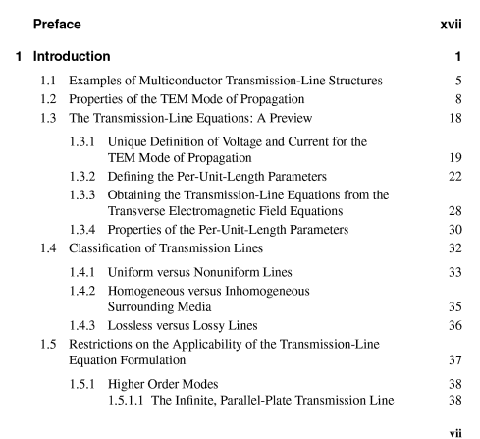

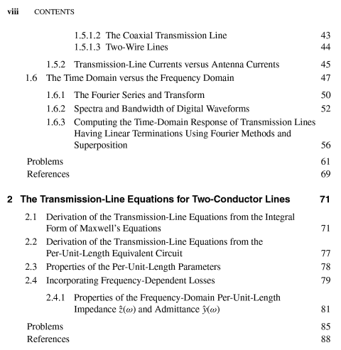

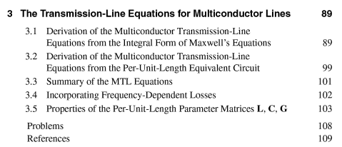

e 