Very Low Frequency Limit of the Appendix D fields PhL 3.9.14

[ On 5.15.14 I carefully reviewed this document. Interestingly, whether or not you include loss in the model, you find that β' → 0 as ω → 0 and this leads to the small argument Bessel limits as noted below and this leads to the fact that Jz is asymmetric is maintained at arbitrarily low ω and in fact approaches the 3D plot shown below. There just seems no way out of this fact beyond that escape hatch fact that I → 0 in this limit as well. I added various red comments in the text below as I went. At the very end I show the most convincing fact:

As β'→0 as ω→0, Helmholtz for Ez → Laplace for Ez which => Am rm cos(mθ) solution

and unless Am coefficient is 0 (I→0), you must have asymmetry in Ez . The only way to make Am vanish is to have I→0 or to have ηm → 0 .This all assumes the two BC's of Appendix D! ]

1. First shot at computing the low ω limit of the E fields. 1
Case 1: Inside the conductor, where β is called β 1
Case 2: Outside the conductor, where β is called β_{d} 2
Examine a Typical Bessel function for low ω 2
Digression on the Symmetries of the Square Bracket Objects 3
What is this small x limit of J_{m}(x) ? 5
What is the small x limit of f_{m} ? m ≥ 0 6
What is the small ω limit of E 6
Calculate and Plot E_{z}(r,θ) at very low frequency. 7
What are the other currents doing for very small ω? 8
What about the B fields from Appendix D? 10
Let's have a look at the z equation itself. 16

1. First shot at computing the low ω limit of the E fields.

I used to have a section in Appendix D on this low frequency limit, but I removed it. Now, I am having confusions in this limit, and that is why I am starting this new doc you are reading.

When the boundary conditions are applied, we find that

Second summary of the E field solutions : Rdc = $\frac{1}{σπa2}$ β'2 = β2 - βd2 (D.2.33)
Ez(r,m) = (1/4) ηm I Rdc (aβ') [$\frac{Jm(x)}{Jm+1(xa)}$ - $\frac{Jm(x)}{Jm-1(xa)}$ ] a = radius ηm ≡ $\frac{Nm}{N0}$
Er(r,m) = (j/4) ηm I Rdc (aβd) [ $\frac{2mx-1Jm(x)}{Jm-1(xa)}$+ $\frac{Jm+1(x)}{Jm+1(xa)}$ - $\frac{Jm+1(x)}{Jm-1(xa)}$ ] x = β'r
Eθ(r,m) = (1/4) ηm I Rdc (aβd) [ - $\frac{2mx-1Jm(x)}{Jm-1(xa)}$+ $\frac{Jm+1(x)}{Jm+1(xa)}$ + $\frac{Jm+1(x)}{Jm-1(xa)}$ ] xa = β'a

One thing we must do carefully is obtain the correct expressions for β and βd and make sure they are correct for very small values of ω. In general we know that

β2 = μεω2 - jωμσ = ω2μ ( ε - jσ/ω) = ω2μ ξ ξ ≡ ε - jσ/ω . (1.5.1)

Case 1: Inside the conductor, where β is called β

β2 = ωμ(ωε -jσ)

At some finite frequency ω, we usually argue that we can say β2 = -jσωμ since σ is so large. You can see that for very small ω, this is even more valid, since then ωε <<< -jσ so to speak. So this seems a viable expression for β2. We choose our usual root of -j and then get

β = [ (j-1)/$\sqrt{2}$] $\sqrt{σωμ}$ = e-3πj/4 $\sqrt{σωμ}$ ok

Case 2: Outside the conductor, where β is called βd

βd2 = ωμd(ωεd -jσd)

I am willing to restrict everything to a vacuum dielectric which really has σd ≡ 0. Then

βd2 = ωμd(ωεd) = ω2 (μdεd) = ω2/vd2 = (1/vd)2 ω2

Summary

β = e3πj/4 $\sqrt{σμ}$ ω1/2 // β = ej3π/4 ($\sqrt{2}$/δ)

βd = (1/vd) ω // later this becomes βd = (1/vd) (ω - jωc)

[ The red correction includes the effect of loss as discussed in "DC limit...". For 8281 fc = 7.7 KHz. ]

You see that these β's differ in their power of ω.

We are often interested in the ratio:

| βd/β| = (1/vd) (1/$\sqrt{σμ}$) ω1/2 // = (1/vd) (1/$\sqrt{σμ}$) $\frac{ω-jωc}{ω1/2}$

We often argue that this ratio is very small since σ is so large for a conductor. Due to the factor ω1/2, this smallness is even more dramatic for very small values of ω. [ But with ωc included, we get the reverse result that | βd/β| becomes very LARGE as ω → 0 ]

Since β'2 = β2-βd2, if the ratio | βd/β| is very small, then we expect β' ≈ β for all practical purposes. Especially for very small ω we expect this to be true, as just noted. so we will assume

β' = β

Just to make sure of this, here is more detail:

β'2 = β2-βd2 = -jσμω - ω2/vd2 = ω [ -jσμ - ω/vd2 ]

so for small ω we get

β' ≈ $\sqrt{-jσμω}$ = e3πj/4 $\sqrt{σμ}$ ω1/2 = β [ valid for ω >> ωc ]

[ But with our red correction, as ω→0 we have | β/βd| → 0 so this means β'2 = -βd2. Then

βd ≈ (1/vd)(-jωc) low ω => β'2 = -βd2 = - (-1) (1/vd)2 ωc2 => β' = ωc/vd

For 8281 coax what is β'a? Recall that a = 394μ and vd = 2 x 108 m/sec and fc = 7770 Hz, so then

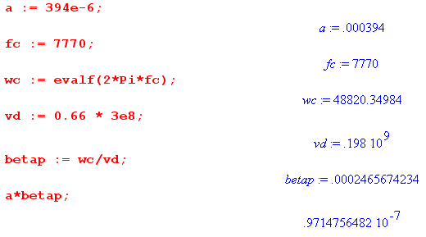

This shows then that as ω→0, if we include the effect of loss, we have xa= β'a ≈ 10-7 = very small. But when we ignored loss, we also found that β' → 0 as shown above, so with or without loss, you want to know about Bessel functions of small argument! ]

Examine a Typical Bessel function for low ω

1. We are really interested in Jm(x) for |x| << 1.

Consider

Jm(x) = Jm(β'r) = Jm(βr) = Jm [e3πj/4 $\sqrt{σμ}$ ω1/2 r ]

Let's work at the maximum value of r which is a, then we have

β a = e-3πj/4 $\sqrt{σμ}$ ω1/2 a

For a normal transmission line, we have

βa = $\sqrt{2}$ej3π/4 (a/δ)

so if we are in the skin depth regime, we think of βa > 1. But in the small region, we will instead have the fact that βa < 1 and in fact βa can be very small as we lower ω, which is our interest today.

So we are then interested in Jm(x) where |x| << 1 in our limit of small ω. correct

Digression on the Symmetries of the Square Bracket Objects

If we define

fm ≡ [$\frac{Jm(x)}{Jm+1(xa)}$ - $\frac{Jm(x)}{Jm-1(xa)}$ ]

then consider

f-m = [$\frac{J-m(x)}{J-m+1(xa)}$ - $\frac{J-m(x)}{J-m-1(xa)}$ ] = - [$\frac{Jm(x)}{Jm-1(xa)}$ - $\frac{Jm(x)}{Jm+1(xa)}$ ] = fm

On the other hand, if we define

gm ≡ [ $\frac{2mx-1Jm(x)}{Jm-1(xa)}$+ $\frac{Jm+1(x)}{Jm+1(xa)}$ - $\frac{Jm+1(x)}{Jm-1(xa)}$ ]

then we find

g-m = [ - $\frac{2mx-1J-m(x)}{J-m-1(xa)}$+ $\frac{J-m+1(x)}{J-m+1(xa)}$ - $\frac{J-m+1(x)}{J-m-1(xa)}$ ]

= [ + $\frac{2mx-1Jm(x)}{Jm+1(xa)}$+ $\frac{Jm-1(x)}{Jm-1(xa)}$ - $\frac{Jm-1(x)}{Jm+1(xa)}$ ] // negative all orders

But there is a Bessel function identity of interest here

or

Jm-1(x) + Jm+1(x) = (2m/x)Jm(x)

We let Maple internally use this identify and we end up with g-m = gm after all:

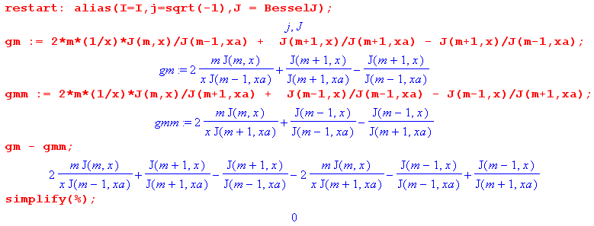

Finally, let's define the third square bracket, where notice that two signs are different(red)

hm ≡ [ - $\frac{2mx-1Jm(x)}{Jm-1(xa)}$+ $\frac{Jm+1(x)}{Jm+1(xa)}$ + $\frac{Jm+1(x)}{Jm-1(xa)}$ ]

so following the above, where we again negate all orders, but now we have two new signs,

h-m ≡ [ - $\frac{2mx-1Jm(x)}{Jm+1(xa)}$+ $\frac{Jm-1(x)}{Jm-1(xa)}$ + $\frac{Jm-1(x)}{Jm+1(xa)}$ ]

In this case we find that

h-m = - hm

as Maple shows:

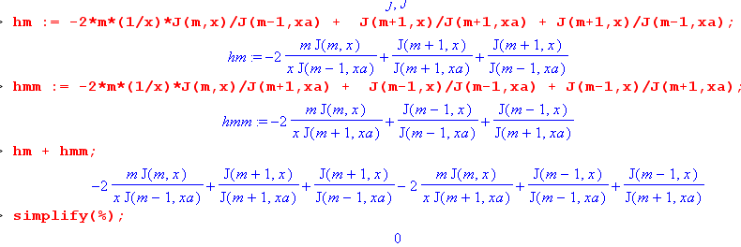
Summary of results: I think these symmetries are all correct

fm ≡ [$\frac{Jm(x)}{Jm+1(xa)}$ - $\frac{Jm(x)}{Jm-1(xa)}$ ] f-m = fm

gm ≡ [ $\frac{2mx-1Jm(x)}{Jm-1(xa)}$+ $\frac{Jm+1(x)}{Jm+1(xa)}$ - $\frac{Jm+1(x)}{Jm-1(xa)}$ ] g-m = gm

hm ≡ [ - $\frac{2mx-1Jm(x)}{Jm-1(xa)}$+ $\frac{Jm+1(x)}{Jm+1(xa)}$ + $\frac{Jm+1(x)}{Jm-1(xa)}$ ] h-m = - hm

We will find below that only fm blows up for small ω because only fm has a term where the power of the numerator is less than the power of the denominator.

What is this small x limit of Jm(x) ?

If we keep only the leading term in the Jm(x) expansion, we get this

therefore

Jm(x) = (x/2)m / m! for m = 0,1,2,.....

But the rule

J-m(x) = (-1)mJm(x)

says then that

J-m(x) = (-1)mJm(x) = (-x/2)m / m! for m = 0,1,2....

However, due to our symmetry rules found above, we can restrict our interest to m ≥ 0 ! ok

What is the small x limit of fm ? m ≥ 0

fm = [$\frac{Jm(x)}{Jm+1(xa)}$ - $\frac{Jm(x)}{Jm-1(xa)}$ ] = [$\frac{(x/2)m / m!}{(xa/2)m+1 / (m+1)!}$ - $\frac{(x/2)m / m!}{(xa/2)m-1 / (m-1)!}$ ]

= [ (m+1) (x/2)m (xa/2)-m-1 - (1/m) (x/2)m(xa/2)-m+1]

= (x/2)m (xa/2)-m [ (m+1) (xa/2)-1 - (1/m) (xa/2) ]

= (r/a)m [ (m+1) (2/β'a) ] since xa→ 0 m > 0

For m = 0 we start over and get twice the first term so

f0 = 2 (x/xa)0 [ (0+1) (xa/2)-1 ] = 2 (2/xa) = 4/xa m = 0

But then I can use the symmetry of fm to extend this to say

fm = (x/xa)|m| [ (|m|+1) (2/xa) ] m ≠ 0

I am concerned that we might need to keep two leading terms due to this subtraction in fm ?

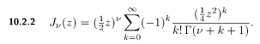

Jm(x) = (x/2)m [ 1/m! - (x2/4) / (m+1)! + O(x4) ]

Well no, this would only matter if the leading terms cancelled, which they do not, so forget that.

[ In "low w limit of fm.mws" I allow the use of any number of leading terms in the Jm(x) limit, but the results are always the same and are as given above. ]

What is the small ω limit of Ez ? m ≥ 0

Ez(r,m) = (1/4) ηm I Rdc (aβ') fm Rdc = $\frac{1}{σπa2}$
= (1/4) ηm I Rdc (aβ') (x/xa)m [ (m+1) (xa/2)-1 ]

= (1/4) ηm I Rdc (aβ') (r/a)m [ (m+1) (2/β'a) ]

= (1/2) (|m|+1) ηm I Rdc (r/a)|m| [ no change here despite βd change due to loss ]

I am rather astounded to find that for m > 0, Ez(r,m) ≠ 0 as we go to very low ω. I always thought the z current was uniform at super low frequency ( I will avoid ω = 0 exactly).

[ So there it is! For either method of handling β' (loss or no loss), conclusion is the same: Jz is asym at ω=0. This says that even at ω = 0, the moments ηm "get into" Ez as shown above. ]

Calculate and Plot Ez(r,θ) at very low frequency.

Ez(r,θ) = $\sum_{m = -∞}^{∞}{}$ Ez(r,m) ejmθ // expansion (A.1)
Ez(r,m) = (1/2π) $^{\int_{-π}^{π}{}}$dθ Ez(r,θ) e-jmθ . // projection (A.2)

Method A:
Ez(r,θ) = $\sum_{m = -∞}^{∞}{}$ Ez(r,m) ejmθ = $\sum_{m = -∞}^{∞}{}$ (1/4) ηm I Rdc (aβ') fm ejmθ

But I know that both ηm and fm are symmetric in m, so we get

= (1/4) I Rdc (aβ') f0 + (1/2) I(aβ')Rdc $\sum_{m = 1}^{∞}{}$ ηm fm cos(mθ)
= (1/4) I Rdc (aβ') (4/xa) + (1/2) I(aβ')Rdc $\sum_{m = 1}^{∞}{}$ ηm fm cos(mθ)
= (1/4) I Rdc (aβ') (4/aβ') + (1/2) I(aβ')Rdc $\sum_{m = 1}^{∞}{}$ ηm fm cos(mθ)
= I Rdc + (1/2) I(aβ')Rdc $\sum_{m = 1}^{∞}{}$ ηm fm cos(mθ)
= I Rdc [ 1 + (1/2) (aβ') $\sum_{m = 1}^{∞}{}$ ηm fm cos(mθ) ] // ηm ≡ Nm/N0 = (-1)m e-|mξ$_{1}$|
= I Rdc [ 1 + (1/2) (aβ') $\sum_{m = 1}^{∞}{}$ ηm (x/xa)|m| [ (|m|+1) (2/xa) ] cos(mθ) ]
= I Rdc [ 1 + $\sum_{m = 1}^{∞}{}$ ηm (x/xa)|m| [ (|m|+1)] cos(mθ) ]
= I Rdc [ 1 + $\sum_{m = 1}^{∞}{}$ (-1)m e-|mξ$_{1}$| (r/a)|m| [ (|m|+1)] cos(mθ) ]

Therefore I find that as ω → 0, Ez(r,θ) approaches this asymmetric shape which is indep of ω :

Ez(r,θ) = I Rdc [ 1 + $\sum_{m = 1}^{∞}{}$ (-1)m e-m|ξ$_{1}$| (r/a)m [ (m +1)] cos(mθ) ]

and here is a plot where I set ξ1 = -2, which is supposedly the wide-spaced twin lead

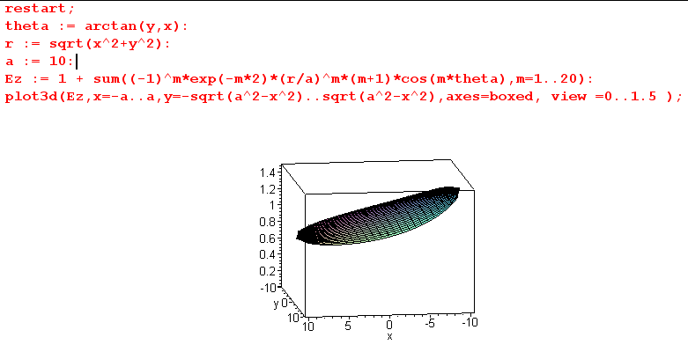

I don't believe this large amount of asymmetry. I need an external source on this subject!!!

This is very mysterious, I just don't believe it. Everything has now come to a complete halt! I have to decide whether or not I believe my Appendix D fields. If I do, then I need to understand why DC current would be asymmetric as the above plot shows. The web is turning up nothing on this subject , I don't have a search handle that works. still mysterious on 5.14.14

[ Here is a later plot for ξ = 0.75 which shows an even stronger effect, from "very low freq 1.mws"

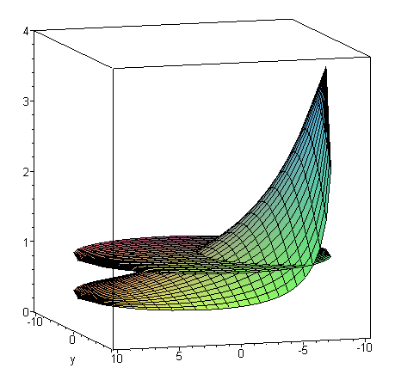

This then is the constant shape indep of ω which you get for low ω. Notice there is no "skin effect" visible and in fact current seems larger toward the conductor center. ]

What are the other currents doing for very small ω?

Er(r,m) = (j/4) ηm I Rdc (aβd)gm

gm ≡ [ $\frac{2mx-1Jm(x)}{Jm-1(xa)}$+ $\frac{Jm+1(x)}{Jm+1(xa)}$ - $\frac{Jm+1(x)}{Jm-1(xa)}$ ]

= [ $\frac{2mx-1 (x/2)m / m!}{(xa/2)m-1 / (m-1)!}$+ $\frac{(x/2)m+1 / (m+1)!}{(xa/2)m+1 / (m+1)!}$ - $\frac{(x/2)m+1 / (m+1)!}{(xa/2)m-1 / (m-1)!}$ ]

Now

$\frac{2mx-1 (x/2)m / m!}{(xa/2)m-1 / (m-1)!}$ = $\frac{2mx-1(x/2)m}{(xa/2)m-1 m}$ = $\frac{(x/2)m-1}{(xa/2)m-1}$ = (x/xa)m-1 = (r/a)m-1

$\frac{(x/2)m+1 / (m+1)!}{(xa/2)m+1 / (m+1)!}$ = (x/xa)m+1

$\frac{(x/2)m+1 / (m+1)!}{(xa/2)m-1 / (m-1)!}$ = $\frac{(x/2)m+1}{(m+1)m(xa/2)m-1}$ = (x/xa)m (x/2)(xa/2) / [m(m+1)]

Therefore

gm = (r/a)m-1 + (r/a)m+1 + (r/a)m (β2ra/4) / [m(m+1)]

It would seem that for small ω, we can neglect the β2 term and we then have

gm = (r/a)m-1 + (r/a)m+1 // small ω

[ the gm mws gives this same result for m > 0. We need a different expression for g0 since our J expansion is not valid for J-1. ]

Then

Er(r,m) = (j/4) ηm I Rdc (aβd)gm = (j/4) ηm I Rdc (aβd) [(r/a)m-1 + (r/a)m+1]

and thanks to βd this term → 0 as ω → 0 for all m. Thus Er(r,θ) → 0 as ω→0.

[ Change: As ω → 0, we get βd → -jωc/vd and then we have

Er(r,m) = (j/4) ηm I Rdc (a[-jωc/vd]) [(r/a)m-1 + (r/a)m+1]

= (1/4) ηm I Rdc (aωc/vd) [(r/a)m-1 + (r/a)m+1]

=> Er(a,m) = (1/2) ηm I Rdc (aωc/vd) ≠ 0 ωc = vdα

=> Er(a,m) = (1/2) ηm I Rdc (aα) ≠ 0 α = loss coefficient

= (1/2) ηm I Rdc (a RdcC (vd/2)) = (1/2) ηm (I Rdc2) a C (vd/2)

and this does NOT vanish as ω → 0. This needs an interpretation! ]

Next

Eθ(r,m) = (1/4) ηm I Rdc (aβd) hm

Now hm differs by two signs, so I expect to get

hm = - (r/a)m-1 + (r/a)m+1 very small ω

and then

Eθ(r,m) = (1/4) ηm I Rdc (aβd) [- (r/a)m-1 + (r/a)m+1]

and this too → 0. So Ez is the only Problem Child. The reason is that for the other fields, the gm and hm don't blow up as ω→0, but fm does blow up!

Conclusion: My equations are saying that the Jz current is asymmetric even at ω= 0, and I cannot find anything wrong. agreed 5.14.14

If this is correct, then the asymmetry is being caused by one of two things:
(1) the magnetic field due to the other wire
(2) the magnetic field gradient due to the other wire. [ both in fact for ω>0, see App P ]

[ so this I guess is how I got all involved with the Hall effect at this point. ]

If (1) were true, then you would expect to see this asymmetry effect in a conductor sitting in a uniform external magnetic field! That might be a problem I can find somewhere. The Lorentz force on electrons might create a transverse voltage and charge density on the conductor surfaces, maybe this is related to the Hall effect. Well, that is precisely the Hall effect, here from wiki

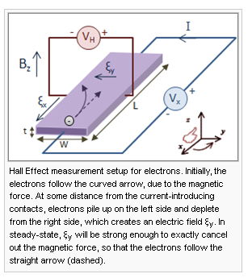
Web searching, hard to find stuff.

" The current distribution on the conductor cross-section is not uniform as long as the current varies with tim

What about the B fields from Appendix D?

[ Well, I don't care so much about B on 5.15.14, but this did lead me to write the various limit mws programs so I could verify all those limit results used above. ]

Bz(r,m) = (β'/ω) ($\frac{Km}{2}$ + $\frac{am}{m}$ )Jm(x)
Br(r,m) = j(β'/ω){ + ( m$\frac{Km}{2}$ $\frac{β'}{βd}$ - $\frac{βd}{β'}$ am) x-1Jm(x) + $\frac{βd}{β'}$ ($\frac{Km}{2}$ + $\frac{am}{m}$ ) Jm+1(x) }
Bθ(r,m) = (β'/ω){ - ( m$\frac{Km}{2}$ $\frac{β'}{βd}$ - $\frac{βd}{β'}$ am) x-1Jm(x) + $\frac{Km}{2}$ ( $\frac{βd}{β'}$ + $\frac{β'}{βd}$ ) Jm+1(x) } , (D.4.8)

am = (j/4) (aβd) ηm I Rdc * 2m $\frac{1}{Jm-1(xa)}$
$\frac{Km}{2}$ = (j/4) (aβd) ηm I Rdc * [$\frac{1}{Jm+1(xa)}$ – $\frac{1}{Jm-1(xa)}$ ]
($\frac{Km}{2}$+ $\frac{am}{m}$ ) = (j/4) (aβd) ηm I Rdc * [$\frac{1}{Jm+1(xa)}$ + $\frac{1}{Jm-1(xa)}$ ] .

First, look at Bz . There we see this combination of coefficients:

[$\frac{1}{Jm+1(xa)}$ + $\frac{1}{Jm-1(xa)}$ ] Jm(x) (β'/ω) (aβd)

Now [$\frac{1}{Jm+1(xa)}$ + $\frac{1}{Jm-1(xa)}$ ] Jm(x) is the same as in Ez with sign change second term which did not contribute anything, so this term should be the exact same as fm in our limit:

fm = (r/a)m [ (m+1) (2/βa) ] m ≠ 0 and f0 = 4/βa

Thus, the combined coefficient on Bz for all values of m looks like

(r/a)m [ (m+1) (2/βa) ] (β/ω) (aβd) = (r/a)m [ (m+1) 2 ] (1/ω) (βd)

= (r/a)m [ (m+1) 2 ] (1/ω) (1/vd) ω = (r/a)m [ (m+1) 2 ] (1/vd)

And thus we get

Bz(r,m) = (β'/ω) ($\frac{Km}{2}$ + $\frac{am}{m}$ )Jm(x)
= (β'/ω) Jm(x) (j/4) (aβd) ηm I Rdc * [$\frac{1}{Jm+1(xa)}$ + $\frac{1}{Jm-1(xa)}$ ]

= { (β'/ω) Jm(x) (aβd) [$\frac{1}{Jm+1(xa)}$ + $\frac{1}{Jm-1(xa)}$ ]} (j/4) ηm I Rdc

= (j/4) ηm I Rdc (r/a)m [ (m+1) 2 ] (1/vd) m > 0

= (j/4) I Rdc 4 (1/vd) m= 0

Now this is a VERY strange result and I am sure must be wrong.

I think I need a more automated way to compute all these limits using Maple, there is too much room for algebraic error. I learn just now that the series thing returns a special non-usable type=series data structure and only works for specific m. Suppose I roll my own using the following which I regard OK m = 0,1,2

This works very well. For example,

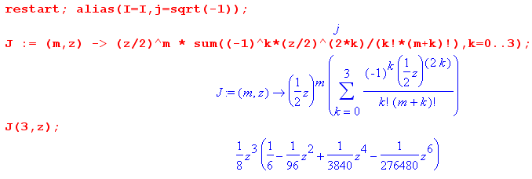

so as a fringe benefit I can keep any number of series terms I want. However, this expansion should not be used for m = -1,-2 and so on because our factorial (m+k)! is then ill-defined. Just don't use it!
Now look at

fm ≡ [$\frac{Jm(x)}{Jm+1(xa)}$ - $\frac{Jm(x)}{Jm-1(xa)}$ ]

For m ≥ 1 we can use the above expansion, while m = 0 needs to be a special case where we know we can drop the second term and double the first term.

OK, I have now written "low w limit of fm.mws" and the results it gives are these:

β fm → (r/a)m (m+1) (2/a) compare fm = (x/xa)|m| [ (|m|+1) (2/xa) ]
β f0 → (4/a) compare f0 = 4/xa

You have to rerun the program until it does a certain power simplification of (βr)m (βa)-m = (r/a)m. When it does not do this, you get a divide by 0 error.

Now let's make a version of this program that does my Bz calculation

Bz(r,m) = (β'/ω) ($\frac{Km}{2}$ + $\frac{am}{m}$ )Jm(x)
= (β'/ω) (j/4) ηm I Rdc (aβd) * [$\frac{Jm(x)}{Jm+1(xa)}$ + $\frac{Jm(x)}{Jm-1(xa)}$ ]

= (β'/ω) (j/4) ηm I Rdc (aβd) * sm

Notice that s0 ≡ 0 so right off we know there is no m = 0 component!
Program is "low w limit of sm.mws" . The result is

β sm → (r/a)m (m+1) (2/a)

which is of course the same result as for Ez. We then get

Bz(r,m) = (β/ω) (j/4) ηm I Rdc (aβd) * sm =

= (1/ω) (j/4) ηm I Rdc aβd * (βsm) =

= (1/ω) (j/4) ηm I Rdc a[(1/vd) ω] * (r/a)m (m+1) (2/a)

= (j/4) ηm I Rdc a[(1/vd) ] * (r/a)m (m+1) (2/a)

and this replicates our strange result of Bz activity in the m≠0 partial waves, though Bz(r,0) = 0.

Let's now try Bθ :

Bθ(r,m) = (β'/ω){ - ( m$\frac{Km}{2}$ $\frac{β'}{βd}$ - $\frac{βd}{β'}$ am) x-1Jm(x) + $\frac{Km}{2}$ ( $\frac{βd}{β'}$ + $\frac{β'}{βd}$ ) Jm+1(x) }

I am going to get more Maple oriented now. Write

am = (j/4) (aβd) ηm I Rdc * 2m $\frac{1}{Jm-1(xa)}$
$\frac{Km}{2}$ = (j/4) (aβd) ηm I Rdc * [$\frac{1}{Jm+1(xa)}$ – $\frac{1}{Jm-1(xa)}$ ]

Let's define

Q = (j/4) ηm I Rdc

so then

am = Q (aβd) * 2m $\frac{1}{Jm-1(xa)}$
$\frac{Km}{2}$ = Q (aβd) * [$\frac{1}{Jm+1(xa)}$ – $\frac{1}{Jm-1(xa)}$ ]

Next write

β = e3πj/4 $\sqrt{σμ}$ ω1/2 = c ω1/2 = cu c = e3πj/4 $\sqrt{σμ}$

βd = (1/vd) ω = (w/v) = u2/v

I now have a more sophisticated Maple program which I can now describe.
Program is "low w limit of Btheta.mws".

1. First, get the quantities of interest entered, where I replace ω everywhere by u2 in order to avoid having the factor $\sqrt{ω}$ lying around which complicates life for Maple. Also b = β and bd = βd . We can easily check the entries against above.

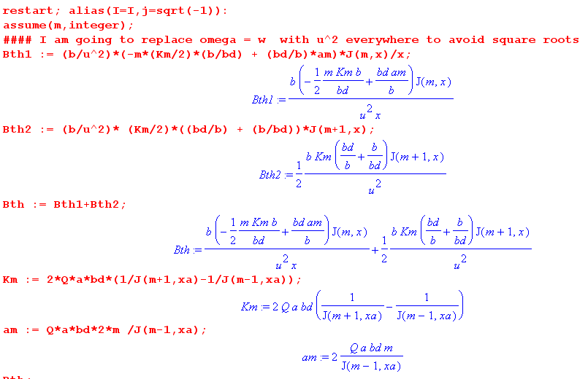

Now set in the constants and series for the J function

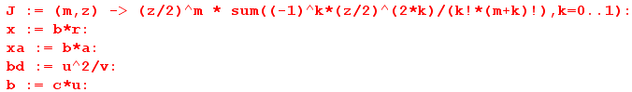

At this point, Bth is a big mess, but if we expand and then simplify,

we end up with

Btha = -(Q/4)(poly(u) / [ u2 poly(u) ]

We can then have it compute

and then just set u = 0 to get a result. The result is this:

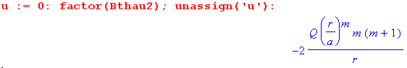

which is valid only for m = 1,2,3... Notice that constant c does not appear. There are lots of c's sitting in Btha above, but they are always multiplied by powers of u and these go away.
Now in the above I kept the first two terms in the Jm(x) expansion. If I increase to three terms, program is a little slower, but get exact same answer!
The result here is this:

ω Bθ(r,m) = -2Qm(m+1)(r/a)m (1/r)

= -2 (j/4) ηm I Rdc m(m+1)(r/a)m (1/r)

Dimensions seem odd.

LHS = sec-1 amp henry/m2 = sec-1 amp ohm-sec /m2 = amp ohm/m2 = volt/m2

RHS = amp (ohm/m) (1/m) = volt/m2 so OK

So fine, I now have a reliable method of computing things like this in Maple.

I can do the m = 0 result by hand:

Bθ(r,m) = (β'/ω){ - ( m$\frac{Km}{2}$ $\frac{β'}{βd}$ - $\frac{βd}{β'}$ am) x-1Jm(x) + $\frac{Km}{2}$ ( $\frac{βd}{β'}$ + $\frac{β'}{βd}$ ) Jm+1(x) }
Bθ(r,0) = (β'/ω){ - ( 0 $\frac{K0}{2}$ $\frac{β'}{βd}$ - $\frac{βd}{β'}$ a0) x-1J0(x) + $\frac{K0}{2}$ ( $\frac{βd}{β'}$ + $\frac{β'}{βd}$ ) J1(x) }

= (β'/ω){ $\frac{K0}{2}$ ( $\frac{βd}{β'}$ + $\frac{β'}{βd}$ ) J1(x) }

a0 = Q (aβd) * 20 $\frac{1}{Jm-1(xa)}$ = 0
$\frac{K0}{2}$ = 2 Q (aβd) * $\frac{1}{J1(xa)}$

I added code at the end of the above program and it shows that

Bθ(r,0) = 2 c2Q r = 2Qr (e3πj/4 $\sqrt{σμ}$)2 = -j2Qr σμ

= -j2(j/4) η0 I Rdc r σμ

= (1/2) I Rdc r σμ = (1/2) I(1/σπa2) r σμ

= (μI/2π)(r/a2) // dim(RHS) = henry/m * amp * 1/m = correct!

which says

Hθ = (I/2π)(r/a2)

But my usual method says 2πrHθ = I (r2/a2) => Hθ = (I/2π)(r/a2) which is what I got. So that is good news. At least the m = 0 component here does what I expect!

But again, how should I interpret this low frequency result:

ω Bθ(r,m) = -2 (j/4) ηm I Rdc m(m+1)(r/a)m (1/r) m = 1,2,3....

It does not even make sense as ω → 0 !! Something is very wrong as usual.

Dimensions: since curl E = -jωB, I know that dim(ωB) = dim(E)/m = volts/m2 = dim(LHS)

dim(RHS) = volts/m * 1/m = volts/m2 so OK

So my question above is really a question about curl E = -jωB . If you have some fixed curl E due to some fixed E field, then you must have B→∞ as ω→0. In my case I have

curl E = [ r-1∂θEz - ∂zEθ] + [∂zEr - ∂rEz] + [ r-1∂r(rEθ) - r-1∂θEr ]

But as ω→0, the Er and Eθ m > 0 moments all vanish, but Ez does not, so I guess I have

curl E = [ r-1∂θEz ] + [- ∂rEz ] = [ r-1jm Ez ] + [- ∂rEz ]

and then I get

-jωBθ = [curl E]θ = - ∂rEz = -∂r { (1/2) (|m|+1) ηm I Rdc (r/a)|m| }

= -(1/2) (m+1) ηm I Rdc m (r/a)m-1 (1/a)

= -(1/2) (m+1) ηm I Rdc m (r/a)m (1/r)

=> ωBθ =- j(1/2) (m+1) ηm I Rdc m (r/a)m (1/r)

which is exactly my result from above

ω Bθ(r,m) = -2 (j/4) ηm I Rdc m(m+1)(r/a)m (1/r)

so I guess this result is correct. Once again

ω Bθ(r,m) = - (j/2a) ηm I Rdc m(m+1)(r/a)m-1 dim checks!

But still, if I am trying to take the limit ω → 0, what does this say? I am totally confused by the interpretation of this result! It really does say that Bθ(r,m) → ∞. Maybe this is a clue as to my overall problem. What is says is that I need to have Ez(r,m)→ 0 or else I have this disaster.

Question: Why is Bθ(r,m) = ∞ as we approach DC ?

I just add this to the list for a while. // Well, in the lines edit log, I think I have an explanation of this fact.

[ The Z0 Escape Hatch says I →0 and then this problem goes away! ]

2. Let's have a look at the z equation itself.

[r2∂r2 + r ∂r + (r2 β'2 - m2)] Ez(r,m) = 0 (D.2.1)

This nice thing is that this stands entirely alone, no entanglement with Er and Eφ. Just suppose (not justified) that for low ω we could neglect the β'2 term to get

[r2∂r2 + r ∂r - m2] Ez(r,m) = 0 (D.2.1)

Maple says

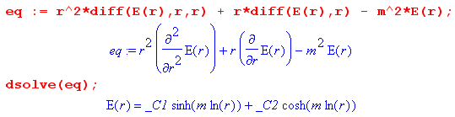

For m ≠ 0, the term cosh(mln(r)) is like emlnr + e-mlnr = rm + r-m. These are the real solutions and we have to throw out r-m for m>0 so we basically have

Ez(r,m) = K rm

and this in fact agrees with the result I could above which was

Ez(r,m) = (1/2) (|m|+1) ηm I Rdc (r/a)|m| [ no change here despite βd change due to loss ]

[ This last method is quite convincing! If you go right to the bare bones Helmholtz equation for Ez(r,m), you find that the m > 0 solutions do not vanish as ω→0 and you have the asymmetry, apart from the escape hatch fact that I → 0. ]

[ Basically as β'→0, the Helm (∇2+β'2)Ez = 0 equation becomes Laplace (∇2)Ez(r,θ) = 0 and we know the atom forms for this equation to be [ r±m, e±imθ ] and this is what we are seeing here! ]

