Very Low Frequency Limit of the Appendix D fields, Version 2 PhL 3.13.14

[ Reviewed on 5.15.14 after reviewing the original doc. Basically I just summarize the results and there is nothing new happening here, the mystery continues unabated. I assume only the no-loss β'=β here but the original doc shows same conclusions for loss or no loss. ]

Here I am going to redo the "version 1" results all using Maple, to eliminate possible algebra errors.

1. Consider fm = [$\frac{Jm(x)}{Jm+1(xa)}$ - $\frac{Jm(x)}{Jm-1(xa)}$ ] . f-m = fm says Version 1

In "low w limit of fm.mws" I show that, in agreement with Version 1 of this doc,

fm = (2/aβ) (m+1)(r/a)m m > 0
f0 = (4/aβ) m = 0 β = e3πj/4 $\sqrt{σμ}$ ω1/2

I note the strange fact that these things all blow up as 1/$\sqrt{ω}$ and therefore Ez(r,m) do not vanish.

2. Consider gm ≡ [ $\frac{2mx-1Jm(x)}{Jm-1(xa)}$+ $\frac{Jm+1(x)}{Jm+1(xa)}$ - $\frac{Jm+1(x)}{Jm-1(xa)}$ ]. g-m = gm says Version 1

In "low w limit of gm.mws" I show that,

gm = (1/ar) (r2+ a2)(r/a)m = (r/a)m+1 + (r/a)m-1 m> 0
g0 = 2(r/a) m = 0

Neither of these blows up as ω→ 0.

3. Consider hm ≡ [- $\frac{2mx-1Jm(x)}{Jm-1(xa)}$+ $\frac{Jm+1(x)}{Jm+1(xa)}$ + $\frac{Jm+1(x)}{Jm-1(xa)}$ ]. h-m = - hm says Version 1

In "low w limit of hm.mws" I show that,

hm = (1/ar) (r2- a2)(r/a)m = (r/a)m+1 - (r/a)m-1 m> 0
h0 = 2(r/a) m = 0

Neither of these blows up as ω→ 0.

4. Now consider

Second summary of the E field solutions : Rdc = $\frac{1}{σπa2}$ β'2 = β2 - βd2 (D.2.33)
Ez(r,m) = (1/4) ηm I Rdc (a β) fm a = radius ηm ≡ $\frac{Nm}{N0}$
Er(r,m) = (j/4) ηm I Rdc (aβd) gm x = β'r

Eθ(r,m) = (1/4) ηm I Rdc (aβd) hm xa = β'a

I don't understand the following blue text which involves "α" which has never been defined in this doc, so I am going to redo all this in black text following. Also, various things are done wrong in the blue!

Thus, for m > 0 we find that, for ω → 0,

Ez(r,m) = (1/4) ηm I Rdc (aβ) (2/aβ) (m+1)(r/a)m = (1/2) ηm I Rdc (m+1)(r/a)m

Er(r,m) = (j/4) ηm I Rdc (aβd) gm = (j/4) ηm I Rdc (-ajα) (1/ar) (r2+ a2)(r/a)m

Eθ(r,m) = (1/4) ηm I Rdc (aβd) hm = (1/4) ηm I Rdc(-ajα) (1/ar) (r2- a2)(r/a)m

Then for m = 0 we get instead, as ω → 0,

Ez(r,0) = (1/4) I Rdc(aβ) f0 = (1/4) I Rdc(aβ) (4/aβ) = I Rdc

Er(r,0) = (j/4) I Rdc (aβd) g0 = (j/4) I Rdc (aβd)2(r/a) = (j/4) I Rdc(-ajα)2(r/a)

Eθ(r,0) = (1/4) I Rdc (aβd) h0 = (1/4) I Rdc (aβd) 2(r/a) = (1/4) I Rdc(-ajα)2(r/a)

To summarize:

Ez(r,m) = (1/2) ηm I Rdc (m+1)(r/a)m for m > 0
Ez(r,0) = I Rdc for m = 0

Er(r,m) = 0 for all m => Er(r,θ) = 0

Eθ(r,m) = 0 for all m => Eθ(r,θ) = 0

For m > 0 we find that, for ω→0,

Ez(r,m) = (1/4) ηm I Rdc (aβ) (2/aβ) (m+1)(r/a)m = (1/2) ηm I Rdc (m+1)(r/a)m

Er(r,m) = (j/4) ηm I Rdc (aβd) gm = (j/4) ηm I Rdc (aβd) [(r/a)m+1 + (r/a)m-1]

Eθ(r,m) = (1/4) ηm I Rdc (aβd) hm = (1/4) ηm I Rdc (aβd) [(r/a)m+1 - (r/a)m-1]

For m = 0 we find that, for ω→0,

Ez(r,0) = Ez(r,0) = (1/4) I Rdc (a β) (4/aβ) = I Rdc

Er(r,0) = (j/4) I Rdc (aβd) g0 = (j/4) I Rdc (aβd) 2(r/a) = (j/2) I Rdc (rβd)

Eθ(r,0) = (1/4) I Rdc (aβd) h0 = (j/4) I Rdc (aβd) 2(r/a) = (j/2) I Rdc (rβd)

To summarize:

Ez(r,m) =(1/2) ηm I Rdc (m+1)(r/a)m
Ez(r,0) = I Rdc

Er(r,m) = (j/4) ηm I Rdc (aβd) [(r/a)m+1 + (r/a)m-1]
Er(r,0) = (j/2) I Rdc (rβd)

Eθ(r,m) = (1/4) ηm I Rdc (aβd) [(r/a)m+1 - (r/a)m-1]
Eθ(r,0) = (j/2) I Rdc (rβd)

These fields should satisfy div E = 0 in (D.1.20) :

div E = 0 :
∂r [r Er(r,m)] + jmEθ(r,m) -jβd r Ez(r,m) = 0 (D.1.19)

The first two terms are zero, then so is the third due to βd. [ ??? ]

How about this equation?

[∇2E]z + β2 Ez = 0 :
[r2∂r2 + r ∂r - m2 + r2 ( β2- βd2)] Ez(r,m) = 0 (D.1.15)

Since both β and βd vanish, we have really just

[r2∂r2 + r ∂r - m2] Ez(r,m) = 0

For m = 0, Ez(r,0) = I Rdc satisfies it.

And the m > 0 is also OK, says Maple,

[r2∂r2 + r ∂r - m2] rm

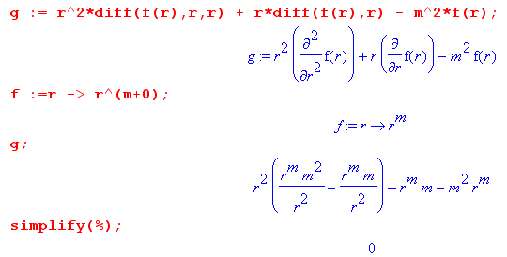

I keep checking and checking and can find nothing wrong.

5. Compute Ez(r,θ)

I did this in Version 1 and I just checked it. Here is the result.

Ez(r,θ) = $\sum_{m = -∞}^{∞}{}$ Ez(r,m) ejmθ = $\sum_{m = -∞}^{∞}{}$ (1/4) ηm I Rdc (aβ') fm ejmθ
= I Rdc + (1/2) I(aβ')Rdc $\sum_{m = 1}^{∞}{}$ ηm fm cos(mθ)
= I Rdc [ 1 + $\sum_{m = 1}^{∞}{}$ (-1)m e-m|ξ$_{1}$| (r/a)m [ (m+1)] cos(mθ) ]

Put this in a box:

Ez(r,θ) = I Rdc [ 1 + $\sum_{m = 1}^{∞}{}$ (-1)m e-m|ξ$_{1}$| (r/a)m [ (m+1)] cos(mθ) ]

Just for fun, compare this with the following result from bipolar doc

n1(ξ1,θ) = (q/2π)[ 1 + 2 $\sum_{m = 1}^{∞}{}$ (-1)m e-m|ξ$_{1}$| cos(mθ) ] (A.13)

Now let's check the divergence again.

∂r (r Er) + ∂θEθ + r ∂zEz = 0 .

r (-jβd)Ez = 0 . OK

Check the Ez Helmholtz again:

[∂r2 + (1/r) ∂r + (1/r2) ∂θ2 + ∂z2 + β2 ] ej(ωt-β$_{d}$z)Ez(r,θ) = 0 . (1)

[∂r2 + (1/r) ∂r + (1/r2) ∂θ2 + β2 - βd2 ] ej(ωt-β$_{d}$z)Ez(r,θ) = 0

[∂r2 + (1/r) ∂r + (1/r2) ∂θ2 + β2 - βd2 ] Ez(r,θ) = 0

Again, at ω = 0 we have β2 - βd2 = 0 so the "1" is clearly OK. Other terms are

[∂r2 + (1/r) ∂r + (1/r2) ∂θ2 ] (r/a)m cos(mθ)
or
[∂r2 + (1/r) ∂r -m2 (1/r2)] (r/a)m cos(mθ)
or
[∂r2 + (1/r) ∂r -m2 (1/r2)] (r/a)m
or
[r2∂r2 + r ∂r -m2] (r/a)m

and Maple just showed above that this vanishes, so Helm is OK.

Maple does not give a special function for Ez(r,θ) above [?] . I can only plot it. Here is for ξ1 = 0.75:
Maple code: "very low freq 1.mws".

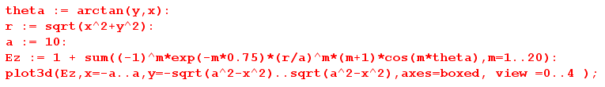
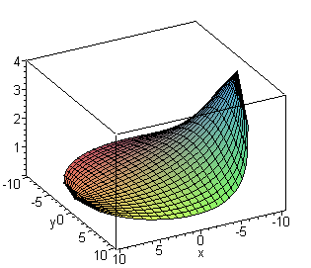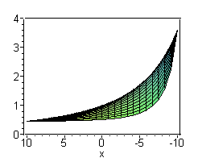

This shows an extremely asymmetric Jz for the relatively distance value ξ1 = 0.75

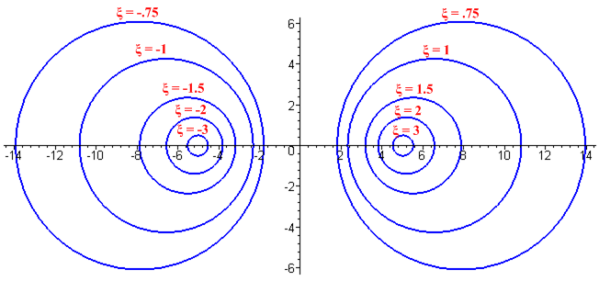

So the mystery continues!

6. Here is another path to look at. First, consider just the ratio

$\frac{Ez(r,m)}{Ez(a,m)}$ = $\frac{Jm(x)}{Jm+1(xa)}$$\frac{Jm(x)}{Jm-1(xa)}$$\frac{Jm(xa)}{Jm+1(xa)}$$\frac{Jm(xa)}{Jm-1(xa)}$ = $\frac{Jm(x)}{Jm(xa)}$ * $\frac{1}{Jm+1(xa)}$$\frac{1}{Jm-1(xa)}$$\frac{1}{Jm+1(xa)}$$\frac{1}{Jm-1(xa)}$ = $\frac{Jm(x)}{Jm(xa)}$

Then we have this very simple fact

$\frac{Ez(r,m)}{Ez(a,m)}$ = $\frac{Jm(x)}{Jm(xa)}$

We know that for small x,

Jm(x) = (x/2)m / m! for m = 0,1,2,.....

J-m(x) = (-1)mJm(x)

So then the result is easily stated,

$\frac{Ez(r,m)}{Ez(a,m)}$ = (r/a)m

This is consistent with what I found above

Ez(r,m) = (1/2) ηm I Rdc (m+1)(r/a)m for m > 0
Ez(r,0) = I Rdc for m = 0

This new simple form raises an interesting question

Question: We have found that

$\frac{Jz(r,m)}{Jz(a,m)}$ = (r/a)m in limit ω → 0

In the parallel plate case, as ω → 0, the expo into the conductor just spreads out and the current moves away from the gap and becomes even. But in the two cylinders case, maybe there is no place for the current to go? It cannot move out to infinity.

