Whiteboard Regarding Asymmetry of Jz PhL photo 8.6.14

First part is this: (left side of photo) // an earlier whiteboard display.

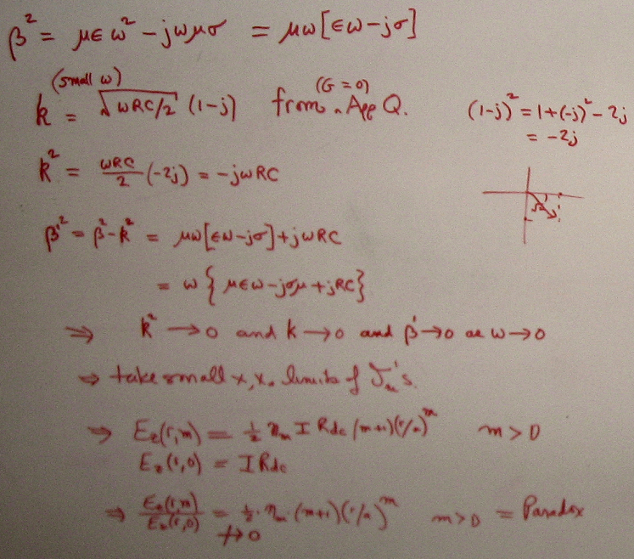

This shows with standard form for k that as ω→0, all three objects β,k,β' → 0. Since β'→0, we use the small arg limits of the Bessel functions in fm and we end up with the ratio on the bottom not approaching 0, and this is our anomaly or paradox. It means the Ez and Jz current distribution is asymmetric even when ω = 0, and we think this strange since we expect naively that Jz should be a constant at ω = 0.

Next, we make different assumptions about what happens to k as ω → 0. The assumptions here are different power possibilities:

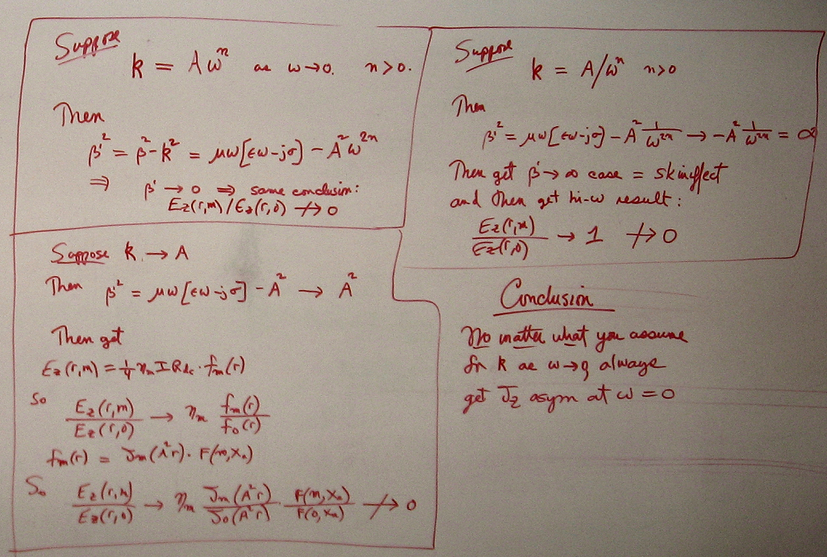

Correction: on top right, should say → ηm instead of → 1, but conclusion is the same.

I show three different possibilities. In each case, however, one finds again that that ratio does not → 0 and we end up with Jz asymmetry. In the first case above, we again get β'→0 so can use the Bessel function limits as previously. In the last two cases, we are stuck with ratios of fm as shown, but in general these ratios also do not → 0, so the conclusion remains as stated on the lower right.

The point is this: regardless of how k behaves near ω = 0, we always get Jz asymmetry.

Having written D.11 on this limit, I am less concerned about it now. If G = 0, the current charges the caps along the line, and as ω → 0, the caps are still there and still need charging and discharging. Since n(θ) is asym, so is Jr to charge and discharge, and then through div E = 0 we find Jz is also asym. It just happens that once ω is small enough, the shape of the asym becomes constant, as shown in D.11. I originally through that this shape should gradually approach a constant, but that is not what happens! Also, this is not the eddy current problem with two cylinders with a short and one end.

// However, I later constructed this shorted two-cylinder problem (see "Plan C Revised") and it too has this same asymmetry of Jz.

