Appendix B Version 2 PhL 11.19.13

History: I wrote this Appendix in a separate doc, then installed it into lines and probably did some edits. I then ran into "the Disaster" and also added new BC things to Sec 1.1. Today I take a copy of the current lines version of App B and put it right here where I will do some corrective editing.

Appendix B: Magnetization Surface Currents on a Conductor

Overview

When a conductor of magnetic permeability μ2 is embedded in a medium of μ1 with μ1 ≠ μ2, a "bound current" appears on the conductor surface. This so-called magnetization current must be accounted for when computing quantities like the B field or vector potential A.

Section B.1 shows how this surface current K is related to the H field at the surface.
Section B.2 shows how to compute H from the volume current density J.
Section B.3 then outlines a general plan for computing surface current K for an arbitrary conductor.

The above sections apply in both AC and DC conditions (ω > 0 and ω = 0). The remaining three sections consider the simple case of a round wire where the volume current Jz is uniform in the conductor, a situation that arises at DC and low frequency where there is no skin effect.

Section B.4 computes H and the surface current K for a round wire using symmetry.
Section B.5 repeats the calculation using the general method outlined in Section B.3.
Section B.6 assumes the K computed above, along with uniform Jz, and computes from these the vector potential A. Then B = curl A and H = B/μ and the simple results of Section B.4 are replicated.

The conductors considered here are those of a transmission line in the "transmission line limit" in which it is assumed that the wavelength along the line is much longer than the transverse dimensions of the line. In this case, it is reasonable to use 2D wave equations whose solutions then involve use of the 2D Poisson free-space propagator ln(R/2π) as discussed in Appendix I.

B.1 Relationship between surface current K and the field H at a conductor boundary

First, consider this blow up of a piece of the boundary between a conductor (medium 2) and a dielectric (medium 1). Both media extend uniformly in the z direction, so we are looking at a piece of the cross section of a transmission line at a particular point on the surface of one of the conductors.

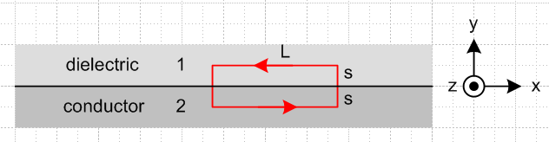 Fig B.1

We shall assume that the conduction current in the conductor is positive in the z direction, so J = Jz with Jz > 0. Since the lower medium is the conductor in the drawing, the B and H field at the boundary are in the - direction, that is to say, they point to the left due to the right hand rule relating J and B or H .
We expect to find at the boundary between two dissimilar media (μ1≠μ2) a magnetization surface current. Since this is not a "free" surface current (it is a "bound" current), we have Kzfree = 0 in (1.1.44) and we may then conclude that

Hx2 = Hx1 (1/μ1)Bx1 = (1/μ2)Bx2 . (B.1.1)

Since B can "see" this magnetization current, Bx takes a jump at the boundary, whereas Hx does not.

Assuming μ2 ≥ μ1 (which would be the case if μ1 = μ0), the right equation implies |Bx2| ≥ |Bx1| so the B field is larger inside the conductor. But in our picture, both Bx2 and Bx1 are negative, so -Bx2 ≥ - Bx1 which then says Bx2 ≤ Bx1 and finally (Bx2 - Bx1) ≤ 0. Also, Hx2 = Hx1 ≤ 0. For the red loop shown in the figure one then has,

B • ds ≈ Bx2L - Bx1L = (Bx2 - Bx1)L ≤ 0 . (B.1.2)

Now consider (1.1.24) which says ( in the ω domain) that curl B = μ0(jωD + Jc + Jm). Application of Stokes's Theorem then says,

B • ds = μ0 ∫S [ jωεE + Jc + Jm] • dS (B.1.3)

where dS = dS . Since E • dS involves only Ez (parallel to surface). We know from (1.1.41) that such Ez is continuous at the boundary so Ez1= Ez2. But since region 2 is a conductor, we set Ez2 = 0. Therefore both Ez1 and Ez2 vanish at the boundary, so the εjωE term makes no contribution, giving then

B • ds = μ0 ∫S [ Jc + Jm] • dS . (B.1.4)

Since Jc flows in the + direction, the surface current Jm flows in the - direction (something we know from elsewhere, see below), so write

Jm = Kzm δ(y) (B.1.5)

where Kz ≤ 0 is the magnitude of the surface current. We now write the integral on the right side of (B.1.4) as

∫S [ Jc + Jm] • dS = $^{\int_{-s}^{s}{}}$dy$^{\int_{0}^{L}{}}$dx [ Jc + Jm]

= $^{\int_{-s}^{0}{}}$dy$^{\int_{0}^{L}{}}$dx [ Jc2z] + $^{\int_{0}^{s}{}}$dy$^{\int_{0}^{L}{}}$dx [ Jc1z] + $^{\int_{-s}^{s}{}}$dy$^{\int_{0}^{L}{}}$dx Kzm δ(y)

= (sL) Jc2z + (sL) Jc1z + L Kzm

Then (B.1.4) with (B.1.2) says

(Bx2 - Bx1)L = μ0 [Jc1z + Jc2z ] (s/2)L + μ0 Kzm L (B.1.7)

Since the volume conduction currents are not infinite at the boundary, as s→ 0 we find

μ0 Kzm = (Bx2 - Bx1) . (B.1.8)

The signs are consistent with Kzm ≤ 0 and (Bx2 - Bx1) ≤ 0 as noted above. Then from (B.1.1) we find

μ0Kzm = (μ2Hx2 - μ1Hx1) = (μ2-μ1) Hx2

and finally

Kzm = [(μ2-μ1)/μ0] Hx2 (B.1.9)

As noted earlier, Hx2 < 0 so Kz ≤ 0 is consistent with μ2 ≥ μ1.

We now rewrite this result in terms of a different picture:

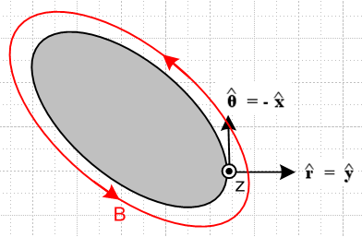 Fig B.2

This shows the cross section of the entire conductor in gray, and Jc is still directed toward the viewer. In this picture a point on the surface is associated with a local coordinate system for which = is normal to the surface and = - is tangent to the surface (so Hθ = -Hx). We are thinking of (r,θ,z) as local cylindrical coordinates at the point shown on the conductor surface, where x = , and the x,y,z directions of the figure match those of the previous figure where as usual x = . Then (B.1.9) says

Kzm = - [(μ2-μ1)/μ0] Hθ (B.1.10)

where Hθ > 0 and Kz ≤ 0.

Conclusion: At the surface of a conductor, if the conduction current is in the + z direction, the magnetization surface current is in the - z direction and has a magnitude given by Kzm = - [(μ2-μ1)/μ0] Hθ where Hθ is the tangential H field at the surface of the conductor (either inside or outside since both are the same). If μ1 = μ2 then there is no such surface current since there is no imbalance of magnetization current at the boundary.

Example: For a round wire of radius a carrying an axially symmetric current distribution, we know that 2πaHθ = I so Hθ = I/(2πa) at the surface. Then

Kzm = - [(μ2-μ1)/μ0] [ I/(2πa)] round wire of radius a and μ2, dielectric μ1 (B.1.11)

Physical mechanism of the surface current. As a reminder, a surface magnetization current arises at a boundary between media with different μ values just the way surface polarization charge arises at a boundary between media with different ε. In the μ case, here is a suggestive picture :

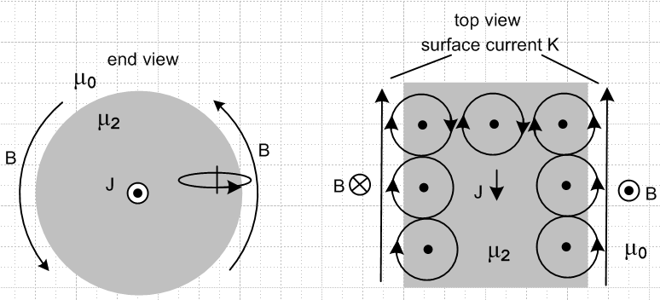 Fig B.3

On the left we look at a round wire end on, while the right shows a top view where the wire has been tilted down. Here μ1= μ0 so there is only vacuum outside the wire. The B field lines up the little magnetic dipoles (or creates them) which we represent schematically as little atoms with orbiting electrons. The atoms in the interior always have cancelling current arrows, but there is an imbalance on the outer surface which is the surface magnetization current. The picture shows why it is that the surface current is directed opposite to the current J which creates it, a sort of magnetic Lenz's Law. The surface current is not seen by H, but it is seen by B.
In the case that the outer medium has some μ1 > μ0, both media have surface currents at the boundary, and then when μ1 ≠ μ2 there is a surface current imbalance resulting in a net surface current. If it happens that μ1 < μ2, then the directions shown above are correct, but if μ1 > μ2, the surface current runs in the opposite direction to that shown.

B.2 Calculation of H from the current J in a conductor

Start with Maxwell's equation (1.1.1), and we are now working inside a conductor so E = 0 and then

curl H = jωεE + J = J (B.2.1)

where J is the conduction current. Apply curl to both sides and use curl curl = grad div -∇2 to get

grad div H - ∇2H = curl J . (B.2.2)

But in a uniform medium div H = 0 since div B = 0 so

∇2H = - curl J . (B.2.3)

Now let's assume that we have J = Jz(x,y) and assume that the solution H does not depend on z. In that case we have

∇22D H(x,y) = - curl J J = Jz(x,y) (B.2.4)

The particular solution to this PDE is shown in (I.1.8) to be

H(x,y) = ∫d2x' [ $\frac{1}{2π}$ln(1/R) ] curl' J(x') R = |x-x'| (B.2.5)
or
H(x,y) = - $\frac{1}{4π}$∫d2x' ln(R2) curl' J(x') R = |x-x'| (B.2.6)

where $\frac{1}{2π}$ln(1/R) is the Poisson 2D free-space propagator.

B.3 General Method for computing the surface current Jm on a wire

Here are the steps for a wire of arbitrary cross sectional shape:

1. From the prescribed conduction current J in the wire, compute curl J. As will be shown in the example below, some or all of curl J may lie on the outer surface of the wire.

2. Compute the H field at all points in the wire cross-sectional plane section using (B.2.5)

H(x,y) = - $\frac{1}{4π}$∫d2x' ln(R2) curl' J(x') R = |x-x'| . (B.2.5)

3. Evaluate this H field at xb = (xb,yb) for all points xb on the cross section boundary.

4. Compute the component of H which is tangential to the boundary in the cross sectional plane. Call this component Hθ.

5. The magnetization surface current density is then given by (B.1.10),

Kzm = - [(μ2-μ1)/μ0] Hθ amp/m (B.1.10)

B.4 Surface current on a round wire with uniform J

For a round wire of radius a with uniform Jz (as would be the DC case ω = 0) , geometric symmetry makes the calculation of H very easy. One need only apply Ampere's Law separately for a point r outside the wire, and for another point r inside the wire. For the outside case one finds

2πr Hθ(r) = I => Hθ(r) = I/(2πr) r ≥ a . (B.4.1)

And then for the inside case the "current enclosed" is determined by a simple area fraction.

2πr Hθ(r) = I (πr2/πa2) => Hθ(r) = I r/(2πa2) r ≤ a . (B.4.2)

At the boundary the two expressions agree and we have

Hθ = I/(2πa) . (B.4.3)

If this wire has magnetic permeability μ2 and is embedded in an infinite medium of μ1, then the surface magnetization current induced on the wire is

Kzm = - [(μ2-μ1)/μ0] Hθ = - [(μ2-μ1)/μ0] I/(2πa) amp/m (B.4.4)

Kzm = Kzm (B.4.5)

and this surface current is in the direction opposite J if μ2 > μ1. If μ1 = μ2, the surface current vanishes. This result could be expressed in volume density form as

Jm = Kzmδ(r-a) amp/m2 . (B.4.6)

B.5 Surface current on a round wire using the General Method

For a wire of some general cross section, symmetry is not available to allow the simple solution outlined in the previous section. We then have to use the more general method outlined in section 3 above. As a check on the viability of this general method, we shall apply it here to the round wire and attempt to replicate the results found in Section 4 above.
The conduction current density in a round wire with uniform Jz is given by

Jz(r) = J0θ(a-r) (B.5.1)

where θ is the Heaviside step function. Our first step is to compute curl J, and we do this in cylindrical coordinates. We stare at the cylindrical-coordinates curl formula,

curl J = [ r-1∂θJz - ∂zJθ] + [∂zJr - ∂rJz] + [ r-1∂r(rJθ) - r-1∂θJr ] (B.5.2)

and identify the only non-zero piece which is this (uniform Jz)

curl J = [-∂rJz(r)] . (B.5.3)

Inserting Jz(r) from above we find

∂r Jz(r) = J0 ∂rθ(a-r) = - J0 δ(r-a) (B.5.4)

=> curl J(r) = J0 δ(r-a) . (B.5.5)

so we have a "ring source of curl J". For use in our integral for H we then have

curl' J(r') = ' J0 δ(r'-a) . (B.5.6)

For a current distribution which tapers off smoothly to 0 at the wire edge one would not have this singular contribution, but for a wire with prescribed uniform current, it is present, and curl J vanishes everywhere but on the boundary. The relevant picture is this:

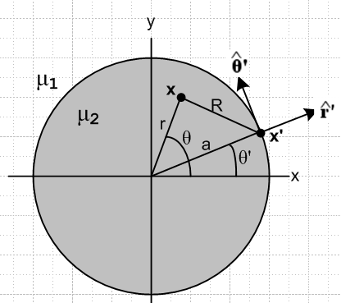 Fig B.4

From (B.2.5) the H field at any point x = (x,y) is then given by

H(x,y) = ∫d2x' [ $\frac{1}{2π}$ln(1/R) ] curl' J(x') = $\frac{1}{2π}$∫d2x' ln(1/R) ' J0 δ(r'-a)

= $\frac{J0}{2π}$$^{\int_{0}^{∞}{}}$r'dr' $^{\int_{-π}^{π}{}}$dθ' (1/2) ln(1/R2) ' δ(r'-a) = $\frac{J0a}{4π}$ $^{\int_{-π}^{π}{}}$dθ' ln(1/R2)|r'=a '

= - $\frac{J0a}{4π}$ $^{\int_{-π}^{π}{}}$dθ' ln(R2)|r'=a '
or
H(r,θ) = - $\frac{J0a}{4π}$ $^{\int_{-π}^{π}{}}$dθ' ln [ r2 + a2 - 2ar cos(θ'-θ) ] ' . (B.5.7)

The figure shows that

' = cosθ' - sinθ' (B.5.8)

so then
H(r,θ) = - $\frac{J0a}{4π}$ $^{\int_{-π}^{π}{}}$dθ' ln [ r2 + a2 - 2ar cos(θ'-θ) ] [cosθ' - sinθ' ] . (B.5.9)

Next, let x ≡ θ'-θ. Since the ∫dθ' has full range 2π, one can replace $^{\int_{-π}^{π}{}}$dθ' = $^{\int_{-π}^{π}{}}$dx . Then

H(r,θ) = - $\frac{J0a}{4π}$ $^{\int_{-π}^{π}{}}$dx ln [ r2 + a2 - 2ar cos(x) ] [cos(x+θ) - sin(x+θ) ] . (B.5.10)

Now writing H = Hx + Hy , decompose the above into two equations

Hx(r,θ) = + $\frac{J0a}{4π}$ $^{\int_{-π}^{π}{}}$dx ln [ r2 + a2 - 2ar cos(x) ] sin(x+θ)
Hy(r,θ) = - $\frac{J0a}{4π}$ $^{\int_{-π}^{π}{}}$dx ln [ r2 + a2 - 2ar cos(x) ] cos(x+θ) (B.5.11)
or
Hx(r,θ) = + $\frac{J0a}{4π}$ $^{\int_{-π}^{π}{}}$dx ln [ r2 + a2 - 2ar cos(x) ] [ sinxcosθ+cosxsinθ ]
Hy(r,θ) = - $\frac{J0a}{4π}$ $^{\int_{-π}^{π}{}}$dx ln [ r2 + a2 - 2ar cos(x) ] [cosxcosθ - sinxsinθ ] . (B.5.12)

Since $^{\int_{-π}^{π}{}}$dx is over an even range, throw out odd integrand terms, and then fold the negative range into the positive adding a factor of 2 to get

Hx(r,θ) = + sinθ $\frac{J0a}{2π}$ $^{\int_{0}^{π}{}}$dx ln [ r2 + a2 - 2ar cos(x) ] cosx ≡ sinθ $\frac{J0a}{2π}$C
Hy(r,θ) = - cosθ $\frac{J0a}{2π}$ $^{\int_{0}^{π}{}}$dx ln [ r2 + a2 - 2ar cos(x) ] cosx = -cosθ $\frac{J0a}{2π}$C (B.5.13)

where C is the following integral,

C ≡ $^{\int_{0}^{π}{}}$dx ln [ r2 + a2 - 2ar cos(x) ] cosx . (B.5.14)

Before evaluating this integral, we see that

H = Hx + Hy = - $\frac{J0a}{2π}$C [ cosθ -sinθ ] = - $\frac{J0a}{2π}$C = Hθ . (B.5.15)

Thus we find that the resulting H is entirely in the direction and

Hθ = - $\frac{J0a}{2π}$C . (B.5.16)

We seek now to evaluate this integral C

C ≡ $^{\int_{0}^{π}{}}$dx ln [ r2 + a2 - 2ar cos(x) ] cosx

= $^{\int_{0}^{π}{}}$dx ln [ {a2}{ (r/a)2 + 1 - 2(r/a) cos(x)} ] cosx

= $^{\int_{0}^{π}{}}$dx { ln (a2) + ln[(r/a)2 + 1 - 2(r/a) cos(x)] } cosx

= ln (a2)[$^{\int_{0}^{π}{}}$dx cosx ] + $^{\int_{0}^{π}{}}$dx ln[(r/a)2 + 1 - 2(r/a) cos(x)] cosx

= ln (a2)[0] + $^{\int_{0}^{π}{}}$dx ln[α2 + 1 - 2α cos(x)] cosx where α ≡ r/a

= $^{\int_{0}^{π}{}}$dx ln[α2 + 1 - 2α cos(x)] cosx . (B.5.17)

This integral is the n=1 special case of the following integral from GR7 page 589,

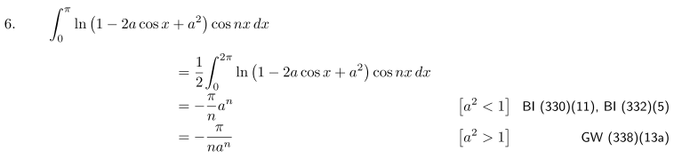
Therefore we find

C = (B.5.18)
so
Hθ = - $\frac{J0a}{2π}$C = . (B.5.19)

Now the total current in the wire is I = J0πa2 so (aJ0/2) = (I/2πa) and then

Hθ = = . (B.5.20)

Thus, we finally arrive at the same results for H as obtained in (B.4.2) and (B.4.1). We then evaluate Hθ on the boundary Hθ = I/2πa and conclude as in (B.1.11) that the surface current is Kz = - (μ2/μ1 - 1) I/(2πa).

B.6 An Acrobatic Exercise: Compute H from J and Jm via the vector potential A.

For the round wire with a uniform Jz we are aware of both the volume current JZ and the surface current Kzm. In this exercise, with justification to be given later, we insert both these currents into our formula for the vector potential A, we do the required integrals, and at the end we compute B = curl A and finally use H = B/μ. Hopefully in the end we shall recover once again the results for Hθ shown above. Here again is the picture of interest:

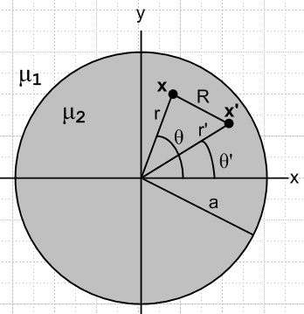 Fig B.5

Law of Cosines: R2 = r2 + r'2 -2rr'cos(θ-θ')

Start with a 2D magnetostatics equation which is (1.5.4) with β2 = 0,

∇22DA(x) = -μ0Jm(x) -μ2Jc(x) . (B.6.1a)

This 2D approximation is appropriate for a transmission line conductor in the "transmission line limit".

The particular solution from (I.1.8) is there are two equations (B.6.1) !

A = (1/2π) ∫dV' [μ0Jm(x') + μ2Jc(x')] ln(1/R) R = |x-x'|

= (1/2π) { ∫dS' [μ0Km(x')] ln(1/R) + ∫dV'[ μ2Jc(x')] ln(1/R) }
so
Az = (1/2π) { ∫dS' [μ0Kzm(x')] ln(1/R) + ∫dV'[ μ2Jcz(x')] ln(1/R) }

= -(1/2π) { ∫dS' [μ0Kzm(x')] ln(R) + ∫dV'[ μ2Jcz(x')] ln(R) }

= -(1/4π) { μ0∫dS' [Kzm(x')] ln(R2) + μ2∫dV'[Jcz(x')] ln(R2) } . (B.6.1b)

Here ∫dV' represents an integral over the "volume" of the wire slice shown in the figure (which is really a disk) and ∫dS' represents an integral over the "surface" of the wire slice (which is really a circle).

We now insert the uniform prescribed current Jcz and our previously computed surface current Kz,

Jcz(x') = Jcz = I/(πa2) // uniform in round wire (B.6.2)

Kzm(x') = Kzm = - [(μ2-μ1)/μ0] I/(2πa) // from (B.4.4) (B.6.3)

with the result that

Az = - (1/4π) { - μ0 [(μ2-μ1)/μ0] I/(2πa) ∫dS' ln(R2) + μ2 I/(πa2)∫dV' ln(R2) }

= - [I/(4π2a2)] { (μ1-μ2) (a/2) ∫dS' ln(R2) + μ2∫dV' ln(R2) } . (B.6.4)

The volume integral (per unit length in the z direction, so really an area integral as just noted) is,

∫dV' ln(R2) = $^{\int_{0}^{a}{}}$r' dr' $^{\int_{-π}^{π}{}}$dθ' ln [r'2 +r2-2rr' cos(θ-θ')]

= $^{\int_{0}^{a}{}}$r' dr' $^{\int_{-π}^{π}{}}$dx ln [r'2 +r2-2rr' cosx]

= 2 $^{\int_{0}^{a}{}}$r' dr' $^{\int_{0}^{π}{}}$dx ln [r'2 +r2-2rr' cosx] . (B.6.5)

Define the x integral as

Q(r',r) ≡ $^{\int_{0}^{π}{}}$dx ln [r'2 +r2-2rr' cosx] (B.6.6)

so then

∫dV' ln(R2) = 2 $^{\int_{0}^{a}{}}$r' dr' Q(r',r) . (B.6.7)

Meanwhile, our surface integral of interest (really a line integral) is

∫dS' ln(R2) = $^{\int_{-π}^{π}{}}$[a dθ'] ln [r'2 +r2-2rr' cos(θ-θ')] |r'=a

= 2a $^{\int_{0}^{π}{}}$dx ln [r'2 +r2-2rr' cosx] |r'=a = 2a Q(a,r) (B.6.8)

so that both integrals of interest require computation of Q(r',r), which we replicate here,

Q(r',r) ≡ $^{\int_{0}^{π}{}}$dx ln [r'2 + r2 - 2rr' cosx] . (B.6.6)

This integral may be evaluated using GR7 p 531 4.224,

with a = r'2 +r2 and b = -2rr' and a2-b2 = (r'2-r2)2 so that $\sqrt{a2-b2}$ = | r'2-r2 | .The condition a > |b| > 0 is met since (r±r')2 > 0 => r2+r'2 > ±2rr' which says a > ±b so a > |b|. Thus,

Q(r',r) = $^{\int_{0}^{π}{}}$dx ln [r'2 +r2-2rr' cosx)] = π ln [ $\frac{(r'2 +r2) + | r'2-r2 |}{2}$] =
= 2π . (B.6.9)

This our two integrals of interest are

∫dS' ln(R2) = 2a Q(a,r) = 4πa (B.6.10)
∫dV' ln(R2) = 2 $^{\int_{0}^{a}{}}$r' dr' Q(r',r) = 4π $^{\int_{0}^{a}{}}$r' dr' , (B.6.11)

where we still have a dr' integral to carry out for the ∫dV' case. For r > a we know that r > r' since r' integrates over the inside of the wire. Then

∫dV' ln(R2) = 4π$^{\int_{0}^{a}{}}$r' dr' ln(r) = 4π ln(r) [ a2/2 ] = 2πa2 ln(r) r > a (B.6.12)

On the other hand, for r < a we have to break the integral into two parts :

∫dV' ln(R2) = 4π $^{\int_{0}^{r}{}}$r' dr' ln(r) + 4π $^{\int_{r}^{a}{}}$r' dr' ln(r')

= 4πln(r) (r2/2) + 4π [(1/2)x2(lnx-1/2) ]|ar

= 2π r2 ln(r) + 4π [(1/2)a2(lna-1/2) - (1/2)r2(lnr-1/2)]

= 2π r2 ln(r) + 2π [a2(lna-1/2) - r2(lnr-1/2)]

= 2π r2 ln(r) + 2π a2lna - πa2 - 2π r2lnr + πr2

= 2π a2lna + π(r2-a2) . r < a (B.6.13)

The result then is the following, where below it we repeat the earlier surface integral result,

∫dV' ln(R2) = (B.6.14)
∫dS' ln(R2) = 4πa . (B.6.15)

Now install these integrals into the Az expression (B.6.4) to get

Az = - [I/(4π2a2)] {(μ1-μ2) (a/2) ∫dS' ln(R2) + μ2∫dV' ln(R2) } (B.6.4)

= - [I/(4π2a2)] {(μ1-μ2) (a/2) 4πa + μ2} (B.6.16)

Then write these out for the two separate regions :

Az(r>a) = -[I/(4π2a2)] { (μ1-μ2) (a/2) 4πa ln(r) + μ2 2πa2 ln(r) }

= -[I/(4π2a2)] { (μ1-μ2) 2πa2 ln(r) + μ2 2πa2 ln(r) }

= -[I/(2π)] { (μ1-μ2) ln(r) + μ2 ln(r) }

= -[I/(2π)] { μ1ln(r) } region 1 (B.6.17)

Az(r<a) = -[I/(4π2a2)] { (μ1-μ2) (a/2) 4πa ln(a) + μ2( 2πa2ln(a) + π(r2-a2) ) }

= -[I/(4πa2)] { (μ1-μ2) 2a2 ln(a) + μ22a2ln(a) + μ2(r2-a2) ) }

= -[I/(4πa2)] { μ1 2a2 ln(a) + μ2(r2-a2) ) }

= -[I/(2π)] { μ1 ln(a) + μ2(r2-a2)/(2a2) ) } region 2 (B.6.18)

At the boundary r = 0 both expressions give

Az(r=a) = -[I/(2π)] { μ1ln(a) } . (B.6.19)

The next step is to compute the magnetic field B = curl A given our function Az(r). We find from the usual cylindrical coordinates curl formula (B.5.2),

B = curl A = - ∂rAz(r) . (B.6.20)

First, for r > a one finds,

-∂rAz(r) = ∂r[I/(2π) { μ1ln(r) }] = (I μ1/2π) (1/r) r > a (B.6.21)

and then for r < a,

-∂rAz(r) = I/(2π) ∂r { μ1 ln(a) + μ2(r2-a2)/(2a2) ) } = (I μ2/2π) r/a2 (B.6.22)

Inserted material: Notice that

(1/μ1) ∂rAz(r)1 =(1/μ2) ∂rAz(r)2 in the form (I /2π) (1/r) = (I/2π) r/a2 at r = a

Thus

B = (I μ1/2π) (1/r) for r > a which is in the dielectric medium with μ1
B = (I μ2/2π) (r/a2) for r < a which is in the conductor medium with μ2 . (B.6.23)

Using B = μH in each region we then get

H = (I /2π) (1/r) for r > a => Hθ = (I/2πr)
H = (I /2π) (r/a2) for r < a => Hθ = (Ir/2πa2) (B.6.24)

Amazingly, these results agree with the elementary calculation results given in (B.4.1) and (B.4.2). The important point here is that these results only come out right when both the volume and magnetization surface currents on the round wire are included in the calculation. The elementary Ampere's Law calculation of Hθ is simple because in the Maxwell equation curl H = J (Ampere's Law), the field H does not "see" the surface magnetization current, so one can forget about it.

Maple provides plots of Az from (B.6.17,18), Bθ from (B.6.23) and Hθ from (B.6.24) for this round wire situation. Parameters are set to I = 1, a = 2, μ1 = 2, μ2 = 3.

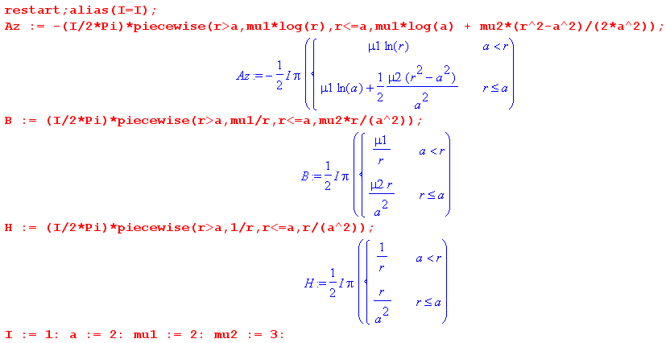

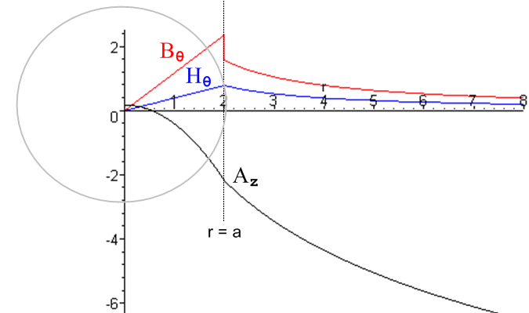 Fig B.6

Az wanders down as ~ -ln(r) for large r, Bθ jumps at r = a while Hθ is continuous there.

B.7 Reader Exercise: Repeat the above calculation of A using a 3D analysis

This is a guided exercise with waypoints. The starting point is this:

∇2A(x) = -μ0Jm(x) -μ2Jc(x) // 3D wave equation from (1.5.4) with β= 0

A(x) = (1/4π) ∫dV' [μ0Jm(x') +μ2Jc(x')] (1/R) R = |x-x'| . // according to (H.1.8)

(a) Insert Jm and Jc from (B.6.2) and (B.6.3) to get

Az(x) = (1/4π) (1/2πa) I { (μ1-μ2) ∫dS' (1/ R) + (2/a) μ2∫dV' (1/ R) }

where now we have true surface and volume integrals. Notice that we are using currents which do not vay in z, so here we are making the same "transmission line limit" approximation made in the 2D analysis.

(b) Show these integrals may be written:

∫dS' (1/R) = ∫(adθ') $^{\int_{-∞}^{∞}{}}$dz' (1/R) = a $^{\int_{-π}^{π}{}}$ dθ' $^{\int_{-∞}^{∞}{}}$dz' (1/ $\sqrt{s2 + z'2}$)

∫dV' (1/R) = ∫(r'dθ') ∫dr'$^{\int_{-∞}^{∞}{}}$dz' (1/R) = $^{\int_{0}^{a}{}}$ r'dr' $^{\int_{-π}^{π}{}}$ dθ' $^{\int_{-∞}^{∞}{}}$dz' (1/ $\sqrt{s2 + z'2}$)

where s2 = (x-x')2+ (y-y')2 = R2 of the 2D problem.

(c) Install a a large cutoff Λ to get

$^{\int_{-∞}^{∞}{}}$dz' (1/ $\sqrt{s2 + z'2}$) → $^{\int_{-Λ/2}^{Λ/2}{}}$dz' (1/ $\sqrt{s2 + z'2}$) = -2ln(s/Λ) = - ln(R2/Λ2) .

(d) Show then that

Az(x) = = - (I/4π2a2) { (μ1-μ2) [ a2 Q(a,r) - πa2 ln(Λ2)]
+ 2 μ2 [ $^{\int_{0}^{a}{}}$r' dr' Q(r',r) - ln(Λ2) π a2] }

where Q(r',r) is the integral defined in (B.6.6).

(e) Finally, show that the Az(x) obtained here is the same as that obtained in the 2D analysis apart from the appearance here of the following extra terms

+ (I/4π) ln(Λ2) (μ1+ μ2) .

(f) Compare the 2D and 3D methods with an interpretation of these extra terms which of course have no effect on B = curl A. Physically why does the infinite term appear in the 3D analysis and not in the 2D analysis?

