Repair of Appendix B PhL 1.26.14

Here I realized the embarrassing situation that E • B ≠ 0 for my own rectangular conductor field plot! But I just got done proving that E • B = 0 !! This is now all resolved.

1. Statement of the Problem

I had this little "reader exercise" at the end of Chapter 3 which I was just going to discard since I didn't understand it,

" Reader Exercise: Reconcile the appearance of Appendix C Fig C.2 with the above proofs of Fact 7. "

I now understand the above reader exercise. I claim in Section 3.7 Fact 5 that B lines outside a conductor are parallel to the surface. One argument is that they have to be that way in order to be perp to the E field at the surface, in the transverse picture. But in Appendix C Fig C.2, the H lines do NOT seem to be parallel to the surface! Why is that?? The Maple file is rectangle v3.mws. I increased grid to 60x60, same problem. For me, this is a big problem!
(1) is my claim wrong that H should be parallel? [ no ]
(2) is my plot math wrong so graph is wrong? [ no, graph is right ]
I guess I now have to face this issue and stop proofing.

Here I think the problem has something to do with homo adder solutions which was a red herring.

I assume uniform current flow. Is that correct for a square conductor at DC? [I think yes ]
I have a "particular solution" for H, how do I know there aren't adder homo solutions??? Reading at (B.2.6). Who says the particular solution meets BC's? And what are the BC's on H ?

Ht2 = Ht1 or (1/μ2)Bt2 = (1/μ1)Bt1 (1.1.44)

Bn1 = Bn2 or μ1Hn1 = μ2 Hn2 (1.1.49)

I think I would make the same argument I did with Aa which is this: the particular solution,

H(x,y) = - $\frac{1}{4π}$∫d2x' ln(R2) curl' J(x') R = |x-x'| (B.2.6)

will be "naturally continuous" at the boundary and cannot possibly satisfy μ1Hn1 = μ2 Hn2 !! So you must have to add a homo solution to this thing! But then my whole advertised method of computing Jm then falls apart! However, this (B.2.6) will "naturally satisfy" Ht2 = Ht1 so perhaps it gives the correct tangential value! So maybe think of it as two equations

Hn(x,y) = - $\frac{1}{4π}$∫d2x' ln(R2) [curl' J(x')]n R = |x-x'|
Ht(x,y) = - $\frac{1}{4π}$∫d2x' ln(R2) [curl' J(x')]t R = |x-x'|

Maybe we can use this last one alone to compute the Jm stuff. In my round wire example, the normal H field is 0 because [curl' J(x')]n = 0 and therefore in that example, μ1Hn1 = μ2 Hn2 says 0 = 0 which is then OK. That explains why the example happened to work.

The first can be written

Hn(x,y) = - $\frac{1}{4π}$∫d2x' ln(R2) [curl' J(x')] • R = |x-x'|
2. How to repair the problem?

I need to find homo solutions to this equation

∇22D Hn(x,y) = 0

such that μ1Hn1 = μ2 Hn2. This is a 2D scalar Laplace equation so I have a chance

Hn(x,y) = Cartesian harmonics.

Ouch, that would be

A, B ln(x2+y2), (x2+y2)n/2 n = ±1,2,3....

I can rule out negative n integers to keep finite at the origin. So I then have

Hhomon(x,y) = A + B ln(x2+y2) + Σn=1∞ Cn(x2+y2)n/2

with lots of TBD coefficients! I then have to solve a particular problem and then add this mess and find all the coefficients!
For example, in the rectangular wire cross section I know that the normal field on the right edge is given by

Hpartx(a,y) = $\frac{1}{16πab}$F(a,y,a,b)

Hhomon(a,y) = A + B ln(a2+y2) + Σn=1∞ Cn(a2+y2)n/2

Then I have to find coefficients such that

μ1Hn1 = μ2 Hn2

3. Back up and start again

Suppose I assume that μ1 = μ2 . Then my particular solution should be the correct solution since it will then be "automatically continuous" at the boundary in both normal and transverse sense. In Appendix B I never say anything about the μ values. I might add a comment near (C.4.1) that it is valid for μ1 = μ2. But then why don't the results look right??? I think probably the H field is continuous at all my arrows, and then the real problem is E and H being perpendicular! So we still have a big mystery here! My Section 3.7 Fact 4 that E•B = 0 everywhere still seems good, so what is wrong at my surface?

(a) Let's examine one piece at a time. Here is a chunk from Appendix B:

Start with Maxwell's equation (1.1.1), and we are now working inside a conductor so E = 0 and then

curl H = jωεE + J = J (B.2.1)

where J is the conduction current. Apply curl to both sides and use curl curl = grad div -∇2 to get

grad div H - ∇2H = curl J . (B.2.2)

But in a uniform medium div H = 0 since div B = 0 so

∇2H = - curl J . (B.2.3)

Since I am at DC, ω = 0 so that is another reason the E term goes away. But this is value both inside and outside the conductor if ω = 0. I am just trying to get the DC H field, cannot be that hard! The curl curl theorem is correct, I checked.

(b) My next chunk is this:

Now let's assume that we have J = Jz(x,y) and assume that the solution H does not depend on z. In that case we have

∇22D H(x,y) = - curl J J = Jz(x,y) . (B.2.4)

The particular solution to this PDE is shown in (I.1.8) to be

H(x,y) = ∫d2x' [ $\frac{1}{2π}$ln(1/R) ] curl' J(x') R = |x-x'| (B.2.5)
or
H(x,y) = - $\frac{1}{4π}$∫d2x' ln(R2) curl' J(x') R = |x-x'| (B.2.6)

Two items here. First, H does in fact depend on z, so there is a β'2 term missing in (B.2.4) where this is whatever β' describes the traveling wave. Second, we have a vector Helmholtz, not a scalar, so not clear that this is the particular solution! But I guess OK in Cartesians. Near DC we have very LONG λ and thus very small β' so I guess both items are OK.

(c) I claim Hn and Ht are naturally continuous at the boundaries for H from the above particular solution. Do plots bear this out? For example, Hx along the right edge. A 3D plot of Hx shows that Hx is continuous, though its slope is not continuous. Here is that plot

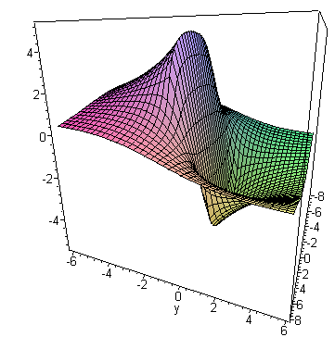

where the top and bottom edges are at y = ±b = ±1

Let's go with a square just to get less complexity. My field plot still shows the problem that H is not tangent to the square edge.

What does the web say about the mag field of a square conductor? Maybe i should at least learn what the right answer is, then I will know where to look for my error.

Galvan Paper: They start with this equation

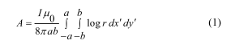

which I think is my 2D vector potential formula for rectangular conductor with a uniform current. This is a 2D version of an equation I usually show in 3D. I do have this in Appendix I

-∇2D2 f(x) = s(x) => f(x) = ∫d2x' [ln(1/R)/2π] s(x') + homogeneous solutions
The Poisson Equation (I.1.8)

I do have in (1.5.4),

(∇2 + β2)A = - Σi μiJi all of region R (1.5.4)

and then at ω = 0 this becomes

(∇2)A = - Σi μiJi

and then for one wire and with the 2D assumption it becomes

-(∇2D2)A = μJ

and then the solution is

A = + ∫d2x' [ln(1/R)/2π] μJ (x') + homogeneous solutions

and then if J = I/4ab this says

Az = μI/(8πab) ∫d2x' [ln(1/R)]
or
Az = - μI/(8πab) ∫d2x' [ln(R)]
or
Az = - μI/(16πab) ∫d2x' [ln(R2)]

So this agrees with their equation apart from sign. I will ignore this sign issue, does not matter much for what I am doing. Then they compute this Az for rectangle and get,

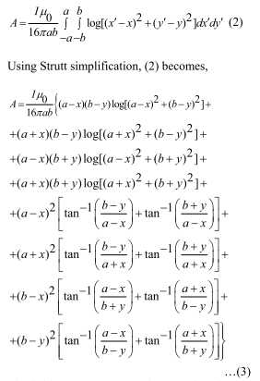

This certainly has functions similar to my expression say for Hx. The phrase " "Strutt simplification" has only their paper as a web hit! They then end up with a form of the result in terms of angles

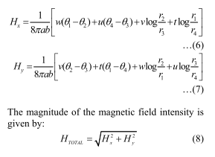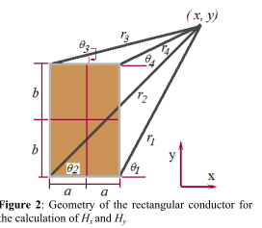

What is the meaning of Az contours as they plot? In electrostatics the E field is perp to the φ contours, but I don't know what that means for the B case. I see this paper is mainly about using a software package, so enough.

Web site: http://www.ntmdt.com/spm-basics/view/magnetic-field-rectangular-wire

They treat the rectangular conductor as a set of thin wires and use superposition. He has x,z intead of x,y and he uses h = 2b and 2 = 2a for transverse and he finds that

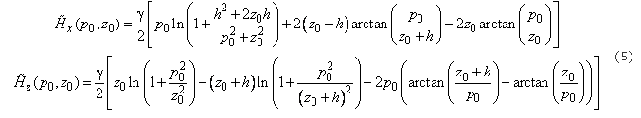

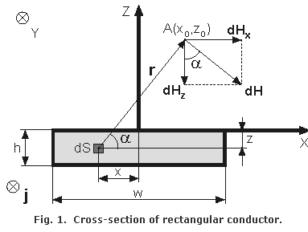

His results look similar to mine in the nature of the terms, but he makes no plot of H. I cannot seem to find a plot anywhere.

NASA Article

It has this interesting plot supporting my parallel claim: but this assumes extreme skin effect!
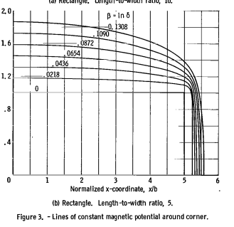

How come I don't have Biot-Savart anywhere? ******* [ I later added this I think in App B ] This gives the B field directly from the current in theory.

I am amazed that I cannot find any plots of the type I made, so I am blocked from knowing the correct answer. Let's look at texts:

Bleaney. Nada.

Purcell. He has a picture on page 209 that is like my plot and does NOT have B parallel to the surfaces of his two busbars. So that is pretty convincing that my claim of B being purely tangent is wrong! Maybe that is only true at high ω [ correct] . My perp proof is just above (3.7.1), I wish I had given all my Facts equation numbers *********. Here is my proof:

Fact 4: In a cross sectional sketch of a transmission line, the E and B field lines are perpendicular at every point in the dielectric.

Proof: Recall these two equations from earlier sections

curl B = μ (jωε E + J ) = μ (jωε E + σE ) = μ(jωε + σ)E (2.2.1)

β2 = ω2 μ [ ε + σ/jω] = ω2 μ( jωε + σ) /jω = ωμ( jωε + σ) /j . (1.5.1)

If follows from these equations that,

curl B = j(β2/ω) E ≡ C E . (3.7.1)

C = j(β2/ω) = j μ( jωε + σ) /j = μ( jωε + σ)

To show that the E and B fields are perpendicular, we will show that E•B = 0. We have from (3.7.1),

C E•B = curl B • B = ( ∂xBy - ∂yBx)Bz + ( ∂yBz - ∂zBy)Bx + ( ∂zBx - ∂xBz)By .

Since Bz ≈ 0 ( see estimate in previous section), we are left with only two terms

C E•B = By(∂zBx) - Bx(∂zBy) = By2 ∂z (Bx/By) .

However, we argued in Fact 3 that the shape of fields does not vary with z. Thus, the ratio of two components like Bx/By cannot vary with z. Thus, E•B = 0 so the E and B lines are perpendicular everywhere in the dielectric. ( We also assume Ez ≈ 0 since it is small in the dielectric).

Now of course in the Purcell case, we are just looking at a DC pair of busbars, there is no electric field at all anywhere. We are not looking at a TEM wave on a transmission line I guess except as ω → 0.

Idea #1. Maybe at very low ω, we still have large Jz but Er is very small.

Idea #2. Where have I stated the E and B fields for a transmission line? I have given expressions for φ12(x) at any point in the dielectric in (4.2.1). At one point I have this

φ12(x) = $\frac{1}{4πξ}$$^{\int_{-∞}^{∞}{}}$dz' q(z'){ $^{\int_{C1}^{}{}}$dx1' dy1' α1(x1',y1') $\frac{1}{R1}$– $^{\int_{C2}^{}{}}$dx2' dy2' α2(x2',y2') $\frac{1}{R2}$ } (4.3.7)

But then I never pursue this further. I go right to V(z) ≡ φ12(x1) - φ12(x2) and I eventually get

V(z) = q(z) $\frac{1}{4πξ}$ {$^{\int_{C1}^{}{}}$dx1' dy1' α1(x1',y1') ln(s212/s112) -$^{\int_{C2}^{}{}}$dx2' dy2' α2(x2',y2') ln(s222/s122) }

I go on to get the transmission line parameters, but I never compute the potentials or the fields IN the transmission line. That seems a major omission.

But maybe I do it in the transverse problem chapter. φ(x,y,z) = $\frac{1}{4πξ}$ q(z) φt(x,y) and I then get a capacitor problem for φt and seemingly the same problem for Azt. See (5.3.8) and (5.3.9).

Possible Issue Spotted: In my low less approximation I try to get rid of the Helmholtz parameter sitting in these equations

[ ∇t2 + (β2-k2)] φt(x,y) = 0 φt(C1) = K1 φt(C2) = K2 K1- K2 = K (5.3.8)
[ ∇t2 + (β2-k2)] Azt(x,y) = 0 Azt(C1) = W1 Azt(C2) = W2 W1- W2 = K (5.3.9)

where (β2- k2) = $\frac{jω Zs 4πξ}{K}$ .

I then make the "low loss assumption" which says

|Zs| << (1/4π) ωμ K sec-1 henry/m = ohm/m

BUT THEN I take the high ω limit of Zs for the round wire to get (δ/a) << K/$\sqrt{2}$.

But in the low ω limit, this is going to basically say

| $\frac{1}{σπa2}$ + jω $\frac{μ}{8π}$ | << (1/4π) ωμ K

or really just

$\frac{1}{σπa2}$ << (1/4π) ωμ K
or
ω >> $\frac{1}{σπa2}$ 4π (1/μ)(1/K)
or
ω >> 4π Rdc/μ (1/K).

so this does seem to put a lower limit on the validity of my solutions, something I have been ignoring.

Let's look at the Belden cable again on this issue. We have a = 394 μ ans then

Rdc = $\frac{1}{σπa2}$

1/Rdc = πσa2 = π 5.81 x 107mho/m * (394)2 * 10-12

= π 5.81 (394)210-5 = 28.3 m/ohm

So then

Rdc = .0353 ohms/m

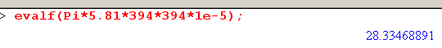
Then we find for μ0 that we require

ω >> 4π * .0353 * 1/(4πx10-7)* (1/K)
or
2πf >> .0353 x 107 (1/K)
or
f >> .0056 * 107* (1/K) = .056 * 106* (1/K) = 5.6 x 103 (1/K) = (1/K)* 5.6 KHz

So if you operate near DC, then you do not have f >> (1/K)* 5.6 KHz and you are then not in the low loss limit of a transmission line. That means you cannot treat the transverse equations for φt and Azt as simple Laplace equations, and that means the "capacitor problem solution" is not valid.

So would this invalidate the idea that E is perp to the surface transversely speaking? I think that would remain valid because there is no strong Eφ field to make this not be true.

So even at 1 Hz, I think there exists some φ and there is some n and E is perp to the conductor surfaces in the transverse picture. Now once again, let us examine the E perp B argument,.

Proof: Recall these two equations from earlier sections

curl B = μ (jωε E + J ) = μ (jωε E + σE ) = μ(jωε + σ)E (2.2.1)

β2 = ω2 μ [ ε + σ/jω] = ω2 μ( jωε + σ) /jω = ωμ( jωε + σ) /j . (1.5.1)

Now of ω = 1 Hz, then ωε0 ~ 10-11 and perhaps σ = 10-15 for the dielectric, so we have

curl B = 4π x 10-7 * 10-11 E = 10-17E

Of course in magnetostatics you take curl B = 0 and then B = -μ0∇φ as in Bleaney p 132 and this then works because curl grad = 0. In electrostatics you have curl E = 0 and then E = -∇φ, so electrostatics and magnetostatics are pretty symmetric in this regard.
Now back to the proof. I would then argue that

E • B = 1017 curl B • B

= 1017 { ( ∂xBy - ∂yBx)Bz + ( ∂yBz - ∂zBy)Bx + ( ∂zBx - ∂xBz)By . }

Notice the huge amplifying factor 1017 sitting there. The next step is to say Bz= 0 exactly. But in my Appendix D analysis of a round wire, I found that Bz ≠ 0. But let's look again at (D.4.9).

β' = β2-βd2

At DC both β and βd are 0 so I guess in that case App D does say Bz= 0, and it does say that for m = 0 which is where the DC limit lives. But even at 1 Hz, there will be some Bz≠ 0 and I guess that 1017 could them amplify it and make it enter into the calculation and then it would be wrong to ignore Bz. I am just guessing that is how this works. SO yes, this is a very subtle issue that I completely ignored when I stated this "fact".

[ So finally I arrived here at the cause of the problem. It is all written up in lines doc now. It took me a long time to realize what was going on here, that 1017 was the first clue. ]

Question: Looking at the m=0 results (D.6.1), what can you say about the relative size of Er and Bφ ? (these are the two strong field components). Well, these are inside the wire, but I want to know Er just outside the wire, so this is not going to help.

I should somewhere add a section on "low frequency characteristics of a transmission line" . I think I could show that Z0 is very small, so V = ZoI means V and this Er is very small in the dielectric relative say to the B field, and then the E•B = 0 argument changes its nature. But somehow V is very large on a power line, so what gives there?
I read up on this. Z0 = 400 ohms typical, it is in the highω limit for Z0 formula even at 60 Hz!

Now how might I qualify my E•B = 0 theorem? Look once again at the derivation:

curl B = CE where C = μ(jωε + σ) where μ and σ are for the dielectric.

