New Section B.7 PhL 1.16.14

Section B.7 Application of the J_{m} Theorem to a round wire with uniform J_{z}. 1
(a) The A_{z}^{(c)} term 1
(b) The A_{z}^{(m)} term 3
(c) Adding the two terms and checking boundary conditions 4
(d) Plots of A_{z} and B_{θ} and H_{θ} 5

Section B.7 Application of the Jm Theorem to a round wire with uniform Jz.

Assuming the transmission line limit of small β so e-jβR ≈ 1, we start with (B.6.1)

Az(x) = ∫$_{}^{}$ dV' [μ2 Jcz(x') + μ0 Jmz(x')] $\frac{1}{4πR}$ . R = |x - x'| (B.6.1) (B.7.1)

but we go at once to the 2D solution [∇22DA(x) = - μ2Jc(x)] limit to get

-Az(x) = ∫$_{}^{}$ dA' [μ2 Jcz(x') + μ0 Jmz(x')] $\frac{ln(R2)}{4π}$ // $\frac{1}{2π}$ln(1/R) = - $\frac{ln(R2)}{4π}$

The two currents are given by

Jcz(x') = Jcz = I/(πa2) // uniform (B.1.10)
Jmz(x') = Kz δ(r-a) with Kz = - ( $\frac{μ2}{μ0}$ - $\frac{μ1}{μ0}$ ) Hθ (B.7.2)

(a) The Az(c) term

The first term in ** is then

-Az(c)(r,θ) = $\frac{μ2I}{πa2}$∫$_{}^{}$ dA' $\frac{ln(R2)}{4π}$ = $\frac{μ2I}{πa2}$$^{\int_{0}^{a}{}}$r' dr'$^{\int_{-π}^{π}{}}$dθ' $\frac{ln(R2)}{4π}$
= $\frac{μ2I}{4π2a2}$$^{\int_{0}^{a}{}}$r' dr'$^{\int_{-π}^{π}{}}$dθ' ln(r'2 +r2-2rr' cos(θ-θ') )
= $\frac{μ2I}{2π2a2}$$^{\int_{0}^{a}{}}$r' dr'$^{\int_{0}^{π}{}}$dx ln(r'2 +r2 - 2rr' cosx )
= $\frac{μ2I}{2π2a2}$$^{\int_{0}^{a}{}}$r' dr' Q(r',r) (B.7.3)

where we have defined the integral

Q(r',r) ≡ $^{\int_{0}^{π}{}}$dx ln [r'2 +r2-2rr' cosx] (B.7.4)

The round wire geometry is shown in this drawing, where R2 comes from the law of cosines,

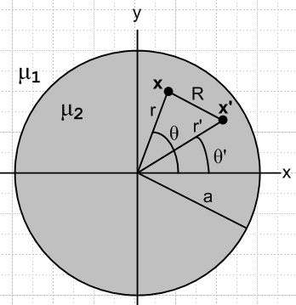 Fig B.7

The integral Q(r',r) may be evaluated using GR7 p 531 4.224,

with a = r'2 +r2 and b = -2rr' and a2-b2 = (r'2-r2)2 so that $\sqrt{a2-b2}$ = | r'2-r2 | .The condition a > |b| > 0 is met since (r±r')2 > 0 => r2+r'2 > ±2rr' which says a > ±b so a > |b|. Thus,

Q(r',r) = $^{\int_{0}^{π}{}}$dx ln [r'2 +r2-2rr' cosx)] = π ln [ $\frac{(r'2 + r2)+ | r'2- r2 |}{2}$] =
= 2π . (B.7.5)

We then have

-Az(c)(r,θ) = $\frac{μ2I}{2π2a2}$$^{\int_{0}^{a}{}}$ dr' r' Q(r',r) = $\frac{μ2I}{πa2}$$^{\int_{0}^{a}{}}$ dr'r'
= $\frac{μ2I}{πa2}$$^{\int_{0}^{a}{}}$ dr' r' { lnr' θ(r'>r) + lnr θ(r'<r) }
= $\frac{μ2I}{πa2}$[ θ(r<a) $^{\int_{r}^{a}{}}$ dr' r' lnr' + lnr $^{\int_{0}^{min(a,r)}{}}$ dr' r' ]
= $\frac{μ2I}{πa2}${ θ(r<a) (1/2){a2lna - r2lnr - (a2-r2)/2} + (1/2)lnr [min(a,r)]2 } (B.7.6)

where Maple says

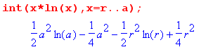 .
We then write out Az(c)(r) in its two regions

Az(c)(r>a) = - $\frac{μ2I}{πa2}$ { (1/2) a2lnr } = - $\frac{μ2I}{2π}$lnr (B.7.7)
Az(c)(r<a) = - $\frac{μ2I}{πa2}$ { (1/2){a2lna - r2lnr - (a2-r2)/2} + (1/2) r2 lnr} = $\frac{μ2I}{2πa2}$ { (a2-r2)/2 - a2lna }

(b) The Az(m) term

From (B.7.1) and (B.7.2),

-Az(m)(x) = μ0∫$_{}^{}$ dA' Jmz(x')] $\frac{ln(R2)}{4π}$
= $\frac{μ0}{4π}$ $^{\int_{0}^{a}{}}$r' dr'$^{\int_{-π}^{π}{}}$dθ' [- ( $\frac{μ2}{μ0}$ - $\frac{μ1}{μ0}$ ) Hθ(r') ] δ(r'-a) ln(R2)
= - $\frac{a}{4π}$ Hθ(a) (μ2- μ1)$^{\int_{-π}^{π}{}}$dθ' ln(a2 +r2-2ra cos(θ-θ'))
= - $\frac{a}{2π}$ Hθ(a) (μ2- μ1) $^{\int_{0}^{π}{}}$dx ln(a2 +r2-2ra cos(x))
= - $\frac{a}{2π}$ Hθ(a) (μ2- μ1) Q(a,r)
= - $\frac{a}{2π}$ Hθ(a) (μ2- μ1) 2π
= a Hθ(a) (μ1- μ2) (B.7.8)

From Ampere's law (1.1.37) we have (ignoring displacement current inside the conductor)

H • ds = 2πaHθ(a) = ∫S J • dS = I => Hθ(a) = $\frac{I}{2πa}$

and then

-Az(m)(x) = $\frac{I}{2π}$ (μ1-μ2) . (B.7.9)

Then

Az(m)(r>a) = $\frac{I}{2π}$(μ2-μ1) lnr
Az(m)(r<a) = $\frac{I}{2π}$ (μ2-μ1) lna (B.7.10)

(c) Adding the two terms and checking boundary conditions

Az(r>a) = - $\frac{μ2I}{2π}$lnr + $\frac{I}{2π}$(μ2- μ1) lnr = - $\frac{μ1I}{2π}$lnr

Az(r<a) = $\frac{μ2I}{2πa2}$ { (a2-r2)/2 - a2lna } + $\frac{I}{2π}$ (μ2-μ1) lna
= $\frac{μ2I}{2π}$ { (a2-r2)/(2a2) - lna } + $\frac{I}{2π}$ (μ2-μ1) lna
= - $\frac{I}{2π}$ { μ2 (r2-a2)/(2a2) + μ1 lna }

Here then are the finally results for the potential Az = Az(c) + Az(m),

Az(r>a) = - $\frac{I}{2π}$ μ1lnr
Az(r<a) = - $\frac{I}{2π}$ { μ1 lna + μ2$\frac{r2-a2}{2a2}$ } (B.7.11)

As a check, we calculate the B and H fields implied by these potentials

B = curl A = [ r-1∂θAz - ∂zAθ] + [∂zAr - ∂rAz] + [ r-1∂r(rAθ) - r-1∂θAr ]

= [- ∂rAz] => Bθ = -∂rAz(r)

Then
Bθ(r>a) = $\frac{I}{2π}$μ1 (1/r)
Bθ(r<a) = $\frac{I}{2π}$μ2 $\frac{2r}{2a2}$ = $\frac{I}{2π}$ μ2 (r/a2) (B.7.12)

so the H fields are then

Hθ(r>a) = $\frac{I}{2π}$ (1/r)
Hθ(r<a) = $\frac{I}{2π}$ (r/a2) (B.7.13)

which agrees with Ampere's Law applied in these two regions:

2πr Hθ(r>a) = I => Hθ(r>a) = $\frac{I}{2π}$(1/r)
2πr Hθ(r<a) = I(πr2/πa2) => Hθ(r>a) = $\frac{I}{2π}$(r/a2) . (B.7.14)

Next, we check our two boundary conditions required by (B.6.0) :

value at r = a:

Az(r>a)|r=a – Az(r<a) |r=a = - $\frac{I}{2π}$ μ1lna - ($\frac{I}{2π}$[ μ2 $\frac{a2-a2}{2a2}$- μ1 lna ]) = 0 OK

slope at r = a: [∂rAz = -Bθ so use(B.7.12) ]

∂rAz(r>a) |r=a = - $\frac{I}{2π}$μ1 (1/a)
∂rAz(r<a) |r=a = - $\frac{I}{2π}$μ2(a/a2) = - $\frac{I}{2π}$μ2(1/a)

$\frac{1}{μ1}$∂rAz(r>a) |r=a – $\frac{1}{μ2}$∂rAz(r<a) |r=a = - $\frac{I}{2π}$(1/a) - [- $\frac{I}{2π}$(1/a)] = 0 OK

Thus we have shown for the round conductor with uniform Jz that "the Jm theorem" works. By adding the bogus surface current term, we generate the correct homogeneous solution which when added to the Helmholtz integral provides the correct total solution which meets both boundary conditions.

(d) Plots of Az and Bθ and Hθ

Maple provides plots of Az from (B.7.11), Bθ from (B.7.12) and Hθ from (B.7.13) for this round wire situation. Parameters are set to I = 1, a = 2, μ1 = 2 (dielectric), μ2 = 3 (wire).

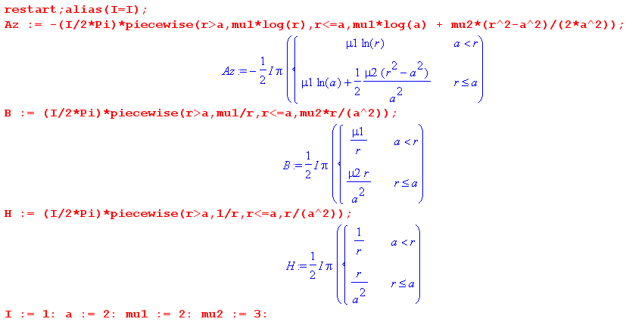

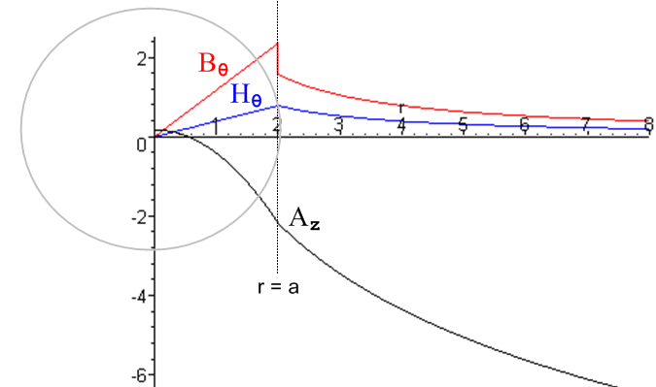 Fig B.8

Az wanders down as ~ -ln(r) for large r; Bθ jumps down at r = a while Hθ is continuous there.

