Old Sections B.6 and B.7 PhL 1.17.14

B.6 An Acrobatic Exercise: Compute H from J and Jm via the vector potential A.

For the round wire with a uniform Jz we are aware of both the volume current JZ and the surface current Kz. In this exercise, we insert both these currents into our formula for the vector potential A, we do the required integrals, and at the end we compute B = curl A and finally use H = B/μ. Hopefully in the end we shall recover once again the results for Hθ shown above. Here again is the picture of interest:

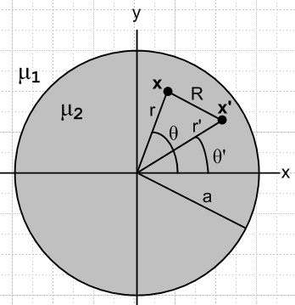 Fig B.5

Start with a 2D magnetostatics equation which is (1.5.4) with β2 = 0,

∇22DA(x) = -μ1Jm(x) -μ2Jc(x) . (B.6.1)

This 2D approximation is appropriate for a transmission line conductor in the "transmission line limit".

The particular solution from (I.1.8) is

A = (1/2π) ∫dV' [μ1Jm(x') + μ2Jc(x')] ln(1/R) R = |x-x'|

= (1/2π) { ∫dS' [μ1Km(x')] ln(1/R) + ∫dV'[ μ2Jc(x')] ln(1/R) }
so
Az = (1/2π) { ∫dS' [μ1Kz(x')] ln(1/R) + ∫dV'[ μ2Jcz(x')] ln(1/R) }

= -(1/2π) { ∫dS' [μ1Kz(x')] ln(R) + ∫dV'[ μ2Jcz(x')] ln(R) }

= -(1/4π) { μ1∫dS' [Kz(x')] ln(R2) + μ2∫dV'[Jcz(x')] ln(R2) } . (B.6.1)

Here ∫dV' represents an integral over the "volume" of the wire slice shown in the figure (which is really a disk) and ∫dS' represents an integral over the "surface" of the wire slice (which is really a circle).

We now insert the uniform prescribed current Jcz and our previously computed surface current Kz,

Jcz(x') = Jcz = I/(πa2) (B.6.2)

Kz(x') = Kz = (1-μ2/μ1) (1/2πa) I (B.6.3)

with the result that

Az = - (1/4π) { μ1(1-μ2/μ1) (1/2πa) I ∫dS' ln(R2) + μ2 I/(πa2)∫dV' ln(R2) }

= - [I/(4π2a2)] { (μ1-μ2) (a/2) ∫dS' ln(R2) + μ2∫dV' ln(R2) } . (B.6.4)

The volume integral (per unit length in the z direction, so really an area integral as just noted) is,

∫dV' ln(R2) = $^{\int_{0}^{a}{}}$r' dr' $^{\int_{-π}^{π}{}}$dθ' ln [r'2 +r2-2rr' cos(θ-θ')]

= 2 $^{\int_{0}^{a}{}}$r' dr' $^{\int_{0}^{π}{}}$dθ' ln [r'2 +r2-2rr' cos(θ-θ')]

= 2 $^{\int_{0}^{a}{}}$r' dr' $^{\int_{0}^{π}{}}$dx ln [r'2 +r2-2rr' cosx] . (B.6.5)

Define the x integral as

Q(r',r) ≡ $^{\int_{0}^{π}{}}$dx ln [r'2 +r2-2rr' cosx] (B.6.6)

so then

∫dV' ln(R2) = 2 $^{\int_{0}^{a}{}}$r' dr' Q(r',r) . (B.6.7)

Meanwhile, our surface integral of interest (really a line integral) is

∫dS' ln(R2) = $^{\int_{-π}^{π}{}}$[a dθ'] ln [r'2 +r2-2rr' cos(θ-θ')] |r'=a

= 2a $^{\int_{0}^{π}{}}$dx ln [r'2 +r2-2rr' cosx] |r'=a = 2a Q(a,r) (B.6.8)

so that both integrals of interest require computation of Q(r',r), which we replicate here,

Q(r',r) ≡ $^{\int_{0}^{π}{}}$dx ln [r'2 +r2-2rr' cosx] . (B.6.6)

This integral may be evaluated using GR7 p 531 4.224,

with a = r'2 +r2 and b = -2rr' and a2-b2 = (r'2-r2)2 so that $\sqrt{a2-b2}$ = | r'2-r2 | .The condition a > |b| > 0 is met since (r±r')2 > 0 => r2+r'2 > ±2rr' which says a > ±b so a > |b|. Thus,

Q(r',r) = $^{\int_{0}^{π}{}}$dx ln [r'2 +r2-2rr' cosx)] = π ln [ $\frac{(r'2 +r2)+ | r'2-r2 |}{2}$] =
= 2π . (B.6.9)

This our two integrals of interest are

∫dS' ln(R2) = 2a Q(a,r) = 4πa (B.6.10)
∫dV' ln(R2) = 2 $^{\int_{0}^{a}{}}$r' dr' Q(r',r) = 4π $^{\int_{0}^{a}{}}$r' dr' , (B.6.11)

where we still have a dr' integral to carry out for the ∫dV' case. For r > a we know that r > r' since r' integrates over the inside of the wire. Then

∫dV' ln(R2) = 4π$^{\int_{0}^{a}{}}$r' dr' ln(r) = 4π ln(r) [ a2/2 ] = 2πa2 ln(r) r > a (B.6.12)

On the other hand, for r < a we have to break the integral into two parts :

∫dV' ln(R2) = 4π $^{\int_{0}^{r}{}}$r' dr' ln(r) + 4π $^{\int_{r}^{a}{}}$r' dr' ln(r')

= 4πln(r) (r2/2) + 4π [(1/2)x2(lnx-1/2) ]|ar

= 2π r2 ln(r) + 4π [(1/2)a2(lna-1/2) - (1/2)r2(lnr-1/2)]

= 2π r2 ln(r) + 2π [a2(lna-1/2) - r2(lnr-1/2)]

= 2π r2 ln(r) + 2π a2lna - πa2 - 2π r2lnr + πr2

= 2π a2lna + π(r2-a2) . r < a (B.6.13)

The result then is the following, where below it we repeat the earlier surface integral result,

∫dV' ln(R2) = (B.6.14)
∫dS' ln(R2) = 4πa . (B.6.15)

Now install these integrals into the Az expression (B.6.4) to get

Az = - [I/(4π2a2)] {(μ1-μ2) (a/2) ∫dS' ln(R2) + μ2∫dV' ln(R2) } (B.6.4)

= - [I/(4π2a2)] {(μ1-μ2) (a/2) 4πa + μ2} (B.6.16)

Then write these out for the two separate regions :

Az(r>a) = -[I/(4π2a2)] { μ1-μ2) (a/2) 4πa ln(r) + μ2 2πa2 ln(r) }

= -[I/(4π2a2)] { μ1-μ2) 2πa2 ln(r) + μ2 2πa2 ln(r) }

= -[I/(2π)] { μ1-μ2) ln(r) + μ2 ln(r) }

= -[I/(2π)] { μ1ln(r) } (B.6.17)

Az(r<a) = -[I/(4π2a2)] { μ1-μ2) (a/2) 4πa ln(a) + μ2( 2πa2ln(a) + π(r2-a2) ) }

= -[I/(4πa2)] { μ1-μ2) 2a2 ln(a) + μ22a2ln(a) + μ2(r2-a2) ) }

= -[I/(4πa2)] { μ1 2a2 ln(a) + μ2(r2-a2) ) }

= -[I/(2π)] { μ1 ln(a) + μ2(r2-a2)/(2a2) ) } (B.6.18)

At the boundary r = 0 both expressions give

Az(r=a) = -[I/(2π)] { μ1ln(a) } . (B.6.19)

The next step is to compute the magnetic field B = curl A given our function Az(r). We find from the usual cylindrical coordinates curl formula (B.5.2),

B = curl A = - ∂rAz(r) . (B.6.20)

First, for r > a one finds,

-∂rAz(r) = ∂r[I/(2π) { μ1ln(r) }] = (I μ1/2π) (1/r) r > a (B.6.21)

and then for r < a,

-∂rAz(r) = I/(2π) ∂r { μ1 ln(a) + μ2(r2-a2)/(2a2) ) } = (I μ2/2π) μ2 r/a2 (B.6.22)

Thus

B = (I μ1/2π) (1/r) for r > a which is in the dielectric medium with μ1
B = (I μ2/2π) (r/a2) for r < a which is in the conductor medium with μ2 . (B.6.23)

Using B = μH in each region we then get

H = (I /2π) (1/r) for r > a => Hθ = (I/2πr)
H = (I /2π) (r/a2) for r < a => Hθ = (Ir/2πa2) (B.6.24)

Amazingly, these results agree with the elementary calculation results given in (B.4.1) and (B.4.2). The important point here is that these results only come out right when both the volume and surface currents on the round wire are included in the calculation. The elementary Ampere's Law calculation of Hθ is simple because in the Maxwell equation curl H = J (Ampere's Law), the field H does not "see" the surface magnetization current, so one can forget about it.

Maple provides plots of Az from (B.6.17,18), Bθ from (B.6.23) and Hθ from (B.6.24) for this round wire situation. Parameters are set to I = 1, a = 2, μ1 = 2, μ2 = 3.

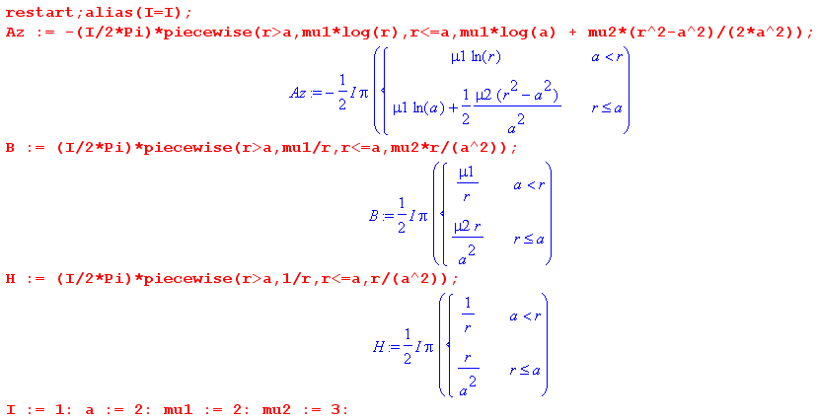

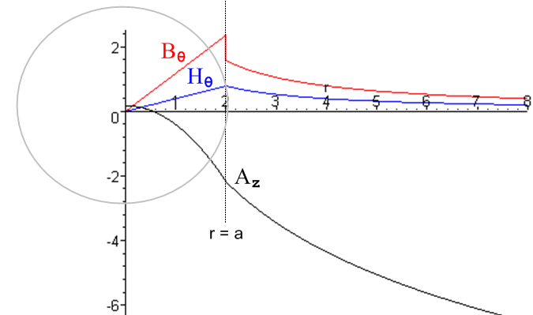 Fig B.6

Az wanders down as ~ -ln(r) for large r, Bθ jumps at r = a while Hθ is continuous there.

B.7 Reader Exercise: Repeat the above calculation of A using a 3D analysis

This is a guided exercise with waypoints. The starting point is this:

∇2A(x) = -μ1Jm(x) -μ2Jc(x) // 3D wave equation from (1.5.4) with β= 0

A(x) = (1/4π) ∫dV' [μ1Jm(x') +μ2Jc(x')] (1/R) R = |x-x'| . // according to (H.1.8)

(a) Insert Jm and Jc from (B.6.2) and (B.6.3) to get

Az(x) = (1/4π) (1/2πa) I { (μ1-μ2) ∫dS' (1/ R) + (2/a) μ2∫dV' (1/ R) }

where now we have true surface and volume integrals. Notice that we are using currents which do not vay in z, so here we are making the same "transmission line limit" approximation made in the 2D analysis.

(b) Show these integrals may be written:

∫dS' (1/R) = ∫(adθ') $^{\int_{-∞}^{∞}{}}$dz' (1/R) = a $^{\int_{-π}^{π}{}}$ dθ' $^{\int_{-∞}^{∞}{}}$dz' (1/$\sqrt{s2 + z'2}$)

∫dV' (1/R) = ∫(r'dθ') ∫dr'$^{\int_{-∞}^{∞}{}}$dz' (1/R) = $^{\int_{0}^{a}{}}$ r'dr' $^{\int_{-π}^{π}{}}$ dθ' $^{\int_{-∞}^{∞}{}}$dz' (1/$\sqrt{s2 + z'2}$)

where s2 = (x-x')2+ (y-y')2 = R2 of the 2D problem.

(c) Install a a large cutoff Λ to get

$^{\int_{-∞}^{∞}{}}$dz' (1/$\sqrt{s2 + z'2}$) → $^{\int_{-Λ/2}^{Λ/2}{}}$dz' (1/$\sqrt{s2 + z'2}$) = -2ln(s/Λ) = - ln(R2/Λ2) .

(d) Show then that

Az(x) = = - (I/4π2a2) { (μ1-μ2) [ a2 Q(a,r) - πa2 ln(Λ2)]
+ 2 μ2 [ $^{\int_{0}^{a}{}}$r' dr' Q(r',r) - ln(Λ2) π a2] }

where Q(r',r) is the integral defined in (B.6.6).

(e) Finally, show that the Az(x) obtained here is the same as that obtained in the 2D analysis apart from the appearance here of the following extra terms

+ (I/4π) ln(Λ2) (μ1+ μ2) .

(f) Compare the 2D and 3D methods with an interpretion of these extra terms which of course have no effect on B = curl A. Physically why does the infinite term appear in the 3D analysis and not in the 2D analysis?

