This is the Title PhL 3.26.05

Do not edit this document, it is already installed.

C.3 The DC inductance of a round wire

We assume here that μi is the permeability of the wire, and μe of the region outside the wire.

The energy density (joules/m3) stored in an electromagnetic field within a medium of negligible loss is given by uem = (E•D + B•H)/2 [ Jackson p 259 Eq. (6.106) ] . We are interested only in the portion of this energy density stored in the magnetic field, so u = (1/2) B•H. Since μ and ε are assumed to be non-tensor in nature, we find that

u = (1/2) μ H2. (C.3.1)

For any inductor of inductance L carrying current I and having potential difference V, we know that

V = L dI/dt (C.3.2)

P = IV = I (L dI/dt) = d/dt [ (1/2)L I2 ]. (C.3.3)

But since the power fed into an ideal inductor goes into the magnetic field energy, P = dU/dt and so

U = (1/2)L I2 . (C.3.4)

For our straight wire, we now redefine symbol L to mean inductance per unit length, so then

U = (1/2)[Ldz] I2 (C.3.5)

For either the internal or external region we have U = ∫dV u = dz ∫dS u where dV is a volume element and dS is a cross sectional area element. Thus,

U = dz∫dS (1/2) μ H2 = (1/2)[Ldz] I2 => L = μ ∫dS (H/I)2 (C.3.6)

In particular

Li = μi ∫in dS (Hi/I)2 (C.3.7)
Le = μe ∫outdS (He/I)2 (C.3.8)

For the round wire it is a simple matter to compute Hi and He using Ampere's Law (1.1.37),

H • ds = ∫S J • dS

2πr Hi = I(πr2/πa2) => Hi/I = $\frac{1}{2π}$(r/a2) .
2πr He = I => He/I = $\frac{1}{2π}$(1/r) (C.3.9)

We then compute the two inductances as follows:

Li = μi ∫dS (Hi/I)2 = μi $^{\int_{0}^{a}{}}$rdr$^{\int_{-π}^{π}{}}$dθ [$\frac{1}{2π}$(r/a2)]2 = $\frac{μi}{2πa4}$ $^{\int_{0}^{a}{}}$r3dr = $\frac{μi}{8π}$
Le = μi ∫dS (He/I)2 = μe $^{\int_{a}^{∞}{}}$rdr$^{\int_{-π}^{π}{}}$dθ [$\frac{1}{2π}$(1/r)]2 = $\frac{μe}{2π}$ $^{\int_{a}^{∞}{}}$(1/r) dr = ∞

Both results are interesting. Li is interesting because it is independent of the wire radius a. For the same current, a smaller a results in a larger H and B field, which is then offset by the smaller volume (area).

Le is interesting because it is infinite ! Even a tiny 1 cm piece of round wire stores an infinite amount of energy in its magnetic field. We therefore limit the external region by some large radius R and then we have
Li = $\frac{μi}{8π}$ = $\frac{μi}{μ0}$ $\frac{μ0}{8π}$ = $\frac{μi}{μ0}$ $\frac{4π x 10-7}{8π}$ = $\frac{μi}{μ0}$ * 50 nH/m (C.3.10)
Le = $\frac{μe}{2π}$ln(R/a) (C.3.11)

Thus for a round wire in air the internal inductance is exactly 50 nH/m.

A "practical wire" is more like a loop of wire than an infinitely long wire. It is difficult to conjure up an experiment to test (C.3.11) even for a very long straight piece of wire without having some return path for the current to return to the driving "battery". For wire and dielectric both having μ0, Jackson shows (p 216-218) that the inductance per unit length of a loop of projected area A of radius-a wire is given by
Le + Li = (μ0/4π) [ ln(ξA/a2) + 1/2], where ξ is a near-unity factor which accounts for messy details of the calculation. The 1/2 term accounts for the internal inductance Li = μ0/8π as in (C.3.10).

For a circular loop of radius R, one has A = πR2 and, if R >> a, ξ = 64/(πe4) ≈ .373. So,

ln(ξA/a2) = ln(64 πR2/πe4a2) = 2 ln(8R/ae2) = 2 ln(8R/a) + 2 ln(e-2) = 2 ln(8R/a) - 4

and then the total inductance per unit length is

Le + Li = (μ0/4π) [2 ln(8R/a) - 4 + 1/2] = (μ0/2π) [ ln(8R/a) - 2 + 1/4] = (μ0/2π) [ ln(8R/a) -7/4] .

The total inductance of such a loop is then

L = 2πR(μ0/2π) [ ln(8R/a) -7/4] = μ0R [ ln(8R/a) -7/4] (C.3.12)

in agreement with Jackson Problem 5.32 p 234. If one omits the internal inductance, the last factor is -2 instead of -7/4, and this result is seen in some sources. The point is that this is a finite result, even though the (dipole) magnetic field of such a loop does extend to infinity. A loop of N turns gets an extra factor N2 because in effect current I → NI in (C.3.5), so the total field energy increases by factor N2.

Suppose there were two parallel wires with currents flowing in opposite directions. In this case, we could compute the magnetic field H at any point in space as the vector sum of the fields of the two wires, then we could integrate H2 over all space to get the total energy U and from that the external inductance Le. In this case, the ln(R) divergence does not appear. In effect, the divergence cancels between the two wires, similar to the way opposite short segments of the circular wire cancel to give the finite result quoted above. Since we will be doing this computation by another means in the main text, we do not bother with the parallel wire calculation here.

We really only care about the internal inductance Li of a wire in our transmission line analysis because the external inductance Le is already accounted for by the techniques of Chapter 4. That is, Le is computed by considering the magnetic potential Az ( or W ) between the wires.

C.4 The DC inductance of a wire of arbitrary cross section

The expressions above apply to any cross sectional shape,

Li = μi ∫in dS (Hi/I)2 (C.3.7)
Le = μe ∫outdS (He/I)2 (C.3.8)

so the only problem is how to compute H for a non-round wire. That problem is solved in Appendix B where it is shown that

H(x,y) = - $\frac{1}{4π}$∫d2x' ln(R2) curl' J(x') R = |x-x'| . (B.2.6) (C.4.1)

We can do a wire of rectangular cross section a x b (uniform Jz) as an example.

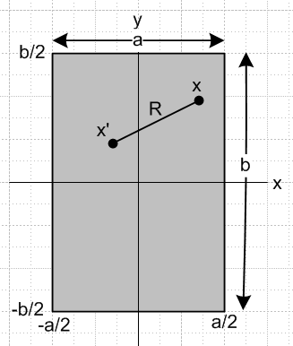

The current density is given by

Jz(x) = (I/ab)θ(-a/2 ≤ x ≤ a/2) θ(-b/2 ≤ y ≤ b/2)

= (I/ab) θ(x ≤ a/2)θ(x≥-a/2) θ(y ≤ b/2)θ(y≥-b/2) // θ(s≥r) means θ(s-r) Heaviside

= (I/ab) θ(a/2- x)θ(x + a/2) θ(b/2- y)θ(y + b/2) (C.4.2)

Then calculate curl J :

curl J = (∂yJz - ∂zJy) + (∂zJx - ∂xJz) + (∂xJy - ∂yJx)

= (∂yJz) + (- ∂xJz) (C.4.3)

∂xJz = (I/ab) θ(b/2- y)θ(y + b/2) ∂x [θ(a/2- x)θ(x + a/2)] // ∂xθ(a-x) = - δ(x-a)

= (I/ab) θ(b/2- y)θ(y + b/2) [θ(a/2- x)δ(x +a/2) - θ(x + a/2)δ(x-a/2) ]

Swap x↔y and a↔b to get

∂yJz = (I/ab) θ(a/2- x)θ(x + a/2) [θ(b/2- y)δ(y +b/2) - θ(y + b/2)δ(y-b/2) ]

so then

[curlJ]x = (I/ab) θ(a/2- x)θ(x + a/2) [θ(b/2- y)δ(y +b/2) - θ(y + b/2)δ(y-b/2) ]
[curlJ]y = - (I/ab) θ(b/2- y)θ(y + b/2) [θ(a/2- x)δ(x +a/2) - θ(x + a/2)δ(x-a/2) ] (C.4.4)

Finally calculate H from (C.4.1):

Hx(x,y) = - $\frac{1}{4π}$∫d2x' ln(R2) [curl' J(x')]x R = |x-x'|
= - $\frac{1}{4π}$$^{\int_{-a/2}^{a/2}{}}$dx'$^{\int_{-b/2}^{b/2}{}}$dy' ln [ (x-x')2 + (y-y')2] (I/ab) [ δ(y'+b/2) - δ(y'-b/2) ]
= - $\frac{1}{4π}$ (I/ab) $^{\int_{-a/2}^{a/2}{}}$dx' { ln [ (x-x')2 + (y+b/2)2] - ln [ (x-x')2 + (y-b/2)2] }
= - $\frac{1}{4π}$ (I/ab) $^{\int_{-a/2}^{a/2}{}}$ds ln [ $\frac{(x-s)2 + (y+b/2)2}{(x-s)2 + (y-b/2)2}$ ]
≡ - $\frac{1}{4π}$ (I/ab) F(x,y,a,b)

We shall evaluate this F integral below. Meanwhile, the expression for Hx(x,y) is

Hy(x,y) = - $\frac{1}{4π}$∫d2x' ln(R2) [curl' J(x')]y R = |x-x'|

= $\frac{1}{4π}$$^{\int_{-a/2}^{a/2}{}}$dx' $^{\int_{-b/2}^{b/2}{}}$dy' ln [ (x-x')2 + (y-y')2] (I/ab) [ δ(x'+a/2) - δ(x'-a/2) ]

= $\frac{1}{4π}$ (I/ab) $^{\int_{-b/2}^{b/2}{}}$dy' { ln [ (x+a/2)2 + (y-y')2] - ln [ (x-a/2)2 + (y-y')2] }

= $\frac{1}{4π}$ (I/ab) $^{\int_{-a/2}^{a/2}{}}$ds ln [$\frac{(y-s)2 + (x+a/2)2}{(y-s)2 + (x-a/2)2}$ ]

= $\frac{1}{4π}$ (I/ab) F(y,x,b,a)

To summarize

Hx(x,y) = - $\frac{1}{4π}$ (I/ab) F(x,y,a,b)
Hy(x,y) = + $\frac{1}{4π}$ (I/ab) F(y,x,b,a) (C.4.5)

The function F(x,y,a,b) is rather unpleasant, although expressible in closed form. Maple computes F as follows:

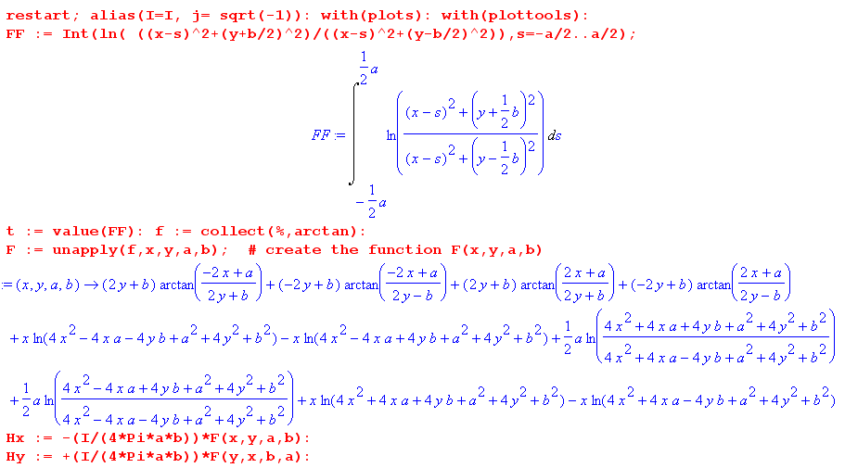

The 2nd line displays the integral of interest as FF. The t = value(FF) causes Maple to do the integration analytically, then the collect command puts the four arctan terms first (cosmetic). The unapply command causes the expression f to be interpreted as F(x,y,a,b). The last two lines then compute Hx and Hy.

The internal inductance of the rectangular wire is then given by

Li = μi ∫dS (Hi/I)2 = μi($\frac{1}{4πab}$)2$^{\int_{-a/2}^{a/2}{}}$dx$^{\int_{-b/2}^{b/2}{}}$dy [F(x,y,a,b)2 + F(y,x,b,a)2] . (C.4.6)

Since F(x,y,αa,αb) = αF(x/α,y/α,a,b) one can show that Li must have this form

Li = (μi/8π) f(b/a) (C.4.7)

though that conclusion is obvious based on dimensions alone. The problem is to find function f

f(b/a) = (8π/μi) μi($\frac{1}{4πab}$)2$^{\int_{-a/2}^{a/2}{}}$dx$^{\int_{-b/2}^{b/2}{}}$dy [F(x,y,a,b)2 + F(y,x,b,a)2]

= $\frac{1}{2πa2b2}$$^{\int_{-a/2}^{a/2}{}}$dx$^{\int_{-b/2}^{b/2}{}}$dy [F(x,y,a,b)2 + F(y,x,b,a)2]

f(b) = (8π/μi) μi($\frac{1}{4πb}$)2$^{\int_{-1/2}^{1/2}{}}$dx$^{\int_{-b/2}^{b/2}{}}$dy [F(x,y,1,b)2 + F(y,x,b,1)2] . (C.4.8)

Notice that f(b/a) = f(a/b), which seems also clear on physical grounds, so f(b) = f(1/b).

We were not successful (in a few minutes) trying to get Maple to compute this integral analytically or numerically, but certainly the numerical integration can be done. De Smedt quotes the following numerical approximate formulas for two special cases:

Li = (μi/8π) [0.96639] a = b (square wire) // very close to the round conductor

Li = (μi/8π) [(4π/3) a/b ] a/b << 1 (flat wire) // ≈ (μi/8π) [ 4.2 a/b ] (C.4.9)

Reader Exercise: Do the numerical integration (C.4.8) to determine function f(b) for several b values and plot for b = 0 to 1. Is f(1) = 0.96639 ?

We now plot the H field for the rectangular conductor in two ways. First, setting a = 1, b = 2, I = 1:

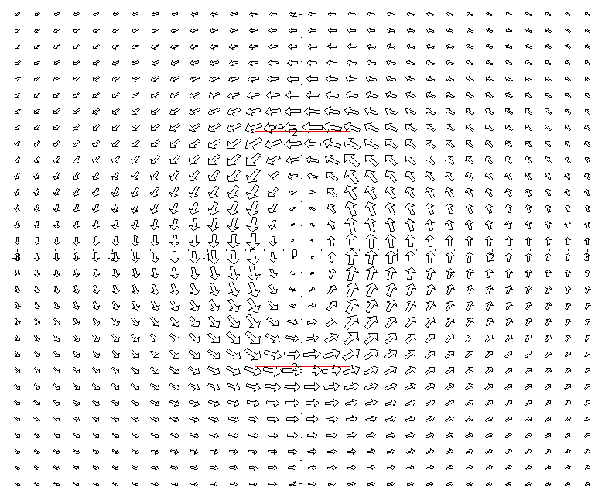
In this plot the H field appears to be maximal at the conductor boundary (shown in red) and as one moves away it becomes the field of a thin round wire. Current Jz is flowing in the z direction toward the viewer.
The second plot is of |H|2 as a surface over the x,y plane:

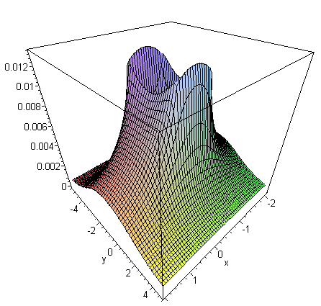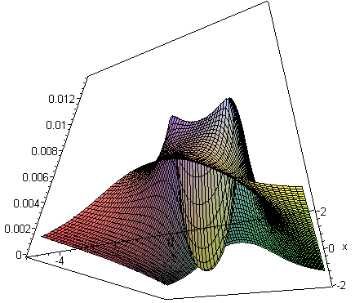
view from above view from below

The H field surface is very steep at the conductor boundaries, somewhat resembling a rectangular volcano which dips all the way down to 0 in the center, as shown on the right. The Li integration is over this central part of the volcano.
The red plot below is a slice through the volcano at x = 0 :

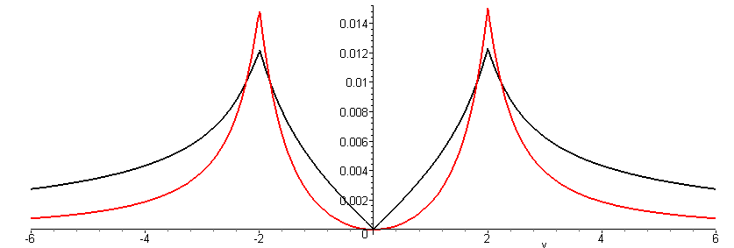

The black plot is of | H | (but scaled down) and resembles the Hθ plot for the round wire shown in Fig B.8.

