New C_5 Feb 2 2014 PhL 2.2.14

This is the version that ended up in lines doc. I made it an intentionally misleading section for fun to take the reader down the wrong road with me, then I show why this is wrong.

C.5 The DC internal inductance of a thin ribbon conductor

This is a fascinating problem with a result that is non-obvious.

Consider an infinitely long conductor whose cross section has the shape of a thin strip of width w and height t with t << w,

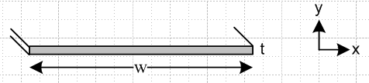 Fig C.6

The correct result for Li was given earlier in (C.4.11) and we repeat it here, setting w = 2a and t = 2b,

Li = (μi/8π) [(4π/3) t/w ] = (1/6) μi (t/w) t << w (C.4.11)

We shall now attempt to obtain this result in a simple manner.

The uniform current density is Jz = I/(wt), flowing toward the viewer. Here is a blowup of a piece of the strip near its center,

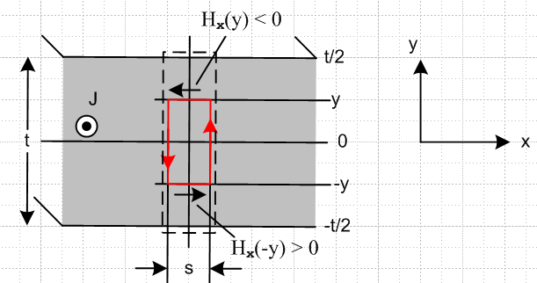 Fig C.7

The red math loop is positioned as shown for an application of Ampere's Law,

∫S J • dS = C H • ds . (1.1.37)

Starting at the lower left corner of the red loop for C, this says

Jz 2y s = s Hx(-y) + 0 2y - Hx(y)s - 0 2y .

We assume that "near the center of the strip" there is no significant transverse field component Hy, though we accept that such transverse fields do exist far away "near the edges" of the strip as Fig C.2. Thus, the two vertical sections of the red loop make negligible contribution to the line integral. Symmetry indicates that Hx on the upper red loop segment is equal and opposite to that on the lower segment, so the line integral is then -2Hx(y) s and we continue :

Jz 2y s = - 2 Hx(y)s

Jz y = - Hx(y)s

I/(wt)*y = - Hx(y)s

Hx(y)/I = - y/(wt) .

The result is that Hx(y) = -(I/wt)y which is a very reasonable linear function of y, with Hx(y=0) = 0. The fact that Hx(y) does not depend on x is also reasonable since, when w >> t, the central region of the strip is basically all of the strip excluding the tiny end regions which we ignore. A similar argument is made for the analysis of a parallel plate capacitor, where the end effects are ignored if w >> t.
To get the internal inductance due to this Hx energy storage, we compute its contribution from the dotted rectangle in Fig C.6, then multiply by (w/s) to get Li for the entire strip. So, using (C.3.6),

Li = (w/s) μ ∫dotted dS (H/I)2 = (w/s) μ∫dotted (sdy) [-y/(wt)]2

= (w/s) μ s (wt)-2 $^{\int_{-t/2}^{t/2}{}}$dy y2 = (w/s) μ s (wt)-2 2 $^{\int_{0}^{t/2}{}}$dy y2

= (w/s) μ s (wd)-2 2 (1/3) (t/2)3 = w-1 μ t-2 (2/3) t3/8

= (1/12) μ (t/w) = (μi/8π) [ 2π/3 (t/w) ] // strip w>>t , due to Hx (C.5.3)

But this is only half the correct result for Li which was just quoted above. By luck, (C.5.3) happens to be the correct result for the Hx contribution to Li; by luck because it is derived from Fig C.6 with the assumption that Hy ≡ 0 which is not true. The other half of Li in fact comes from the Hy field in the strip. One can write

Li = μ $^{\int_{-t/2}^{t/2}{}}$ dy $^{\int_{-w/2}^{w/2}{}}$ dx [ (Hx/I)2 + (Hy/I)2 ] = Lix + Liy

so the Hx and Hy contributions are simply additive with no interference.

So where did the argument above go wrong? It all seemed so reasonable. One is of course biased by the appearance of the fields in Fig C.2 the central part of which we repeat here

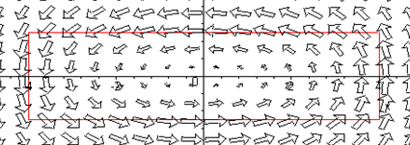 Fig C.8

One's impression is that as the aspect ratio is increased from 4:1 to perhaps 100:1, the nature of the above plot should become even more convincing: large horizontal arrows to the left along the top of the strip, large horizontal arrows to the right along the bottom of the strip, and some minor edge effects at the distant ends.

But this is in fact not a correct impression! For a 10:1 aspect ratio strip, here is the field map (Hx,Hy) for the upper right quadrant of the strip

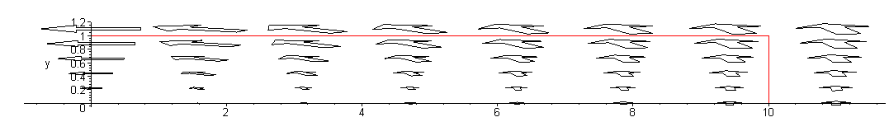 Fig C.9

If we plot only the Hx component by setting Hy = 0 in our field plot, we get

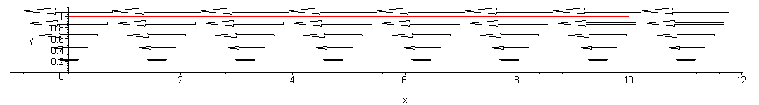 Fig C.10

and this displays our conjectured functional shape Hx(y) = -(I/wt)y applying not just at the center of the strip, but all along the strip. This then explains graphically why our calculation above came up with the correct result for the Hx contribution to Li. The other half of Li comes from the transverse field component Hy which has this appearance (we now set Hx = 0 in the field plot)

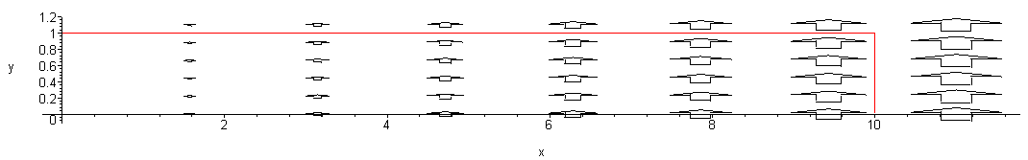 Fig C.11

The fact that the Hy contribution to Li is exactly equal to the Hx contribution is just not obvious. One would think some simple argument could be concocted to explain this fact. For example, one might conjecture looking at the above plot that Hy ≈ Hy(x) so that Ampere's law for the Fig C.6 red loop says

Jz 2y dx = dx Hx(-y) + Hy(x+dx) 2y - Hx(y)dx - Hy(x)2y .

Jz 2y = -2 Hx(y) + [Hy(x+dx) - Hy(x)]/dx * 2y .

Jz y = - Hx(y) + y ∂xHy(x) .

Then using Hx(y) ≈ -(I/wt)y and Jz = I/(wt) one gets y ∂xHy(x) = 0 which says

Hy(x) = Bx

which seems reasonable in terms of the last figure above. But it is problematical in two respects: (1) there is no obvious way to determine B without taking a limit of the complicated full Hy formula ; (2) Even when that is done, Hy(x) is in fact not linear in x as a simple plot shows, so the model is inaccurate and does not give the result that Li due to Hy is (1/12) μ (t/w).

The field plots shown above and the energy plots of Fig C.3 are easy to produce from Maple. These latter plots are like topographical maps and they can be displayed in that manner as shown on the right below

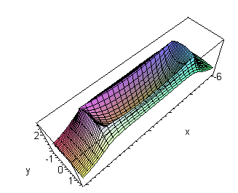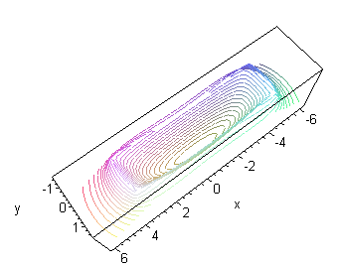 Fig C.12

where we have reverted to the 4:1 aspect ratio strip.

One should not confuse the topo contour lines shown here with a plot of the H field lines. Making a field line plot is not a built-in function for our old Maple V and requires some minor coding to implement. Here is such a field line plot for a 20:1 aspect ratio thin strip,

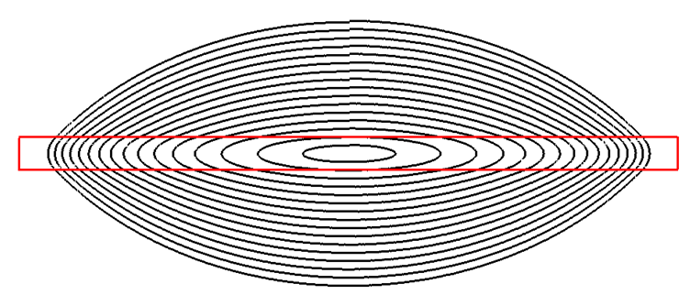
Fig C.13

Each contour starts at x = 0 and y = some value and is iterated CCW (chasing the direction of the H vector) until it arrives back where it started. The little jogs at the top represent the small error of this numerical process. Looking at this field line plot, it is totally obvious that there does not exist some "broad central region" in the strip where the field lines are mostly horizontal. The transverse field components (vertical) appear as soon as one leaves the exact center of the strip and it is totally wrong to ignore such transverse Hy components in the computation of Li.
The correct calculation of Li is done in the 2009 paper of Holloway and Kuester. They point out errors made by earlier authors and make the point that half the internal inductance comes from each field component. They do not claim that the transverse contribution is exactly half the result, but that it is half to a high degree of numerical precision. In an email communication, Prof. Kuester made the appropriate point that, since div H = 0 (there is no magnetic charge), the H field lines must close on themselves and that is what forces the above figure to have the shape it has, where there is no "broad central region" having essentially horizontal field lines. In the corresponding parallel plate capacitor picture for electrostatics, since electric charge does exist, the E fields lines do not need to close on themselves, and have sources and sinks all along the capacitor cross section, allowing for a uniform broad central region.
Here is one more field line plot showing a larger range of field lines,

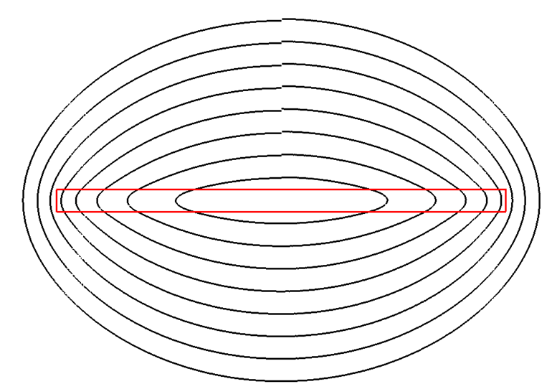
Fig C.14

As the field lines are continued outward, they eventually become circles as the strip eventually becomes a line source ( a point source in cross section) when viewed from far away.

Reader Exercise: Come up with a simple explanation for why the Hx and Hy fields each contribute half the total Li value for the strip.

