This is the Title PhL 3.26.05

This is now installed in Appendix C, and I found external verification for the result in a 1922 book!

A new problem:

Consider a cylindrical shell conductor of inner radius a and thickness δ. What is the DC internal inductance of such a shell?

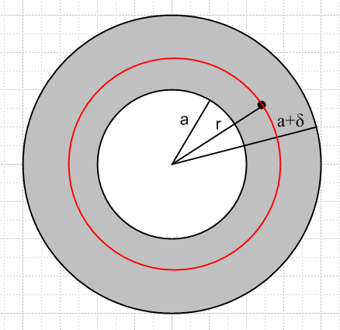

First, compute the H field. The total area of the shell is this

A = π(a+δ)2 - πa2 = π [(a+δ)2 - a2]

If we assume a constant current density in this shell, we find that

Jz(r) = I/A =$\frac{I}{π [(a+δ)2-a2]}$

The current enclosed by a loop of radius r is given by

Ienc(r) = ∫ dS Jz = 2π$^{\int_{a}^{r}{}}$rdr Jz(r)dS = 2π $\frac{I}{π [(a+δ)2-a2]}$$^{\int_{a}^{r}{}}$r' dr'

= 2π $\frac{I}{π [(a+δ)2-a2]}$ [r2-a2] (1/2) = $\frac{r2- a2}{[(a+δ)2-a2]}$ I

The current enclosed at radii ranging from a to a+δ is this

Ienc(r) = $\frac{r2- a2}{[(a+δ)2-a2]}$ I Ienc(r) = $\frac{r2}{δ2}$ I

which I could have started off with, it is a completely obvious fact.

Now compute Hθ(r)
2πrH(r) = current enclosed = Ienc(r) =$\frac{r2- a2}{[(a+δ)2-a2]}$ I dim OK
H(r) = $\frac{r2- a2}{[(a+δ)2-a2]}$ (I/2πr)

u = (1/2)μ1 H2 = (1/2) μ1 ($\frac{1}{[(a+δ)2-a2]}$)2 (1/2π)2 I2 $\frac{(r2-a2)2}{r2}$

U = ∫dS u = 2π $^{\int_{a}^{a+δ}{}}$dr r u = (1/2) μ1 ($\frac{1}{[(a+δ)2-a2]}$)2 (1/2π) I2 $^{\int_{a}^{a+δ}{}}$dr r $\frac{(r2-a2)2}{r2}$

Maple does the integral

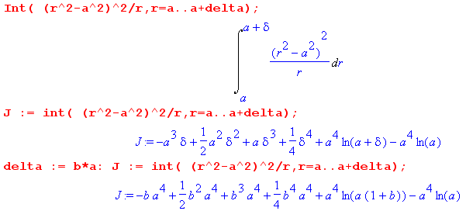

which result we re-express in terms of the ratio b ≡ δ/a,

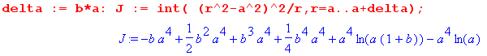
Given this expression for J, we have

U = (1/2) μ1 ($\frac{1}{[(a+δ)2-a2]}$)2 (1/2π) I2 J

= (1/2) μ1a-4 ($\frac{1}{[(1+b)2-1]}$)2 (1/2π) I2 J = (1/2) μ1a-4 ($\frac{1}{[b2(2+b)2]}$) (1/2π) I2 J

and then

U = (1/2)L I2
so
L = μ1a-4 ($\frac{1}{[b2(2+b)2]}$) (1/2π) J(b)

In the limit a→0 we have b→∞ and then J(b) = (b4a4)/4 so

L = μ1a-4 b-4 (1/2π) (b4a4)/4 = μ1 (1/8π)

which is the correct result for a solid round wire.

For a thin cylindrical shell, we instead take b→ 0. Maple tells us that

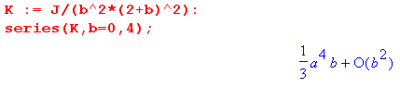

so that in this limit we get

Li = μ1a-4 (1/2π) { J(b) $\frac{1}{[b2(2+b)2]}$} = μ1a-4 (1/2π) (a4b/3) = μ1 (1/2π) (b/3) = (μ1/6π)b

= (μ1/6π)(δ/a) = (μ1/8π)(4/3)(δ/a)

Now if I crudely think of this as a rolled up microstrip of width w = 2πa then I am getting

Li = (μ1/8π) (4/3) (2πδ/w) = (μ1/8π) [8π/3] (δ/w)

This is not too different from the quoted result for an unrolled microstrip,

Li = (μi/8π) [(4π/3) a/b ] a/b << 1 (flat wire) // ≈ (μi/8π) [ 4.2 a/b ] (C.4.11)

I think my result is the right one!

It is true that the flat wire and the annulus have different H field distributions so that might account for the difference.

Amazingly I found as PDF which has these quotes
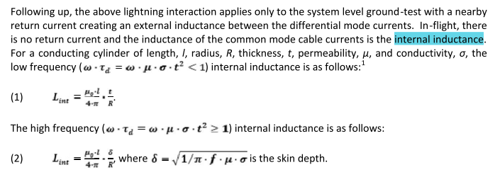

My result was μ1(1/4π)[ 3-4ln2] (δ/a), but their result is μ1(1/4π) (δ/a). They give this reference for their results

and I think I have access to that stuff now. I download the thing and save it. I then do OCR with Acrobat so I can search the thing. None of them come searchable for some reason. It is 48 pages long. But I don't see this formula in there. The result quoted does match my Appendix K high frequency result

Li(ω) = (1/ω) Im(Zs) = (1/ω) $\frac{1}{σ1(2πa1)δ1}$ = μ1σ1δ2/2 $\frac{1}{σ1(2πa1)δ1}$ = μ1 (1/4π) (δ1/a1)

except the quote shows some R' thing. I cannot find anything like this in that PDF! But I know exactly what they are saying. So no need for The BSTJ thing.

There is no H field inside my cylinder by the way. I think my result is correct and that airline PDF paper is a red herring result that is wrong.

So I will redo each step in the a = 0 limit and see where it disagrees with the round wire step.

