C.5 The DC internal inductance of a thin strip conductor

Here I tried to bail out my thin strip derivation after the Kuester email set me straight, but I failed. I first tried doing Hx and Hy separately which now seems wrong if they are in the same red loop. I then tried doing them together, but that did not work either. Basically the model here is too simple to explain the physical situation. I eventually wrote up a little of this in lines doc. Below are the graphs I refer to which show that the model is no good. I then left it as a Reader Exercise to come up with a simple model that works! This problem is too specialized for me to work more on in terms of lines doc.

The strip geometry is as follows, where we assume Jz is uniform and total current is I , w = width and h = height,

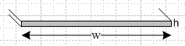 Fig C.5

We also assume w >> h. The figures below is a magnified end view of a short section of the conductor's width

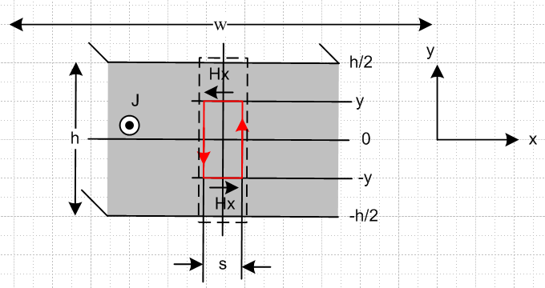 Fig C.6

The uniform current density Jz is out of the plane of paper.

Jz = I/(wh) . (C.5.1)

Based on Fig C.2 we expect the x component of the H field to have the direction shown. That is to say, at ±y we argue from symmetry that Hx has equal and opposite values. For the moment we imagine that Hy ≡ 0.

Applying Ampere's Law to the red loop one finds

∫S J • dS = C H • ds (1.1.37)
so
Jz 2y s = 2Hx(y) s => Hx(y) = Jzy = Iy/(wh) Hx(y)/I = y/(wh) (C.5.2)

We have made a quiet assumption that Hy(y) is not a function of x based on the fact that w >> h and we ignore end effects. We end up then with Hx(y) being a function that is linear in y as y moves from -h/2 to h/2.

To get the internal inductance due to Hx, we compute its contribution from the dotted rectangle, then multiply by (w/s) to get Li for the entire strip. So using (C.3.6)

Li = (w/s) μ ∫dotted dS (H/I)2 = (w/s) μ∫dotted (sdy) [y/(wh)]2

= (w/s) μ s (wh)-2 $^{\int_{-h/2}^{h/2}{}}$dy y2 = (w/s) μ s (wh)-2 2 $^{\int_{0}^{h/2}{}}$dy y2

= (w/s) μ s (wd)-2 2 (1/3) (h/2)3 = w-1 μ h-2 (2/3) h3/8

= (1/12) μ (h/w) = (μi/8π) [ 2π/3 (h/w) ] // strip w>>h, Hx only (C.5.3)

This is the inductance due to the storage of energy in the Hx magnetic field. Since the total energy involves H2 = Hx2 + Hy2 we are allowed to compute the Hx and Hy contributions separately and then add them together.
We now compute the Hy contribution to Li. The picture is this

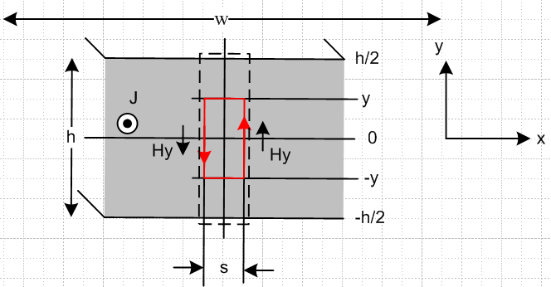

We now make the radical assumption that Hy has no dependence on y, so it is Hy(x). Therefore we extend the red math loop to the surfaces at h/2 and -h/2 and apply Ampere's Law

∫S J • dS = C H • ds (1.1.37)
so
Jz h dx = hHy(x+dx) - hHy(x)
or
Jz = [Hy(x+dx) - Hy(x)] /dx = ∂xHy(x).

Since Jz = I/(wh) this says

∂xHy(x) = I/(wh) => Hy(x) = Ix/(wh)

where there is no added constant since Hy(0) = 0 at the center of the bar where x = 0 is defined. So with our functional form assumption, we find that Hy(x) is linear in x along the width of the bar.

The contribution of this assumed Hy(x) to the bar's internal inductance is then

Li = μ ∫bar dS (Hy/I)2 = μ h $^{\int_{-w/2}^{w/2}{}}$dx [x/wh]2 = μ h 2 (wh)-2 $^{\int_{0}^{w/2}{}}$dx x2

= μ h 2 (wh)-2 (1/3) (w/2)3 = μ (1/12) w/h

Well, this is not what I wanted! But the Maple graph makes the linear assumption fairly reasonable, so why is this result blowing up! [ I got this same disturbing result earlier by hand ]

What happens if I combine the two pieces into the same red math loop but make the same functional form assumptions: here is a new version of the picture

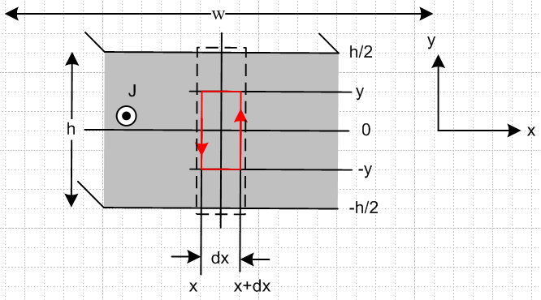

∫S J • dS = C H • ds for red loop (1.1.37)

Jz 2y dx = 2yHy(x+dx) - 2yHy(x) - dx Hx(y) + dxHx(-y)

Now claim from symmetry that Hx(-y) = - Hx(y), more justification later. Then we get

Jz 2y dx = 2yHy(x+dx) - 2yHy(x) - 2dx Hx(y)

Jz 2y dx = 2y[Hy(x+dx) - Hy(x)] - 2 Hx(y)dx

Jz y dx = y[Hy(x+dx) - Hy(x)] - Hx(y)dx

Jz y = y[Hy(x+dx) - Hy(x)] /dx- Hx(y)

Jz y = y∂xHy(x) - Hx(y)

Jz = ∂xHy(x) - (1/y)Hx(y)

Now things are all jumbled together. I could now make the assumption that Hx(y) is linear in y which look perfect from the graph. So assume

Hx(y) = Ay

Then we are left with

Jz = ∂xHy(x) - A

∂xHy(x) = Jz + A

Hy(x) = [Jz + A]x Hy(x,y) = [Jz + A]x

with no constant because want this to vanish at bar center, but we don't know A. So we are then facing these two equations,

Hx(y) = Ay Jz = I/(wh)

Hy(x) = [Jz + A]x ` A = unknown

What about curl H = J? I can see that div H = 0 just from the functional dependence.

curl H = (∂yHz - ∂zHy) + (∂zHx - ∂xHz) + (∂xHy - ∂yHx)

Get rid of all z stuff

= (∂xHy - ∂yHx) = Jz

Is this a new equation or same on I already have ?

∂xHy - ∂yHx = Jz

[Jz + A] - A = Jz

so it is nothing new, but at least it is respected. So how can I find a value for A?

OK, maybe the only way is to take it from the actual formula. I can evaluate Hx(y=b,x=0) and see what I get:

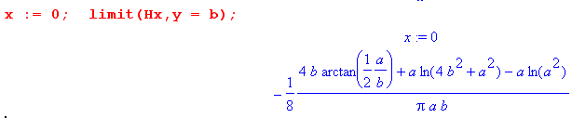

Interesting, at least it is something! Now I assume that

2a = w, 2b = h w >>h => a >> b

tan-1(a/2b) = tan-1(+∞) = π/2

ln(a2/(a2+4b2)) = ln(1 - 4b2/a2) = - 4b2/a2 = very small

a ln(a2/(a2+4b2)) = -4b2/a = -4b(b/a) = very small

4b tan-1(a/2b) = 4b π/2 = much larger than the above line

Then it seems that

Hx(y=b = h/2) = (-1/8) [4 b (π/2) + very small ] / (πab)

= (-1/8) [4 b (π/2) / (πab)

= (-1/8) [4 (1/2) / (a) ] = (-1/2) [(1/2) / (a) = -(1/4a) = -(1/4[w/2]) = -(1/2w)

and this is times current of 1 ampere so result is amp/m correct.
OK, so above I have

Hx(y) = Ay

=> Hx(h/2) = A(h/2)

Comparing these expressions shows that

A(h/2) = -(1/2w)

Ah = -1/w

A = -1/(wh)

And there is a candidate value for A. But now throw in I

A = -I/wh

and then this says

A = -Jz

and I then have

Hx(y) = Ay Jz = I/(wh)
Hy(x) = [Jz + A]x ` A = unknown

becoming

Hx(y) = -Jzy // this is the same as for my original solution apart from sign

Hy(x) = [Jz-Jz]x = 0 // this is twice my part 2 result

So I need to keep another term!!!

Continuing on Sat 2.1.14.

My problem is that I want Hy(x) [ the transverse field] to be linear so it is proportional to x. Then its square runs as x2 and then the integral will give (1/3)(w/h)3 which involves w3 and we end up with
Li = stuff * w3 and this makes it hard to get Li = stuff * (d/w) which is the known result. Somehow, the intercept of the linear behavior needs to have some w-n power to make this all work. But when I evaluate the Hy field at the point x = a, b = 0 which is at the far end of the thin bar, I got Hx = -(1/2w) . At least this is in the "right direction" in that the intercept drops off as w increases. But it is not enough to tame things. Here is what happens, from above. I allow both Hx and Hy to exist and apply Ampere to my red loop and I get

Jz = ∂xHy(x) + (1/y)Hx(y)

where of course I have assumed certain "functional forms". At this point I float as a trial balloon the idea that maybe Hx(y) = Ay because this is EXACTLY what the plot of this longitudinal field looks like versus the transverse coordinate, this plot being abs of Hx

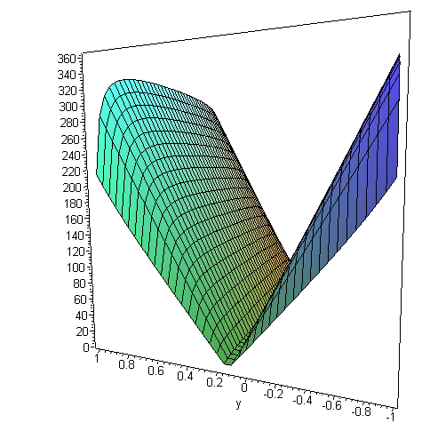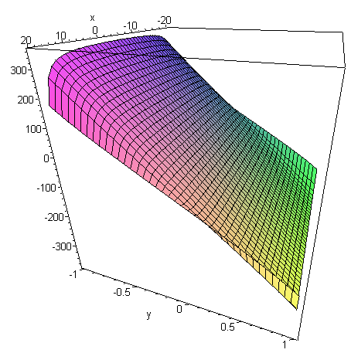

This seems very reasonable since the end effects to appear to be localized in the plot. Making this assumption then gives

Jz = ∂xHy(x) - (1/y)Hx(y)

Jz = ∂xHy(x) - A

∂xHy(x) = Jz + A

Hy(x) = [Jz + A]x

Here I am then in the danger zone where Hy2 ~ x2 and I will pick up that (w/2)3 factor from integration dx. So I need a strong w-n factor to come out of [Jz - A] = [ I/(wh) - A] where A is some function presumably of w and h. If A were the right thing, like perhaps A = I/(ωh) + I/(ωh)2 it could maybe save the day. So A must have some well-defined value. It is

Hx(y) = Ay => Hx(y=b/2) = A(b/2)

where this time I pick b/2 to avoid the singular edge of the V shape. So I can then evaluate

Hx(x=0,y=b/2) = A(b/2)

in order to evaluate A. Here we go:

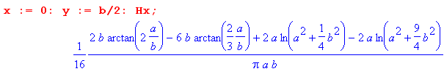

Now how do you take the limit of this accurately for a >> b? For a→∞, Maple says the limit is 0. But I think I need to know how it approaches 0 as a power. I try instead a series for the above for small b

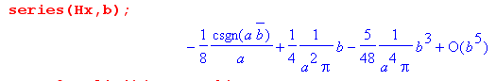

I think the csgn is +1 so this says that for small b,

Hx(x=0,y=b/2) ≈ -1/8a + b/(4πa2) + order(b3)

Then I conclude that

A(b/2) = -1/8a + b/(4πa2)

A = (-1/8a)(2/b) + b/(4πa2) *(2/b) = - (1/4ab) + 1/2πa2

I confirm with plot that Hx(x=0,y=b/2) is in fact a negative number (removed abs from plot).

This would be promising IF the leading term had been I/wh. But

I/wh = I/[2a*2b] = I/4ab

and this is what I want !!!! So maybe there is hope yet. How go back to

Hy(x) = [Jz + A]x = [ I/wh + {- I/wh + 1/2πa2 } ] x

= + Ix/2πa2 = Ix/[2π (w/2)2] = 2Ix/πw2 //a = w/2

and now finally I have a stronger negative power of w in my Hy(x) expression. Then consider

Liy = μ ∫ dS (Hy(x)/I)2 = μ ∫dx∫dy (Hy(x)/I)2 = μ h ∫dx (Hy(x)/I)2

= μ h $^{\int_{-w/2}^{w/2}{}}$dx [2x/πw2]2 = μ h (2/πw2)2 2 $^{\int_{0}^{w/2}{}}$x2dx

= μ h (2/πw2)2 2 (1/3) (w/2)3

= μ h 22 π-2 w-4 2 (1/3) w3 (1/8)

= μ h π-2 w-1 2 (1/3) (1/2)

= μ h π-2 w-1 (1/3)

= μ π-2 (1/3) (h/w)

= μ (1/3π2) (h/w)

= μ (1/29.6) (h/w) // exact result is μ (1/12) (h/w)

At least the result is in the right ball park!! The "undesired" π2 factor appeared as a 1/π when I evaluated the small b limit of H at the half way point on the flat hill.

Do I get the same result if I evaluate that full end of the flat hill?

Hx(y) = Ay => Hx(y=b) = A(b)

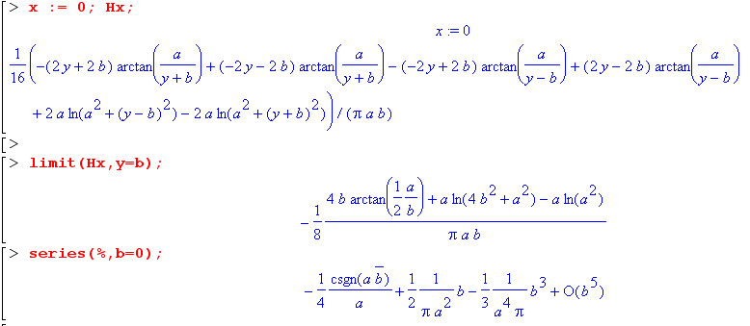
This result is in fact exactly twice the previous result for the first two terms, so it will give the same result. Fine.

So, why is my result only about 1/2 of the correct result? I did make a lot of assumptions.

1. The assumption that Hx = Hx(y) AND the second assumption that Hx(y) is linear in y seem together to match the plot with very small edge effect. So these particular assumptions seems very good ones. They involve the longitudinal field, not the transverse field.

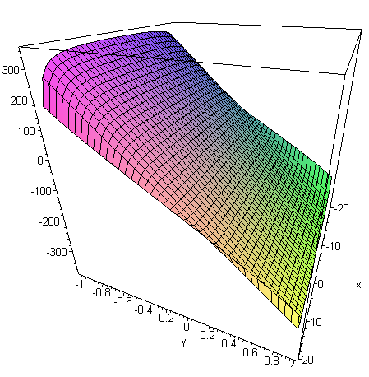

2. The next assumption is that Hy = Hy(x) and varies only with x. My graph shows that assumption also to be a very good one.

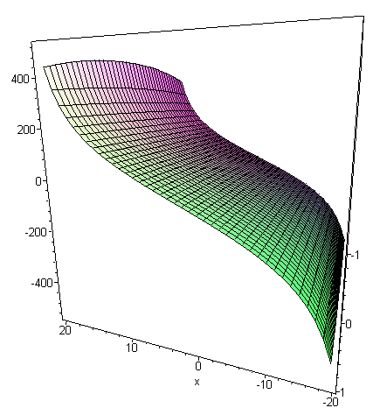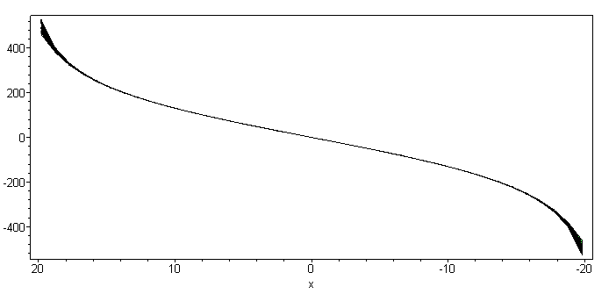

But you can see that it is not linear in x, although that would be a crudely valid approximation.

Fact: when I make the two assumptions above and do Ampere on my red loop, I end up with

Hy(x) = [Jz + A]x

which conflicts with the plot above which shows non-linear shape! So what is going wrong here?

Paradox : My simple assumptions

1a. Hx = Hx(y)
1b. Hx(y) = Ay
2. Hy = Hy(x)

all fit the data extremely well. But when I use these assumptions and apply Ampere, I get the result

Hy(x) = [Jz + A]x

which disagrees violently with the data which I can see is strongly not linear. Well, here is my plot of Hy versus x. It is in fact quite linear for the inside half of the rod, say from x = -10 to +10.

But consider this plot of Hx

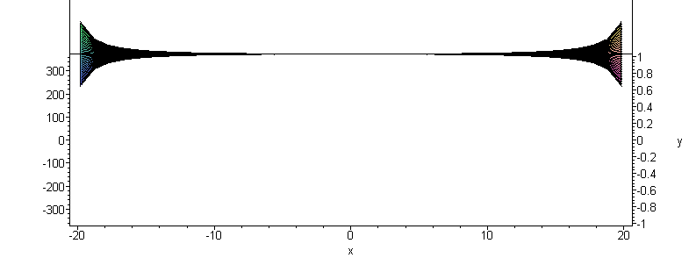
You can see that the planarity of this function is good for x = -10 to x= +10. What this means is that you can model Hx = Ay for the inner region , but to be more general, you need Hx = A(x) y where the constant A(x) varies in the large |x| regions.

So once again, I am faced with "end effects" which permeate more than just the ends.

Sunday 2/2/14.

As a sort of last gasp here, what happens if you just "series in b" the entire formulas for Hx and Hy in Maple? It has to give something, and that something has to match the pictures above it would seem. Before doing series b, we have the full blown expressions

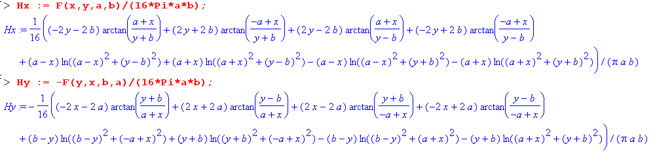

Well, we do get a reasonable simplification

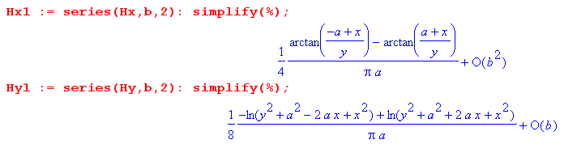

The second item appears to match Kuester (17), but the first does not match their (16) because their (16) shows both variables I call a and b, whereas mine shows only a. Probably my form leads to a problem and that is why they have their more complicated form.
In terms of numerical integration, we now are faced with far fewer terms to worry about. I can then write

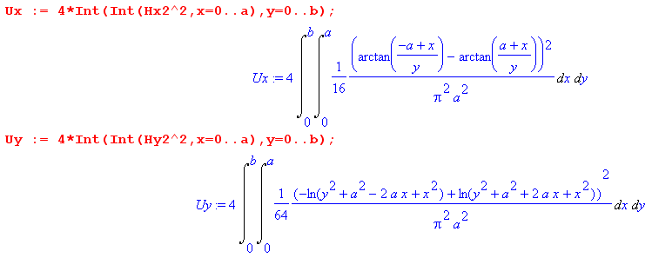

But now to get a numerical integral, you have to select a and b. I could take a = 1 and b = 10-6 for example and then just give it a try.

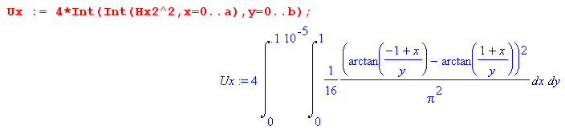

So it has trouble with those arctans no doubt at the endpoints. Adding Re{} does not help. Maple just cannot do these integrals come hell or high water. The _CCquad does not help, so you really have to go down the same road that Kuester did to get a numeric value, so I won't do that in Appendix C !

I think this wraps up this little effort.

