The Kuester Response PhL 1.28.14

Here after a while I grok what Kuester was telling me in his email. He is right, I was wrong.

It took me a while to understand what he is saying, but now I do understand. Here is my own plot of the right half of a 6x1 bar, rotated to match my PDF drawing

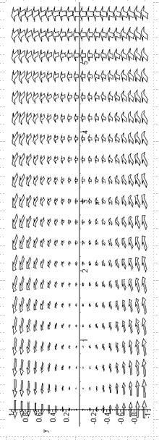

No matter how long the bar is, you will still see strong vertical even half way in from the end.
Now in terms of my usual picture, this is

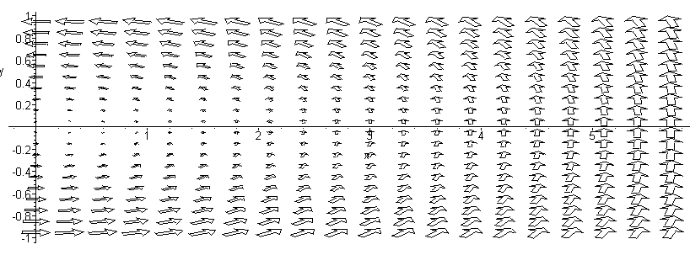

The Hy field at the right end is this:

Hy = - $\frac{I}{16πab}$F(y,x=a,b,a)

Maple gives the F function at that point and y = 0

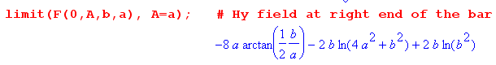

Write this then as

Hy = - $\frac{I}{16πab}$[ -8a tan-1(b/2a) + 2b ln($\frac{b2}{b2+4a2}$)

Now take the limit for large b/a. The ln term goes to ln(1) = 0, and you get

Hy = - $\frac{I}{16πab}$ [ -8a tan-1(∞)] = $\frac{I}{2πb}$ (π/2) = $\frac{I}{4b}$

which is a nice number to know about. Now suppose you model this in the bar as follows:

Hy(x,y) = $\frac{I}{4b}$ (x/a). = $\frac{I}{4ab}$x

But in terms of the Kuester PDF I sent, this says instead

Hx = $\frac{I}{4ab}$y

and this is then a model for the Hx component of the H field in the bar. Then maybe

Li = μ d $^{\int_{-w/2}^{w/2}{}}$dy (H/I)2 = 2 μ d $^{\int_{0}^{w/2}{}}$dy [$\frac{1}{4dw}$y]2

= 2μd (4dw)-2 $^{\int_{0}^{w/2}{}}$dy y2 = 2μd (4dw)-2 (1/3) (w/2)3

= 2 (1/16)(1/8) μ d1-2 w-2+3 = (1/64) μ w/d

The ratio is wrong here and the result increases with bar length ! So this overestimates that component.

