C.4 The DC inductance of a wire with rectangular cross section

The internal inductance expressions above apply to any cross sectional shape,

Li = μi ∫in dS (Hi/I)2 (C.3.7)
Le = μe ∫outdS (He/I)2 (C.3.8)

so the only problem is how to compute H for a non-round wire. That problem is solved in Appendix B where it is shown that

H(x,y) = - $\frac{1}{4π}$∫d2x' ln(R2) curl' J(x') R = |x-x'| . (B.2.6) (C.4.1)

We can do a wire of rectangular cross section 2a x 2b (uniform Jz) as an example.

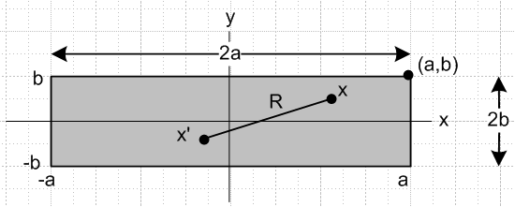 Fig C.1

The current density is given by

Jz(x) = (I/4ab)θ(-a ≤ x ≤ a) θ(-b ≤ y ≤ b)

= (I/4ab) θ(x ≤ a)θ(x≥-a) θ(y ≤b)θ(y≥-b) // θ(s≥r) means θ(s-r) Heaviside

= (I/4ab) θ(a- x)θ(x + a) θ(b- y)θ(y +b) . (C.4.2)

Calculate curl J :

curl J = (∂yJz - ∂zJy) + (∂zJx - ∂xJz) + (∂xJy - ∂yJx)

= (∂yJz) + (- ∂xJz) (C.4.3)

∂xJz = (I/4ab) ∂x[θ(a- x)θ(x + a)] θ(b- y)θ(y +b)
= (I/4ab) [θ(a-x)δ(x+a) - δ(x-a) θ(x+a)] θ(b- y)θ(y +b) // ∂xθ(a-x) = - δ(x-a)

∂yJz = (I/4ab) θ(a- x)θ(x + a) ∂y[θ(b- y)θ(y +b)]
= (I/4ab) θ(a- x)θ(x + a) [θ(b- y)δ(y+b) - δ(y-b) θ(y +b)]

so then

[curl J]x = (I/4ab) θ(a- x)θ(x + a) [θ(b- y)δ(y+b) - δ(y-b) θ(y +b)]
[cur lJ]y = - (I/4ab) [θ(a-x)δ(x+a) - δ(x-a) θ(x+a)] θ(b- y)θ(y +b) . (C.4.4)

Notice that we can obtain [cur lJ]y from [curl J]x by doing a↔b, x↔y and adding a minus sign.

Finally calculate Hx from (C.4.1).

Hx(x,y) = - $\frac{1}{4π}$∫d2x' ln(R2) [curl' J(x')]x R = |x-x'|
= - $\frac{1}{16πab}$$^{\int_{-a}^{a}{}}$dx'$^{\int_{-∞}^{∞}{}}$dy' ln [ (x-x')2 + (y-y')2] [θ(b- y')δ(y'+b) - θ(y'+b)δ(y'-b) ] }

= - $\frac{1}{16πab}$$^{\int_{-a}^{a}{}}$dx'$^{\int_{-∞}^{b}{}}$dy' ln [ (x-x')2 + (y-y')2] δ(y' +b)
+ $\frac{1}{16πab}$$^{\int_{-a}^{a}{}}$dx'$^{\int_{-b}^{∞}{}}$dy' ln [ (x-x')2 + (y-y')2] δ(y'-b) ] }

= - $\frac{1}{16πab}$$^{\int_{-a}^{a}{}}$dx' ln [ (x'-x)2 + (y+b)2] + $\frac{1}{16πab}$$^{\int_{-a}^{a}{}}$dx' ln [ (x'-x)2 + (y-b)2] }

= $\frac{1}{16πab}$( -I1+I2) I1(b) = $^{\int_{-a}^{a}{}}$dx' ln [ (x'-x)2 + (y+b)2]
I2(b) ≡ $^{\int_{-a}^{a}{}}$dx' ln [ (x'-x)2 + (y-b)2] = I1(-b) . (C.4.5)

Since we will be plotting things below, we assist Maple in computing these integrals in simple form:

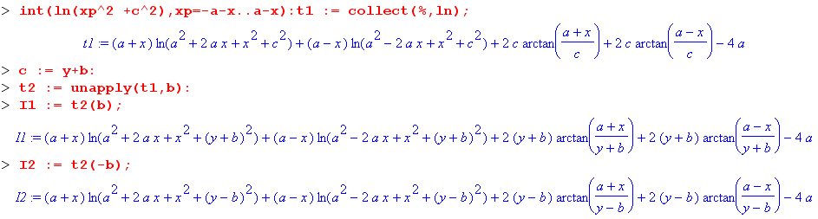

Although the font is small, one can see that each integral contains two ln terms, two arctan terms, and a constant term. Next, write

Hx(x,y) = $\frac{1}{16πab}$F(x,y,a,b) where F(x,y,a,b) = I2 - I1

The Maple unapply command causes an expression to be a function of the specified arguments, so

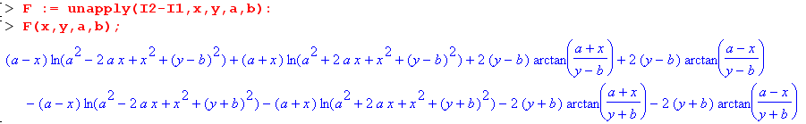

The function F(x,y,a,b) has four ln terms and four arctan terms (the constant cancelled). Now based on the comment below (C.4.4) above, we may conclude that

Hy(x,y) = - $\frac{1}{4π}$∫d2x' ln(R2) [curl' J(x')]y = Hx(x,y) if we swap a↔b, x↔y and add a minus
= - $\frac{1}{16πab}$F(y,x,b,a) . (C.4.6)
Just for the record,

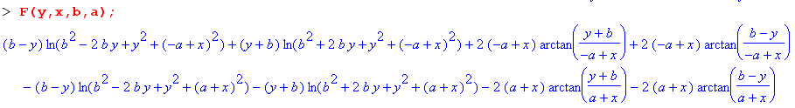

We can now make a "field plot" showing the H field (direction and magnitude) in the cross section plane of our rectangular conductor, where we stick with the 4:1 ratio of edges,

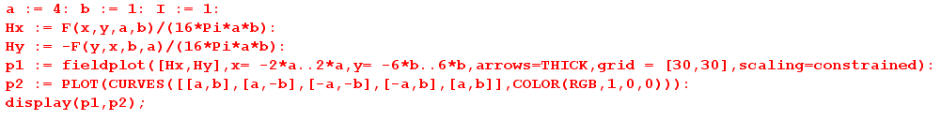
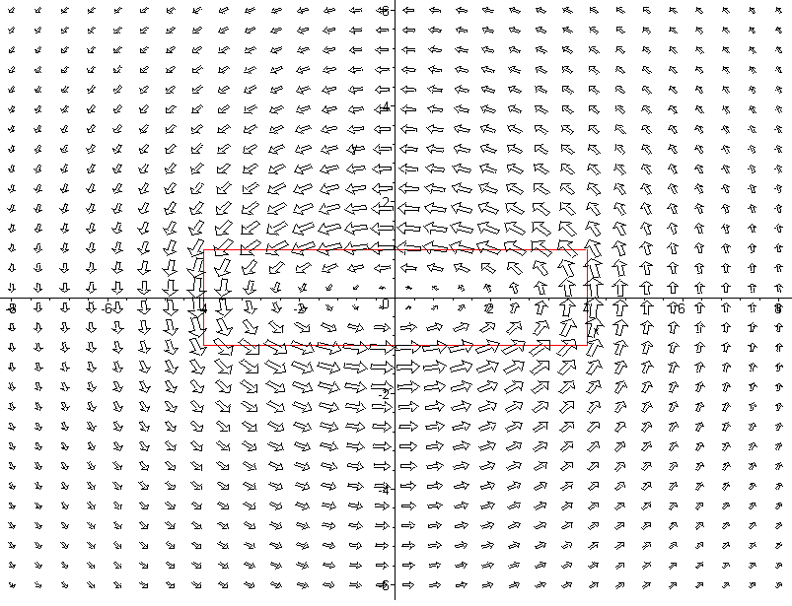

Fig C.2

In this plot the H field appears to be maximal at the conductor boundary (shown in red) and as one moves away it becomes the field of a thin round wire. Current Jz is flowing in the z direction toward the viewer.
The second plot is of |H|2 as a surface over the x,y plane. Recall that |H|2 is proportional to the energy density in the magnetic field.

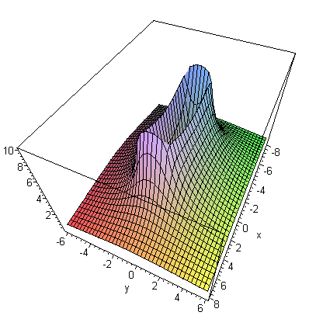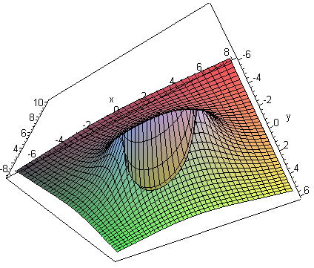
view from above view from below
Fig C.3

The |H|2 surface is very steep at the conductor boundaries, somewhat resembling a rectangular volcano which dips all the way down to 0 in the center, as shown on the right. The Li integration discussed below is over this central "cone" of the volcano.
The red plot below is a slice through the volcano at x = 0 :

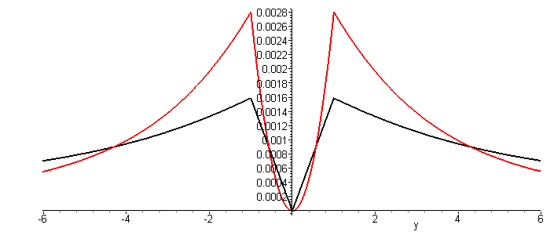 Fig C.4

The black plot is of | H | (but scaled down) and resembles the Hθ plot for the round wire shown in Fig B.8.

We return now to a computation of the internal inductance Li of the rectangular wire. From (C.3.7),

Li = μi ∫idS (H/I)2 = μi ($\frac{1}{16πab}$)2$^{\int_{-a}^{a}{}}$dx$^{\int_{-b}^{b}{}}$dy [F(x,y,a,b)2 + F(y,x,b,a)2] . (C.4.7)

Since F(x,y,αa,αb) = αF(x/α,y/α,a,b) one can show that Li must have this form

Li = (μi/8π) f(b/a) (C.4.8)

though this conclusion is obvious based on dimensions alone. The problem is to find function f . We can set a = 1 with no loss of generality, and we can use the obvious four-fold symmetry of the energy density so that

Li = 4 μi ($\frac{1}{16πb}$)2 $^{\int_{0}^{1}{}}$ dx$^{\int_{0}^{b}{}}$dy [F(x,y,1,b)2 + F(y,x,b,1)2]
= ( $\frac{μi}{8π}$) { $\frac{1}{8π2b2}$$^{\int_{0}^{1}{}}$ dx$^{\int_{0}^{b}{}}$dy [F(x,y,1,b)2 + F(y,x,b,1)2] } . (C.4.9)

Thus our function of interest is

f(b) = $\frac{1}{8π2b2}$$^{\int_{0}^{1}{}}$ dx$^{\int_{0}^{b}{}}$dy [F(x,y,1,b)2 + F(y,x,b,1)2] (C.4.10)

where

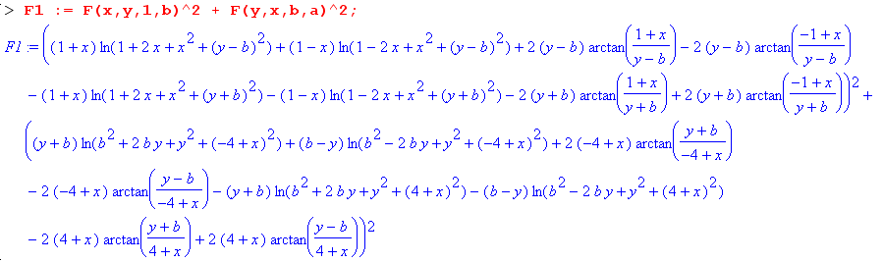

If one were to expand this expression, there would be 162 + 162 = 256 + 256 = 512 terms if no terms combined. In fact there are 232 terms:

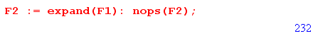

Here are four sample terms in the integrand of (C.4.10),

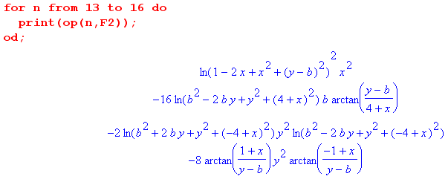

It seems rather unlikely that all 232 terms can be double-integrated analytically! For example, if we ask Maple to analytically integrate the last term shown above just over the x range, it gives up,

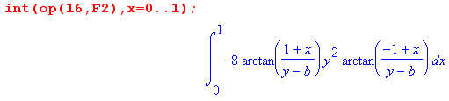

Thus, in order to compute f(b) we must turn to numerical integration which, for each value of b, requires doing 232 numerical double integrals and adding up the results. As is visible in Fig C.3 and Fig C.4, the overall integrand is singular at the conductor edge, so we might expect some difficulties with the numeric integrations near the upper endpoints.

We were not successful trying for a hour to get Maple to compute the integral (C.4.10) analytically or numerically, but certainly the numerical integration can be done. De Smedt quotes the following numerical approximate formulas for two special cases:

Li = (μi/8π) [0.96639] a = b (square wire) // very close to the round conductor

Li = (μi/8π) [(4π/3) a/b ] a/b << 1 (flat wire) // ≈ (μi/8π) [ 4.2 a/b ] (C.4.11)

Reader Exercise: Do the numerical integration outlined above to determine function f(b) for several b values and plot for b = 1 to 10. Is f(1) = 0.96639 ?

