Field Lines for a rectangular conductor PhL 1.30.14

I made these plots with my new plotting Maple code, and these pics are actually used now in lines.doc The code is in rectangle***.mws, I did many different versions, I should clarify this eventually.

This plot shows 16 field lines from b = 1/2 to b = 8 with ds = .04 for speed.

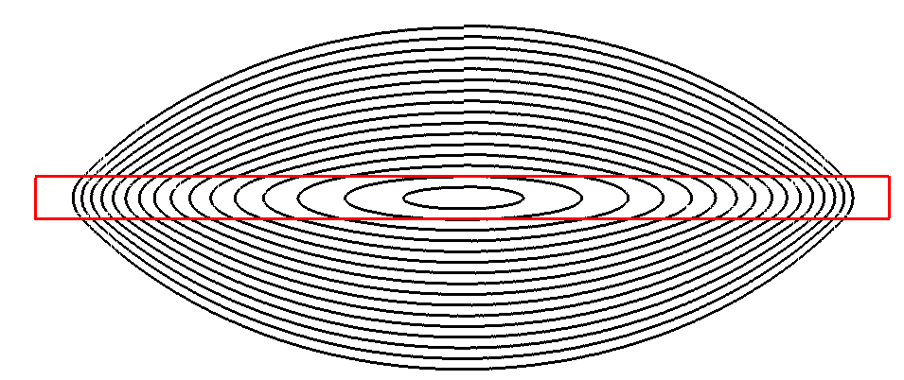

The above shows the strong amount of "transverse field" inside the bar even near the center.
The plot below shows 8 field lines from b = 2 to b =16

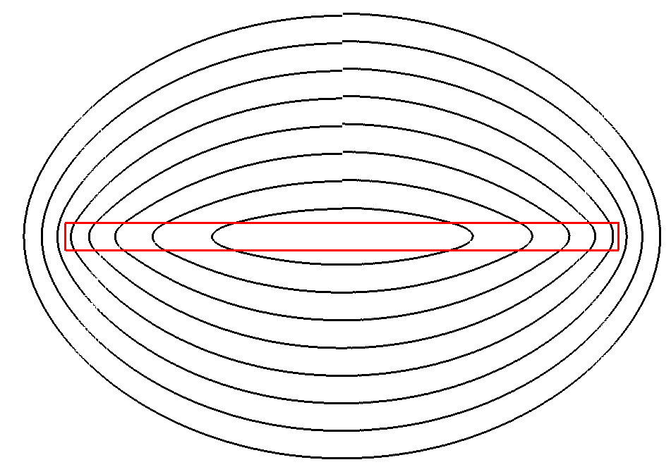
As we move further away, the lines will become circular.

Below are 4 lines with y0 = 8,16,24 and 32, getting very circular.

